HEALTH AND SOCIAL CARE CAREER PORTFOLIO
STUDENT NAME: AMINA NOOR
STUDENT NUMBER: 2421445
MODULE CODE: LCHS4009
MODULE TITLE: Professional Development within Health and Social Care
LECTURER NAME: WAFA NASIR
ASSIGNMENT TITLE: Personal Development Portfolio
Submitted date: 17 July 2026

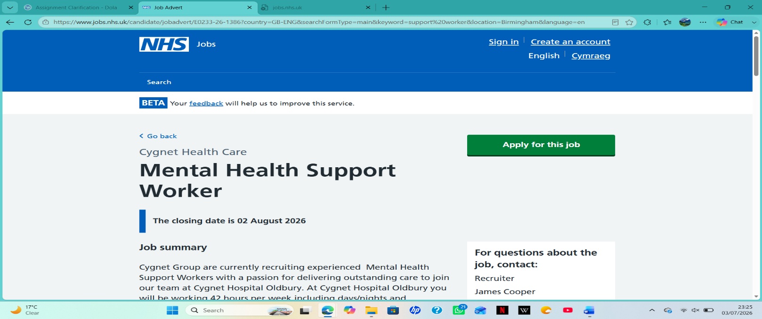
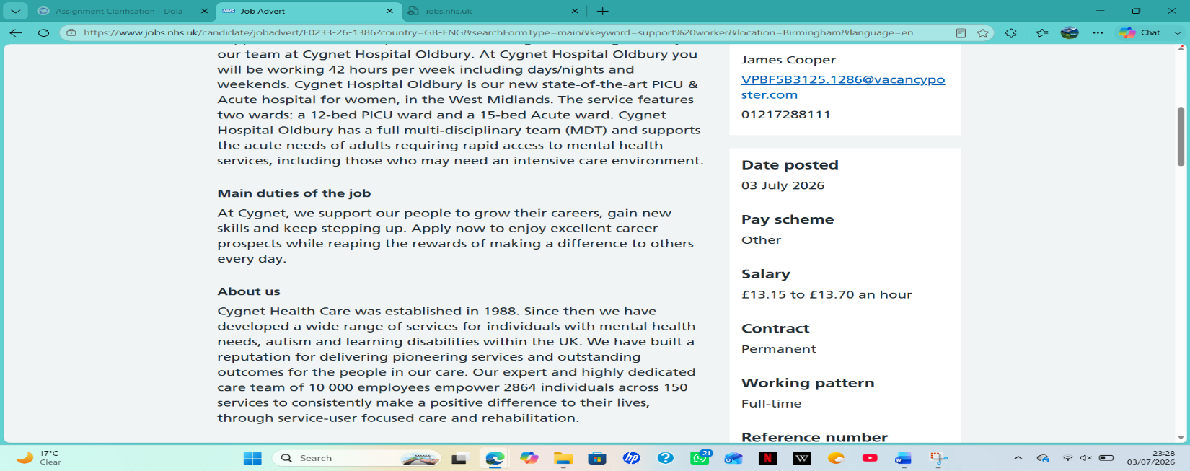
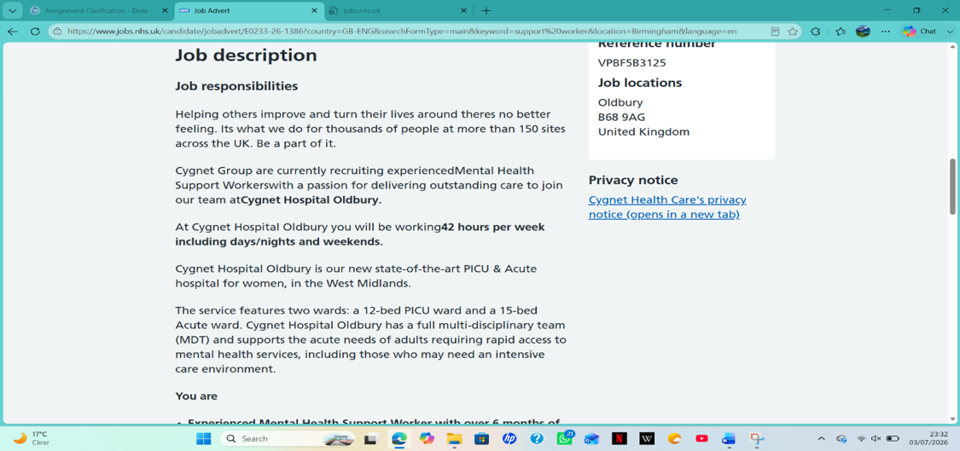
JOB SEARCH
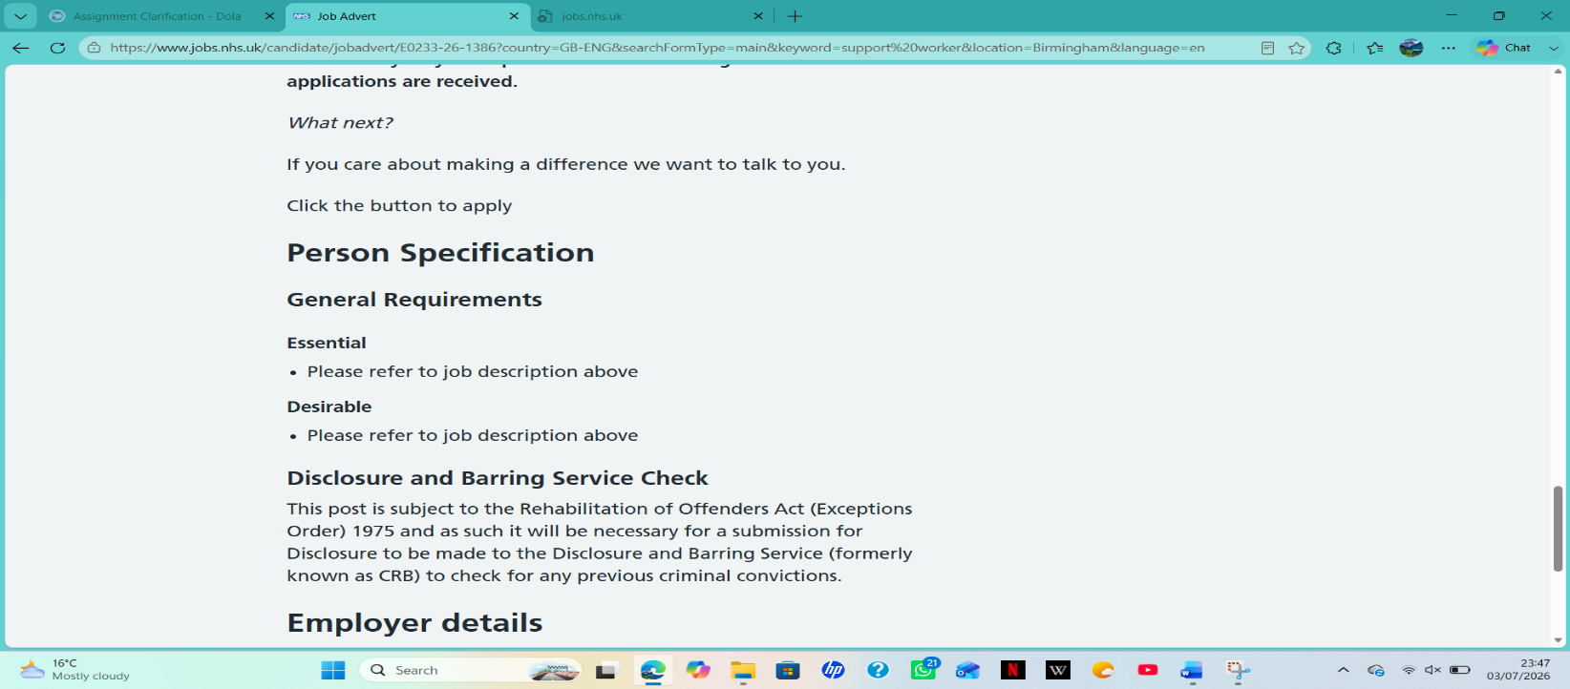
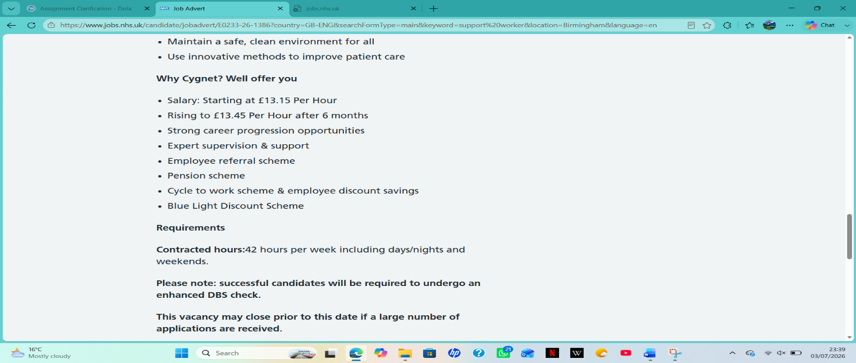
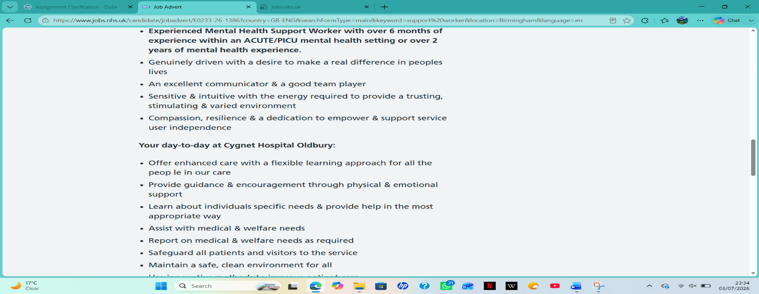
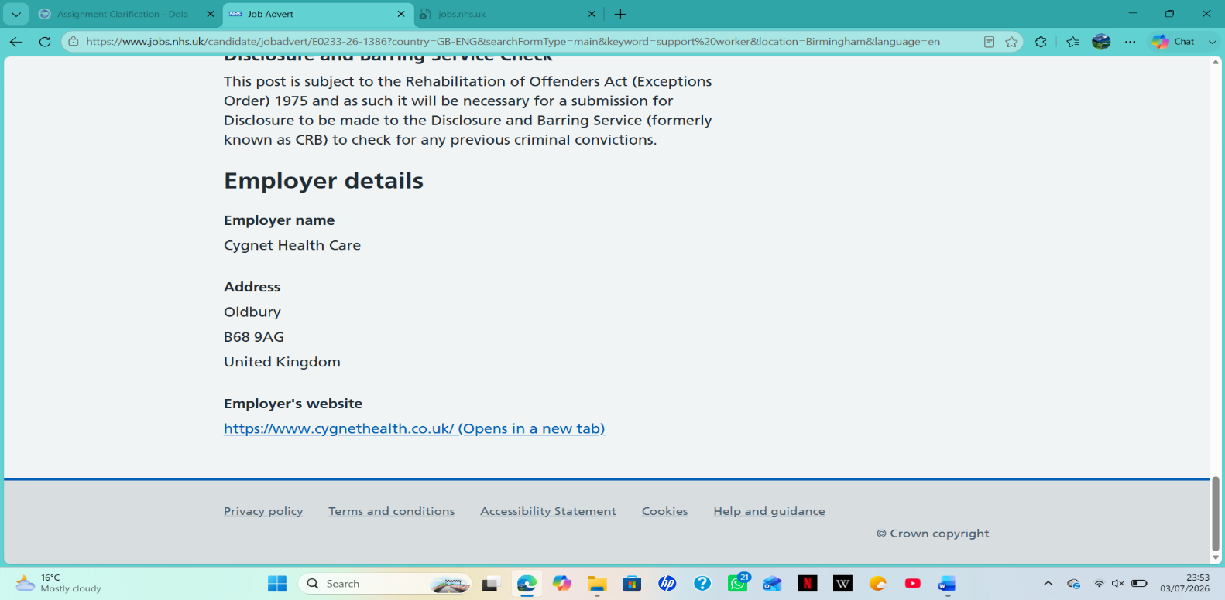

(Task 1)
AMINA NOOR
07541 917320 | aminanoor24@gmail.com

PERSONAL PROFILE
A resolute and caring individual currently studying towards a Certificate of Higher Education in Health and Social Care. I hold a Level 3 Diploma in the sector and have gained direct experience through voluntary work and college placements. I have developed a strong understanding of person-centred care, safeguarding principles, and relevant legislation, including the Care Act 2014. I am dependable, patient, and able to remain calm in challenging situations. I work well within a team and am fully flexible to work shifts, nights, and weekends as required. I am keen to join Cygnet Health Care to apply my skills, support individuals with mental health needs, and progress my career within a respected organisation.

EDUCATION & QUALIFICATIONS

- Certificate of Higher Education in Health and Social Care
- University of Wales Trinity Saint David | Sep 2025 – Present
- Module: LCHS4009 – Professional Development
- Key topics: Safeguarding, mental health awareness, communication, duty of care
- Expected completion: Jun 2027

Level 3 Diploma in Health and Social Care

- NCFE / City & Guilds | Completed Jun 2025 • Grade: Merit
- Units: Safeguarding, mental health principles, communication, equality, legislation

GCSEs

- Birmingham City Academy | Completed Jun 2023
- English Language: Grade 0035
- Mathematics: Grade 4
- Science: Grade 4
- Health and Social Care: Grade 5

TRAINING

- Safeguarding Adults Level 2 & 3 – Skills for Care, 2025
- Mental Health Awareness – CQC recognised, 2025.
- Equality & Inclusion – 2025
- Health & Safety & First Aid – 2025
- Confidentiality & Record Keeping – 2025 Emergency First Aid & Basic Life Support – FAIB Accredited, 2025
- Confidentiality and Data Protection – 2025

EXPERIENCE

Volunteer Support Assistant

Birmingham Community Mental Health Service | Sep 2024 – Present
- Help people with mental health needs with daily activities and social support.
- Listen well and build trusting, respectful relationships.
- Follow policies, safety rules, and confidentiality guidelines.
- Report changes in mood or health to senior staff quickly and clearly.
- Encourage independence and respect each person’s choices.

Student Work Placement

- Greenview Residential Care Home, Oldbury | Feb – May 2025
- Helped staff with daily routines and personal care under supervision
- Learned how care plans and risk assessments are used in practice
- Practised speaking and interacting calmly with people in distress
- Wrote clear, accurate notes and followed all health and safety rules

KEY SKILLS

- Communication: Clear speaker, good listener; adapts to different people’s needs
- Person-centred care: Respects rights, dignity, and individual choices
- Safeguarding: Knows how to spot risks and follow reporting procedures
- Teamwork: Works well with others; happy to do shifts when needed
- Empathy & resilience: Stays calm in tricky situations, shows understanding
- Record-keeping: Writes clear, accurate and confidential notes

REFERENCE

WAFA NASIR
ROLE: lecturer
Email: w.nasir@uwtsd.ac.uk

(TASK 2)

Personal statement

I am applying for the position of mental health support worker at Cygnet Hospital Oldbury, which was listed on the Cygnet Health Care website. This role particularly appeals to me because it focuses on supporting people through periods of acute mental health need, an area I am deeply passionate about. I am now pursuing a Certificate of Higher Education in Health and Social Care, and I have a Level 3 Diploma in the same profession. These certifications have provided me with both the theoretical and practical knowledge required to function safely and compassionately in this situation. My education, practical experience, and personal beliefs have equipped me to provide high-quality treatment that fulfils both organisational requirements and the needs of those living with mental illnesses.

My studies have provided me with a solid knowledge of the fundamental ideas that underpin excellent care practice. I have learnt the value of treating everyone as an individual, respecting their rights, preferences, and right to make their own informed choices – even when those choices differ from what I might think is best. I am also aware of the legal and professional frameworks that provide safe and supportive care, including the responsibility to protect individuals from harm and promote their general well-being. My training has included topics such as safeguarding, mental health awareness, communication, and health and safety, which has given me a great basis for working responsibly in my position.

Through my volunteer work at Birmingham Community Mental Health Service and my student placement at Greenview Residential Care Home, I have been able to put this learning into practice. I have helped clients with problems including anxiety, sadness, and cognitive impairment, tailoring my approach to everyone’s needs. I have provided daily routines, social activities, and emotional support to people with a variety of requirements. To make service users feel secure, respected, and appreciated, I have discovered that developing trust and demonstrating true empathy are essential while working in mental health settings. I consistently allocate time to listen without prejudice and affirm an individual's emotions, instead of hastily proposing answers. Even in trying or demanding circumstances, I can maintain composure and patience, and I recognise the significance of noticing behavioural or wellness abnormalities and swiftly and clearly reporting them to senior staff.

Cygnet Health Care has a great reputation for providing exceptional services, with numerous facilities being acknowledged for their high quality of care. I am particularly intrigued by your concept of empowering individuals and collaborating with a multidisciplinary team to produce excellent results. I am completely adaptable and willing to work shifts, including days, evenings, and weekends, as necessary for this role. I really like how your staff works with families, nurses, doctors, and occupational workers to give regular, all-around help. I am excited to contribute my devotion, dependability, and good attitude to your team while also learning and developing my professional abilities throughout my career.

TASK 3a: SWOT ANALYSIS Role: Mental Health Support Worker | Employer: Cygnet Health Car
This analysis identifies my personal strengths, weaknesses, opportunities, and threats in relation to working in a mental health care setting, with a focus on my development needs. A SWOT analysis is a useful tool for assessing current capabilities and planning for future development (Hudson, 2024).
✅ Strengths  I have a solid foundation from my education and training, including information on safety, mental health awareness, and person-centred care (Care Quality Commission, 2023). Through my volunteering and placement experiences, I have sharpened my skills in active listening, clear communication, and building trust, which are vital when helping people with mental health challenges (Skills for Care, 2022). I am reliable, on time, and flexible, which helps me meet the shift requirements, including nights and weekends, for this position. I also understand the importance of following policies and keeping information confidential (Care Act, 2014). | ⚠️ Weaknesses  My main area for improvement is my limited direct experience in an acute or specialist mental health setting like Cygnet Hospital Oldbury. I feel less confident managing highly challenging behaviour or complex situations without close support from senior staff. I also need to develop a more detailed understanding of specific mental health laws and improve my skills in authoring formal daily reports and care records (Jasper, 2020).
🚀 Opportunities  Cygnet Health Care provides solid chances for training and career growth, with induction programmes and further qualifications (Hudson, 2024). Being part of a multi-disciplinary team will allow me to learn from experienced nurses and support workers. I can also use my time in this role to build confidence, improve my practical skills, and work toward a Level 4 qualification in the future. | 🛑 Threats  There is intense competition for this type of role, so I need to show commitment and willingness to learn. Working in an acute setting can also be emotionally demanding (Hudson, 2024), so I must build my own resilience to manage this. Keeping up with changes in rules and standards is also important to stay competent in the job (Care Quality Commission, 2023).

TASK 3b: PERSONAL DEVELOPMENT PLAN

This strategy outlines specific, achievable objectives to assist me in developing the knowledge, skills, and confidence essential for functioning effectively as a mental health support worker at Cygnet Health Care. It prioritises addressing the aspects identified in my SWOT analysis and facilitates my professional development over the upcoming 12 to 24 months (Hudson, 2024).
(Goal 1): Improve knowledge of policies and mental health legislation.
- what I want to achieve: Gain a thorough awareness of the primary laws, rules, and organisational policies that relate to this position so I can perform securely and within legal boundaries (Care Act, 2014).
- Actions: Read all necessary policy materials supplied during my introduction, attend every internal training session offered by Cygnet, and take notes for future review. I will also ask my supervisor to clarify anything I do not comprehend.
- Timescale: 6 to 7 months
- How to measure progress: Check my comprehension via conversations in supervision meetings and ensure I can apply regulations appropriately in daily duties.
- Outcome: I will feel comfortable discussing and implementing policies without constant supervision.
(Goal 2): Build confidence in supporting people with complex needs
- What I want to achieve: Develop the capacity to respond calmly and effectively while assisting people who are disturbed or engaging in demanding conduct (Skills for Care, 2022).
- Actions: Observe seasoned members of the diverse team during their shifts to learn about effective practices. Finish training in conflict management and de-escalation and contemplate my own experiences following each shift.
- Time scale: 6 to 12 months
- How to measure progress: Ask for regular input from senior staff and keep a short record of situations I have handled effectively and what I can better.
- Outcome: I will be able to serve service consumers independently while also recognising when to seek help if needed.

(Goal 3): Develop accurate record-keeping skills.
- What I want to achieve: Create care records that are clear, factual, and timely, meeting both professional and legal obligations (Care Quality Commission, 2023).
- Actions: Examine the organisation's documentation rules, look at examples of best practices, and ask a senior colleague to review my notes early on.
- Time scale: 2 to 8 months
- How to measure progress: Ensure that my records are complete, easy to comprehend, and accepted without modification.
- Outcome: I will create regular, reliable reports that help to ensure safe and effective care.

TASK 4: REFLECTIVE PRACTICE USING GIBBS’ REFLECTIVE CYCLE

Reflection helps us learn deeply and practically from experience and build lasting professional confidence. Gibbs’ six-stage model gives us a clear way to look at what happened, our feelings, and areas for improvement (Gibbs, 1988). This reflection focuses on my Component 1 presentation on Communication in Professional Health and Social Care. I used the Shannon and Weaver communication model for this presentation.
1. Description
For this assessment, I delivered a structured 5-minute presentation on why communication is an essential skill for safe, compassionate practice in health and social care. I discussed definitions, legal standards, common barriers, and practical examples. I used the Shannon and Weaver model to illustrate how clear messages are sent, received, and understood. My tutor provided positive feedback: I kept good eye contact, spoke clearly, and finished on time. The only weakness mentioned was that I seemed nervous, especially at the beginning, and hesitated a bit when explaining parts of the model.
2. Feelings
Before starting the presentation, I felt quite anxious and constantly worried I might forget key details or accidentally speak too fast. My hands felt shaky, and I found myself rushing through the opening sentences to get past the introduction quickly. However, once I made steady eye contact and saw my tutor listening attentively, I gradually started to relax and find my natural rhythm. After finishing within the strict time limit, I felt hugely relieved and genuinely pleased that I had covered every planned point clearly. When I heard the full feedback, I was glad my preparation and delivery were acknowledged, but I also recognised that my nerves had impacted how confidently I explained some of the more complex ideas.
3. Evaluation
My key strengths were engagement and managing my time effectively: maintaining good eye contact demonstrated my connection with the audience, and adhering to the schedule indicated that I had practised sufficiently (Gibbs, 1988). The information presented was accurate and organised well. The main challenge I faced was that my nervousness impacted my fluency and made me reluctant to elaborate on explanations, despite having a solid understanding of the material. Research indicates that presentation anxiety is a prevalent source of study-related stress for university students and can temporarily diminish confidence, even when knowledge and preparation are adequate (Vitasari et al., 2010).
4. Analysis
Feeling nervous does not mean I was not prepared, but it did affect how I conveyed my knowledge. Research indicates that presentation anxiety often stems from the fear of being evaluated or making errors, which can result in hesitation or speaking too quickly (Vitasari et al., 2010). In the fields of health and social care, having confidence while sharing information is just as crucial as the information itself, as it fosters trust with both colleagues and service users. My feedback indicates that my abilities in maintaining eye contact and managing timing are already solid. I now need to develop the confidence to complement these skills.
5. conclusion
The presentation achieved success by fulfilling every requirement which had been established. I have learned that anxiety exists as a natural feeling which I should try to manage instead of using it as evidence of my inability. I now understand that preparing what to say is only half the task; feeling calm enough to say it clearly is the other half (Gibbs, 1988).
6. Action plan
- Practise out loud multiple times before future presentations.
- Take a slow breath and pause for two seconds before starting.
- Remind myself that presentation anxiety is very common among students (Vitasari et al., 2010) and does not mean I will do badly.
- Focus on talking to the audience rather than worrying about being perfect.

References
Care Act (2014) Care Act 2014. London: The Stationery Office.
Care Quality Commission (CQC) (2023) Regulation 9: Person‑Centred Care. Available at: https://www.cqc.org.uk/guidance-providers/regulations/regulation-9-person-centred-care (Accessed: 10 July 2026).
Gibbs, G. (1988) Learning by Doing: A Guide to Teaching and Learning Methods. Oxford: Further Education Unit.
Hudson, S. (2024) Personal and Professional Development for Health and Social Care. London: Sage.
Jasper, M. (2020) Beginning Reflective Practice. 3rd edn. Andover: Cengage Learning.
Skills for Care (2022) The Care Certificate Standards. Leeds: Skills for Care. Available at
https://www.skillsforcare.org.uk/Home.aspx (Accessed: 10 July 2026).
Vitasari, P., Wahab, M.N.A., Othman, A. and Awang, M.G. (2010) ‘A research for identifying study anxiety sources among university students’, International Education Studies, 3(2), pp. 189–196.
Available at: https://eric.ed.gov/?id=EJ1066077 (Accessed: 16 July 2026).

