Advanced process amd Materials Report

By Michael Thame
  - Assignment 1

Contents
Introduction 2
The material 2
Density 2
Strength 2
Properties 2
Heat treatment of Aluminium 3
CNC milling 3
Introduction 3
Process Cycle 5
Choices of possible processes 5
Water jet cutting 5
Equipment 5
Capabilities 6
Costs 6
Advantages (mech4study, 2017) 7
Disadvantages (mech4study, 2017) 7
Laser jet cutting 8
Process 8
How it works 8
Advantages (mech4study, 2017) 9
Disadvantages (mech4study, 2017) 9
Which to choose 10
Conclusion 12
Bibliography 12

Advanced Processes and Materials

Introduction
An aircraft companies manufactures a variety of aerospace components including an Aluminium helicopter cockpit floor measuring 50.8 x 33 x 2.5cm (508 x 330 x 25mm) to a maximum tolerance of +/- 0.0127cm (0.127mm). They use CNC Milling processes to machine the part. The company wants to modernise and expand and considering using non-traditional machining as part of this modernisation and expansion, also they want to improve the surface quality.
Looking at the image provided the component is rectangle shaped, the component has two holes in the piece probably 10cm each side and a 2cm hole. There are four bracket/slats/strips alone the surface of the component presumably riveted or welded.

The material
The Aluminium I guess that will be used will be an alloy been the fact that pure Aluminium is low in strength and mainly used for coating wires. Aluminium is mostly alloyed with Copper, Zinc, Magnesium, and lithium.

Density
Aluminium has a density about one third of steel or copper making it one of the lightest metals. The subsequent high strength to weight ratio makes it an important structural material allowing increased payloads or fuel savings for transport industries in particular. (materials, 2005)

Strength
The adding of alloying elements like manganese, silicon, copper and magnesium will increase the strength of aluminium and can be produced to suit different applications. Aluminium is well suited in multiple climates, which the helicopter will be used in so the material. (materials, 2005)

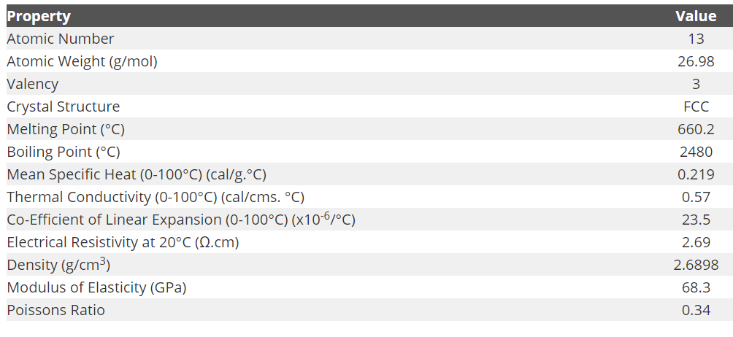
Properties

Table 1 properties of alumimium (materials, 2005)

Heat treatment of Aluminium
A number of heat treatments can be used for aluminium alloys including: (materials, 2005)
- Homogenisation- removal of segregation by heat after casting
- Annealing- cold working to soften work – hardening alloys
- Precipitation but solution heat treatment must be done before the ageing of precipitation hardening.
- Stoving for the curing of coats

CNC milling

Introduction
Milling is a material removal process, which can create a variety of features on a part by cutting away the unwanted material. The milling process involves a milling machine, workpiece, fixture, and cutter. The workpiece is a piece of pre-shaped material that is secured to the fixture, which itself is attached to a platform inside the milling machine. The cutter is a cutting tool with sharp teeth that is also secured in the milling machine and rotates at high speeds. By feeding the workpiece into the rotating cutter, material is cut away from this workpiece in the form of small chips to create the desired shape. (CustomPartNe, 2018)
Milling machines are able to be computer controlled, meaning they are referred to as a computer numerical control (CNC) milling machine. CNC milling machines move the workpiece and cutter on commands that are pre-programmed and offer very high precision. The programs that are written are often called G-codes or NC-codes. Many CNC milling machines also use another axis of motion besides the standard X-Y-Z motion. The angle of the spindle and cutter can be changed, allowing for even more complex shapes to be milled. (CustomPartNe, 2018)

Table 2 brief capabilites of CNC Milling (CustomPartNe, 2018)
 | Main | Achievable
Shapes | Cubic and Complex solid shapes | Thin walled Flat and cubic and solid cylindrical.
Part Size | Length approx : 0.04- 72 in  Width approx : 0.04-72in
Materials | Alloy steel  Carbon steel  Cast iron  Stainless steel  Aluminium  Copper  Magnesium  Zinc | Cermaics Composites  Lead  Nickel  Tin  Titanium  Elastomer  Thermoplastic  Thermosets
Surface finish | 32-125 um | 8-500 um
Tolerance | +/- 0.001 in | +/- 0.0005 in.
Max thickness | 0.04 -40 in. | 0.04-72in
Quantity | 1-1000 (feeder will have to be applied) | 1-1000000 (feeder will have to be applied)
Lead time | days | Hours
Advantages | All materials compatible and ease to fit and assemble.  Very good tolerance  Short lead time
Disadvantages | Limited shape complexity compared to non-traditional machining.  High equipment costs  Significant tool wear overtime causing tolerance and surface finish issues.  Scrap metal wasted
Applications | Main use is machine components and engine components

Process Cycle
Using the Milling process cycle (Load/unload time, (time required to load/unload workpiece into milling machine including fixing and completion) Cut time, (time measured to make all cuts) Idle time (any uneventful occurrences that occur in the production time) and Tool replacement time (replacing any tools that are worn, generally not performed in every cycle)) there is no post processing required. But Secondary processes might be required to improve surface quality. The scrap material is in forms of big piles of small materials chips cut from the workpiece. Its propelled away from the work piece from motion of cutter and spraying of lubricant. Meaning no process steps are required to remove scrap metal, which can be collected and discard after production. (CustomPartNe, 2018)

Choices of possible processes
Choices have chosen to substitute the CNC Milling are water jet cutting and Laser cutting. I feel these are the most suited and easiest form of alternative machining. It will be suited as well of cutting the helicopter part and aluminium.

Water jet cutting
Waterjet cutting is the usage of specialist cutters that has a high-pressure jet stream of water to cut the material. Its basically a system of nature where a waterfall erodes a rock but speed up.

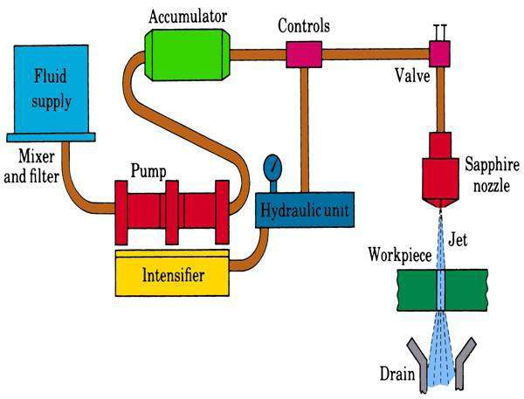
Equipment
picutre 1 1 Diagram of Wter jet cutting (mech4study, 2017)

- Water is filled in a reservoir which provides water for cutting operations.
- The pump sucks the water, which is powered by a 100hp electric motor generally. It then sends to the intensify.
- The intensifier increases the water from about 4 bars to 4000 bars. Sending water then to the accumulator.
- High pressure water is sent through system to nozzle flowing through regulator valves regulating flow.
- A high-speed pressure water jet is exited the nozzle.
- The water jet strikes the workpiece eroding the metal removing the metal.

Capabilities
Table 3 capabalites of Water jet cutting (university, 2018)
Velocity | 5-15ms
Flow rate | 75 L min-1
Force | 5-135 N
Pressure | 70 – 415Mpa
Power | 40kW for pumps maybe, density power of about 107kWm-2
Nozzle size | Varys from 0.075 to 0.40mm
Nozzle material | Usually sapphire but can be made of hardener steel and stainless steel.
Angle of nozzle | 0° to 30°
Stand off distance | 2.5mm to 50mm typically 5mm depending on material and cut
Cutting speeds | Depending on material, fibre glass generally has a cutting speed of 2.5mm a second. Generally aluminium would have a cutting speed of 15mm a second.
Materials | Most suitable is non-metallic materials and thin soft metals. Mainly Aluminium, Copper and Lead.
Thickness cut | Varies on materials but can cut a max of 50mm but will reduce cutting speed

Costs
Costs of Water jet cutting are valued on many factors including:
- Tooling/parts
- Power to machine
- water purification
- Maintenance
Tooling- as already stated the tool (Nozzle) is made from Sapphire, Sapphire been very expensive due to their rarity and machining the nozzle to size, requiring non-traditional techniques to cut like diamond. It may be worth replacing the sapphire with a cheaper hardened steel but bearing in mind sapphire will last 8x longer than hardened steel be nearly has hard as diamond. It all depends on price range and best over. Say a Hardened steel nozzle cost £10 and a sapphire nozzle cost £100 pounds, but a hardened steel nozzle lasts only 1 month but a sapphire nozzle last a year in the long run the sapphire nozzle will save money over the hardened steel.
Power to machine- More will be covered in which is best section but briefly the whole system requires 147kW per mintute to power it meaning a generator will be required to power it adding costs.
Water purification- Water purification is required to stop scaling and limescale in the system without it futher costs will be required for cleaning or replacing parts in system, but the act of purifying the water can become costly depending on method of purifying either a purifier or additive. Additive will be the best but will still be cost due to solution adding.
Maintenance- Maintenance will be costly especially unprepared maintenance due to shut down of manufacturing line. Which there are number of costs that are required during, before and after maintaining including:
- Safety checks carried out following all legislation and safety requirements
- A trustful person to carry out maintenance and safety checks meaning hiring or bringing someone in to do the job in hand.
- Lost time and shut down halting the production line losing money and profit and causing down time for staff.
- Any parts that are required to be replaced, which will be costly due to buying of the parts and fitting them and checking that the part is safety fitted and is in standards. Bearing in mind a fitter and safety inspector will have to called out to check and fit part.

Advantages (mech4study, 2017)
- Mechanical properties of work piece are unchanged.
- Environmentally friendly doesn’t form any dust particles and water is used as cutting fluid.
- Good surface finish.
- No physical tool is required.
- It can cut both soft and hard material.
- It is ideal process for laser reflective materials where laser beam machining cannot be used.
- Lower cost of machining.

Disadvantages (mech4study, 2017)
- It cannot be machined while submersed in water
- Low metal removal rate
- High intial cost.
- Thick material cannot be machined easily.

Laser jet cutting

Process
The process works by using lasers. Using a laser beam, which is narrow, monochromatic high intense light which cuts or machines any metal and non-metal. (mech4study, 2017)

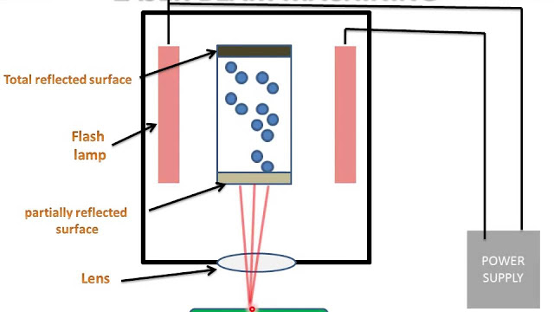
How it works
picutre 1 2 diagram of laser jet cutting (mech4study, 2017)

Summarizing the process of laser cutting can be explained as followed: (university, 2017)
- Laser material CO2 and Nd- YAG is filled into laser discharge tube.
- Switching on the power supply (about 25KW +/- ) connected to flash lamps. The lamps produce light energy which when used charge electrons of atoms.
- The atoms absorb energy from the light energy created by the flash lamp. Causing a jump of orbital electron of atom, forming low energy level to high energy level. Causing unstable condition of atom.
- The energy is built up as laser material. The atoms absorb quality energy when this happens it starts to emit energy nonstop.
- The laser light absorbed by the lens are directed towards the work piece.
- The laser is pointed onto the workpiece and machining can begin by melting material from the surface.

Table 4 capabilities of Laser cutting (university, 2017) (mech4study, 2017)
Gases used | CO2 (30% efficient) and Nd-YAG (2% efficient)
Gas pressures | No real pressures for main gases but assisting gases (Oxygen or air) have pressures of 140 to 825 kPa.
Power | Varies 0.25 to 25kW. But in pulsed mode its about 50KW and continuous mode about 1KW.
Drilling rates | Can be fast example been a 0.5mm diameter, 2.5mm thick can cut in about 1-3s
Materials | Most metals, glass, ceramics, and Polymers
Cuts | See diagram below
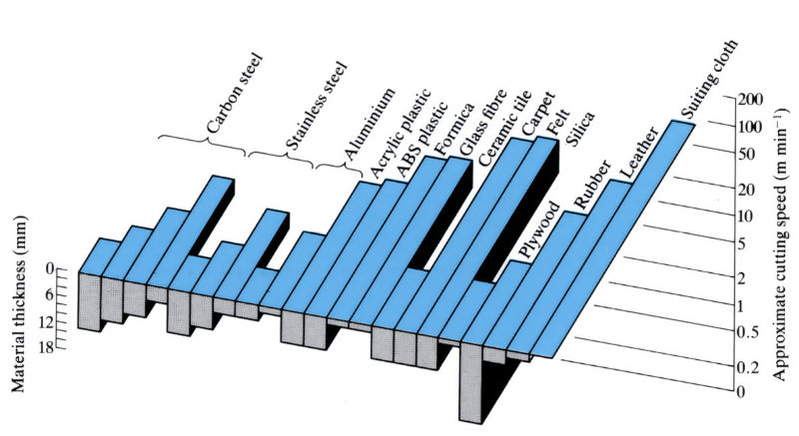
diagram 1 cutting speeds over thickness of laser cutter (university, 2017)

Advantages (mech4study, 2017)
- Can cut all material.
- No tooling cost no physical tool is used.
- Produces finish part with high surface finish no need to improve surface quality
- Complex shapes can be machined with ease with lase been able to move in any path.
- Hard materials can be cut with ease
- High accuracy
- Can be CNC programmed and automated and flexible.

Disadvantages (mech4study, 2017)
- Uneconomical when high volume of same shape is to be cut.
- High capital and maintenance cost due to specialist requirements and fitting.
- Blind holes can not be produced
- Laser produce a fine vapour which solidifies, forming a fine dust which is health Hazard and requires removal. Eye protection must be worn because of refection of laser.

Which to choose
Table 5 compare and contrast of CNC milling, Laser cutting and Water jet cutting (McHone Industries, 2018) (university, 2017) (university, 2018) (mech4study, 2017) (mech4study, 2017) (CustomPartNe, 2018)
 | CNC Milling | Laser cutting | Water Jet Cutting
Cost | Initial cost of equipment is quite high, but a good use can be got out of it if treated correctly. Programming the machine as well the use of computer time.  Preventative and ongoing maintenance will cause a rise in costs caused by the lost time and downtime.  Bearing in mind this is what the company pays now, so if the other machining techniques are less may consider switching.  Cost per hr $11-18/hr | Although no tooling and tool wear. Costs would look higher than CNC milling. Main reasons include the huge amount of power required to run the laser (about 25KW compared to 100W plus CNC milling machine using your standard 24V supply to workshops meaning a specialist generator or transformer is required). Another factor is maintenance been done by a specialist not a trained mechanical fitter. Also, spare parts cost is high seeing that Lens and flash lamps are involved.  Cost per hr $13-20/hr | Although machining cost will be lower than CNC Milling and there is no physical tool required meaning no need to replace any existing tools. You would think that sapphire would be cheaper than diamond tips used on CNC (of course both industrial). However not the case because its industrial diamond is less expensive to make than Sapphire. Remembering there’s a 0.04mm – 0.4mm hole not easy to machining.  Cost per hr $15-30/hr
Tolerances | +/- 0.0025mm | +/- 0.005mm | +/- 0.2mm
Quantity | 1-1000
Size | Length approx : 1mm- 1828mm  Width approx : 1mm- 1828  But material can be fed | Any size | Any size
Tool wear | Yes | No | Yes on Nozzle
Materials | Alloy steel  Carbon steel  Cast iron  Stainless steel  Aluminium  Copper  Magnesium  Zinc | Alloy steel  Carbon steel  Cast iron  Stainless steel  Aluminium  Copper  Magnesium  Zinc | Alloy steel  Carbon steel  Cast iron  Stainless steel  Aluminium  Copper  Magnesium  Zinc
Power | 50W to 1000W depending on size of machine | Varies 0.25 to 25kW. But in pulsed mode it’s about 50KW and continuous mode about 1KW. | 40kW for pumps maybe, density power of about 107kWm-2
Pressure | None apart from lubrication | No real pressures for main gases but assisting gases (Oxygen or air) have pressures of 140 to 825 kPa. | 70 – 415Mpa
Surface finish | 32-125 um | 2um | 0.5um
Force | N/A | N/A | 5-135N
Thickness cut | 1086mm max | 4mm max | 50mm max
Drilling rates/cutting speeds | 120-250 mm a min | Can be fast example been a 0.5mm diameter, 2.5mm thick can cut in about 1-3s. 1mm a min cutting speed | Depending on material, fibre glass generally has a cutting speed of 2.5mm a second. Generally aluminium would have a cutting speed of 15mm a second.
Advantages | All materials compatible and ease to fit and assemble.  Very good tolerance  Short lead time | •Can cut all material.  •No tooling cost no physical tool is used.  •Produces finish part with high. surface finish no need to improve surface quality.  •Complex shapes can be machined with ease with lase been able to move in any path.  •Hard materials can be cut with ease.  •High accuracy.  •Can be CNC programmed and automated and flexible. | •Mechanical properties of work piece are unchanged.  •Environmentally friendly doesn’t form any dust particles and water is used as cutting fluid.  •Good surface finish.  •No physical tool is required.  •It can cut both soft and hard material.  •It is ideal process for laser reflective materials where laser beam machining cannot be used.  •Lower cost of machining.
Disadvantages | Limited shape complexity compared to non-traditional machining.  High equipment costs  Significant tool wear overtime causing tolerance and surface finish issues.  Scrap metal wasted | •Uneconomical when high volume of same shape is to be cut.  •High capital and maintenance cost due to specialist requirements and fitting.  •Blind holes cannot be produced  •Laser produce a fine vapour which solidifies, forming a fine dust which is health Hazard and requires removal. Eye protection must be worn because of refection of laser. | •It cannot be machined while submersed in water.  •Low metal removal rate.  •High intial cost.  •Thick material cannot be machined easily.

Conclusion
It’s a really clear winner here really. The company really should stick to CNC Milling reason are really simple.
- Costs- Although costs are worked out for running, making CNC Milling slightly cheaper to run. The fact is Maintenance of CNC Milling will be far less than Laser and water cutting alone, due to the simplex of the parts of the machine, compared to the other two especially Laser with its lenses. Also cutting speeds are much faster, reducing production, time reducing costs (time is money). Looking at waste CNC Milling does have a large of swarf/chips waste but waste can be transported into a waste bin. Through a conveyer belt that is meshed to allow coolant to pass through. Looking at Water cutting, the abrasive waste requires special disposal (due to possible toxicity), which further drives up the cost. (McHone Industries, 2018)
- Surface finish- Although surface finish is worse than Laser and water cutting. Tools can be added to the tool holder in the Miller. Such as a Grinders. Which will improve the surface quality (which the assignment asks).
- Pressure and power- power input for the CNC milling depending on size of machine is around 50W to 1000W much less than Water cutting and laser cutting.

Bibliography
CustomPartNe, 2018. Milling. [Online]
Available at: https://www.custompartnet.com/wu/milling
[Accessed 19 11 2018].
materials, A., 2005. Aluminium - Specifications, Properties, Classifications and Classes. [Online]
Available at: https://www.azom.com/article.aspx?ArticleID=2863
[Accessed 19 11 2018].
McHone Industries, I., 2018. The Cost of Laser Cutting Steel Sheet Metal Vs. Waterjet Cutting. [Online]
Available at: https://blog.mchoneind.com/blog/cost-laser-vs-waterjet-cutting
[Accessed 19 11 2018].
mech4study, 2017. Laser Beam Machining : :Principle, Working, Equipment’s, Application, Advantages and Disadvantages. [Online]
Available at: http://www.mech4study.com/2017/03/laser-beam-machining-principle-working-equipment-application-advantages-and-disadvantages.html
[Accessed 19 11 2018].
mech4study, 2017. Water Jet and Abrasive Water Jet Machining : Principle, Working, Equipment’s, Application, Advantages and Disadvantages. [Online]
Available at: http://www.mech4study.com/2017/04/water-jet-and-abrasive-water-jet-machining-principle-working-equipment-application-advantages-and-disadvantages.html
[Accessed 19 11 2018].
RUSA, U., 2017. WHAT IS ALUMINIUM?. [Online]
Available at: https://www.aluminiumleader.com/about_aluminium/what_is_aluminum/
[Accessed 19 11 2018].
university, o., 2017. Laser cutting. [Online]
Available at: https://www.open.edu/openlearn/science-maths-technology/engineering-technology/manupedia/laser-cutting
[Accessed 19 11 2018].
university, o., 2018. Water jet cutting (Hydrodynamic cutting). [Online]
Available at: https://www.open.edu/openlearn/science-maths-technology/engineering-technology/manupedia/water-jet-cutting-hydrodynamic-cutting
[Accessed 19 11 2018].

Word count: 2782 words

