

A Comparative Analysis of IKEA and its Market

Student Name: MD Mahtabur Rahman Tarek
Student ID: 2504937
Module Name: International Marketing: Principles & Practices

Module Code: LCMB7026

Lecturer’s Name: Tushara Balendran

Term 2

Submission Date: 24 April 2026

I acknowledge the use of the following artificial intelligence‑assisted tools to support the writing and research process on 05th of April 2026 to 20th April 2026.:

- Grammarly was used for proofreading, grammar checking, and stylistic refinement of the final draft.
- Quillbot was employed for paraphrasing selected source materials to improve clarity and academic expression.
- Semantic Scholar was used as a research AI tool to identify relevant academic literature and to organise source materials during the early stages of the literature review. Such as: “Identify 5–8 recent peer-reviewed journal articles on the topic of ‘Analytic Approach to Business Policy for Growth and Expansion’. Summarise the key findings, research methods, and limitations of each study. Write in an academic tone and include Harvard-style in-text citations and references from 2021 onwards’’.

It is confirmed that no AI‑generated text has been presented as my own original work. All analysis, synthesis, strategic recommendations, and conclusions contained in this report are my own, derived from critical evaluation of primary and secondary sources obtained through independent research. Copies of all drafts, handwritten notes, and other resources consulted before and after the use of these AI tools have been retained and may be submitted as evidence of original work if required.

Contents
Section 1: Business and Market Analysis 4
1.1 Introduction 4
1.2 Background Analysis of IKEA 4
1.3 Macro‑Environmental Analysis (PESTLE) 4
1.3.1 PESTLE Analysis of United Kingdom vs Sweden 5
Hofstede Cultural Dimensions Analysis 7
PESTLE Similarities and Differences between UK & Sweden 11
1.4 Comparative Analysis of STP Strategies 11
1.4.1 Segmentation 11
1.4.2 Targeting 12
1.4.3 Positioning 12
Perceptual Map (Market Positioning) 12
Similarities & Difference of STP in UK & Sweden Markets 13
1.5 Comparative Analysis of Marketing Mix (7Ps) 14
1.5.1 Product 14
Product width and depth analysis 15
1.5.2 Price 16
1.5.3 Place 17
1.5.4 Promotion 17
1.5.5 People 19
1.5.6 Process 19
1.5.7 Physical Evidence 20
1.6 Directional Development Strategy Analysis using Ansoff Matrix 20
1.6.1 Justification for the selection of two strategies in this report: 20
1.6.2 Application to IKEA UK & Sweden: 21
Market Penetration 21
Market Development 22
1.6.3 Strategic Evaluation 22
1.7 Ethical & Unethical Issues Evaluation 22
1.7.1 Ethical Marketing Practices 22
1.7.2 Unethical Marketing Practices 23
1.8 Strategic Recommendations 23
Section 2: Reflective Account (Gibbs Reflective Cycle) 24
2.1 Description 24
2.2 Approaches 24
2.3 Evaluation 25
2.4 Analysis 25
2.5 Conclusion 26
2.6 Action Plan 26
Conclusion 27
References: 28

Section 1: Business and Market Analysis

1.1 Introduction
IKEA, the Swedish multinational furniture retailer, is recognised as the world’s largest home-furnishing brand, and is widely known for its ready-to-assemble flat-pack furniture, democratic design principles and Omni channel retail experience (IKEA Global, 2025). A comprehensive comparative analysis of IKEA’s international marketing strategies is presented across two distinct markets: Sweden, which is regarded as the domestic market of origin, and the United Kingdom, where a strong but increasingly challenged brand presence has been established for more than three decades. The strategic selection of these two countries is intended to enable a critical examination of the ways in which marketing approaches are adapted across different macro-environmental contexts, consumer behaviour patterns and competitive landscapes (Johnson et al., 2020). Macro-environmental factors affecting IKEA in both nations are evaluated through PESTLE analysis, and this evaluation is supported by Hofstede’s cultural dimensions framework (Hofstede, 2011). Segmentation, targeting and positioning (STP) strategies are compared, and the international marketing mix (7Ps) is analysed in detail (Kotler et al., 2019). Further analysis is directed toward the directional development strategy employed within both markets, which is examined through the application of the Ansoff Matrix (Ansoff, 1965). The report is concluded with a reflective account, structured using the Gibbs Reflective Cycle, through which the research process is evaluated and an action plan for future professional development is outlined (Gibbs, 2013).

1.2 Background Analysis of IKEA
The origins of IKEA are traced to 1943 in Älmhult, where the business was founded by Ingvar Kamprad using personal savings. The name was derived as an acronym from Kamprad, Elmtaryd, and Agunnaryd. Furniture was introduced in 1947, and a showroom was established in 1953 to enable product inspection. The flat-pack concept was developed in 1956 to reduce transport costs and damage (IKEA Museum, 2024). International expansion was initiated in 1963 and subsequently extended across Europe, including the United Kingdom in 1987. The corporate vision is defined as improving everyday life through affordable, functional design (IKEA Global, 2025).
At present, over 400 stores are operated across more than 60 markets, with global retail sales reaching €44.6 billion and store visits exceeding 900 million (Inter IKEA Group, 2025). The business model is structured through franchising, with brand ownership retained centrally while retail operations are largely managed by franchise groups.

1.3 Macro‑Environmental Analysis (PESTLE)
The macro environment is defined as the broad set of external political, economic, social, and technological forces by which an organisation’s operating context is shaped beyond its direct control, and by which strategic decisions and long-term sustainability are significantly influenced (Johnson et al., 2020). For international firms such as IKEA, these forces are required to be carefully understood, as variations in regulations and cultural trends across borders are observed, and both opportunities and threats are consequently presented (Cordell, 2018). For this report, PESTLE analysis is considered appropriate, as a structured framework is provided for systematically evaluating macro-environmental factors across the United Kingdom and Sweden (Bromiley, 2017).

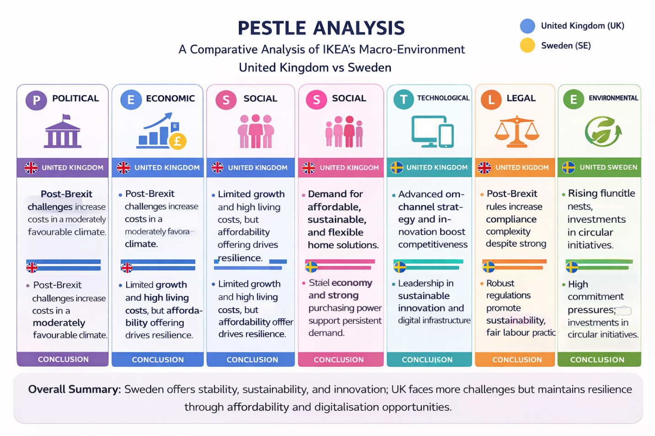

Fig: 01 PESTLE analysis of IKEA in the UK & Sweden ( Porter M,2024)
(Self-Analyzed from IKEA Group)

1.3.1 PESTLE Analysis of United Kingdom vs Sweden
Political Factors in UK: In the United Kingdom, political conditions are characterised as both supportive and challenging for IKEA. Increased trade friction following Brexit has been observed to raise supply chain costs and administrative complexity, particularly in cross-border logistics. Retail investment has been encouraged through planning reforms, and expansion has been supported by new store openings. However, labour shortages and rising National Insurance contributions have been identified as constraints, leading to higher operating costs. Overall, political factors are assessed as moderately favourable (OECD, 2025).
Political Factors in Sweden: In Sweden, a stable and transparent political environment is recognised as beneficial for IKEA’s operations. Strong governance and export-oriented policies have been supported, enabling favourable business conditions. Circular economy initiatives have been promoted by the government, aligning with sustainability objectives. Nevertheless, stricter environmental regulations and labour market reforms have been associated with increased compliance and wage costs. Despite these pressures, political factors are evaluated as highly favourable due to strong policy alignment and institutional stability (Swedish Agency for Economic and Regional Growth, 2025).
Economic Factors of UK: The United Kingdom economy in FY25 was characterised by limited economic growth, high interest rates and rising living costs — key growth barriers for the home-furnishing market (IKEA UK, 2025). IKEA UK retail sales of £2.25 billion for FY25 were reported, representing a 2.1% decrease compared to FY24, despite a £117 million investment in price reductions. However, a return to growth in the final quarter of the year (+3.3%) was observed, which was continued into FY26. Sales volumes were increased by 4%, and online sales were accounted for at 43% of total sales. The UK furniture market was valued at approximately £15 billion, with a stable market share being maintained amidst intense competition from DFS, Dunelm, Wayfair and new entrants such as Primark Home and Søstrene Grene (IBISWorld, 2025). Overall, economic factors were assessed as moderately favourable, as affordability strategies were driving volume growth despite the challenging macroeconomic backdrop.
Economic Factors of Sweden: Economic factors of Sweden were demonstrated as resilient relative to other European markets. IKEA Sweden’s sales for FY25 of 18 billion kronor (approximately €1.6 billion) were recorded, representing an increase of 1.7% compared to the previous year. The number of physical store visitors was increased to 36.5 million, up from 35.3 million, while total visitation across digital and physical channels was reached at 208 million (Inter IKEA Group, 2025). A market share of 25% within the Swedish home-furnishing market was held. Online sales were accounted for at 21.4% of total sales. Future market growth was expected to be supported by increased consumer purchasing power. Overall, these economic factors were assessed as highly favourable, as market share gains were achieved within a growing market while strong brand resonance was maintained (Inter IKEA Group, 2025).
Social Factors of the UK: Distinctive patterns in UK consumer behaviour are being demonstrated, which have been successfully capitalised upon by IKEA. The cost-of-living crisis has increased demand for affordable, durable and multifunctional furniture, with 63.6% of consumers citing range as the driver of choice for furniture purchases (ResearchAndMarkets, 2025). The highest purchasing penetration for bedroom furniture has been recorded among young adults aged 16–24, and a shift toward city-centre stores designed for metropolitan shoppers without cars has been observed among younger consumers. IKEA’s social resonance is reflected in a YouGov Quality and Value Score (QVS) of 86 — the highest among all markets surveyed globally (YouGov, 2025). Overall, these social factors are considered favourable, as alignment between IKEA’s brand values of thrift and clever living and prevailing consumer sentiment is being demonstrated.
Social Factors of Sweden: In its domestic market, deep cultural integration and generational loyalty are enjoyed by IKEA. Consumer preferences in Sweden are increasingly being reflected in minimalist, functional and sustainable design — principles that were pioneered by IKEA. Demand for space-efficient, multi-functional furniture has been created by the aging population and the prevalence of smaller households (Humphreys, 2011). A YouGov QVS score of 82 — second only to the UK — indicates that sustained brand trust is being maintained (YouGov, 2025). Through initiatives such as home-visitation research, the Swedish home market continues to be mapped directly in customers’ living rooms to shape future assortment and to secure relevance (IKEA Global, 2025). Overall, these social factors are considered highly favourable, as the default choice for Swedish home-furnishing needs continues to be represented by IKEA.
Cultural Factors of UK: The cultural analysis of marketing strategies emphasising individualism, humour and self-expression is supported by the cultural characteristics of the United Kingdom. Practicality and value are valued by British consumers, but positive responses to witty, self-deprecating and locally relevant advertising are also demonstrated — as evidenced by IKEA‘s Brighton seagull campaign (de Mooij, 2019). High indulgence and openness to experiential retail are exhibited, through which innovative store formats and digital integration are enabled (Hofstede, 2023).
Cultural Factors of Sweden: It is demonstrated through the cultural analysis that egalitarianism, environmental consciousness and design minimalism are favoured within the cultural environment of Sweden. A strong preference for sustainability and transparency is demonstrated by Swedish consumers, and emphasis on “democratic design” and long-term responsibility is reflected in IKEA’s brand messaging (Hofstede, 2023). High uncertainty avoidance is balanced with moderate indulgence, through which IKEA‘s consistent and reliable brand experience is supported while product innovation and seasonal campaigns are allowed (de Mooij, 2019).

Hofstede Cultural Dimensions Analysis
Hofstede’s cultural dimensions framework is applied to systematically compare national cultural characteristics between the United Kingdom and Sweden, through which consumer behaviour patterns and managerial expectations are interpreted. The model is widely used in international marketing analysis because cultural values are translated into measurable indices that support strategic adaptation decisions across different national markets (Hofstede, 2011).

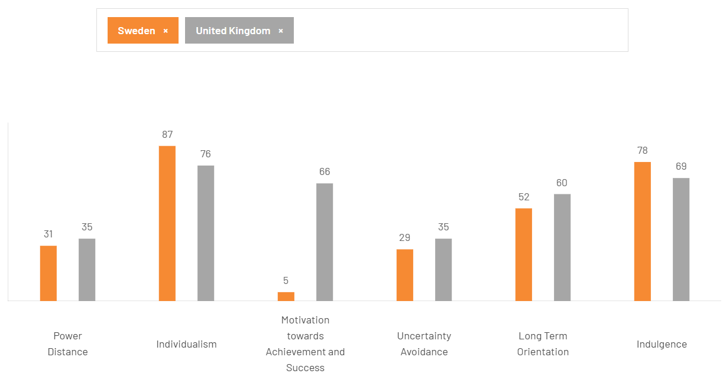

Fig: 02 Hostede Cultural Dimension analysis between UK & Sweden (Hoftede, 2011)
Power Distance: Sweden is characterised by a low score of 31 on the power distance dimension, while the United Kingdom records a slightly higher score of 35. In both countries, relatively flat organisational hierarchies and participative management practices are preferred. IKEA’s decentralised leadership style and emphasis on employee empowerment are therefore considered culturally compatible with both national environments (Hofstede, 2011).
Individualism: A high level of individualism is demonstrated in both societies, with Sweden scoring 87 and the United Kingdom scoring 76 on this dimension. Strong emphasis on personal autonomy, self-expression and individual choice is therefore reflected in consumer behaviour. IKEA’s product customisation options and personalised home-design solutions are consequently positioned to align with these culturally driven expectations (de Mooij, 2019).
Motivation towards Achievement and Success: Sweden records a notably low score of 5, while the United Kingdom demonstrates a significantly higher score of 66 on the masculinity dimension. A stronger competitive and performance-oriented culture is therefore observed in the UK, whereas cooperation and quality of life are prioritised in Sweden. IKEA’s messaging around balance, equality and social wellbeing is thus reinforced within the Swedish cultural context (Hofstede, 2011).
Uncertainty Avoidance: A relatively low score of 29 is recorded for Sweden, while the United Kingdom registers a slightly higher score of 35 on uncertainty avoidance. In both countries, tolerance for ambiguity and openness to innovation are generally exhibited. IKEA’s introduction of new store concepts, digital services and experimental retail formats is therefore facilitated within these flexible cultural environments (de Mooij, 2019).
Long-Term Orientation: Sweden demonstrates a moderate score of 52, while the United Kingdom records a slightly higher score of 60 on long-term orientation. A balanced perspective between future planning and present performance is therefore indicated in both markets. IKEA’s continued investment in sustainability initiatives, circular economy programmes and long-term pricing strategies is consequently supported by these cultural tendencies (Hofstede, 2011).
Indulgence: High indulgence levels are observed in both countries, with Sweden scoring 78 and the United Kingdom scoring 69 on this dimension. A strong desire for enjoyment, leisure and lifestyle satisfaction is therefore reflected in consumer expectations. IKEA’s experiential store environments, family-friendly facilities and affordable lifestyle positioning are thus considered consistent with this culturally driven consumption pattern (Philip, 2024).
Advantages and Disadvantages of Hostede Model:
The application of Hofstede’s framework in this report is considered to provide several advantages. A systematic and quantifiable basis for cross-national comparison is offered, through which cultural differences in consumer behaviour and management practices are made measurable (Hofstede, 2011). This comparability is regarded as particularly useful for international marketing analysis, as strategic adaptations—such as IKEA’s contrasting promotional styles in the United Kingdom and Sweden—are directly linked to cultural dimension scores (de Mooij, 2019). Furthermore, benchmarking against prior studies is enabled, thereby supporting analytical validity (Johnson et al., 2020). However, several limitations are recognised. National cultural homogeneity is assumed; whereby internal variations are overlooked. The data are considered outdated, and complex cultural realities may be oversimplified. Consequently, the framework is recommended to be used alongside complementary research (Hofstede, 2011; de Mooij, 2019).
Technological Factors for UK: IKEA UK omnichannel convenience is being focused on as a core strategic priority. Online sales are accounted for as 43% of total revenue, with support being provided through 101 “Collect Near You” points and enhanced delivery operations via the Dartford distribution centre (IKEA UK, 2025). The mobile application is equipped with augmented reality features for furniture preview, while AI-driven product recommendations are generated based on local housing stock data. At the Croydon store, digital integration with Decathlon is implemented to enable a seamless cross-retailer experience. Customer friction is being reduced through these technologies, and volume growth is being driven despite challenging economic conditions (IKEA UK, 2025).
Technological Factors for Sweden: IKEA Sweden is recognised as a leader in circular economy technology, with a second-hand marketplace having been launched in January 2026, featuring AI-powered pricing guidance and detailed product listings (IKEA, 2026). The “Spionerar på kunderna” programme is utilised, through which digital data capture is conducted during 350 home visits to inform assortment development (IKEA, 2023). Virtual products are developed on Roblox, through which brand affinity is built among younger consumers (IKEA, 2024). Advanced digital planning tools for kitchens and storage are implemented, by which design time is reduced, while the online platform is integrated seamlessly with physical stores (IKEA, 2023).
Legal Factors for UK: Post-Brexit trade regulations have been observed to increase customs paperwork and supply chain costs for IKEA UK (UK Government, 2023). However, planning reforms have enabled nine new locations since 2025, including city-centre stores on Oxford Street (Department for Levelling Up, Housing and Communities, 2024). Rising National Insurance and the National Living Wage have been recognised to raise labour costs (HM Treasury, 2023). The Advertising Standards Authority has been noted to enforce strict green claims rules, requiring substantiation of sustainability messaging (Advertising Standards Authority, 2022). Product safety regulations have been required to ensure compliance with flammability and chemical content standards for all furniture sold in the UK (UK Office for Product Safety and Standards, 2023).

Legal Factors for Sweden: Sweden’s legal framework is mandated through extended producer responsibility for furniture under EU circular economy directives, by which alignment with IKEA’s second-hand marketplace is achieved (European Commission, 2020). Forestry laws are required to comply with the EU Timber Regulation, although sourcing from Romanian ancient forests was exposed by a Greenpeace investigation, where logging was identified as legal but ecologically damaging (Greenpeace, 2021). Strong collective bargaining agreements are established, through which high labour standards are maintained (OECD, 2020). Customer data collection is strictly governed under GDPR, while unsubstantiated environmental claims are prohibited by the Swedish Marketing Act (European Union, 2016; Swedish Consumer Agency, 2022).
Environmental Factors for UK: Extended Producer Responsibility for packaging waste is faced by IKEA UK, by which reductions in plastic use and increased utilisation of recycled cardboard are driven (UK Government, 2021). Consumer demand for sustainable products is supported through the buy-back programme and recycled-material furniture for example MITTZON desk) (IKEA Group, 2023). Net-zero emissions by 2030 are targeted, with delivery fleets being transitioned to electric vehicles (IKEA Group, 2023). However, greenwashing litigation risk under the Competition and Markets Authority Green Claims Code is raised by the Greenpeace forest sourcing controversy (Competition and Markets Authority, 2021).
Environmental Factors for Sweden: Sweden’s national circular economy strategy is observed to drive IKEA’s second-hand marketplace target of 170,000 active listings by 2026 (Swedish Government, 2021). However, in the Greenpeace report (September 2025), a link between IKEA and the destruction of 59 km² of Romanian ancient forests was identified, by which its home-market reputation has been damaged (Greenpeace, 2025). In response, all stores in Sweden are powered by 100% renewable energy, and a target of 80% recycled wood in particle-board by 2030 has been established (IKEA, 2023). Consumer expectations for environmental leadership are maintained at an exceptionally high level (European Commission, 2022).

PESTLE Similarities and Differences between UK & Sweden
Several similarities and differences were identified between the two markets. High levels of individualism and indulgence were observed in both contexts, thereby supporting IKEA’s positioning as a personal and enjoyable shopping destination (Geert Hofstede, 2001). Legal and regulatory pressures were evident in each context, though they were manifested differently, with labour costs and trade friction being emphasised in the UK and environmental compliance being prioritised in Sweden (OECD, 2022). Strong investment in omnichannel technology and digital integration was required in both markets to meet consumer expectations for convenience (Statista, 2023). However, notable differences were identified. A dominant “hunter” position was held by IKEA in Sweden with a 25% market share, whereas a competitive “follower” role was observed in the UK, alongside contrasting economic conditions — stable growth was demonstrated in Sweden, while declining sales despite volume increases were experienced in the UK (Euromonitor, 2023).

1.4 Comparative Analysis of STP Strategies
IKEA’s segmentation, targeting, and positioning strategies are differently shaped across the UK and Swedish markets due to variations in competitive environments and consumer behaviours. In the UK, broad demographic segmentation and value-based targeting are applied, although the target audience is fragmented and market position is pressured by intense competition. In Sweden, precise psychographic segmentation and heritage-based targeting are implemented, while market leadership and design authority are emphasised in positioning (Kotler & Keller, 2024).

1.4.1 Segmentation
United Kingdom: In the UK market, multiple segmentation bases are employed to identify distinct consumer groups. Regional variations in housing and preferences are addressed through geographic segmentation, with diverse formats established in locations like London and Hull (de Moji,2019). Furthermore, demographic segmentation is utilized to target young adults and families via specific furniture ranges (de Moji,2019). Finally, lifestyle differences are managed through psychographic segmentation, where "value-seeking savers" and "sustainability-conscious consumers" are engaged through targeted campaigns and circular initiatives (Philip, 2024).
Sweden: In the Swedish market, IKEA’s segmentation strategy is adapted to local characteristics. Regional accessibility is enhanced through geographic segmentation, with new units established in locations such as Varberg and Gotland (IKEA, 2024). Simultaneously, young families and older adults are targeted via demographic segmentation focusing on accessible design (Oblak & L, 2020). Furthermore, psychographic segmentation is utilized to engage "design-conscious minimalists" through designer collaborations and "environmental advocates" via circular economy initiatives and second-hand marketplaces (Inter IKEA Group, 2025).

1.4.2 Targeting
United Kingdom: In the United Kingdom, a broad mass-market targeting strategy is demonstrated, with particular attention directed toward younger consumers as primary drivers of growth. Metropolitan shoppers are specifically targeted through city-centre stores, which are designed to appeal to younger demographics compared to traditional formats (IKEA, 2024). Furthermore, value-conscious families are prioritized due to the significance of affordability. Finally, convenience-oriented consumers are engaged through expanded collection points, contributing to a 43% online sales share (Inter IKEA Group, 2023).
Sweden: In Sweden, a precise targeting strategy is demonstrated. While the mass market is addressed, particular emphasis is placed on homeowners and renters prioritizing design and sustainability (IKEA, 2024). Demand for children’s furniture is driven by young families, while growing segments of older adults are targeted through accessible, adaptable solutions for aging in place (Oblak & L, 2020). Additionally, younger consumers are engaged via the second-hand marketplace, as cost-driven preferences for pre-owned items are exhibited by over half of this demographic (Inter IKEA Group, 2023).

1.4.3 Positioning
United Kingdom: In the UK market, IKEA’s positioning is characterised by value, cleverness, and accessibility (Gazo & R,2005). It is highlighted by the tagline “The Wonderful Everyday” that affordable home solutions are made to ease everyday life and enable thrifty living. IKEA is positioned as an accessible brand for “the many people”, in contrast to premium competitors, while price competition is also faced from discounters. The brand’s Swedish heritage is leveraged as a mark of quality (Billore & S, 2025).
Sweden: In Sweden, a stronger and more emotionally resonant market position is held by IKEA, as the Swedish home‑furnishing market was essentially defined by the brand. IKEA is positioned as culturally embedded, design‑authoritative and sustainability‑led ; a natural part of everyday Swedish life. The “Wherever Life Goes” campaign, which features no products but only price tags superimposed over life moments (a kiss, a tear, an ultrasound scan), positions IKEA as a quiet but essential supporter of life’s transitions. The brand is positioned not merely as a retailer but as a partner in living; a message that resonates deeply with Swedish consumers.

Perceptual Map (Market Positioning)
It is indicated that a perceptual map of IKEA’s positioning in both the United Kingdom and Sweden would place the brand within the “affordable–high quality” quadrant. However, in Sweden, the brand is positioned closer to the premium perception boundary, where strong design authority and emotional resonance are emphasised. In contrast, within the UK market, a position closer to the value boundary is observed due to heightened price competition from Primark, B&M, and Søstrene Grene. Across both markets, a distinctive “design-led value brand” position is maintained, which is considered difficult to replicate by competitors (Kotler et al., 2020).

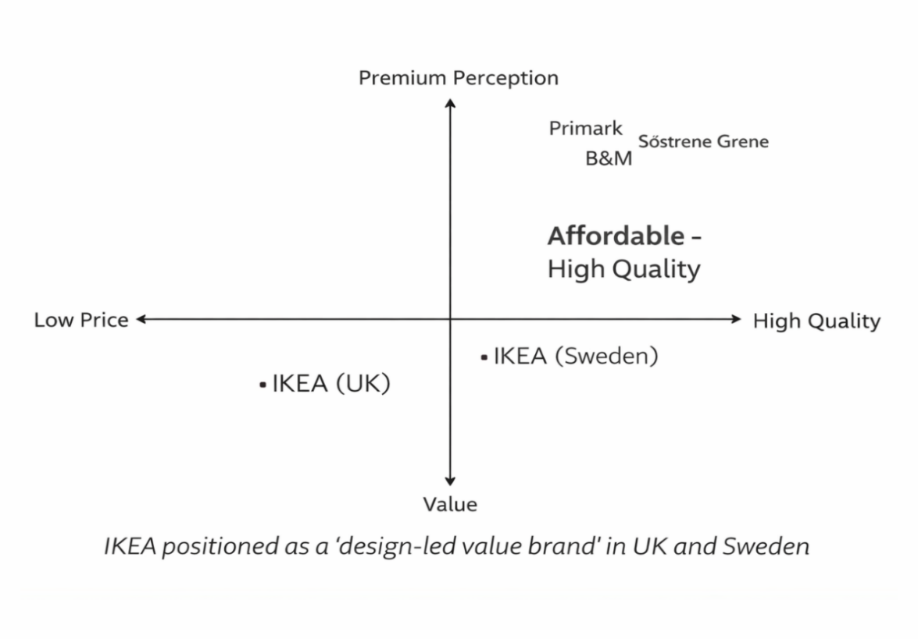

Fig: 03 Perceptual map of IKEA in the UK & Sweden (Self-analyzed-followed Kotler et.al, 2020)

Similarities & Difference of STP in UK & Sweden Markets

Similarities and differences in segmentation, targeting, and positioning are identified across the two markets. In both contexts, demographic, geographic, and psychographic bases are utilised for segmentation. However, in the United Kingdom, additional emphasis is placed on occasion-based behavioural segmentation (e.g., moving home and furnishing a first flat), whereas in Sweden, greater focus is directed toward lifecycle segmentation (e.g., young families and older adults) and values-based segmentation (e.g., sustainability and design). Targeting strategies are differentiated, with a broad mass-market approach being adopted in the UK, particularly focusing on younger urban consumers, while in Sweden, homeowners and families are primarily targeted alongside expansion into emerging segments. Positioning is centred on value and functional cleverness in the UK, whereas emotional resonance and design authority are emphasised in Sweden (Kotler et al., 2020).

1.5 Comparative Analysis of Marketing Mix (7Ps)
It is indicated that IKEA’s marketing mix is differentiated across markets. In the United Kingdom, small-space products, value-led pricing, omnichannel distribution, and humorous promotion are emphasised, while in Sweden, circular innovation, accessibility, and design-led emotional promotion are prioritised (Kotler et al., 2020).

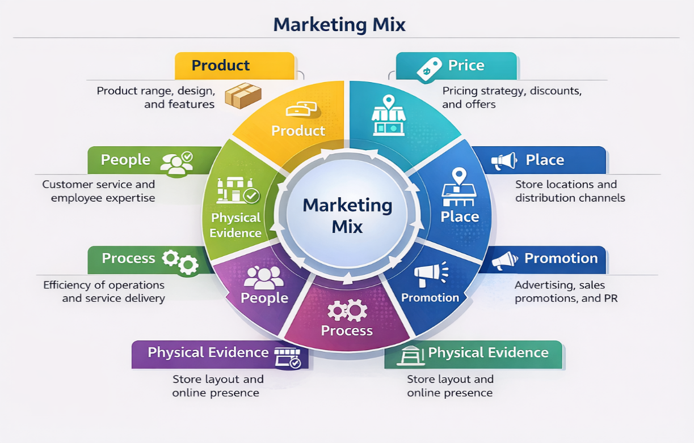

Fig: 04 Marketing Mix analysis of IKEA (IKEA Global,2025)

1.5.1 Product
United Kingdom:
In the United Kingdom, IKEA’s product strategy is centred on a core range exceeding 12,000 items, including furniture, accessories, textiles, and kitchenware. Product innovation is primarily focused on small-space and multifunctional solutions suited to urban living. Adaptations are made through locally relevant designs, colours, and sizes aligned with UK housing. Limited-time collaborations are introduced to stimulate demand, while sustainability-oriented products are increasingly emphasised (Kotler et al., 2020).
Sweden:
In Sweden, IKEA’s product strategy is maintained through its full core range, with adaptations reflecting Nordic design preferences. Minimalist, functional, and light-coloured aesthetics are prioritised. Local collaborations, including those with Gustaf Westman, are incorporated. Circular economy initiatives, such as second-hand marketplaces, are implemented, and sustainability targets, including increased recycled material usage, are established to meet consumer expectations (Kotler et al., 2020).

Product width and depth analysis
In marketing mix analysis, product width is defined as the number of product lines, while product depth is described as variants within each line. A balanced strategy is enabled to target segments and differentiate offerings. IKEA’s portfolio is structured across home-furnishing categories (Kotler et al., 2019).

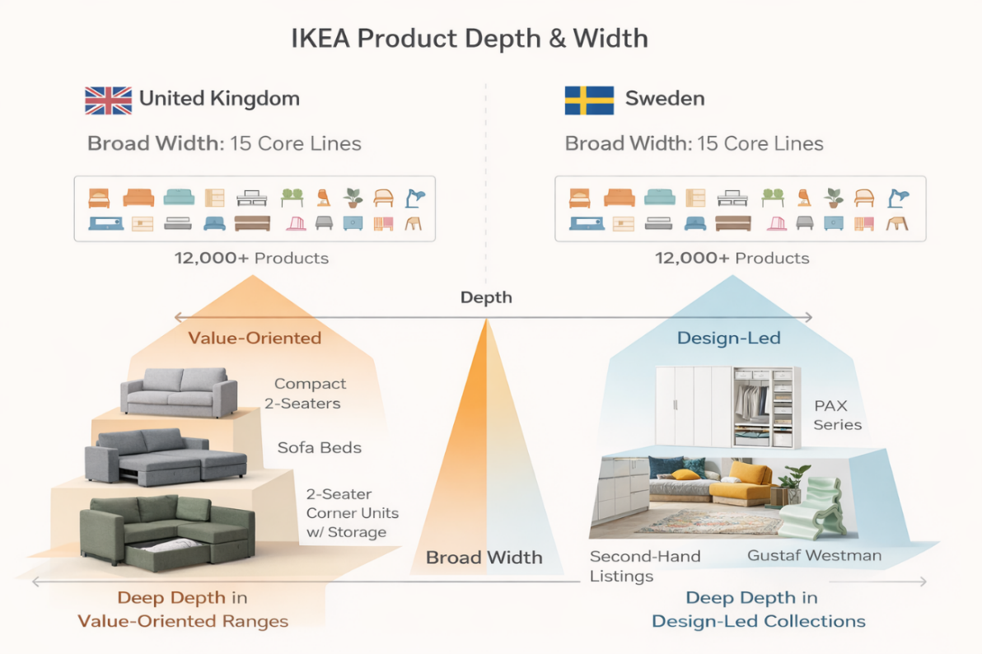

Fig: 05 Product depth & width Analysis (Self-Analyzed-Kotler et al.,2019)

United Kingdom:
In the United Kingdom, product width is maintained as broad, with over 12,000 items across core lines. Greater depth is emphasised in small-space solutions, while premium ranges are limited, as value-oriented offerings are prioritised to address cost pressures (Kotler & Keller, 2020).
Sweden:
In Sweden, product width is maintained across similar categories, but depth is differentiated through circular and design-led offerings. Modular systems and second-hand options are expanded, while entry-level depth is reduced, as higher willingness to pay for sustainability and design quality is observed (de Mooij, 2019).

1.5.2 Price
It is indicated that pricing decisions are influenced by macroeconomic and market factors, including supply chain costs, trade policies, competition, and consumer behaviour. In both the United Kingdom and Sweden, low-price leadership strategies are utilised to enhance customer value, while transaction volumes are optimised and cost pressures are mitigated (Kotler et al., 2020).
United Kingdom: An aggressive affordability strategy has been implemented by IKEA in the United Kingdom. Following a £117 million investment in price reductions during FY24, prices were reduced by approximately 10% across the range over two years. A 4% increase in sales volumes has been recorded despite a 2.1% decline in value (IKEA,2023). Bundle pricing, loyalty benefits, and online-exclusive offers have been provided to enhance engagement and encourage repeat purchasing (Kotler et al., 2020).
Sweden: In Sweden, value-oriented pricing strategies have been implemented by IKEA, with selective premium opportunities being captured. A 10% price-reduction programme has been supported by a 1.7% sales increase. However, price adjustments have been introduced due to rising import tariffs, affecting cost structures (IKEA,2023). Value bundles, loyalty pricing, and second-hand marketplace options have been promoted to support affordability, extend product lifecycles, and attract price-sensitive consumers while maintaining market competitiveness (Kotler et al., 2020).

1.5.3 Place
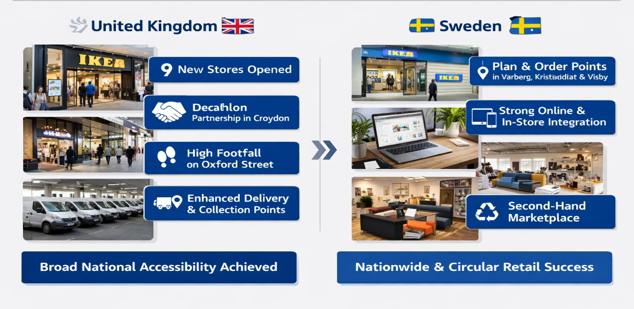

Fig: 06 Places of IKEA’s showrooms in the UK & Sweden (Self-Analyzed, Source-IKEA Global,2025)

United Kingdom
It is indicated that IKEA’s place strategy in the United Kingdom has been significantly expanded through new store formats and locations. Nine outlets, including city-centre and small-format stores, have been opened, with strong footfall recorded at Oxford Street. A partnership with Decathlon has been trialled in Croydon, and omnichannel growth has been supported through delivery enhancements and collection points. Market penetration has been increased, with broad national accessibility being achieved (Kotler et al., 2020).
Sweden
It is indicated that IKEA’s place strategy in Sweden has been focused on nationwide accessibility, including remote regions. Expansion has been achieved through smaller Plan and Order Points in Varberg, Kristianstad, and Visby. Strong integration of physical and digital channels has been maintained, with high levels of combined traffic recorded. Online sales and digital engagement have been strengthened, and a second-hand marketplace has been introduced to support circular retail practices and local peer-to-peer exchange (Kotler et al., 2020).

1.5.4 Promotion
United Kingdom: In the United Kingdom, promotional strategies have been widely implemented with emphasis placed on creativity, humour, and cultural resonance. The “Show off Your Savvy” campaign (2025) has been delivered across TV, digital platforms, social media, CRM, PR, and in-store channels, with affordability and everyday practicality being communicated. Store-opening activations in Brighton and Oxford Street have been executed through hyper-local experiential marketing, and IKEA has been positioned as a facilitator of culturally relevant urban experiences. Award-winning campaigns, including the “Sleep” campaign, have been recognised for driving measurable performance outcomes, while engagement on TikTok, Instagram, and Pinterest has been enhanced through youth-oriented content strategies (Kotler et al., 2020).
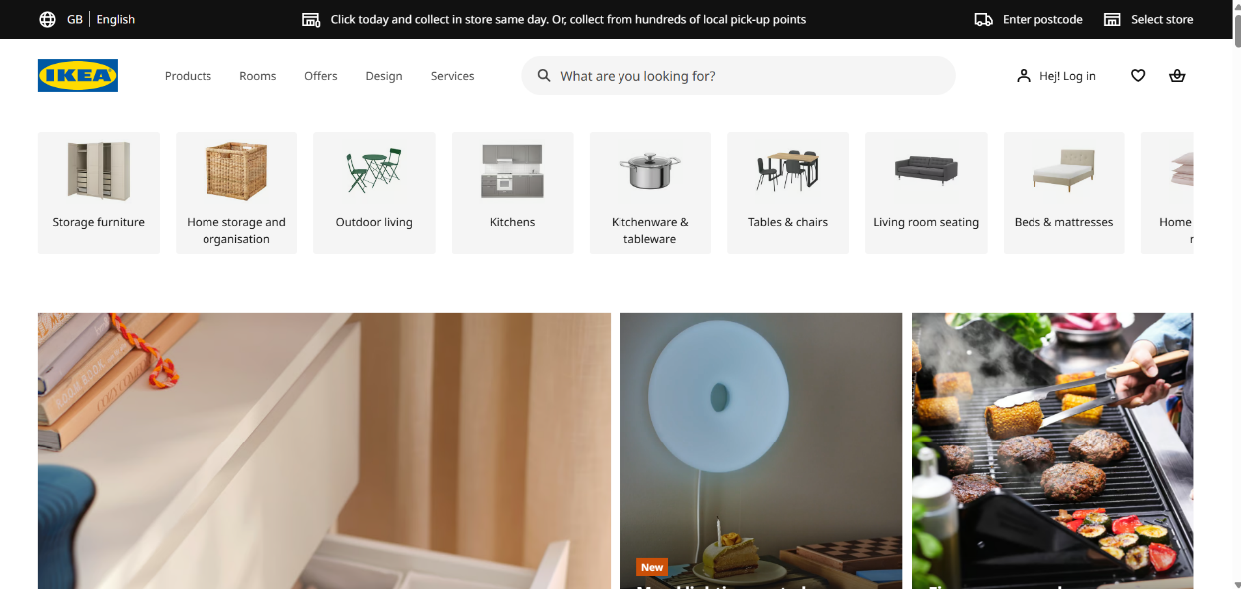

Fig: 07 Website view of IKEA UK (IKEA,UK website)

Sweden: In Sweden, promotional strategies have been developed around emotional storytelling, design authority, and value communication. Campaigns such as “Wherever Life Goes” have been executed using life-stage narratives with minimal product visibility, while price communication has been prioritised to reinforce accessibility. Outdoor advertising innovation has been achieved through the transformation of residential blinds into media surfaces, creating widespread micro-touchpoints. Additionally, consumer insight initiatives involving household visits have been conducted to inform product development and strengthen authenticity. Through these approaches, IKEA has been positioned as deeply embedded in everyday life and transitions (Kotler et al., 2020).

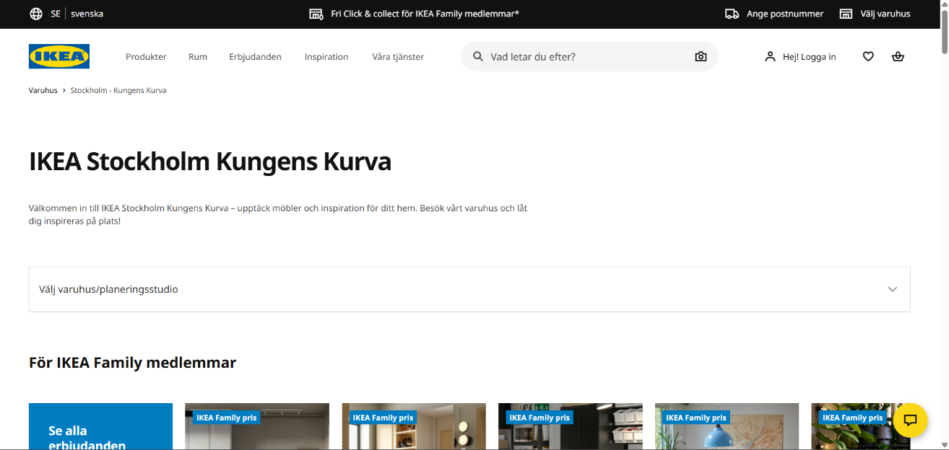

Fig: 08 Website view of IKEA-Sweden (IKEA,Sweden website)

1.5.5 People
United Kingdom:
It is indicated that in the United Kingdom, co-workers across stores, distribution centres, and digital channels are utilised as brand ambassadors for IKEA. Training is provided with emphasis on service quality, product knowledge, and organisational culture (Inter IKEA Group, 2025). In 2026, David McCabe was appointed as Country Retail Manager and Chief Sustainability Officer to lead UK and Ireland operations. Recruitment, training, and retention are prioritised due to expansion, with structured career pathways, benefits, and a flat culture being maintained (Kotler et al., 2020).
Sweden:
In Sweden, co-workers are similarly depended upon for brand delivery, with egalitarian and customer-centric values being embodied by staff. The “Spionerar på kunderna” programme is implemented, through which 350 households are visited to understand real customer needs. Training is focused on sustainability, circular economy practices, second-hand operations, and digital capabilities (Inter IKEA Group, 2025). Strong labour protections and collective bargaining agreements are provided, resulting in high retention and satisfaction levels among co-workers, while product and service development are continuously informed by customer insights (Kotler et al., 2020).

1.5.6 Process
United Kingdom: It is indicated that IKEA’s UK processes are structured around a standardised flat-pack and self-assembly model, through which operational consistency is ensured across stores. Omnichannel transactions are enabled through digital ordering, payment, and delivery systems. Fulfilment has been streamlined via “Collect Near You” points and enhanced logistics from the Dartford distribution centre (Verhoef et.al, 2015). Customer feedback is captured through integrated digital platforms, and improvements are informed accordingly. Cross-retailer process integration has been introduced through collaboration with Decathlon in Croydon (Kotler et al., 2020).
Sweden:
It is indicated that similar core processes are adopted by IKEA in Sweden, while adaptation is made for circular economy priorities. A second-hand marketplace process is implemented for listing, pricing, verification, and customer-to-customer exchange. In-home research processes are enhanced through customer home visits, enabling direct behavioural observation (Christopher, 2016). Digital kitchen planning tools are improved to reduce planning time and increase accuracy. Supply chain processes are strengthened through shorter logistics distances and integrated networks, resulting in faster replenishment and reduced delivery costs (Kotler et al., 2020).

1.5.7 Physical Evidence
United Kingdom: In the United Kingdom, physical evidence within IKEA stores is conveyed through consistent branding elements, including the blue-and-yellow colour scheme, inspirational showrooms, in-store restaurants serving Swedish meatballs, children’s play areas (Småland), and self-service warehouses. The Oxford Street store is positioned as a curated urban format, through which high footfall has been generated in early months (IKEA, 2024). Smaller retail-park stores are designed for convenience, while iconic blue bags and flat-pack packaging are utilised to extend brand visibility beyond store environments (Kotler et al., 2019).
Sweden: In Sweden, similar physical evidence elements are applied, while stronger emphasis is placed on sustainability and circular economy practices. A second-hand marketplace is introduced, where listings are supported with pricing guidance, images, and detailed specifications (IKEA, 2023). In-store circular zones and buy-back points are incorporated to reinforce sustainable positioning. Furthermore, the “Spionerar på kunderna” programme is utilised, through which customer homes are examined as extensions of physical evidence, demonstrating commitment to understanding everyday living needs (Kotler et al., 2019).

1.6 Directional Development Strategy Analysis using Ansoff Matrix
Directional development strategy is defined as the strategic framework through which the future direction of an organisation’s business activities is determined. Through this approach, the markets in which competition will occur and the products that will be offered to achieve growth objectives are specified (Ansoff, 1965). A structured framework for the analysis of growth opportunities is provided by the Ansoff Matrix, in which four primary strategic options are identified: market penetration, market development, product development, and diversification (Ansoff, 1965).

1.6.1 Justification for the selection of two strategies in this report:
For the comparative analysis of IKEA in the United Kingdom and Sweden, only market penetration and market development have been selected. These strategies are considered most relevant, as customer relationships are being deepened and accessibility is being expanded through new formats. Product development and diversification are not prioritised, as is evidenced by corporate reports (Inter IKEA Group, 2025; IKEA UK, 2025). Thus, a clearer, evidence-based evaluation of growth direction is enabled.

1.6.2 Application to IKEA UK & Sweden:
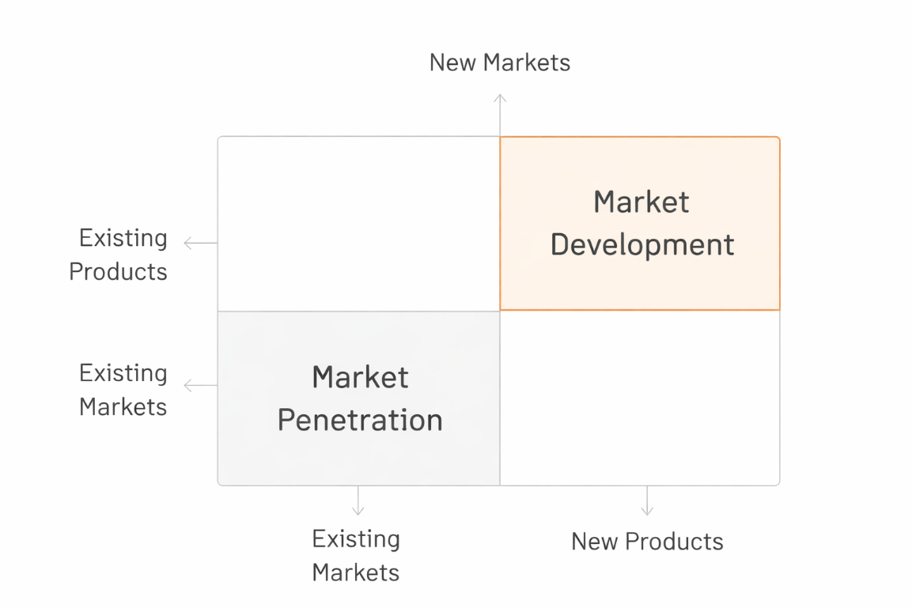
Application of market penetration and market development strategies is demonstrated across both IKEA UK and Sweden. Customer engagement is increased through pricing and loyalty initiatives, while accessibility is expanded via new store formats and locations, enabling sustained growth and strengthened market presence (Ansoff, 1965).

Fig: 09 Development Strategies of IKEA (Ansoff, 1965)

Market Penetration
Market penetration strategies have been implemented by IKEA in both markets to increase consumption among existing customers. In the United Kingdom, a 4% increase in sales volumes year-on-year was recorded following the £117 million price-reduction programme, through which successful penetration of the existing customer base was demonstrated (IKEA UK, 2025). Increased purchase frequency has been encouraged through loyalty programmes and IKEA Family benefits, while repeat visitation has been stimulated through in-store restaurants, children’s play areas and seasonal promotions. In Sweden, market penetration is evidenced by increased visitor numbers, with 36.5 million physical visitors recorded, up from 35.3 million, and by a stable market share of approximately 25% (Inter IKEA Group, 2025). These indicators suggest that penetration strategies have been effectively utilised to maintain a dominant market position in the domestic market and to defend market share against competitors in the United Kingdom (Ansoff, 1965).

Market Development
Market development through geographic and format expansion has been prominently featured in IKEA’s strategic plans in both markets. In the United Kingdom, a commitment to open nine new locations since the start of 2025 has been established, including city-centre stores on Oxford Street and Brighton, small-format retail-park stores in Harlow, Norwich and Chester, and Plan and Order Points in Hull, York, Waterford and Dundee (IKEA, 2025). Through these new formats, the brand’s physical presence has been extended into urban and metropolitan areas where traditional out-of-town stores were not considered feasible. In Sweden, market development has continued with the opening of smaller units in Varberg, Kristianstad and Visby on Gotland — the first IKEA unit on Gotland ever — through which accessibility has been provided to customers who previously had no local access (IKEA, 2025). The continued importance of accessible and convenient locations has therefore been recognised as essential for sustaining market reach and strengthening brand visibility in both countries.

1.6.3 Strategic Evaluation
The application of market penetration and development strategies by IKEA in markets is considered to reflect a risk-conscious approach to growth. Market penetration has been prioritised as a low-risk strategy, whereby brand equity, customer relationships, and infrastructure are leveraged (Ansoff, 1965). Market development has been pursued through city-centre models, through which uncertainty is reduced. As a result, overall volume growth has been achieved in the UK and leadership maintained in Sweden, without exposure to higher-risk strategies (Johnson et al., 2020).

1.7 Ethical & Unethical Issues Evaluation

1.7.1 Ethical Marketing Practices

Example 01: Second-Hand Marketplace and Circular Economy
An example of ethical marketing practice is demonstrated by IKEA through the launch of a second-hand marketplace in Sweden in January 2026, with expansion being undertaken across Sweden, Spain, Norway, Portugal, and Poland. A target of 170,000 active listings is set for 2026 (IKEA, 2026). Product lifecycles are extended, waste is reduced, and affordability is improved through local resale. Sustainable consumption habits are encouraged, and circular economy principles are reinforced, reflecting alignment between commercial objectives and environmental responsibility (Ellen MacArthur Foundation, 2019).
Example 02: Transparency During the Tariff Crisis
Ethical transparency is demonstrated by IKEA during the tariff crisis, where price adjustments are communicated following increases in import tariffs from 25% to 30%. It is acknowledged that costs can no longer be absorbed, and pricing strategies are revised accordingly (IKEA, 2026). External pressures are disclosed openly, and consumer trust is maintained through clear communication. Cost management efforts are highlighted, while a commitment to affordability is reaffirmed, representing ethical crisis communication and responsible stakeholder engagement (OECD, 2021).

1.7.2 Unethical Marketing Practices
Example 01: Ancient Forest Sourcing Controversy
Continuous criticism regarding IKEA’s wood sourcing practices has been faced. An investigation titled “Felling the Future: IKEA’s Sourcing Threatens Romania’s Irreplaceable Forests” was released by Greenpeace Central and Eastern Europe in September 2025, through which links to forest destruction in Romania’s Carpathian Mountains were exposed (IKEA, 2026). A loss of 59 square kilometres of High Biodiversity Value Forests was documented in 2024. Evidence connecting suppliers to the Rusca Montană Forest was provided, highlighting sustainability concerns under the EU Biodiversity Strategy (Greenpeace, 2025).
Example 02: Fast Furniture and Planned Obsolescence
Ethical concerns regarding IKEA’s business model have been raised, as “fast furniture” consumption patterns are encouraged. Products designed for affordability and convenience are perceived as less durable, contributing to frequent replacement cycles. Although circular initiatives, including buy-back programmes, have been introduced, high-volume sales continue to be prioritised, leading to increased waste generation (Greenpeace,2025). The furniture industry’s contribution to landfill waste has been widely acknowledged, with IKEA often being criticised due to its scale. Efforts such as the PAX wardrobe range have been developed, though their long-term impact remains debated (Cooper, 2010).

1.8 Strategic Recommendations
Based on the comprehensive analysis of IKEA’s marketing strategies in the United Kingdom and Sweden, the following recommendations are proposed for the future development of international marketing strategies:
Recommendation 1: Accelerate Second-Hand Marketplace Expansion and Integration
The expansion of IKEA’s second-hand marketplace should be accelerated beyond the current pilot countries, with the United Kingdom prioritised as the next launch market due to strong demand for affordable and sustainable furniture. Integration of the platform with existing omnichannel systems should be implemented so that pre-owned and new products are displayed together across digital channels (Inter IKEA Group, 2025). In Sweden, increased marketing investment and seller incentives should be introduced to stimulate listing volumes and to strengthen leadership in circular retailing and sustainable consumption practices (Kotler and Keller, 2020).
Recommendation 2: Expand Small-Format and Urban Store Network in Both Markets
Continued expansion of city-centre and small-format stores should be pursued in the United Kingdom to improve accessibility and convenience for urban consumers. A target of reaching the majority of the population within a reasonable travel distance should be maintained as part of long-term retail development planning (IKEA, 2025). In Sweden, the Plan and Order Point network should be extended to additional regional locations to ensure nationwide service coverage. Through improved accessibility and proximity, market leadership can be sustained and competitive pressures from convenience-focused retailers can be effectively managed (Wrigley and Lambiri, 2015).
Recommendation 3: Invest in Digital Innovation and AI-Driven Personalisation
Increased investment in digital innovation and artificial intelligence technologies should be prioritised to strengthen customer engagement and operational efficiency across both markets. AI-driven recommendation systems and enhanced augmented reality tools should be implemented to improve product selection accuracy and to reduce purchasing friction during the online shopping process (Chaffey and Ellis-Chadwick, 2022). In Sweden, AI-supported pricing guidance should be introduced within the second-hand marketplace to optimise resale values and demand matching. Continued development of immersive digital environments should also be supported to build long-term brand relationships with younger consumer segments (Inter IKEA Group, 2025).

Section 2: Reflective Account (Gibbs Reflective Cycle)

2.1 Description
The research and preparation of this international marketing report on IKEA’s UK and Sweden operations were conducted through structured stages of investigation, analysis and synthesis. Analytical frameworks including PESTLE, STP, the 7Ps and the Ansoff Matrix were identified following a review of assignment requirements (Saunders et al., 2019). Relevant market data were collected from industry publications and corporate sources, through which current competitive dynamics were interpreted. Ethical considerations were evaluated objectively, and sensitive sustainability issues were addressed to ensure balanced academic analysis (Kotler et al., 2022).

2.2 Approaches
Throughout the research process, a range of emotional responses was experienced, through which the analytical approach was influenced. Initially, a degree of overwhelm was felt regarding the scope of the assignment, particularly due to the requirement to apply multiple analytical frameworks across two markets while maintaining a data-driven focus. Challenges were presented by the large volume of information available on IKEA, requiring careful source selection. As the research progressed, confidence was gradually developed in synthesising information and identifying meaningful patterns, which is considered essential in systematic academic inquiry (Saunders et al, 2019).
Genuine interest was generated by identifying the contrast between IKEA’s emotional storytelling approach in Sweden and its humorous and pragmatic communication style in the United Kingdom. This observation motivated a deeper investigation into the cultural factors shaping marketing adaptation across markets. Mixed feelings were also experienced during the ethical evaluation stage. Positive sustainability initiatives were documented with relative ease; however, careful judgement was required when addressing environmental allegations, reflecting the ethical responsibility expected in responsible research reporting and balanced interpretation of corporate conduct (Bryman and Bell, 2018).

2.3 Evaluation
What worked well: Several methodological strengths were identified during the research process, through which analytical reliability was enhanced. A strong focus on recent sources from 2025 to 2026 was maintained, ensuring that the analysis reflected current market conditions rather than outdated evidence. Timely data on IKEA’s UK performance, competitive dynamics and strategic initiatives were obtained from credible industry publications and corporate disclosures. The PESTLE framework was found to be effective for structuring macro-environmental analysis, while the Ansoff Matrix enabled clear linkage between theory and practical company initiatives, supporting structured strategic evaluation (Kotler and Keller, 2022).
Areas for Improvement: Certain limitations were encountered during the research process that may have affected analytical depth. Detailed competitive market share data for the Swedish furniture sector was found to be limited beyond IKEA’s reported 25% share, potentially constraining comparative accuracy. It is also acknowledged that Hofstede’s cultural dimensions model may not fully capture evolving cultural behaviours, particularly among younger consumers influenced by globalisation and digital media. Additionally, access to Swedish-language sources was restricted by language barriers, meaning that some local market insights may not have been fully incorporated into the analysis (Hofstede, 2023).

2.4 Analysis
Several key insights were identified through this research, through which an understanding of international marketing practice was deepened. The importance of cultural adaptation was clearly demonstrated through the contrast between IKEA’s United Kingdom and Swedish marketing campaigns (de Mooij, 2019). A humorous, socially relevant communication style was adopted in the UK, while emotional and design-led storytelling was emphasised in Sweden. It was thereby suggested that effective international marketing is achieved not simply through message translation but through deep cultural interpretation, by which local humour, values and consumption rituals are carefully understood and integrated into marketing execution (Hollensen, 2020).
The role of format innovation in supporting market development was identified as a critical strategic factor. A significant departure from IKEA’s traditional large-format retail model has been represented by the introduction of small-format stores and city-centre locations in the United Kingdom. Access to younger, urban and car-free consumers has thereby been enabled through improved convenience and proximity (Kotler and Keller, 2022). It is suggested that this strategic insight may be transferable to other markets experiencing rapid urbanisation and changing mobility patterns, through which flexible retail formats are increasingly required to sustain competitive advantage and customer accessibility in modern metropolitan environments (Ansoff, 1965).

2.5 Conclusion
Through this research process, an understanding of international marketing complexities was developed, particularly the need for strategy adaptation to local conditions while consistent brand identity and core values are maintained (Kotler and Keller, 2019). Recognition was gained that market leadership in a home market, such as Sweden, does not guarantee immunity from competitive threats, as continuous investments in innovation and accessibility are demonstrated by IKEA. Through the practical application of PESTLE, STP, 7Ps and the Ansoff Matrix, an enhanced ability to systematically structure marketing analysis was developed, and appreciation was gained for the interconnection between macro-environmental factors and strategic decisions (Kotler and Keller, 2019).
Alternative Approaches: Given additional time, primary research would have been conducted through interviews with IKEA customers in both markets or through the analysis of social media sentiment. Through this approach, secondary research would have been supplemented with direct insights into consumer perceptions of IKEA within each national context (Porter and Michael, 2008). Additional analytical frameworks would also have been applied, including Porter’s Five Forces for competitive intensity assessment or VRIO analysis for resource-based evaluation, through which a more comprehensive and strategically robust assessment of organisational capabilities and market positioning could have been provided (Barney, 1991).

2.6 Action Plan
Based on this reflective analysis, several actions have been identified to enhance future international marketing research and analysis:
Immediate Actions: Awareness of current developments in the home-furnishing retail industry will be maintained, with particular attention given to competitive dynamics, sustainability regulations and evolving consumer behaviour trends. Proficiency in analytical frameworks will be continuously strengthened through repeated application to diverse case scenarios beyond formal academic assignments (Kotler and Keller, 2016).
Short-Term Development: Opportunities to examine international marketing strategies across diverse industry sectors will be actively sought, through which broader comparative knowledge will be developed. A deeper understanding of ethical marketing issues, including supply chain transparency and circular economy models, will be cultivated through engagement with academic literature and applied case studies (Peattie, 2010).
Long-Term Professional Development: Opportunities for international experience will be pursued through study abroad, professional assignments or cultural immersion, so that direct exposure to cross-cultural marketing environments can be achieved. Professional networks with industry practitioners and academic researchers will be maintained to remain informed about emerging sustainability-focused marketing strategies and global retail practices (Hollensen, 2020).

Conclusion
Significant insights regarding the complexities of operating across diverse international markets have been gained. A strategic contrast has been demonstrated, whereby IKEA is positioned as a dominant leader in Sweden with approximately 25% market share, while a more competitive position is held in the United Kingdom, where affordability investments have driven volume growth (Inter IKEA Group, 2025). The importance of cultural adaptation, format innovation and ethical supply chain transparency has been reinforced through the systematic application of PESTLE, STP, 7Ps, Ansoff Matrix and Hofstede’s framework (Hofstede, 2023).

References:

Advertising Standards Authority (2022) Environmental claims on goods and services. London: ASA.
Ansoff, H. I. (1965). Corporate Strategy: An Analytic Approach to Business Policy for Growth and Expansion. New York: McGraw-Hill.
Billore, S., Genc, E.A. and Ozturkcan, S., 2025. Brand museums, commodification of cultural heritage and cultural transfer: The case of IKEA museum. Scandinavian Journal of Management, 41(1), p.101388.
Bromiley, P. (2017) The SAGE Encyclopedia of Strategic Management. Sage.
Barney, J. B. (1991). Firm Resources and Sustained Competitive Advantage. Journal of Management, 17, 99-120. https://doi.org/10.1177/014920639101700108
Christopher, M. (2016) Logistics and Supply Chain Management. 5th Edition, Pearson, London.
Cordell, V.V. (2018) International Marketing. Routledge.
Competition and Markets Authority (2021) Green Claims Code.
Cooper, T. (2010). Longer Lasting Products: Alternatives to the Throwaway Society. Gower.
de Mooij, M. (2019) Consumer Behavior Across Cultures. 3rd edn. London: SAGE Publications.
European Commission (2020) Circular Economy Action Plan. Brussels: European Commission.
European Union (2016) General Data Protection Regulation (GDPR). Brussels: EU.
Ellen MacArthur Foundation (2019). Completing the Picture: How the Circular Economy Tackles Climate Change. https://circulareconomy.europa.eu/platform/sites/default/files/emf_completing_the_picture.pdf.
Gibbs, G. (2013). Learning by Doing: A Guide to Teaching and Learning Methods. Oxford: Oxford Polytechnic.
Greenpeace (2021) IKEA’s Logging in Romania’s Ancient Forests. Amsterdam: Greenpeace International.
Greenpeace (2021) IKEA forest sourcing investigation report
Gazo, R. and Quesada, H.J., 2005. A review of competitive strategies of furniture manufacturers. Forest Products Journal, 55(10), p.4.
Hollensen, S. (2020). Global Marketing (8th ed.). Pearson.https://doi.org/10.1142/y0020.
Hofstede, G. (2011). Dimensionalizing cultures: The Hofstede model in context. Online Readings in Psychology and Culture, 2(1), pp.1–26.
Humphreys, K., Grankvist, A., Leu, M., Hall, P., Liu, J., Ripatti, S., Rehnstroem, K., Groop, L., Klareskog, L., Ding, B. and Grönberg, H., 2011. The genetic structure of the Swedish population. PloS one, 6(8), p.e22547.
HM Treasury (2023) Autumn Statement 2023. London: UK Government.
Hollensen, S. (2020) Global marketing. 8th edn. Harlow: Pearson Education.
IKEA Global. (2025). About IKEA. Available at: https://www.ikea.com. (Accessed: 16 April 2026).
IKEA Museum (2024) The history of IKEA. Available at: https://ikeamuseum.com. (Accessed: 16 April 2026).
IKEA Global (2025) Our business idea and vision. Available at: https://www.ikea.com. (Accessed: 16 April 2026).
Inter IKEA Group (2025) Annual summary and financial results FY25. Available at: https://www.inter.ikea.com. (Accessed: 16 April 2026).
IKEA UK (2025) IKEA UK Financial Results FY25. Available at: https://www.ikea.com/gb/en/this-is-ikea/newsroom/. (Accessed: 16 April 2026).
IBISWorld (2025) Furniture Retailing in the UK Industry Report. Available at: https://www.ibisworld.com. (Accessed: 16 April 2026)
Inter IKEA Group (2025) Annual Summary and Financial Results FY25. Available at: https://www.inter.ikea.com (Accessed: 16 April 2026).
IKEA (2023) Annual Report 2023. Inter IKEA Group.
IKEA (2024) Retail and Digital Development Report. Inter IKEA Group.
IKEA (2026) Press Release: Launch of Second-Hand Marketplace. Inter IKEA Group.
IKEA Group (2023) Sustainability Report.
Johnson, G., Scholes, K. and Whittington, R. (2020) Exploring Strategy. Pearson.
Johnson, G., Scholes, K. and Whittington, R. (2020). Exploring Strategy: Text and Cases (12th ed.). Harlow: Pearson.
Kotler, P., Keller, K. L., Brady, M., Goodman, M. and Hansen, T. (2019). Marketing Management (4th European ed.). Harlow: Pearson.
Oblak, L., Ayrilmis, N. and Kitek Kuzman, M., 2020. The european furniture industry: market, design and trends. Proceedings of Scientific Papers, 113.
OECD (2020) Employment Outlook. Paris: OECD Publishing.
OECD (2025) Economic outlook: United Kingdom. Available at: https://www.oecd.org. (Accessed: 16 April 2026).
Peattie, Ken. (2010). Green Consumption: Behavior and Norms. Annual Review of Environment and Resources. 35. 10.1146/annurev-environ-032609-094328.
Philip Kotler and Keller, K. (2024) Marketing Management. 16th edn. Harlow: Pearson.
Porter, Michael. (2008). The Five Competitive Forces That Shape Strategy. Harvard business review. 86. 78-93, 137.
Research And Markets (2025) UK Furniture Market Report 2025: Consumer behaviour and purchasing drivers. Dublin: ResearchAndMarkets.
Swedish Consumer Agency (2022) Marketing Act Guidelines. Stockholm: Konsumentverket.
Swedish Agency for Economic and Regional Growth (2025) Business conditions in Sweden. Available at: https://tillvaxtverket.se. (Accessed: 16 April 2026).
UK Government (2023) Border operating model: Post-Brexit trade guidance. London: HM Government.
UK Office for Product Safety and Standards (2023) Furniture and furnishings (fire safety) regulations guidance. London: OPSS.
UK Government (2021) Extended Producer Responsibility for Packaging: Policy Statement.
Verhoef, Peter & Kannan, P. K. & Inman, J.. (2015). From Multi-Channel Retailing to Omni-Channel Retailing. Journal of Retailing. 91. 10.1016/j.jretai.2015.02.005.
Wrigley, N. and Lambiri, D. (2015) British high streets: From crisis to recovery? Southampton: University of Southampton.
YouGov (2025) BrandIndex Quality and Value Scores: Global furniture retail sector.

