Reflective Report


MARCH 2018

MODULE NAME: Academic Skills
Project Name: Down To Earth
Name: Liam Jeffreys
Student Number: 1705236

Table of Contents

1 Introduction 4
1.1 Report remit …………………………………………………………………………………………………………………..4
1.2 Breif background of project…………………………………………………………………………………………...5
1.3 Models of reflection……………………………………………………………………………………………………….6
1.4 Masterclass sessions………………………………………………………………………………………………………8
1.5 Influence of masterclass on personal learning and development 8
1.6 Conclusion…………………………………………………………………………………………….............................9
2 References 10

List of Figures

Figure 1
The Down to Earth Project, 2015. Down to Earth. [Online] Available at: http://www.downtoearthproject.org.uk/ (Accessed 01 03 2018)
Figure 2
Reflecting on ‘Reflective Practice’. PBPL, 2008. Linda Finlay.
Available at: https://www.open.ac.uk/opencetl/sites/www.open.ac.uk.opencetl/files/files/ecms/web-content/Finlay-(2008)-Reflecting-on-reflective-practice-PBPL-paper-52.pdf P8
(Accessed 12 03 2018)

LIST OF TABLES

No table of figures entries found.
APPENDICES
- A Down To Earth leaflet that we were first given: (Click link to view)

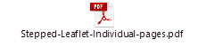

Introduction
The aim of this report is describe and analyse my experience in a project I have been a part of in the semester. In addition, from attending weekly masterclasses I have gained the information local and current entrepreneurs. I will be discussing how the masterclasses had an impact on myself and my project experience. An explanation of the project will be provided in one of the sections below.

Report Remit
This report will begin by describing the project I have been involved with in the past semester. I hope to present a brief background of the project containing highlights of important events that should be recognised. Through the report I will be reflecting on the project and the events that happened within the project. By constructing a reflective report, using a reflective model, I am able to present what I feel suited the project and what did not through a depth analysis. I also aim to discuss how the weekly masterclasses had impact on my learning and development.

Brief background of project
As a class we were assigned a project. Team leaders were chosen out of the class then we were organised into groups of 6 and chose a charity or a social enterprise to work with as a project. The focus of the project was to raise awareness for the organisation through proceeding with different activities that was most appropriate to the organisation itself. ‘Down To Earth’ was the organisation my group was involved with.
Down to Earth are a non-profit organisation which engage with unemployed and vulnerable people. Engagement with these individuals allow them to get on an educating platform where Down to Earth offer an array of different training programmes. They are an accredited company which means they have the authority to teach and qualify individuals based on their knowledge and practical experience. Remarkable and sustainable orientated buildings are constructed through these training programmes by supervision of down to earth specialists in different fields and those being taught.

(Figure 1)
Down To Earth
(Down to Earth Project, 2015)
As a group we began to meet up occasionally and discussed what could be done to put Down to earth in a better position. Many ideas were brought forward by members but after plenty of research, we came to the realisation that fund raising was out of the option as Down To Earth were fortunate to receive a post code lottery fund known as ‘Dreamfund’. Keeping the thought of raising awareness, we came to an agreed decision that the more beneficial option for our social enterprise was to attempt to feature an article of Down To Earth in a national or regional newspaper. In course of the project, we spent one morning visiting one of the sites to get a real feel of what the business had to offer to further support us when thinking on what to write in the article. Although we had tried to communicate with the organisation on many occasions and visited one of the sites, the clarity of what we had to do was low. The end result was not what we hoped as we did not achieve our goal by featuring an article in a newspaper. However, we still managed to raise awareness through other tools, one of which speaking to the public in front of our Down To Earth stand in unit 19 abled us to speak about the social enterprise and what they do. We also created blogs as a group, each member having 2 blogs each to do. These blogs focussed on Down To Earth and sustainability. We based our blogs on what was present at each site. We published a blog three times a week, taking it in our turns.

Models of reflection
After completing the project, I think reflecting upon the experience we had as a group is essential. Initiating reflection can help the group look at what we did, what we would have done differently and what we could improve. Doing this will ensure we are prepared for future projects keeping in mind how we did on this project. Regardless of what the project is about, its important to remember past projects because if there are similar elements that projects have in common, as a group and an individual we will use the experience as an advantage.
There are different models that could be used in hope of reflection. A model I will be using to appropriately describe, analyse and evaluate the project is Gibbs 1988 Model. This model is used widely across any industry. Below is figure 2 which illustrates the different stages thought by Graham Gibbs would be the best way to reflect.
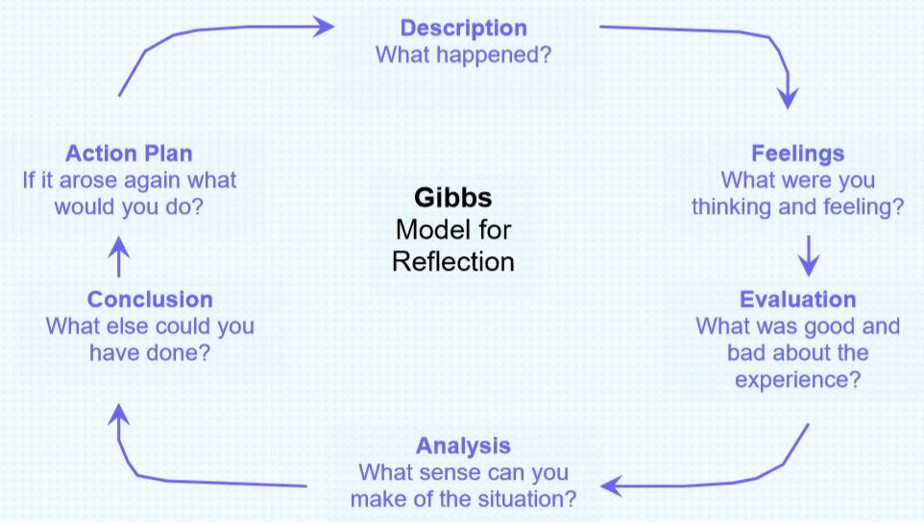
(Figure 2)
Gibb’s model for reflection
(Gibbs, 1988)
As appose to how our project went, this model will allow me to work through the different stages analysing each stage in depth. As a description of our project is that it did not go as planned. Unfortunately, the aims and objectives set out at the start of the project were not met as we failed to feature an article in a newspaper. When we first started the project, Down to earth suggested for us to research in depth about electric cars as they were looking to expand their sustainable reputations by providing the Swansea area with electric buses and taxi’s as a step forward towards sustainable living. However, this approach for the project was not suited as there was not much we could have done. We then as a group decided to have meetings to discuss what we could base our project on as we had little time to waste. By visiting one of their sites and ensuring that every member of our team were more familiar with what the business does and has to offer, we concluded that the best option to raise awareness was to feature an article in the newspaper.
During the assignment I felt an element of uncertainty. The reason I felt this way was because even though we had a clear aim of what we needed to achieve, we did not have back up plan in case we failed to reach the newspaper as we knew there were obstacles that we could face in attempt of featuring Down to Earth in an article. When we began to email different reporters, I felt that members of the group may not have been confident about the outcome of the reporter’s decision.
Thirdly, If I was to evaluate the project, personally I believe that there with elements that worked well but it came down to the lack of creativity. The initial idea of getting hold of a reporter and advertising through a newspaper was exciting, however, the idea did not pull through. This was where the group needed to pull together come up with innovative option for what could be done to still raise awareness for Down To Earth. Considering our circumstance, it was difficult to rethink another idea within the time scale we had. I also think that inconsistency of attendance of members of the group also had a part to play in that as it led to having members missing frequently. When all members were present, I believed we worked effectively as a team.
From situation the group has been in, and the problems we have faced, time management would have put the group in a more comfortable position to raise more awareness.
“Generally, time management refers to the development of processes and tools that increase efficiency and productivity - a desirable thing in business because good time management supposedly improves the bottom line.” (Susan Ward, 2017)
If our time management was at a better standard, then it would have set the tone on a more positive note for the rest of the project. We did not have a second idea and we were in a position where we relied on the initial idea for our project. As mentioned by Susan Ward, efficiency and productivity would have increased. With that being the case, new ideas would have been brought forward and could have essentially given us more time to act upon it. We could have ensured our time management was better by contacting reporters earlier on or even sharing the responsibilities evenly through out the team could have spurred the project to move on quicker.
To conclude, failure to feature an article came down to a mix of events which did not go our way. I think the lack of communication earlier on in the project with down to earth led us to a slow start. However, with some members missing from discussions, it was difficult for the group to pin point exactly what the project was going to consist of. The lack of attendance had a knock-on effect on the creativity. The misleading of the initial proposal of electrical vehicles also did not go to plan, and more time was being spent on research we did not end up needing in the project.
As an action plan if the project were to take place again, there are some elements that id keep in place that I thought went well in the project. For example, the way we worked together when it came to tools we used to raise awareness. As we did the blogs, we were organised and efficient and kept to a theme. We agreed on a plan which illustrated when each person would publish their blog, what their blog would be about and how often (once every two weeks). We also presented ourselves with a stand in a public event which contained information of Down To Earth. Each member of the group spoke to members of the public about Down To Earth and what we had achieved through working with them. As far as reaching our goal of featuring a newspaper, we were unsuccessful but by the reason of time management and a limit to what our project could be based on. If the project was to go ahead again, we could react to the failure strongly by immediately coming up with ideas that could replace the newspaper article. For instance, creating an account on different social medias such as ‘Instargram’ that Down to Earth may not have had account on. The group would still be in the position to raise awareness.

Masterclass Sessions
Over the winter months, the university brought in experienced business owners and entrepreneurs to present us with what they have achieved over the coming years and how. Through speaking to us about their individual journey, and how they have ended up succeeding with their organisation today. Over the course of 9 consecutive weeks, several different organisation owners came in to give advice to us students. Each giving a totally different story and experience in which us students can remember and use to our advantage for the project and future references.
Through listening to each masterclass session, there are many themes that have had a significant impact on me as an individual as well as how I went about my involvement in the project. Personally, I found that the masterclass based on ‘to ensure you can get the best out of you’ that ill be speaking about in detail, was useful for myself as it focussed on how people presented themselves across to others. Whether that may be in front of a large audience or a o group conversation. From paying close attention to the masterclass, I took the advice and applied them to my presentation skills. Being that I was not the most confident with presenting, I found this useful and most definitely relevant to my needs. Entrepreneurship was another theme that took my interest in many of the master class, as an entrepreneur discussed how he started his entrepreneurial journey and the stages between that brought him to where he is now.

Influence of the masterclasses on personal learning & development
The masterclasses have had an significant impact on my personal learning & development. Stifyn Parry, the owner of mrproducer, 2016.
“Entrepreneur and entertainer, Stifyn Parri, is the Managing Director of Mr Producer. The company offers a wide range of creative services including developing creative concepts, mentoring on presentation skills and confidence, event hosting, media training and creative consultancy.” (Stifyn Parry, 2016)
Stifyn as an individual has accomplished incredible achievements and has built a career starting from acting in famous shoes in the west end. His aim the workshop he conducted in the masterclass was ‘to ensure you can get the best out of you.’ Through the workshop, Stifyn mentioned that by putting yourselves in situations where you feel a lack of confidence and fearful, a hit of euphoria will help yourself build courage to do a presentation, it would become a natural doing the more you put yourself out there. I have taken this on board, I think putting myself in a situation where doing a presentation will influence my presentation skills and confidence.
An entrepreneur called Benedict Room also came in for one of the masterclass sessions to speak about his journey. He started his journey in 2001 and he made a business plan when he was a graduate. In 2001, he came up with idea of creating a skatepark in Swansea by the sea front. Since then, Ben has progressed as an entrepreneur by creating and running 3 businesses. His passion and hobby consisted of skating. However, he transformed his passion of skating into other sports. In 2008, Ben used his innovative qualities to come up with a new business that was similar to skating but taking into account the Welsh climate and landscape, he decided to create a business called brdsports, 2008 (Board Riding Development). Ben took into account that the recession would have an impact on starting up a leisure business in this in particular year.(Always be wary of current affairs) In addition, a second business under the name of surfabilityukcic is run around the basis of adaptive and inclusive surfing.
“After volunteering at events for children with autism conditions, Surfability UK founder, Benjamin Clifford, could see the positive impact of surfing for everyone involved. He wanted to start something that would allow people who have additional needs to be able to participate in surfing regularly rather than as a one-off event.” (Surfability UK)
During his talk, he spoke about how he turned his hobby into a living, which then made me think about turning my hobby into a career and living. It is more than possible for an individual to transform what they enjoy doing into their career. I felt that Ben gave a positive energy which got us students to think that anything is possible if you’re willing to put time, effort and the right attitude towards it.

Conclusion
To conclude the report, I have come to the realisation that after conducting an event or project in the near future, a depth reflection of how it has gone will add to my knowledge and experience. I have learnt that time management is essential for the success of any project. Misinterpreting time with the amount of work that needs to be completed could lead to the loss of quality and professionalism. By reflecting more frequently, I can see what I could improve myself and what I could bring to the table as a part of a group. The masterclasses I attended benefited my development as I took plenty of advice that will benefit me in the future. Listening to successful people in the local business industry has put things into perspective for myself and has now given me a sudden spur of determination to start something. I did not find the masterclasses as beneficial for the project as I did not find it very relatable to what we had to do.

References

The balance, The management definition. Susan Ward, 2017.
Available at: https://www.thebalance.com/time-management-2948668
(Accessed 08 03 2018)

Mr producer, 2016. Stifyn Parry.
Available at: https://mrproducer.co.uk/homepage/
(Accessed 10 03 2018)

Board Riding Development, 2008. Home.
Available at: http://www.brdsports.co.uk/
(Accessed 12 03 2018)

Surfability UK, Homepage.
Available at: https://surfabilityukcic.org/
(Accessed 12 03 2018)

