

Student Name : Bee Jian Sheng
Student Number : 1805203
Module : Project Management and Research Methods (ACDA5004)
Assignment Title : Managing a Software Project for Disaster Recovery
: Individual Project Report

No. | Topic
1 | Risk Management
2 | Code of Practice: Sustainability
3 | Code of Practice: Ethical and Legal
4 | Quality Assurance
5 | Reference

Table of Content

Introduction
Project Title:
Disaster Traffic Control Mobile Application
Background:
This project is made up of the idea of guiding disaster victims to leave the affected area in the shortest time safely. It’s often when warning of potential disaster such as typhoon and earthquake is announced, traffic becomes a problem as people eager to leave the area. The application will help people to determine the fastest and safest way to use.
Purpose:
With the built in GPS and first-hand information of potential disaster, the application will be able to identify affected area and gather traffic information which will be provided to users. This will help the user to reduce the time taken to retreat by providing them alternative way with less traffic.
Objectives:
- To help users determine best route to use to leave the area within shortest time.
- To inform user about the disaster coming
- To show region affected by the disaster

 | Roles | Responsibilities
University of Wales Trinity Saint David | Project Sponsor | Monitor and provide necessary resources
Sue Maw | Mentor | Monitor and provide necessary guidance and advice
Abdul Halim | Project Manager | Manage and keep track of the progression
Adam Safuan | Team Member | Complete task given within capability
Bee Jian Sheng | Team Member | Complete task given within capability
Project Team:
- Risk Management

Risk Management in project management is a process of analysing and identifying any risk that might affect a project and preparing corresponding solution. A risk is the possibility of an unforeseen issue of future events.
As project plans are based on assumptions, there is possibility that an assumption will go wrong. Thus, a good risk management will have an alternative or a solution for possible issues or problems in a result of incorrect assumption. Risk management also includes methods to control the consequences in case of unavoidable risks.
We have produced risk management for our project including a list of identified risks, its respective risk management methods, and a Risk Evaluation Matrix.

Risk Identification:
- Gold plating:

Gold plating is a bad practice where features that is not included in project planning is added by developer or project manager. Due to informal way of working, this can happen to our project during our development. For example, three of us may agree on an addition of feature during development stage despite that the feature is not included in our original planning.

- Late changes to requirement:

Any requirement changes that is needed after requirement analysis stage is considered late and sometimes has huge impact on cost controlling of a project. When an amendment of requirement is made during development, developer might need to redo a part of the project if not the whole project to meet the latest requirement. This will end up increasing time and money costs of a project.

- Shortfalls in externally supplied component:

There is always a risk for externally supplied components as it is out of the project planning control and can happen anytime. For our project, accurate data of predicted or happening natural disaster is needed. This means a collaboration with local government to get precise and official information. Any shortfalls in this collaboration can happen as it’s indeed out of our control.

- Development technically too difficult:

Sometimes, project manager does not recognize the limit of the team developers before starting a project. This will cause development issues as the developers might not have the skillsets to complete the tasks given. This risk is crucial as it leads to huge increment in budget to improve developers’ skills or hire new developers, or in worse case makes the project a failure.

- Personnel shortfalls:

Personnel shortfalls means the shortage of team members in the project team to handle a project. In order to complete a project within given time, some works, or stages must happen simultaneously. This will become a problem when there is less member that needed to keep the project on-going.

Risk Evaluation Matrix
Probability
Impact
High | 1, 2 |  | 4 | 3
Significant
Moderate |  |  | 5
Low
 | Low | Moderate | Significant | High

From the matrix, we can tell that shortfalls of supplied components and development difficulties shall be given priority to be solved as they are both beyond the tolerance line. As for gold plating and late changes of requirement, with their low probability the team can still perform necessary practices to prevent the risks as they give high impact on the project.

Risk Planning:
- Gold plating:

Gold plating can be avoided by having regular meetings among the team members. Project manager shall review the progress of the developers and keep them on track. By meeting up frequently, any gold plating behaviour can be identified earlier and be removed as needed. In addition, requirement scrubbing is also important to keep the project on the right track. It should be done during reviewing and prototyping to ensure project requirements is recognized and only project requirements.

- Late changes to requirement:

Requirement should be finalized during requirement analysis stage and it should not be changed anytime after it. If client wants to make any changes to requirement, project manager should inform client that they need to bear the consequences such as increment in budget and later completion date. In this way project team will not need to bear any extra cost.

- Shortfalls in externally supplied components:

In order to make sure supplied components are supplied sufficiently, agreement should be made with respective supplier at the starting of a project. We can have agreement with government unit to have them supply us the natural disaster prediction data before we start the development stage. We can also have a back up supplier such as private weather forecast agency in case that the local government stopped supplying data for us in future.

- Development technically too difficult:

Project Manager should always keep track on one’s team members skill level regularly. In our case, a period can be included in planning for us to self-learn enough skills to complete the project.

- Personnel shortfalls:

Project manager needs to identify the workload of a project and the capability of one’s team in term of human resource before project manager initiate a project. A organization chart is produced during our project initiation stage to ensure we recognize the human resources we own.

- Code of Practice: Sustainability Issues

With arising awareness of human activities impact on environment, how a project impact on the surroundings has become an important part. A good project should improve human lifestyle with least impact on the environment. Sustainable choices should be given priority when making decision for a project.
In this section, direct and indirect impact of the project will be identified and listed down.

1st order impact (direct):
- Production of e-waste increase to set up servers and network infrastructure
- Power usage on mobile and servers
2nd order impact (indirect):
- Radio or SMS disaster warning to be substituted with faster and more accurate online warning for disaster
3rd order impact (systematic):
- Decrement of victims affected by natural disaster
- Decrement of loss of property due to natural disaster
- Decrement of resources to be used for rescue operation

- Code of Practice: Ethical and Legal Issues

People who works in computing industry needs to be regulate by laws and rules. As computing industry taking over the future, concerns on what the industry can do has rose. Ethical rules and laws is made to ensure computing skills will not be abuse and causes data leakage etc.
This part will be presenting ethical and legal issues for our project as well as application of code of conduct in our project.
Our project team has followed the IEEE code of conduct to ensure ethical behaviour in our team.

IEEE Code of Conduct
The user and developer will be bound by the following regulations upon making and using the application according to IEEE Code of Conduct.

- Be respectful to others

Every party that is involved in the project or stakeholders should show respect to each other. The project team members especially should be respectful and show professionalism to other stakeholders. This includes respecting others privacy and personal information that is submitted or generated by using the mobile application.

- Treat people fairly

Harassment or discrimination to any stakeholders should not be tolerated. The mobile application and every feature within should be made available to everyone within the coverage. No features should be excluded for any users in a result of discrimination to their race, religion, gender etc.

- Avoiding injuring others, their property, reputation or employment

The personal information submitted by user should be kept safe and accessible by respective user only. Any data generated during user experience on the application should only be use for analysis purposes. Any form of leakage of information and data besides developers and users is not bearable and avoided. Developers will also do every effort they can to prevent any accident happens.

- Refrain from retaliation

The application shall be open to any review and feedback. Nobody will be retaliated for reporting violation of any rules and regulations. Reporter identity can be kept secret upon request to protect them from any possible retaliation.

- Comply with applicable laws in all countries where IEEE does business and with the IEEE policies and procedures

The project team shall reject bribery in all forms as regulated. Avoiding real or perceived conflict of interest whenever possible, and disclosing them to affected parties is also vital under this code of conduct.

User confidential belonging must be protected from any possible leakage. For example, user will be required to fill up personal information in order to sign up an account for the application. However the information shall only be accessible to respective user and development team when needed.

The team will not agree with competitor to maintain an open market. Agreeing with competitor to rip off user’s rights and wellbeing is not acceptable.

Intellectual property of others shall not be misused or infringed according to local laws. Use of others intellectual property must be authorised.

Prediction of possible legal and ethical outcomes
when Brexit occur:

As we chose UK as our targeted primary market, Brexit also fall into our consideration. When Brexit happen, the difficulty of EU country that shares borders with UK to give access to data of natural disaster is increased. Sometimes a natural disaster occurs in neighbour country can affect one another. Although we are starting in Swansea, Wales, as we expand to other area of UK, we will need to deal with another country authority to increase our functionality and accuracy. This will lead to having the developer team and the application itself to be bound under possible a different set of laws and ethical regulations from another country. The increase of costs in different aspects can be predicted for extra development and maintenance to fits multiple rules and regulations.

- Quality Assurance Issues

Quality assurance includes practices and methods to make sure the good quality of the application. This section will contain the quality assurance and the appropriate quality metrics for it.
Quality assurance can prevent mistakes and defects in developed application and avoid problems after it is delivered to client. We have used the ISO 25010 Software Qualities to assure our quality meets client and user expectations.

ISO 25010 Software Qualities
- Functionality:

To measure the quality of the application, we can track the statistics of the number of users that gain benefits from using the application during natural disaster.

The quality specification includes a full checked on list of features from the application description.

- Reliability:

We should develop the application in a way that it works in the worst situation. However, the performance of the application is very dependant on the device that users is using our application on. For example, a device’s GPS functionality is very crucial for our application to work normally. Other than that, the application should work without crashes and issues given the requirements of hardware are met.

The quality specification is getting none server crashes and less than 4 error reports per month.

- Usability:

The application is targeted to general residents of any age group and with basic knowledge of using smart device. Hence, the application will be easy to use and require minimal number of steps to access the functions.

Quality specification of usability is by having a novice user to access the feature of the application within 2 minutes and having less than 10% of the users reaching help desk for usability issues.

- Efficiency:

The application shall use minimal of internet access and battery to work as it is expected that user will be using the application in emergency.

Quality specifications for efficiency is to achieve 2 seconds or less response time and runs without undue delay.

- Maintainability:

Regular updates can be performed monthly to ensure the map up-to-date and maintenance purposes. Due to the exclusive function of the application, server downtime for maintenance should be flexible at such it will not clash with any possible predicted natural disaster.

There should be only less than 4 hours of downtime per month to meet the quality specification.

- Portability:

The application is available for most of the smart device such as smartphones and tablets with a low requirement on storage space.

Quality specification to ensure the portability of the application is to use less than 500MB of storage space.

- Reference

- https://www.projectmanager.com/blog/risk-management-process-steps
(Ray, 2017)
- https://policy.bcs.org/position_statements/bcs-digital-brexit-report
(Policyhubadmin, 2017)
- https://ieeemy.org

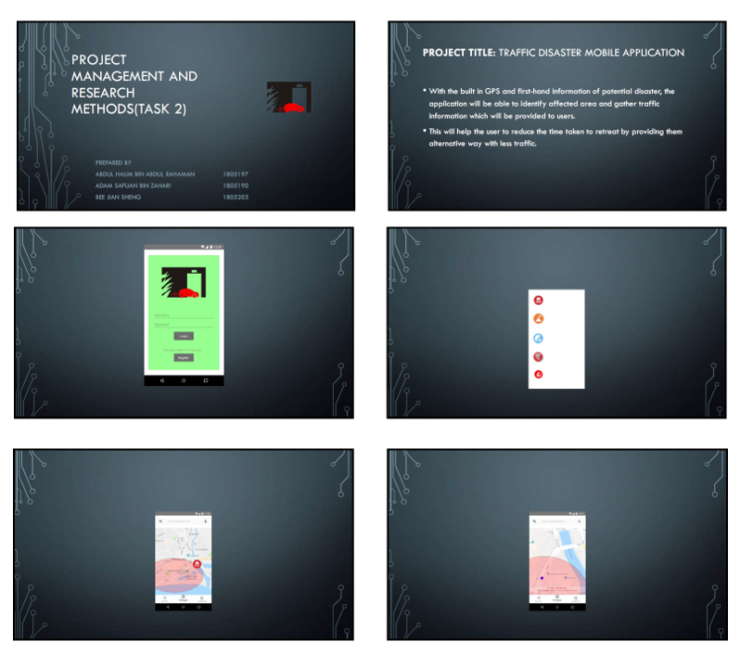
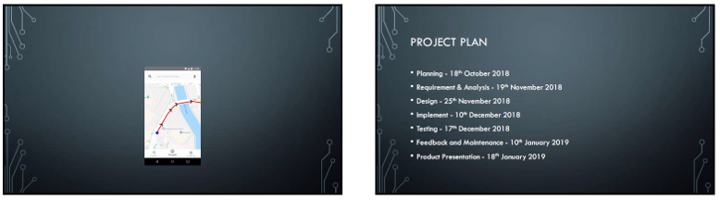
Slides of demo

