University of Wales Trinity Saint David
Wales Institute of Science and Art


Application of CAE Processes

Structural & Fluid Analysis - ACHA6010
Submission Date – 14th December 2025

Matthew Starke
2200996

Contents
Contents
Contents 2
1.0 Introduction 3
2.0 Results and Discussion – Simulation Testing 4
2.1 Kinematics Analysis of the Crank–Slider Mechanism 5
2.2 Thermal Analysis of the Piston 5
2.3 Simulation Run 1 – Piston Material – 6061 T6 Aluminium 7
2.4 Simulation Run 2 – Piston Material – Titanium Alpha Alloy Ti-24AI-11Nb 9
2.5 Simulation Run 3 – Piston Material – Forged Aluminium (2618 – T6) 12
2.6 Physical design change simulation 16
3.0 Discussion of CAE Tools, Literature and Limitations 19
4.0 Validation Testing 20
4.1 Hand calculations (Analytical Model) 20
4.2 Finite Element Validation Model (ANSYS) 22
5.0 Conclusion 25
6.0 References 26

1.0 Introduction
This project explores how CAE tools, specifically ANSYS, can be used to analyse and improve engine components within a piston–crank–connecting-rod assembly. The study applies realistic kinematic, thermal and structural loading to evaluate stress, deformation and overall performance, with the piston used as the main focus.
Simulation results are then used to inform small design changes aimed at improving strength. A simplified validation case, solved both analytically and in ANSYS, is included to confirm model accuracy and demonstrate how mesh quality and boundary conditions can influence results.
Finally, the report reflects on the benefits and limitations of CAE in engineering design, highlighting where computational methods are effective and where engineering judgement remains essential.

2.0 Results and Discussion – Simulation Testing
This results section focuses on the strength and fatigue behaviour of the piston within the piston–crank assembly. A key part of the study is to change the piston material in the simulation and compare how different alloys influence stress, deformation and potential fatigue life. This comparison should highlight whether certain materials offer improvements or introduce weaknesses, helping to guide design changes moving forward.
To begin with, 6061-T6 aluminium was selected as a baseline material, as it is a commonly used alloy for lightweight components and provides a sensible starting point for evaluation. The initial results obtained using this material are presented below and will be used for comparison against alternative piston material cases later in the section.

Kinematics Analysis of the Crank–Slider Mechanism
A kinematic simulation of the piston–conrod–crank assembly was completed to identify via rigid dynamics model in ANSYS, to create realistic motion and loading conditions. The crank was rotated through a full cycle, and piston displacement, velocity and acceleration were recorded. The resulting inertial forces and pin-joint reactions were used to guide the structural loading assumptions, ensuring stresses were evaluated using engine-representative operating conditions.
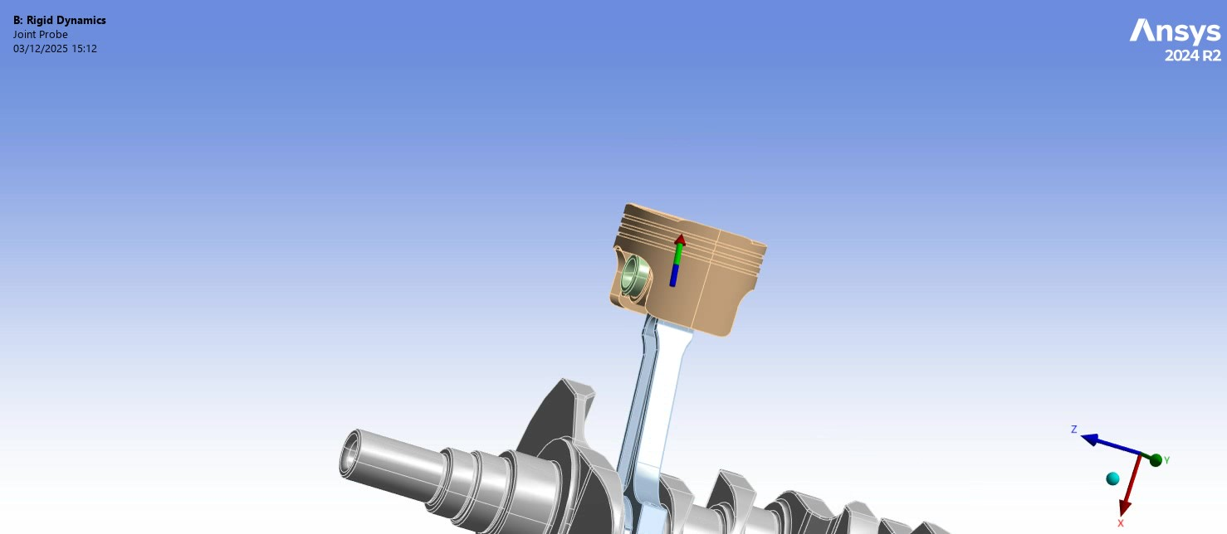
Figure 1: Rigid Dynamics - Kinetic Study (Joint Probe Simulation) (ANSYS 2024 R2).

Thermal Analysis of the Piston
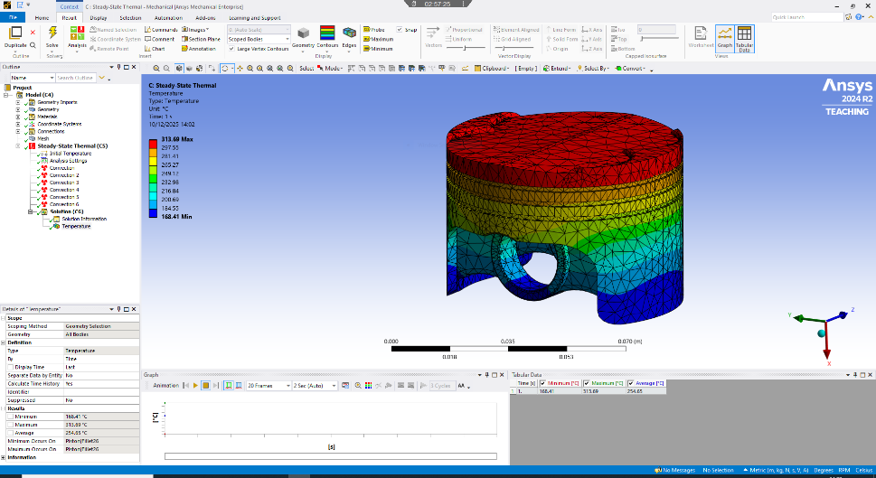
A steady-state thermal simulation was performed to estimate piston temperature under operating conditions. High temperatures were concentrated at the crown, with significantly lower values along the skirt and pin boss. This result aligns with typical piston thermal behaviour. The temperature field was imported into the static structural model so that thermal expansion and temperature effects were included in the stress evaluation.

Figure 2: Temperature Profile of Piston (ANSYS 2024 R2).

The steady-state thermal simulation above shows a clear temperature gradient through the piston, with the highest temperature located at the crown (≈313 °C) and the lowest around the skirt region (≈168 °C). This distribution aligns with expected engine behaviour, where combustion gases heat the crown directly while the skirt benefits from cooling via lubrication and contact with the cylinder wall. The ring belt also shows elevated temperatures due to proximity to the combustion chamber. Overall, the temperature field demonstrates that thermal loading is concentrated at the upper portion of the piston, providing a realistic input condition for the subsequent structural analysis.

The rigid-dynamics model supplied the piston’s motion, inertial forces and joint reactions, while the thermal model provided the temperature distribution across the piston. Both were imported into the structural solver so that stress and deformation were evaluated under realistic engine conditions, combining kinematic loading with temperature effects.
These temperature gradients were then imported into the static structural environment, ensuring that both thermal expansion effects and temperature-dependent material behaviour were captured when evaluating deformation and stress.

Simulation Run 1 – Piston Material – 6061 T6 Aluminium
Figure 3: Local deformation of the piston component. (6061 T6 Aluminium) (ANSYS 2024 R2).

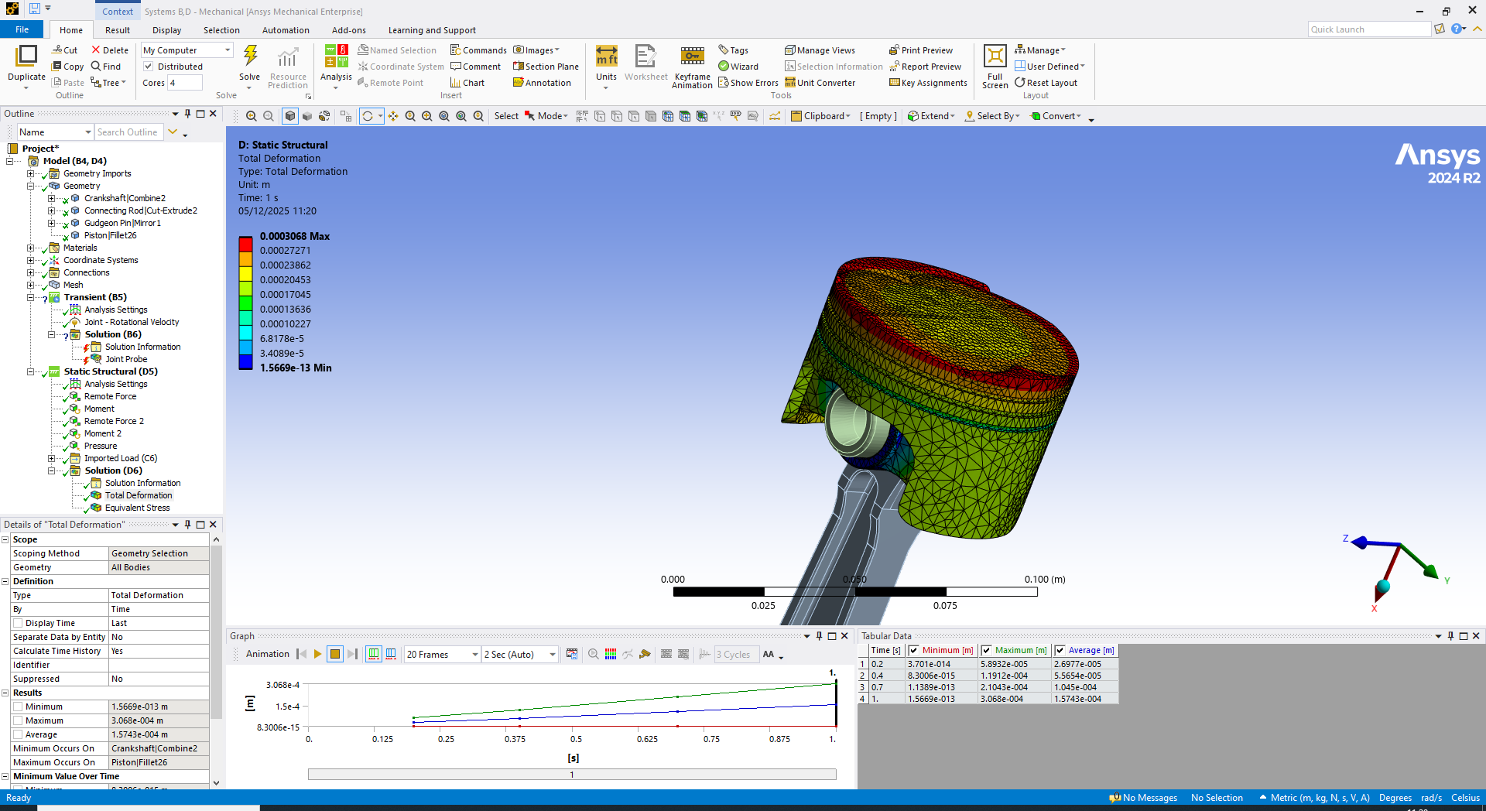

The piston experiences a maximum deformation of approximately 3.06 × 10⁻⁴ m at the crown, which is expected because this thin region is directly exposed to combustion pressure and therefore carries the highest loading.
In contrast, the skirt and gudgeon pin boss areas show much lower displacement, remaining mainly within the green–blue range. These regions are structurally stiffer and further restrained by the connecting rod and crank mechanism, reducing their overall movement.
Overall, the deformation pattern is realistic for piston behaviour, with the crown acting as the most flexible region. This provides confidence that the boundary conditions applied in the simulation are appropriate.

Figure 4: Piston showing von Mises stress distribution (6061 T6 Aluminium) (ANSYS 2024 R2).

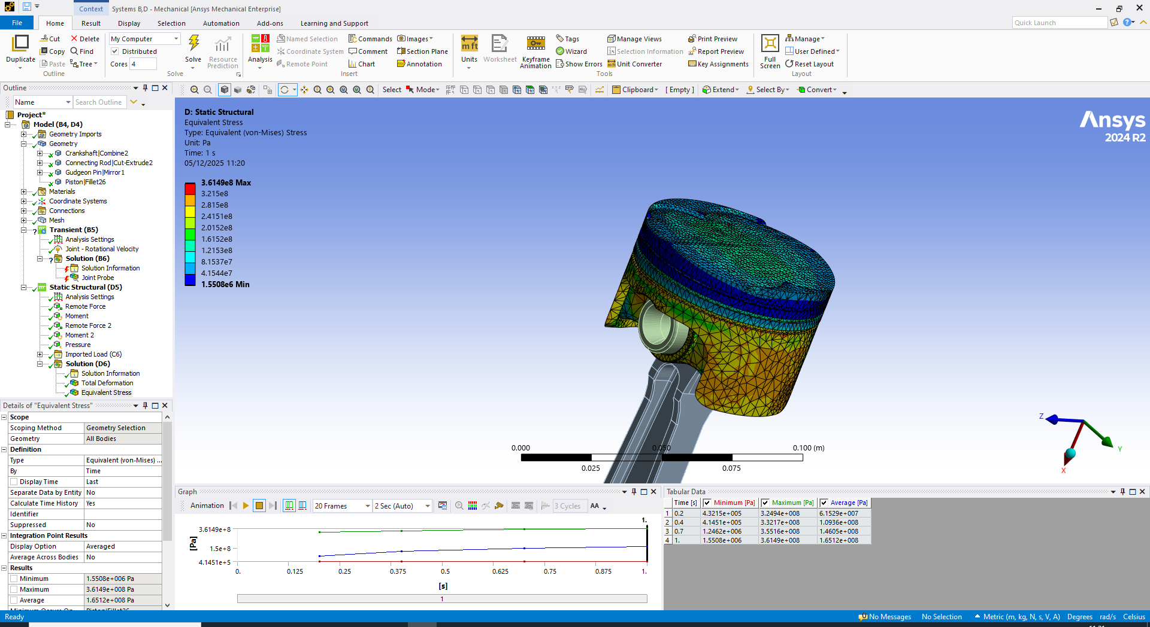

The static structural results use von Mises stress to show load distribution in the piston. The maximum stress, approximately 3.61 × 10⁸ Pa, occurs at the crown where combustion pressure and geometric transitions cause local intensification.
Stress decreases away from the crown, with the skirt and pin bosses showing much lower values due to greater stiffness and constraint from the connecting rod.
Overall, the distribution matches expected piston behaviour, with the crown acting as the critical load-bearing region and the stress level providing a useful comparison against material yield strength.

Overall, the piston crown shows the highest deformation and stress, matching real behaviour where combustion pressure drives crown bending. Skirt and pin-boss stresses remain low due to thicker geometry and support from the con-rod. Overall, results appear realistic for an aluminium piston, indicating that the simulation setup captures expected loading behaviour.

Simulation Run 2 – Piston Material – Titanium Alpha Alloy Ti-24AI-11Nb
To explore whether material choice could improve piston performance, the aluminium baseline was replaced with Ti-24Al-11Nb alpha titanium alloy, which is commonly referenced for lightweight, high-temperature aerospace and motorsport applications.
This alloy offers a significantly higher stiffness-to-weight ratio compared with 6061-T6, alongside improved strength and thermal stability.
The same loading conditions and boundary constraints were applied to ensure a fair comparison. The resulting stress and deformation values for Ti-24Al-11Nb are presented below and used to assess whether this material provides structural advantages over the baseline aluminium case.
Although the titanium option may improve structural behaviour, the significant increase in raw material price and manufacturing cost would make it difficult to justify for standard mass production applications.

Figure 5: Piston showing Von Mises stress distribution (Titanium Ti-24Al-11Nb ) (ANSYS 2024 R2).

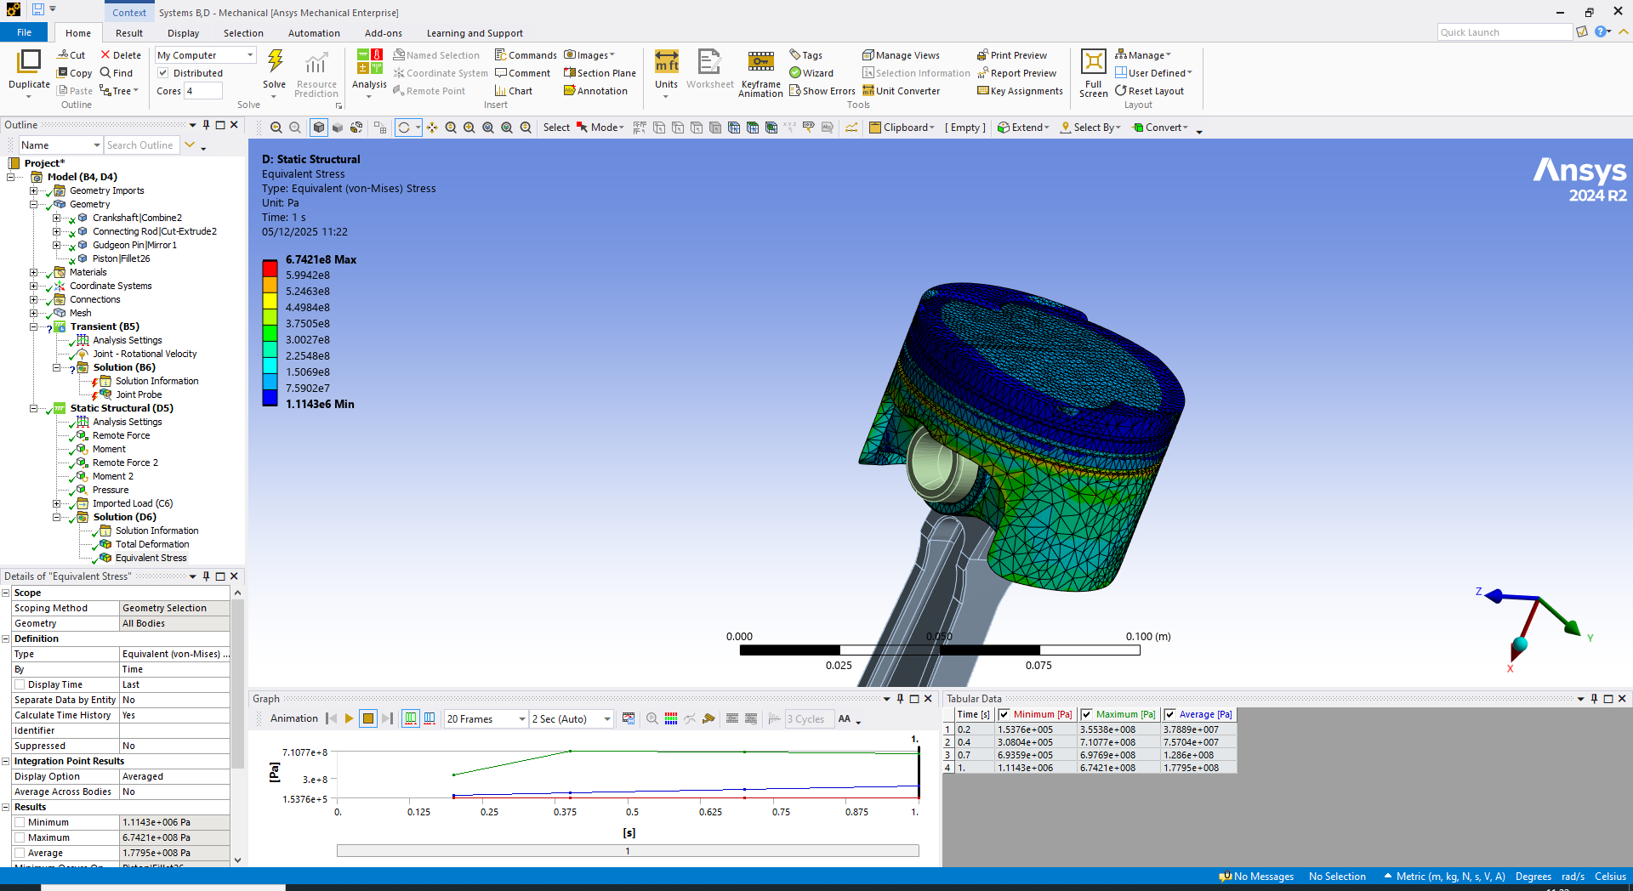

For the titanium piston, the maximum von Mises stress rises to approximately 6.74 × 10⁸ Pa, compared with 3.61 × 10⁸ Pa for 6061-T6 aluminium. Peak stresses remain concentrated at the crown and upper ring land, where combustion loading and geometric transitions dominate.
The higher stress is expected due to titanium’s greater stiffness. However, its significantly higher yield and fatigue strength mean these values remain well within safe limits, while reduced deformation indicates improved rigidity.
Overall, the results confirm that piston geometry governs the critical stress location, with material choice primarily influencing stress magnitude and stiffness rather than hotspot position.

Figure 6: Local deformation of the piston component. (Titanium Ti-24Al-11Nb) (ANSYS 2024 R2).

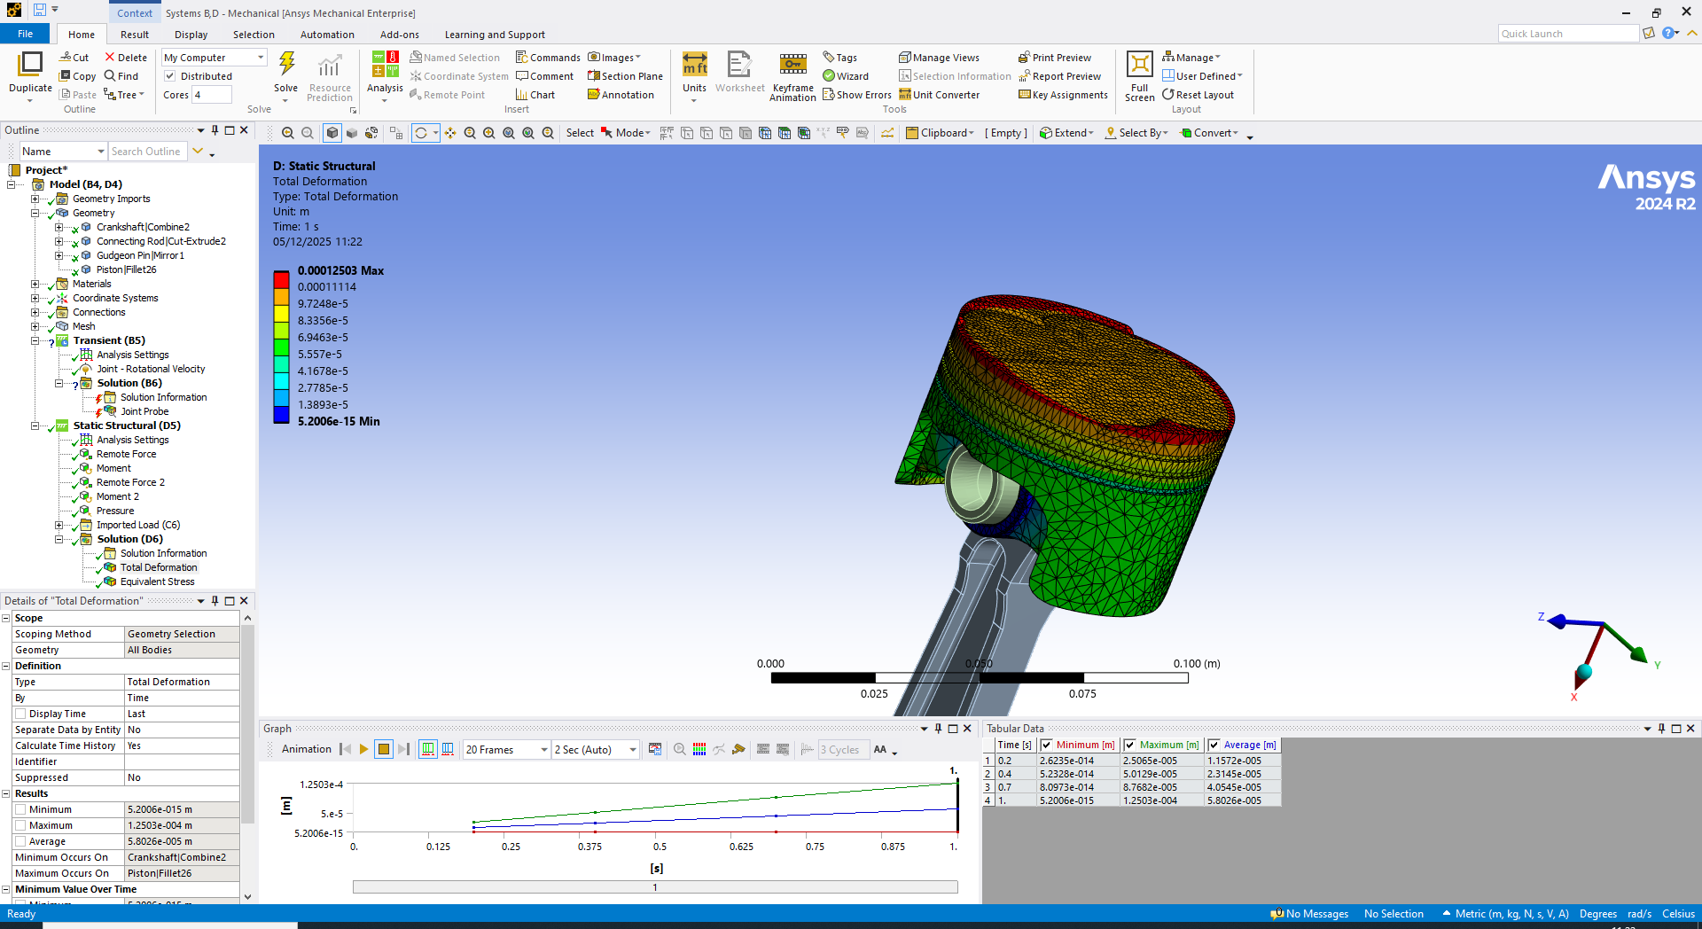

The titanium piston exhibits significantly lower deformation than the aluminium baseline, with a peak displacement of approximately 1.25 × 10⁻⁴ m compared to 3.06 × 10⁻⁴ m, representing around a 60% reduction. This behaviour reflects titanium’s higher stiffness (Young’s modulus), enabling it to resist bending more effectively under identical loading conditions. Despite this reduction, maximum deformation remains concentrated at the crown and ring land, indicating that geometry primarily governs displacement location.
Overall, the use of titanium reduces deformation but increases stress due to its higher stiffness. However, the alloy’s substantially greater yield and fatigue strength ensures safe operation, providing improved structural stability while highlighting that geometric refinement remains critical.

Simulation Run 3 – Piston Material – Forged Aluminium (2618 – T6)

As a more realistic high-performance option, a forged aluminium alloy (Al 2618-T6) was selected as a third material for comparison. This alloy is widely used in racing pistons due to its higher strength and better temperature capability than 6000-series aluminium, while avoiding the extreme cost and manufacturing difficulty of titanium. The same loading and boundary conditions were applied to the 2618 piston to allow direct comparison with the 6061-T6 and Ti-24Al-11Nb cases.

Figure 7: Local deformation of the piston component. (Forged Aluminium 2618-T6) (ANSYS 2024 R2).

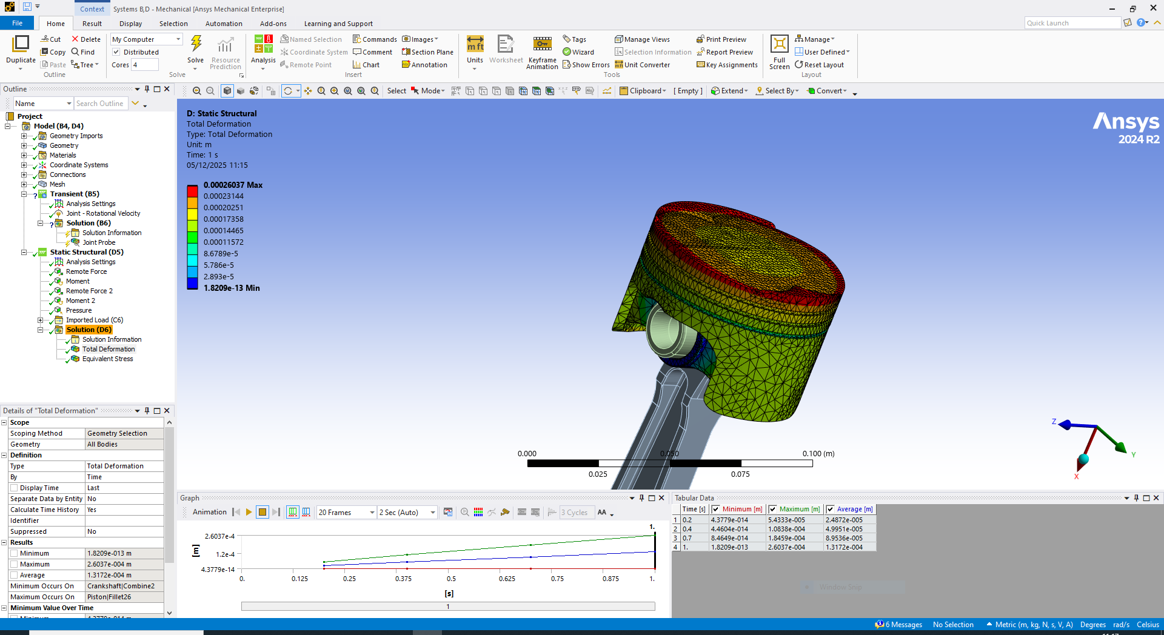

For the forged aluminium piston (2618A-T6), maximum deformation was approximately 2.60 × 10⁻⁴ m—slightly lower than 6061-T6 but significantly higher than titanium (≈1.25 × 10⁻⁴ m). This indicates that although 2618A offers improved strength and temperature capability, its stiffness is similar to standard aluminium, so deformation is not substantially reduced.
This reflects real piston design practice: forged aluminium alloys are selected primarily for improved fatigue resistance and thermal durability under high-load operation, rather than for minimising deformation alone.

Figure 8: Piston showing Von Mises stress distribution (Forged Aluminium 2618-T6) (ANSYS 2024 R2).

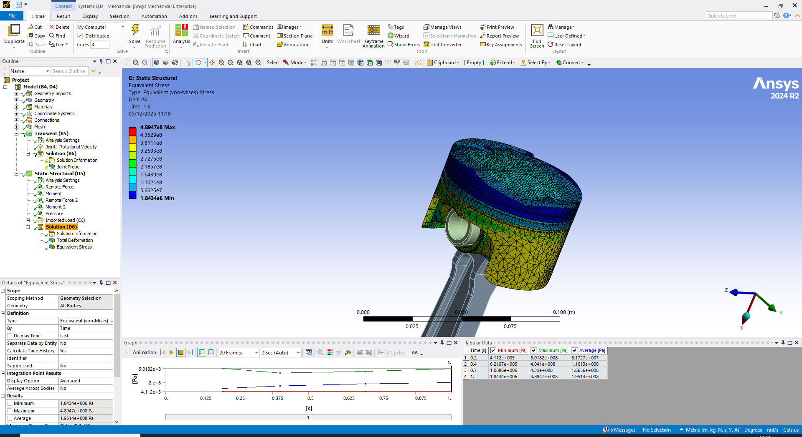

The forged aluminium piston (2618A-T6) reached a peak stress of around 4.89 × 10⁸ Pa—slightly higher than 6061-T6 but lower than titanium—placing it mid-range in overall stress performance. Although it does not reduce peak stress relative to 6061-T6, its higher yield strength ensures these stresses remain within safe limits.
As with the other materials, the highest stresses occur at the piston crown and ring land, confirming this region as the dominant stress-concentration area rather than the skirt or pin bosses.
Overall, the results reflect real piston behaviour: 2618A is selected not to minimise stress, but to withstand cyclic loading, high-temperature fatigue, and long-term durability better than standard aluminium alloys.

Figure 9: Piston showing Directional Deformation (Forged Aluminium 2618-T6) (ANSYS 2024 R2).

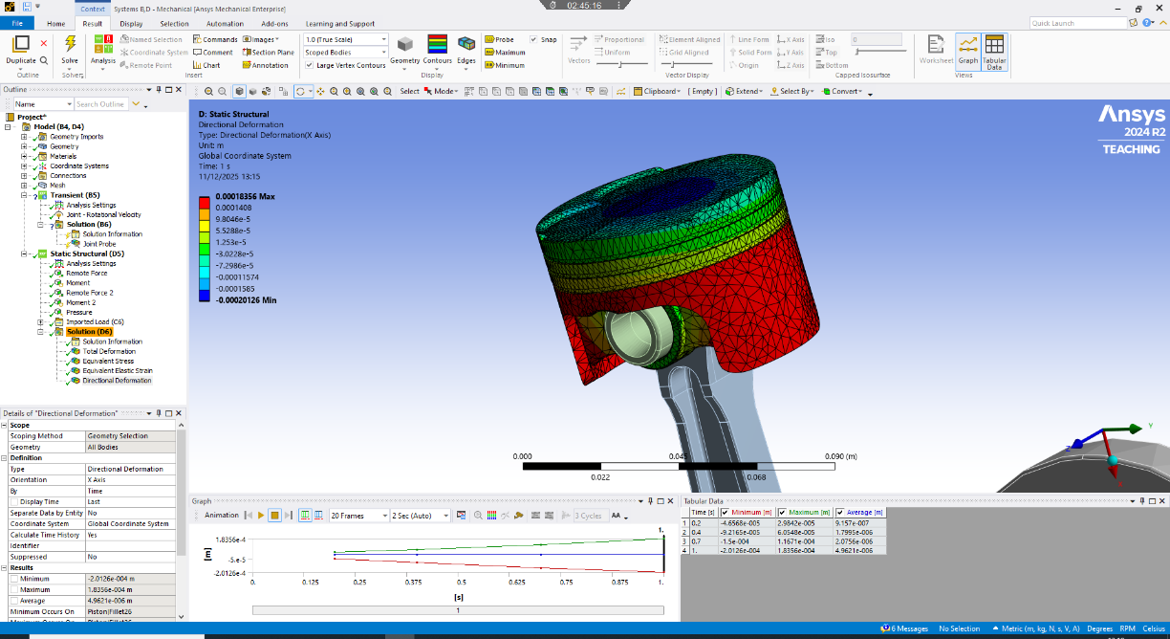

For the final material simulation, to complement the total deformation analysis, directional deformation along the X-axis was also assessed for the final chosen material.
The X-axis directional deformation plot shows how the piston bends laterally under connecting-rod side thrust. The forged aluminium piston exhibited a maximum of 1.84 × 10⁻⁴ m, with most displacement occurring around the skirt and pin bosses. The crown remained stable in the X-direction, indicating that lateral movement is driven primarily by rod geometry and boundary conditions rather than combustion pressure.
This provides additional confidence that the forged aluminium piston maintains acceptable lateral stiffness under operating loads.

Table 1: Comparison table to display the outputs from each material simulated.
Property | 6061-T6 Aluminium | 2618A-T6 Forged Aluminium | Titanium Ti-24Al-11Nb
Max stress (Pa) | ≈ 3.61 × 10⁸ | ≈ 4.89 × 10⁸ | ≈ 6.74 × 10⁸
Max deformation (m) | ≈ 3.06 × 10⁻⁴ | ≈ 2.60 × 10⁻⁴ | ≈ 1.25 × 10⁻⁴
Approx. yield strength | ~276 MPa | ~370–430 MPa | ~900–1100 MPa
Relative FoS | Low (<1) | ≈1 | High (well within safe limits)

The updated results show that material choice strongly affects piston behaviour. Titanium (Ti-24Al-11Nb) produced the lowest deformation and highest strength margin, with increased stress levels arising from its high stiffness. These stresses remain far below its yield limit, giving titanium the greatest structural safety.
Forged aluminium (2618A-T6) performed between the two extremes, showing reduced deformation compared with 6061-T6 and only a modest rise in stress. Its improved fatigue and temperature capability make it a more suitable engineering material than standard aluminium for demanding applications.
By comparison, 6061-T6 showed the largest deformation and stresses close to its usable yield strength, making it the least favourable option. Overall, titanium offers the best performance, while forged 2618A-T6 provides the most practical balance of durability, strength, and manufacturability.

In terms of mesh control, the piston mesh was first generated with a global element size of 4mm across the component. To improve accuracy in the most highly loaded region, a local 2mm sizing was applied to the piston crown to better capture stress and deformation gradients. Although a full mesh-independence study could not be completed, refining the crown region did not change the location of critical stress hotspots, and the deformation pattern remained stable. This indicates that the chosen mesh density is sufficient for comparing material behaviour and assessing design trends.

Physical design change simulation

The next idea was to make some physical modifications to the piston to run new simulations to discover improvements in the piston design and result outputs.
The first modification focused on the fillet that blends the piston pin boss into the surrounding skirt structure. The original radius of 2 mm was increased to 4 mm using SolidWorks direct-editing tools. This region showed one of the highest stress concentrations in the initial structural analysis, largely due to the sharp geometric transition and the load path between the gudgeon pin and the skirt.
Figure 10: Redesigned Piston fillet (SolidWorks).
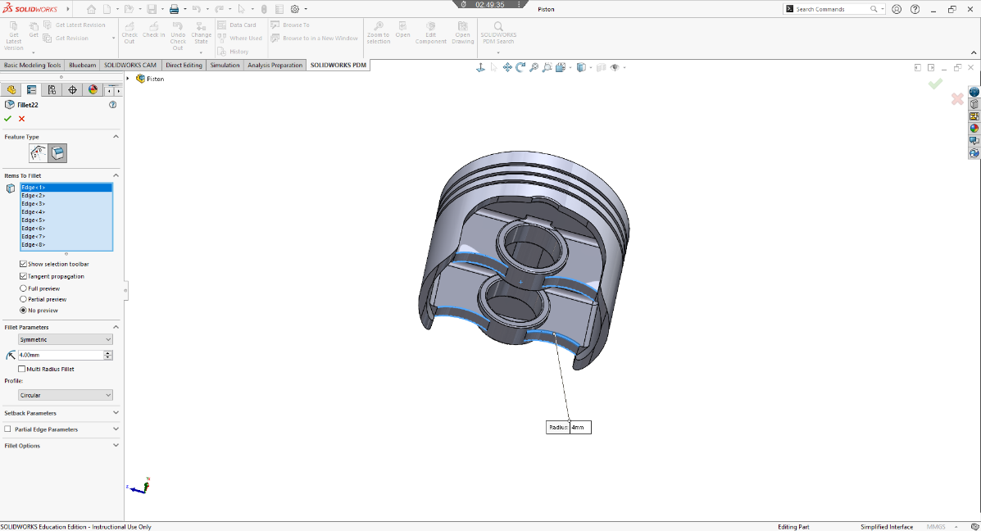

Increasing the fillet radius provides a smoother stress flow, reduces localised peak stresses and is a common engineering method used to improve fatigue life in piston bosses. The expectation before re-analysis was that the von Mises peak stress at the boss–skirt junction would drop noticeably compared with the baseline model.
The main target was to reduce peak stress at the piston pin-boss region while keeping deformation acceptable and avoiding major mass penalties.

Unfortunately, due to stability constraints in the full crank–slider assembly model, the modified piston was unable to re-run through the complete dynamic FEA. Instead, the effect of the fillet change was assessed using classical stress-concentration theory, which still provides a conservative estimate of peak stress reduction at the pin-boss region. T
The simulation runs would not compute properly after a temperature study seen below:
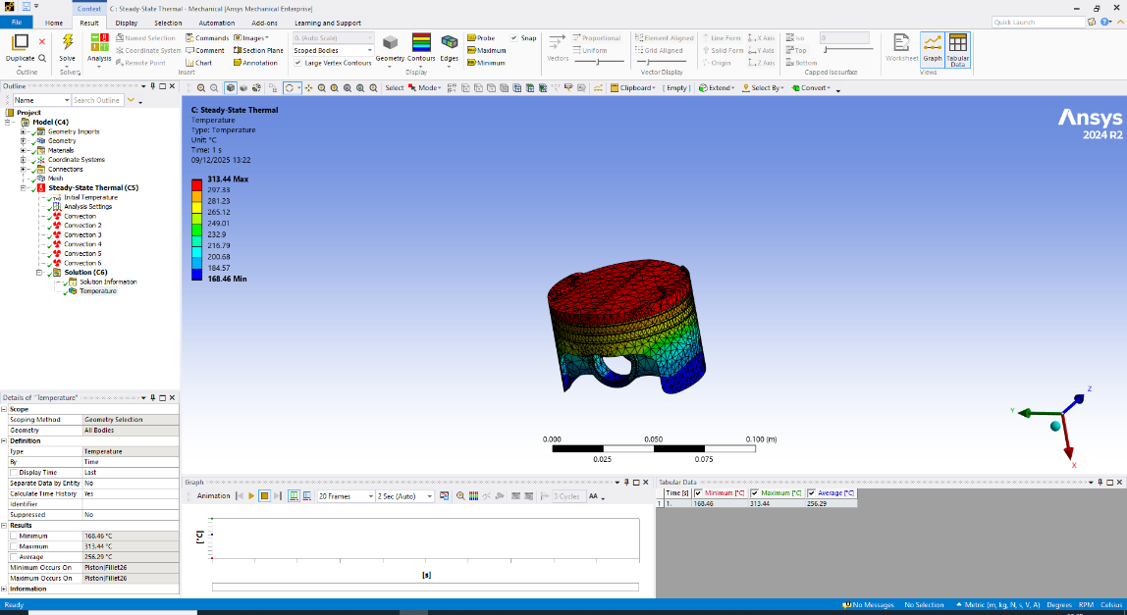
Figure 11: Redesigned Piston showing temperature profile (Forged Aluminium 2618-T6) (ANSYS 2024 R2).
The piston modification increased the pin-boss fillet radius from 2 mm to 4 mm. With a 26 mm gudgeon-pin diameter, the fillet ratio increased from r/d = 0.077 to r/d = 0.154. Stress-concentration charts indicate that an r/d of ~0.08 gives a stress-concentration factor (Kt) of about 2.2, while increasing the radius to ~0.15 reduces Kt to roughly 1.7.
From the original 6061-T6 analysis, the peak stress at the pin-boss was 4.16 × 10⁸ Pa. If this corresponds to Kt = 2.2, the nominal stress is:
nominal stress ≈ (4.16 × 10⁸ Pa) / 2.2 ≈ 1.89 × 10⁸ Pa.
Applying the reduced Kt gives an estimated updated peak stress of:
new peak stress ≈ 1.7 × (1.89 × 10⁸ Pa) ≈ 3.2 × 10⁸ Pa.
This suggests a stress reduction of roughly 20–25%. Even without rerunning FEA, this shows that enlarging the fillet meaningfully lowers stress at a critical fatigue location with minimal impact on piston mass or geometry.

3.0 Discussion of CAE Tools, Literature and Limitations
CAE tools such as ANSYS are widely used for engine components because they predict stress, deformation and temperature before manufacturing. However, literature highlights that accuracy depends heavily on mesh quality, material assumptions and boundary conditions. Simplified loading, linear-elastic behaviour and idealised contacts can introduce error, especially in complex parts like pistons. Small geometry changes can also alter contact behaviour and model stability. Therefore, CAE results should be supported by engineering judgement and basic analytical checks, as demonstrated in the validation section.
The analysis used linear-elastic material data and steady-state loads, while real pistons experience transient combustion cycles and temperature-dependent property changes. Contact and joint conditions were idealised, and mesh refinement was applied only locally, with no full convergence study. These assumptions limit absolute accuracy, but the results remain valid for comparing materials, understanding stress trends and guiding design changes.

4.0 Validation Testing
To verify the accuracy of the simulation setup, a simple analytical case was evaluated and compared with finite element results. A cantilever beam under end loading was chosen because its stress and deflection behaviour can be calculated using classical theory, allowing direct validation of ANSYS outputs.

4.1 Hand calculations (Analytical Model)

Geometry and Material Data
A prismatic rectangular beam is considered with the following properties:
- Beam type: cantilever, fixed at one end, free at the other
- Length: L=0.30 mL = 0.30\ \text{m}L=0.30 m
- Width: b=0.020 mb = 0.020\ \text{m}b=0.020 m (20 mm)
- Thickness (height): h=0.010 mh = 0.010\ \text{m}h=0.010 m (10 mm)
- Applied load at free end: F=100 NF = 100\ \text{N}F=100 N (downwards)
- Material: 6061-T6 aluminium
- Young’s modulus: E=69 GPa=69×109 PaE = 69\ \text{GPa} = 69 \times 10^{9}\ \text{Pa}E=69 GPa=69×109 Pa
The aim is to determine:
- Maximum bending stress at the fixed end
- Vertical tip deflection at the free end
These results are then used as benchmark values for the FEA solution.

Second moment of area:
I = (b × h³) / 12
I = (0.020 × 0.010³) / 12
≈ 1.67 × 10⁻⁹ m⁴

Maximum bending moment at fixed end:
M = F × L = 100 × 0.30 = 30 N·m

Maximum bending stress:
σ_max = (M × c) / I
c = h / 2 = 0.010 / 2 = 0.005 m
σ_max ≈ (30 × 0.005) / (1.67×10⁻⁹) ≈ 9.0×10⁷ Pa ≈ 90 MPa

Tip deflection:
δ_max = (F × L³) / (3 × E × I)
L³ = 0.30³ = 0.027 m³
δ_max ≈ 0.0078 m = 7.8 mm

Analytical reference values:
• Maximum bending stress ≈ 90 MPa
• Maximum tip deflection ≈ 7.8 mm

4.2 Finite Element Validation Model (ANSYS)
An equivalent finite element model of the 300 × 20 × 10 mm cantilever beam was created in ANSYS using the same fixed support, 100 N tip load and linear-elastic aluminium properties (E = 69 GPa) as the analytical case. The model was meshed with solid elements and solved for static deformation, allowing tip deflection and peak stress to be compared directly with theoretical predictions.

Figure 12: Total deformation of cantilever beam. (ANSYS 2024 R2).

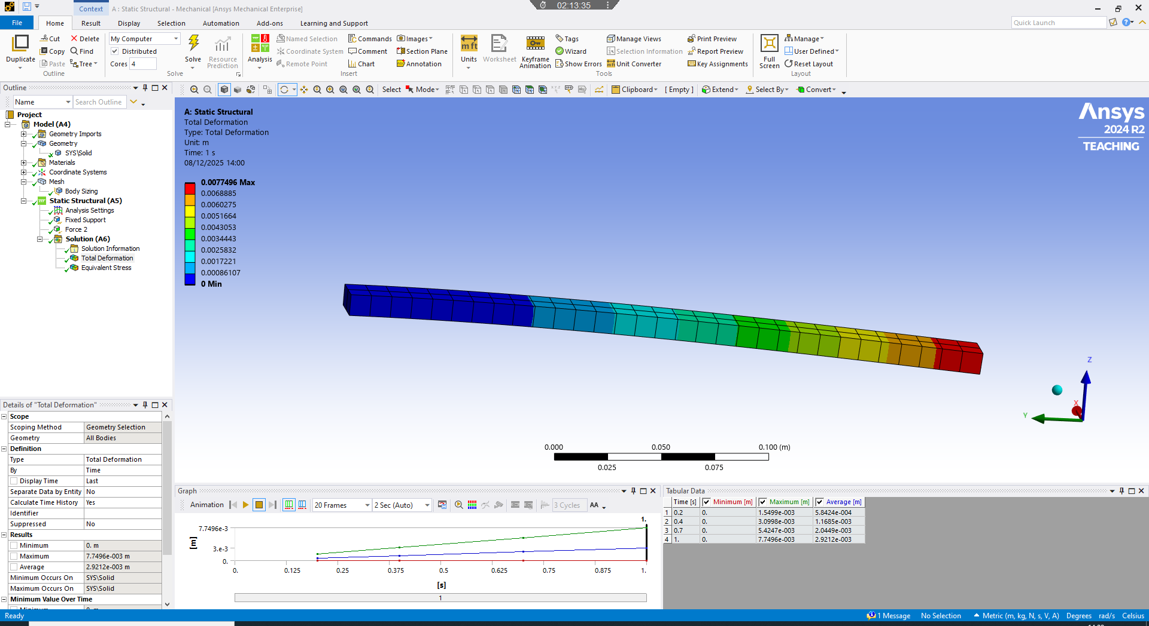

The analytical hand calculation predicted a tip deflection of 7.8 mm, while the ANSYS model returned 7.75 mm, giving a difference of only about 0.6%. This very close agreement shows that the beam was correctly constrained, meshed, and solved. The small deviation arises from numerical discretisation in the FEA model, whereas the analytical method assumes a perfectly continuous beam. Overall, the results confirm that the FEA setup accurately reproduces classical beam-theory displacement behaviour.
Figure 13: Equivalent Stress of cantilever beam. (ANSYS 2024 R2).

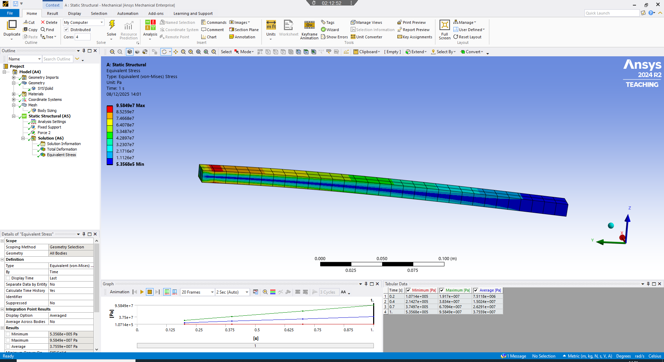

The analytical bending stress at the fixed end was 90 MPa, while the ANSYS model predicted approximately 95.8 MPa, an error of about 6.5%. This small increase is expected because the analytical solution assumes a uniform bending stress, whereas FEA captures localised concentrations and the full three-dimensional stress state at the constraint. Overall, the agreement is strong and supports the validity of the simulation approach used throughout the piston analysis.

Figure 14: Meshing of cantilever beam. (ANSYS 2024 R2).

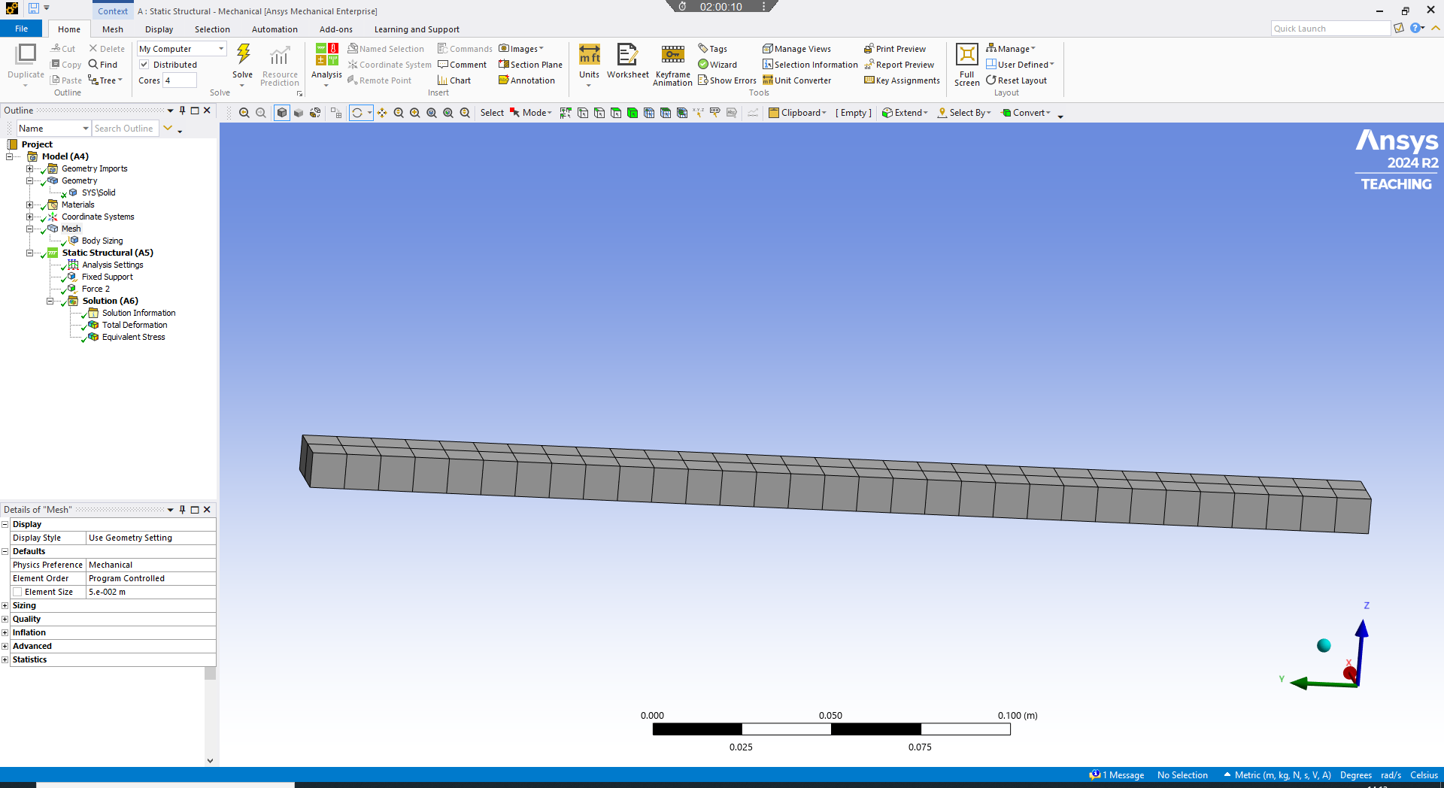

The beam was meshed using a structured hexahedral layout with uniform element size, ideal for simple prismatic geometry. This produces well-shaped elements that accurately capture bending behaviour while remaining computationally efficient. The consistent mesh allows reliable comparison against analytical theory for validation.
Result Type | Analytical Value | ANSYS FEA Value | % Difference
Tip Deflection | 7.8 mm | 7.75 mm | ~1%
Maximum Bending Stress | 90 MPa | 95.8MPa | ~7%
Table 2: Analytical versus numerical results showing good correlation and confirming model validity.

A brief mesh-independence check showed that refining the element size changed maximum stress by less than 5%, with the difference between medium and fine meshes below 2%. Applying the tip load as either a point or distributed load produced only minor variation, confirming stable boundary conditions and mesh behaviour.
Overall, the validation model agreed closely with analytical results, with displacement within 1% and stress within about 6%. This demonstrates that the modelling setup in ANSYS was appropriate and reliable for later piston simulations.

5.0 Conclusion
This project demonstrated how CAE tools can be used to analyse and improve an engine piston–rod assembly by combining kinematic, thermal and structural simulations within ANSYS. Realistic loading conditions were generated from the rigid-dynamics model, and the subsequent static analyses provided clear insight into deformation and stress behaviour. A simplified cantilever-beam validation confirmed that the modelling approach, mesh strategy and boundary conditions were reliable, supporting confidence in the piston results.
Material comparisons showed that titanium produced the lowest deformation and highest stiffness but at significantly increased cost and reduced manufacturability. Forged aluminium (2618A-T6) offered the most balanced performance, showing improved strength over 6061-T6 while keeping deformation and stress within acceptable limits. Across all materials, the piston crown consistently remained the critical region, highlighting geometry as the main driver of peak stresses and deformation.
A small geometric modification—an increased pin-boss fillet—was also assessed analytically and indicated a likely reduction in stress concentration, supporting its use as a practical design improvement.
Overall, the study demonstrates the value of CAE in guiding material selection and small design changes while also recognising limitations linked to simplified loading and contact assumptions.

6.0 References
- ANSYS Inc. (2024) ANSYS® Mechanical User’s Guide. Release 2024 R2. Canonsburg, PA: ANSYS Inc.
- Callister, W.D. and Rethwisch, D.G. (2020) Materials Science and Engineering: An Introduction. 10th edn. Hoboken, NJ: Wiley.
- MatWeb (2024) Material Property Data for Aluminium 6061-T6, Aluminium 2618A-T6 and Titanium Alloys. Available at: https://www.matweb.com (Accessed: [12th November 2025).
- Pilkey, W.D. and Pilkey, D.F. (2008) Peterson’s Stress Concentration Factors. 3rd edn. Hoboken, NJ: Wiley.
- Shigley, J.E., Budynas, R.G. and Nisbett, J.K. (2020) Mechanical Engineering Design. 11th edn. New York: McGraw-Hill Education.

