

Hotel Trinity
Hotels - Inns – Resorts

Hotel Employee Handbook

Name: Oluwatosin Osoba
Module title: Foreign Languages & Cultural Awareness (BMIH5003)
Module leader: Rodrygo Aguilera

Executive Summary
The employee handbook helps to give the employee first-hand information about the culture, values, mission, and vision of the hospitality industry, in this case, Hotel trinity. The dos and don'ts of the organization are highlighted, and the employee procedure for operating is also highlighted to give the employee a brief and quick understanding of the mode of operation of the hotel. The operating hours for the employee and the hotel are also highlighted. Specific instructions were also given to employees regarding international customers. By following these guidelines, you will help ensure that our guests have an exceptional experience during their stay at our hotel. Thank you for your commitment to excellence in guest service!

Content Lists
Contents
Executive Summary 2
Content Lists 3
1.0 Introduction 4
2.0 Who we are 4
2.1 Our Vision and Mission Statement 4
3.0 Our values 4
3.1 Integrity 4
3.2 Respect 4
3.3 Customer Services 5
4.0 General Hotel Name details 5
4.1 Operating Hours 5
5.0 Workplace requirements 6
5.1 Do's: 6
5.2 Don'ts: 6
6.0 Health and Safety 8
6.1 Emergency evacuation athering point 8
7.0 Employee Procedure 9
7.1 How toOpen Hotel Trinity 9
7.2 How to apply for leave 9
9.0 Summary 10
10. Recommendations for staffs 10

1.0 Introduction
Welcome to Hotel trinity,
Welcome to our hotel! As a staff member, your role is to provide excellent service to our guests, particularly international visitors. Here are some guidelines to follow to ensure that our guests have a positive and memorable experience during their stay

2.0 Who we are
The vision and mission below reflect what we stand for and where we are heading. This would form the basis for what we do at Hotel trinity.

2.1 Our Vision and Mission Statement
Mission Statement | Our Vision
At Hotel Trinity, we strive to be the best at identifying, qualifying, and delivering solutions and services that enhance our quests bottom line | The vision of the Hotel Trinity is to offer the best hospitality services in the most sustainable way possible

3.0 Our values
Our employers are the most valued assets of our company and are also expected to be responsible for achieving the company's mission and vision. Therefore, we organized these motivations and performances into values we hope employees embrace as everyday culture and habit.

3.1 Integrity
- Be courteous and friendly
- Act responsibly with honesty and trustworthiness
- Operate with transparency

3.2 Respect
- Be respectful of privacy
- Be aware of cultural differences
- Offer constructive solutions

3.3 Customer Services
- We Offer assistance with translation
- Speak clearly and slowly.
- We provide awesome services

4.0 General Hotel Name details
The details for the hotel trinity are highlighted in the table below
Hotel Trinity Details
Street Address | Swansea SouthWales
Telephone | +44(0) 1792 20567X
Email Address | hoteltrrinity@gmail.com
Website | www.hoteltrinity.com

4.1 Operating Hours
The operating hours for hotel trinity are shown in the tables below; employees are expected to arrive at work on time and notify the hotel manager if there is going to be any reason for delay or lateness.
Office Hours
Work Starts at | 8:30 pm
Work finishes at | 5:30 pm

Hotel trinity Hours
Work Starts at | 24 hours
Work finishes at | 24 hours

Shift Hours
Early shift starts and Finish | 5.00 am – 3.00 pm
Late shift start and finish | 3.00 pm -11.00 pm
Night Shift Start and Finish | 11.0pm – 5.00 am

Details for conditions and entitlement can be accessed from the Hotel trinity manager

5.0 Workplace requirements
The requirements of the workplace as an employee are summarized in the do's and don't section shown below

5.1 Do's:
- Greet guests with a warm smile and welcoming attitude.
- Address guests by their preferred name and use polite language.
- Listen attentively to guest inquiries and concerns, and respond promptly and appropriately.
- Ensure guest safety and security at all times.
- Be knowledgeable about hotel facilities, services, and amenities.
- Keep guest information confidential and secure.
- Maintain a clean and tidy appearance and work area.
- Be attentive and accommodating to guest requests.

5.2 Don'ts:
- Do not engage in any discriminatory behavior or language towards guests or fellow employees.
- Do not share or disclose guest information without their permission.
- Do not use inappropriate language or make inappropriate jokes in front of guests.
- Do not consume alcohol or drugs on hotel premises.
- Do not engage in any form of harassment or inappropriate behavior towards guests or fellow employees.
- Do not ignore or dismiss guest inquiries or complaints.
- Do not enter a guest room without their permission or unless there is an emergency.
- Do not engage in any activity that could harm the hotel's reputation or image.
By following these guidelines, you will help ensure that our guests have an exceptional experience during their stay at our hotel. Thank you for your commitment to excellence in guest service!
Other International services
- It is important to understand and respect these differences and be sensitive to cultural nuances. Be aware of gestures, facial expressions, and body language that may be perceived differently across cultures.

- Many international visitors may be unfamiliar with the local area. Provide them with information about nearby attractions, restaurants, and shops, as well as transportation options.

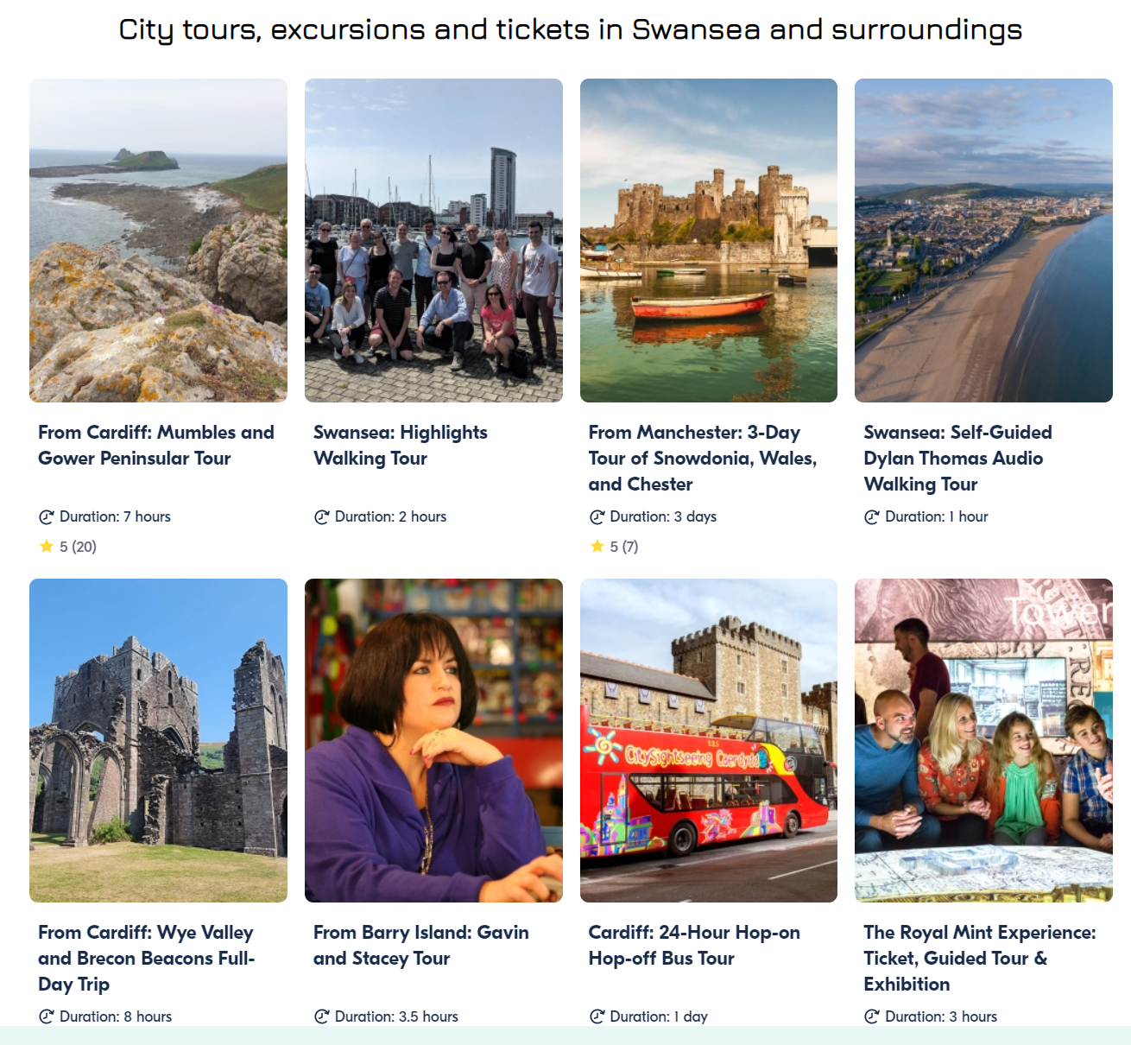
Source: https://www.orangesmile.com/travelguide/swansea/culture--2609220.htm

- If a guest has difficulty communicating in English, offer to assist with translation

- International visitors may not be fluent in English. Speak clearly and slowly, using simple language and avoiding idioms and jargon

6.0 Health and Safety
Be aware of security concerns: International visitors may be more vulnerable to theft or scams. Be aware of security concerns, and take appropriate measures to ensure the safety and security of our guests. This includes being vigilant about suspicious behavior and offering safe deposit boxes for valuables.

6.1 Emergency evacuation gathering point
The building plan of the hotel is shown in the figure below, and the emergency gathering point is indicated.
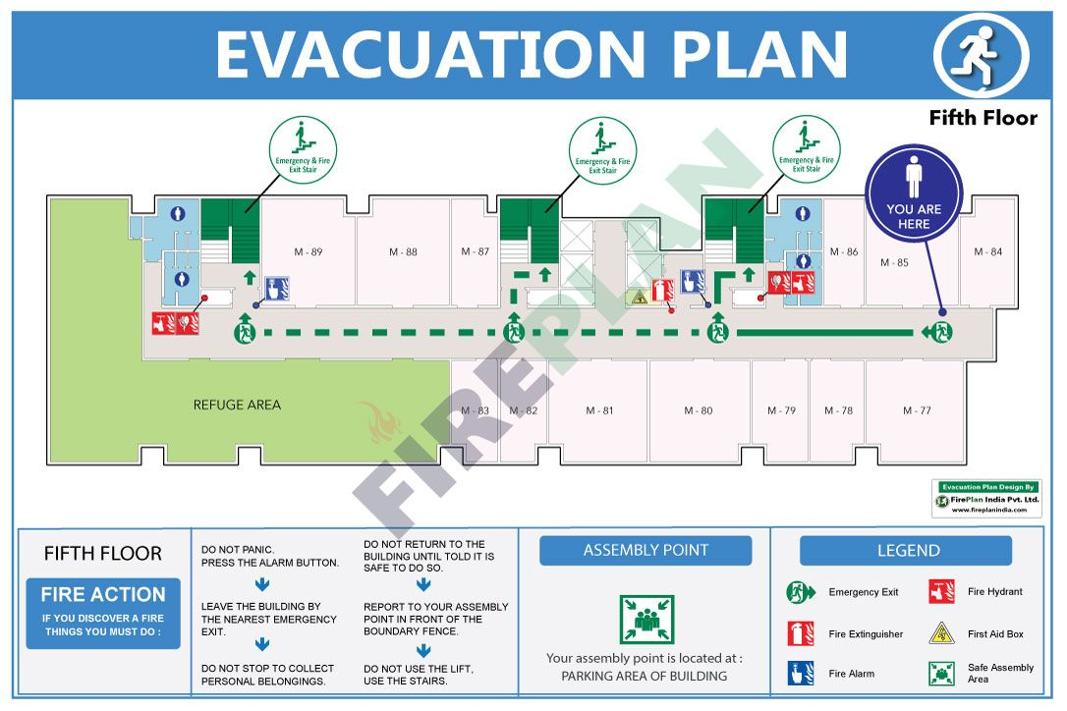
(Source: https://in.pinterest.com/pin/784400460088006957/ )

7.0 Employee Procedure
Some of the workplace procedures for employees, such as; How to Open the Hotel trinity and How to apply for leave, are shown in the tables below

7.1 How to open Hotel Trinity
Steps to be completed | Completed
Step 1: Get the keys or wait for the assigned person to come
Step 2: Open the front door and turn off the alarm
Step 3: Turn on air conditioners and other equipment
Step 4: Carry out another task

7.2 How to apply for leave
Steps to be completed | Completed
Step 1: Get a suitable time to leave
Step 2: Record your time as "Holiday Leave"
Step 3: Complete the leave form
Step 4: Submit the form

9.0 Summary
In summary, the employee should keep the handbook so that they can refer to it daily. You will need this handbook to fulfill your duty and position correctly; failure to follow these procedures may denote that you are not complying with the rules and regulations of the organization. We work as a team and are guided by the same rules and regulations so that work can be performed efficiently; following this guideline in the employee handbook will grant Hotel trinity a competitive edge above others in the market.

10. Recommendations for staff
If there are questions, concerns, and/or suggestions regarding the handbook and how to improve its quality and effective service delivery, please contact the hotel manager

