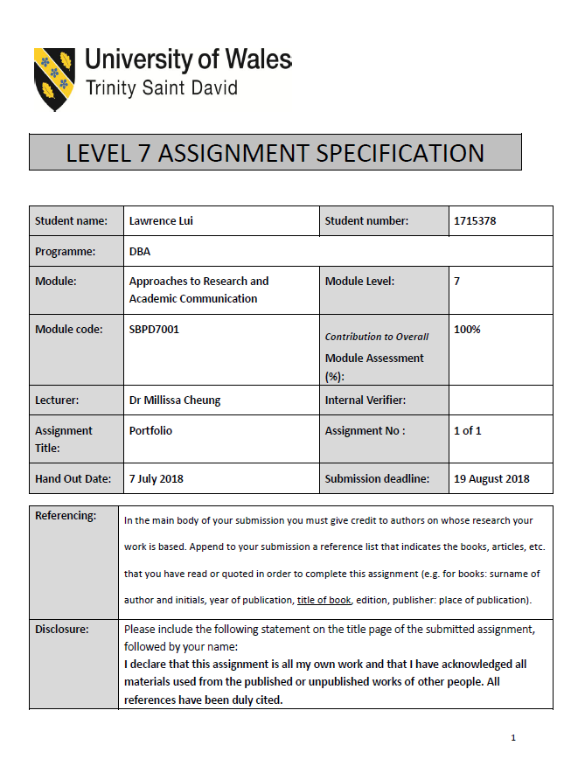


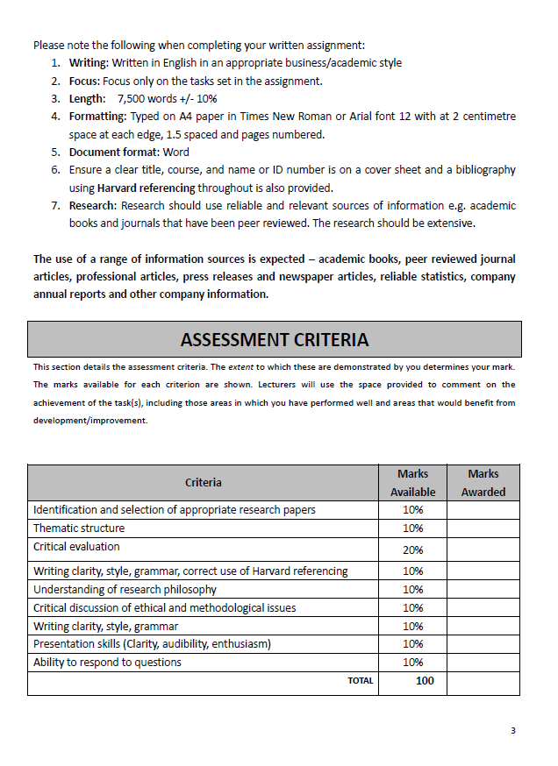

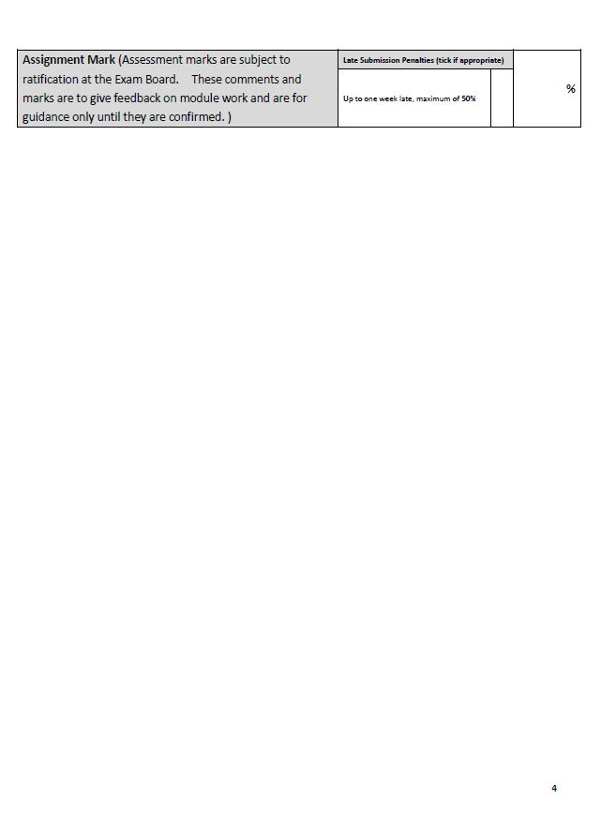

RESEARCH PAPER

Housing Prices in Hong Kong

Lawrence Lui

Table of Contents
- 1. INTRODUCTION 7
- Background 7
- Objectives and Significance of the Study 7
- 2. RESEARCH PROBLEMS AND RESEARCH QUESTIONS 9
- Research Problem 9
- Research Questions 9
- 3. RESEARCH GAP 10
- 4. LITERATURE REVIEW 11
- Introduction 11
- Housing Affordability Analysis 13
- Housing Bubble 14
- ONTOLOGY 15
- Land Supply and Housing Supply 15
- Appreciation of Land Price 16
- Investors from Mainland China 18
- EPISTEMOLOGY 19
- Quantitative Easing and Money Supply 19
- Effects of QEs on Housing Prices 21
- Low Interest Rates for Mortgages 22
- Government Policies on Real Estate Market in Hong Kong 22
- The Ease of Topping up Mortgages 24
- Population and the Invisible Population 25
- Qualified Domestic Institutional Investor (QDII) Scheme 29
- Ethical Issues 29
- 5. CONCLUSION 30
- CRITIQUING THE PAPER 31
- Critique Introduction 32
- Summary 33
- Evaluation 36
- 6. REFERENCES 40

INTRODUCTION

Background
When it comes to the cost of real estate, Hong Kong is for many years at the top of the list in the world. Currently, purchasing a new one-bedroom apartment of just 30 square meters in the central business district of Hong Kong will cost you US$1.2 million. With this price, one can buy a decent house in the U.S. or in other advanced countries. Is the current real estate price level in Hong Kong justified? Or is it bubble?

A lot of people think that increases in household income, low interest rate and buyers from mainland China are uncompromising reasons that have pushed up prices in Hong Kong. Is it that straight-forward? Are we blaming correctly the Chinese rich people? With more concrete reasons gathered herein, this research paper analyses a relatively complete picture behind the trend.

Hence, the statement of the problem is what is happening to the high housing prices in Hong Kong? What really caused the surge of housing prices over the ten years from 2008 to 2018?

Objectives and Significance of the Study
The purpose of this study is threefold: (1) to conduct literature reviews on the property industry to find out the factors that caused the increase in residential property prices, and (2) to understand the housing market as a whole (3) to find out whether the current real estate market in Hong Kong is a bubble, or whether the prices are justified by valid reasons.

This research paper will illustrate the truths which justify the increase in average prices of residential properties, there will be a basket of supportive reasons explaining why the housing prices are likely to stay at a high level in the near future. This will contradict to the public’s belief that housing prices are likely to fall simply because the housing bubble should be about to blast.

The significance of this study can be described in certain areas. On a relatively comprehensive level, this paper focuses on analyzing the factors that support Hong Kong’s housing price to explain why it almost moved upwards all the time. This paper will relate prices of residential properties to the unique population structure, government policies, worldwide monetary policies, mortgages in interest rate and land supply. This paper will give a much wider spectrum of knowledge than other researchable studies about the housing prices in Hong Kong. In some people’s mind, what caused the high real estate prices are simply because of the ever-growing Hong Kong’s population, the limited supply of land and the increased investors from Mainland China. This research paper will carry out an important message that housing prices are reflected by a bunch of factors, and the new knowledge herein will benefit the readers to understand the Hong Kong real estate in a more complete picture.

This paper will introduce the housing affordability analysis. What is housing affordability? How does it reflect the price level of real estate and whether it is a bubble?

In addition, a major significance of this study is to explain to Hong Kong people the importance of owning a residential property, and to portrait the difficulties that citizens will experience if they do not have a property on hand in this city.

RESEARCH PROBLEMS AND RESEARCH QUESTIONS

Research Problem
One of the research problems is to examine whether the trend of household income or housing affordability index should be used as the main indicator to assess the level of housing price. This paper will illustrate other elements which caused the uptrend of the property price level in Hong Kong.

Research Questions
Readers may also be interested in knowing whether there is any relationship between Price-Income Ratio (PIR) and housing prices. What are the underlying assumptions of the model? Are they valid?

Another research question that will be discussed in this study is “how do Hong Kong property developers maintain sustainability of their businesses? With respect to the sustainability practices implemented by the property developers, to what levels are applied on a strategic level? And how all these would affect the property price level in Hong Kong?

RESEARCH GAP
Previous studies have suggested that the increase in household income is correlated to the property price level. Some people like to use the Affordability Index to conclude whether the city has housing bubble. This paper will highlight and discuss that such elements are so minimal that in fact there are many more significant factors or new knowledge that contribute to the surge in asset prices in this city’s economy, and most importantly these factors are more correlational than using household income or Affordability Index to measure. While most people believe that the high property prices in Hong Kong is caused by increase of household income, popularity of investors from Mainland China and limited land supply in Hong Kong, this study will give a more complete picture as to the factors that caused the housing prices to climb up over the years in this city.

This study therefore helps people to make better decisions through knowing the strengths and weaknesses of the facts and developed themes.

LITERATURE REVIEW

Introduction
In the old days of 1960s when there were analyses of housing prices first appeared in the western world, generation models (e.g. Muth, 1960; Smith, 1969) were created to apply the demand and supply analysis by adding an inventory-flow interaction. This is briefly summarized as inventory (supply) of housing to add the new completion units (new flow), demand for housing is a function of price & other variables like income and population to arrive at an assumption that house price will adjust to make sure that the inventory of housing is “willingly held by homeowners and wealth-holders”. Hence, income and population are long-ingrained factors in people’s mind to interpret housing prices.

The second generation model is known as the User Cost Models (Topel and Rosen, 1988). It was evolved to incorporate more realistic factors such as expected capital gain would reduce the effective cost of homeownership and could have major effects on housing demand. It also took into consideration of the tax deductibility of mortgage interest to reflect the attractiveness of homeownership. Lastly, it also took inflation as a demand booster because housing will increase capital gain which should well cover the inflationary effect.

The long-ingrained concept of the positive correlation between housing price and household income is still applicable in the period from 1990 to 2006. According to a study (Hui, 2009), the upward and downward trend of property prices in Hong Kong was parallel to the household income. However, in the recent 15 years from 2004 to 2018, it is noted that asset price movements in Hong Kong are triggered by many more reasons.

The problems for the above models or studies are not contemporary but also incomprehensive. Some people who might not have a thorough understanding of the housing market or if they trust in some research papers done in narrow perspectives, would describe Hong Kong is having a housing bubble. For example, Lai and Chan (2014) analyzed to illustrate Hong Kong residential property prices correction is imminent when they wrote the research paper.

The residential property prices in Hong Kong kept an overall upward trend from 2003 to 2018 in an overall basis. The following plotted graph reflects the “Centa-City Index” which is announced weekly by the largest property agency company in Hong Kong, Centaline Properties. Some might make a slapdash judgement of the existence of housing bubble when they read this index:

The above statistical chart depicts that Hong Kong property price index surged approximately 370% from 35 to 164 during the fifteen years from January 2013 to January 2018. The latest price index as of 30 June 2018 was further risen to 186.33, a 13.6% increase in just 6 months from January to June 2018.

Housing Affordability Analysis
In recent years, many literatures cover income affordability, which mainly uses Price-Income Ratio as the measure to analyze housing affordability. Price-Income Ratio is defined as median home price to median annual household income (Suhaida et al, 2011).
Ratings for House Price to Income Ratio are as follows:
Rating | Median Multiple
Severely Unaffordable | ≥5.1
Seriously Unaffordable | 4.1 - 5.0
Moderately Unaffordable | 3.1 - 4.0
Affordable | ≤3.0
According to the 14th Annual Demographia International Housing Affordability Survey (2018 Edition, data from 3rd Quarter 2017), Hong Kong has been ranked for eight straight yeas as the least affordable city to buy a home in the world.
Rank | City | Median Multiple, Year 2017
1 | Hong Kong, China | 19.4
2 | Sydney, NSW, Australia | 12.9
3 | Vancouver, BC, Canada | 12.6
4 | San Jose, CA, USA | 10.3
5 | Melbourne, VIC, Australia | 9.9
6 | Los Angeles, CA, USA | 9.4
7 | Honolulu, HI, USA | 9.2
8 | San Francisxo, CA, USA | 9.1
9 | Auckland, Australia | 8.8
10 | London (Greater London Authority), UK | 8.5
The Demographia International Housing Affordability Survey
The table indicates that in year 2017, an average Hong Kong household had to save 19.4 years of income to purchase an average-priced apartment in this city.

Significance of Housing Price-to-Income Ratio
The original concept behind the PIR is that if housing prices outpace income growth, at some point families will not be able to afford buying houses anymore, and demand will largely contract, bringing prices lower (Md. Sani @Abd. Rahim, 2015). However, in the case of Hong Kong, for which the housing price-to-income ratio has been ranked No.1 in the world for a consecutive 8 years, still we should not jump to a conclusion that Hong Kong is having big housing bubble as this paper will reveal a variety of factors that support its home prices.

Housing Bubble
The existence of a bubble can be identified when prices surge faster than a rate that can be explained by market fundamentals (Kindleberger, 1987). Stiglitz (1990) shared a view that a bubble exists if the reason that the price is high today is solely because investors trust that the selling price will be higher in future, to the extent where fundamental reasons no longer justify such a high price. The buyers are willing to purchase properties with inflated prices because they expect to enjoy future appreciation (Himmelberg et, al., 2005).

The era is changing quickly and a more detailed study is necessary to be performed to prove the reasons for asset appreciation. Let us take a look at the below Ontology and Epistemology sections for sharing the literatures and economic reasons as to how the high housing prices is studied in recent years from 2008 to 2018.

ONTOLOGY
There are some factors which in society are common beliefs that cause the rise of property prices. Society is aware of real situation – issues of land supply and housing supply, investors from Mainland China and rise in household income.

Land Supply and Housing Supply
After the downward trend of property prices for a consecutive 4 years from 1998 to 2002, Hong Kong issued a “Statement on Housing Policy” (Li 2010), which stated that the Government would make as little intervention as possible in the private property market. It decided to cancel all scheduled land sales and stipulated that future land sales would only be conducted upon successful triggering of land sites contained in the government’s application list. This situation did not change until 2010 when Donald Tsang, ex-Chief Executive of Hong Kong started a new measure which is covered in later section in this study – “Government Policies on Real Estate Market in Hong Kong”.

Seriously speaking, land itself should not be a big problem in this city of about 1,106 square kilometres. The core problem that causes the shortage of land supply is the fact that land planning has been locked in a stalemate due to the complexity of changing the “Purpose of land usage”. About 1,000 hectares of farmlands are held by the four largest Hong Kong property developers (Tse, 2018). If the purpose of land usage can be changed by the government and that the property developers are willing to pay a percentage of land premium, 116,000 flats of 600 square foot can be built if assuming that 20% of the 1,000 hectares are released to construct homes. In Hong Kong, the Government’s target of annual supply of private housing is 18,000 apartments (Tse, 2018), which occupies about 60% of the overall target of 30,000 apartments which include public housing.

Limited supply of land inevitably causes limited supply of housing. From the below diagram which compares the number of housing from 2007 to 2017 in Hong Kong, the number only increased by 266,000 units.

Number of housing in Hong Kong by type of permanent housing:
Overall Number of Housing in Hong Kong | Mar 2007  (‘000) | Mar 2012  (‘000) | Mar 2017  (‘000)
Overall Number of Housing in Hong Kong | 2 479 | 2 599 | 2 745
Public permanent housing | 1 115 | 1 151 | 1 208
Rental housing | 717 | 761 | 808
Subsidised sale flats | 398 | 391 | 400
Private permanent housing | 1 364 | 1 447 | 1 537

The population of Hong Kong increased from 6,994,500 in 2006 to 7,336,600 in 2016:
 |  | Mid-2006 | Mid-2011 | Mid-2016
Population (Thousands) |  | 6 994.5 | 7 097.6 | 7 336.6
Usual Residents (Thousands) |  |  |  | 7 116.8
Mobile Residents (Thousands) |  |  |  | 219.8
Average annual growth rate over a 5-year period |  | 0.8% | 0.9% | 0.7%
Table 1 Hong Kong Population

Appreciation of Land Price
The limited supply of land attracts property developers to use a higher-than-valuation price to bid land. The Government receives a big sum of revenue every year from sales of land use rights (“land lease”), and it is often seen that tender results break record high price. For example, Sun Hung Kai Properties won the tender in May 2018 for a plot of residential land at Kai Tak Development Area where the old airport was located, paying a record HK$25.16 billion (US$3.2 billion) for the city’s most expensive land parcel of Gross Floor Area 1.42 million square foot. The total price translates to HK$17,776 per square foot (Sito & Li, 2018). It is worth mentioning that the land in Hong Kong is not freehold, it is indeed a land lease set at 99 years under most of the circumstances. For the most expensive land per square foot, Sun Hung Kai Property paid record high of HK$42,196 per square foot for a land at Mount Kellett Road at the Peak of Hong Kong Island, where the housing price per square foot is the most expensive in the world. In 2017-2018, a super deluxe project called Mount Nicholson on The Peak has Asia’s three most expensive apartments with prices as high as HK$560 million, or HK$132,060 per square foot.

The significance of high land price will result in accelerated price in completed homes. The total costs of a residential project comprise of land cost, construction costs, finance costs, consultancy fees, etc., whereas the land cost is a significant portion which usually accounts for 40% - 70% of the total costs to a property developer.

Under the circumstance of land inflation, Hong Kong Government has no special intent to bring the land cost down as it receives a large sum of sales proceeds from developers every year. It should be noted that through the tendering process of land sales, the eventual transacted land price is determined by the property developers in the way of tendering, depending on their level of optimism.

No specific correlation between real house prices and real per-capita income
Though it is a proposition in people’s mind that housing prices should be correlated to household income or personal income, it does not mean that it is a true statement. Taking the U.S. for the period from 1977 to 1997 as an example, the real house prices only rose 8 percent whereas the real per capita income rose 35%. But in the five years from 1997 to 2002, the real house prices surged 28% whereas the real per capita income was up by 15% only. This shows that the common proposition “the rise in housing prices can’t outpace the increase in household income” is incorrect (Gallin, 2003).

Investors from Mainland China
In many people’s perception, investors from Mainland China is a critical factor which caused the rise in home prices. However, this is not true enough. According to Shih Wing Ching, Chairman of the Board of Directors of Centaline Property Agency Limited, pointed out the fact that there is only less than 10% of purchase volume of Hong Kong properties is from Mainland buyers.

The actual amount from non-resident Chinese investors going into residential property is probably lower than the rendering by some news reports. It would be fair to say the influence brought by Chinese buyers has been somewhat overhyped.

The past literatures seem not persuasive enough to explain housing prices in Hong Kong. It is important to read the next section because it will cover the under-researched areas on Hong Kong’s housing prices as noted in a majority of past studies.

EPISTEMOLOGY
From the view of real estate perspective, there are other contemporary reasons or new knowledge of factors that support the rocket high residential property price in Hong Kong. This section illustrates the researches made to demonstrate that the high prices are caused by a number of reasons other than the standpoints held by traditional knowledge or phenomenon as illustrated in the previous “Ontology” section. The following part of research paper is done to aim at delivering new knowledge for readers who are interested in property market or will undergo a property transaction in Hong Kong in the near future. This following section is of reference value because it covers the under-researched areas after understanding and synthesizing the past studies.

Quantitative Easing and Money Supply
In recent years, new mechanisms have changed the world financial markets rapidly and some of these changes hit the real estate markets directly and indirectly. One example is after the financial tsunami in 2008, the Quantitative Easing (QE) measures were implemented in the United States whereas other similar measures followed to take place in Europe, China and Japan. The QE had helped the global economy avoid a great depression as the central banks used QE to stimulate the economy such as by facilitating the functioning of particular financial markets. After 2008, the worldwide money supply has increased more than doubled.

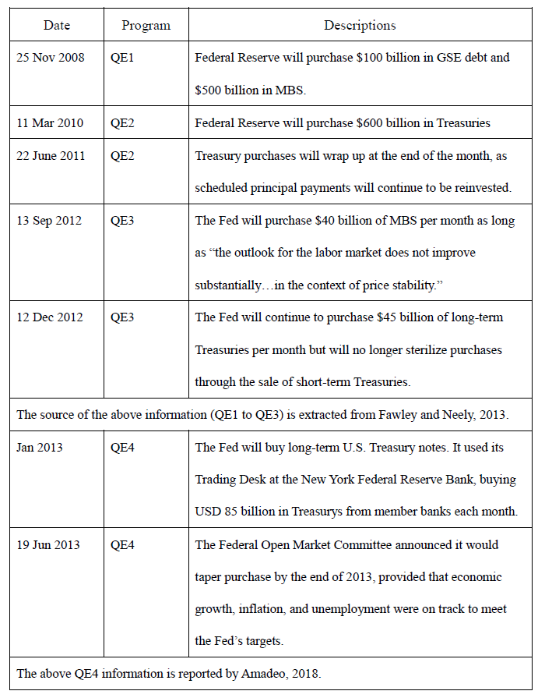
Taking the States as an example, the Federal Reserve announced its QE1 to QE4 from 2008 to 2013:

Effects of QEs on Housing Prices
Implementations of QEs majorly affected the Asia’s financial market segments. Uncompromisingly, QEs have contributed to easing financial situation in Asia by reducing tail risks of the worldwide financial market which reduced the Credit Default Swap (CDS) premium in the region. In addition, given the stable inflation in Asia, asset prices have considerably surged in some financial markets, including Hong Kong, China and India. These places have a remarkable 100% increase in asset prices from 2008 to 2012 (Cho and Rhee, 2013).
In Hong Kong, the money supply (M1) ascended the stairs from HK$645 billion in 2008 to HK$2,431 billion in 2017. The effect of the tremendous increase of money supply inevitably leads to appreciation of asset prices.

M1 supply in Hong Kong from 2008 – 2017:
Year | Hong Kong Dollar  (in million) | Foreign Currencies  (in million) | M1 Supply  (in million)
2008 | 491,115 | 154,718 | 645,833
2009 | 671,241 | 230,578 | 901,819
2010 | 730,093 | 287,134 | 1,017,227
2011 | 794,726 | 332,593 | 1,127,320
2012 | 920,920 | 456,439 | 1,377,359
2013 | 1,000,344 | 510,552 | 1,510,895
2014 | 1,116,675 | 592,049 | 1,708,724
2015 | 1,253,380 | 717,766 | 1,971,146
2016 | 1,428,775 | 785,195 | 2,213,970
2017 | 1,598,014 | 833,447 | 2,431,461
From the above chart, the result depicts that there is a significant change of an increase in M1 Supply by 276%. According to the Centa City Leading Index, the housing price also sharply jumps 194% from 55.46 in December 2008 to 163.22 to December 2017.

An increase in money supply causes interest rates to drop and makes more money available for customers to borrow from banks. At the same time, it causes the value of the currency to decrease and this has high reference value because the Hong Kong dollar is officially pegged to the U.S. dollar at the rate of 7.8 Hong Kong dollars to one U.S. dollar. Hence, it is very important to see how money supply affects housing prices and yet not many people in society comprehend this theory and its significance. Such impact on housing prices is far more important than factors such as residents’ household income.

Low Interest Rates for Mortgages
Following the practice of super low interest rate in the U.S., Hong Kong’s mortgage interest rate also has been staying at a very low level for a long time. From 2011 to 2018, the mortgage interest stayed at 1% - 2.15%, hence the cost of loan is at low levels. When the cost of borrowing is low, it attracts buyers to purchase properties as these investors or users are likely to believe property price will increase while the cost of funds is low.

Government Policies on Real Estate Market in Hong Kong
From 2010 to 2016, the Government of HKSAR has implemented different measures aiming to cool down the real estate market. This sounds to be measures which should bring down the property prices. However, these policies were later proved to be unsuccessful. There are 3 measures on stamp duty and loan-to-value arrangements:

Special Stamp Duty (SSD)
The adjusted SSD has three levels of regressive rates for different holding periods:
- 20% of the selling price (SP) if the property has been held for six months or less;
- 15% of the SP if the property has been held for more than six months but for 12 months or less; and
- 10% of the SP if the property has been held for more than 1 year but for 3 years or less.
Buyer’s Stamp Duty (BSD)
If the property is purchased by a person or entity who are not a Hong Kong Permanent Resident, the BSD will be charged at a flat rate of 15% of the property price.
Double Stamp Duty (DSD)
A DSD is an additional 1.5% - 8.5% stamp duty depending on the price of the property to be purchased charged on those buyers who own another residential property in H.K.
Loan Ratio Arrangements
The maximum loan-to-value ratio was revised as follows:
- For property < HK$7 million, the buyer can only apply for 60% mortgage; and for a buyer whose income is mainly derived outside H.K., only 50% mortgage is allowed.
- For property ≥HK$7 million but < HK$10 million, the mortgage loan is capped at HK$5 million, and for a buyer whose income is mainly derived outside Hong Kong, only HK$4 million mortgage is allowed.
- For a property ≥HK$10 million, the buyer can only apply for 50% mortgage; and for a buyer whose income is mainly derived outside H.K., only 40% mortgage is allowed.

These measures could actually cool down the property market for a short period of time, say 2 months to 6 months. Many existing owners are not willing to sell their properties because the stamp duty of their next property will be costly. Therefore, the private housing supply is contracted, thereby supporting the rise in property prices.

The Ease of Topping up Mortgages
According to the information from Hong Kong Census Statistics Department in 2017, more than 65% of the mortgages of purchased properties in Hong Kong have already been fully repaid. This does not only indicate that the banks are facing a safe line for bad debt risks, but also implies there is a huge purchasing power in the city. Reporting in an interview with Hong Kong Economic Times, Dr. Andy Cheuk-Chiu Kwan, an economist & journalist in Hong Kong, said that more than 400,000 families of which the owners are aged 50 and above actually do not have any liabilities. This accumulates a powerful purchasing power in the sense that the owners can top up their mortgages on (i) the increased value of their properties and (ii) the amount of their repayments made so far. For instance, if an owner purchased a property in 1990 at HK$3 million and after 20 years when the mortgage was fully paid in 2010 the property was valued at HK$10 million. Provided that the owner wanted to buy another apartment which the seller was asking for HK$8 million, he could approach a bank to apply for a top-up mortgage. The bank may approve by topping up 60% (maximum) of the market value of the old property (i.e., HK$10 million x 60% = HK$6,000,000) which the buyer can use it as down-payment for the new property and he might borrow the remaining HK$2 million which the bank would assess and approve based on the owner’s future repayment ability as a whole, or else the buyer uses his own savings.

Based on the above top-up mortgage arrangement, it is therefore important to note that in an era of asset appreciation and hot money in the banking system, property owners are relatively easy to get approval on new mortgages without harming his personal finance. This mortgage type is particularly useful for the parents who have fully or partially repaid their mortgages to support their children who need a house as they step into marriage ages.

Population and the Invisible Population
Referring to Table 1 illustrated in the Section “Land Supply and Housing Supply”, the Census data reveals that the population of Hong Kong increased from 6,994,500 in 2006 to 7,336,600 in 2016. This moderate increase should not be a major factor that caused shortage of housing. In this section, we will dig into the core problem of population which created the scarcity of housing – the “invisible population”. We believe these invisible population in Hong Kong are occupying or will occupy housing units in future, thereby causing housing prices to keep going upwards and arriving the conclusion that the housing supply is seriously underestimated by Hong Kong Government.

Tourists
According to Hong Kong Tourism Board, the number of tourists (including non-overnight tourists) surged gradually from 28.17 million in 2007 to 58.47 million in 2017. It is slightly doubled in 10 years of time. The effect of the increase in tourists bring a problem in housing because some of the buildings applied for the change of use to motels to capture the profit from tourism. This means that the residential living spaces are pulled back and indirectly creates the scarcity of property. The following table summarises Hong Kong's tourism performance in 2017:

 | 2017 | vs. 2016
Total visitor arrivals | 58 472 157 | +3.2%
- Overnight arrivals | 27 884 543 | +5.0%
- Same-day arrivals | 30 587 614 | +1.6%
Average hotel occupancy rate | 89% | +2 percentage points
Average achieved hotel room rate | HK$1,288 | +0.1%
Average length of stay of overnight visitors | 3.2 nights | -0.1 night
Overnight visitor per capita spending | HK$6,443 | -2.4%
Total tourism expenditure  associated to inbound tourism | HK$296.7 billion | +1.0%

Source: Hong Kong Tourism Board (Tourism.gov.hk, 2018)

Mainland Chinese – One-way Permit holders for cross-border marriages or family reunion
According to Article 22 of the Basic Law and the interpretation by the Standing Committee of the National People's Congress in 1999, Mainland people who want to enter Hong Kong must apply to the relevant authorities of their residential districts for approval in accordance with the relevant national laws and administrative regulations, and must hold valid documents issued by the relevant authorities. Accordingly, Mainland Chinese who want to settle in Hong Kong for family reunion must apply for Permits for Proceeding to Hong Kong and Macao (commonly known as One-way Permits (OWPs)) from the Exit and Entry Administration Offices of the public security authority at the places of their household registration in the Mainland.
The numbers of holders of OWPs entering Hong Kong from 2007 to 2016：
 | 2007 | 2008 | 2009 | 2010 | 2011
Holders of Certificates of Entitlement | 4,487 | 4,490 | 5,025 | 4,662 | 3,758
Spouses separated for 10 years or more and their accompanying children | 823 | 1,041 | 829 | 651 | 619
Other categories (Note 1) | 28,555 | 36,079 | 42,733 | 37,311 | 39,002
Total by year | 33,865 | 41,610 | 48,587 | 42,624 | 43,379
 | 2012 | 2013 | 2014 | 2015 | 2016 | 2007-2016
Holders of Certificates of Entitlement | 3,750 | 4,329 | 4,938 | 3,655 | 3,508 | 42,602
Spouses separated for 10 years or more and their accompanying children | 733 | 742 | 791 | 753 | 870 | 7,852
Other categories (Note 1) | 50,163 | 39,960 | 34,767 | 33,930 | 53,009 | 369,809
Total by year | 54,646 | 45,031 | 40,496 | 38,338 | 57,387 | 420,263
Note 1: Quoted from Immigration Department – “Arrivals under ‘other categories’ include those who come to H.K. for reunion with their spouses separated for less than 10 years and their accompanying children aged under 18; who are aged above 18 and under 60 and need to come to H. K. to take care of their parents settled in H.K. both of whom are aged above 60 and have no children in H.K.; who are aged above 60 and have no children in the Mainland, and have to depend on their children aged above 18 settled in H.K.; or who are aged under 18 and have to depend on their parents settled in H.K.; "overage children", etc.”
The essence of the table shows the root of the problem that family reunion will cause to need more housing in Hong Kong – same issue exists either in the case for joining their parents in Hong Kong, or apply for their mainland parents to stay in Hong Kong. The total number above (420,263 people) is not the end because some of the holders will apply for further family reunion in future.

Mainland Talents & Professionals Working in Hong Kong
In July 2003, The Immigration Department of Hong Kong implemented the Admission Scheme for Mainland Talents and Professionals. The Scheme’s purpose is to attract Mainland China’s talents and professionals to work in H.K. to meet local manpower needs, and to enhance H.K.'s competitiveness in the world market (Info.gov.hk, 2018).

This scheme brings some issues on housing – not only they need housing during their stay in Hong Kong, but they will also need housing for their families if become a permanent HK resident after seven years and then apply their family members to live in this city. So far, there have been over 150,000 mainland Chinese who joined this Scheme, and about 90,000 of them have been granted Hong Kong ID card.

Mainland Students Studying in Hong Kong
In recent years, there is an increasing number of Mainland Chinese students came over to Hong Kong to pursue their university studies. There have been more than 80,000 students of which over 50,000 stayed in Hong Kong and eventually became permanent residents. In Hong Kong, quantity of dormitory is inadequate and most Mainland students rent an apartment in the city. This deepens the scarcity of housing issue because every student will need housing.

Qualified Domestic Institutional Investor (QDII) Scheme
QDII Scheme enables financial specialists to put resources into foriegn securities markets by means of certain fund management companies, insurance agencies, securities firms and other asset management companies which have been affirmed by China Securities Regulatory Commission ("CSRC").

On 13 April 2006, the Chinese government announced the QDII Scheme, enabling Chinese companies and citizens to invest abroad through Chinese commercial banks. From the commencement of this scheme to 30 June 2018, the lines granted to Chinese financial institutions are amounted to US$103 billion. QDII Scheme has therefore successfully captivated the inflow of huge capital into Hong Kong’s financial markets, especially from Mainland Chinese investors. (Hui, Ng and Lau, 2011)

Ethical Issues
Generally, it has been not uncommon to consider Ethics in the context of real estate transactions, normally in these aspects: (i) Policy issues (2) Industry practice (3) Environmental Issues (4) Ethical Issues in the Context of Transactions. For ethical issues in the context of transactions, Roulac (1995) quoted the words of Chris Manning who delved into buyers and sells of property transactions and determine to distinguish what is ethical and what is unethical behavior. Roulac also pointed out the fact that highly important ethical issues can be associated with tenants. Recently, Lefcoe (2016) addressed the importance of real estate agents’ professionalism. He considers the agents should be competent and ethical. He points out risky areas such as agency commission, insider information, quick profits, omission of disclosure of conditions of the property, frauds, etc.
If a study is to comprise a test of validity and reliability of the data as well as ethical standard of property agents in the industry, a questionnaire should be designed to cover with a relatively large sampling due to the numerous property transactions incurred in Hong Kong and there is a large number of real estate agents in this industry.

Hong Kong’s real estate transactions are governed by the Code of Ethics under Hong Kong Estate Agents Authority (HKEAA), which ensures estate agents comply to las, have good understanding of legislation and requirements, avoid conflict of interests, and that due diligence is exercised when estate agents perform their duties.

Property transactions and lease agreements are registered with Land Registry which centrally governs all the sales and lease data and hence virtually no such data contains false information.

CONCLUSION
This paper has covered a relatively wide spectrum of reasons that support the housing prices in Hong Kong. Past Literatures and analyses in this paper are synthesized to show that housing prices in Hong Kong are far more complicated than by just considering etic perspectives e.g., land supply, housing supply, Mainland investors as well as residents’ household income. Issues such as worldwide monetary policies, Hong Kong’s population and invisible population, government policies, city’s mortgage level, and cross-border investment policies are much more important factors. It is strongly recommended to look at Hong Kong real estate market in a more complete picture. The emic perspectives in this paper is of reference to people who want to understand Hong Kong’s housing market more, and those who want to make a real estate investment in this city.

CRITIQUING THE PAPER
“THE IMMINENT HOUSING COLLAPSE – WILL HISTORY REPEAT ITSELF?”

Critique Introduction
The title of the peer-reviewed article to be critiqued is “The Imminent Housing Collapse – Will History Repeat Itself?” The authors are Ping-fu (Brian) LAI and Ho Sum CHAN and the article was published in 2014. The authors’ main point is to address why they opine that the Hong Kong’s residential property market is going to have an imminent downward adjustment.

As the authors did not consider Hong Kong’s private housing market in a complete picture but at the same time alleged that the property market is going to adjust downwards, I consider that the paper does not land on a good theory because a wide spectrum is necessary to be studied in order to come up with a conclusion on nowadays property prices.

I would give a rating to this article a “4” if the full score is 10. In the article, I noted that there are quite a number of areas which I do not agree or which I think is not written professionally. This includes their standpoints, advocates, clarity of language and expression of propositions based on superficial information, wrong concepts or hasty generalization, etc.

Summary
The authors have orientated the readers to the study by giving a sense of what was done in the study and started an introduction on the relationship among Hong Kong’s property market, Asian financial crisis in 1997 and 2008.

What are the weak points of the article
Did not identify research questions, research gap and contributions
The paper did not carry out the message clearly of research questions, research gap as well as the contributions of this paper. Although the purpose of the paper is mentioned on the first page, that it is analysed to illustrate that “Hong Kong resident (residential) property prices correction (adjustment) is imminent today”, still we cannot easily tell who the target audience are, and the significance of the research study that can be brought to the readers. Based on the title of the article and the tone in the beginning paragraphs, I believe that the authors wish to target audience who hold a pessimistic view on real estate market and the authors will get resonance from these readers.

Bad Opening (Abstract)
The authors started with four elements to arrive the standpoint that real estate market adjustment is imminent: (1) there was stagnant transaction volume in Hong Kong (period not mentioned by the authors); (2) Mainland China’s economic growth was slowing down; (3) Interest would certainly go up; (4) Hong Kong Government imposed new regulations on the real estate market. These four elements do not constitute enough power to establish a standpoint about the complex property market, particularly for Hong Kong. The abstract may cast an image to certain readers that the authors are not very much familiar with the real estate environment in Hong Kong.
Bad Introduction
The Introduction was not ideally written. It does not prepare the reader for the information they will gain from the article. It is not able to hook the reader into masticating the article or at least persuade the reader they want to read the article. In addition, there is no statement that labels what the article is about.

It is stated in the Introduction that the rise in Hong Kong property prices from 2008 to 2012 leads the Centa City Leading Index to surpass the Index valued at 100 in year 1997, (note that there was a dramatic drop between 1998 to 2002. The Index is 110 in year 2012). It is unwise to say this because it looks like there is only 10% increment in residential property prices from 1997 to 2012. And it is unwise to hold a “downright bearish view” just based on the rapid surge from 2009 to 2012.

Research Issue
The research issue in the paper is not clearly with discussion on significance. Without clearly stating the research problem, it misses the chance to introduce the reader to the importance of the topic being studied and place the topic into a particular context. And it might be not easy to provide the framework for reporting the results and indicate what is possibly vital to perform a study and how the findings will present the information.

Insufficient Information
In the Introduction section, the authors should give some more examples of what’s actually happening in Hong Kong in terms of housing prices. For instance, they could give the recent transaction prices of properties or land to show that Hong Kong seems to have lost control over the sky-high prices. They do not describe how bad it was at the time they wrote the research paper.
Research Gap
Throughout the article, Lai and Chan have not identified clearly the research gap in the paper. The authors only mentioned that there are lots of bullish people who think the property market will continue to blossom. It appears that they do not have enough information for them to establish their standpoint that the housing prices are going to fall.

Authors did not provide a wide spectrum on the perspectives
There are some areas that have not been explored, e.g. population and invisible population, tourists’ effects, land supply issues, housing affordability analysis, the ease of topping up mortgages and QDII Scheme, and this maybe why the authors estimated that the residential property price would drop.

Evaluation
Authors’ perspectives are technically wrong, unfair, or inadequately researched(P.70)
In the article, Lai and Chan opines that Japan in 1990s is similar to Hong Kong today. They think low birth rate and aging of population will lower residential housing demand. This perspective is very narrow because Lai and Chan have not considered in the study the impact brought by Mainland Chinese who are one-way permit holders, mainland talents and professionals working in Hong Kong, mainland students studying in Hong Kong, and tourists. Something is wrong with the author’s concept “aging of population has a negative impact on residential housing demand”. Aging of population will actually cause the flow of housing become relatively more stagnant, because the aged will still be occupying the houses which cannot be supplied to other residents in Hong Kong.

Coherence problem - Some points have very little value to the article (P.71, 72)
Lai and Chan quoted the words of Neil Monnery (2012), who presents statistics from different nations for a few hundred years. Neil discovered that the real house prices have basically been flat over time, or have just risen 1% a year. I think Lai and Chan should not quote Neil’s words because the financial world nowadays is very different to the business environment before 1980s, not to mention that the data is extracted spanning more than 100 years. The contemporary financial world is complicated particularly in respect of monetary policies, investors’ preferences, variety of financial products, etc. In addition, it also mentions that the house price trend for Germany, Switzerland have been “flat-to-lower” (P.72). This is of little value to the situation in Asia, particularly non-applicable to Hong Kong’s market. Hence, I think this article comprises of researches that have almost no value.
Assumptions & Authors’ Critical Thinking Ability
In the article which they published in 2014, Lai and Chan have assumed about government policies imposed in 2010 – 2013 “will dampen the private market”. They have also assumed that the market is close to the peak. As analyzed in my research study, such government intervention only has short-term cooling effect to the real estate market -- such policies will contract the housing supply because people are unwilling to sell their existing properties due to higher transaction costs for the new one. This eventually lead to higher house prices. Seemingly, the authors do not have critical thinking ability in this area.

It appears that the Lai and Chan seem to trust that the government will easily honour commitment. In 2012, Mr. C.Y. Leung, the former Chief Executive of Hong Kong, promised Hong Kong people to “end expensive land policy”, “speed up the rollout of subsidized housing” and “make more land available”. Unfortunately, none of these commitments was honoured during his five years of service. The authors should have independent thinking ability to analyse the difficulties in achieving these goals.

Logic problem (P.73)
The authors expressed in the article that there is a survey saying 55% of rich Mainland Chinese with liquid assets of over RMB 1 million preferred Hong Kong over other places “because of the strength of CNY (Chinese Yuan)”. Here I think there is a logic problem. The authors should further elaborate why they select Hong Kong but not other locations. It is because the phrase “because of the strength of CNY” does not only apply to Hong Kong. The strength of CNY also applies to most countries in the world during the last ten years.

Validity Problem (P.68)
Lai and Chan said that HSBC’s Purchasing Managers’ Index (PMI) for China declined from 49.3 in April 2012 to 48.7 in May 2012. This quote does not have much validity to the article because the extraction of data is just two months, and such decline is later replaced by PMI over 50 (an optimistic sign of purchasing activities) in a short period of time. Secondly, such drop of PMI in China does not have any direct relationship to the housing price in H.K.

Ethics
No ethical issues are mentioned in the paper. Regarding the accuracy of information, the authors could have done some questionnaires to ensure the validity and reliability of data. This will make the study more objective and reliable.

English proficiency and clarity of writing seriously questionable (P.66, 67, 73)
Here are just some of the examples that I think the authors’ English proficiency and clarity of writing is not up to the standard:
- “As a reminder, unless ‘China is fixed’ and quite soon, the situation will first get worse before it gets much worse.”
- “We have already aware about something very obvious but Andrew and Lawrence didn’t thought so: Federal Reserve does not determine interest rates in Hong Kong, but the Hong Kong banking system does.”
- “The report added that, at the moment, impact of BSD, mainlanders wealthy segment is very conservative, thus, only less than 5% bought property by mainlanders in 2013.”

For all research papers, authors should have satisfactory English standard to write a research paper if they are to use English language. This is important because successful delivery of messages relies on how easy people can masticate the words without any misunderstanding.

Referencing Problem (P.71)
The reference of in-text citing of “Neil Monnery (April 2012)” cannot be found in the Reference section of the research paper.

Good Points to Note about the Article
It is worth mentioning that the good point about the article is the application of regression analysis and factor analysis to attain the authors’ objective to decide the number of factors underlying a set of measured variables. The authors also clearly state that there are two goals in the second stage of analysis, i.e., to statistically manipulate the results to make the factor more interpretable and to make final decisions about the number of underlying factors. Hence, although the variables are not good enough (as mentioned in previous paragraphs, the authors to the minimum tried their best to perform the analyses to achieve their set objectives.

REFERENCES
Amadeo, K. (2018). How QE4 Changed Fed History. [online] The Balance. Available at: http://www.thebalance.com/qe4-explanation-pros-and-cons-3305532 [Assessed 13 Aug 2018]

Cho, D. and Rhee, C. (2013). Effects of Quantitative Easing on Asia: Capital Flows and Financial Markets. ADB Economic Working Paper Series, (350), pp.14-15

Fawley, B. and Neely, C. (2013). Four Stories of Quantitative Easing. Federal Reserve Bank
of St. Louis REVIEW, 95(1), pp. 51-88.

Gallin, J. (2003). The Long-Run Relationship between House Prices and Income: Evidence from Local Housing Markets. SSRN Electronic Journal, pp.1-4

Himmelberg, C., Mayer, C. and Sinai, T. (2005). Assessing High House Prices: Bubbles, Fundamentals and Misperceptions. Journal of Economic Perspectives, 19(4), pp.67-92.

Hui, E. and Ng, I. (2009). Price discovery of property markets in Shenzhen and Hong Kong. Construction Management and Economics, 27(12), pp. 1175-1196.

Hui, E., Ng, I. and Lau, O. (2011). Speculative bubbles in mass and luxury properties: an investigation of the Hong Kong residential market. Construction Management and Economics, 29(8), pp.781-793.

Info.gov.hk. (2018). Admission Scheme for Mainland Talents and Professionals. [online] Available at: http://www.info.gov.hk/gia/general/200307/03/0703170.htm [Accessed 16 Aug. 2018].

Kindleberger, C.P. (1987). Bubbles, in Eatwell, J., Milgate, M. and Newman, P. (eds) The New Pulgrave: A Dictionary of Economics, Vol. 1, A to D, Maruzen, London, pp. 281-2.

Lai P, & Chan, H. (2014). 'THE IMMINENT HOUSING COLLAPSE - WILL HISTORY REPEAT ITSELF?', Financial Studies, 18, 4, pp. 63-104, Business Source Complete, EBSCOhost, viewed 21 July 2018.

Lefcoe G. (2016). Students’ Guide and Supplement to Real Estate Law and Business (2016). Brokering, Buying, Selling, and Financing Realty, Chapter 3, pp.1-7.

Md. Sani @ Abd. Rahim, N. (2015). Price to Income Ratio Approach in Housing Afforadability. Journal of Economics, Business and Management, pp. 1190-1193.

Muth, RF (1960). The demand for nonfarm housing. In The Demand for Durable Goods, AC Harberger (ed.), Chapter 2. Chicago: University of Chicago Press.

Roulac, S. (1995). The Ethics of Property Involvements, Ethics in Real Estate, pp.21-25

Smith, LB (1969). A model of the Canadian housing and mortgage markets. Journal of Political Economy, 77(5), 795-816.

Stiglitz, J.E. (1990). Symposium on bubbles. Journal of Economic Perspectives, 4(2), 13-18.

Suhaida, M., Tawil, N., Hamzah, N., Che-Ani, Basri, H. and Yuzainee, M. (2011). Housing Affordability: A Conceptual Overview for House Price Index: Procedia Engineering, 20, pp. 346-353.

Topel, R and S Rosen (1988). Housing investment in the United States. Journal of Political Economy, 96(4), 718-739.

Tse, T. (2018). Seeking Land & Improving Land Approval Procedures. [online] Our Hong Kong Foundation. Available at http://www.ourhkfoundation.org.hk/en/insight/18/land [Accessed 12 Aug 2018].

