Student name: Harry Bicker
Student number: 1905858
Assignment: Marketing Essentials M4X01916
Lecturer: Dale Clarke

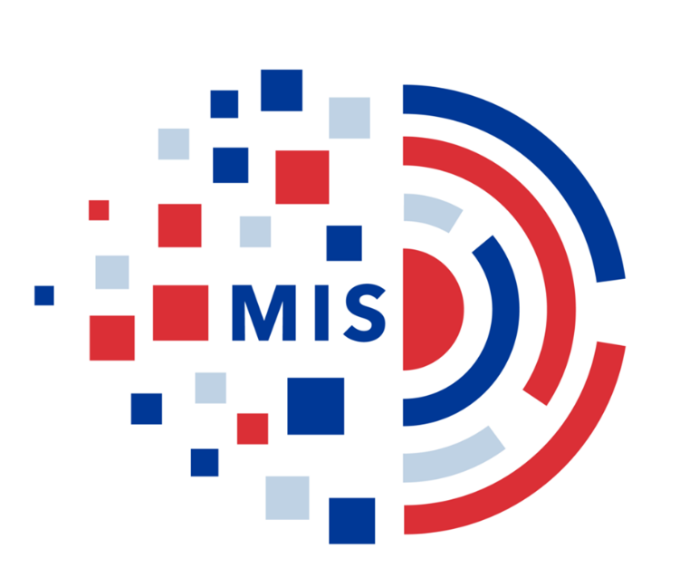
Page 2.. Introduction
Page 3.. Marketing Information Systems, Best Western description
Page 4.. Best Westerns business overall, BWVRE, Best Western use of Marketing Information System.
Page 5.. Conclude Best Westerns’ use of Marketing Information System, conclusion, references.

Introduction
This assignment will analyse Marketing Information System (MIS) and highlight its techniques use in almost every company in the modern-day. Acquired from guru99.com it explains that MIS is a collection of information obtained from people, data, business procedures, hardware and software to be used in organization’s day to day operation. This helps with decision making and recording all transactions that the business makes. MIS systems make it simpler to communicate information about the business to their employees and assists in communicating to customers and suppliers. It is said that the first-time MIS was used in 1967 by Cox and Good, but the first-time computers were tired in marketing was 1966 by Kotlerin. Marketing Nerve System which is the name of the original marketing systems applied by Kotler as he describes how a company can benefit from using a computer system for helping their marketing activities (Kotler P 1966). Without the actions of these pioneers most of the general systems used in marketing today might not be as advance as if it was not for their ideas. A business which has used the advancements of technology to advertise their services to customers is Best Western. They provide a virtual reality tour for over 2200 of their hotels across North American and with this it gives the customers a try before you buy scheme like none other at Best Western’s competitive position. Because of this marketing decision, it put Best Western in the top 10 world’s Most Innovative Companies by Fast Company in 2018.
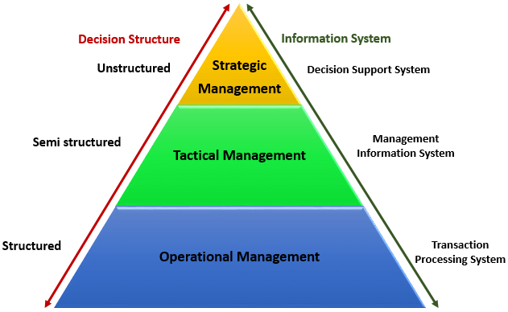
Side Note
A diagram taking from guru99.com gives an example of an information system structure that one might look to depending on their level within the business.
The structure is categories into 3 segments:
- Transaction Processing System (TPS) is every transaction of the business for example point of sale (POS) system records daily sales. Making it structured.
- Management Information System (MIS) assists tactic managers to form semi-structured decisions from the recordings of the transactions processing system.
- Decision Support System (DSS) only used by higher level managers to create semi-structured decisions. Data gained from MIS is transferred to DSS along with other sources such as competitors, current market forces etc.
Marketing Information System
Why do companies use MIS?
- It gives them accurate information on current movements.
- Shows the business what their actual or potential customers demand.
- Can lead to better quality and productivity, giving the customers a better service and reliability.
- Help provide daily activities and manages companies’ decision making.
How do companies implement MIS?
- Collected data from their customers through transactions, feedback and suggestions.
- Researching the current market and their competitor’s strategies.
- Display marketing messages, price slashing, environmental factors and promotional offers are all examples of how to push sales.
In the hospitality industry a business will need to use MIS to predict where their customer forecast is, as this will be their biggest point of sale. Taking advantage of seasonal changes, upcoming events and national or international holidays with promotions and offers can lead to increase in revenue.
Best Western Hotels and Resorts
According to worldatlas.com Best Western Hotels and Resorts is ranked 7th in The Largest Hotel Chains In The World with Best Western International considered the fastest going chains in Asia and the Middle East along with its $6billion (£4.7 billion) revenue in 2012.
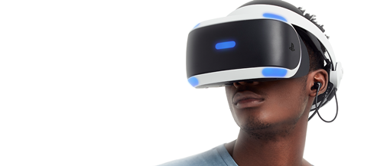
Best Western Virtual Reality Experience (BWVRE) has grasped its customers imagination and giving them a visual tour for what to expect when staying in any of their 2200 plus hotels in North America. Picking the right hotel isn’t always an easy task and then for the guest to imagine what their overall stay will be, can restrict their options. The VR tours includes music or narrative over a 3D video of the rooms, front desk, lounge areas, available facilities, restaurants and the exterior. The videos durations vary between 50 seconds to 2 minutes long and can only be viewed on platforms that are supported HTML5 such as Youtube, Google Maps and Facebook. A statement taking from bestwestern.com “Best Western is a first-mover in this effort, and we know our guests and our hotels will benefit from this game-changing technology.” by Chief Marketing Officer (Dorothy Dowling) and Senior Vice President of Best Western Hotels & Resorts. An article taken from marketingweek.com by Thomas Hobbs in 2015 says the chain has undergone a major rebranding and has inspired to move into the luxury sector taking the idea off LIDL in their focus to knock off its budget perception.
What are Best Western doing?
They have been implementing the use of MIS excessively for the pass two year, developing their hotels in North America by funding $2billion into property improvements and renovations. The company’s collective data and research showed it was either the decision of their North Americas hotels being the most profitable or the most loss-making. This has given them a more attractive look providing the customers with more intention to stay at their resorts. Showing demonstration of magnificent understanding of the market and how to utilise MIS.
How is the use of BWVRE effective?
By Best Western using these VR tours can identify some characteristics of potential customers giving them information to use in marketing and advertising. Analysing video views to transactions spent on the same hotel will give an estimated recording at how successful the BWVRE is working. Obtaining feedback from videos to visits can show how accurate the VR tours are or give recognition for enhancement.
Best Western’s use of MIS.
These are the main marketing and operational strategies Best Westerns use to
- Best Western Reservations Network and eCommerce leads the way through a wide range of efficient distribution channels to touch, connect and book customers 24/7.
- Best Western Reward Loyalty Program explores the revenue-driving potential of Best Western rewards, one of the industry’s quickest sprending loyalty programmes for consumers.
- Through regional campaigns and high-profile alliances to comprehensive on-site marketing, there promotional efforts are focused on increasing a global brand’s ability to deliver revenue to member-owners.
- Worldwide marketing, Best Western hires one of the most proactive and creative sales team in the industry on a mission to channel the revenue from business, community and leisure travel to member hotels around the world.
- Hotel operations support to help build the company and ROI (Return on Investment), every Best Western member-owner provides committed operational personnel experience, tactical Resources and state of the art technology.
A quote from bestwesterndeveploers.com phrases behind every Best Western branded hotel is a powerful business engine that is always running the power of their enormous global network to maximise revenue delivery, capitalise on new opportunities, and promote hotel development to improve the earning potential of their member-owners.

Is the use of MIS effective within Best Western?
Best Western uses a vary of methods to communicate, gather information and market their business to succeed in securing the highest possible satisfaction from their customers along with a most profitable revenue. Discussed in this report there are many effective strategies that Best Western are using such as technology advancements, competing in the luxury hotel market and improving the face of the company. Best Western aims to bring an abundance of hotels and resorts all over the globe.
Conclusion
Marketing Information system give a company vast amount of research and information to exploit, giving them a great advantage over their competitors if in place there is an expert team and advance systems. Best Western is one of the top five hotel chains in the world and with the understanding of MIS as well as evolving their company to meet needs of customers shows why they are dominating the market. Gupta(2012) mentions that in general, the information system could be characterised as a collection of interconnected components that work together to gather, process, store and retrieve data and distribute information in order to facilitate the preparation, control, coordination and evaluation of the decision-making process within the business.
References
Books
Gupta, A. (2012). An overview of information technology in tourism industry. International Journal Applied Services Marketing, 1 (1)
Kotler, P. (1966). A design for the firm's marketing nerve center. Business Horizons, 9, 63-74.
Websites
Anon, (2019). [online] Available at: https://www.bestwestern.com/en_US/about/press-media/2016-press-releases/bw-launches-vr-tours.html [Accessed 11 Dec. 2019].
Bestwesterndevelopers.com. (2019). Best Western Development Support | Hotel Development Support. [online] Available at: https://www.bestwesterndevelopers.com/marketing-and-operations/ [Accessed 11 Dec. 2019].
Chepkemoi, J. (2019). The Largest Hotel Chains in the World. [online] WorldAtlas. Available at: https://www.worldatlas.com/articles/the-largest-hotel-chains-in-the-world.html [Accessed 28 Nov. 2019].
Guru99.com. (2019). [online] Available at: https://www.guru99.com/mis-definition.html [Accessed 20 Nov. 2019].
Hobbs, T. (2019). Best Western wants to follow Lidl’s example as it aims to shake off ‘budget perception’ – Marketing Week. [online] Marketing Week. Available at: https://www.marketingweek.com/best-western-wants-to-follow-lidls-example-as-it-aims-to-shake-off-budget-perception/ [Accessed 11 Dec. 2019]

