University of Wales Trinity Saint David

Student name: Sorin Cristian Tudor
Student ID: 1815536
Module Title: M4X01916 Marketing Essentials
Assignment title: Analysing how important is MIS, in hospitality and tourism industry.
Module Lecturer’s name: Jahanzeeb Qurashi

Table of Contents
University of Wales Trinity Saint David 1
INTRODUCTION 3
DISCUSSION/EVALUATION 3
1. Identifying how the company is using MIS and its components 3
Internal record system 4
Marketing Intelligence system 4
Marketing research system 5
Marketing models 5
2. Evaluation of the effectiveness of the use of MIS 5
Essential requisites of an effective MIS 6
3. Is it effective or not 7
CONCLUSION 7
REFERENCES 8

INTRODUCTION
Marketing information system is an effective tool in marketing that collects, process, store and disseminate the data in the collective form of information needed to carry out the functions of management. There are four major components of MIS; Internal records, Marketing intelligence system, Marketing research, Marketing decision support system. All the components are
interrelated and interdependent. The study of marketing essential is based on Thomas Cook. Company is a renowned brand in the marketplace and implies the MIS system and the components effectively. The essay will aim to identify that how the company is using MIS and will critical analyse its key elements.

DISCUSSION/EVALUATION
Thomas Cooks is a multinational travel and Tourism company. The information system in the industry collects data from external and internal sources of market (Gentile and et. al., 2017). Marketing manager collects the data and marketing decision maker of Thomas Cook use the gathered data to identify and solve marketing related issues. The area served by the company is very wide population wise and service wise, the requirements of consumers may differ from person to person, for that purpose, organisation implies MIS system in the marketing activity to understand the need of market.
The components of MIS are categorised in four major parts that used by Thomas Cook in its marketing activities.
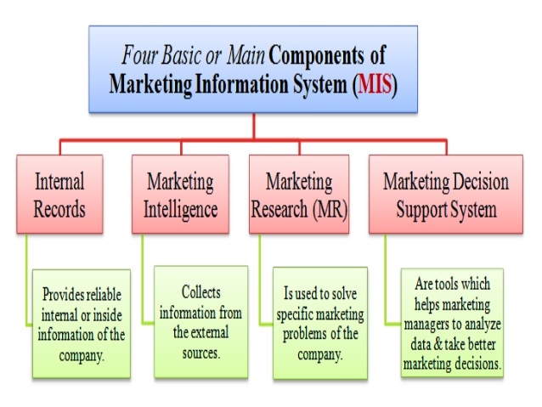Fig 1: Component of MIS
(Reference:Marketing Information System, 2018)

This is the very first component of MIS system that is use by the Marketing Manager of Thomas Cook to gather information regarding the performance of each member. The internal record system enables marketing manager of the industry evaluate information about the sales, inventories, costs, service quality, on time services, etc. It helps the company to keep an eye on what is going on inside the business structure (Jovanović, 2016).
This also use by the company as a marketing tool as the gathered information from within the company use by the marketing manager to evaluate marketing performance and to detect issues in marketing and available opportunities.

Marketing Intelligence system
The marketing intelligence system use by Thomas Cook to deal with cost of running a marketing department and the organisation as whole. The aim of this components is to gather information from external sources. This help the marketer to gather information regarding the current marketing environment and changing situations in the marketplace (Li et. al., 2017). After the gather information, marketing manager communicate this with the sales department, production department, service department of the industry to evaluate and arrange the information in proper order and then finally use by the marketing manager to take the decisions and make policies regarding marketing.

Marketing research system
Marketing manager of Thomas Cook conducts marketing research that allow them to find out what their consumers think of the current trends and understand what their views on certain items (Mishulin et. al., 2016). This uses by the industry to understand the gap between market and services. Marketing manager use this component and gather quantitative information through survey by personal observation, telephone, etc. and gather qualitative information from projective test and focus group. After collecting all the data, recommendation is given by the top management people in the organisation for solving the problem

Marketing models
This component utilised by the industry to analyse data and to take better decisions. They implement a computer hardware and software programmes that help the marketing manager to analyse marketing information. There are many software programmes that help the marketing manager of Thomas Cook to segment the market, fix pricing and in advertising budget. This model use by the company to get direction regarding marketing decision (Rowley, 2016). Thomas Cook use time series sales model, Linear programming, etc.
The marketing manager categorised the level of decision making that supports by marketing information system;
- Strategic decision
- Control decision
- Operational decision

The marketing information system is effective for Thomas Cook in their marketing activity and to evaluate the promotional efficiency. It has been analysed that it helps the company to understand the need and wants of their potential consumers and assist them to take appropriate decisions. The MIS system appears as an effective system for Thomas Cook because marketing information system present all the gathered data in terms of facts, opinions, views, guidelines and policies that are necessary to make crucial marketing decisions (Marketing Information System– Definition, Components and Applications, 2018). The data collected from consumers, competitors, sales force of the company, etc.
Effectiveness of the MIS system can be evaluated by understanding the benefits it provides to Thomas Cook. Following are some advantages of MIS system;
- Recognise change: MIS help marketing manager of Thomas Cook to understand the change in marketplace. Thomas Cook may be handling or marketing a wrong line of products that make them unable to make profits. It has been stated that a business that is well equipped with MIS will able to realise that they are required to change the line of business.
- Quality decision making: In every part of marketing, there is a requirement to make constant and accurate decisions. Properly designed marketing information system effectively supplies reliable and related information to the marketing manager of Thomas Cook (Gentile and et. al., 2017). By using computer and other data processing equipment’s, marketing manager can make appropriate decisions at the right time.
- Provide marketing intelligence: With the use of marketing intelligence, marketing manager of Thomas Cook observe what is happening in the external environment such as; change in consumer taste, international environment in hospitality and tourism industry, government policies, etc. and with the help of MIS specialist, it is possible for the industry to gather marketing intelligence that is essential to make effective marketing decisions (Jovanović, 2016).
- Monitor market: MIS help the marketing manager of Thomas Cook to understand the current market trend that can be in respect of product design, price, packaging, marketing, etc. It helps manager to take effective decisions in all the elements of current market trend.

MIS must be unified and centralised, and all the gathered information also required to be unified and centralised. MIS must facilitate marketing manager of Thomas Cook in decision making as well as effective MIS must not be very costly that affect the operating cost of an industry. It should be economical (Li et. al., 2017). The marketing information system must able to use new techniques to gather, analyse, store and supply information. The company will be successful if their marketing manager are future oriented as well as the information system too.

It is effective for Thomas Cook. The market research provides current trend and opportunities to the company that is required to address need and want of the market and accordingly marketing manager take decisions and plan to grab the marketing opportunities. The effective use of MIS system enable company to manage all the promotional tool for the tourism services, hospitality services, it provides the foundation for developing information system and e-commerce strategies (Mishulin et. al., 2016). As the system help in recognising the current market trend, manager at all the level and in all the departments of Thomas Cook cooperate and coordinate with each other and make required changes in their promotional schemes, prices of services, etc.

A problem analysed through marketing information system in Thomas Cook such as; brand positioning for that the solution has been analysed and considered by the marketing manager is that they are require new global marketing campaign. The worldwide campaign brought back the roots of Thomas Cook (Gentile et. al., 2017).
For example; the marketing manager evaluate by gathering external sources that trend of the brand is changing in hospitality and tourism industry such as; smart device supported check-in and check-out facility, on-air services, etc. The industry implements computer-based data storing and managing the information regarding market, consumers, competitors that used by all the level of management for marketing plans, policies and strategies (Rowley, 2016).
CONCLUSION
From the present study it has been summarised that MIS plays an essential role in marketing activity of hospitality and travel industry. It is important factor in growth of business as it helped the company in make marketing decisions for increased competition and environmental changes that affect the consumers. It has been analysed as life blood of marketing in the industry. It is becoming essential for the marketing manager to have up-to-date information to carry out its tasks. The computer-based MIS is more effective as the data can be store for long term safely that help the company understand what information they gather in the past.

REFERENCES
Gentile, C. and et. al., 2017. Method and system for retrieving information using serialized scannable codes.

Jovanović, V., 2016. The application of GIS and its components in tourism. Yugoslav Journal of Operations Research. 18(2).
Laudon, K. C. and Laudon, J. P., 2016. Management information system. Pearson Education India.
Li, Y. and et. al., 2017. The concept of smart tourism in the context of tourism information services. Tourism Management. 58. pp.293-300.
Mishulin, G. M. and et. al., 2016. Integrated Marketing Information and Communication System: New Quality of the Communication Interaction. International Review of Management and Marketing. 6(6S).
Rowley, J., 2016. Information marketing. Routledge.
Marketing Information System– Definition, Components and Applications. 2018. [Online]. Available Thorugh:<https://datasagar.com/2018/01/14/marketing-information-systemmkis-definition-components-and-applications/>.(Accessed: 21 April 2019).

