1/7/2020
Viorel Melinteanu (1815993)

An Analysis into the Decline of Ford
A Report for Ford Motor Company

UNIVERSITY OF WALES TRINITY SAINT DAVID

Executive Summary
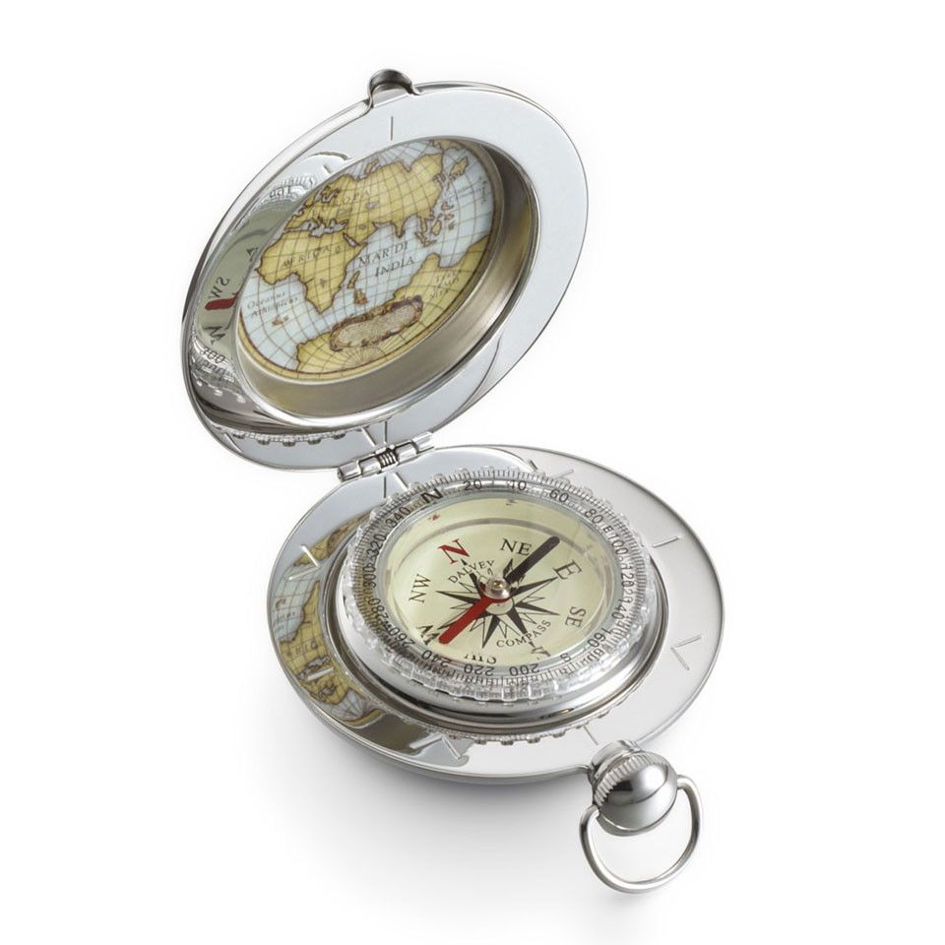
Problems in companies happen all the time, often things can go wrong and managers can missed many opportunities. Melinteanu Consultancy LTD is an experienced company that offers personalized and precise solutions for their clients in order to anticipate, prevent, identify and fix the problems they face.
Ford Motor Company is struggling with earnings over Wall Street.
This document analysis the root of the issues and offers the steps to be followed to minimize the impact, to turn the decline into growth, to increase profits and the welfare of the business.

Table of Contents
Executive Summary 1
1.0 Introduction 3
2.0 Findings 4
2.1 About Ford Motor Company 4
2.2 Problems that Ford Motor Company faces 5
2.3 SWOT Analysis of Ford Motor Company 7
2.4 PESTEL Analysis 9
Political Factors 9
Economic Factors 9
Social Factors 10
Tehnological Factors 10
Environmental Factors 10
Legal Factors 10
3.0 Conclusion 11
3.1 Main concerns 11
4.0 Options 12
5.0 Action Plan 13
6.0 Appendices 15
7.0 Acknowledgements 16

1.0 Introduction

The current report provides an analysis of the problems that the Ford Motor Company faces based on the case study. The Ford Motor Company is also analysed using the analytical tools like SWOT and PESTEL. The report includes strategies that Ford Motor Company could follow for the next years.
The present document was requested by Maria Heffernan for Ford Motor Company at 2nd November 2019.
Melinteanu Consultancy LTD realised the report and provided to beneficiary at 7th January 2020.
In the elaboration of the report, all the factors present in the case study were considered. In order to establish a clearer picture of the difficult situation faced by Ford, various sources of information such as newspapers and electronic journals like Sky News, Reuters, BBC, CNBC, News18, Forbes, The Guardian and many more have been used. In addition, official statements published on the Ford site or their partners, as well as on the European Union site, were analyzed.

2.0 Findings

2.1 About Ford Motor Company
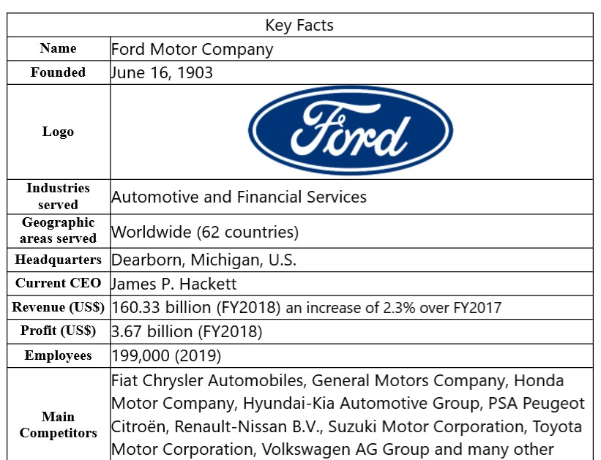
The Ford Motor Company, founded by Henry Ford in 1903, has revolutionized the industry repeatedly. It is probably one of the best-known car brands in the world and as a symbol of American innovation, as part of US top car manufacturers. The company produces and distributes vehicles on six continents.

2.1.1 History of Ford
Ford Motor Company (2019) shares a part of their 100 years history.
The first Ford car was built in the Mack Avenue facility in July 1903, following the formation of the Ford Motor Company. The successful Model T was introduced five years later, in 1908. Due to the rapid development, Ford has introduced new mass production methods. The development of the company continued with the opening of the first branch in Kansas City, Missouri in 1911 and with the first factory abroad in Manchester, England.
Through 1923, the company produced over half of the American automobiles. By the late 1920s, Ford had more than 20 overseas assembly plants in Europe, Latin America, Canada, Asia, South Africa and Australia.
Ford had purchased the Lincoln Motor Company in 1922 that would produce the Lincolns and Continentals comfort of Ford.
The Ford Motor Company began limited diversification in the 1950’s and 1960’s, but by the 1990’s it had concentrated on its automotive and financial services.
Between 1990 and 2000, Ford purchased the Jaguar, Aston Martin, Volvo, Land Rover, and part of Mazda. The problems that arose in the following years caused Ford to give up these acquisitions.
The dynamics of the automotive industry makes Ford focus on electric and autonomous cars, give up some models and keep only the profitable part of the business.

2.1.2 What products does it offers
The Company operates in four segments: Automotive, financial services by Ford Motor Credit, Ford Smart Mobility LLC and Central Treasury Operations. It pursues positions of leadership in electrification, autonomous vehicles and strategies for mobility as well.

2.2 Problems that Ford Motor Company faces
Analysing the case study, it can be easily seen that Ford Motor Company is struggling with earnings over Wall Street. Investors consider that Chief Executive Officer Jim Hackett takes decisions in slow motion. He is the man that supposed to make things running fast, to develop strategies and make decisive decisions. In response to his hesitations, despite the $ 11 billion restructuring promises, earnings fell about 27 percent to $ 7 Billion and shares lose value.

2.2.1 Where the problems come from
The decline of a company like Ford cannot come from a single problem. A detailed analysis reveals different roots of the issues.

2.2.2 Identification (Nature)
Talking about the FY2018, James P. Hackett, CEO of Ford, says
‘it was a challenging year, in that we were hit by some headwinds outside of our control and, frankly, poor performance in some parts of the business’. (Motley Fool Transcription, 2019)
That means Ford faces two types of issues: externals and uncontrollable and internals.

Classification
Strategic problems: Increasing rentability by redesign the business in a more sustainable and profitable way. This is possible with higher-performance products and services, innovation in production plants, orientating offer according the market needs and trends. As their motto says: ‘Go Further’.

Operational problems: Fees, negative currency exchange rates, consequences related to Brexit, raw material costs are included here.
A major problem that Ford faces is lower sales on the Chinese market.
Jim Farley, Executive Vice President for Global Markets told that shortcomings for that are ‘dealership profitability, excess inventory and a lack of a fresh lineup of new vehicles’ (CNBC, 2019)
The same downward trend can also be seen in India, where in August 2019, Ford India reported a 31.4% decrease. (News18, 2019)
We can say that this is a diversion problem as sales continue to fall despite new models recently introduced on the market.
Hackett points the new direction: ‘We’re going to feed the healthy part of our business and deal decisively with the areas that destroy value.’ (Schoenberger, 2018)
Ford reworks its line of products-ups around the world and concentrates only on producing its most successful products. This generates consequences like:
- Closure of engine plant in Bridgend, south Wales
- Closure of engine plant in Romeo, Michigan (Shepardson, 2019)
- Shut down Brazil's oldest plant (Reuters, 2019)
- Reducing production costs through layoffs
- Reducing the range of cars for classic markets

2.2.3 Scope
The Guardian (2019) said Ford has confirmed that it will be shutting its Bridgend engine plant in September 2020 with the loss of 1,700 jobs.
BBC (2019) has reported that by the end of 2020, Ford plans to cut about 12,000 jobs throughout its European operations.
Reuters announced that Ford Motor Company is cutting around 450 jobs at its Oakville assembly plant in Ontario, Canada. (Reuters, 2019)
Spending related to recalls of vehicles with defective equipment were recorded.

2.2.4 Impact
The carmaker tries to reduce costs and restructure their operations in the areas where is losing money. This strategy involves drastic measures with a strong impact on local communities, such as closing factories and reducing staff. The effect of these decisions is on the employees, their families, the partners that complete the economic chain and the whole society. Before every jobs cut, the company have to meet to the same table works councils, trade unions and government representatives in order to provide the best support and to find optimum solutions.

2.3 SWOT Analysis of Ford Motor Company

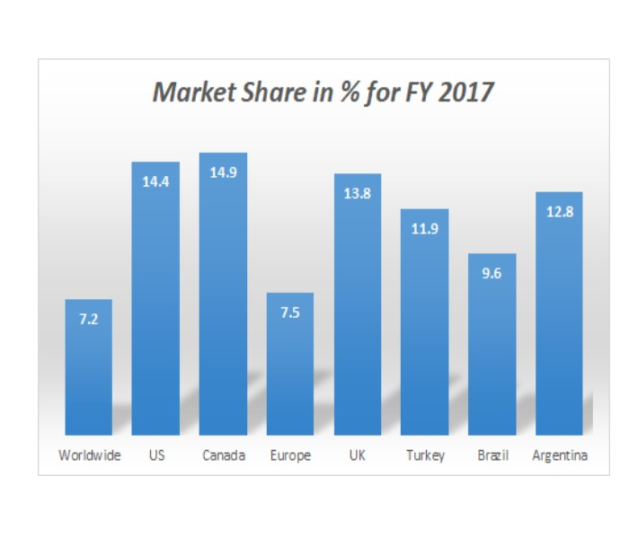

2.4 PESTEL Analysis

PESTEL analysis on Ford reveals the environment in which the company operates, clarifying the factors that led to the existing situation.

Political Factors
There are some concerns on the UK market, after Brexit, if a no-deal disruptive UK exit from the EU will occur, of what would happen to car prices and sales.

Economic Factors
According CNBC (2019) sales fell by 37% in 2018, following a 6% fall in 2017.
In China, Ford's sales fell 35.8% in the first quarter and 21.7% in the second quarter. In the third quarter, the automotive company lost 37.7 %, while its luxurious Lincoln division fall by 24.1 %. During the next five years, the automaker plans to introduce more than 50 new models, including electric cars.
The loss generated by the South American business amounts to 678 million US dollars. In response, Ford has reduced costs with wages with more than 20% and this year in São Bernardo do Campo in Brazil, they will stop production. (Miller, 2019) The causes that led to these losses were the monetary devaluation and the unfavorable exchange rates.
Rising prices for raw materials like aluminium and steel costs Ford over 1.8 billion in 2018.
Shanks CFO of Ford reported the cost of nearly $750 million, as a direct result of Trump's tariffs.
Expenses related to recall in service of vehicles equipped with defective airbag inflators made by Japanese supplier Takata raise up to $775 million. (Rosevear, 2019)

Social Factors
People increased interest on high quality, clean, safe, interactive, smart and economic vehicles.

Tehnological Factors
The Ford Motor Company and Volkswagen will invest about $7 billion in the Argo AI platform, the autonomous vehicle technology company based in Pittsburgh, a development that gives every car maker the ability to independently incorporate the self-driving technology into the cars they are expected to build in the US and Europe. (Chanthadavong, 2019)
At the Frankfurt Motor Show, Ford Motor Company made its debut a series of new electrified vehicle models and the ' Go Electric ' concept. (The Drum, 2019)

Environmental Factors
Diesel cars continued to lose popularity with consumers, while sales of petrol vehicles and alternatively powered cars increased.
The auto market pays more attention to the products with low CO2 emissions, fuel consumption, reducing the impact on climate change.

Legal Factors
On February 1, 2019, the strategic partnership signed between the European Union and Japan entered into force, eliminating customs duties for a wide range of products including cars. This gives the competition an advantage. (European Commission, 2019)
Council of the European Union updated new standards for CO2 emission targets for new cars and light-commercial vehicles that will apply from 2021 in the European Union. In addition, The European Parliament adopted a resolution on autonomous mobility in the European transport.

3.0 Conclusion

Ford Motor Company, which has made the planet more mobile and brought cars closer to the mass market, will continue to innovate the auto industry. But they need to find the perfect balance between quick financial results and sustainable solutions for a long term business.

3.1 Main concerns

Considering that Ford is a global company, the analysis of problems must be structured by region.
For US market, Ford must fill the gap produced by the withdrawal of sedan models.
In Europe, they must focus on high quality products, fuel-efficient, high level in performance and safety, in line with EU standards and customer requirements.
For the Asia Pacific region, the goal is to diversify the range of new models, develop a network of performance-oriented distributors and reduce the existing stocks.

4.0 Options

In a fast moving industry with high competition, there is no room for mistakes. The only viable option is the right one. The company must develop a strategy that results in increased sales.
This strategy must follow several steps:
- to understand and accept that it is going through a critical period that can lead to disastrous consequences
- to recognize that there is a need of change
- to find motivation for adopting new ideas
- to communicate inside and outside the company the changes to be made in order to provide transparency, to ensure control and safety as a result of changes. The movements are designed to speed up the return of Ford to profitable growth
- to associate the own brands with highly motivating values such as safety, high-performance, technology, ecological friendly, local produced vehicles
- to explore new developing areas like its own network of taxis with or without human drivers, pushing the company into a new transportation age
Source: https://www.insidercarnews.com/wp-content/uploads/2019/04/autonomous-Ford-Fusion.jpg
- to produce in the place where it sells, in order to avoid the costs of import duties on raw materials and export of finished products, in addition, avoiding the closure of some production plants and their impact.

5.0 Action Plan

The company will redesign classic models with high sales over time, adapting them to current market requirements.
The models are:
  - Ford Mustang and the F series for the American market,
  - Ford Focus, Escort, Mondeo, Explorer(Kuga), Mustang for Europe and Asia Pacific with specific design for each interest areas
  - Lincoln Continental, Navigator, Nautilus and Navigator for China
All new vehicles will be powered exclusively by electric motors.


Source: https://www.ford.com/suvs/mach-e/2021/

6.0 Appendices

6.1 SWOT Analysis on Ford Motor Company

6.2 Implementation of decisions

Announcement of the new model

Introduction of the new electric F-150
Advertising
Sets the sales and revenue target

Have you reached the motivational goal?
No
Launch the new Ford F-150

Yes

Have you reached the revenues goal?
Monitors the value of sales
Modify the sales strategy
No
Sets new target
Yes
Continue selling, monitor the purchase motivation and launch a new model

6.3 Monitoring, Reviewing and Communicating Decision
Decision implemented: Introduction of the new electric F-150

Monitoring the decision:
Resources: Database files collected from own sources and partner companies

Key Indicators:
- Customer information
- Customer preferences
- Market preferences
- Accounting data

Targets:
- sales increase by 20% in 12 months

Data Sources:
- internal
- external (from business partners)

Reviewing the decision:
The following parameters are monitored in each area of interest:
- customers
- preferences and options
- pre-orders / orders
- revenues
- buying methods

The dynamics of these indicators dictate the direction and volume of the business

Communicating the Decision:
Internal Stakeholders  - direct meetings  - video conferencing  - internal releases | External Stakeholders  - direct meetings  - Press Releases  - auto shows

7.0 Acknowledgements

I would like to express my special thanks to my lecturer Maria Heffernan for giving me the support to do this project on the topic 'An Analysis into the Decline of Ford', she also helped me in doing a lot of Research and to learn about so many new things.
Secondly, I would also like to thank my family for their patience and understanding, helping me to accomplish this project within the requested time.

8.0 References

- BBC (2019) ‘Ford to cut 12,000 jobs in Europe’, 247th Jun, Available at: https://www.bbc.co.uk/news/business-48787165 (Accessed: 11th Dec 2019)

- Brand Finance (2019) Global 500 2019 - The annual report on the world’s most valuable and strongest brands. Available at: https://brandfinance.com/images/upload/global_500_2019_free.pdf (Accessed: 17th Nov 2019).

- Chanthadavong, A. (2019) ‘Volkswagen and Ford join forces in $7b Argo AI alliance deal’, ZDNet, 15th Jul, Available at: https://www.zdnet.com/article/volkswagen-and-ford-join-forces-in-7b-argo-ai-alliance-deal/ (Accessed: 3rd Nov 2019)

- CNBC (2019) ‘Ford issues 3 recalls covering about 1.5 million Ford and Lincoln vehicles, some over potential whiplash concerns’, 13th Feb, Available at: https://www.cnbc.com/2019/02/13/ford-issues-3-recalls-covering-nearly-1point5-million-vehicles.html (Accessed: 17th Nov 2019).

- CNBC (2019) ‘Ford’s China sales decline again despite new models’, 11th Oct, Available at: https://www.cnbc.com/2019/10/11/fords-china-sales-decline-again-despite-new-models.html (Accessed: 4th Nov 2019)

- European Commission (2019) ‘ Acordul comercial UE-Japonia, în vigoare din 2019!’, Available at: https://ec.europa.eu/romania/news/20181213_adoptare_acord_comercial_ue_japonia_in_vigoare_din_2019_ro (Accessed: 20th Nov 2019)

- Ferris, R. (2019) ‘Ford’s 5 big fixes for its troubled international business’, CNBC, 24th Jan, Available at: https://www.cnbc.com/2019/01/24/fords-5-big-fixes-for-its-troubled-international-business.html (Accessed: 19th Nov 2019)

- Forbes (2019) The World’s Most Valuable Brands. Available at: https://www.forbes.com/powerful-brands/list/#tab:rank (Accessed: 17th Nov 2019)

- Ford Motor Company (2019) Company Timeline. Available at: https://corporate.ford.com/history.html (Accessed: 21st Nov 2019)

- MarketLine (2019) Company Profile – Ford Motor Company. Available at: https://web-a-ebscohost-com.ezproxy.uwtsd.ac.uk/ehost/pdfviewer/pdfviewer?vid=2&sid=b5abf48a-3218-4f47-9f58-8ac6ccf97c2d%40sessionmgr4006 (Accessed: 14th Nov 2019).

- Marketing Tour (2019) Ford SWOT Analysis. Available at: https://www.marketingtutor.net/ford-swot-analysis/ (Accessed: 18th Nov 2019).

- Miller. D (2019) ‘Where Ford Is Failing, and What It's Doing About It’ - The Moolei Fool, 25th Feb, Available at: https://www.fool.com/investing/2019/02/25/where-ford-is-failing-and-what-its-doing-about-it.aspx (Accessed: 20th Nov 2019)

- Motley Fool Transcription (2019) ‘Ford Motor Company (F) Q4 2018 Earnings Conference Call Transcript’, 11th Apr, Available at: https://www.fool.com/earnings/call-transcripts/2019/01/23/ford-motor-company-f-q4-2018-earnings-conference-c.aspx (Accessed: 5th Nov 2019).

- News18 (2019) ‘Ford India Registers a Year-on-Year Decline of 31.4 Percent in August 2019’, 2nd Sep, Available at: https://www.news18.com/news/auto/ford-india-registers-a-year-on-year-decline-of-31-4-percent-in-august-2019-2293511.html (Accessed: 3rd Nov 2019)

- Reuters (2019) ‘Ford shutters oldest Brazil plant as revival bid faces doubts’ 30th Oct, Available at: https://www.reuters.com/article/us-ford-brazil/ford-shutters-oldest-brazil-plant-as-revival-bid-faces-doubts-idUSKBN1X92LW (Accessed: 8th Nov 2019)

- Reuters (2019) ‘Ford to cut 450 jobs at Canada plant on Flex, Lincoln MKT production halt’, 28th Oct, Available at: https://www.reuters.com/article/us-ford-motor-layoffs/ford-to-cut-450-jobs-at-canada-plant-on-flex-lincoln-mkt-production-halt-idUSKBN1X720H (Accessed: 20th Nov 2019)

- Rosevear, J (2019) ‘Why Ford Motor Company's Earnings Fell in 2018’ The Motley Fool, 29th Jan, Available at: https://www.fool.com/investing/2019/01/29/why-ford-motor-companys-earnings-fell-in-2018.aspx (Accessed: 20th Nov 2019)

- Shepardson, D. (2019) ‘Ford plans to close engine plant in Michigan as part of UAW deal’ Reuters, 31st Oct, Available at: https://www.reuters.com/article/us-usa-autos-labor/ford-plans-to-close-engine-plant-in-michigan-as-part-of-uaw-deal-idUSKBN1XA2BS (Accessed: 8th Nov 2019)

- Schoenberger, R. (2018) ‘Ford getting out of most car production by 2020’, Today’s Motor Vehicles, 27th Apr, Available at: https://www.todaysmotorvehicles.com/article/ford-exiting-car-business-042718/ (Accessed: 19th Nov 2019)

- The Drum (2019) ‘Ford: Go Electric by Imagination’, Available at: https://www.thedrum.com/creative-works/project/imagination-ford-go-electric (Accessed at: 20th Nov 2019)

- The Guardian (2019) ‘Ford to close Bridgend factory by September 2020’, 6th Jun, Available at: https://www.theguardian.com/business/2019/jun/06/ford-to-close-bridgend-factory-in-september-2020 (Accessed: 4th Nov 2019).

