
Applied Leadership and Management in the Workplace
Module Assignment Submission
Student Name: | Lisa Ann James
Student Number: | 2115847
Module No: | BMSK4012
Module Title: | Enterprise and Intrapreneurship

Statement of Confirmation of Authenticity
By the act of making this submission, the student declares that this is the work of the student named above. The work has not, in whole or in part, been knowingly presented elsewhere for assessment, or where assessment has been built on a previous assessment, this has been identified. Where materials have been used from other sources it has been properly acknowledged. If this statement is untrue, the student acknowledges that an assessment offence has been committed.
Attention is drawn to the plagiarism and unfair practice policies of both the University and of ILM.

Table of Contents

Executive Summary 2
Introduction 2
Market and Competitors 3
Sales and Marketing Strategy 9
Operational Details Breakdown 16
Market Research 20
References 21

Executive Summary
Percy the Pilgrim: A Heartfelt Fusion of Vintage Event Hire and Celebrancy Services
Business Plan Overview
Percy the Pilgrim is an imaginative dual-service business that seamlessly blends vintage event transport with bespoke celebrant-led ceremonies. At its core is a lovingly restored 1964 VW Split Screen Campervan Percy serving as both a striking centrepiece for milestone events and a vehicle for meaningful moments.
Founded and operated by Lisa James, an emotionally intelligent and creatively driven finance professional, the venture leverages her deep understanding of motivation theory, branding, and customer experience to offer something truly distinctive: a journey that celebrates life in motion and memory.
Structured as a sole proprietorship, Percy the Pilgrim prioritises simplicity, autonomy, and reinvestment. All profits are reinvested in expanding the vintage VW fleet, transforming a personal dream into a rolling celebration collective. The plan will include market positioning, focusing on clients seeking nostalgic charm, heartfelt ceremonies, and immersive event experiences. Operational strategy, solo ownership, phased fleet expansion, and curated packages combining transport and celebrancy. Financial projections, sustainable startup costing, manageable overheads, and scalable revenue streams. Marketing approach, emotion-led storytelling, strong branding, and targeted outreach to wedding, prom, and life-event audiences. With emotional resonance at its heart and strategic clarity in its foundation, Percy the Pilgrim is poised not just to grow but to leave an unforgettable trail of joy wherever it travels.

Introduction
Percy the Pilgrim is a thoughtfully curated dual-service venture, born from a passion for vintage charm and meaningful connection. The business idea centres on providing nostalgic event transport using a classic 1964 VW Split Screen Campervan, paired with bespoke celebrant-led ceremonies that bring heart, story, and atmosphere to life’s most treasured milestones.
Launched by Lisa James, an experienced Senior Finance Assistant with a strong foundation in communication theory, emotional intelligence, and strategic business insight, the enterprise reflects her vision to combine her operational strengths with her creative and affiliative talents. The venture is designed to serve weddings, proms, civil ceremonies, vow renewals, and other life-defining events through a lens of inclusivity, elegance, and personal storytelling.

Legally registered as a sole trader business (GOV.UK, 2025), Percy the Pilgrim offers Lisa full autonomy and flexibility in shaping the brand and service offerings. This structure allows for straightforward financial management and reinvestment, supporting her long-term goal to expand the vintage VW fleet and grow a celebrant collective aligned with her values of joy, authenticity, and emotional resonance.
The product/service offering includes:
- Vintage VW Event Hire: Stylish, nostalgic transport for milestone celebrations, featuring the iconic Percy campervan.
- Celebrant Services: Tailored ceremonies delivered with empathy, warmth, and creative flair, reflecting clients’ unique journeys and values.
Percy the Pilgrim is more than a business; it’s a soulful experience on wheels, designed to honour life’s chapters with grace, colour, and connection.
Future Owner/Management team details
Percy the Pilgrim will eventually become ‘Percy the Pilgrim and Friends,’ founded as a sole trader business, with Lisa at the helm as celebrant, creative lead, and fleet owner. The initial management structure focuses on establishing an average wage to facilitate reinvestment and gradual growth. Plans include expanding the vehicle fleet, beginning with the acquisition of a vintage VW Beetle convertible to complement Percy, the 1964 split-screen campervan. As the business develops from a solo venture into a scaled service offering, operational strategy includes recruiting a dedicated driver with basic mechanical skills. This role will support delivery logistics, routine vehicle care, and event-day facilitation, enabling Lisa to focus on the celebrant experience and client connection. This strategic hire will ensure both the charm and reliability of the fleet are upheld, marking a shift toward collaborative growth, increased service availability, and sustained quality while preserving the brand's emotionally resonant and heart-led ethos.

Market and Competitors
Market Overview, Size and Trends
The UK wedding and celebrant services market continues to grow, driven by a rise in personalised ceremonies, vintage-themed events, and sustainable choices. Demand for unique transport options and emotionally tailored celebrations is rising, with couples and families seeking suppliers who blend aesthetics with authenticity.
Wedding Industry Value: £14 Billion+
- Valued at over £14.7 billion annually, the wedding industry in the UK presents a lucrative opportunity for emerging businesses. (liv-mstructures, 2025)
- This includes spending across venues, fashion, photography, décor, and honeymoons.
- The average UK wedding cost is now around £23,250, reflecting a shift toward more personalised and experience-rich celebrations. (Burke, 2024)

Vintage Vehicle Hire: Niche but Expanding
- While exact market size figures are limited, platforms like BookAclassic and Classic Car Hire Guild show strong national demand for vintage vehicles, especially for weddings, proms, and film shoots. (Vintage Car Hire, 2015)
- VW campervans and other character-rich vehicles are increasingly sought after for their nostalgic and aesthetic appeal, often used as photo props and storytelling elements.
Celebrancy Trends: 10,000+ Ceremonies Annually
- The UK celebrant industry is still developing, with 3,000 to 4,000 active celebrants across weddings, funerals, and naming ceremonies.
- Celebrant-led weddings are growing rapidly, with over 10,000 ceremonies annually and a 21.92% increase in global searches for celebrant weddings last year. According to the UK Society of Celebrants. (2024). Annual celebrancy insights report (Celebrant Training Courses, 2025)
- Legal reform is underway to potentially allow independent celebrants to conduct legally binding weddings in England and Wales.
Experience Economy: Emotionally Resonant Brands
- UK consumers are increasingly prioritising experiences over possessions, with spending on entertainment and travel consistently outperforming retail.
- According to 2024 research from Barclays, which surveyed 2,000 UK adults, one in four UK consumers plan to spend more on memorable experiences this summer compared to their spending last year. This figure is even higher (32%) for those aged 18–34. (Barclays, 2024)
- Brands that offer story-driven, emotionally engaging moments are thriving, especially in hospitality, weddings, and cultural events.
Market Overview & Size
While specific data on VW-only classic car hire is limited, it's part of the broader UK classic car market, which is thriving. These insights are taken from The Heritage Classic Car report of 2025 (Heritage Classic Car Insurance, 2025)
- UK classic car market turnover: £1.87 billion annually
- Classic car insurance market: £757.6 million in 2024, showing steady growth.
- Number of historic classic cars registered in the UK: Over 415,000, with a 5.8% increase from 2023
- South East & South West England: Highest concentration of classic car ownership, with Wales showing growth potential
VW campervans, especially split-screen models like the iconic Percy, are highly sought after for weddings, festivals, and nostalgic experiences, making them prime candidates for hire businesses.

Key Trends in 2025
Here’s what’s shaping the classic car hire landscape this year:
- Nostalgia-driven demand: Post-pandemic, people are craving meaningful, retro experiences—perfect for celebrant-led events and vintage transport (Market, 2023)
- Rise of electric conversions: Some classic VW owners are exploring EV retrofits to meet sustainability goals, though originality still holds strong appeal (A Guide to Understanding the Classic Car Market Trends in 2025 | Affordable Classic San Diego, 2025)
- Younger demographics entering the market: Millennials and Gen Z are increasingly drawn to classic cars for their aesthetic and experiential value (Exactitude Consultancy & Exactitude Consultancy, 2025)
- Online visibility matters: Digital platforms and social media are key to attracting bookings—especially for weddings and lifestyle events (Market, 2023)
Opportunities for Percy the Pilgrim
By incorporating the celebrant experience and examining branding strengths, this business can shine, thrive, and stand out from the rest.
Experience-first marketing: Position Percy not just as a vehicle, but as a character in the story ideal for weddings, vow renewals, and heritage-themed events
Partnerships with venues and planners: Collaborate with local wedding venues, photographers, food suppliers and stylists to create bundled offerings
Eco-conscious storytelling: Even without EV conversion, highlight sustainable practices like low-mileage use, local sourcing, and heritage preservation
Expand into micro-events: special moment picnics, retro photo shoots, or storytelling sessions, Film and TV appearances, Percy becomes the centrepiece.
PESTLE Analysis (Kenton, 2025)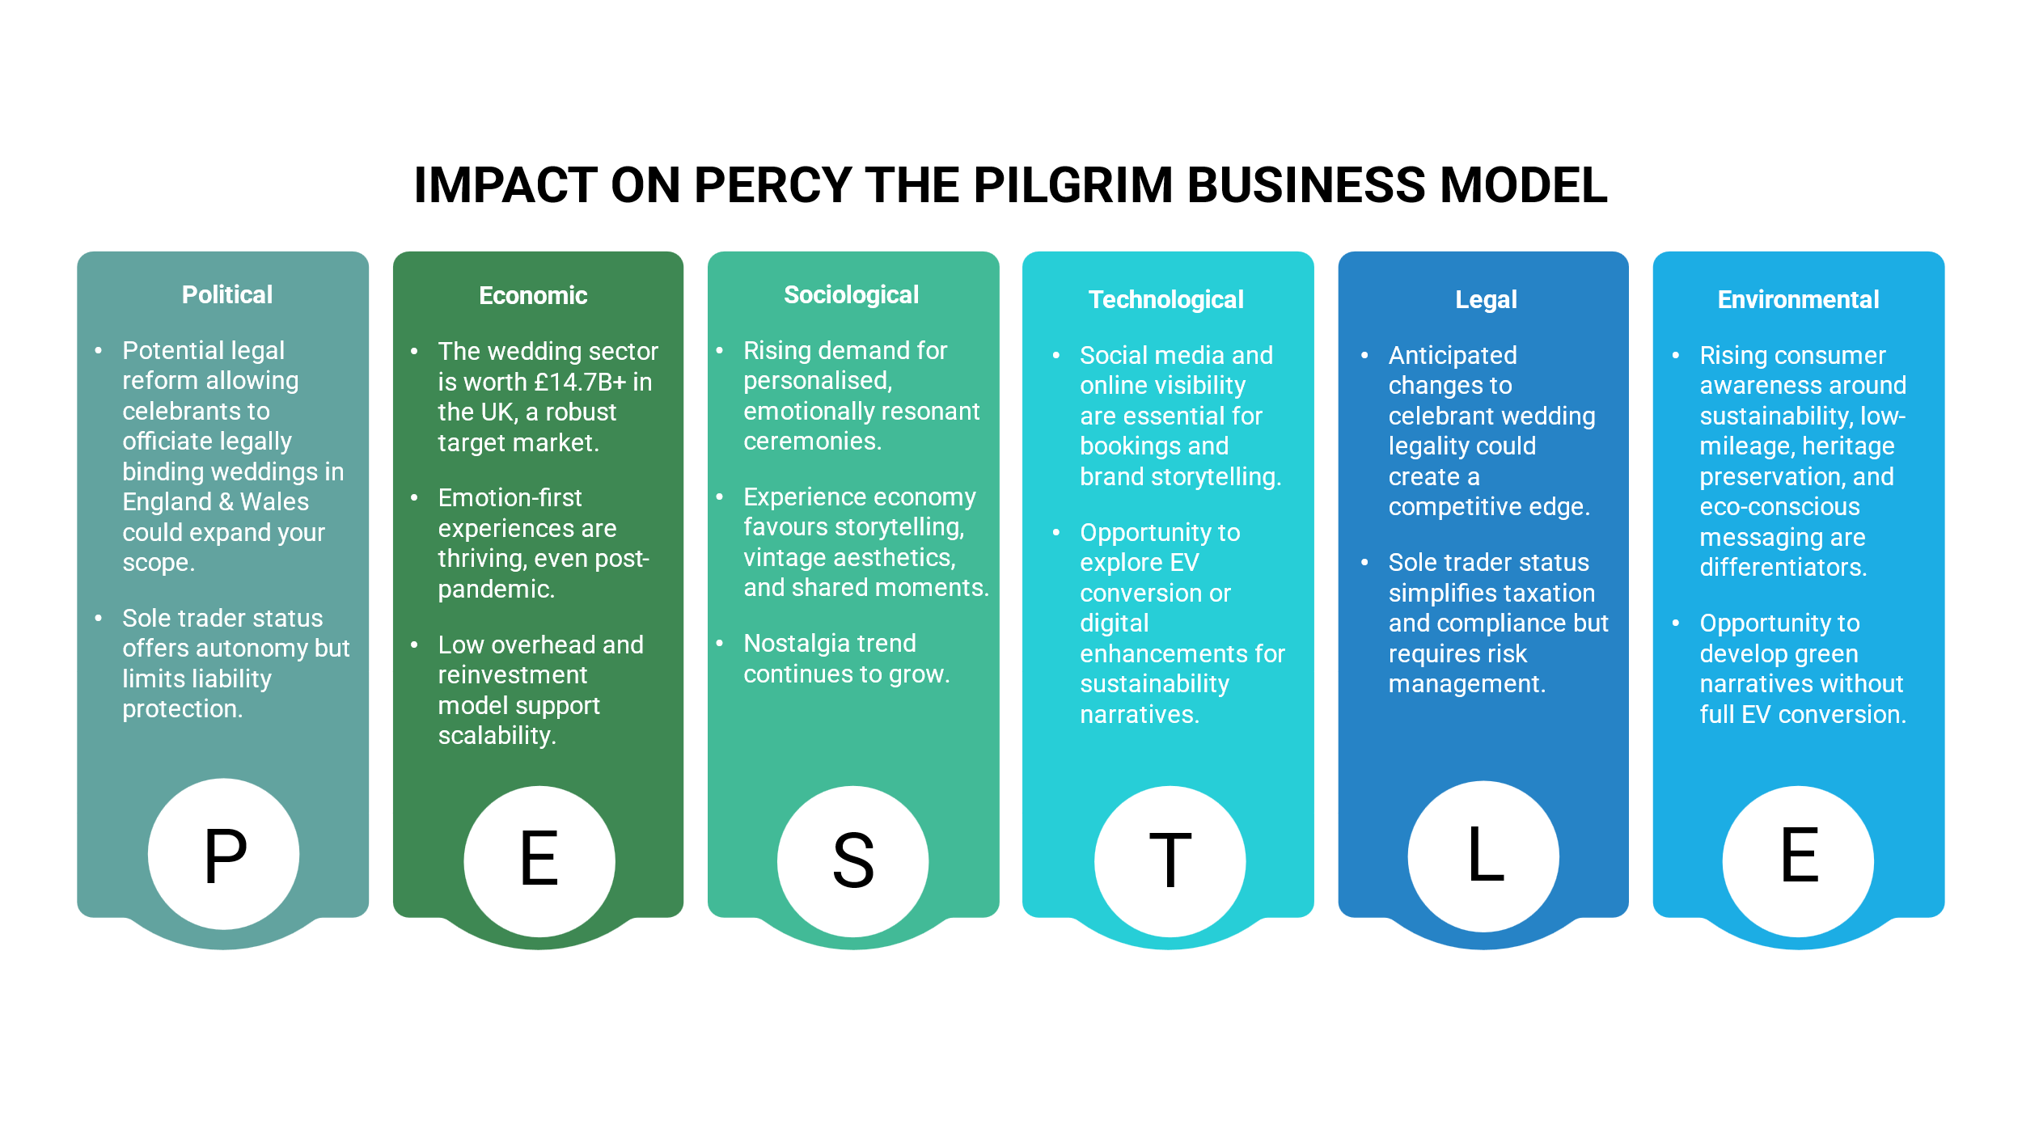
A PESTLE analysis shows the environment where you want your business to sit, and a SWOT analysis shows your position in that environment. Clients love businesses that respond to the world around them.

SWOT Analysis (Richter, 2018)
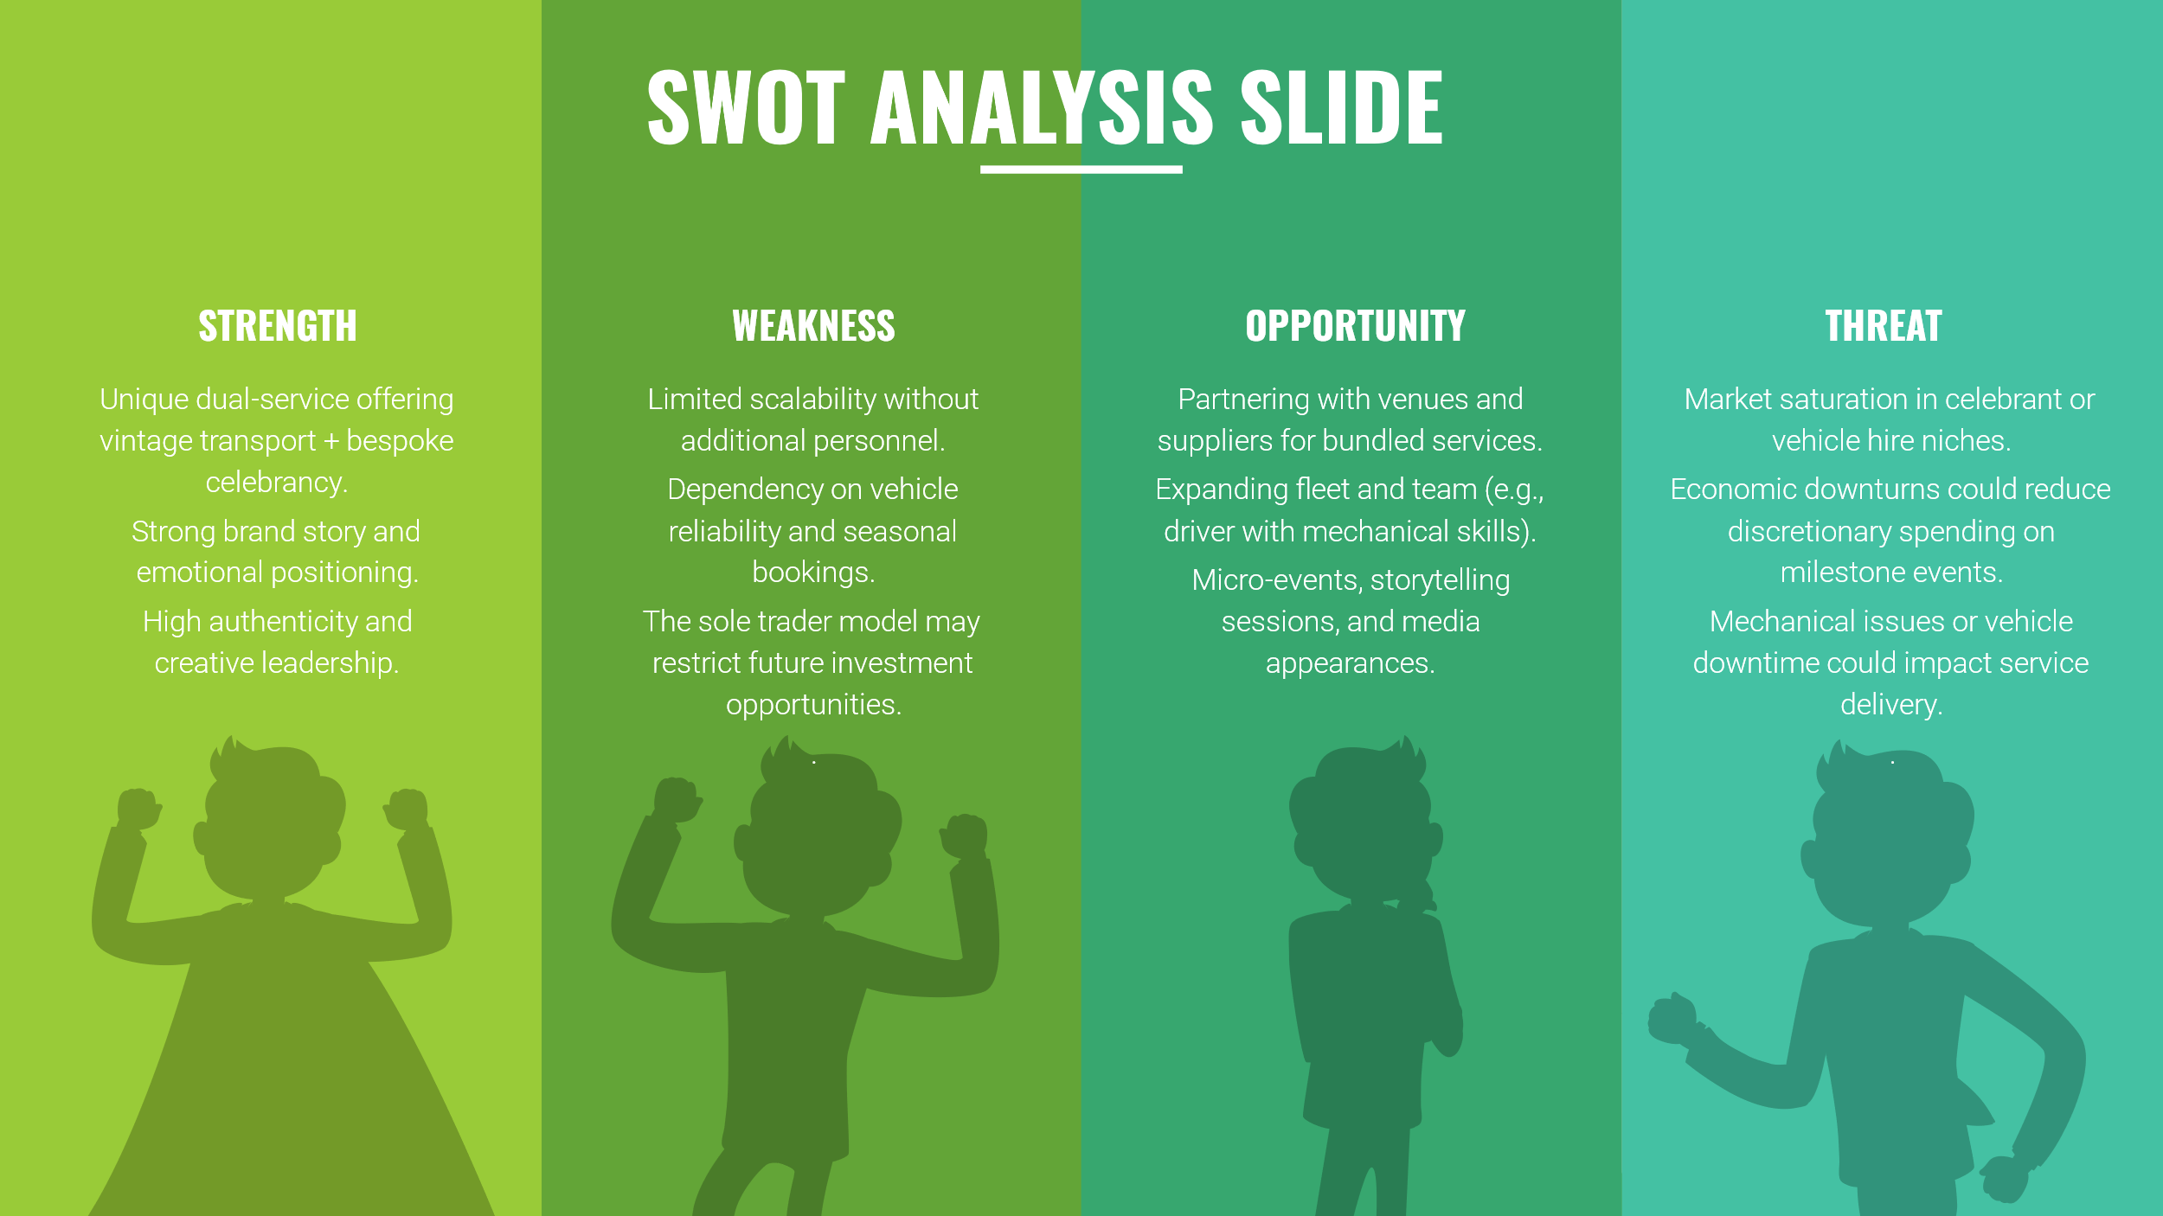
With SWOT analysis, you can see what you're good at, what you have going for you, and what you could do better. Point out things that could be done better or challenges, trends, or holes in the market that could come from within, as well as outside risks or problems that could affect your success. As your business changes, it's a good idea to look at your SWOT again to help you make decisions, like whether to buy a VW Beetle convertible next. Your business model will be better if you get regular feedback from clients, coworkers, or even just social media fans.
Target Markets for Percy the Pilgrim
Key customer segments likely to be drawn to this unique offering:
Weddings & Civil Ceremonies
- Couples seeking a non-traditional, heartfelt experience
- Those drawn to vintage aesthetics or outdoor venues
- LGBTQ+ couples looking for inclusive celebrant services
Celebrations & Milestones
- Families planning birthdays, anniversaries, or retirement celebrations
- Clients wanting a nostalgic or whimsical touch
Festivals & Community Events
- Local organisers looking for standout mobile features
- Eco-conscious or heritage-themed events
Creative Professionals
- Photographers and stylists seeking props or backdrops
- Influencers or brands wanting a retro shoot location
- TV and Film opportunities
Corporate & Wellness Retreats
- Businesses hosting team-building or mindfulness events
- HR teams looking for memorable employee experiences
Strategic positioning means Percy isn’t just a camper or a celebrant service, it’s a mobile memory-maker. This business's USP lies in combining transport and ceremony in one soulful package. Appealing to affiliative, eco-conscious, and creative clients. Offering inclusive, story-led experiences with vintage charm. Percy’s edge offers event-ready, story-rich experiences not just a van, but a meaningful moment on wheels. Most competitors focus on conversions and sales, not hiring or emotional connection.

VW Camper Experience Competitors (South Wales)
Business Name | Location | Strengths | Opportunities for Percy
VW Weddings Wales (VW Weddings Wales, 2016) | Caerphilly | Beautiful VW fleet of 4 vehicles, 10+ years of experience | No celebrant services; transport-only offer, Google shows some negative reviews.
Van Kampers (VW Camper van Hire in Pembrokeshire, Wales | van Kampers, 2023) | Pembrokeshire | Luxury camper hire, family-run, wedding packages available | Primarily holiday-focused; lacks emotional ceremony design
Deliciously Vintage (VW Camper van Hire for Weddings & Events | Deliciously Vintage, 2019) | Carmarthenshire | VW ice cream van + Beetle hire, vintage styling, family-run | Focused on treats and transport; no celebrant or story-led ceremonies
Premier Carriage (Volkswagen Split Screen Campervan, 2022) | Newport & surrounding area | Immaculate 1966 Split Screen VW, 6-passenger capacity, wide coverage | Transport-only; lacks emotional depth or ceremony integration

Celebrant Services Competitors (Wales)
Celebrant Name/Group | Region | Strengths | Opportunities for Percy
Tracey Taylor (Taylor, 2024) | Bridgend/Cardiff | Qualified, covers wide area | Traditional tone; lacks mobile/event integration
James Amos (James Amos- South Wales Celebrant, 2024) | South Wales | Storyteller, broadcaster, national reach | Less visual branding; not tied to a unique setting
Seren Celebrants (Home - Seren Celebrants, 2022) | Wales-wide | Inclusive ceremonies, good reviews | No mobile venue or vintage aesthetic
The Celebrant Directory (The Celebrant Directory, 2025) | Wales listings | Wide range of celebrants | Generic listings; Percy offers a distinct brand

Sales and Marketing Strategy

Startup marketing objectives will cover brand awareness and secure bookings for Percy the Pilgrim and Friends by positioning it as South Wales’s premier provider of emotionally resonant, vintage event experiences, combining celebrant-led ceremonies and nostalgic VW transport through targeted digital marketing, local partnerships, and story-led content.
Marketing Objective Focus Areas
- Target conversion: Achieve 20+ paid bookings within the first 12 months across weddings, vow renewals, styled shoots, and milestone events
- Brand visibility: Grow Percy’s online and offline presence via SEO-optimised website, Instagram storytelling, and collaboration with local venues and creatives
- Community engagement: Position Percy as a trusted, inclusive brand by joining local wedding directories, celebrant networks, and eco-conscious collectives
- Emotional resonance: Ensure marketing channels reflect Percy’s values — storytelling, inclusion, nostalgia, and celebration with soul
Focused core marketing strategies to consider:
Digital Storytelling & Visual Identity - Tap into the emotional power of Percy’s narrative
- Instagram & Pinterest: Showcase Percy’s vintage charm through styled shoots, behind-the-scenes stories, and heartfelt ceremony highlights
- Website blog series: Share stories of meaningful events, your celebrant insights, and VW adventures that reflect the spirit of celebration and connection
- Branded visuals: Develop a cohesive aesthetic with your logo, fonts, colours, and tone of voice that amplifies Percy’s nostalgic, inclusive energy
Strategic Partnerships & Local Collaboration - Build roots in the South Wales creative scene
- Connect with wedding venues, photographers, florists, and eco-conscious brands for styled shoots and cross-promotions & local wedding services
- Join local celebrant and wedding directories to increase visibility and credibility
- Attend industry meetups or host a launch event to position Percy as both a service and a story
SEO & Online Visibility - Make it easy for the right people to find you
- Optimise your website and blog with search terms like “Vintage VW wedding hire South Wales” or “Celebrant-led ceremonies Cardiff”
- Encourage client testimonials and Google reviews to boost trust and local rankings
- Submit Percy to online directories like Hitched, Bridebook, or unique wedding listings with personality
Emotional & Seasonal Campaigns - Use time-sensitive moments to inspire bookings
- Create themed campaigns around “The Journey of Meaning,” “Love in Motion,” or “The Soulful Ceremony Series”
- Celebrate seasonal touchpoints, e.g. autumn vow renewals, winter pop-up ceremonies, summer VW road-trip shoots
- Offer limited packages or early-bird pricing to prompt action while preserving Percy’s premium feel
Email & Community Engagement - Stay warm and memorable in inboxes and hearts
- Launch a monthly email newsletter with stories, ceremony tips, and vintage inspiration
- Build your mailing list via your website and event sign-ups
- Include behind-the-scenes content that reinforces trust, warmth, and emotional resonance

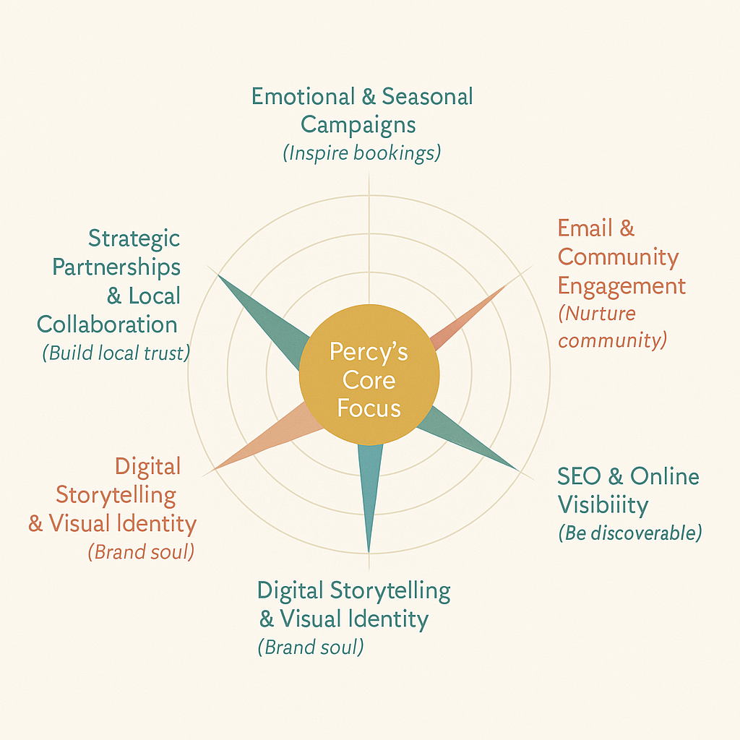

Target market
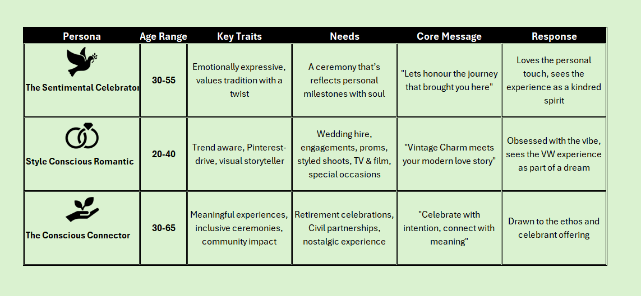
Pricing Strategy
Refined Tiered Packages
Package Name | Inclusions | Price Range
Moments on Wheels | VW hire + basic styling + 1 hour for photos or transport + free glass of champagne or mocktail (1 hour) | £295–£395
The Heartfelt Journey | VW hire + celebrant-led ceremony + storytelling + styled staging + free glass of champagne or mocktail (2–3 hours) | £695–£795
Soulful Celebration | VW hire + ceremony + script writing + rituals + consultation + full styling + free glass of champagne or mocktail (3–4 hours) | £895–£995
The Percy Experience | All-inclusive: VW + celebrant + tailored ceremony + mood board + travel within 50 miles + free glass of champagne or mocktail (All Day) | £1,200–£1,550
Picnic with Percy | VW setup at scenic location + styled picnic table + cushions + florals  (1-2 hours) | £295
Picnic & Photoshoot | VW setup at scenic location + styled picnic + professional photoshoot with partnered photographer (2-3 hours) | £445

Package Add-ons:
- Extra mileage: £0.75/mile
- Polaroid photo props: £45
- Bespoke ritual design: £75
- Seasonal styling: £65
- Pet Ring-bearer prep £40
- Celebrant overnight stay £85-£120 per night
- Grazing board for 2–4: £55
- Sparkling soft drinks or mocktails: £15
- Handwritten love letter or vow scroll: £25
- Keepsake Polaroid bundle: £45

Seasonal & Emotional Pricing
- Weekday or winter bookings: 10–15% discount
- Peak weekends (May–Sept): Full rate or premium uplift
- Bundle options for vow renewals, elopements, or styled shoots

Booking Checklist
☐ Choose your package
☐ Pick your date & location
☐ Confirm ceremony details (if celebrant-led)
☐ Select any add-ons
☐ Review travel distance
☐ Chat with Lisa for styling, mood board, or custom elements
☐ Sign your agreement + pay deposit
☐ Get ready for magic on wheels!
Sales Forecast
Percy the Pilgrim Sales Forecast (Year 1)
📌 Assumptions:
- Launch and marketing begin within the first quarter
- Goal: 20+ bookings within 12 months
- Focused on weddings, vow renewals, styled shoots, picnics, and milestone events
- Pricing reflects your tiered packages and seasonal adjustments
- Mixed booking types, with 10%–15% choosing add-ons
- Average occupancy: 2–4 bookings per month (ramping up to 6+ in peak season)

Monthly Booking Forecast
Month | Estimated Bookings | Avg Package Value | Add-On Revenue | Monthly Total
Jan–Feb | 2 | £495 | £45 | £1,080
Mar–Apr | 4 | £695 | £90 | £2,870
May–Jun | 6 | £895 | £135 | £5,505
Jul–Aug | 6 | £1,050 | £160 | £6,460
Sep–Oct | 4 | £795 | £90 | £3,270
Nov–Dec | 3 | £595 | £60 | £1,845
Annual Projection Summary
Category | Amount
Total Bookings | 25
Core Package Sales | £29,275
Add-On Revenue | £580
Annual Revenue | £29,855
This Suggests
- A modest year-one goal of around 25 bookings sets a strong foundation while preserving Percy’s premium feel.
- Summer peaks (May–August) may represent 40–50% of total annual revenue.
- Emotional campaigns and creative bundles could increase conversion, especially around winter vow renewals or seasonal pop-up ceremonies.
Year 2 Sales Forecast Expansion Scenario
📌 New Assumptions
- Addition of VW Beetle mid-year (Month 6), enabling parallel bookings
- Recruitment of a part-time driver to support logistics and increase capacity
- Increased brand awareness, repeat clients, and word-of-mouth referrals
- Upgraded event styling, travel range, and ability to service more midweek or multi-day requests

Monthly Booking Capacity & Forecast
Month | Percy Bookings | Beetle Bookings | Avg Value Percy | Avg Value Beetle | Add-On Revenue | Monthly Total
Jan–Feb | 3 | – | £595 | – | £75 | £1,860
Mar–Apr | 5 | – | £795 | – | £125 | £4,100
May–Jun | 6 | 2 | £995 | £445 | £180 | £7,855
Jul–Aug | 7 | 3 | £1,200 | £495 | £230 | £10,215
Sep–Oct | 5 | 3 | £895 | £495 | £180 | £6,300
Nov–Dec | 4 | 1 | £595 | £295 | £75 | £2,640
Annual Projection Summary
Category | Amount
Total Percy Bookings | 30
Total Beetle Bookings | 9
Core Package Sales | £36,850
Add-On Revenue | £865
Annual Revenue | £37,715
Impact of Fleet Expansion & Dedicated Driver
Benefits
- Increased capacity for weekend bookings or styled shoots on the same day
- Logistics support for Percy allows deeper client engagement (ceremony prep, rituals, storytelling)
- New markets like corporate or media work with dual-vehicle setups
- Pricing resilience: Percy retains premium pricing while Beetle targets shorter or lower-cost moments
Additional Costs to Consider
- Part-time driver wages and holiday cover (estimate: £8,000–£10,000 annually)
- Beetle acquisition and restoration (~£10,000–£15,000 depending on condition)
- Insurance, maintenance, and branding updates for the new vehicle (£3,000 annually)

How I Estimated Average Package Values
For each month and booking type, I used a weighted average based on:
- Tiered package prices range from £295 (Picnic with Percy) to £1,550 (The Percy Experience), so I estimated likely booking mixes for each period.
- Seasonal and emotional pricing impact, discounts in quieter months (like Jan–Feb) and uplifts during peak months (May–Aug) were factored in.
- Event type mix I imagined how bookings might distribute for example:
- Winter months: More short ceremonies, picnics, or weekday bookings at lower price points
- Peak season: Higher-value packages like Soulful Celebration or The Percy Experience
Here is an example: Percy’s Booking Average in July
Here’s the estimated breakdown:
Package Type | Qty | Price | Subtotal
Percy Experience | 3 | £1,350 | £4,050
Soulful Celebration | 2 | £995 | £1,990
Heartfelt Journey | 2 | £795 | £1,590
Total | 7 | – | £7,630
Avg Package Value | – | – | £1,090
I rounded to £1,200 to reflect peak-season potential and the emotional richness of those events.
For Beetle Bookings
Packages like Picnic with Percy or Photoshoot Bundles typically land in the £295–£445 range, depending on styling and photography add-ons. I averaged those based on these pricing tiers and seasonal activity.
Budget and timeline
Year 1 Budget Overview (with Celebrant Training)
Category | Estimated Cost | Notes
VW Camper Operational Costs | £3,000 | Maintenance, insurance, styling upgrades
Marketing & Branding | £2,500 | Website, SEO, logo, photography, social media ads
Event Supplies | £1,500 | Props, seasonal styling, picnic setup, ritual materials
Legal & Admin | £500 | Sole trader registration, contracts, accounting setup
Celebrant Materials | £750 | Script templates, mood boards, ceremonial add-ons
Celebrant Training | £1,546 | Formal qualifications that elevate credibility and depth
Contingency Reserve | £1,000 | Buffer for unexpected costs
New Year 1 Total: £10,796
With a projected revenue of £29,855, the business is still in a healthy position to reinvest, build brand equity, and explore creative growth while prioritising professional development and emotional impact.
Year 2 Expansion Budget Summary
Category | Estimated Cost | Notes
VW Beetle Acquisition & Restoration | £10,000–£15,000 | Purchase and vintage stylisation for event readiness
Driver Recruitment (Part-Time) | £8,000–£10,000 | Weekend logistics support, vehicle care, and event facilitation
Insurance & Branding for Beetle | £3,000 | Vehicle branding, insurance, and signage
Elevated Styling & Props | £1,500 | Enhanced ceremony setups, picnic scenes, and seasonal decor
Celebrant & VW Brand Marketing | £2,000 | PR for launch of dual vehicle offering, styled shoots, venue collabs
Admin & Operations Uplift | £1,000 | Additional legal, booking, and logistical resources
Year 2 Total Estimated Range: £25,500–£31,500
This aligns comfortably with projected Year 2 revenue of £37,715, leaving scope for reinvestment, fine-tuning the Percy experience, or even laying groundwork for Year 3 surprises, perhaps team building experiences or celebrant mentorship?

Operational Details Breakdown
📍 Location & Premises
- Primary Premises:
  - Home garage used for vehicle storage, prep, equipment loading, and operational admin. No public access is expected at this location, so no commercial premises licensing is required.
  - Mobile Event Locations: Event services are mobile. Check venue policy for any external vendor fees, services delivered on location using your vintage VW vehicle(s), making the setup highly flexible.
  - Establishment Check: Prior to any booking, confirm whether a venue or event space charges additional fees for external suppliers. If so, ensure these are either built into your package or passed on transparently to the client.
- Weather Contingency:
  - A pop-up event tent is available for outdoor use in poor weather, ensuring a consistent guest experience. Large Printed Gazebo (2022) with Back Wall & Two Half Side Walls used in poor conditions and trade shows.
🎶 Music & Entertainment
- PPL Music Licence:
  - Required for playing recorded music at events.
  - Annual cost: £300 (Public Performance Licence via PPL UK).
  - Covers music played as part of event ambience, celebration setup, or VW-hosted experiences.
🥂 Alcohol & Refreshments
- Personal Alcohol Licence:
  - Not required since champagne is offered as a complimentary gift, not sold.
  - Ensure the offering is clearly presented as part of an all-inclusive experience, not itemised, or charged separately.
- Food Hampers & Prepacked Goods:
  - Sourced from licensed third-party suppliers.
  - Registration with the local authority is free, but supplier compliance with food safety standards is critical.
  - Supplier must provide documentation confirming they handle legal and hygiene requirements (e.g., allergen info, traceability) this is built into the partnership agreement document.
🚐 Equipment Use
- Primary Vehicle(s):
  - Vintage VW van used as both a transport and visual centrepiece.
  - Regular safety checks and maintenance records should be maintained to comply with mobile business standards.
- Additional Equipment:
  - Event tent for rain protection.
  - Decor, furnishings, sound systems (if applicable) may be stored in home garage and transported per booking.
🛒 Production & Distribution Processes
- Collaborations with local wedding planners for event coordination.
- Partnerships with food suppliers for ready-to-serve hampers.
- Coordination with graphic designers and florists to enhance the visual and emotional experience.
- All services are curated to maintain your brand’s emotional resonance and aesthetic consistency.
- Legal documentation for partnerships
🤝 People, Staff & Suppliers
- Local partnerships with:
  - Photographers for event documentation.
  - Beauticians to offer guests optional pampering experiences.
  - Florist to offer beautiful personal floral tributes
- One casual labourer to support launch operations and act as a basic mechanic/driver.
- These relationships streamline operations and reduce startup costs while preserving quality and local connection.
🧾 Systems & Procedures
- Booking System: Centralised digital platform for customer engagement, event scheduling, and invoicing.
- Licensing & Insurance: All relevant documentation maintained, including:
  - Music licence (PPL) £300
  - Food supplier verification
  - Vehicle and passenger transport insurance private hire and reward insurance rough annual policy £1,455 (How Much Does Taxi Insurance Cost? | UK Guide 2024, 2024)

  - Public Liability Insurance (2025 UK Average) £115 with £2m cover (How Much Does Public Liability Insurance Cost? | AXA UK, 2024)
- Brentarce Insurance: Reliable provider with 30+ years experience used previously with positive outcomes.
🛡️ Health, Safety & Legal Compliance
- Insurance covers safe transport of passengers as part of event delivery.
- Ongoing checks for food safety via supplier agreements.
- Compliance with public liability, music, and vehicle regulations.
- Gazebo and equipment reviewed for stability and weather protection.
- Risk assessments should be completed for each new event location.

Set up and Operational Costs
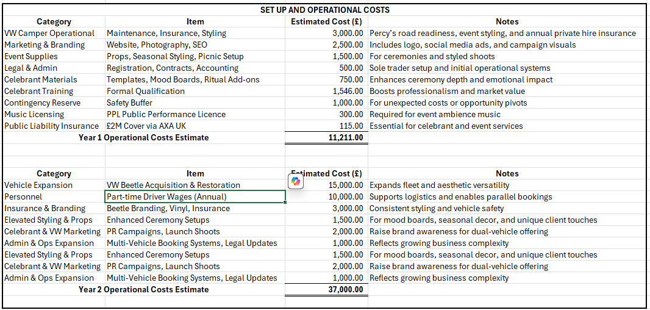
Fixed and Variable Costs
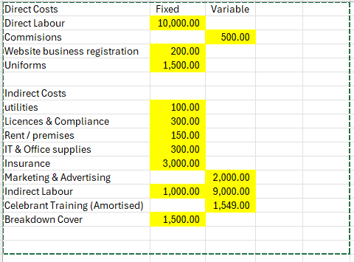

Market Research
A Guide to Understanding the Classic Car Market Trends in 2025 | Affordable Classic San Diego. (2025). Affordableclassicssandiego.com. https://www.affordableclassicssandiego.com/blog/A-Guide-To-Understanding-The-Classic-Car-Market-Trends-In-2025
Barclays. (2024). Making memories: the Rise of the Experience Economy | Barclays. Home.barclays. https://home.barclays/insights-old/2024/06/making-memories--the-rise-of-the-experience-economy/
Brentacre Insurance | Modified & Specialist Car Insurance Brokers. (2023, August 8). Brentacre. https://www.brentacre.co.uk
Burke, Z. (2024, August 15). How Much Does a Wedding Cost? The UK Average Revealed. Hitched.co.uk; hitched.co.uk. https://www.hitched.co.uk/wedding-planning/organising-and-planning/the-average-wedding-cost-in-the-uk-revealed/
Celebrant Training Courses. (2025). UK Society of Celebrants. https://www.uksoc.com/celebrant-training-courses
Classic Car Hire - HCHG. (2025). Classiccarhire.co.uk. https://www.classiccarhire.co.uk/
Exactitude Consultancy, & Exactitude Consultancy. (2025, March 16). Classic Car Market Research Report by Product Type (Classic Cars, Vintage Cars, Antique Cars, Replica Cars), By Vehicle Condition (Restored, Original, Project Cars), By Engine Type (ICE, Electric Conversions), By Ownership Type (Private Collectors, Museums, Investors, Dealerships) – Forecast to 2034. Exactitude Consultancy; https://exactitudeconsultancy.com/. https://exactitudeconsultancy.com/reports/47843/classic-car-market
Heritage Classic Car Insurance. (2025). Heritagecarinsurance.co.uk. https://www.heritagecarinsurance.co.uk/insurance/classic-car-insurance/heritage-classic-car-report/
Home - Seren Celebrants. (2022, July 4). Seren Celebrants - Alternative Ceremonies in Mid Wales. https://serencelebrants.com/
How much does public liability insurance cost? | AXA UK. (2024). AXA UK Home Page. https://www.axa.co.uk/business-insurance/public-liability/how-much-does-public-liability-insurance-cost/
How Much Does Taxi Insurance Cost? | UK Guide 2024. (2024, July 2). Zego. https://www.zego.com/blog/how-much-does-taxi-insurance-cost-uk/
James Amos- South Wales Celebrant. (2024). SouthWalesCelebrant. https://www.southwalescelebrant.co.uk/
Large Printed Gazebo with Printed Back Wall and 2 Half Side Walls. (2022). Xldisplays.co.uk. https://www.xldisplays.co.uk/products/large-printed-gazebo-with-printed-back-wall-and-2-half-side-walls.aspx?utm_source=www.brandedgazebos.co.uk&utm_medium=website
liv-mstructures. (2025, February 17). Big Business: Exploring the Pub Wedding Market | Marble Structures. Marble Structures. https://www.marblestructures.co.uk/food-for-thought/pub-gardens/
Market. (2023). Classic Car Market Size, Growth, Trends, Report 2032. Marketresearchfuture.com. https://www.marketresearchfuture.com/reports/classic-car-market-24502
Taylor, T. A. (2024). Tracey A. Taylor, Civil Celebrant. Tracey A. Taylor, Civil Celebrant. https://traceyataylor.com/
The Celebrant Directory. (2025, February 22). Find Celebrants in Cardiff | The Celebrant Directory. The Celebrant Directory. https://www.thecelebrantdirectory.com/area-covered/cardiff/
Vintage Car Hire. (2015, August 8). BookAclassic.co.uk. https://www.bookaclassic.co.uk/vintage-car-hire
Volkswagen Split Screen Campervan. (2022). Premier Carriage Wedding Cars. https://www.premiercarriage.co.uk/vw-beetle-campervan-hire-for-weddings/volkswagen-split-screen-campervan-2
VW Camper Van Hire for weddings & events | Deliciously Vintage. (2019, August 29). VW Camper van Hire for Weddings & Events | Deliciously Vintage. https://www.deliciouslyvintage.co.uk/
VW Camper Van hire in Pembrokeshire, Wales | Van Kampers. (2023, January 11). Van Kampers. https://www.vankampers.co.uk/
VW Weddings Wales. (2016). VW Weddings Wales. https://www.vwweddingswales.co.uk/

References

Barclays. (n.d.). Writing a business plan | Business plan guide | Barclays. Www.barclays.co.uk. https://www.barclays.co.uk/business-banking/business-insight/writing-a-business-plan/
GOV.UK. (2013, March 26). Alcohol Licensing. GOV.UK; GOV.UK. https://www.gov.uk/guidance/alcohol-licensing
GOV.UK. (2025). Become a sole trader. GOV.UK. https://www.gov.uk/become-sole-trader
Government Digital Service. (2012, July 3). Get information about a company. GOV.UK. https://www.gov.uk/get-information-about-a-company
Home. (2025, April 25). PPL PRS. https://pplprs.co.uk/?_gl=1
Kenton, W. (2025, February 26). What Is PEST Analysis? Its Applications and Uses in Business. Investopedia. https://www.investopedia.com/terms/p/pest-analysis.asp
Kerzner, H. (2022). Project Management: a Systems Approach to planning, scheduling, and controlling. (13th ed.). John Wiley & Sons.
LIVE, B. (2025). Operating a food business - Frequently asked questions – London Borough of Bromley. London Borough of Bromley. https://www.bromley.gov.uk/food-safety/operating-food-business-frequently-asked-questions/3
Luke. (2021, July 28). How to tell if you need an alcohol license. Johnson & Boon Solicitors. https://johnsonandboon.co.uk/2021/07/28/how-to-tell-if-you-need-an-alcohol-license/
Richter, A. (2018). SWOT Analysis: idea, Methodology, and a Practical Approach. Grin Verlag.

