

Student name: Ekaterina Kist
Student ID: 2336279

Module name: Protecting and Supporting Families
in Health and Social Care

Module code: BMHP5021

Lecturer name: Diola Bijlhout

Table of Contents:

Introduction | 3
Policy and Theoretical Framework | 3
Evaluation Criteria | 5
Comparative Evaluation | 5
Comparative Summary | 9
Conclusion | 13
References | 14

Introduction
The purpose of this report is to analyse, compare and evaluate how the Early Help framework for families is signposted and made accessible through local authority websites. Early Help is a key component of the safeguarding system in England and plays an important role in supporting children and families, promoting wellbeing, and identifying concerns at an early stage in order to prevent harm and escalation to statutory intervention.
Local authority websites are often the first and most immediate point of contact for families seeking help and for professionals coordinating services. They provide information about available support, access routes for referrals, and guidance for practitioners. As such, the effectiveness, clarity and accessibility of Early Help information on these websites can have a direct impact on families’ ability to access timely support and on overall family wellbeing.
This report examines and compares how Early Help is communicated and signposted on the websites of three UK local authorities:
- Norfolk County Council
- Leeds City Council
- Leicestershire County Council
Using national policy guidance and relevant theoretical perspectives, the report evaluates which local authority appears to provide the most effective and accessible online information relating to Early Help and family support services.

Policy and Theoretical Framework
Early Help is a central component of the safeguarding system in England, with the primary aim of identifying and addressing emerging needs at the earliest possible stage in order to prevent escalation to statutory intervention. The principles underpinning Early Help are set out in key national policy documents, which form the framework for this analysis.
Working Together to Safeguard Children (HM Government, 2023) defines Early Help as support that can be provided at any point in a child’s life when a concern first arises. The guidance emphasises that effective Early Help depends on early identification, accessibility for families, and coordinated multi-agency responses. It places a statutory responsibility on local authorities, alongside health, education and police services, to work collaboratively to safeguard children and promote their welfare.
A key principle of Working Together (HM Government, 2023) is that Early Help should be easy for families and practitioners to access, with clear referral pathways and opportunities for self-referral. The guidance highlights the importance of proportionate information sharing and clarity regarding professional roles and responsibilities. These expectations position local authority websites as a crucial mechanism for communicating Early Help provision.
The Early Help System Guide further develops this policy direction by promoting a whole-system approach to Early Help (HM Government, 2023a). The guide outlines how local authorities should coordinate universal, targeted and specialist services across agencies to ensure a “no wrong door” approach for families. Local authorities are therefore expected not only to commission services, but also to clearly articulate how families and professionals can navigate the system.
Several theoretical perspectives further strengthen understanding of Early Help practice. Bronfenbrenner’s ecological systems theory emphasises that child development is influenced by multiple interconnected systems, including family, school, community and wider social structures (Bronfenbrenner, 1994). Early Help aligns with this theory through its emphasis on multi-agency working and whole-family support.
In addition, Skinner’s behaviourist theory highlights the role of environmental factors, reinforcement and behaviour in learning and development, particularly in addressing barriers linked to learning difficulties and mental health challenges (Skinner, 1985). Finally, Vygotsky’s sociocultural theory emphasises the importance of social interaction and guidance from more knowledgeable others. His concept of the Zone of Proximal Development (ZPD) highlights how children can achieve greater outcomes with appropriate support, which aligns with Early Help’s preventative and supportive approach (Vygotsky, 1978).
Together, these policy frameworks and theoretical perspectives provide a robust foundation for evaluating how effectively local authority websites communicate Early Help to families.

Evaluation Criteria

The report uses the informed criteria to enable consistent evaluation, statutory guidance and safeguarding literature were used. Please refer to the criteria table below:

- 1. Accessibility and Usability | - Clarity of Early Help Pathways | - 3. Multi-agency and Partnership Working (LO1)
- - Is Early Help easy to find?  - - Plain language?  - - Family-friendly tone?  - - Clear navigation? | - - Clear explanation of Early Help  - - Who it is for  - - How families can access it | - - Collaboration with:  - a. Health  - b. Education  - c. Voluntary sectors  - - Clear roles and responsibilities?
- 4. Range of Preventative and Protective Services (LO2) | - 5. Inclusivity and Targeting Need | - 6. Transparency and Professional Guidance
- - Parenting support  - - Mental health  - - Domestic abuse  - - SEND  - - Financial hardship | - - Vulnerable groups addressed  - - Recognition of diverse family needs | - - Availability of practitioner guidance  - - Threshold documents  - - Contact details and accountability
Comparative Evaluation

1. Accessibility and Usability
Norfolk County Council presents Early Help information in a relatively clear and family-friendly manner. The Early Help pages are accessible via a dedicated “Help for Families” section and use plain language aimed at reassuring families that support is available before difficulties escalate (Norfolk County Council, 2025a). The navigation is intuitive, but can feel fragmented, as families may need to move between separate pages relating to family hubs, professional information and referral processes.
Leeds City Council demonstrates a more cohesive and user-centred approach. The integrated design supports accessibility and aligns with statutory expectations that Early Help should be visible and easy to engage with, however it feels more formal.
Early Help information is embedded within the Family Information Service and Local Offer. The website is structured to for clarity and ease of navigation, with information grouped logically around family hubs and local services.
Leicestershire County Council provides comprehensive information under the banner of “Family Help”, but the presentation is even more formal and service-led. Although information is available, it is less intuitive for families, as it relies on professional terminology and multi-layered navigation and may present barriers for families seeking early support (Leicestershire County Council, 2025a).

2. Clarity of Early Help Pathways
Norfolk County Council defines Early Help clearly as support for families with children aged 0–18, or up to 25 for young people with SEND. The website outlines who Early Help is for and provides a direct online route for families or professionals to request support, reinforcing transparency and accessibility (Norfolk County Council, 2025a; Norfolk County Council, 2025b).
Leeds City Council frames Early Help as a way of working rather than a discrete service, emphasising early conversations and relationship-based practice. Families are encouraged to access support through family hubs or trusted professionals, with hub locations and contact details clearly signposted (Leeds City Council, 2025b). This approach limits direct self-referral.
Leicestershire County Council outlines referral pathways through its Family Help service, including self-referral and professional referral options. The information is detailed, but process is presented in a more procedural manner, which may be less accessible to families unfamiliar with safeguarding systems (Leicestershire County Council, 2025a). Compared with Leeds and Norfolk, the pathway is less intuitively explained.

3. Multi-agency and Partnership Working (LO1)
Leeds City Council demonstrates the strongest and most explicit commitment to partnership working. Its cluster model brings together education, health, social care, police and voluntary organisations within defined localities, promoting shared responsibility for early intervention (Leeds Safeguarding Children Partnership, 2025). This model evidences coordinated, interdisciplinary practice.
Norfolk County Council also highlights partnership working through its family hub model, which integrates services such as health visiting, parenting support, welfare advice and education services. Early Help Advisors work across agencies to coordinate support and ensure families are directed to appropriate services (Norfolk County Council, 2025b). While partnership working is evident, it is less explanatory than in Leeds’ cluster approach.
Leicestershire County Council integrates partnership working through its Family Help model, which combines multiple services under one structure. However, partnership arrangements are described more implicitly, with less visibility of multi-agency working for families and professionals (Leicestershire County Council, 2025a).

4. Range of Preventative and Protective Services (LO2)
Norfolk County Council highlights a broad range of early intervention support through family hubs, including parenting programmes, financial and housing advice, and early years services (Norfolk County Council, 2025a). This holistic offer reflects a public health approach to safeguarding.
Leeds City Council similarly offers a wide range of support through family hubs, covering parenting support, mental health, emotional wellbeing, SEND provision and youth services. The integration of these services within local communities strengthens protective factors and reduces stigma associated with seeking help (Leeds City Council, 2025b).
Leicestershire County Council provides extensive preventative services through Family Help, including group work, parenting interventions and enhanced family support. The presentation is more service-focused and less linked to preventative safeguarding (Leicestershire County Council, 2025a).

5. Inclusivity and Targeting Need
Leeds City Council demonstrates the strongest explicit focus on diverse needs, including SEND coordinators within family hubs and geographically distributed services designed to reach different communities (Leeds City Council, 2025b). This reflects a place-based approach to addressing inequality.
Norfolk County Council recognises inclusivity through age-specific provision and support for families facing financial or housing challenges. However, specific groups are less clearly foregrounded on main Early Help pages, requiring further navigation to identify targeted support (Norfolk County Council, 2025a).
Leicestershire County Council includes support for SEND and additional needs but presents this information within broader service descriptions, which may reduce visibility for families seeking tailored support (Leicestershire County Council, 2025a).

6. Transparency and Professional Guidance
Leeds City Council provides extensive practitioner guidance through one-minute guides and safeguarding partnership resources, supporting clarity and shared understanding across agencies (Leeds City Council, 2025c).
Norfolk County Council also provides clear professional guidance, including assessment processes and online plan uploads, alongside accessible contact details (Norfolk County Council, 2025c). This dual focus supports both families and practitioners.
Leicestershire County Council outlines referral processes and accountability but provides less visible practitioner guidance on public pages, potentially limiting transparency for professionals unfamiliar with the local system (Leicestershire County Council, 2025a)

Comparative Summary
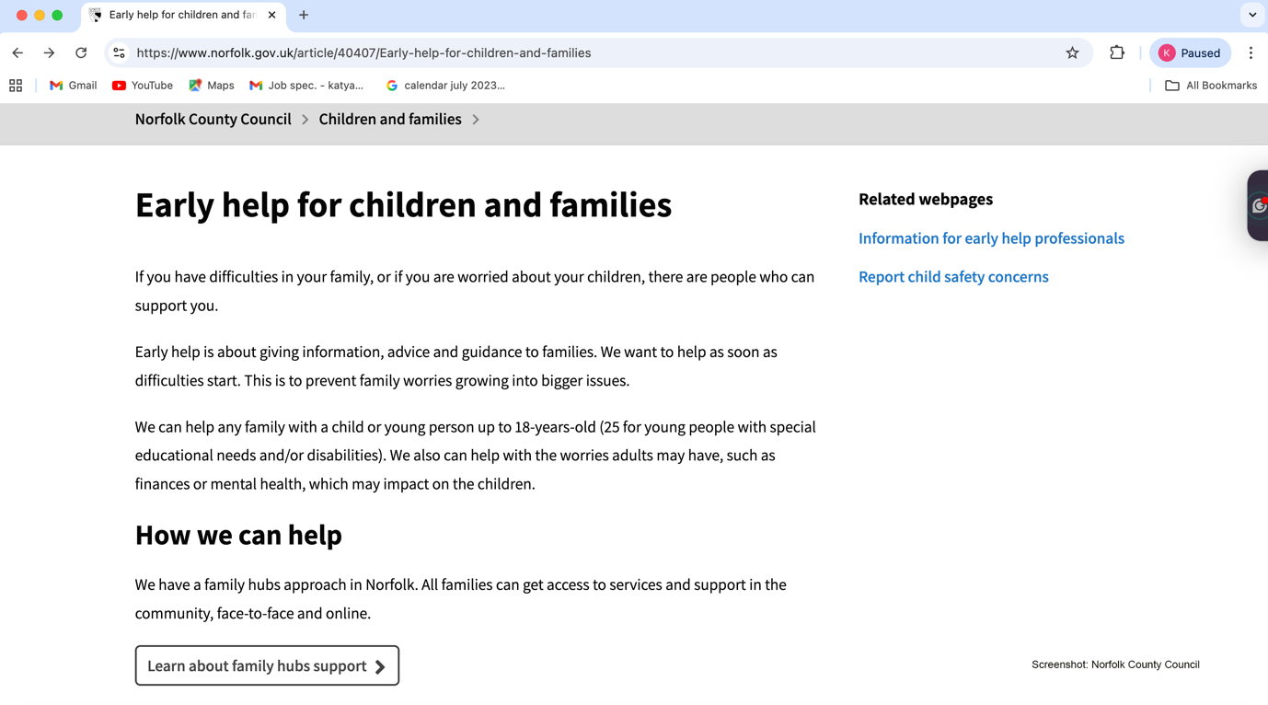

Norfolk County Council

How Early Help is presented:
- Norfolk’s Early Help page clearly defines the service for families, describing what it is and who it’s for in plain language. It states the aim is to give information, advice and guidance early on to prevent problems escalating. They also link to family hubs as a central point for accessing support in the community (Norfolk County Council, 2025).

- Clarity & navigation
- Information for families is easy to find via a dedicated Early Help page.
- Users can access resources and request support through an online form.

- Professional resources
- There is specific information for professionals, including guidance on Early Help assessments and uploading plans — showing dual targeted audiences (families and professionals).

Partnership emphasis
- Norfolk’s strategy documents emphasise prevention and multi-agency working with schools and local partnerships.
Pros:
- Written clearly for families.
- Strong signposting to family hubs.
- Professional toolkits and guidance available.
Cons:
- Website sectioning can feel slightly fragmented — separate pages for families vs professionals.

Leeds City Council

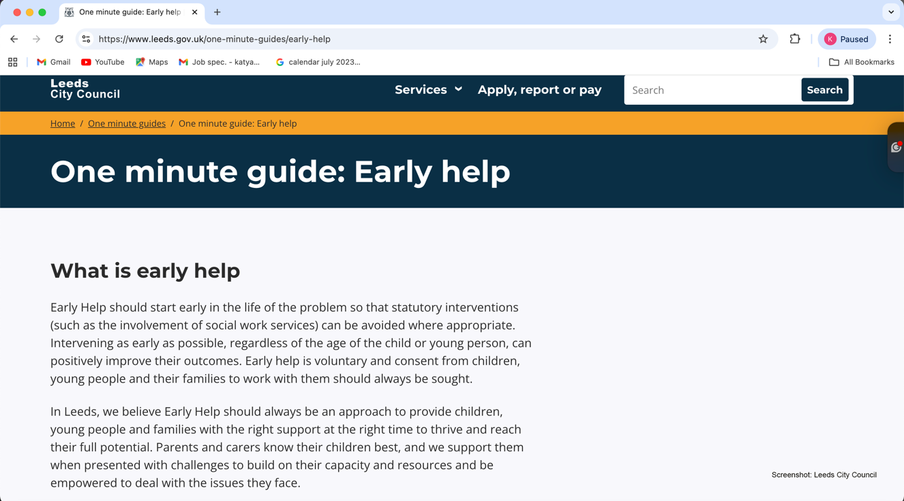

How Early Help is presented
- Leeds embeds Early Help within its Local Offer and Family Information Service, emphasising support at the right time through collaboration across agencies.
- They describe Early Help as not just a service but a “way of working” — focused on the right conversation at the right time and avoiding escalation of issues (Leeds City Council, 2025).

Family hubs & clusters
- Leeds clearly signposts family hubs as physical and contact points where families can get support across multiple issues — parenting, health, education, and SEND.
- They also outline cluster partnerships that link education, health, community and social care to deliver more place-based support.

Clarity & detail
- Their “One minute guide” explains Early Help principles clearly and links to follow-up services and contacts.

Partnership emphasis
- Leeds highlights long-standing multi-agency collaboration, family engagement, and a shared citywide commitment to Early Help.
Pros:
- Very structured approach with hubs and clusters offering well-defined pathways to support.
- Strong emphasis on partnership and whole-family support.
Cons:
- Information is sometimes spread across multiple pages (Local Offer, one-minute guide, safeguarding partnership site), which may make navigation harder for some users.

Leicestershire County Council

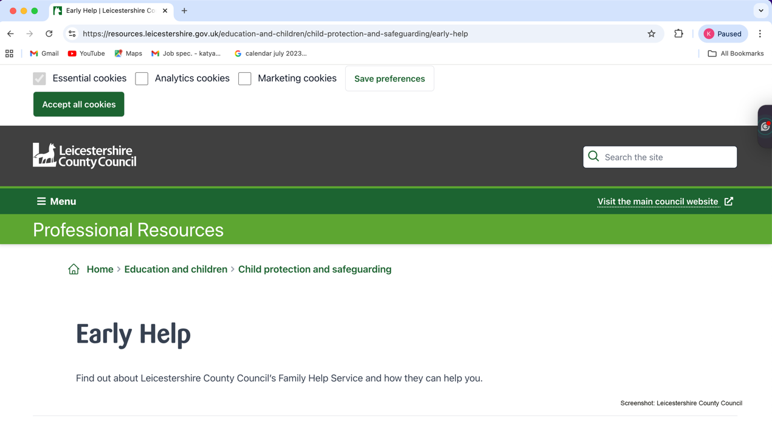

How Early Help is presented
- Early Help here is branded as Family Help, integrating multiple previous services (e.g., Children’s Centres, Youth Offending) under one umbrella.
- The narrative is service-oriented with detail about types of support available (Leicestershire County Council, 2025).

Clarity & accessibility
- Website content tends to be more formal and service-focused, which may make it less immediately accessible to families searching for help.
- Key aspects like how to access support, who can refer, and service types are there — but families might need to click through multiple pages to get the full picture.

Partnership emphasis
- Official strategy documents emphasise inter-agency working and having ‘no wrong door’ for families, and early help as a shared responsibility across sectors.

Service detail
- There are clear descriptions of different levels of support and how referrals are processed — which may be useful for professionals but harder for families.
Pros:
- Detailed service breakdown and multi-agency strategy.
- Integrates a broad range of support under Family Help.
Cons:
- Less family-friendly language and organisation.
- The site feels more professional-oriented and may require users to search through multiple sections.

Conclusion
- Norfolk and Leeds score highly in terms of accessibility and family-friendly signposting — Norfolk for clear service explanation and an intuitive family hub model, and Leeds for structured hub/cluster pathways and strong partnership framing.
- Leicestershire offers a comprehensive suite of services, but its online signposting could be more navigable and family-focused.
- Based on the full range of evaluation criteria, this report positions Norfolk County Council as the most accessible and effective source of information for families.

References

Bronfenbrenner, U. (1994) Ecological models of human development. In: International Encyclopedia of Education, Vol. 3. Oxford: Elsevier. Available at: https://www.ncj.nl/wp-content/uploads/media-import/docs/6a45c1a4-82ad-4f69-957e-1c76966678e2.pdf (Accessed: 29 December 2025).
HM Government (2023) Working together to safeguard children: A guide to inter-agency working to safeguard and promote the welfare of children. London: HMSO. Available at: https://assets.publishing.service.gov.uk/media/6849a7b67cba25f610c7db3f/Working_together_to_safeguard_children_2023_-_statutory_guidance.pdf (Accessed: 29 December 2025).
HM Government (2023a) Early Help System Guide. London: Department for Education. Available at: https://assets.publishing.service.gov.uk/media/628de13be90e071f5f7e1bd2/Early_Help_System_Guide.pdf (Accessed: 29 December 2025).
Leeds City Council (2025) Early Help: One minute guide. Available at: https://www.leeds.gov.uk/one-minute-guides/early-help (Accessed: 29 December 2025).
Norfolk County Council (2025a) Early help for children and families. Available at: https://www.norfolk.gov.uk/helpforfamilies (Accessed: 29 December 2025).
Norfolk County Council (2025b) Request for support. Available at: https://www.norfolk.gov.uk/article/60983/Request-for-support (Accessed: 29 December 2025).
Norfolk County Council (2025c) Information for early help professionals. Available at: https://www.norfolk.gov.uk/article/41092/Information-for-early-help-professionals (Accessed: 29 December 2025).
Leeds City Council (2025a) Family Information Service. Available at: https://www.leeds.gov.uk/children-and-families/family-information-service (Accessed: 29 December 2025).
Leeds City Council (2025b) Early help. Leeds Local Offer. Available at: https://leedslocaloffer.org.uk/education/early-years/early-help (Accessed: 29 December 2025).
Leeds City Council (2025c) Early Help one-minute guides. Available at: https://www.leeds.gov.uk/one-minute-guides/early-help (Accessed: 29 December 2025).
Leeds Safeguarding Children Partnership (2025) Early Help approach. Available at: https://leedsscp.org.uk/practitioners/working-with-families/early-help (Accessed: 29 December 2025).
Leicestershire County Council (2025) Early Help / Family Help. Available at: https://resources.leicestershire.gov.uk/education-and-children/child-protection-and-safeguarding/early-help (Accessed: 29 December 2025).
Skinner, B.F. (1985) Cognitive science and behaviourism. British Journal of Psychology, 76(3), pp. 291–301. Available at: https://coehuman.uodiyala.edu.iq/uploads/Coehuman%20library%20pdf/English%20library%D9%83%D8%AA%D8%A8%20%D8%A7%D9%84%D8%A7%D9%86%D9%83%D9%84%D9%8A%D8%B2%D9%8A/linguistics/Skinner,%20B.%20F.%20(1985)%20Cognitive%20science%20and%20behaviourism.pdf (Accessed: 29 December 2025).
Vygotsky, L.S. (1978) Mind in society: The development of higher psychological processes. Cambridge, MA: Harvard University Press. Available at: https://www.nysed.gov/sites/default/files/programs/bilingual-ed/zone_proximal_development.pdf (Accessed: 29 December 2025).

