10/26/2025
University of Wales Trinity Saint David
London campus
Module Name: Learning In the Digital Era
Module Code: ACCA 4025

Student Name: ABBAS AHMED
Student ID:2512870
Group: 2

Lecturer’s Name: Koushik Modak

E-Portfolio Link: https://2512870.wixsite.com/abbas
LDE Assignment 1
E-Portfolio
Table of Contents
Introduction 2
Main Body 2
Task 1: Essential Academic and Employment Skills for the future career Path 2
Task 1 (a): Report on Essential Academic and Employment Skills 2
Task 1 (b): Evaluation of Task 1 (a) based on Similarity report 2
Task 2: Collaborative Mind Map and Individual Poster 3
Mind Map (Collaborative) 3
Poster (Individual) 3
Task 3: Virtual Collaboration and RefWorks 3
Report on Virtual Collaboration 3
Step-by-step process of using RefWorks with visuals 3
Task 4: E-Portfolio Creation and Evaluation 3
Task 4 (a): E-Portfolio Creation 3
Task 4 (b): Illustrative Review of E-Portfolio tool Selection 4
Conclusion 4
References 4
Task 1 References: 4
Task 3 References: 4

Introduction

Main Body

Task 1: Essential Academic and Employment Skills for the future career Path

Task 1 (a): Report on Essential Academic and Employment Skills
Essential academic and employment skills for the future career
Success in the 21st century labour market relies heavily on a robust integration of Academic rigor and practical employment skills; these two domains are interdependent Forming the bedrock of a highly effective and adaptable workforce.
Academic skills Provide the essential cognitive infrastructure; critical thinking complex problem -solving, and analytical reasoning, developed through education, these abilities enable Individuals to research information, evaluate argument, and articulate sophisticated ideas in both written reports and verbal presentations, these core competencies are Highly sought after by employers who need staff capable of making informed, Evidence-based decisions. [1]
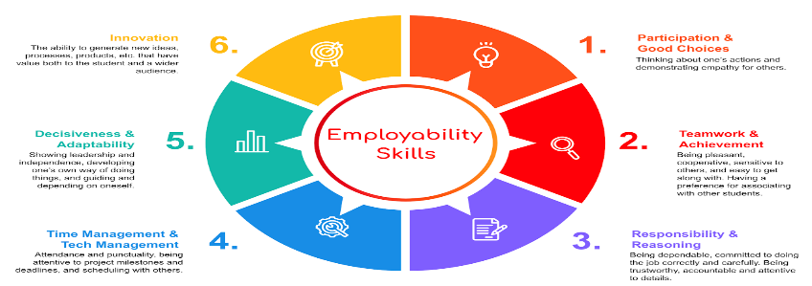 [1, 2]

However, academic knowledge alone is insufficient, it must be paired with essential Employment skills, often referred to as soft skills key skills identified in reports from Organizations like the world economic forum include adaptability, communication. Teamwork and time management, these skills dictate how knowledge is applied in a Professional sitting – facilitating effective collaboration, managing projects efficiently and navigating workplace dynamics.
The synergy is crucial for instance, an engineer needs strong technical academic skills to design a bridge, but requires, collaboration and communication employment skills to Work effectively with a team and present plans to the local council,
To bridge existing skill gaps, education systems must actively embed practical, work- ready scenarios into curricula. Fostering a blend of analytical prowess and interpersonal aptitude ensures individuals are not just qualified, but genuinely ready to contribute and thrive in a professional environment that demands continuous learning and adaptation. [3]
 [4]

Task 1 (b): Evaluation of Task 1 (a) based on Similarity report
An “evaluation of task 1 based on similarity “can refer to several different contexts. Such as evaluating a tasks similarity to another task <like in NLP research> or using Similarity” vocabulary to evaluate a student’s performance a test like IELTS Writing Task 1 in the IELTS context. This involves using comparison vocabulary. To describe Visual date and ensuring the report accurately compares, and contrasts information. From graphs. Charts or maps in NLP. It refers to using metrices to measure how similar. Two tasks are, often to reduce the number of evaluation tasks needed without losing validation quality, [5]

Task 2: Collaborative Mind Map and Individual Poster

Mind Map (Collaborative)

Poster (Individual
A collaborative mind is a dynamic, interactive tool for brainstorming and Organizing ideas as a group, while an individual poster is a static, formal presentation. Of a finished project.
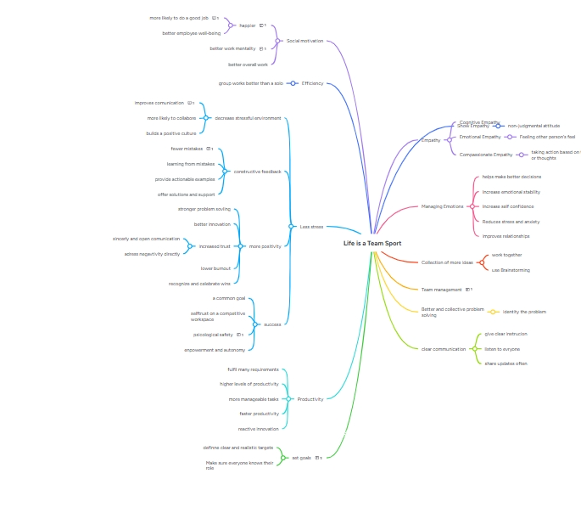

Virtual RefWorks Collaboration and Task 3:

Report on Virtual Collaboration
Put your Chosen topic here
RefWorks is on online research management, writing, and collaboration tool that helps Research teams work together virtually. it enables groups to gather, organize, annotate and share research materials, and to instantly create citations and bibliographies.

Step-by-step process of using RefWorks with visuals

Task 4: E-Portfolio Creation and Evaluation

Task 4 (a): E-Portfolio Creation
An e-portfolio is a digital collection of your work, achievements, and skills, which can be created using various platforms. The creation process involves curating content that demonstrates your abilities, choosing an appropriate platform, and presenting.

Task 4 (b): Illustrative Review of E-Portfolio tool Selection
An illustrative review of e-portfolio tool selection highlights that the optimal choice Depends on aligning the tools and the target audience. An effective selective process should consider the purpose, functionality, cost , and the level of institutional support available.

Conclusion

References

Task 1 References

Task 3 References: [2].


