UNIVERISTY OF WALES TRINITY SAINT DAVID LONDON

Certificate of Higher Education in Skills for the Workplace
Module Name: Managing Enterprise in the 21st Century
Module Code: BMSW4006

Business plan
CEMENTFIX LIMITED
-READY-MIXED CONCRETE PLANT-

STUDENT NAME: IULIAN-MARIAN BATANOIU
STUDENT ID: 1817136
LECTURER’S NAME: Afzal Mannua

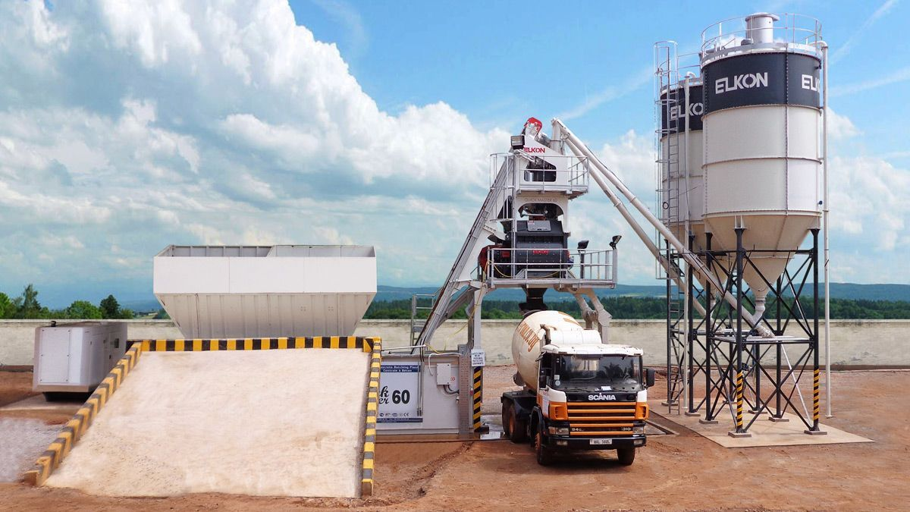

BUSINESS DESCRIPTION
CEMENTFIX LIMITED it is a start-up business, trading as a private limited company in Dagenham, Essex. The company is a local supplier of ready-mixed concrete for the construction industry, supplying one single product- ready-mix concrete- for private local customers and commercial customers. Ready-mix concrete it is a basic product, required in the construction industry for various projects such as: building, restoration, structural engineering, driveways, walls/foundations.
Our product will differ from the competition’s goods and services through 2 key-elements: quality and price. We aim to offer the best mixing quality of cement by using relevant ratios and also personalized ratios according to the customer’s needs for their specific projects. We are looking to provide our product to the local area of Dagenham plus a maximum of 10 miles radius. We intend to keep our business local and to run it as a local trusted business, keeping a good business relationship with existing and potential customers.
CEMENTFIX LIMITED is founded by two shareholders, each of them owning 50% of the shares. The shareholders contributed with equal parts of capital investment of £250.000; Both shareholders are acting as directors of the organization and it is agreed that no dividend payments will be made for the next 5 years of trading. All revenue income will be reinvested in the business for future growth and expansion of the range of production offered.
By working close with other local construction companies, we aim to become the top local supplier of ready-mix concrete. Our product will be available for purchase on-site, from our ready-mix concrete plant or delivered to the customers.
On-site purchases will be available to all types of customers, private or commercial, at competitive prices, as long as the customers can arrange their own transport that will fit the requirements.
CEMENTFIX LIMITED is aiming to become the top supplier in the Essex area and to expand within 2 years of trading in order to provide on-site solutions for extensive commercial projects where a mobile concrete ready-mix plant is required.
Deliveries can be arranged online, through our website or via telephone, during business hours Monday To Saturday from 6.00a.m to 6.00p.m. The customers will be able to choose specific dates and times for the delivery and to process the order, the invoice will have to pe paid in full, up-front for new customers and for regular customers, there is the option of paying only a 10% deposit payment up-front and the rest of the payment can be arranged on delivery, in cash or by bank transfer. Payments can be processed over the telephone, where customers can pay with their credit or debit cards into the company’s merchant account.
CEMENTFIX LIMITED cannot arrange credit accounts for new customers and its main supplier of materials required in the process of work, it is also its main competitor: HANSON HEIDELBERG GROUP UK.
CEMENTFIX LIMITED consists of one ready-mix plant, ELKOMIX-60 QUICK MASTER which is equipped with a 1500/1000 l. ELKON twin shaft mixer and a 4×15 m³ aggregate storage bin. The plant had been purchased, delivered and installed for a total cost of £280.000 from UK manufacturer OBPLANT LIMITED. The plant can produce up to 55 cubic meters per hour. (Design,2019)
THE STRUCTURE OF THE BUSINESS
2 DIRECTORS
1 QUALITY AND CONTROL MANAGER
1 SITE-MANAGER
1 PLANT ENGINEER
3 PLANT OPERATIVES
6 HGV DRIVERS
1 COMPANY SECRETARY
1 RECEPTIONIST
The office is based in Dagenham, Essex, at the plant’s location. The total area of the site it is 4500 square meters and it is divided in 4 sections:
- production area where the plant is installed
- administrative area consisting off: reception, meeting room and 1 office
- loading area: authorized personnel use only
- parking area: 12 parking lots for staff and customers
CEMENTFIX LIMITED STRUCTURAL MANAGEMENT HIERARCHY

SWOT ANALYSIS
Strengths  - Improving the product rather than expanding the business;  - Constant focus on improving the supply chain;  - De-centralized management model;  - Strong operational capabilities;  - Competitive costs per quantity;  - Specific, realistic business targets;  - Excellent customer service, fast and reliable staff;  - Qualified personnel able to determine the exact quantity of product required;  - Providing free, no obligation formal estimates;  - Developing a basic product that it is fundamental for the construction industry; | Weaknesses  - Inability to purchase materials on credit;  - Inability to access funds from external sources: banks, credit lenders, credit unions;  - not owning the site- the land and annexes are leased for 50 years by agreement;  - inability to raise capital from investors;  - no real interest in the business from the stakeholders;  - all 6 trucks are leased by agreement for 5 years  - geographical position of the business  - instability of the construction industry
Opportunities  - realistic leverage by producing better quality than mass-production organizations;  - privately-owned ready-mix companies can process orders faster than mass-production organizations;  - digitalization;  - product standardization;  - accessing a start-up loan for capital investments; | Threats  - increased financial costs due to the economic climate  - environmental emissions of co2  - environmental incidents  - increased costs for electricity, water, waste management and recycling  - decreased demand from U.E based companies due to BREXIT rules and regulations after 30th of October 2019

CRITICAL RISKS AND PROBLEMS
We aim to plan and manage the business according to an honest assessment of risks which is due to be updated regularly once we will start trading at full potential.
We have considered all eventualities and all possible outcomes in case the business will fail.
- Little trading history: it has become extremely difficult for new business to raise capital, therefor we have financed the business with private capital. The director it is not looking to have dividends paid for the next 5 years. Company’s profit will be reinvested in the business. No external funds or loans had been requested so far.
- Economic uncertainties: Supply and demand in the construction industry within The United Kingdom varies according to the economical climate. We are unable to supply the business with materials unless paid in advance. We have not yet found a supplier of aggregates willing to enter a contract with CEMENTFIX LIMITED and arrange a credit account. While the company benefits of not paying interest rates, we must always have available funds for purchases of aggregates. A separate account had been created to support and facilitate the business at operational level for the next 2 years.
- Failure to meet sales targets: Three main competitors are operating in our business market segment. As a new business, we can only estimate and project sales for the upcoming year. If the business fails to meet sales targets, we must be able to sustain the business on all levels: paying rents, paying staff, covering for all maintenance works with private capital.
- A sudden increase in competition: at any given time, another local supplier can start trading, therefor we must be ready to increase performance and the products portfolio. Within the first year of trading, we are looking to access financing through Start-Up Loans. The funding is meant to cover any lack of resources at key stages of development;
Sustainability Statement
CEMENTFIX LIMITED GUARANTEES TO:
- TAKE ALL NECESSARY PRECAUTIONS TO AVOID ENVIORMENTAL IMPACT
- FOLLOW U.K. STANDARDS, RULES AND PROCEDURES USING THE BEST WORK METHODS
- WHENEVER POSSIBLE REDUCE THE AMOUNT OF WASTE GENERATED AND RECYCLE
- PROVIDING HIGH LEVELS OF SUSTAINABILITY TO MAINTAIN THE INTEREST OF THE STAKEHOLDERS
- COMPLY WITH ALL STATUATORY RULES AND REGULATIONS, CARRYING LICENCED ACTIVITIES APROVED BY ALL RELEVANT STRUCTURES
- MAINTAINING A GIGH LEVEL OF COMMUNICATION WITH SUPPLIERS FOR A SUSTAINABLE WORK RELATIONSHIP

- INVEST IN COURSES, TRAINING OR PROGRAMMES FOR EMPLOYEES TO ENSURE A HIGH LEVEL OF PERFORMANCE WITHIN THE ORGANIZATION
- AIM TO REDUCE CARBON EMISSIONS, WATER CONSUMPTION AND ENERGY USAGE DURING WORK OPERATIONS
- AID LOCAL COMMUNITY THROUGH CHARITABLE DONATIONS
- ENGAGE IN THE LOCAL COMMUNITY THROUGH EDUCATION, SPORT, HEALTH AND SAFETY PROJECTS.
- MEET CLIENT REQUIRMENTS AT ALL TIMES
PESTEL ANALYSIS
The activities of competitors, suppliers and customers will often mean that an organization will have to implement changes. Customers who change their requirements, competitors who merge or acquire within the industry may require an organization to modify in structure, culture or other internal features to survive and compete. (Campbell and Craig, 2016)
We have conducted a PESTEL analysis to determine the impact that various factors may have on the results of the business.
POLITICAL FACTORS:
The current political instability of the government in the United Kingdom can affect the implementation of policies. Government actions may affect the organization by acting against certain rules and regulations or by increasing the rates of corporation tax that will add to the company’s costs.
From 1 April 2015 there is a single Corporation Tax rate of 19% for non-ring fence profits. (GOV.UK, 2019)
The United Kingdom will leave the European Union on 31st of October 2019, therefor the political climate is constantly changing.
CEMENTFIX LIMITED it is not looking to trade any goods or services with the European Union and goods will not be imported from the EU or exported to the EU. Goods will be transported by road only within the UK. Even if the business is trading only within the UK, political instability may lead to changes that can impact the business.
ECONOMIC FACTORS:
Fiscal and monetary factors can manifest themselves in different ways depending on the business sectors.
CEMENTFIX LIMITED cannot be affected by exchange rates or trade tariffs because there is no import-export of goods implementation.
CEMENTFIX LIMITED may be affected by a decrease of spending from the customers which can be influenced by employment levels, taxation, interest rates, inflation issues. If the customer is reducing spending, the business may have less demand for the product.
TECHNOLOGICAL FACTORS
CEMENTFIX LIMITED aim to remain competitive and cost efficient by adapting specific skills to the impact of technology for all aspects of activities.
New developments in the construction industry, usually accessible to the mass-production organizations, may destroy the viability of local traders.
Market leaders can invest in innovation and research while small companies do not have the financial resources to progress as fast as the competition does.
ECOLOGICAL FACTORS:
Global economic growth comes with a high cost- high levels of ecological degradation.
Waste disposal and energy consumption are the main 2 issues addressed by CEMENTFIX LIMITED.
The company is following the UK legislation for sustainable development by using energy-efficient engines, water conservation and enabling management systems that can develop a sustainability strategy after the first year of trading.
LEGAL FACTORS:
There are certain business laws and regulations within UK, covering areas such as employment, competition, health and safety and trading standards.
CEMENTFIX LIMITED it is a private limited company with more than 5 employees therefor a risk assessment must be recorded permanently. We must ensure that all our employees have health and safety trainings, up to date and specific emergency procedures are in place.
CEMENTFIX LIMITED is compliant with the Working Time Regulations and the Control of Substances Hazardous to Health (COSHH).
In Great Britain, substances which cause harm to health are subject to the Control of Substances Hazardous to Health Regulations (COSHH) 2002 (as amended). The Regulations require employers to prevent or, if that is not reasonably practicable, adequately control employees’ exposure to hazardous substances. (Hse.gov.uk, 2019)

REFERENCES
GOV.UK. (2019). Rates and allowances: Corporation Tax. [online] Available at: https://www.gov.uk/government/publications/rates-and-allowances-corporation-tax/rates-and-allowances-corporation-tax [Accessed 2 Sep. 2019].
Hse.gov.uk. (2019). Portland Cement Dust Hazard assessment document EH75/7. [online] Available at: http://www.hse.gov.uk/pubns/web/portlandcement.pdf [Accessed 3 Sep. 2019].
Campbell, D. and Craig, T. (2016). Organisations and the Business Environment. New York: Routledge, pp.451-545.
Design, I. (2019). Elkomix-60 Quick Master - OB Plant - 55 m³/h Concrete product capacity. [online] OB Plant. Available at: https://www.obplant.com/products/concrete-batching-plants/compact-concrete-batching-plants/elkomix-60-quick-master/ [Accessed 3 Sep. 2019].

Photo Gallery

 

