Information Technology and Security Assignment
By Kyle Lovell

Table of Contents
- Abstract (Pg. 2)
- Problem Formulation
- New Policies
- Related Work
- Advantages and Disadvantages
- Packet Tracer
- Data Flow Diagram

Abstract
In recent years, the use of technology, both wired and wireless, has increased exponentially. Most, if not all, large companies use technology to communicate and carry out their work. Hyper-fort is a consultancy company that “uses cloud services to deliver IT services to its staff”. The purpose of this report is to highlight the pros, cons and requirements of a Bring Your Own Technology (BYOT) framework. This will then be used to design a BYOT framework that covers all aspects of Hyper-forts network. Included in the report will be examples of the BYOT frameworks that large companies similar to Hyper-fort use, data flow diagrams to show how a BYOT framework would function, as well as screenshots and descriptions of the BYOT framework that will be designed for Hyper-fort.

Problem Formulation
The task that Hyper-fort gave was to create a Bring Your Own Technology network for the company's entire enterprise network. This would include access points for employees' PCs and smartphones, servers to allow for internet access, emails and file transfers, and would also automatically set a device's IP Address when a new device connects to the network. In addition to this, Hyper-fort has requested that firewalls be included in the network so as to help prevent any external attacks by hackers wanting to gain unauthorised access to Hyper-fort's network.
New Policies
In order to make sure the new system works at it’s optimal efficiency, new policies have had to be designed. This is a list of those policies:
- In the case of storing files on a mobile device, iPhones and other iOS products cannot be used in conjunction with the new system was there is no way to keep those files secure and separate from the general storage on the device. Devices that use Android, however, can be used in conjunction with the new system, as all modern android devices have access to a “secure folder" that keeps all files, passwords and data separate from the general storage of the device.
- In order to keep company files safe from the public, when an employee leaves the company, they are required to hand in each of their devices for a complete check for any company files. Any files found will be permanently removed.
- If an employee doesn’t own a device suitable for daily tasks, or their device was lost or damaged, the company may temporarily lend them a device. If the employee were to lose or damage said device, they would be required to either pay the company back in full within 6 weeks or have their wages reduced by an amount agreed upon by the company and the employee until they have paid the company back in full.

Related Work
Microsoft Intune is a mobile management software developed by software company, Microsoft. This software allows the user to protect their data from any device, including iOS, Android and Windows, using protection policies, such as the ones above, that can be personalised to the users' needs. Intune also grants the users with unlimited access to all Microsoft Office tools, including Word, PowerPoint and Excel. With each of these Microsoft Office tools, users can also have multiple accounts, allowing them to keep their personal and business data separate.

Advantages and Disadvantages of BYOT
- Using a BYOT framework would mean users could use their own devices. This is an advantage as it would be easier for employees to work from home and on the way to and from work. The downside to this would be that there is an increased chance that an employee could lose their device, with all of their work still on it.
- Another advantage of a BYOT framework would be that allowing employees to use their own devices would mean that they wouldn't have to become familiar with a new device every time the company upgraded. The downside to this is that employees may have access to different software, which would cause problems when sharing work, so Hyper-fort would have to make sure every employee has the necessary software. In contrast, while Hyper-fort would need to provide software to employees, they would not need to provide any devices for them, unless an employee lost or damaged their device.
- Another disadvantage of using a BYOT framework would be that it would be more difficult to prevent virus' from infecting the network as a user could use their personal device at home to accidentally download a virus, which could then spread to the company's network when they connect to it.

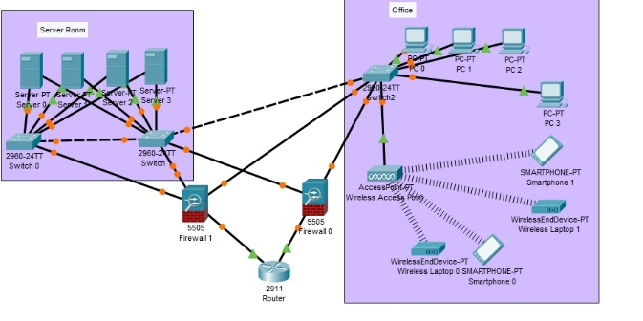
Packet Tracer
In this Packet Tracer example of the network I have designed for Hyper-fort, there are 4 servers, 2 firewalls, 3 switches, 4 wired PCs, 2 wireless smartphones, 2 wireless laptops and 1 router. The router will automatically assign each device that connects to the network with a unique IP Address, using Dynamic Host Configuration Protocol (DHCP). In the event of a connection or one of the switches connected to the servers going down, there is a second switch with its own set of connections available to take over, which serves as redundancy. There are also 2 firewalls connected to the network, which will be used to protect the network from external attacks, with each serving as redundancy in the event of the other deactivating or losing connection. Finally, there is a switch that connects 4 PCs and a wireless access point, which can connect to multiple wireless devices, including smartphones and wireless laptops. One advantage of the system is that it would be quite simple for a user to add a set of devices for an extra office. One drawback of the system, however, is that, due to the wireless access point and the wired PCs only having one connection port each, should Switch 2 deactivate or lose connection, all of the devices will also lose connection to the network.
Data Flow Diagrams
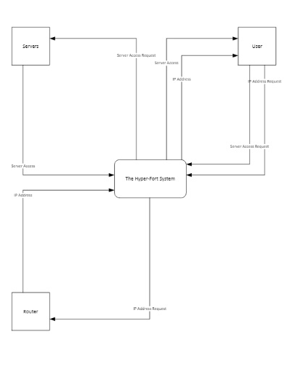
In this Data Flow Diagram, there is 1 process, the Hyper-fort System, and 3 interfaces, User, Servers and Router. The ‘User' interface interacts with the ‘Router’ interface and the ‘Servers' interface, the ‘Servers’ interface only interacts with the ‘User' interface and the ‘Router’ interface also only interacts with the ‘User' interface. The ‘User' interface interacts with the ‘Router’ interface as it requests that the ‘Router’ interface send it an IP Address, which the ‘Router' interface then accepts the request and sends a unique IP Address to the ‘User’ Interface. The ‘User' interface interacts with the ‘Router' interface as it sends a request for server access, which the ‘Servers' interface then accepts the request and gives the ‘User' interface access to the servers.

References

[1] | "Microsoft". [Online]. Available: https://www.microsoft/en-gb/cloud-platform/microsoft-intune [Accessed 28th December 2018].

