Introducing the Modern Workplace

Name: Angela Nastasiu
Student number: 1907399
Module title: LCBB4003 (IMW)
Assignment title: Structure and Culture (Assessment 1)
Module lecturer’s name: Gregory Cowan

Contents
Introduction 3
Apple Inc’s Structure and Culture 4
Apple Inc’s Structure and Structural Model: 4
Spoke and Wheel Hierarchy: 4
Divisions Based on Product: 5
Feeble Functional Matrix: 5
Apple Inc’s Culture and Cultural Model: 7
Evangelism and Mac Culture: 7
Confidentiality Culture: 7
People Oriented Culture: 7
Culture of Innovation: 8
Risk-Taking Culture: 8
Diversified Culture: 8
Impact of Structure and Culture on Apple Inc 9
Conclusion 10
Reference 11

Introduction
A company's structure and culture define how the company is doing its business and how the company is interacting with its different parties like employees, partners, consumers, shareholders, etc. Basically, a company's structure and culture are known as the foundation of any company. The structure of a company mostly talks about the rules and regulations and its strategies whereas the culture talks about the etiquette, manner, and values of the employees, guidelines and it sets the limitations and expectations. If a company has a strong structural and cultural model then it tends to make better results than those companies that have weaker structure and culture going on inside the company (Hinton, 2017). A company’s structure directly makes an impact on its culture because of the position of individual people inside the structure. So, it can be said that a company’s structure and culture compliments each other. For a successful company like ‘Apple’, it is very important to preserve its structure and culture to make the best use of its expectations. Apple follows its own structural and cultural model to maintain its quality, reputation, and fame among its consumers. In this assignment, the structure and culture of a company and its importance will be discussed.

Apple Inc’s Structure and Culture

Apple Inc’s Structure and Structural Model:
A company's structure is the platform that is used to decide how the information will flow between the various levels of management. It also consists of many sectors that eventually contribute to the whole goals and expectations of a company. As it is known to all that Apple Inc is one of the most successful multinational technology companies based on America. Being a multinational company it is not easy for Apple to set up its structure because the services and products of it are consumed by a large number of people globally. To maintain its quality and fame among its different parties including consumers, Apple has to follow its structural model (Goudarzi, Far, and Far, 2015). Apple makes sure that the information spreads evenly among the employees working for this very company. Thus, they will be ensured about their quality and goals globally. Just like any other company Apple Inc also follows the Hierarchical Structural Model primarily with a significant divisional characteristic and feeble functional matrix. The Hierarchical Structural Model consists of (1) Hierarchy (Spoke and wheel), (2) Divisions based on the product, and (3) Feeble Functional Matrix.

Spoke and Wheel Hierarchy:
Various multinational companies follow the Hierarchy Structural Model because it helps reduce the communication gap between general employees and the people of higher levels. As a result, the company can reach its goals within a short period of time. In 1976, Apple was founded by three young entrepreneurs named Steve Jobs, Ronald Wayne, and Steve Wozniak. Despite having the three co-owners, Steve Jobs used to make all the major decisions at the beginning. But, later on, when the company was under the leadership of Tim Cook (Former Chief Operating Officer of Apple), the hierarchy model of Apple has slightly changed (Dempsey, 2011). The company started to communicate and have more collaboration with the different parts of the company. After that, the company started to hire different leaders for each of its sections. For example, a senior vice president for different sections such as marketing, retail, management, etc.
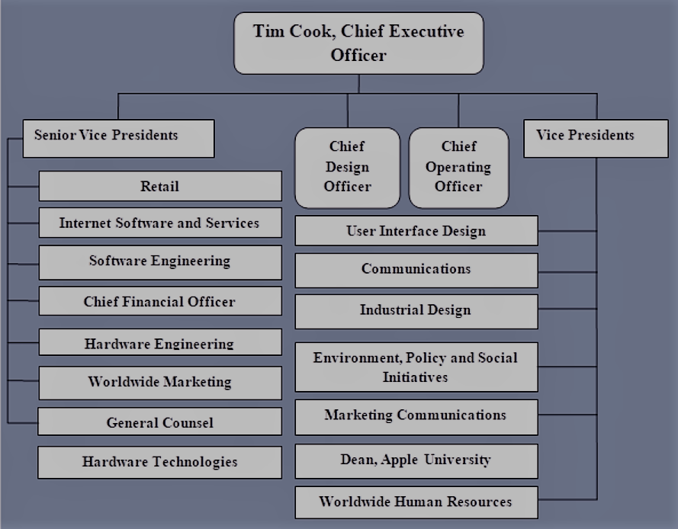
Figure 1: Tim Cooks Spoke and Wheel Hierarchy Model

Divisions Based on Product:
The higher and lower stages of Apple Inc’s corporate structure have divisions that are product based. This division is a part that directly comes from the company's structure and divisional type. Apple Inc has a different leader leading their different parts of the company. For instance, Apple has a senior vice president for both Software Engineering that includes iOS/ macOS and Hardware Engineering that includes iPhone, iPad, Mac, iPhone, etc, technologies, hardware components, and so on (Garfinkel, 2013). These divisions which are based on products help Apple reach its customers, expectations, and targets.

Feeble Functional Matrix:
Apple Inc. has a weaker functional matrix than most other multinational companies. Which means it has mutual communication among the different stages of the company. In a feeble functional matrix, the higher-ranked management controls the project directions whereas the project leaders have restricted power. For instance, the hardware engineering team is allowed to work with the software engineering team. In this way, Apple Inc can be more innovative when it comes to introducing new items and it is considered as the most important business strength (Alsaleh and Haron, 2016). For this reason, Apple Inc can continue producing new and innovative products, and thus it will also support brand progress.

Apple Inc’s Culture and Cultural Model:
A company’s culture is known to be the only aspect that makes a company unique from the others. Starting from products, marketing ideas, innovations, plans, and goals, all these can be duplicated. But, for a company, the norms, and values, personality and culture make them different from other companies. A strong and positive organizational culture can not only help the company reach its shareholders' expectations but also differentiates a business in a positive way from its competitors. Apple Inc is a multinational company. Since its service is spread globally its workforce is pretty huge. So, here the company’s culture plays a big role in motivating its employees (Setiyaningrum, 2015). Apple's cultural characteristics help the company helps the company be innovative, develop its products, and maintain its standards. The main characteristics of Apple Inc's culture are given below:

Evangelism and Mac Culture:
In the year 1983, Apple Inc hired a marketing specialist named Guy Kawasaki as a ‘Product Evangelist. He invented and introduced the company with the latest computer named 'Mac'. That newly invented computer changed the whole idea of the computer for Apple Company. Later on, it became so popular among its consumers globally and it became one of the most valuable assets for Apple.

Confidentiality Culture:
Apple Inc has some kind of apps that gives access to only Apple employees. These apps are only made for its employees and have a high privacy system. "Apple Connect" is one of them. These apps let the employees be more innovative towards their products.

People Oriented Culture:
Apple gives services to both its employees and consumers. It gives its customers a wide range of discounts which makes the customers be more interested in their services. Besides, the company introduces various insurance policies to the products that its customers buy so that the customers can invest in Apple's product without having any risk (Bowers and Martin, 2007). It also pays attention to its employees' insurance policies. Besides, Apple also pays heed to the fitness of its products as well as of its employees.

Culture of Innovation:
Apple is known for introducing innovative products in the market now and then. In today's world, Mouse is a very common input device of the computer. And it was one of the early inventions of Apple USA. It has made the computer operation easier for its users.

Risk-Taking Culture:
With bigger risk comes a bigger profit. Apple is always prepared for taking risks. A decade ago, Apple Inc entered the Indian Market with its new innovation named "iPhone 3G” which means iPhone with 3G network connection, knowing it could be a big risk for them. But later on, they succeeded and 3G Network became widely used in the Indian Sub-continent.

Diversified Culture:
Apple Inc is an international company with a huge workforce. The Apple company’s staff consists of 69% male and 31% female working for them. It also has a 54% white people, 8% black people, 18% Asian people, 11% South American people, 1% of others and 6% of them are undefined.
Apple Inc's strong and positive culture has helped the company be more diversified and ensure its top-notch excellence. Organizational culture makes the company unique to its competitors.

Impact of Structure and Culture on Apple Inc
A company's structure and culture play a big role in influencing different parties related to the company. The company's structure and culture support its employees working for them and gives them the opportunity to speak up and be more communicative and innovative. Other than that, the Company's culture shows how powerful their individuals are as well as a whole team and a company's structure defines the power of leadership, communication, and influences.
A positive company's structure connects from the higher-ranked leader to the normal workforce. The structure of a company decided the growth, innovation, and progress of the company. A company's structure consists of its purpose, goal, employee-leader relationship, professional side, expansion, innovation, and so on. Apple Inc. is a multinational company that has a powerful and positive structure. Its structure includes the company's goals, work priority, targets, standards, and strategic objectives. Apple's hierarchical structure helps the company avoid unstructured and informal management. It also helps the employees be more flexible towards their work (Yatsenko and Balykov, 2019). Apple’s organizational structure also helps the company make a good relationship between the workforce and the leader leading them. There is never any communication gap. It increases the work priority in the employees and as a result, Apple can be able to produce innovative and new goods to its consumers. Apple never compromises in its products and it is only possible because of the structural method that they follow.
Apple Inc's culture is a combination of innovation, progress, creativity, and excellence. The company's culture means the basic set of behavior, attitude, and values that help a company decide what target it sets and how it will operate. Apple Company’s culture plays a big role in motivating its employees and so the employees get more interested to come to work every day. The culture also determines company engagement. Apple Inc's positive organizational culture helps avoid bad management such as heavy workload because of bad work-time management, lack of concentration, impractical deadlines, and so on (Pietruszka-Ortyl, 2019). The positive culture of Apple Inc also helps the employees avoid communication lacking. Lastly, it also makes the workplace a better one so that employees don't hesitate about being comfortable and be innovative. Apple Company's encouraging and optimistic culture is one of the reasons that make the company unique and innovative than other ones.

Conclusion
A company's structure and culture reflect the company's progress, innovation, work ethics, value, and mentality. The structure and culture of a company are interrelated. As Apple Inc is a worldwide company, it has a large number of consumers, shareholders, workforce, products and so on. Apple has a positive structure and culture and it affects the company and its production in a positive way (Xiu, 2017). The strong structure of Apple helps the employees not only communicate but also it gives them opportunities to be more innovative and launch new products every year. Besides, the culture of Apple Inc makes the shareholder more interested in investing in the company. Apple Inc’s own structural and cultural method is the reason that helped them grow in no time.

References
Hinton, D., 2017. Creating Company Culture: Oil Company Camps in the Southwest, 1920-1960. Southwestern Historical Quarterly, 111(4), p.vii-387.
Goudarzi, M., Far, K. and Far, A., 2015. Function and Structure of European Economic Interest Group and Its Structural Difference with Multinational Companies. Asian Social Science, 11(5).
Dempsey, P., 2011. News analysis: Life after Steve Jobs: however will Apple manage without him?. Engineering and Technology, 6(9), pp.20-21.
Garfinkel, S., 2013. Book Review: iPhone and IOS Forensics: Investigation, Analysis, and Mobile Security for Apple iPhone, IPad, and IOS Devices. Journal of Digital Forensics, Security, and Law.
Alsaleh, S., and Haron, H., 2016. The Most Important Functional and Non-Functional Requirements of Knowledge Sharing System at Public Academic Institutions: A Case Study. Lecture Notes on Software Engineering, 4(2), pp.157-161.
Setiyaningrum, A., 2015. Can the good corporate ethics statements and corporate social responsibility create positive consumer responses on the company and its products? An empirical finding in the case of controversial company. Journal of Management and Business, 12(2).
Bowers, M., and Martin, C., 2007. Trading places redux: employees as customers, customers as employees. Journal of Services Marketing, 21(2), pp.88-98.
Yatsenko, R., and Balykov, O., 2019. Optimization of a service it company’s business processes functional structure. Development Management, 17(1), pp.35-50.
Pietruszka-Ortyl, A., 2019. The impact of organizational culture for company's innovation strategy. Marketing and Management of Innovations, (3), pp.178-192.

