

MODULE CODE: Digital Skills for Personal Development and Business Growth BMSW4008

ASSESSMENT COMPONENT: PORTFOLIO

STUDENT NAME: Abdulhafid Ben-Saoud

STUDENT NUMBER: 1501879

LECTURER: Philippa Fitzgerald

DATE:03/12/2025

Contents
Task 1 3
Assessment of Digital Skills 3-5
References 6
Task 2 7
LinkedIn Learning Certificates for Office365 7
Task 3 7
Essay on Relevance of Excel in professional and personal life. 7-10
References 11
Task 4 12
7 Minute Reflective Presentation 12-16

AI acknowledgment, I used Chat GPT to proofread my assignment and give me feedback on what’s good and what could be improved

Task 1

Assessment of Digital Skills
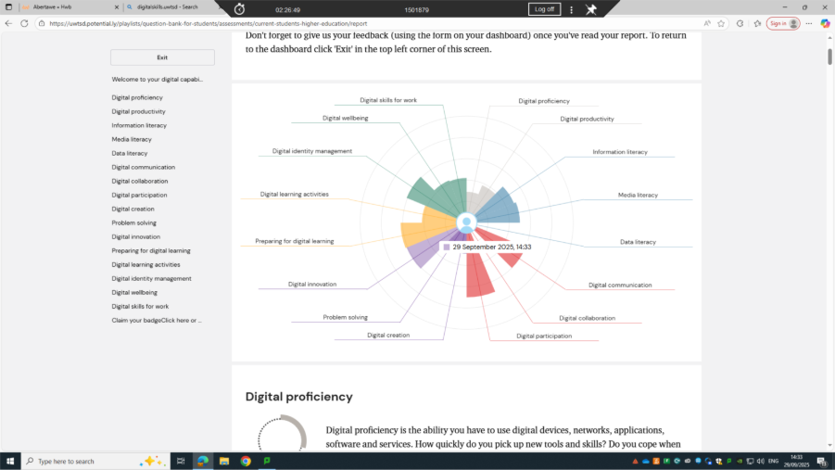
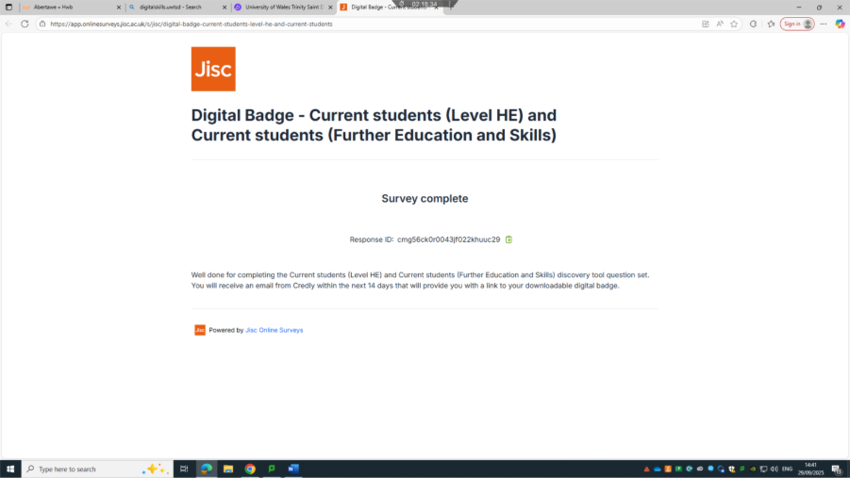
During this term, I have learned a wide range of digital skills that have made me much more confident in using technology for my studies. One of the first things we focused on was Moodle. I logged in using my student number and explored my module. At first, it was a bit confusing, but with practice, I started to move around the platform more easily. I also found where the student support resources are, which is really helpful because I now know where to go if I need assistance. One of the first tasks on Moodle was the Jisc digital capability self-assessment. Completing this activity helped me understand my strengths and areas for improvement, and I earned a digital badge for finishing it. I learned how to save the badge in a Word document so I could include it in my assignments, which made me feel proud of my achievement.
After Moodle, we moved on to Outlook. We learned how to access our emails through Moodle and how to manage the inbox effectively. A big part of this was understanding how to write clear, polite emails and making sure I sent them to the right person. I also explored the Outlook calendar, which was very useful. It reminded me of my class times and locations and using it helped me feel more organised and prepared for my lecture days. I found that having all my tasks and deadlines in one place reduced stress and made it easier to keep on top of my workload.
Another key part of the course was learning about artificial intelligence (AI). We discussed tools like ChatGPT and Notebook LM and explored how to use them responsibly. I learned how to ask effective questions, search for information properly, and make sure I still include my own ideas in assignments. AI can be a great support for learning, but it must be used carefully and ethically. I have started using ChatGPT to proofread my work, which has improved my confidence in writing and helped me check for errors without changing my ideas.
We also worked on Microsoft Word and OneDrive. I learned how to save my work online, which keeps it backed up and allows me to access it from any device. I also learned how to organise folders and adjust settings to keep documents tidy and easy to find. PowerPoint was another area where I gained new skills. I learned how to create a presentation from scratch, insert pictures, videos, and audio, and apply transitions across multiple slides. This made my presentations look more professional and creative, and I enjoyed experimenting with the different features to make my work visually engaging.
Working with spreadsheets was both challenging and rewarding. We practiced using formulas like SUM and AVERAGE and created simple spreadsheets from scratch. Initially, it felt a bit confusing, but once I understood the formulas, I found it easier and even enjoyable. I realised that spreadsheets are incredibly useful for planning, budgeting, and organising information, and the skills I learned can be applied in many areas of life.
We also explored how to create surveys and turn them into QR codes, which makes them easy for others to access on their phones. This helped me see how digital tools can make collecting information faster and more efficient.
Towards the end of the term, we explored LinkedIn Learning. I set up a professional profile, connected with others, and completed a short course that gave me a certificate. This experience showed me how I can continue developing skills online and highlighted the importance of having a strong professional presence for future careers.
Overall, this course has been very valuable. I feel more confident using a variety of digital tools, and I can see how they support both my studies and my future career. Learning how to use Moodle, the Jisc activity, Outlook, Word, PowerPoint, spreadsheets, surveys, AI, and LinkedIn Learning has made me more organised, independent, and capable. These skills will continue to be useful as I progress in my education and prepare for professional life. I now understand that digital literacy is not just about knowing how to use tools but also about using them thoughtfully, creatively, and responsibly to achieve better outcomes.

References
Anderson, T.D., Ogruk Maz, G. & Bell, III, T.J. (2025) ‘Enhancing Digital Literacy in Higher Education: A Comprehensive Analysis of Digital Skill Development Among College Students’, Journal of Higher Education Theory and Practice, 25(3).
Bruckhaus, A.A., Bennett, A., Brawer Cohen, M., Sinclair, M., Ramirez De La Cruz, G., Ragusa, G. & Duncan, D. (2024) ‘Evaluation of students’ digital literacy through an immersive university–high school collaboration’, Frontiers in Education, 9, Article 1429893.
Choi, S. (2023) ‘Improving Student Digital Organization and Communication Skills with Email and Calendar Tools’, International Journal of Educational Technology in Higher Education, 20(2), Article 12.
Jisc (2023) Digital Capability Framework and Self-Assessment. Available at: https://www.jisc.ac.uk/digital-capability (Accessed: 2 December 2025).
Smith, E.E. (2023) ‘Practical Digital Literacies in Higher Education: Using Word and PowerPoint Effectively’, Education and Information Technologies, 28, pp. 3057–3075.
Walter, Y. (2024) ‘Embracing the Future of Artificial Intelligence in the Classroom’, International Journal of Educational Technology in Higher Education, 21, Article 15.

Task 2

LinkedIn Learning Certificates for Office365
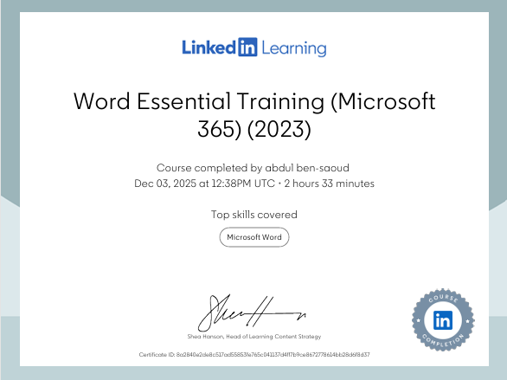

Task 3

Essay on Relevance of Excel in professional and personal life.
Introduction
Microsoft Excel is one of the most widely used digital tools due to its flexibility, functionality, and accessibility. Its ability to organise, analyse, and visualise data makes it essential in both professional and personal contexts. In workplaces, Excel supports budgeting, financial planning, reporting, and data-driven decision-making. In personal life, it assists with household budgeting, event planning, and tracking individual goals. Through completing spreadsheet exercises, reflective tasks, and online Excel courses, I have gained practical experience that demonstrates Excel’s relevance in real-world situations. This essay examines how Excel is applied professionally and personally, discusses its benefits and limitations, and reflects on how using Excel improves digital competence.

Professional Applications of Excel
Excel is fundamental in many professional environments, especially within finance, accounting, business analysis, and project management. Its wide range of functions—such as SUM, IF, and AVERAGE—along with pivot tables and data-filtering tools, enables users to process and interpret large datasets efficiently (Microsoft, 2024). These features support accurate calculations and help organisations make informed decisions more quickly.
One of Excel’s most important professional uses is financial planning. Businesses rely on spreadsheets to create budgets, monitor expenditure, and forecast future revenue. Scenario modelling and what-if analysis allow managers to test different assumptions and evaluate potential outcomes, making Excel a practical tool for strategic planning (10XSheets, 2023). Small and medium-sized enterprises (SMEs) particularly value Excel because it offers robust analytical features without the cost associated with advanced financial software. As a result, Excel supports financial accuracy, data organisation, and improved workflow efficiency (Tawil et al., 2024).
Excel is also widely used for reporting and presenting data. Charts, graphs, and dashboards help translate complex information into clear visuals that can be understood by stakeholders with varying levels of technical skill. These features are especially valuable in professional meetings or performance reviews. Automation through macros allows organisations to reduce repetitive tasks, saving time and limiting the risk of human error (Microsoft, 2025).
Advanced tools such as Power Query and Power Pivot further enhance Excel’s usefulness by allowing the integration of multiple datasets and the creation of analytical models. These features transform Excel into a lightweight business intelligence tool and support more advanced forms of analysis without requiring specialist software (Akrem & Maspul, 2024).
Despite its advantages, Excel does have limitations. Because spreadsheets depend heavily on manual entry, they are vulnerable to human error, such as incorrect formulas or inconsistent data. Mistakes of this kind can impact the reliability of reports and decision-making (Phys.org, 2024). Version control also becomes problematic in collaborative settings. To address these challenges, organisations often introduce governance frameworks such as template validation, peer review, and controlled access (EuSpRIG, 2024). These practices help maintain data integrity and ensure Excel remains a dependable tool.

Personal Applications of Excel
Excel is equally valuable in personal life, where it improves organisation, planning, and financial management. One of the most common uses is household budgeting. Individuals can track income, expenses, and savings, while simple functions such as SUM and AVERAGE make financial calculations easy. Conditional formatting helps highlight overspending or progress toward savings goals, making budgeting more visual and engaging (Microsoft, 2024).
Excel is also useful for event planning. Whether preparing for a birthday, holiday, or family celebration, spreadsheets help manage tasks, timelines, and budgets. Colour coding and checklists create a clear overview of progress and ensure important details are not overlooked. This makes Excel a practical tool for personal organisation.
Goal tracking is another area where Excel supports personal development. Spreadsheets can monitor fitness routines, academic study schedules, or hobby progress. Creating charts and graphs provides visual motivation by displaying improvements over time (10XSheets, 2023). Pivot tables can also summarise weekly or monthly progress, helping individuals stay on track.
Using Excel regularly also strengthens personal data literacy. Working with formulas, charts, and structured tables helps individuals become more confident with data and digital tools. These skills are directly transferable to professional environments and contribute to greater digital competence and employability (Tawil et al., 2024).

Learning and Skill Development Through Excel
Practical experience this term, including creating income and expenditure spreadsheets, helped me develop confidence in using formulas, charts, and data-organisation features. These tasks demonstrated how Excel supports accuracy and efficiency in both personal and professional situations.
Reflective notes created alongside the spreadsheets emphasised the importance of structured data entry, clarity, and validation. Good spreadsheet design reduces error rates and improves reliability. Completing online Excel courses also strengthened my understanding of pivot tables, conditional formatting, and data visualisation techniques (Akrem & Maspul, 2024). Overall, these learning experiences expanded my digital competence and prepared me to use Excel effectively in future work and personal tasks.

Advantages and Limitations of Excel
Excel offers several advantages. It is widely accessible, easy to learn, and highly versatile. It supports data manipulation, automation, and integration with other Microsoft Office applications. Cloud-based sharing through OneDrive also improves collaboration and allows multiple users to edit a spreadsheet simultaneously (Microsoft, 2025). Visualisation tools make data easier to understand and communicate.
However, Excel still has limitations. It is vulnerable to human error, and complex spreadsheets can become difficult to manage (Phys.org, 2024). Large datasets may also cause performance issues (Oracle, 2024). Organisations and individuals can reduce these risks by using validation rules, structured workflows, and peer reviews to ensure accuracy (EuSpRIG, 2024).

Conclusion
Microsoft Excel remains highly relevant in both professional and personal settings. Professionally, it supports budgeting, financial forecasting, reporting, and decision-making. Personally, it helps with budgeting, event planning, and goal tracking. Through practical exercises and online learning, I have developed skills that demonstrate Excel’s versatility and importance. Although Excel has limitations, structured practices and careful design can minimise errors. Overall, Excel is a powerful tool that enhances organisation, productivity, and informed decision-making across a wide range of real-world situations.

abdulhafids excel assignment

References
Akrem, A.M. & Maspul, K.A., 2024. Excel as a sustainable accounting solution for SMEs: a case study of Bash Coffee Buraydah. Jurnal Manajemen, Akuntansi dan Rumpun Ilmu Ekonomi, 3(1), pp.1–15.
10XSheets, 2023. The importance of Excel in business. Available at: https://www.10xsheets.com/blog/importance-excel-business/ [Accessed 2 Dec. 2025].
EuSpRIG, 2024. Proceedings of the EuSpRIG 2024 Conference: Spreadsheet Productivity & Risks. Available at: https://eusprig.org/wp-content/uploads/eusprig-proceedings-2024.pdf [Accessed 2 Dec. 2025].
Microsoft, 2024. Analyze business data in Excel. Available at: https://learn.microsoft.com/en-us/dynamics365/release-plan/2024wave2/finance-supply-chain/dynamics365-finance/analytics-analyze-business-data-excel [Accessed 2 Dec. 2025].
Microsoft, 2025. Track and analyse business data in Excel. Available at: https://support.microsoft.com/en-gb/office/track-and-analyze-business-data-6ac0bf17-b773-4e10-b1a5-e3468ae54a0c [Accessed 2 Dec. 2025].
Phys.org, 2024. Study finds 94% of business spreadsheets have critical errors. Available at: https://phys.org/news/2024-08-business-spreadsheets-critical-errors.html [Accessed 2 Dec. 2025].
Oracle, 2024. 10 Common Spreadsheet Risks and Solutions for Businesses. Available at: https://www.oracle.com/uk/business-analytics/spreadsheet-risks/ [Accessed 2 Dec. 2025].
Tawil, A.R., Mohamed, M., Schmoor, X. & Haidar, D., 2024. Trends and Challenges Towards Effective Data Driven Decision Making in UK SMEs: Case Studies of 85 SMEs. Big Data and Cognitive Computing, 8(7), pp.1–15.

Task 4

7 Minute Reflective Presentation






