

Student Name- AMI PATEL
Student Number- 2508221
Module Title: Population Health and Digital Health Promotion
Module code: LCHS7009
Lecturer’s name-Dr Besty Jose
Assignment Title: MSc Public Health and Social Care in Practice

Table of Contents
Blog 1 3
Title 3
Influence of AI in Addressing and Curing Type 2 Diabetes 3
Advantages 5
Disadvantages and mitigation strategy 6
References 7
Blog 2 9
Title 9
Introduction 9
Description of the new digital technology for promoting health 10
Advantages 10
Disadvantages and Mitigation Strategies 11
References 12

Blog 1

Title
AI-Enabled Glucose Monitoring as a Digital Health Promotion Tool for Type 2 Diabetes in the UK: A Critical Evaluation
Type 2 Diabetes is a chronic disease in which the patient’s body becomes resistant to insulin and causes an extreme surge in blood sugar levels (Lu et al., 2024). It is seen that one in every five UK adults is now diagnosed with type 2 Diabetes. 4.6 million UK people have diabetes, a 4.4 million increase than 2024 (Gregory, 2025).
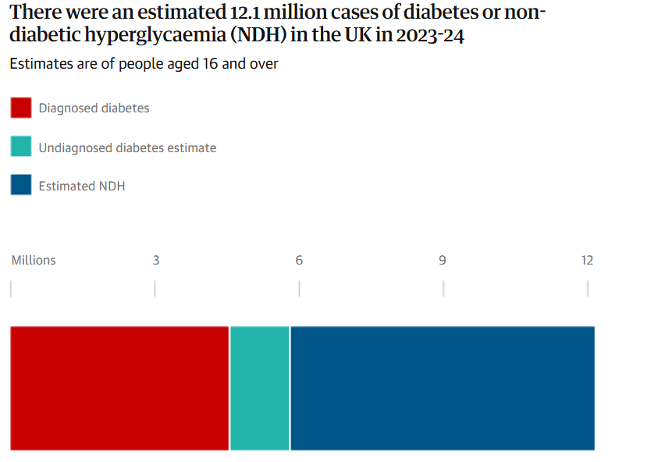
Figure 1: Type 2 Diabetes cases found in the UK in 2025
(Source: Gregory, 2025)
It is a serious health issue that damages blood vessels and nerves of the human body. Sometimes it leads to chronic heart disease and even cardiac failure. Also, it leads to chronic kidney disease and vision loss (Kautzky-Willer et al., 2023). It is seen that, due to the disease, 2909 patients face heart failure each week only in England (Thomas, 2025). This makes the disease a burning health concern in the UK.

Influence of AI in Addressing and Curing Type 2 Diabetes
AI helps address and monitor the health issues related to type 2 diabetes. Moreover, It helps to assist the diabetes patient to get real-time health information and assess the health risks in advance (Guan et al., 2023). According to Social Cognitive theory, an individual’s behaviour is influenced by observation, learning, and environmental factors (Han et al., 2025). AI-based Glucose monitors help monitor and predict fluctuations in glucose levels (Khalifa and Albadawy, 2024). Also, AI helps improve accuracy in diabetes-related medical imaging, and AI personalises insulin dosing and diabetes treatment (Khalifa and Albadawy, 2024). Thus, it helps to influence treatment patterns and influence the change in dietary behaviour of patients, promoting health.
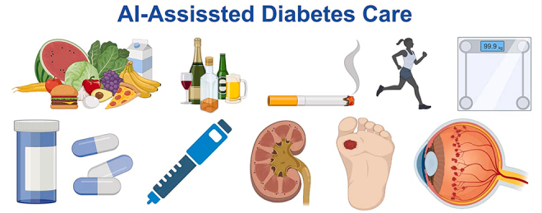
Figure 2: AI-assistance in Diabetes
(Source: Guan et al., 2023)

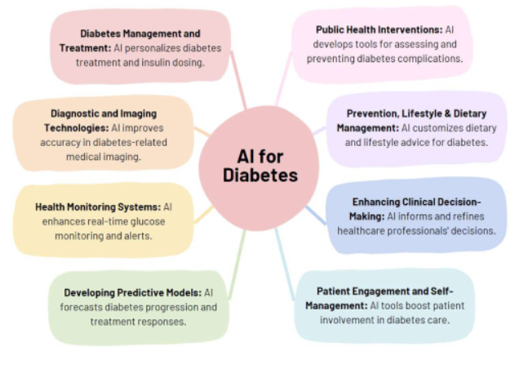
Figure 3: AI in Diabetes Management
(Source: Khalifa and Albadawy, 2024)
Over 200,000 people in the UK with diabetes are getting benefits from real-time CGM or continuous glucose monitoring (Chamber, 2024). In addition, the UK Glucose Monitoring Devices market size is USD 532.2 million in 2024 and is expected to grow at a CAGR of 15.5% from 2025 to 2033 (Grand View Research, 2025).
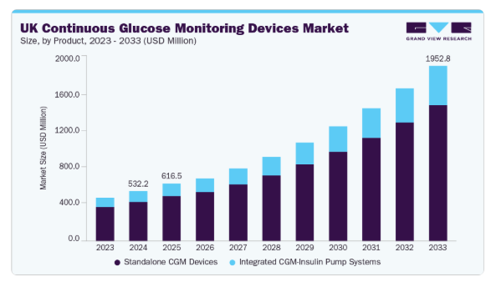
Figure 4: UK Continuous Glucose Monitoring Devices Market 2025-2033
(Source: Grand View Research, 2025)
Therefore, the technology is very beneficial for improving patient health and assessing risks in advance.

Advantages
- AI algorithms help provide 24/7 personalised health services to consumers in the form of monitoring devices and smart wearables.
- It helps in assessing the health-related risks, like Type 2 Diabetes, and acts as a fitness reminder.
- By incorporating AI in healthcare, physicians make better-informed, accurate, and real time insights, which is a time flexible and cost efficient method in healthcare (Traylor et al., 2025).
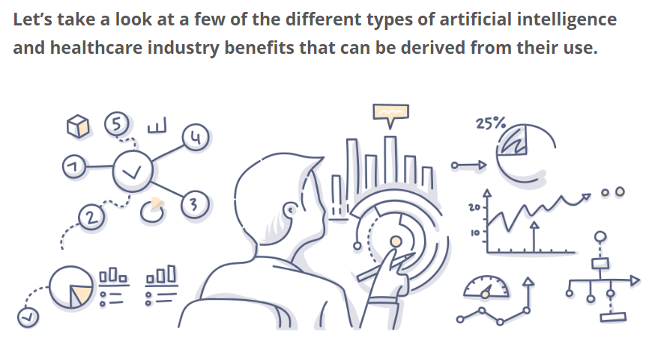
Figure 5: AI in Health Care
(Source: Foreseemed, 2026)

Disadvantages and mitigation strategy
- AI algorithms cannot detect human health irregularities, like hormonal disbalance, stress, or irregular routines, which are the factors that influence glucose levels.
- Also, overreliance on AI suggestions without proper clinical approval can lead to inaccuracy in readings (Diabetes In Control, 2026).
- Therefore, AI-based CGM raises data accuracy issues, making it a less reliable healthcare device in diabetes management (ZERKOUK et al., 2025).
- Implementing rigorous data validation, continuous data monitoring, and improving data labeling techniques are some ways to address and solve the data inaccuracy issue of AI-based devices, like CGM (Matharasi, 2025).

References
Chamber, L. (2024) Type 2 Diabetes: Continuous Glucose Monitors. UK Parliament. Available at: https://hansard.parliament.uk/lords/2024-11-19/debates/267FF80C-7604-41CD-9E01-3DE8514E7D00/Type2DiabetesContinuousGlucoseMonitors (Accessed: 15 January 2025).
Diabetes In Control (2026) AI for Insulin Management: Letting Algorithms Help—Without Handing Over the Wheel. Available at: https://www.diabetesincontrol.com/ai-insulin-management-tools/#:~:text=Algorithms%20can%27t%20always%20account,Black%2DBox%20Concerns (Accessed: 15 January 2025).
Grand View Research (2025) UK Continuous Glucose Monitoring Devices Market (2025 - 2033). Available at: https://www.grandviewresearch.com/industry-analysis/uk-continuous-glucose-monitoring-devices-market-report (Accessed: 15 January 2025).
Gregory, A. (2025) One in five UK adults have diabetes or pre-diabetes, analysis shows. The Guardian. Available at: https://www.theguardian.com/society/2025/feb/06/one-in-five-uk-adults-have-diabetes-or-pre-diabetes-analysis-shows (Accessed: 15 January 2025).
Guan, Z., Li, H., Liu, R., Cai, C., Liu, Y., Li, J., Wang, X., Huang, S., Wu, L., Liu, D. and Yu, S. (2023) ‘Artificial intelligence in diabetes management: advancements, opportunities, and challenges’, Cell Reports Medicine, 4(10). Available at: https://www.cell.com/cell-reports-medicine/fulltext/S2666-3791(23)00380-4 (Accessed: 15 January 2025).
Han, Z., Song, G., Zhang, Y. and Li, B. (2025) ‘Trust the machine or trust yourself: How AI usage reshapes employee self-efficacy and willingness to take risks’, Behavioral Sciences, 15(8), p.1046. Available at: https://doi.org/10.3390/bs15081046 (Accessed: 15 January 2026).
Kautzky-Willer, A., Leutner, M. and Harreiter, J. (2023) ‘Sex differences in type 2 diabetes’, Diabetologia, 66(6), pp.986-1002. Available at: https://doi.org/10.1007/s00125-023-05891-x (Accessed: 15 January 2025).
Khalifa, M. and Albadawy, M. (2024) ‘Artificial intelligence for diabetes: Enhancing prevention, diagnosis, and effective management’, Computer methods and programs in biomedicine update, 5, p.100141. Available at: https://doi.org/10.1016/j.cmpbup.2024.100141 (Accessed: 15 January 2025).
Lu, X., Xie, Q., Pan, X., Zhang, R., Zhang, X., Peng, G., Zhang, Y., Shen, S. and Tong, N., (2024) ‘Type 2 diabetes mellitus in adults: pathogenesis, prevention and therapy’, Signal transduction and targeted therapy, 9(1), p.262. Available at: https://www.nature.com/articles/s41392-024-01951-9 (Accessed: 15 January 2025).
Matharasi, T. (2025) Fix AI at the Source — 5 Data Accuracy Best Practices Every Leader Should Know. Available at: https://www.cdomagazine.tech/opinion-analysis/fix-ai-at-the-source-5-data-accuracy-best-practices-every-leader-should-know (Accessed: 15 January 2026).
Thomas, T. (2025) Almost a third of deaths from heart disease in England occur in diabetes patients, report finds. The Guardian. Available at: https://www.theguardian.com/society/2025/may/14/almost-a-third-of-deaths-from-heart-disease-in-england-occur-in-diabetes-patients-report-finds (Accessed: 15 January 2025).
Traylor, D.O., Kern, K.V., Anderson, E.E. and Henderson, R. (2025) ‘Beyond the Screen: The Impact of Generative Artificial Intelligence (AI) on Patient Learning and the Patient-Physician Relationship’, Cureus, 17(1). Available at: https://www.cureus.com/articles/304273-beyond-the-screen-the-impact-of-generative-artificial-intelligence-ai-on-patient-learning-and-the-patient-physician-relationship.pdf (Accessed: 15 January 2025).
ZERKOUK, M., MIHOUBI, M. and CHIKHAOUI, B. (2025) ‘Non-Invasive Glucose Monitoring Technologies: A ComprehensiveReview of Wearables, AI, and Emerging Technologies’, Advances in Non-Invasive Glucose Monitoring, pp. 1-28. Available at: https://assets-eu.researchsquare.com/files/rs-7879181/v1_covered_4d00f0f6-cca2-450f-8370-62876facb6a8.pdf?c=1764947370 (Accessed: 15 January 2025).

Blog 2

Title
Designing an IoT-Enabled Digital Health Promotion Intervention to Support Behaviour Change in Type 2 Diabetes in the UK

Introduction
Type 2 Diabetes is a common type of diabetes that causes insulin resistance in the body and becomes a public health concern due to its impact, leading to chronic health issues (Kautzky-Willer et al., 2023). According to a report of 2024, type 2 Diabetes cases have increased by 40% in 5 years under the age of 40 years (The Lancet, 2024).
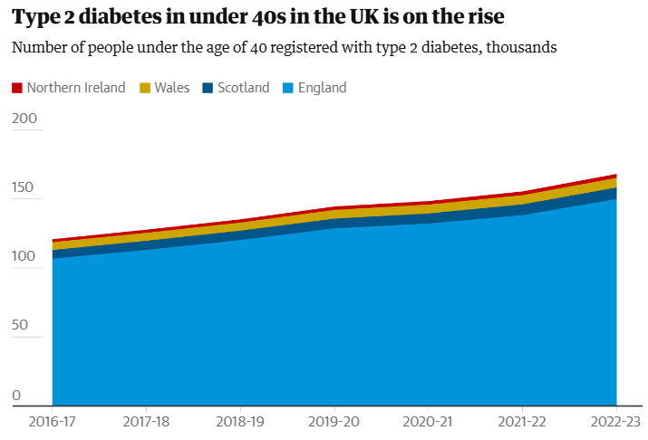
Figure 6: Type 2 diabetes in under-40s in the UK is on the rise
(Source: Gregory, 2024)
Type 2 Diabetes progresses slowly, which is overlooked at the initial stage, as the symptoms cannot be recognised at an early stage (Wester et al., 2024). This makes the disease a health concern in the UK. 57% of UK people would like to have unhealthy food in 2024 (Ozbun, 2025). This leads to obesity, which is a primary reason for the disease among the population. Type 2 Diabetes in under-25 cases rose by 22% in the last 5 years, only in England (BalkanWeb, 2024). This makes the disease a public health concern.
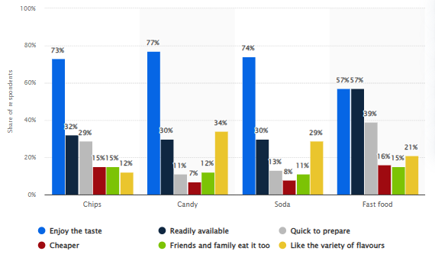
Figure 7: Number of UK unhealthy food consumers in 2024
(Source: Ozbun, 2025)

Description of the new digital technology for promoting health
SmartLifestyle IoT Ecosystem is a synchronised system which connects the day-to-day lifestyle activities, such as movements, sleep and diet, for promoting a sustained behaviour change. This device involves various functions, including a wearable activity tracker, smart glucose sensor, smart food-logging app and mobile app dashboard, which will significantly help a Type 2 Diabetic patient to maintain a healthy lifestyle by supporting in goal-setting, self-monitoring and timely nudges, through the alignment with public health guidance.

Advantages
- The SmartLifestyle IoT Ecosystem will promote sustained behaviour change through real-time self-monitoring, customised nudges and goal-setting, which will ultimately help a Type 2 Diabetic patient in managing their glucose levels, adjusting insulin dosages and improving lifestyle.
- According to the Social learning theory, integrating a new smart IoT Ecosystem will help the patient in enhancing self-efficacy, physical activity and sleep patterns through new habits, which is crucial for Type 2 Diabetic patients (Del-Valle-Soto, 2024).

Disadvantages and Mitigation Strategies
- Though the SmartLifestyle IoT Ecosystem will help a Type 2 Diabetic patient in managing health, however, over-dependency on smart devices can provide negative impacts.
- For example, technical failure or battery drainage can pause health monitoring and may cause loss of critical health data (Alshuhail et al., 2025).
- To mitigate this issue, a cloud system must be incorporated to prevent losses.
- Also, this device can allow unauthorised access to the health data, which can lead to incorrect dosages.
- To mitigate these issues, patients can set a strong and unique password for the app and device, and also should use low-power consumption technologies or systems with early warning functions (Huszti et al.,2022).

References
Alshuhail, A., Alshahrani, A., Mahgoub, H., Ghaleb, M., Darem, A.A., Aljehane, N.O., Alotaibi, M. and Alzahrani, F. (2025). Machine edge-aware IoT framework for real-time health monitoring: Sensor fusion and AI-driven emergency response in decentralized networks. Alexandria Engineering Journal, 129, pp.1349-1361. Available at: https://www.sciencedirect.com/science/article/pii/S1110016825009263 (Accessed: 15 January 2025).
Balkan Web (2024) Type 2 diabetes in under-25s rises 22% in 5 years in England. Available at: https://www.balkanweb.com/en/Type-2-diabetes-in-under-25s-rose-by-22-in-5-years-in-England/#gsc.tab=0 (Accessed: 15 January 2025).
Del-Valle-Soto, C., López-Pimentel, J.C., Vázquez-Castillo, J., Nolazco-Flores, J.A., Velázquez, R., Varela-Aldás, J. and Visconti, P. (2024). A comprehensive review of behavior change techniques in wearables and IoT: implications for health and well-being. Sensors, 24(8), p.2429. Available at: https://www.mdpi.com/1424-8220/24/8/2429 (Accessed: 15 January 2025).
Gregory, A. (2025) One in five UK adults have diabetes or pre-diabetes, analysis shows. The Guardian. Available at: https://www.theguardian.com/society/2025/feb/06/one-in-five-uk-adults-have-diabetes-or-pre-diabetes-analysis-shows (Accessed: 15 January 2025).
Huszti, A., Kovács, S. and Oláh, N. (2022). Scalable, password-based and threshold authentication for smart homes. International Journal of Information Security, 21(4), pp.707-723. Available at: https://link.springer.com/content/pdf/10.1007/s10207-022-00578-7.pdf (Accessed: 15 January 2025).
Kautzky-Willer, A., Leutner, M. and Harreiter, J. (2023) ‘Sex differences in type 2 diabetes’, Diabetologia, 66(6), pp.986-1002. Available at: https://doi.org/10.1007/s00125-023-05891-x (Accessed: 15 January 2025).
Ozbun, T. (2025) Reasons to consume food perceived as unhealthy in the United Kingdom as of July 2024. Statista. Available at: https://www.statista.com/statistics/1497893/reasons-to-eat-unhealthy-food-uk/?srsltid=AfmBOooicM6-yemrs04yy1YJXfqk3NkswfPk0SC6WTgRCeWElXjl4GUh (Accessed: 15 January 2025).
The Lancet (2024) Alarming rise in young-onset type 2 diabetes. Available at: https://www.thelancet.com/journals/landia/article/PIIS2213-8587(24)00161-X/fulltext (Accessed: 15 January 2025).
Wester, A., Shang, Y., Grip, E.T., Matthews, A.A. and Hagström, H. (2024) ‘Glucagon-like peptide-1 receptor agonists and risk of major adverse liver outcomes in patients with chronic liver disease and type 2 diabetes’, Gut, 73(5), pp.835-843. Available at: http://dx.doi.org/10.1136/gutjnl-2023-330962 (Accessed: 15 January 2025).

