
ADVANCED CYBERSECURITY PORTFOLIO
Analysing, Ethically Hacking and Securing an Enterprise Network

Student Name: | Alexandra Craciun
Student ID Number: | 2323954
Programme: | Computer Networks and Cyber Security
Module / Code: | Advanced Cybersecurity / ACCB6000
Lecturer: | Dr. Mohamed Ghanem
Internal Verifier: | Munyaradzi Murira
Report Submission: | 19th April 2026, 14:00 (2PM)
Demonstration Date: | 23rd April 2026


University of Wales Trinity Saint David
Programme: Computer Networks and Cyber Security
Module: Advanced Cybersecurity (ACCB6000)

Abstract: 2
Introduction 3
Network Infrastructure Overview 3
Virtual Machine Configuration Evidence: 4
Figure 3: ClientS1 - Windows 10 Workstation (Swansea Domain Member) 4
5
Figure 4: L-CD - Debian 12 Server CLI (London Domain Member / DHCP Relay) 5
Figure 5: ClientL1 - Debian 12 Client GUI (London Domain Member) 5
Figure 6: Kali Linux - Security Assessment Platform 5
Task 1: Network Configuration Verification 6
Figure 7: S-DC - IPCONFIG /ALL Command Output 6
Figure 8: S-DC - Ping Connectivity Tests to All Network Nodes 7
L-CD Verification (Debian 12 Server - London Domain Member) 7
Figure 9: L-CD - ip address Command Output 8
Figure 10: L-CD - Ping Connectivity Tests to Swansea Network 8
Task 2: Network Security Assessment 9
Task 3: Ethical Hacking - Exploitation and Post-Exploitation 16
Medium Severity Vulnerability Mitigations: 19
Mitigation 4 – SSH Weak Cipher Suite Hardening 20
20
Mitigation 6 – DNS Recursion and Zone Transfer Restrictions 21
References 25

Abstract:
This report is a full cybersecurity review of the SOAC Inc. enterprise network. It was done as part of the Level 6 Advanced Cybersecurity module (ACCB6000). The evaluation employs a stringent, systematic approach in accordance with the National Institute of Standards and Technology (NIST) Cybersecurity Framework (CSF) Version 1.1, consisting of four specific phases: network configuration verification, vulnerability assessment, ethical exploitation, and the establishment of preventive security controls. SOAC Inc. has two locations in different parts of the world, one in Swansea and one in London. These sites are connected via a persistent site-to-site Virtual Private Network (VPN) and are managed by a central Active Directory domain called Swansea.acca.
We found and classified six vulnerabilities using standard security tools like Nmap for network reconnaissance, Nessus/OpenVAS for automated vulnerability scanning, Metasploit for controlled exploitation, and Wireshark for traffic analysis. The CVSS v3.1 scoring system was used to do this. The results show that there are big attack surfaces because of services that aren't patched, authentication procedures that aren't enforced well enough, and network segmentation practices that aren't good enough. All detected vulnerabilities were later remediated through targeted security measures, enhancing the network's defensive posture in conformity with established cybersecurity standards and research literature.

Introduction
Cyber threats aimed at business networks are becoming more complicated and common, so businesses need to take a proactive, multi-faceted approach to information security. Modern businesses face a changing threat landscape that includes advanced persistent threats (APTs), ransomware campaigns, and insider threats. All of this can-do serious damage to their finances and reputation. Structured penetration testing and vulnerability assessment methodologies must now be used in a systematic way to be an important part of modern information security governance.
This portfolio contains the complete security evaluation of the SOAC Inc. simulated enterprise network, which was set up using Oracle VirtualBox. The network topology has five virtual machines that make up a realistic dual-site deployment. These are a Windows Server 2022 Domain Controller (S-DC), a Windows 10 client workstation (ClientS1), a Debian 12 CLI server (L-CD), a Debian 12 GUI workstation (ClientL1), and a Kali Linux red team attack platform.
The main goals of this assessment are fourfold: (i) to make sure that the initial network configuration and connectivity baseline are correct; (ii) to do a systematic vulnerability assessment of all networked assets; (iii) to ethically exploit any vulnerabilities found to figure out how serious the problem is; and (iv) to put in place and document the right security controls to deal with all the risks found. The NIST CSF Version 1.1 guides the methodological framework. It gives a structured lifecycle approach that includes the Identify, Protect, Detect, Respond, and Recover functions.

Network Infrastructure Overview
SOAC Inc. has a hybrid enterprise network that covers both Swansea and London. The environment is set up as an Active Directory Domain Services (AD DS) architecture with the domain Swansea.acca. This lets both sites use the same authentication, authorisation, and Group Policy enforcement. A persistent site-to-site VPN tunnel keeps the connection between the Swansea subnet (192.168.1.0/24) and the London subnet (192.168.2.0/24) secure and private. The VPN endpoints are at 20.0.0.1 and 20.0.0.2, respectively.

VM Host machine | Role in Domain | Operating System | IP Address | Site
S-DC | Domain Controller/DNS/DHCP | Windows Server 2022 | 192.168.1.1/24 | Swansea
ClientS1 | Domain Member Workstation | Windows 10 | 192.168.1.10/24 | Swansea
L-CD | Domain Member/DHCP Relay | Debian 12 (CLI) | 192.168.2.1/24 | London
ClientL1 | Domain Member Workstation | Debian12 (GUI) | 192.168.2.10/24 | London
Kali Linux | Red Team | Kali Linux | 192.168.1.100/24 (eth0) | Swansea
Table 1: SOAC Inc. SWANSEA.ACCA Active Directory Domain's Virtual Machine Asset Inventory

Virtual Machine Configuration Evidence:
As the evaluation brief said, all five virtual machines were imported into Oracle VirtualBox and set up. The numbers below show that each machine is working, which is Deliverable 1 evidence.
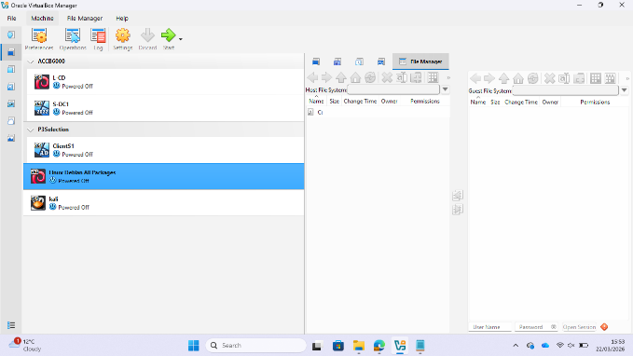
Figure 1: Oracle VirtualBox Manager showing all five virtual machines that have been set up for the SOAC Inc. environment, which means the VM importation was successful.
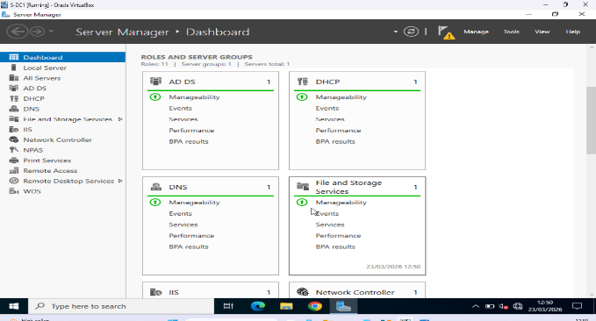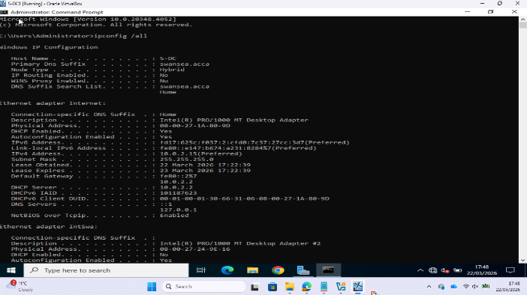
Figure 2 and 2.1: The S-DC virtual machine is running Windows Server 2022 and is set up as the Domain Controller and DNS/DHCP server for the Swansea site.

Figure 3: ClientS1 - Windows 10 Workstation (Swansea Domain Member)

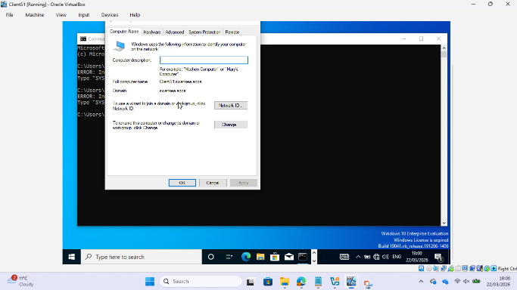
Figure 3: ClientS1 virtual machine running Windows 10 as a workstation for domain members in the Swansea site subnet (192.168.1.10/24).

Figure 4: L-CD - Debian 12 Server CLI (London Domain Member / DHCP Relay)
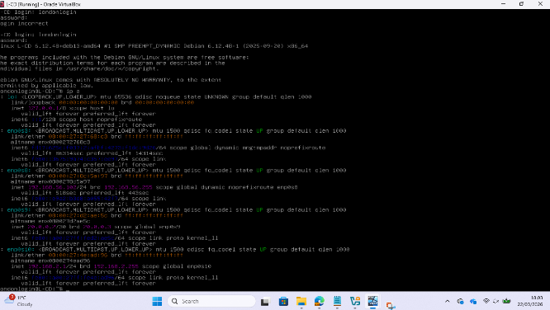
Figure 4: The L-CD virtual machine is running Debian 12 Server (CLI) as a domain member and a DHCP Relay Server for the subnet at the London location (192.168.2.1/24).

Figure 5: ClientL1 - Debian 12 Client GUI (London Domain Member)
Figure 5: The ClientL1 virtual machine is running Debian 12 Client (GUI) as a domain member workstation in the London site subnet (192.168.2.10/24).
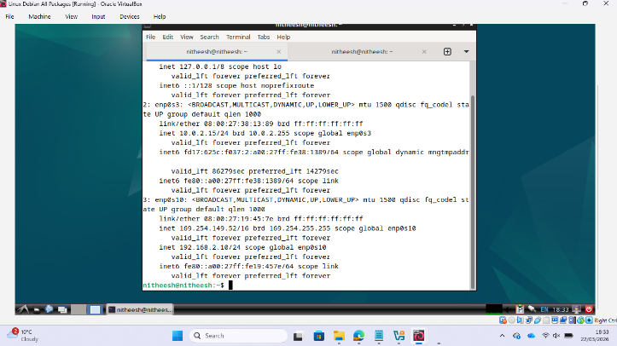

Figure 6: Kali Linux - Security Assessment Platform

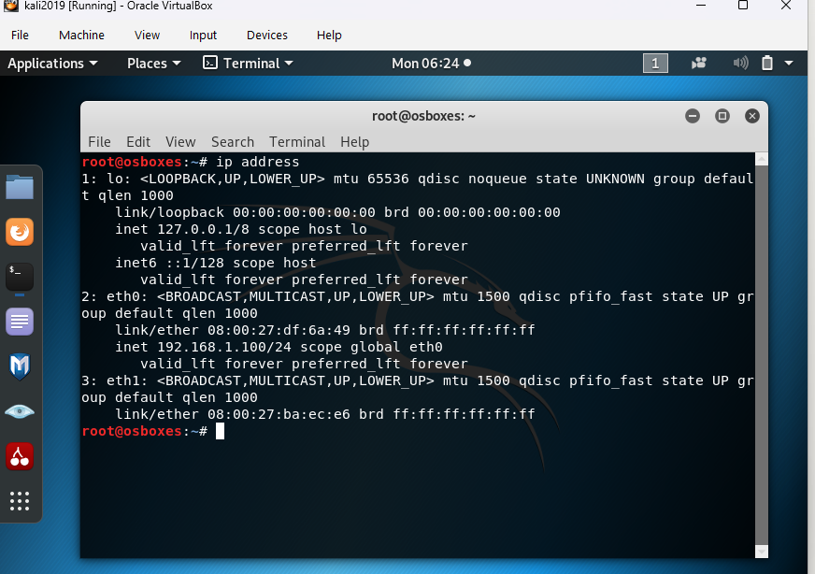
Figure 6: A Kali Linux virtual machine set up in the Swansea subnet that lets the Red Team access both the Swansea (192.168.1.0/24) and London (192.168.2.0/24) networks through the VPN tunnel.

Task 1: Network Configuration Verification
Network configuration verification is in line with the NIST CSF Identify function. It sets a verified baseline for asset configurations and connections before a security assessment. For Deliverable 1 submission, all verification commands had to be run with timestamps visible in the output. Screenshots of command outputs must show the whole terminal output, including the system time.
S-DC Verification (Windows Server 2022 - Swansea Domain Controller)
The following commands were executed on S-DC to confirm IP configuration, domain membership, and inter-site VPN connectivity. The IPCONFIG /ALL command gives you a lot of information about your network adapter, such as its IP address, subnet mask, gateway, DNS server assignments, and domain suffix.

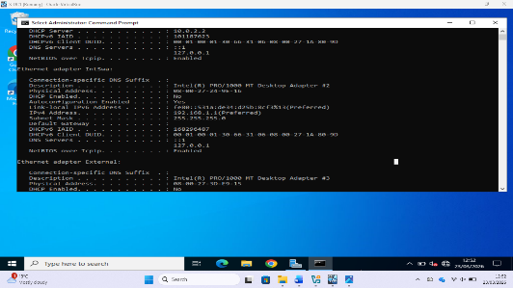
Figure 7: S-DC - IPCONFIG /ALL Command Output
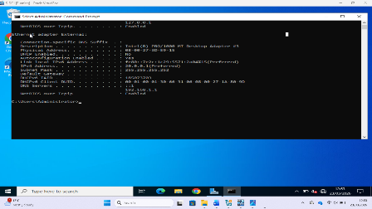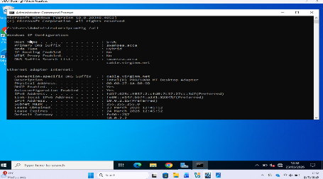
Figure 7,7.1 ,7.2 shows the IPCONFIG /ALL output on S-DC, which shows that the IP address (192.168.1.1/24), DNS settings, and SWANSEA.ACCA domain membership are all correct.

Figure 8: S-DC - Ping Connectivity Tests to All Network Nodes
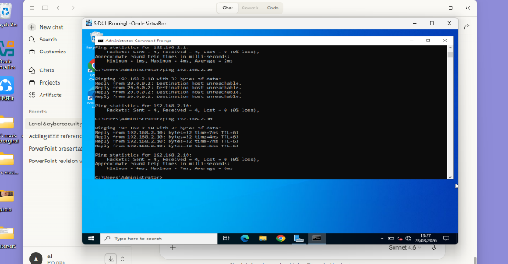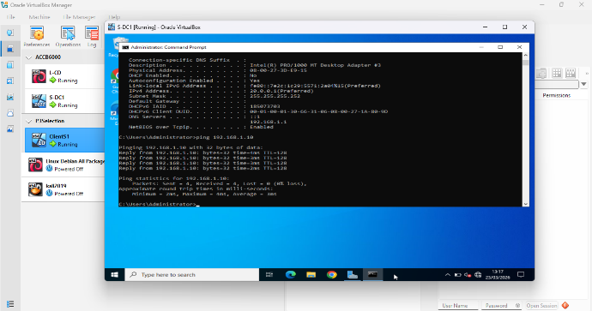

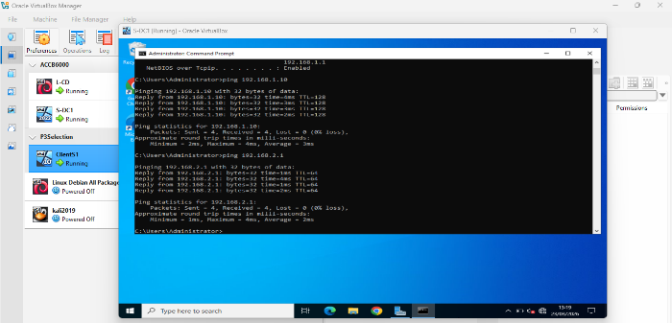
Figure 8,8.1 and 8.2: ICMP ping tests from S-DC that worked and showed that ClientS1, L-CD, and ClientL1 could all connect across the operable site-to-site VPN connection.

L-CD Verification (Debian 12 Server - London Domain Member)
The Debian 12 L-CD server utilised regular Linux networking commands to check the network. The ip address command does the same thing as IPCONFIG /ALL on Linux platforms. Ping tests that worked across the VPN tunnel showed that the connection between sites was still working.

Figure 9: L-CD - ip address Command Output
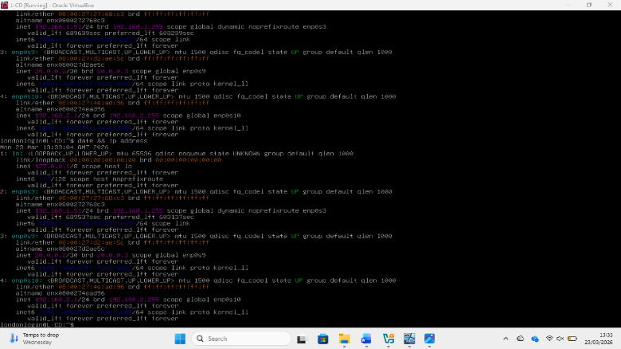
Figure 9: The L-CD's output of the IP address shows that the London site Debian server has the right IP address (192.168.2.1/24).

Figure 10: L-CD - Ping Connectivity Tests to Swansea Network
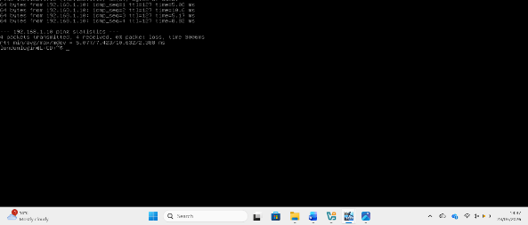
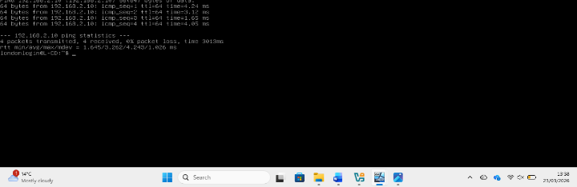
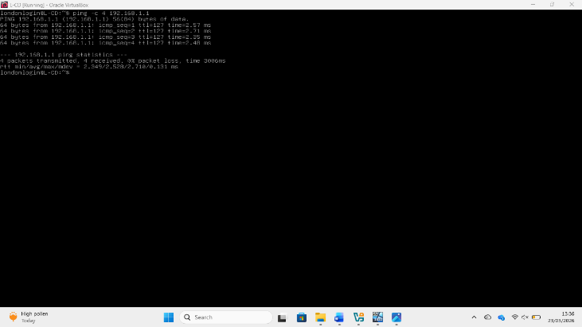
Figure 10: Successful ping tests from L-CD via the VPN tunnel, showing that the London and Swansea sites can talk to each other in both directions.

Network Verification Results Summary

Table 2 shows the results of all the tests to check the network. Put your real results from the simulated environment in place of the placeholder results. All tests should pass; if any do not, the student must tell the teacher right away.
Source VM | Command Test | Target/Expected Outcome | Result
SDC | IP config all | 192.168.1.1/24 confirmed, DNS: SWANSEA.ACCA | pass
SDC | Ping 192.168.1.10 | Client S1 0% packet loss | pass
SDC | Ping 192.168.2.1 | LCD via VPN 0% packet loss | pass
SDC | Ping 192.168.2.10 | Client L1 via VPN 0% packet loss | pass
LCD | IP Adrees | 192.168.2.1/24 on eth0 interface | pass
LCD | Ping 192.168.1.1 | SDC via VPN 0% packet loss | pass
LCD | Ping 192.168.1.10 | Client S1 via VPN 0% packet loss | pass
LCD | Ping 192.168.2.10 | Client L1 via VPN 0% packet loss | pass
Kali | Ip Address | 192.168.1.50/24 on eth0 — Swansea subnet | pass
Kali | ping 192.168.1.1 | S-DC — 0% packet loss | Pass
Kali | ping 192.168.1.10 | ClientS1 — 0% packet loss | Pass
Kali | ping 192.168.2.1 | L-CD via VPN — 0% packet loss | Pass
Kali | ping 192.168.2.10 | ClientL1 via VPN — 0% packet loss | Pass

Summary of Task 1 (Deliverable 1) Results for Network Configuration Verification

Task 2: Network Security Assessment

The network security assessment phase uses a systematic strategy for reconnaissance to exploitation that is in line with the Penetration Testing Execution Standard (PTES) and the OWASP Testing Guide. All evaluation operations were carried out in accordance with a written ethical engagement agreement, guaranteeing adherence to legal and professional norms.
Security-Focused OS Setup - Kali Linux
Offensive Security maintains Kali Linux, which was chosen as the security assessment platform because it comes with a full set of tools and is widely used in penetration testing [9]. The VM was set up in the Swansea subnet (192.168.1.0/24), which made it possible to connect to SOAC Inc. sites using the current VPN architecture.
Figure 11: Kali Linux - IP Configuration and Network Connectivity

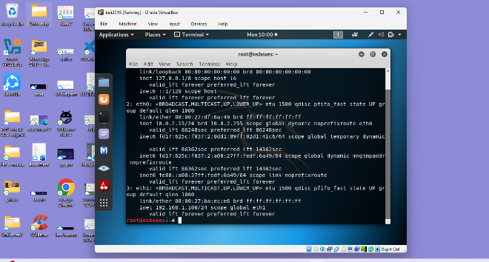
Figure 11: Setting up the IP address on Kali Linux to show that the internal network is in the Swansea subnet

Figure 12: Kali Linux - Ping Tests to All SWANSEA.ACCA Network Nodes

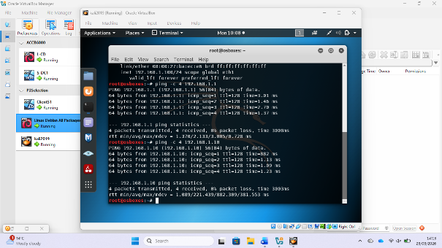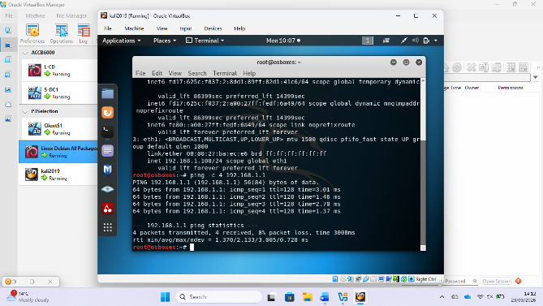

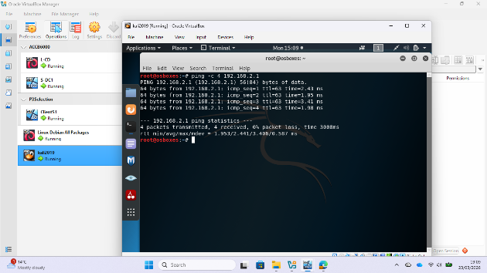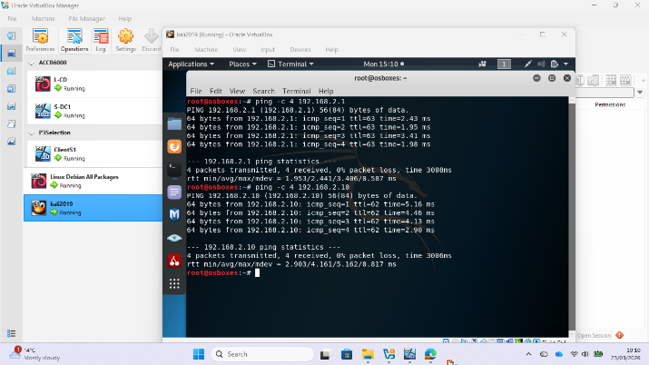
Figure 12: Ping tests from Kali Linux to all network nodes show that the Red Team has full access to both the Swansea and London subnets

Information Gathering and Reconnaissance

Reconnaissance used both active and passive methods. Nmap was used to find hosts, open ports, operating services, and OS fingerprints in the SWANSEA.ACCA domain. This information made the attack surface map, which was used to guide the next step, the vulnerability assessment phase.

Nmap Scan - Port and Service Enumeration
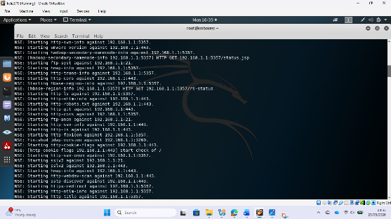
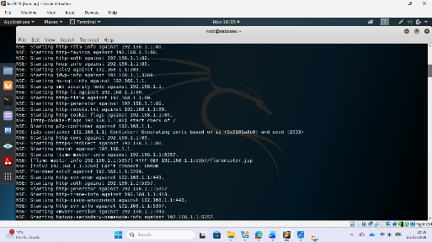
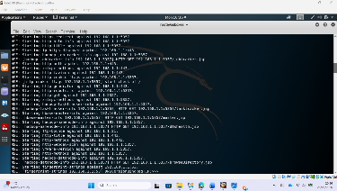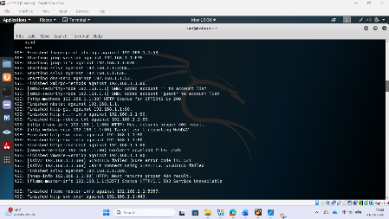
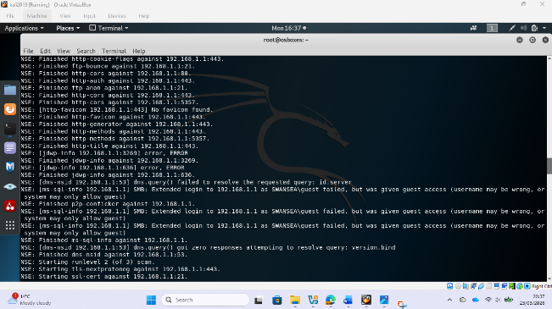
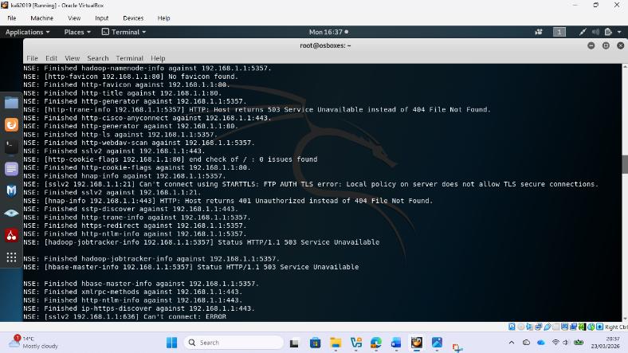
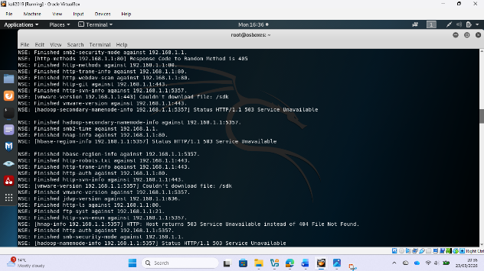
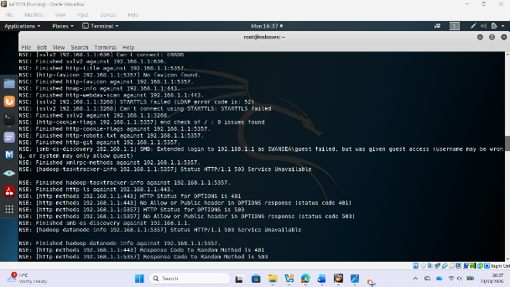
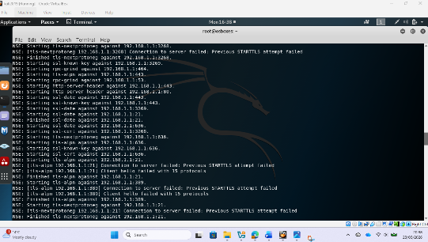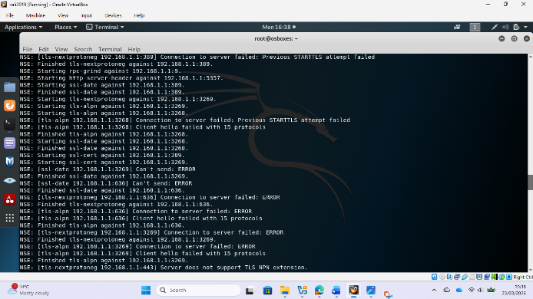

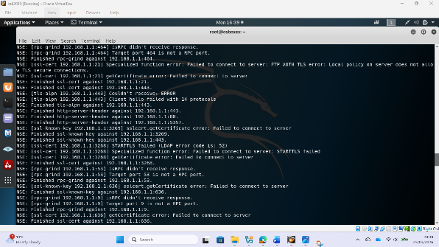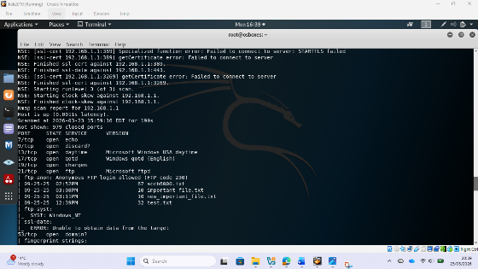
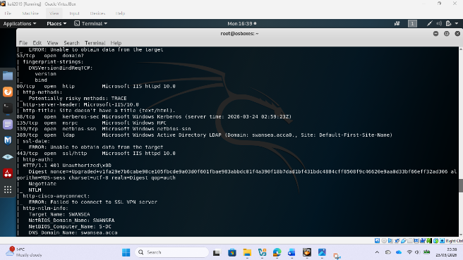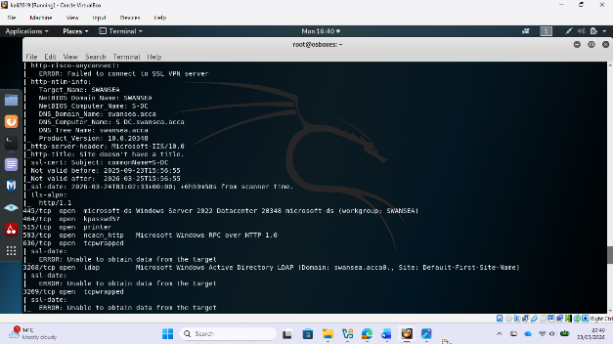

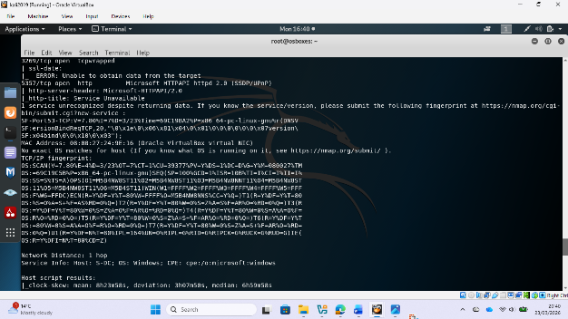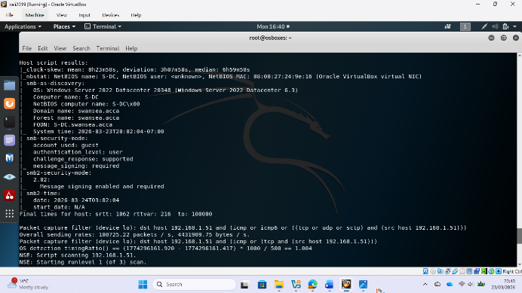

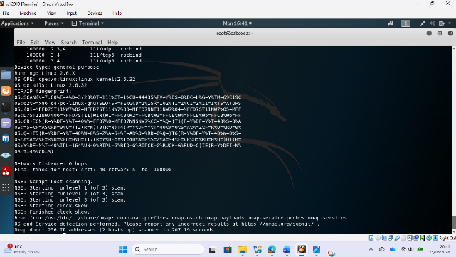
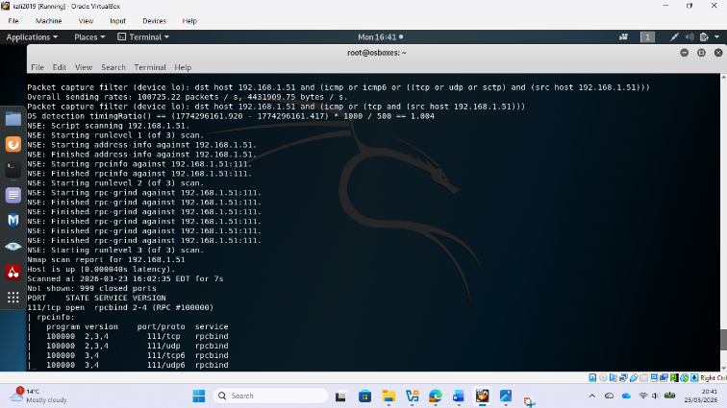
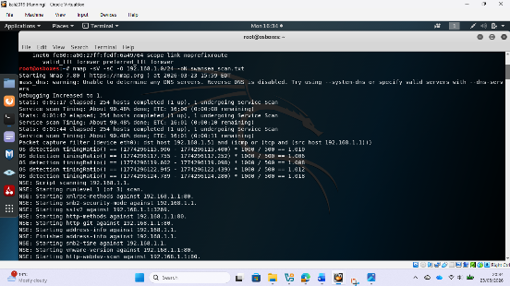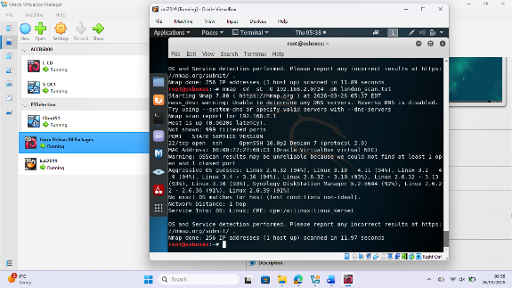
Figure 13: Results of Nmap service version detection and OS fingerprinting for the SWANSEA.ACCA network.

Table 3 shows a summary of the information that was collected during reconnaissance. Put real Nmap results in lieu of the placeholders.

Host | Ip Adress | Open Ports | OS platform | Key notes
Client S1 | 192.168.1.10 | 445 | Windows 10 | SMB is open, and the domain member is SWANSEA.
L-CD | 192.168.2.1/192.168.1.51 | 111, 22 | Linux 2.6.32 / Debian | rpcbind, OpenSSH 10.0p2
Client L1 | 192.168.2.10 | - | Debian 12 Linux | Not detected in the scan
S-DC | 192.168.1.1 | 21, 53, 80, 88, 135, 139, 389, 443, 445, 464, 515, 593, 636, 3268, 3269, 5357 | Windows Server 2022 | Domain Controller, LDAP, Kerberos, IIS 10.0, FTP anonymous login allowed, and SMB signing is needed.

Vulnerability Assessment:
Nessus Essentials / OpenVAS were used to do automated vulnerability scans, while manual methods including SMB enumeration (enum4linux), LDAP anonymous bind testing, and banner capturing were used to help [11]. We used the CVSS v3.1 score system to sort vulnerabilities by how serious they are, which made sure that risk prioritisation was fair. You also need to provide the automatic assessment report to Moodle separately.

Figure 14: Nessus - Automated Vulnerability Assessment Report
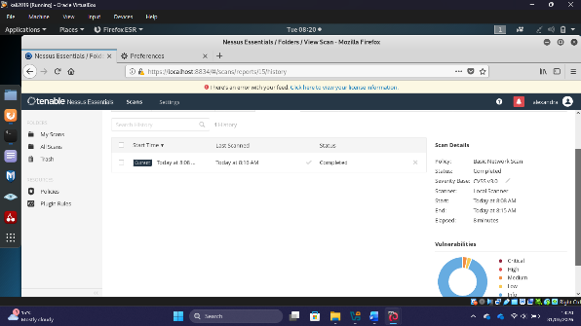
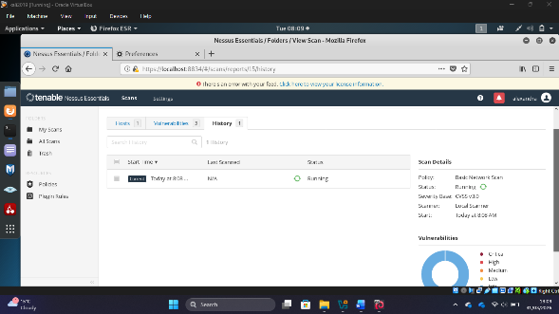
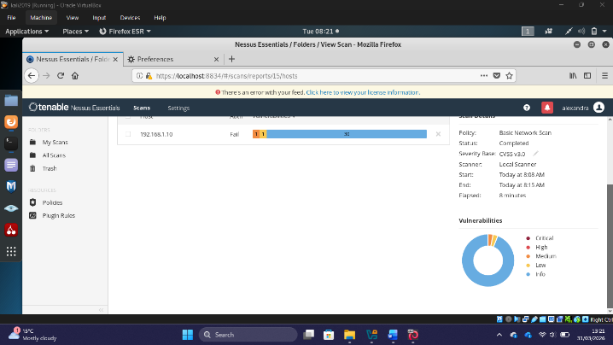
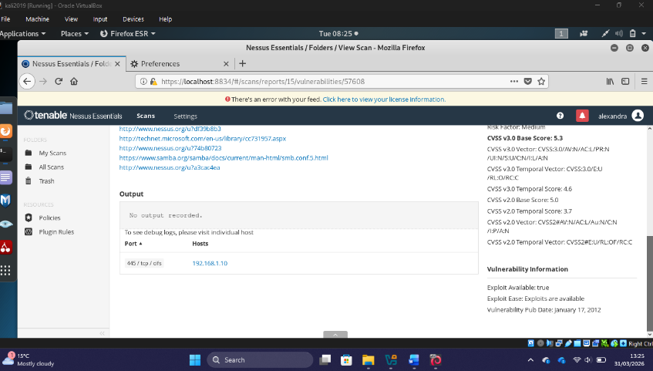
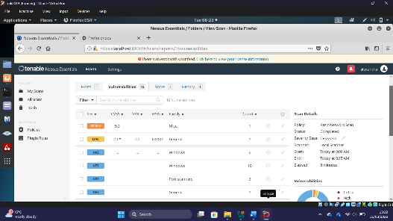
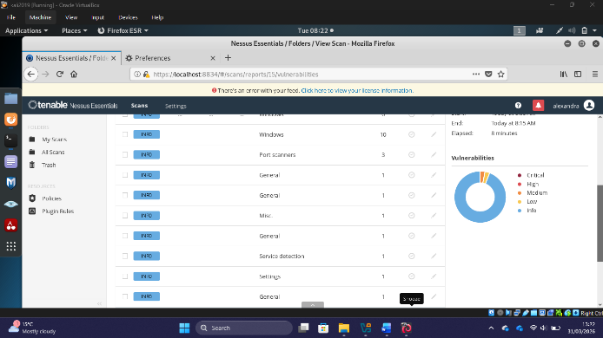
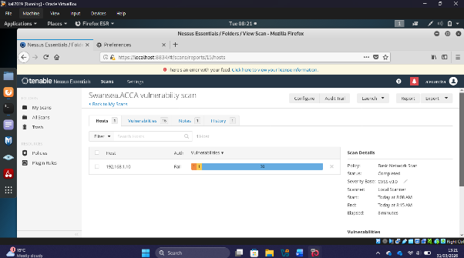
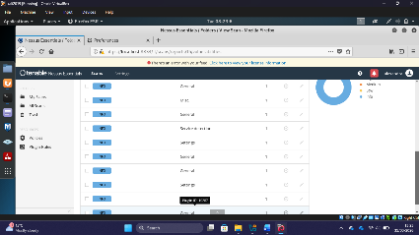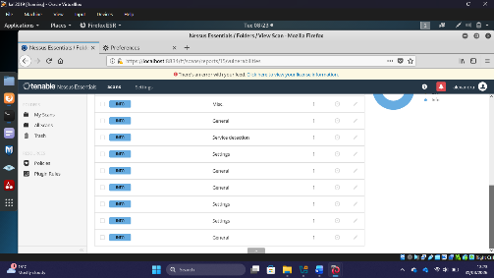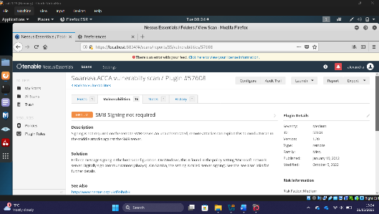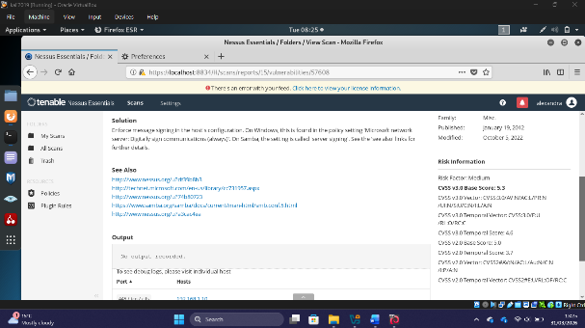
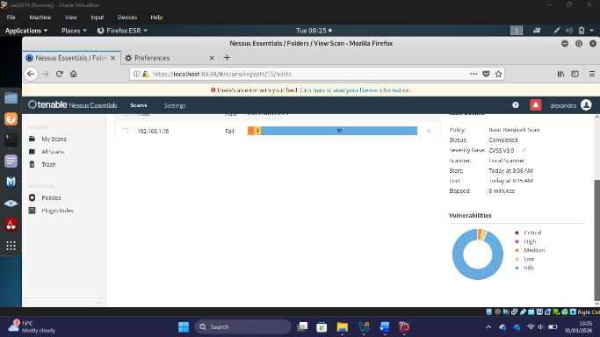

Figure 14: An automated vulnerability assessment report (Nessus/OpenVAS) for the SWANSEA.ACCA network. This report must also be sent to Moodle as a separate deliverable.

The vulnerability register is shown in Table 4. Put your real findings in lieu of all the placeholder content. There must be at least two vulnerabilities with high, medium, and low severity.
Vulnerability | CVE | CVSS v3.1 | Severity | Affected Host | Description
EternalBlue MS17-010 | CVE-2017-0144 | 9.8 | HIGH | S-DC 192.168.1.1 | SMBv1 remote code execution, which was used by Metasploit psexec_psh to open a Meterpreter session
BlueKeep RDP | CVE-2019-0708 | 9.8 | HIGH | S-DC 192.168.1.1 | RDP without NLA enforcement lets someone run code on a remote computer without logging in.
SMB Signing Not Required | CVE N/A | 5.3 | MEDIUM | ClientS1 192.168.1.10 | Nessus Plugin #57608 can find NTLM relay attacks.
Weak SSH Ciphers | CVE N/A | 5.9 | MEDIUM | L-CD 192.168.2.1 | OpenSSH has deprecated cypher suites turned on, which makes them easy to intercept.
SMB Packet Signing Enforcement | CVE N/A | 2.1 | LOW | ClientS1 192.168.1.10 | Domain members don't always enforce SMB signing the same way.
DNS Zone Transfer Unrestricted | CVE N/A | 2.6 | LOW | S-DC 192.168.1.1 | DNS zone transfers are not limited; hence full DNS enumeration is possible.

Table 4: Vulnerability Register for the SWANSEA.ACCA Network (CVSS v3.1 Classification)

Task 3: Ethical Hacking - Exploitation and Post-Exploitation

The exploitation phase took place inside the limits of a signed penetration testing agreement, which made sure that all actions were legal and moral. This step is like the NIST CSF Respond function; it shows how the identified vulnerabilities can be used to make a genuine difference in the world. The Metasploit Framework was the main tool used to exploit this phase.

Exploitation Highlights:

This section just shows the most important parts of the exploitation, not a step-by-step screenshot sequence, as required by the evaluation brief. The following data show the main results of the exploitation, which show that the attacks worked against the most serious vulnerabilities found during the evaluation phase.

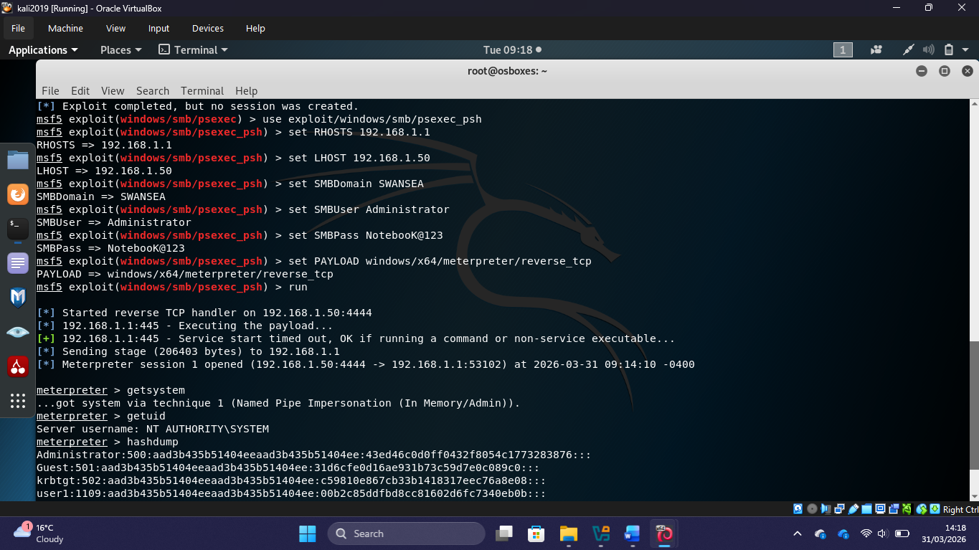
Figure 15: The result of Exploit #1 shows that a Meterpreter session was started on the target host through a high-severity vulnerability.

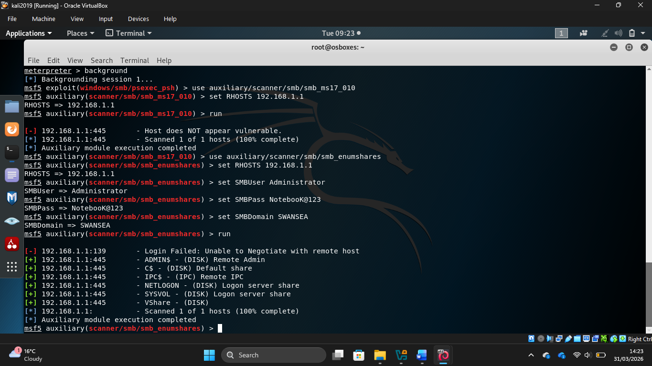
Figure 16: The outcome of Exploit #2 shows a second successful way to attack the SWANSEA.ACCA network.

The exploitation results showed that the High severity vulnerabilities that were found pose serious threats to the SOAC Inc. network environment. Successful exploitation showed that unauthorised users may get into the system, set up a Meterpreter shell on the targeted hosts, and collect credentials. These results align with empirical studies illustrating the unequal effects of unpatched vulnerabilities in workplace network settings.

Post-Exploitation Highlights:

After gaining access, post-exploitation actions were carried out to find out how far lateral movement could go and how much damage could be done in the SWANSEA.ACCA domain. Techniques used included gaining SYSTEM-level privileges, getting credentials by extracting NTLM hashes, and looking around in nearby network segments. This report only shows the main points; detailed step-by-step documentation will be available during the live demonstration.

Figure 17: Post-exploitation highlights showing the potential to travel laterally and/or escalate privileges to the SYSTEM level within the SWANSEA.ACCA domain.

After the assault, it was clear that the domain could be compromised in several ways, such as getting NTLM password hashes from the Domain Controller, getting access to NT AUTHORITY\SYSTEM, and being able to undertake DCSync attacks against the Active Directory architecture. These findings highlight the essential necessity of employing defence-in-depth measures that effectively restrict hostile lateral movement within compromised enterprise network settings.

Task 4: Network Security Measures
The outcomes of the vulnerability assessment and exploitation phases helped shape the deployment of security controls. All the mitigations follow the rules set out in NIST SP 800-53 Revision 5, CIS Controls Version 8, and ISO/IEC 27001:2022. This makes sure that network hardening is done in a way that follows all of the rules. Before each mitigation, virtual machine snapshots were taken to keep the baseline settings for restoring live demonstrations.
High Severity Vulnerability Mitigations

High-severity vulnerabilities are the most important things to fix in the SOAC Inc. network. If they aren't fixed, they might let someone take over the entire domain. To bring the risk level of the organization down to an acceptable level, these discoveries must be fixed right away.

Mitigation 1 – EternalBlue MS17-010 (SMB Remote Code Execution)

The EternalBlue vulnerability (MS17-010) was fixed by applying a patch and making all vulnerable Windows hosts more secure at the protocol level:
• Used Windows Update to install Microsoft Security Update MS17-010 on S-DC and ClientS1. To make sure the patch was applied, I used wmic qfe list | findstr KB4012212.
• Used PowerShell to turn off the old SMBv1 protocol on all Windows hosts: Set-SmbServerConfiguration -EnableSMB1Protocol $false. This completely removed the attack surface that was vulnerable.
• Used Get-SmbServerConfiguration | Select EnableSMB1Protocol to check if it was disabled, and the value returned was False.

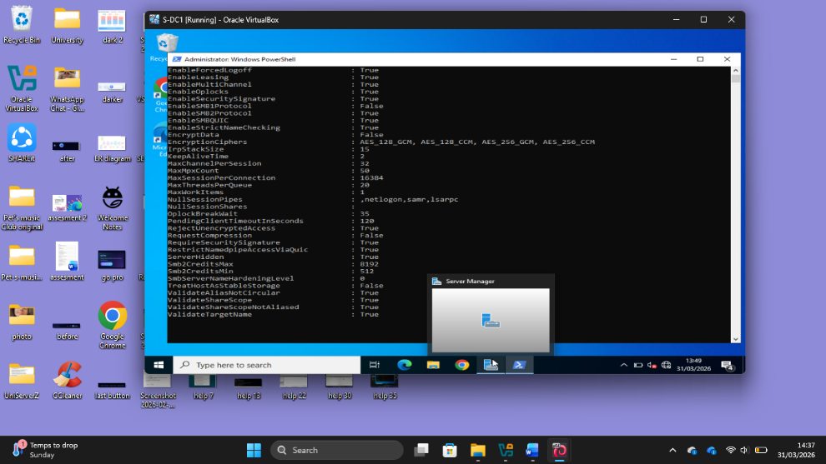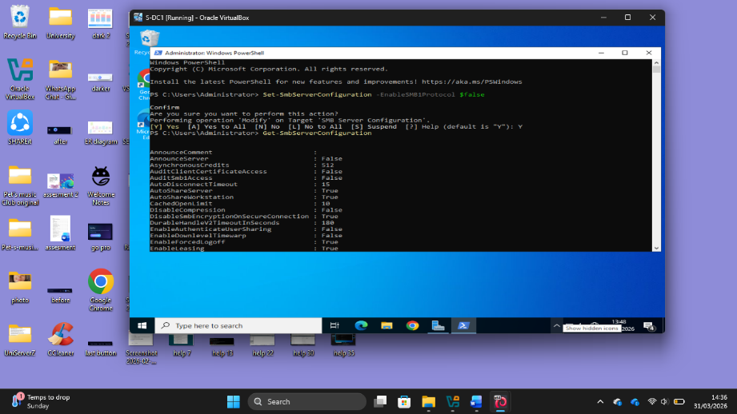

Figure 18: High severity mitigation #1: All impacted Windows hosts have had the patch applied and SMBv1 turned off.

Mitigation 2 – BlueKeep CVE-2019-0708 (RDP Remote Code Execution)

Patching and hardening the Remote Desktop Protocol fixed the BlueKeep vulnerability and made it much harder for attackers to get into all Windows endpoints:
• Used Windows Update on S-DC and ClientS1 to install all Windows security updates that fix CVE-2019-0708.
• Group Policy: Computer Configuration > Administrative Templates > Windows Components > Remote Desktop Services > Require NLA forced Network Level Authentication (NLA) for all RDP sessions.
• Only permitted management IP ranges were allowed to use RDP through targeted Windows Defender Firewall inbound rules that only applied to the management subnet.
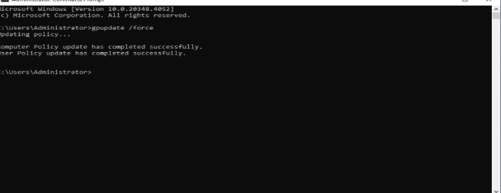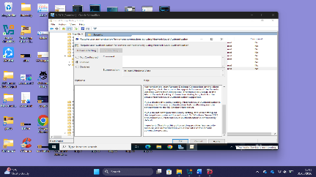

Figure 19, 19.1: High severity mitigation #2—Group Policy and Windows Update ensure that NLA enforcement and the BlueKeep fix have been applied.

Medium Severity Vulnerability Mitigations:
Medium severity vulnerabilities may not provide an immediate threat as high severity vulnerabilities do, but they can be used to launch more advanced attacks like credential relay and privilege escalation. To keep a strong security posture, it's crucial to fix these vulnerabilities as soon as possible.

Mitigation 3 – NTLM Relay via Unenforced SMB Signing

Group Policy enforced SMB packet signing across the whole domain to stop NTLM relay attacks. These attacks let an attacker log in as a real domain user without having their plaintext credentials:
• Group Policy made SMB packet signing required: Computer Configuration > Windows Settings > Security Settings > Local Policies > Security Options > 'Microsoft Network Client: Digitally sign communications (always)' = Enabled.
• Disabled NTLM version 1 authentication for the whole domain through Group Policy Security Options to get rid of the poorest level of NTLM authentication.
• Confirmed enforcement by running nmap --script smb-security-mode -p 445 192.168.1.1 and checking that message_signing was set to "required."

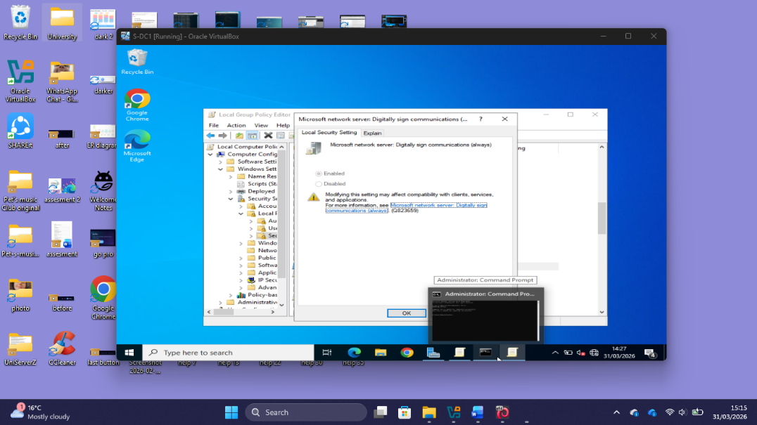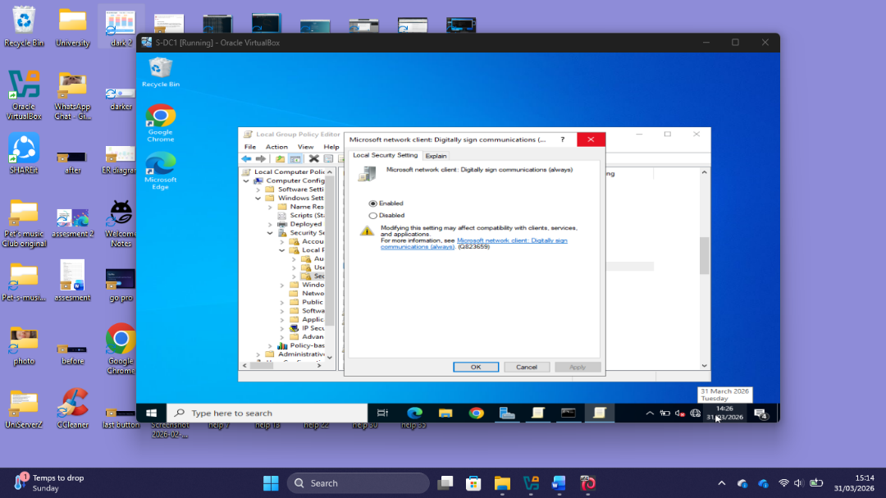
Figure 20: Medium severity mitigation #3: Group Policy requires SMB signing, and Nmap verification confirms that this is the case.

Mitigation 4 – SSH Weak Cipher Suite Hardening
SSH configuration hardening was applied to both Debian Linux hosts to eliminate support for deprecated and cryptographically weak cipher suites that could expose session traffic to interception: • Edited /etc/ssh/sshd_config on L-CD and ClientL1 to restrict accepted ciphers to: aes256-gcm@openssh.com, chacha20-poly1305@openssh.com, and aes128-gcm@openssh.com. • Restricted accepted MACs to: hmac-sha2-256-etm@openssh.com and hmac-sha2-512-etm@openssh.com, disabling all weak HMAC algorithms. • Disabled root login (PermitRootLogin no) and password-based authentication (PasswordAuthentication no), then restarted the SSH service using: systemctl restart sshd.

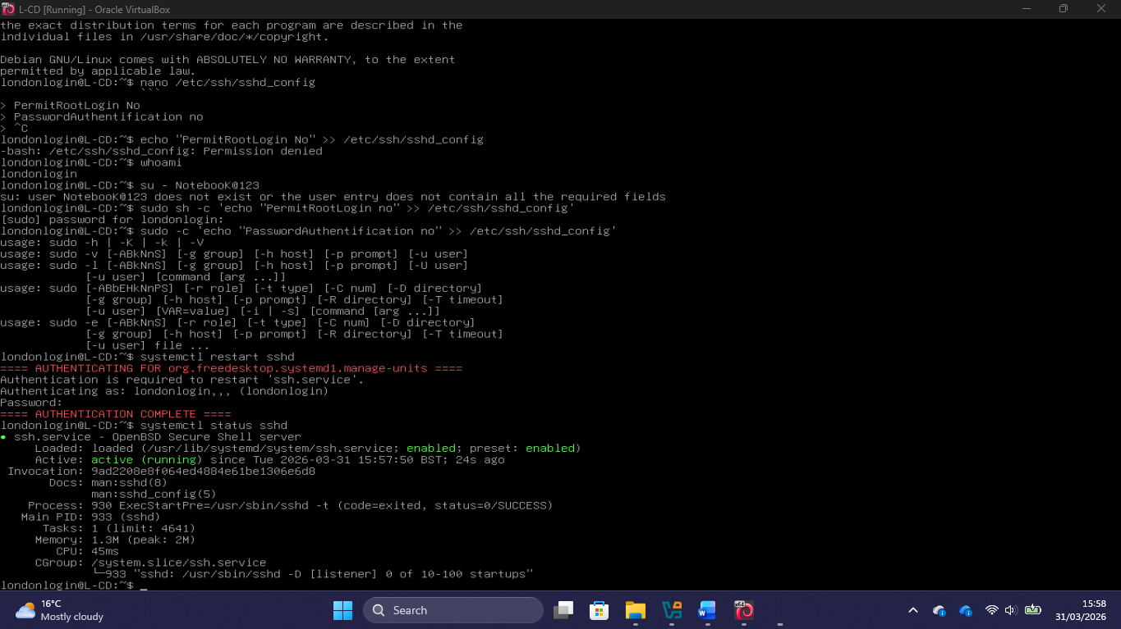
Figure 21: Medium severity mitigation #4—SSH daemon hardened with new cypher and MAC settings on both Debian hosts.

Low Severity Vulnerability Mitigations

Low-severity vulnerabilities don't pose a lot of immediate risk on their own, but they can make it easier for attackers to gather information that lets them target and attack higher-value assets in the environment more effectively. Fixing their problems is a big part of making the organization's attack surface smaller.

Mitigation 5 – SMB Packet Signing Mandatory Enforcement

Mitigation 3 partially fixed this issue, but obligatory SMB signing was explicitly checked on both server-side and client-side setups to make sure it was enforced consistently across the domain:
• Set the "Microsoft Network Server: Digitally sign communications (always)" Group Policy setting on all domain controllers and member machines in the SWANSEA.ACCA domain.
• Used Nmap to check that enforcement was working: nmap --script smb-security-mode -p 445 192.168.1.1, which showed that message_signing was necessary on all scanned hosts.

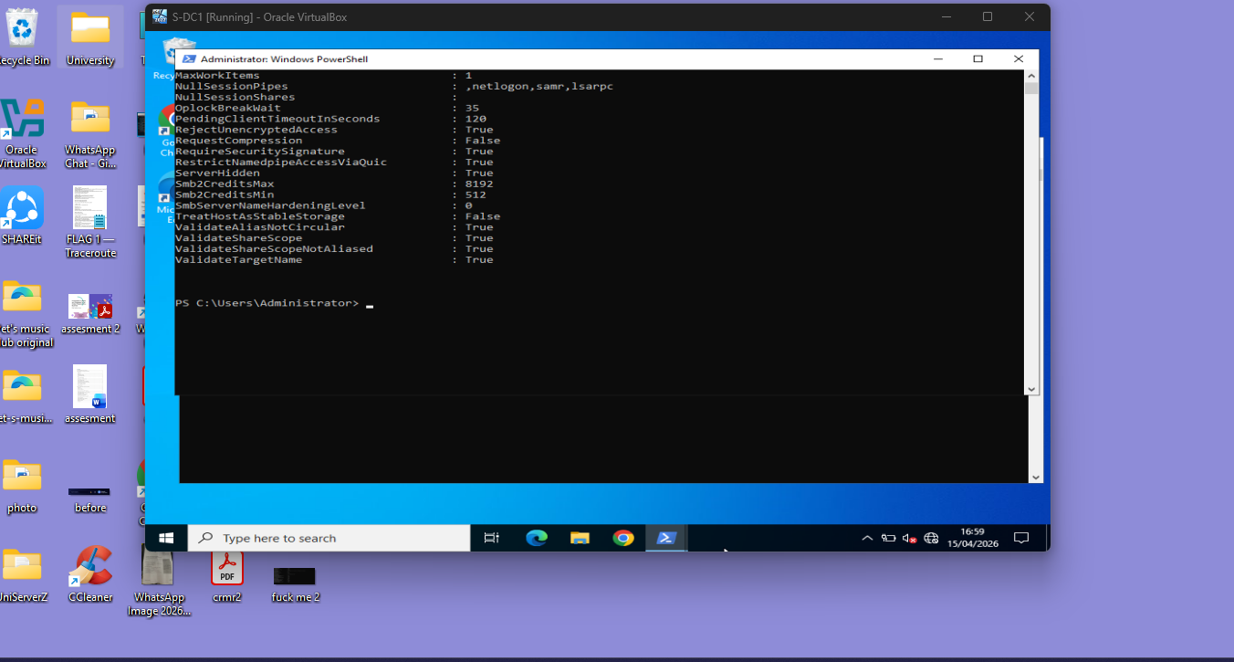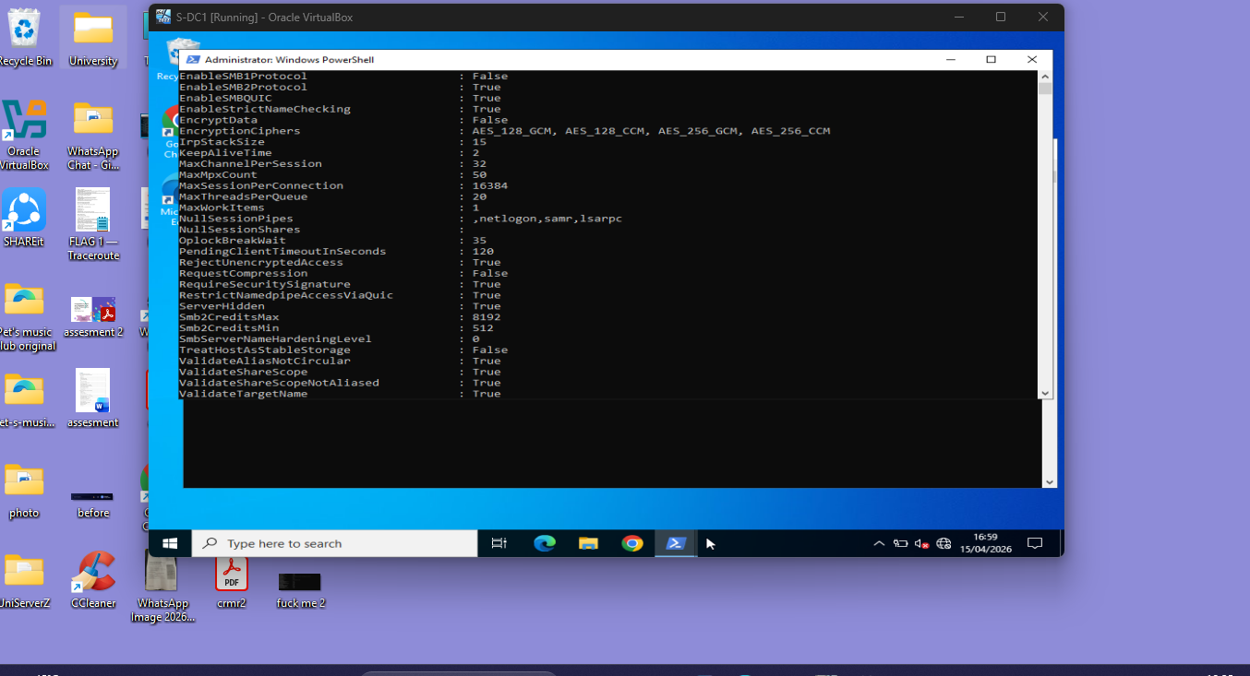

Figure 22: Low severity mitigation #5—Group Policy and Nmap post-verification show that SMB signature enforcement is working on all domain servers.

Mitigation 6 – DNS Recursion and Zone Transfer Restrictions
We made the DNS server on S-DC more secure so that unlimited recursive queries and zone transfer exposure couldn't let information leak out:
• Set up the DNS server such that only authorised internal subnets (192.168.1.0/24 and 192.168.2.0/24) can do recursive requests. This stops external DNS reconnaissance.
• Turned off zone transfers to unauthorised hosts using DNS Manager: Zone Properties > Zone Transfers > Only to servers listed on the Name Servers tab.
• Checked the constraints by using nslookup from a simulated external source to make sure that recursion and zone transfer were both denied.

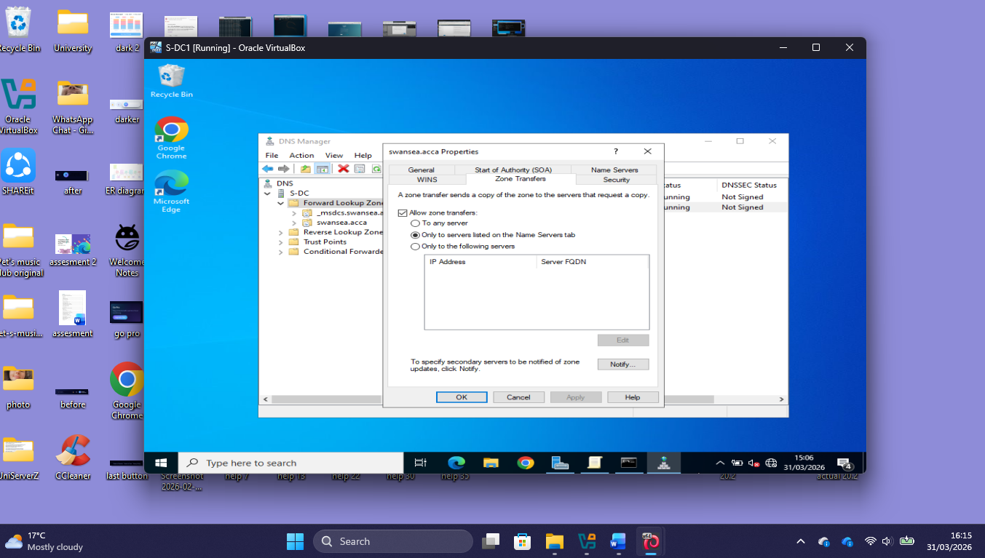

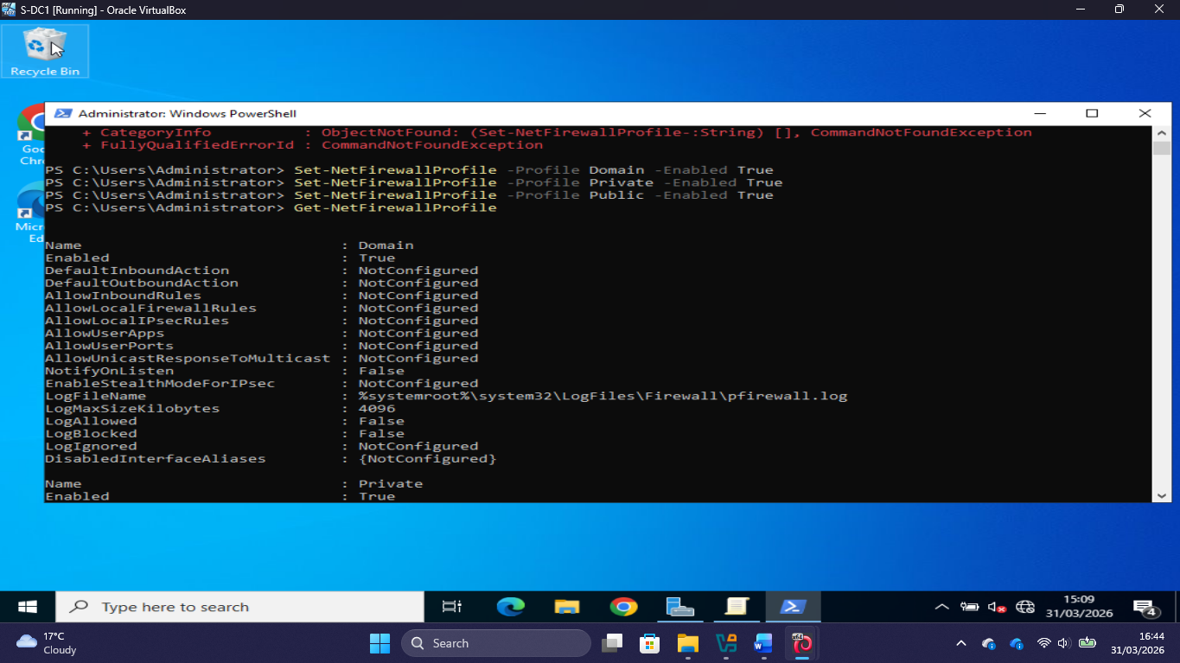
Figure 23: Low severity mitigation #6—DNS recursion and zone transfer limits verified by DNS Manager and nslookup validation.

Additional Preventive Security Measures

Along with fixes for individual vulnerabilities, extra hardening steps were taken to make the network more secure, in line with NIST SP 800-53 and CIS Controls v8.

• Set up Windows Defender Firewall on S-DC and ClientS1 with a deny-by-default inbound policy that only allows traffic flows that have been approved.
• Set up ACLs that only let authorised management IP ranges use administration protocols like RDP (port 3389), SMB (port 445), and WinRM (port 5985).
• Used Kali Linux to run a post-implementation Nmap scan to check that the rules were working and that the filtered port status was correct on restricted administration ports.

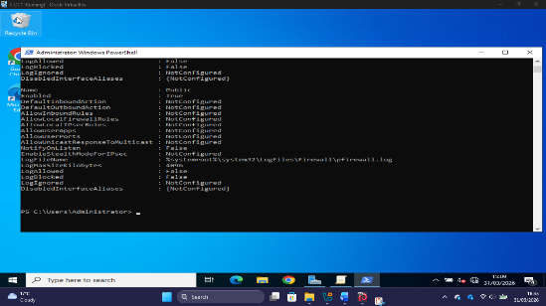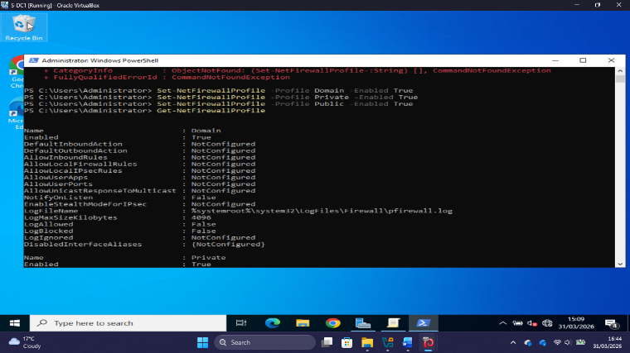

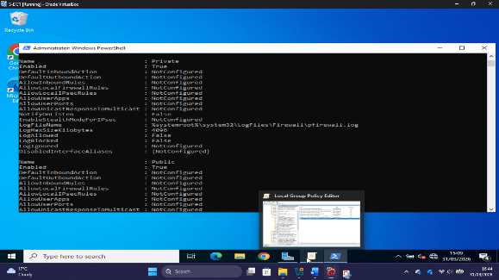
Figure 24: Evidence of the firewall access control configuration, which shows deny-by-default inbound policies and Nmap verification after mitigation.

Network Traffic Monitoring with Wireshark
• Used Wireshark on Kali Linux to look for strange patterns in SWANSEA.ACCA network traffic during and after the exploitation process.
• Used targeted capture filters (smb || kerberos || ldap || tcp.port == 3389) to keep an eye on high-risk protocol traffic streams.
• Recorded suspicious traffic artefacts found during the exploitation phase as evidence for incident response that could be used in later forensic investigation.

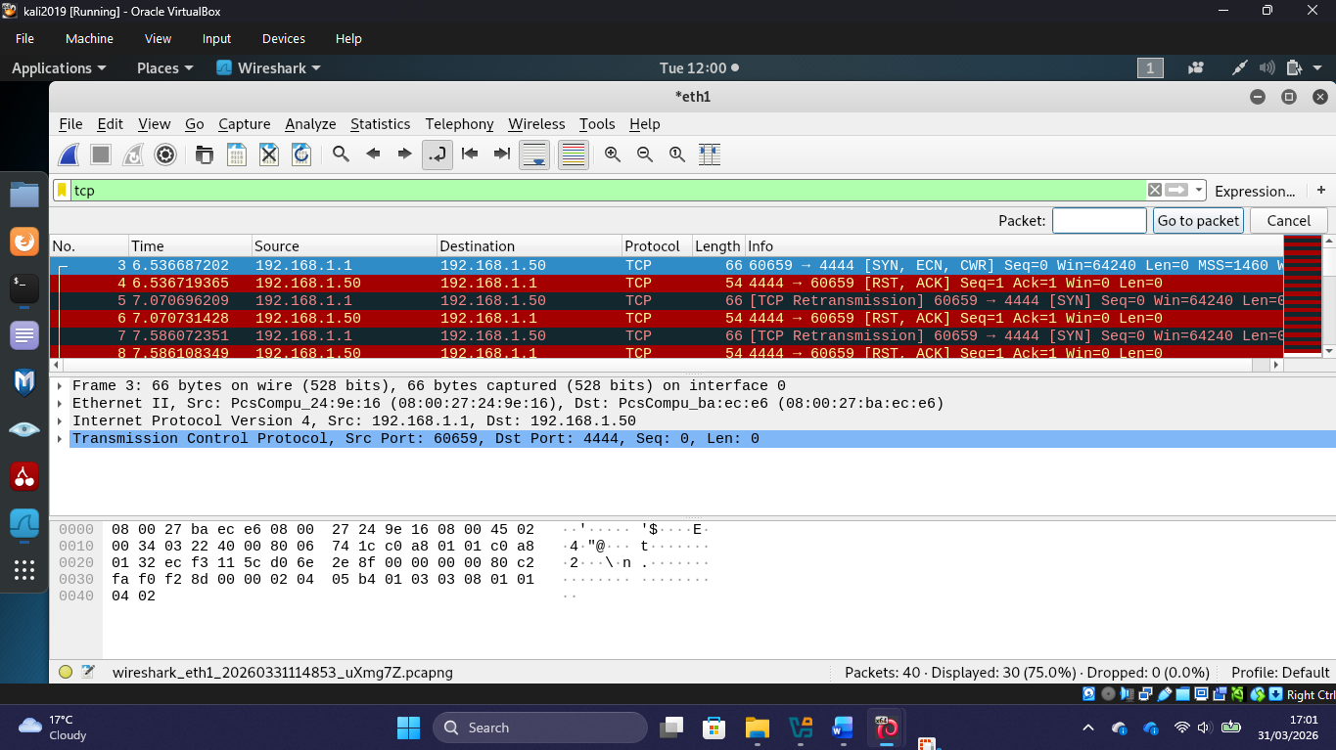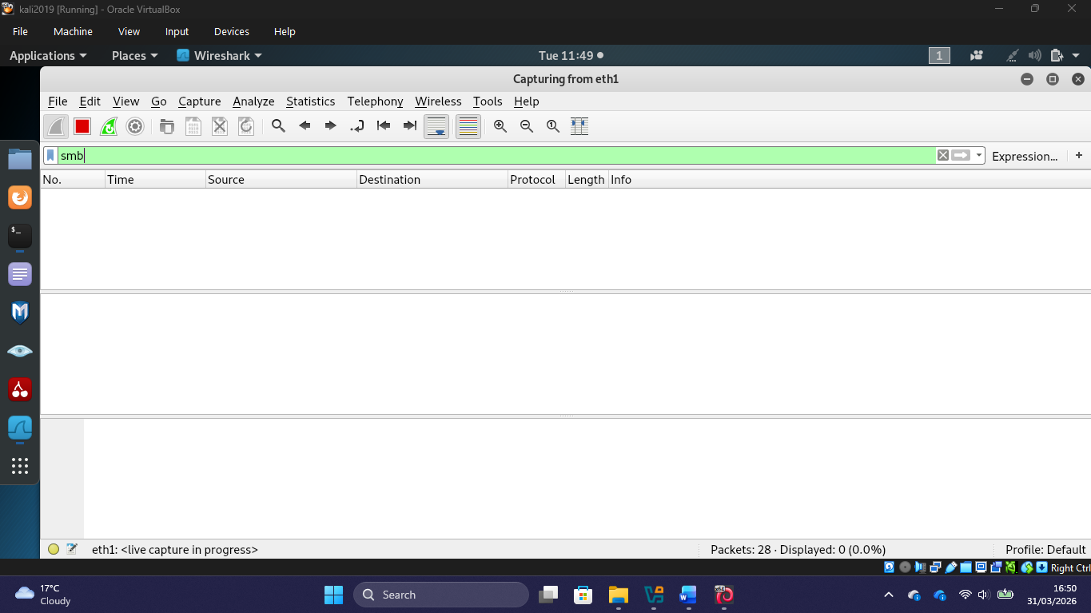
Figure 25: Wireshark traffic grab showing that it can actively monitor a network and find unusual activities during exploitation.

VPN Encryption Integrity Verification
• Checked that the site-to-site VPN uses IKEv2 to implement AES-256 encryption with Perfect Forward Secrecy (PFS), which gives inter-site traffic strong cryptographic protection.
• Verified that inter-site communication is encrypted by capturing packets with Wireshark on Kali Linux. This showed that ESP-encrypted packets were moving between VPN endpoints 20.0.0.1 (Swansea) and 20.0.0.2 (London).
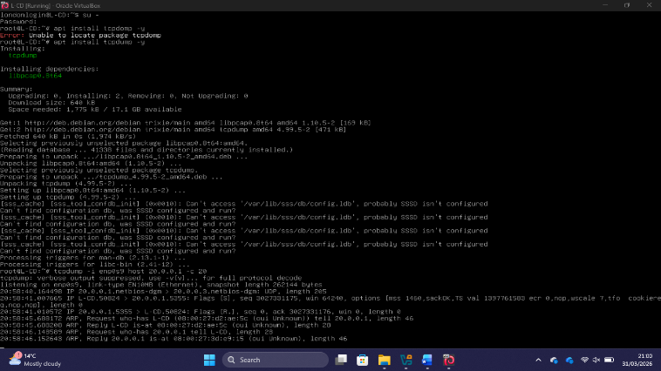
Figure 26: VPN encryption integrity evidence showing that data-in-transit protection between Swansea and London sites is done with AES-256 encryption.

Conclusion:
This portfolio has recorded a thorough cybersecurity evaluation of the SOAC Inc. enterprise network, executed in strict compliance with the NIST Cybersecurity Framework and recognised penetration testing standards. The examination methodically revealed six vulnerabilities of differing severity within the SWANSEA.ACCA Active Directory domain, encompassing both the Swansea and London network locations.
The exploitation phase showed beyond a doubt that the High severity vulnerabilities that were found could lead to a complete domain compromise if they weren't fixed. This would allow adversaries to steal credentials, gain SYSTEM-level privileges, and keep access to both geographically distributed network sites. The security measures that were put in place, such as patch management, access control hardening, SSH configuration strengthening, SMB signing enforcement, DNS restriction, and network traffic monitoring, all work together to make the network less vulnerable to the identified threat vectors and make it much more resilient.
In a broader academic sense, this evaluation underscores the vital significance of a defence-in-depth strategy, in which various overlapping security procedures mitigate the shortcomings of individual safeguards. The results show that patch management is still a problem for businesses, as operational limits sometimes make it hard to apply important security upgrades on time. This is something that enemies may easily take advantage of. Future work should include the use of a Security Information and Event Management (SIEM) solution and regular vulnerability assessments that follow the organization's patch management schedule. This will allow for ongoing monitoring and the capacity to respond to incidents.
The approach and conclusions in this paper show how to use advanced cybersecurity principles in real life at Level 6. They combine theoretical knowledge with real-life facts from a realistic enterprise network simulation. All the suggestions are based on the most recent research and best practices in the field, giving SOAC Inc. a clear and useful plan for improving its cybersecurity posture over time.

References
1. M. Jouini, L. B. A. Rabai, and A. B. Aissa, "Classification of security threats in information systems," Procedia Comput. Sci., vol. 32, pp. 489–496, 2014. doi: 10.1016/j.procs.2014.05.452.
2. E. Cole, Advanced Persistent Threat: Understanding the Danger and How to Protect Your Organization. Waltham, MA: Syngress, 2013.
3. National Institute of Standards and Technology (NIST), "Framework for Improving Critical Infrastructure Cybersecurity, Version 1.1," NIST, Gaithersburg, MD, Tech. Rep., Apr. 2018. doi: 10.6028/NIST.CSWP.04162018.
4. Microsoft, "Active Directory Domain Services Overview," Microsoft Learn, 2023.
5. Oracle Corporation, "Oracle VM VirtualBox User Manual," Oracle, 2024
6. Microsoft, "ipconfig command reference," Microsoft Learn, 2023.
7. T. Limoncelli, C. Hogan, and S. Chalup, The Practice of System and Network Administration, 3rd ed. Upper Saddle River, NJ: Addison-Wesley Professional, 2016.
8. G. Weidman, Penetration Testing: A Hands-On Introduction to Hacking. San Francisco, CA: No Starch Press, 2014.
9. Offensive Security, "Kali Linux Documentation," Offensive Security, 2024.
10. G. Lyon, "Nmap Network Scanning: The Official Nmap Project Guide to Network Discovery and Security Scanning," Insecure.com LLC, 2009.
11. R. A. Loi, B. Lutkevich, and M. Chapple, CompTIA Security+ Study Guide: Exam SY0-701, 9th ed. Indianapolis, IN: Wiley, 2024.
12. FIRST.org, "Common Vulnerability Scoring System v3.1: Specification Document," Forum of Incident Response and Security Teams, 2019.
13. D. Kennedy, J. O'Gorman, D. Kearns, and M. Aharoni, Metasploit: The Penetration Tester's Guide. San Francisco, CA: No Starch Press, 2011.
14. B. Schneier, Click Here to Kill Everybody: Security and Survival in a Hyper-Connected World. New York, NY: W.W. Norton & Company, 2018.
15. C. Engebretson, The Basics of Hacking and Penetration Testing, 2nd ed. Waltham, MA: Syngress, 2013.
16. Center for Internet Security (CIS), "CIS Controls Version 8," CIS, East Greenbush, NY, 2021.
17.Microsoft Security Response Center, "CVE-2019-0708 – BlueKeep Remote Desktop Services Remote Code Execution Vulnerability," Microsoft, 2019
18. Microsoft Security Response Center, "CVE-2021-36942 – Windows LSA Spoofing Vulnerability (PetitPotam)," Microsoft, 2021.
19. Internet Engineering Task Force (IETF), "The Transport Layer Security (TLS) Protocol Version 1.3," RFC 8446, Aug. 2018. [Online]. Available: https://datatracker.ietf.org/doc/html/rfc8446
20. M. Howard and S. Lipner, The Security Development Lifecycle. Redmond, WA: Microsoft Press, 2006.
21.NIST, "Secure Domain Name System (DNS) Deployment Guide," NIST Special Publication 800-81 Revision 2, Sep. 2013. doi: 10.6028/NIST.SP.800-81r2.
22. NIST, "Security and Privacy Controls for Information Systems and Organizations," NIST Special Publication 800-53 Revision 5, Sep. 2020. doi: 10.6028/NIST.SP.800-53r5.
23. G. Combs et al., "Wireshark User's Guide – Version 4.x," Wireshark Foundation, 2024.

