ROLE THAT SOCIAL MEDIA TOOLS SUCH AS LINKEDIN AND FACEBOOK CAN HAVE IN THE RECRUITMENT OF STAFF
Student Name:Irina Jechiu
Student ID: 2337011

Table of Contents
Introduction 3
Discussion 3
Role of social media tool LinkedIn have on recruitment of staff 3
Role of social media tool Facebook have on recruitment of staff 4
Application of relevant theories and models in the recruitment of staff 5
Recommendations 5
Conclusion 6
References 7
Appendices 9

Introduction
The report explores the role social media tools such as LinkedIn and Facebook have in the recruitment of staff. The person-organisation Fit Model and Human Capital theory are applied to show the effectiveness of the tools in recruitment and selection. Recommendations are given to show the use of other relevant social media platforms by real-world companies.

Discussion

Role of social media tool LinkedIn have on recruitment of staff
Pros | Cons
The greatest recruitment tools offer a huge pool of possible candidates for any particular position because there are more than 700 million members worldwide. Employers can easily find candidates by using LinkedIn as a recruiting tool, which includes job title, location, skills, and experience. Candidates can also easily search for recruiters on LinkedIn (Nikolaou, 2021, p 2). | Users should be aware that, although using LinkedIn as a recruiting tool gives them access to a large candidate pool, the platform's diversity might not be as high as that of other online recruitment sites. Owing to the inclination of white-collar professionals to be among the LinkedIn recruitment tool's free user base, employers could overlook qualified candidates who do not suit this particular profile.
Employers may easily search for potential applicants and utilise LinkedIn as a recruiting tool because of its user-friendly and intuitive design. The greatest recruitment tools make it simple for employers to post job openings, find applicants, and get in touch with job seekers. | Macarthy, (2021, p 2454), argues, that free hiring resources like LinkedIn profiles sometimes include personal data about candidates, including work history and educational background, raising privacy concerns. Employers need to be careful to manage this data responsibly and ensure they are not violating any privacy laws, especially considering the significance of LinkedIn as a recruiting tool.

Role of social media tool Facebook have on recruitment of staff
Pros | Cons
The massive user reach on Facebook is one of the biggest advantages of recruiting. Gilch and Sieweke, (2021, p 265), noted, that employers can tap into diverse demographics; they can also find candidates who are not currently seeking jobs but might become potential candidates in future. | Since Facebook is essentially a social media site, recruiters might not be able to locate qualified applicants there. Because there are not many professional profiles on the network, users could not publish content that might draw recruiters. Additionally, prejudices in the hiring process or misleading information on social media could make things more difficult. Compared to professional platforms, the informal aspect of social media sites may cause people to see job advertisements with less gravity (Oksa et al., 2021, p 78).
Facebook's targeted advertising tools let staff members connect with audiences depending on their location, hobbies, employment history, and educational background. Recruiters have the ability to customise job advertisements in order to foster interaction and facilitate interaction with prospective employees. | Facebook has significant privacy issues because it is an open social network. Receiving job advertisements that are tailored to specific users based on their personal data is not appreciated. A tweak in Facebook's algorithm may make job posts less visible. Ultimately, it becomes challenging for qualified candidates to land the positions that suit them (Schneider and Harknett, 2022, p 767).

Application of relevant theories and models in the recruitment of staff
Person-Organization Fit Model
Allal-Chérif et al., (2021, p 9065), clarify, the alignment of an individual's values, beliefs, and work methods with those of an organisation is known as person-organisation fit. It suggests that a strong fit allows an employee to fit right in and contribute to the company's success by facilitating their smooth integration into the culture. Conversely, if this idea is absent, it may result in low performance, increased turnover rates, and unhappiness. Throughout the hiring process, hiring managers give person-organisation fit top priority for a number of reasons. Here, LinkedIn and Facebook help hiring managers find suitable people for the job posting. Since people who share an organisation's values are typically more driven and committed to their work, it increases employee engagement and job satisfaction (Younas and Waseem Bari, 2020, p 34). It creates a positive work atmosphere, which enhances teamwork and collaboration. Lowering attrition and keeping top people, promotes long-term success.
Human Capital Theory
By implementing the Human Capital Theory in the workplace, managers are able to lead, train, and educate their employees on a daily basis. They ought to serve as the major source of direction in the company and strive to keep their organisational prowess, social awareness, and operational skills robust. Managers want to develop their team members' talents and learn how they work; social media platforms help them find these people (Elad, 2021, p 6). They should also be able to handle issues that arise at work and possess emotional intelligence. Employee relations will be based on respect, trust, and unity if one exhibits empathy.

Recommendations
Understanding target audience
Knowing the target demographic is the first step in using social media for recruiting purposes. This entails finding out what channels they watch, what content they interact with, and what kinds of content they like. Recruiters may develop a social media strategy that resonates with the target demographic and sets the company apart by knowing it. For instance, EY's Instagram feed is remarkably well balanced. A common mistake made by businesses on the channel is uploading an excessive amount of graphics in place of actual images. Photographs showing the company's culture and people are expertly balanced with visuals that feature quotes, commemorate significant occasions, or back certain causes like diversity.
Building a strong employer brand
The company's standing as an employer constitutes its employer brand; creating a powerful employer brand is essential to drawing in top candidates. Recruiters should highlight the mission, values, and culture of the organisation by using social media. This can be achieved by displaying company events and projects, telling employee tales, and producing interesting material that captures the essence of the organisation's brand. Companies can develop a devoted following of prospective employees who are eager to work for them by developing a strong employer brand. Salesforce, for example, employs some of the social media-active staff members. By posting staff-generated content on Instagram and Twitter, they make the most of this. It's almost evenly split between their own content and staff members' retweets when users browse through their Twitter accounts.

Conclusion
The report clarifies how social media platforms like Facebook and LinkedIn allow recruiters broad opportunities while recruiting staff. Employers can get access to diverse talents by using social media tools; the application of theory and model signifies the importance of social media recruitment.

References
Allal-Chérif, O., Aránega, A.Y. and Sánchez, R.C., 2021. Intelligent recruitment: How to identify, select, and retain talents from around the world using artificial intelligence. Technological Forecasting and Social Change, 169, p.120822. https://core.ac.uk/download/pdf/599434839.pdf
Elad, J., 2021. LinkedIn for dummies. John Wiley & Sons.
Gilch, P.M. and Sieweke, J., 2021. Recruiting digital talent: The strategic role of recruitment in organisations’ digital transformation. German Journal of Human Resource Management, 35(1), pp.53-82. https://journals.sagepub.com/doi/pdf/10.1177/2397002220952734
Macarthy, A., 2021. 500 social media marketing tips: essential advice, hints and strategy for business: facebook, twitter, pinterest, Google+, YouTube, instagram, LinkedIn, and mor.
Nikolaou, I., 2021. What is the Role of Technology in Recruitment and Selection?. The Spanish journal of psychology, 24, p.e2. https://www.cambridge.org/core/services/aop-cambridge-core/content/view/451DF5C763B110A845EEAD50F5BAF851/S1138741621000068a.pdf/what_is_the_role_of_technology_in_recruitment_and_selection.pdf
Oksa, R., Kaakinen, M., Savela, N., Ellonen, N. and Oksanen, A., 2021. Professional social media usage: Work engagement perspective. New media & society, 23(8), pp.2303-2326. https://journals.sagepub.com/doi/pdf/10.1177/1461444820921938
Schneider, D. and Harknett, K., 2022. What’s to like? Facebook as a tool for survey data collection. Sociological Methods & Research, 51(1), pp.108-140. https://journals.sagepub.com/doi/pdf/10.1177/0049124119882477
Younas, M. and Waseem Bari, M., 2020. The relationship between talent management practices and retention of generation ‘Y’employees: mediating role of competency development. Economic research-Ekonomska istraživanja, 33(1), pp.1330-1353. https://hrcak.srce.hr/file/369790

Appendices
Appendix 1: Importance of different social media tools for recruitment
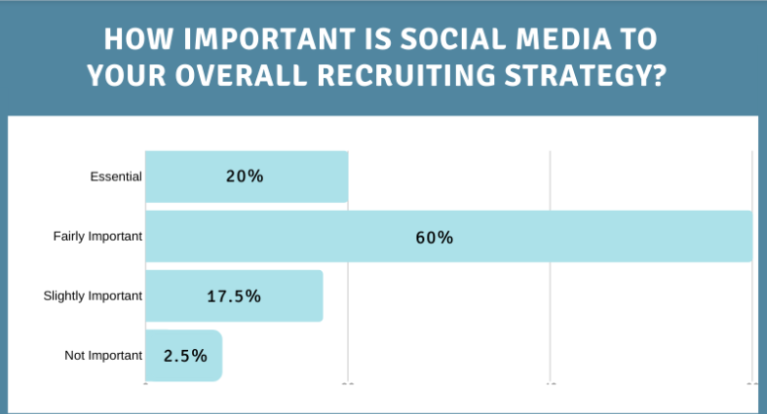
Appendix 2: Most active social media platforms


