Internet Security
Synthesize a Solution to a Potential Real-Life Scenario
M5X01045
Ben McCarthy

Table of Contents
Introduction 2
Policies 2
User Policy 2
Logins 2
Customer Accounts 2
Staff Accounts 2
Authorised Accounts 3
General Use 3
Device Management Policy 4
General 4
Support 4
Reimbursements 4
Additional Disclaimers 4
Security Policy 5
Mobile Device Management System 5
Advantages and Disadvantages of BYOT 6
Advantages 6
Disadvantages 6
List of Tables and Figures 7
Data Flow Diagram 7
Level 0 7
Level 1 8
Network Diagram 8
Conclusion 9
List of Acronyms 9
Reference List 10
Bibliography 10

Introduction
The following report will outline a BYOT framework for Golding-Harvest Ltd due to them coming under pressure from both employees and customers to allow them to access their network. To do this various topics will be covered such as different policies (user, device management and security), diagrams and demonstrations of the framework as well as what software will be used and how they will benefit the company with its pursuit of creating a comprehensive BYOT system.

Policies

User Policy

Logins
Usernames and passwords are the basic means to access the company’s network. For staff this will be their usual login that is given to them when they first got the job. For customers, they will be required to create password when they first attempt to join the network whereas a user ID will be assigned and will be a random assortment of eight numbers. On sign up, as well as a password, they will be required to provide an email address. Only email addresses that exist within the database of customers will be allowed to create an account to join the network. This is due to basic security measures so that only people who are involved with the business can access the network. Users should ensure that they:
- Change password on a regular basis (recommended every 30 days)
- Create a password that is secure and contains at least 8 characters with at least 1 uppercase characters and 1 numeric value
- Avoid creating obvious passwords that include words or phrases related to the user
- Do not share log in details with anyone
- Do not write log in details anywhere obvious
- Contact the IT department if their login is forgotten
- Report any concerns regarding logins to the IT department

Customer Accounts
Customers will be limited to the content that they can access on the network. They will be allowed on a range of websites but nothing that contains the following:
- Graphic content
- Pornographic content
- Gambling
- Games
- Any sites that could contain malicious content/viruses
Customers will also only be able to access information that is to do with themselves but not other customers of Golding-Harvest Ltd or confidential information about the business or its clients. They will not be able to edit or delete information as this will be an option only for select, authorised members of staff. Customer accounts will also be prohibited from downloading any software or executable files onto the devices when connected to the network in order to protect the business, its employees and its clients.

Staff Accounts
Members of staff will be able to access all the content and information on their own devices that they can on their current work devices. They will not be able to access any website that contain the same material as the list provided in the ‘Customer Accounts’ section. As well as this they will not be allowed to access any social media sites or applications (this includes Facebook, Twitter, Snapchat, Reddit and Instagram). This is due to the fact that these sites can be major distractions to some members of staff which would slow down the business as a whole if it were to become an issue. Staff will only be provided to information and details about personnel that is relevant to their job role (e.g. HR will have access to information on all members of staff whereas managers will only have access to information about the members of staff they oversee). This is to reduce the amount of redundant data distributed to employees. If a member of staff’s role where to change the information they can see/edit will change accordingly. Similarly, if a member of staff were to leave the company then they will lose all access to the network and all information they had access to prior to their departure.
Staff will have automatic access to all the software that they will require to fulfil their jobs. If anything else is required they should request a meeting with an authorised member of the IT department to see if exceptions can be made. This should also be the case if a website that they require is blocked by the system.

Authorised Accounts
Some accounts connected to the network will have full access to all websites and any other tools required. The people who have control of these accounts will be kept confidential for their own protection as well as the protection of the company. If you have an authorised account it is advised that you keep this information to yourself and do not share it with any other individuals. Users who have authorised accounts will be able to see all information about the business as well as information on staff and customers and will be able to edit this information if required or instructed to.
Staff members given access to authorised accounts will be informed of this upon recruitment or promotion. Similarly, authorised accounts will be altered to regular staff accounts if their role within the company has changed.

General Use
Golding-Harvest Ltd defines acceptable use of the network as anything that supports the running of the business to a certain degree (this degree will be decided by the relevant supervisors/managers). Network should not be used for personal use by members of staff but may be used for personal use by customers. Cameras and screen recording software on devices will be disabled when connected to the network due to the sensitive nature of the business that the company is involved in.
Devices should not be used to:
- Harass others
- Store or transfer sensitive information that isn’t relevant
- Engage in outside business activities
- Do anything to compromise the performance or security of the business or any of its associates
Any individuals found to be disregarding these rules will be subject to a formal warning. If the problem persists a disciplinary meeting will be held with the individuals’ respective superior.

Device Management Policy

General
Before any devices can connect to the network, they must first be presented to the IT department where they will check over the device to ensure that connecting to the network from device will not result in any damage to the company, device or any individuals. During this process, access to all relevant apps and software will be issued onto the device.
All devices must also be equipped with appropriate anti-virus software before connecting to the network in order to protect any sensitive information that it may contain.
Regular checks may be made on devices by senior IT members of staff to ensure the safety and security of sensitive information that may be present on the device.
If a member of staff or customer is to leave the business, or their device has been lost or stolen, they will lose all access to Golding-Harvest Ltd’s network and various information may be wiped from the device as information may contain personal information about clients or members of staff as well as confidential business information.

Support
The network will support devices that run any of the following:
- iOS 4.0 or above
- Android 4.4 or above
- Widows 7 or above
This include phones, tablets and laptops. Exceptions may be possible for other devices/operating systems but must be confirmed by the IT department on initial inspection.
Connectivity issues will be monitored and dealt with by the IT department. If there is a problem that they are not aware of, please contact them with details of the issue as soon as possible. You should not contact the manufacturer of the device or the mobile provider if a connectivity issue is to occur.

Reimbursements
Golding-Harvest Ltd will not reimburse employees or customers for devices that are lost/stolen or made faulty whilst using the company’s network. All responsibility is left with the owner of the device, Golding-Harvest Ltd will not be held accountable if anything is to happen to an employee’s/customers device. If a device is suspected to have been lost or stolen whilst on the premises of the company, enquiries may be made to security in aid to find the lost/stolen item.

Additional Disclaimers
Under some very rare circumstances, Golding-Harvest Ltd may need to do a remote wipe of a device for security reasons. If personal information is lost, this is not to the fault of the company and it is the responsibility of the owners of the devices to keep regular backups of any important information they wish to keep. Individuals will however be informed if a remote wipe is to be executed.
Golding-Harvest Ltd may disconnect any user from the network without notification if they see fit to do so.
Users will assume full liability and should be made aware of the risks that could occur whilst connected to the company’s network. This could include loss of device or loss of information on the device (please contact IT for a full list of possible risks).
Golding-Harvest Ltd reserves the right to take disciplinary action on any users who are found to be disregarding and not complying to the information provided within the policies provided to them.

Security Policy
All devices connected to the network must have their own passwords in order to comply with the security measures of Golding-Harvest Ltd. Passwords should:
- Be at least 8 characters with at least one uppercase character and one numeric value
- Not be words or phrases that can be easily guessed
- Be changed on a regular basis which will be left to the discretion of the user
- Not be shared with any other individuals
The device should lock itself if left idle for more than 10 minutes.
Jailbroken or rooted devices are recognisable to the system and will not be allowed to the network for security purposes. Users will not be able to download or run any unauthorised programs unless given access via IT department. Devices that are to be used for personal reasons will not be allowed to connect to the network as to not interfere with work. Users will not be able to keep any information about the business or clients/employees on the device (unless given permission), it may only be viewed, not stored. See ‘User Policy’ for user access levels and what can be done with the data available.
The users’ device may be remotely wiped if:
- The employee/customer leaves the company for any reason
- The device is lost or stolen
- A security breach is detected or the user has been found to continue to break any of the policies outlined above

Mobile Device Management System
The mobile device management system used for Golding-Harvest Ltd will be IBM’s MaaS360. Maas360 allows all devices to be managed with thorough security measures in place. MaaS360 allows the company to manage of the devices in bulk and allow the employees to use them for work or customers to use them however the business sees fit.
One of the main positives of MaaS360 is how simple it is to manages devices that are connected to the system. It has an easy interface where all devices can be seen from one place and can easily be picked up by the members of staff responsible for managing it. As well as this, it’s easy to set certain restrictions in place such as what websites can be accessed as well as what apps can be used. This would be useful in blocking social media accounts for members of staff as well as camera apps for security purposes.
The system is very positive in terms of security. MaaS360 encrypts all data and ensures that it is kept away from other apps. By doing this, the IT department can work on the system without invading the privacy of the data that is on there. Employees also can collaborate with work projects whilst keeping existing files. However, this will not compromise data as the correct procedures will be put in place to ensure that only certain users can edit certain files. MaaS360 also has the ability to detect and block jailbroken or rooted devices from accessing the network to prevent any risk of data leakage or harm to the system. MaaS360 comes with a built-in threat detector that will automatically flag and alert the company of any potential risk of malware or any other security threats.
MaaS360 comes with a range of useful features such as…
- Remote device management
- Remote app management
- Interactive app catalog
- Content collaboration
- Secure apps and data
- Simple enrolment
- Mobile malware troubleshooting
- PC and Mac security
These features as well as others will only benefit the business and will be a great device management system for the BYOT system that will implemented.
MaaS360 supports a wide range of devices that include; Windows, Android, iOS, Mac and web-based devices. As well as this it is available is 11 languages. It is suitable for all types of businesses no matter how big, so if the company were to expand then the system will keep up with it without any issues. MaaS360 comes with email support, live chat, a support line as well as training facilities for staff (1).

Advantages and Disadvantages of BYOT

Advantages
One of the biggest advantages of implementing BYOT is that it will lower the costs that need to be spent by the company. This is because the company can rely on its employees to bring in their own devices to work from which will save the company having to purchase equipment such as work phones or tablets for its employees to use. Also, because the equipment used is their own, they are likely to be more careful with them and will reduce the amount of breakages that occur to the devices. As well as this, if the devices are damaged or adopt a fault, then it is the user of the device who will have to replace it or pay for it to be repaired.
Another big advantage is that employees will be using devices that are familiar to them, reducing the confusion or learning curve that could come with trying to use devices that are new to them. They will be able to work on their own devices that they know how to use which should increase productivity of the individuals and in-turn, the business. Training would not be required when using devices that they know how to use which would again reduce the costs of setting up employees with devices as well as the time of the people who would have to train them, who can instead focus on other things.
BYOT also offers flexibility to the users as they can use the same devices that they use at home to do their work so they won’t have to swap and change between devices when they’re at home or work.

Disadvantages
Although BYOT implies the cutting of costs for the business, it may cost the employee a lot of money. If their device isn’t up to date or they don’t have a device to begin with, they would have to purchase one if the company does not supply one for them. This could anger employees and cause potential uproar. There may also be problems if the device the user has can’t support the software needed for their work. In which case there could be problems if the system can only support certain devices and operating systems and the user is forced to buy a new device or the company is forced to buy one for them.
Another problem could be the decline in productivity as users may have access to material that could distract them from the work that they need to do. This may include social media site or programs/apps that the user already has installed. Although often this will be left for the employee or their manager to ensure that there is a reasonable balance, with mobile device management systems such as MaaS360 the company can manage what can and cannot be accessed on the devices, although they are not the company’s property (2).

List of Tables and Figures

Data Flow Diagram

Level 0
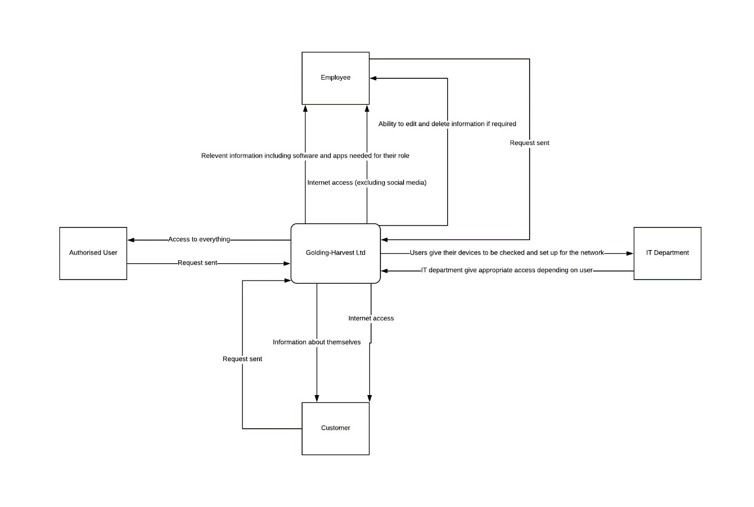
This is a basic level 0 diagram of how the privileges will be distributed to users.

Level 1
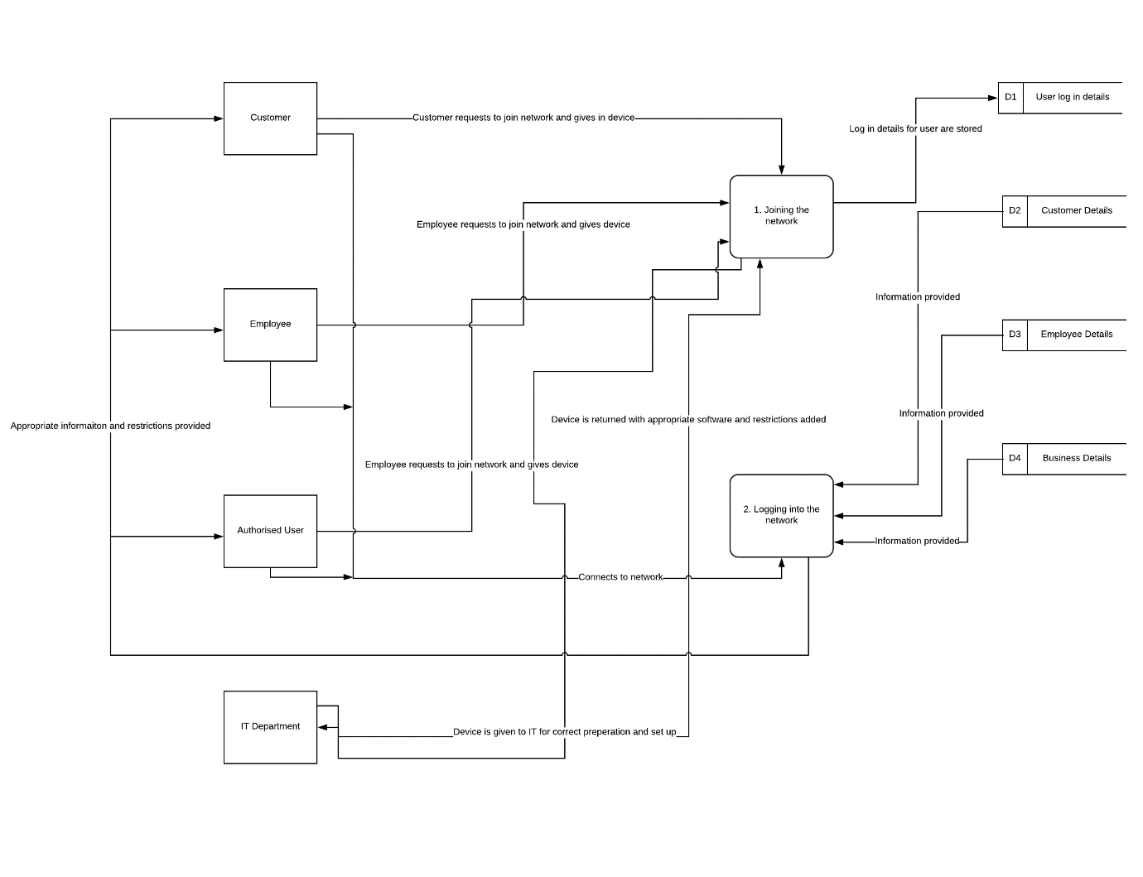
Here is the more in-depth, level 1 data flow diagram. It shows the processes that will be in place for connecting to the network as well as the data stored and how it is distributed.

Network Diagram
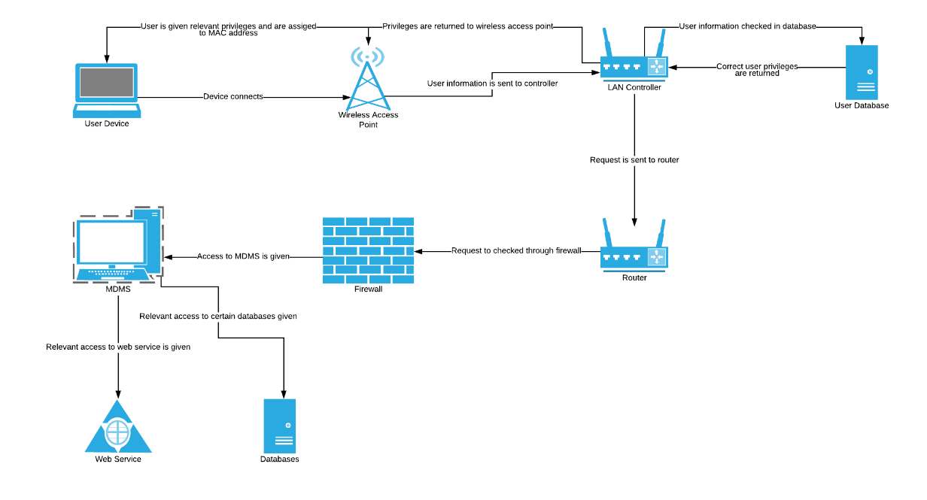
This is the network diagram for the BYOT system. It outlines the process of how a user would access the network and be given the privileges needed to do their job. A more comprehensive diagram could be created in the future to show exactly what privileges are given and exactly how they would be obtained.

Conclusion
The BYOT system implemented for Golding-Harvest Ltd should be a success with the policies put in place and the MDMS that will be used. Everything that has been laid out sets the company up for a safe and secure system that will look to maximise productivity within the workplace.
The system in place will ensure that only the correct information is given to the correct individuals and that no sensitive information will be saved onto the devices when they are brought out of the workplace. As well as this, the correct security procedures will be put in place within the network and MDMS to minimise the risk of data leakage as it could damage the business as well as individuals.
With these measures in place as well as many others, it should only improve the company as a whole and with these changes it should thrive and expand in the future.

List of Acronyms
BYOT – Bring Your Own Technology
MDMS – Mobile Database Management System
ID – Identification
IT – Internet Technology
HR – Human Resources
LAN – Local Access Network

Reference List
1. IBM MaaS360 Reviews: Overview, Pricing and Features [Internet]. Financesonline.com. 2018 [cited 18 February 2018]. Available from: https://reviews.financesonline.com/p/ibm-maas360/
2. The Advantages and Disadvantages of BYOD - Optimus Learning Services [Internet]. Optimus Learning Services. 2013 [cited 20 February 2018]. Available from: http://www.optimuslearningservices.com/blog/practical-ld/advantages-disadvantages-byod-in-learning/

Bibliography
1. Pembrokeshire College. User Access Control Policy. Pembrokeshire; 2018 p. 2-6.
2. The Top Reasons Companies Block Social Media at Work [Internet]. Workplaceanswers.com. 2016 [cited 20 February 2018]. Available from: http://www.workplaceanswers.com/resources/blog/block-social-media-work/
3. BYOD Security & Policies [Internet]. Veracode. 2018 [cited 19 February 2018]. Available from: https://www.veracode.com/security/byod-security
4. Mobile Device Management (MDM) - IBM MaaS360 [Internet]. Ibm.com. 2018 [cited 18 February 2018]. Available from: https://www.ibm.com/security/mobile/maas360/mobile-device-management
5. Ferrill P. The Best Mobile Device Management (MDM) Solutions of 2018 [Internet]. PCMAG. 2018 [cited 18 February 2018]. Available from: https://www.pcmag.com/article/342695/the-best-mobile-device-management-mdm-software
6. Berry M. BYOD Policy Template [Internet]. IT Manager Daily. 2018 [cited 16 February 2018]. Available from: http://www.itmanagerdaily.com/byod-policy-template/
7. The Advantages and Disadvantages of BYOD - Optimus Learning Services [Internet]. Optimus Learning Services. 2013 [cited 20 February 2018]. Available from: http://www.optimuslearningservices.com/blog/practical-ld/advantages-disadvantages-byod-in-learning/
8. What is a Network Diagram [Internet]. Lucidchart. 2018 [cited 21 February 2018]. Available from: https://www.lucidchart.com/pages/network-diagram

marking criteria and Student FEEDBACK
Common Assessment Criteria Applied | Marks available | Marks  awarded
1. Research-informed Literature
Extent of research and/or own reading, selection of credible sources, application of appropriate referencing conventions.
A good range of sources used, with appropriate referencing. |  | 8
A good range of sources used, with appropriate referencing. | 15 | 8
2. Knowledge and Understanding of Subject
Extent of knowledge and understanding of concepts and underlying principles associated with the discipline.
Throughout document, evidence is available to demonstrate your knowledge of BYOT. A discussion of the company’s obligations due to current legislation could be included. Much of your discussions covers areas that are likely to already be in existence (e.g. levels of access to network), your discussion needs to be more focussed on how the implementation of BYOT would affect the current network. |  | 8
 | 15 | 8
3. Analysis
Analysis, evaluation and synthesis; logic, argument and judgement; analytical reflection; organisation of ideas and evidence
Policy documentation included shows you have considered the implications of introducing BYOT to an organisation. You have justified decisions made in your MDMS, however more detail in what features the software has, along with why it was chosen over other available packages, would have strengthened your argument. I would have liked to see more about what features within the software you would actively deploy and why you would deploy them, for example- how is company information stored on the device and if lost, would a remote wipe have the ability to separate company data from personal? |  | 19
 | 40 | 19
4. Practical Application and Deployment
Deployment of methods, materials, tools and techniques; application of concepts; formulation of innovative and creative solutions to solve problems.
You have provided several well-considered network diagrams demonstrating how you would organise the network in line with the introduction to BYOT. Further discussion to support on network implementation to support diagrams submitted and justification of why this choice is better than other options available would have given you more marks. |  | 9
 | 20 | 9
5. Skills for Professional Practice
Attributes in professional practice: individual and collaborative working; deployment of appropriate media; presentation and organisation.
Work is presented logically and is well structured, with good use of diagrams, although some discussion to contextualise these would be beneficial. Some minor errors could have been picked up by proof reading document. |  | 5
 | 10 | 5

Assignment Mark (Assessment marks are subject to ratification at the Exam Board. These comments and marks are to give feedback on module work and are for guidance only until they are confirmed. ) | Late Submission Penalties (tick if appropriate) |  | 49%
 | Up to four weeks late |  | 49%
 | First Attempt? |  | 49%

