Marketing Management – Assessment 2 :Aston Martin
By Himanshu Patidar

Name :- Himanshu Patidar
Student Number :- 2128672
Module :- LCMB7001
Lecturer :- Tushara Balendran
Course :- Master In Business Administration
Submission Date :- 12/09/2022

Table of Contents
Table of Contents 2
Introduction 2
PESTLE Analysis 2
Michael Porter’s Five Forces Model 4
SWOT Analysis 5
Marketing Mix Strategy 6
Conclusion and Recommendations 7
References 9

Introduction
The process of marketing can be quite complicated, depending on the type of product and service that an organization has on offer. As explained by Nurcahyo (2016), the marketing processes responsible for brand building and customer loyalty, two factors which are critical for attaining long-term goals of an enterprise. In the entire process, the role of market and environment analysis is quite critical and the tools used in carrying out the assessment are also important.

In this assessment, five such environment analysis tools are discussed along with their implementation to Aston Martin Lagonda Global Holdings PLC, a UK-based manufacturer of luxury cars. The report aims at providing a brief insight in the internal and external environment of the company along with evaluating the current segmentation, targeting and positioning strategy adopted by the organization. Finally, the report takes account of the marketing mix and recommends actions for the future.

PESTLE Analysis
As explained by Akman (2020), PESTLE analysis is one of the most comprehensive tools that help in carrying out external environment analysis for a business. PESTLE stands for Political, Economic, Social, Technological, Legal, and Environment analysis, and hence it can be regarded as a complete way of evaluating different aspects of business environment in which a business operates. As underlined by the author, a business decision-maker needs to take account of how different external factors would affect the present and future of the business.
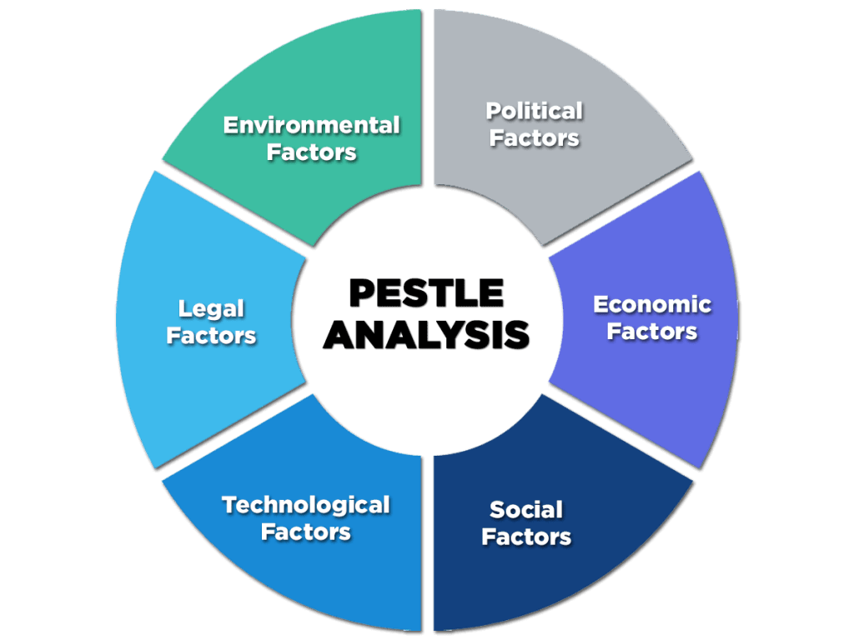
Depending on the nature and size of an organization, the constituents of PESTLE can be different from each other. For Aston Martin, the PESTLE analysis has been carried out and summarised in the following table:
Political Analysis (Medium Favourable Factor)  There is a significant uncertainty in regards to the future of automobile sector post Brexit announcement by the UK government (The impact of Brexit on the UK automotive industry, 2022). There is little clarity about the exports and important arrangements for carmakers in the country.  The company is exposed to global political developments and hence the overall sales can be affected due to ups and downs in other parts of the world as well. | Economic Analysis (Highly Favourable Factor)  The economy of UK is rebuilding after the dual impacts of Brexit and Covid-19. However, as explained by Howell (2021), both these phenomena resulted in a permanent reduction in the country’s economy. This rebuilding phase shall be critical for the enterprise as the future of the company will be shaped during this period. The estimates of the GDP growing by close to 5% can be encouraging stats for the company (Statista, 2022). | Social Analysis (Low Favourable Factor)  There is a change in consumer preferences, especially in the automobile sector due to the increased prices of fuel. However, fuel prices are most unlikely to influence the perception of luxury automobile consumers (Guan, Köstring, Middleton and Möller, 2022). In the UK, the used car market has grown at an unprecedented rate of 28% (Williams, 2022) which indicates another change in the perception of the customers.  In addition, working female customers can be a significant part of the target audience for the company.
Technological Factors (Medium Favourable Factor)  There is a constant change in the technology as the world has moved towards EVs and the first such vehicle would be launched only in 2025 by Aston Martin (Stafford, 2022). It is a significant disadvantage as the company failed to evaluate the technological changes in the environment.  There can also be advancements in self-driven cars, an area where the company has not shown any interest yet. | Environmental Factors (Low Favourable Factor)  It shall be critical for the company to curb emissions in the cars and the manufacturing process. UK has already banned sale of new petrol and diesel cars from the year 2030 (Harrabin, 2020). Hence, the company should take account of greenhouse gas emissions, pollution standards, and the overall trend towards low engine capacity and emissions for protection of environment. | Legal Factors (Medium Favourable Factor)  Capital and research costs of the company shall increase as the research requirements will also rise. There is a rising demand for safer and secure cars which will also affect profit margins. In addition, the country-wise security and emission standards should be considered for long-term expansion of Aston Martin in different parts of the world.

Michael Porter’s Five Forces Model
After taking account of the external environment of the company, the next part is to evaluate the level of competitive rivalry in the sector. Porter’s Five Forces Analysis has been carried out for taking account of this aspect. As explained by Dobbs (2014) Five Forces Analysis is an excellent tool of strategic management that helps in evaluating the most critical five factors that affect competitiveness in the sector and eventually the strengths and weaknesses of the company’s current position is identified.
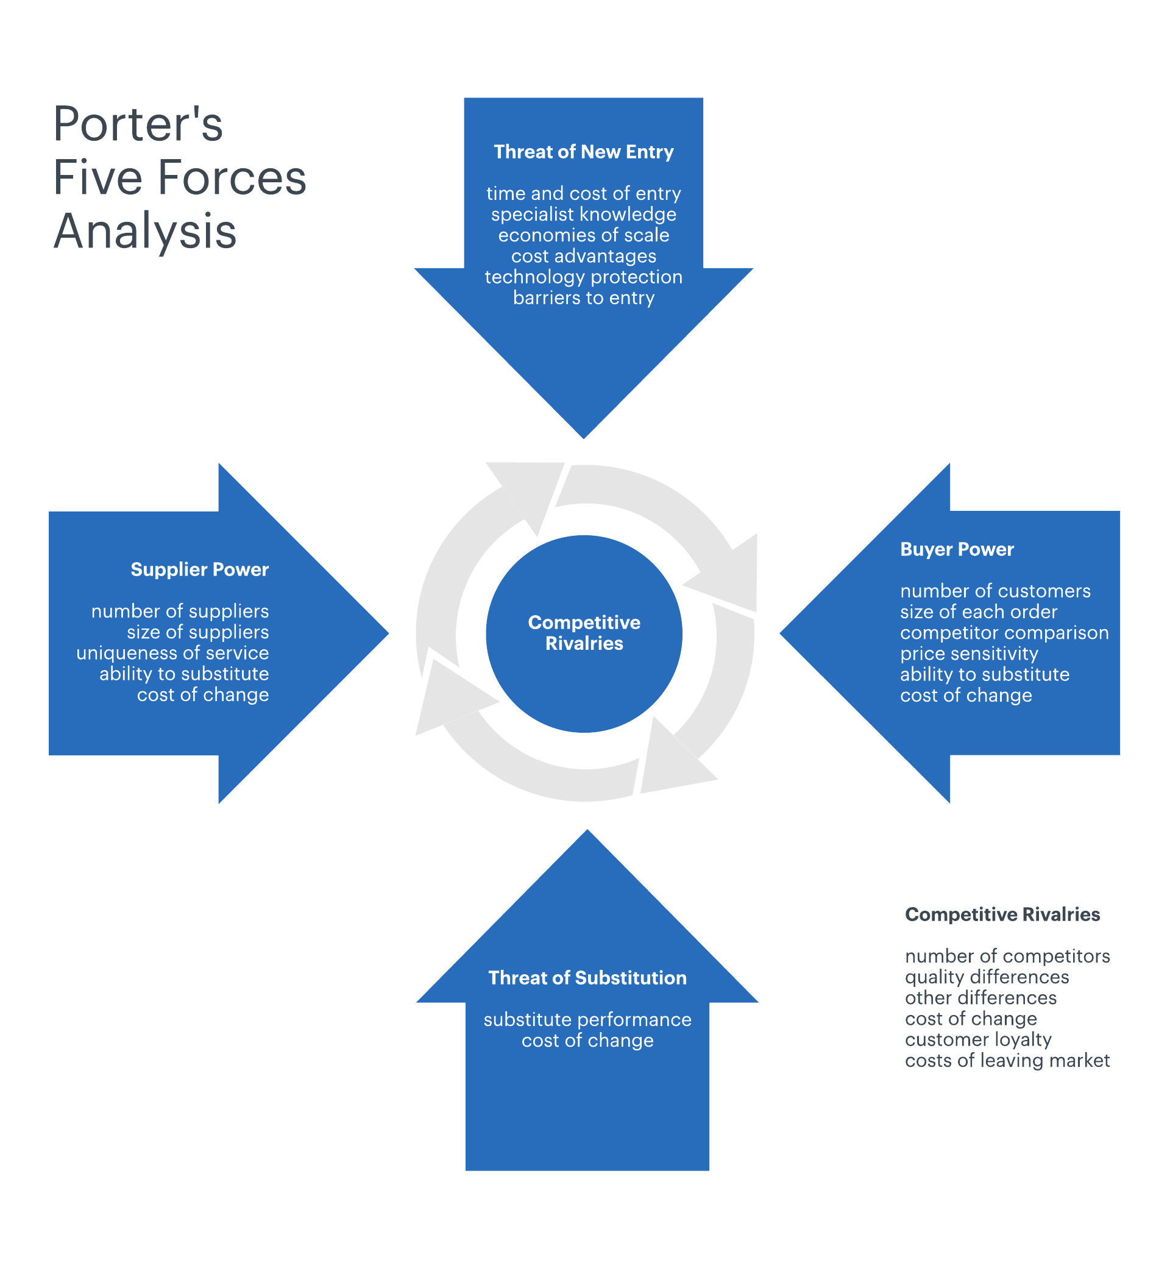
In the context of Aston Martin, the five forces analysis is carried out as follows:

Bargaining Power of Suppliers (LOW): The luxury car market is highly competitive, especially during challenging economic times. There is a significant competition among suppliers as there are around 2600 component manufacturers and suppliers in the UK. This implies that the overall bargaining power of these suppliers is not very strong due to these numbers and the choices available to luxury companies such as Aston Martin.

Bargaining Power of Customers (HIGH): The luxury car market in a struggling economy is customer-centric. There is a significant power in the hands of the customers as they ought to make the eventual decision to buy or reject a car. Hence, a company such as Aston Martin should be aware of the bargaining power of customers due to intense rivalry between firms and lower number of customers.

Threat of New Entrants (HIGH): The entry barriers in the automobile sector are quite high due to fixed costs and capital requirements. Understandably, the barriers are even higher in the luxury car sector. Hence, the overall threat of new entrants is quite low for Aston Martin.
Threat of Substitutes (HIGH): As mentioned before, the luxury car sector has a few players with extremely strong financial background and resources. There are a few customers and both domestic and international brands compete amongst themselves to win over them. Hence, the overall threat of substitutes in this industry is quite high.

Rivalry (HIGH): Once again, due to the average economic conditions, the transformation phase in the industry, and limited number of customers in the industry, it is clear that the overall level of competitiveness in the sector is quite intense. Aston Martin needs to take account of competition from different brands such as Bentley, Mercedes, BMW, Audi, Jaguar, and Porsche, among other luxury car brands.

SWOT Analysis
After taking account of the Porter’s Five Forces Analysis, the next part is to carry out a SWOT analysis of the company. As underlined by Sharma (2020) SWOT analysis is an excellent tool for internal environment analysis by which the most critical strengths, weaknesses, opportunities, and threats of an organisation are listed. For Aston Martin, the SWOT analysis is as follows:

Strengths  - The company has a global brand and sales power. In 2021, the brand managed to sold over 6000 units which was almost 80% more than the previous year (Carey, 2022)  - The company has one of the best design and engineering mechanism in the world  - The company has various strategic partnerships including in different racing arenas (Aston Martin, 2022). | Weaknesses  - The company relies on a few suppliers despite having a large number of potential partners  - Sales and promotion are largely dependent in the hands of the dealers  - The company has recently posted huge financial losses (323 million GBP in 2020) that has affected its liquidity position (Carey, 2022)
Opportunities  - The company needs to move forward towards electric car development soon (Sharma, 2020).  - The company can take account of luxury car opportunities in emerging nations  - The company can collaborate with local dealers and suppliers in geographic expansion | Threats  - There is a huge competition in the industry coupled with a limited number of customers  - The car models currently in place have low mileage and higher emission records  - The development in the emerging markets and geographic expansion can be best defined as unpredictable.

SWOT analysis has a definite benefit in regards to finding and summarising the most critical factors which influence internal environment of a business. However, as explained by Kotler et al. (2009), the entire method is quite single directional and merely helps in providing a summary of the internal environment rather than providing a solution to it.

Marketing Mix Strategy
Marketing Mix refers to a set of four elements: Product, Price, Promotion and Place which are to be taken into account by a company whilst evaluating the customer needs and meeting the enterprise goals. For Aston Martin, the Marketing Mix has been presented as follows:

Product
The company manufactures luxury sports vehicles and grand tourers. In addition to this, the company has offered its branding to a variety of projects including real-estate, apparel, monster trucks, bicycles, submarines, and speedboats. Being a luxury brand, the prestige and the feeling of association with the brand is high. The number of customers, are lower than other general carmakers such as GM or Toyota. There is also the option for customisation in luxury cars and a number of limited-edition sports cars have been introduced. The company is yet to launch an electric vehicle and it is anticipated that the first EV by Aston Martin shall be launched by 2025.
Place
The company has its base in the UK. However, besides the home country, the company has its operations and presence in over fifty other countries in Asia, Europe and Americas. The company has a powerful distributor and dealership network. It also has ensured that all the strategic partners have maintained the luxury brand image. The stores have the ambience of classic elegance and wealth. Personalisation and customisation services are offered to the potential and existing customers.
Price
The company falls in the premium category of automobiles. The company’s cars start with a minimum price range of around £150000 (approximately) which can go up to £3,500,000. Hence, the price strategy followed by the company is high premium pricing for its exclusive vehicles. Because of the company’s luxury status, it is able to charge high prices from the customers who are willing to pay such price as it provides them the association with this luxury brand.
Promotions
The company has a significant worldwide recognition due to a well-managed branding strategy. The company has traditionally relied on the importance of word-of-mouth promotions and direct dealings. However, in the past few years, the overall importance of social media on the branding and marketing campaigns of the company is also tremendous. Aston Martin had a fan following of 6.9 million and 1.1 million on the Facebook page and Twitter account respectively (in 2018), within a few months after its debut on these platforms.

Conclusion and Recommendations
Aston Martin has a special place among its brand loyal customers which has been described in different parts of the report. Furthermore, the report underlined at the strong and challenging areas which the business will face due to its strategic position in the market. The growth opportunities and areas of improvement have also been underlined throughout the report.
Based on the careful assessment of the external and internal environment of the company, following are a few recommendations:
- The company should roll out an effective and achievable strategy of EVs as unnecessary delay on this part would affect the overall brand image. Since EVs shall be mandatorily required in core AM markets, it is important that the resources of the company are invested in bringing them out sooner.
- The company must have a strategic plan to introduce its dealership and manufacturing concerns to emerging nations such as India and Russia.
- The company should provide a clear roadmap of how it would manage different emission-related challenges.

References
Akman, M., 2020. Defense Management and PESTLE Analysis. Ante Portas - Studia nad bezpieczeństwem, 1(14)/2020(1(14)/2020), pp.93-102.
E. Dobbs, M., 2014. Guidelines for applying Porter's five forces framework: a set of industry analysis templates. Competitiveness Review, 24(1), pp.32-45.
Statista. 2022. Economy - United Kingdom | Statista Market Forecast. [online] Available at: <https://www.statista.com/outlook/co/economy/united-kingdom#:~:text=The%20GDP%20(gross%20domestic%20product,US%243.76tn%20in%202025.> [Accessed 12 September 2022].
Guan, M., Köstring, J., Middleton, S. and Möller, T., 2022. Five trends shaping tomorrow’s luxury-car market. [online] Available at: <https://www.mckinsey.com/industries/automotive-and-assembly/our-insights/five-trends-shaping-tomorrows-luxury-car-market> [Accessed 12 September 2022].
Harrabin, R., 2020. Ban on new petrol and diesel cars in UK from 2030 under PM's green plan. [online] BBC News. Available at: <https://www.bbc.com/news/science-environment-54981425> [Accessed 12 September 2022].
Howell, E., 2021. Brexit, Covid-19, and Possible Frameworks for Future UK/EU Financial Governance Cooperation. SSRN Electronic Journal,.
Nurcahyo, B., 2016. The Role of Customer Satisfaction in a Relation of Experiential Marketing and Customer Loyalty. Advances in Social Sciences Research Journal, 3(1).
Stafford, E., 2022. Aston Martin Is Going Electric, Launching Its First EV in 2025. [online] Car and Driver. Available at: <https://www.caranddriver.com/news/a39798418/aston-martin-electric-lineup-reveal-first-ev-2025/> [Accessed 12 September 2022].
Inchcape. 2022. The impact of Brexit on the UK automotive industry. [online] Available at: <https://www.inchcape.co.uk/blog/news/the-impact-of-brexit-on-motoring-in-the-uk/#:~:text=Brexit%20Impact%20on%20Car%20Sales,29%25%20less%20than%20in%202019.> [Accessed 12 September 2022].
Williams, J., 2022. Used car prices grow for 26th consecutive month despite signs of softening market - Auto Trader – Car Dealer Magazine. [online] Car Dealer Magazine. Available at: <https://cardealermagazine.co.uk/publish/used-car-prices-grow-for-26th-consecutive-month-despite-signs-of-softening-market-auto-trader/264998#:~:text=The%20online%20marketplace%20has%20released,in%20the%20past%2012%20months.> [Accessed 12 September 2022].
Williams, S., 2022. ‘Plan B’ measures have little impact on used car prices as growth rockets 28%. [online] Auto Trader Group plc. Available at: <https://plc.autotrader.co.uk/press-centre/news-hub/plan-b-measures-have-little-impact-on-used-car-prices-as-growth-rockets-28/> [Accessed 12 September 2022].

