“A critical evaluation and the identification of the next teaching and learning steps of focusing on a case study of an individual learner or a group of learners, based on an observed critical incident.”

Word Count - 4400 & 1000 Appendices

Introduction:
This assignment focuses around the words ‘Critical’ and ‘Incident’, the ‘incident’ does not have to have been a large out of the ordinary event but something that occurs regularly and can be part of the normal routine, but it is made ‘critical’ by the researcher/
observer through analysis. As Tripp (2012) states “incidents appear to be ‘typical’ rather than ‘critical’ at first sight but are rendered critical through analysis” (Tripp,2012:25). These ‘typical’ incidents tend to be unnoticed in normal practice and the classroom environment. Through analysis we are trying to in some cases “verify something we already suspected” (Tripp,2012:43) but things we did not think about may become apparent in the analysis process.

From identifying an event during observation and then analysing it to make it ‘critical’, what has been found will then be used in reflection to inform and develop my own practice. Reflective practice in regard to teaching is “important in enabling teachers to critically question their assumptions and deepen their awareness” (Jackson, 2019) this means that teachers will be proactive and will understand the importance of continued development in their learning and practice.

Throughout this assignment I will be looking into the observation procedure used to be able to identify a critical incident. The critical incident will then be put into perspective by looking into two or three key themes that arose from the incident and undertaking a literature review to then be able to reflect and think of next steps from these research areas that I can implement into my own practice.

Observation:
The school I was placed in for bridging has over 700 pupils (Welsh Government, 2019) on roll and is three form entry in every year group, making it one of the largest primary schools in the area.
The school is based in a more affluent area of the surroundings and has many facilities, such as a Lego lab that other schools are not fortunate to have (Romilly Primary School, n.d.).
It is an English medium school with very low numbers of children who speak Welsh (Estyn,2015).

The school is Victorian so is on more than one floor, year groups have either a separate or shared building, with collaborative and communal spaces along with outdoor facilities. Each year group has an average of 90 pupils in the main school (Romilly Primary School, n.d.).
The school has a very low number of Free School Meals children (11%), and only 10% of the school community identify as having additional learning needs compared with the national figure of 22% (Estyn, 2015).

For this bridging experience, I spent half a day in three-year groups; reception, year 1 and year 2, but I was placed in an overall learning group because of the current pandemic and the school having staggered start and finish times. For the incident discussed in this assignment it took place in the Year 1 class, Mathematics and Numeracy session, there was on average 30 pupils in the class and the teacher and the learning support assistant.

No defining details about the school for example Name and Location will be given in this assignment as it would be a breach of privacy and confidentiality as shown in the BERA (2018) guidelines. The anonymity of the school is of key importance and as BERA states it is the “norm for the conduct of research” (2018:21) as if the school is identifiable this could have very negative repercussions for the school, its pupils, its staff and other people connected or working with the school. The name of the school, staff or pupils will not be mentioned and if any references include the school name, they will be blacked out to avoid breaking the ethical guidelines and data protection laws.

Methodology:
The methodology for this assignment was predefined as non-participant structured case study, this section will define terms and look at the strengths and limitations of methods used.

“Too often methods of data collection are confused with methodology and methodology confused with design” (Cohen et al, 2018:285). The term methodology is defined as the framework and techniques/methods used in a study or research project (Taber,2013:43), there are many different types of research methodology including case study that was used for this observation. Methodology differs from data collection as this is where we apply the methodology to gather the data and then make judgements from the data set.

As Cohen et al stated observation is “distinctive” and in the research process “it offers an investigator the opportunity to gather ‘live’ data from naturally occurring social situations” (Cohen et al, 2018: 396). This was the best option for the type of research and reflection model that was the focus, as the key aim was to identify an incident and make it critical, so the incident was something that was “typical” and not out of the ordinary in the classroom environment and observation was key in being able to witness an incident in situ and real time.

A case study can be defined as “a single instance of a bounded system” (Creswell,1994:12) and this becomes “the basis of a thorough, holistic and in-depth exploration of the aspect(s) that you want to find out about” (Kumar, 2014: 155). A case study allows you to see incidents in real life contexts, giving you a clear view of what is happening and combine theory and practice. This is one of the main strengths of the approach, as you can establish “cause and effect” (Cohen et al, 253) and this helps us see abstract ideas in practical ways helping to apply theory to practice. Furthermore, this methodology is very in depth and detailed, which can help us understand what is going on in practice not just in theory (Nisbet & Watt 1984 as cited in Cohen et al, p 256).

On the other hand, a limitation is that results are difficult to generalise as it cannot be applied to a wider population (Nisbet & Watt 1984 as cited in Cohen et al, p 256). Another limitation is observer bias becoming a factor, even when the observer is not involved any preconceptions, they may have could influence what they think they witnessed and then how they go about analysing (Nisbet & Watt 1984 as cited in Cohen et al, p 256).

The non-participant method means that as the observer you are not directly involved or taking any active part in the activities and are merely observing the environment and what is going on (Mills et al, 2010). However, even though this was the defined method for the bridging days, I was asked by the staff and children to partake, so I did not stick solely to non - participant method. By participating I felt I was able to gain a fuller understanding but by participating researcher bias “commonly understood to be any influence that provides a distortion in the results of a study” (Polit & Beck 2014 as cited in Galdas, 2017) may have become a part of the observation process. Subsequently this may have led to a change in what I went on to analyse as I had become engrossed in the activity and I may have missed important aspects of the incident.

The method was structured because we had observation/field notes sheets (Appendix A) to follow and focus our observations, this made them more effective and helpful for the analysis process.

4 Purposes:
The critical incident that has been chosen as the focus for this assignment was from my observation of a Mathematics and Numeracy lesson in Year 1 (Appendix A 2.3. and A 1.3).
In the incident, children were in mixed ability learning partners and placed at a learning activity table either focused with the teacher or enhanced. The table they were placed at related to the activities that they had previously done that week, as the activities are the same or only slightly different for the lesson for the whole week, as the children rotate activities.

The main focus of the incident was that the majority of children were keen to be able to do the iPad-based activity or the bingo game with the learning support assistant. The children who were not picked for both activities appeared to be disappointed, even more so those who did get to do the iPad-based activity. The group that did get the opportunity to work on the iPads worked very well together and were very engaged with the number based activity, the children also enjoyed being able to pick a sticker reward for good work in the app, and they appeared disappointed when they could not choose a sticker reward. Those children that were not able to work on the iPads for the lesson did keep coming over to the iPad group and tried to partake in the activities, watch and help the children on the game, so they were distracting the children who were working well at the activity.
There appeared to be less engagement, when the children were not working with an adult or on the iPad game, and these were the groups that were getting rewarded more, so maybe they felt more motivated to work hard.

The new Curriculum for Wales 2022 has four purposes adapted from the Donaldson review (2015) and have become one of the key changes and differences for the curriculum changing since the successful futures document was published.

The critical incident links to two purposes most notably, “ambitious, capable learners who are ready to learn throughout their lives” and “enterprising, creative contributors who are ready to play a full part in life and work” (Welsh Government,2015). It was heavily linked to the use of technology and this is a key focus throughout the four purposes and the importance of technology is further highted in the new Digital Competence Framework (Welsh Government, 2018).

Ambitious, capable learners “can use number effectively in different contexts” (Welsh Government,2015) is evident in the incident, as by using the enhanced provision activities, which varied from matching activities to colour by numbers and the use of iPad technology, children are developing their number understanding so that they can easily apply it in many areas and contexts. This further links to the first ‘what matters’ statement for Mathematics and Numeracy “number system is used to represent and compare relationships between numbers and quantities” (Welsh Government, 2020). The documentation states that this is the “first concept” (Welsh Government, 2020) that learners encounter, so it is important that the way we teach it and develop children’s understanding is very important as they need the basic knowledge and skills to be able to progress onto more complex tasks and formulations within the area of learning, but also to be “confident to participate in the world” (Welsh Government, 2020). Therefore, using technology, creative tasks and interactive methods as seen in the critical incident, will further develop the child’s learning and understanding helping them to become ‘confident individuals’ who are ready to ‘learn throughout their lives, linking it back to the four purposes.
Furthermore, the critical incident of being engaging, interactive and the fact that iPads were used fits well with the ‘enterprising, creative contributors’ as the children are developing skills to be able to “think creatively to reframe and solve problems” and “express ideas and emotions through different media” (Welsh Government,2015) , the first is highly relevant as the focus activity then gives children the understanding and knowledge so they could then apply what they had learnt creatively for the enhanced activities for example, iPad games and colour by numbers.

Literature Review:
From the critical incident and observation, it has highlighted two areas of importance that will be researched and analysed in further detail through this literature review. The two areas of importance are use of technology in the classroom and the use of reward systems.

Technology
This was the main point of interest from my observations, as the all the children wanted to use the iPads and were disappointed when they were not picked. So, when analysing the incident, it raised questions about the importance of technology in the learning experience and how we can use them effectively and what are the overall pros and cons for using technology to develop learning.

Research suggests that the constructivist learning theory links well to the use of technology in the classroom. As stated in Ivers (2003, p40) “technology can help students learn by allowing them to construct knowledge”. This therefore supports the implementation of technology in the classroom as by having independent technology-based activities the children are able to develop and ‘construct’ their own learning. This is further supported by Miles (2019, p.3) who discusses the importance of Vygotsky’s theory of social interaction including collaboration and how this is supported by the use of technology, through technology you can easily encourage collaboration, as shown in the critical incident by the use of mixed ability learning partners as they are supporting and collaborating together it suggests they are more likely to achieve higher, the More Knowledgeable Other idea (Miles, 2019).
Moreover, using technology in the classroom means that the education system is keeping up with the times. “Several studies have stated that it is important to prepare children in the digital age because digital media promotes children’s critical thinking and active learning and allows them to have control over what they are doing” (Pruet , Chee Siang Ang , Farzin, 2014). This is supported by the idea of ‘Media Literacy’ (Donohue,2015, p91), meaning we need to assist young people in evolving life skills that they will need to become “thinkers and makers”. Even though it is of key importance that technology is used in the classroom so children are equipped for life, it should “not be replacing play or hands on creative activities, but rather used to enrich the early learning experience” (Donohue,2015, p193), this shows that we should not always fall back on using technology but make sure we are still using other interactive activities that have high engagement from children, as children still need to have a wide range of learning experiences and skills to develop and construct their understanding of topics even if technology has a good basis for this, we still need to offer different opportunities.

A research study by……p61 found that the use of technology with young children allowed them to transfer knowledge from one form (technology) to another (practical/hands on). The study carried out two experiments to see if the learning transferred and they found that the learning did transfer but that no practical teaching activity needed to take place before the children used the iPad technology, the “children improved their own problem solving task through practice”. The idea that technology supports problem solving is further supported by Ivers (2003) who suggested that using technology “supports higher order thinking, problem solving and problem-based learning”. Overall this emphasises the need for technology to be used in the learning environment and problem-solving links well to the Mathematics and Numeracy area of learning, which means that a cross curricular approach to learning can be taken, which is something the Welsh Government are aiming for.

However, even though many researchers have found that using technology in the classroom is important for both learning and development, there is research that suggests that use of technology in the classroom is not always effective. As there will be “less direct social interaction” through the use of technology, this could be a worrying issue as children need to be able to develop their communication and interaction skills in school to be able to make friends, understand learning but also to be able to lead a fulfilling life as these are basic life skills. So even though the overall impact of technology would be good as it can “increase self-esteem, self-confidence and motivation” (Ivers, 2003) it could impact other key areas of children’s development, so we need to be careful about our reliance on technology.

All in all, from research using technology in the classroom is a good thing but we need to make sure that we do not rely upon it and we need to encompass a wide range of other learning activities. It is important that we use technology in our classrooms because we are in a more technology-based environment, so these skills are just as important to develop as communication and interaction.

Reward systems
Reward systems were a key part of the critical incident, so this is the focus for this section. Reward systems are ways and technologies that are used to reward children for many different, one of the most popular and what I observed was ClassDojo.

In my observations, reward systems were being used for both learning and behaviour management. There were also sticker rewards on the iPad game. Children were very keen to be able to be rewarded for their learning or another reason, and once one child had been rewarded there was a sense of the rest of the class copying their behaviour to try and get more reward points (Dojos). As reward systems were a key part of the classroom culture and the learning activities that I observed, I thought it was key to develop a better understanding of how to implement them, whether we should use them, the general pros and cons to reward systems.

There are two types of reward/ motivation intrinsic and extrinsic, “extrinsic (based on external and usually tangible rewards) or intrinsic (usually based on internal factors such as recognition, feelings of achievement, or simply the satisfaction of completing a task)” (Pinder, 1984 as cited in McClurg &Morris,2014).

Reward systems are used to control behaviour as well as motivate students. This area links to the Behaviourist learning theory approach, “Rewards (or reinforcers), when they follow behaviour, make that behaviour more likely to occur again” (Skinner 1974 as cited in Morgan 2009) because we are rewarding children for getting something right and when children are not rewarded, for example they may not be behaving how we want them to be behaving while others are being rewarded for the way they are behaving there is more of a chance that the children not receiving any reward will change/alter their behaviour so that they can gain rewards. “The learner starts off as a clean slate (i.e. tabula rasa) and behaviour is shaped through positive and negative reinforcement” (Watson,2013). This highlights the impact that rewarding children for behaviour could in some instances mean that a child alters their behaviour in general, so this could positively impact the classroom environment. However, Wilson and Corpus (2001) research states that this model is “ineffective for changing behaviours long term” (p.56).

Moreover, another key area of interest which has arisen during the research into reward systems, is how this effects academic performance. Some research has found that “rewards have interfered with the quality of learning taking place” (Baranek,1996) the example given of when rewarding in the learning process did not work is when children were rewarded with sweets as the children were more distracted by the thought of being rewarded with sweets and as a result it appeared as though “less learning” (Baranek,1996) took place, compared those who received nothing when they got the right answer. This shows that in some cases rewarding children actually hinders learning rather than developing it.

Furthermore, one of the most popular reward systems currently being used is ClassDojo, which is where children create their own monsters and the app was designed to aid classroom management and behaviour. Research has now shown that Class Dojo is now moving away from just being a “behavioural rewards” system and into “growth mindset” (Anon, 2016). A growth mindset is where “they believe that they can learn more or become smarter if they work hard and persevere” (Education Reform, n.d.). Class Dojo have developed this “growth mindset” through videos using the monsters, the idea is then that the children begin to copy/follow the behaviours that are being shown in the videos and work through any problems and work hard to develop (Anon, 2016). Therefore, Class Dojo rewards can be used in a variety of contexts and for many reasons, not just for behaviour and classroom management. The influence that Class Dojo rewards has on children is clear to see in practice, as children love creating and developing their own monsters when they reach certain points.

Overall, the use of reward systems can impact positively and negatively on children’s learning and development experiences. Using reward systems is a good way of improving behaviour and motivation but in some cases, it can hinder the learning, so in practice we need to be careful that we are using reward systems including Class Dojo in the right way and for valid reasons.

Reflection/Evaluation and Next Steps
After research, I can reflect on the next steps for my practice based on literature and observation, meaning my practice will be well informed.

In my observation, the iPads were only used for that one lesson enhanced learning activity, when the opportunity for using iPads or technology arises in my practice my intention will be to follow what I observed and only use the iPads or technology for small/short activities if they are not a focus for the learning, as from my literature review it was clear to see that even though technology in the classroom has its benefits, we can also become too reliant on it and we need to make sure that children are still having a breadth of opportunities. We need to develop a whole person, not just a person who it digitally literate.

Furthermore, the other key area of importance was reward systems. This arose in two contexts within my critical incident, reward stickers were used on the iPad game and then Class Dojo was used with the whole class for behaviour and classroom management as well as for rewarding learning. During my literature review it was highlighted that reward systems for example Class Dojo are useful, but we should be moving towards a ‘growth mindset’ rewarding rather than just for behaviour. In practice, the intention would be to use a reward systems like Class Dojo and use the resources they provide to develop a good and effective way of using the reward system, the intention would also be following Class Dojo to go towards a ‘growth mindset’ so we are helping with children’s wider development not just rewarding them for one good behaviour.

Additionally, reward systems links to the behaviourist learning theory model where we are reinforcing the behaviours, we want children to have and then negatively/punishing the behaviours we do not want the children to have. Even though the behaviourist model is well known and widely used without knowing it, in my practice I intend to not solely use the behaviourist model but use a combination of the following three models logical consequences (Dreikurs 1968), Reality Theory (Glasser 1965) and Ginott model (1971) to form my own model for behaviour management which will be created for the children and with the children so that they know what the rewards and consequences are.

“Critical reflection is the sustained and intentional process of identifying and checking the accuracy and validity of our teaching assumptions” (Brookfield, 2017) Brookfield’s reflective model is based on us reviewing through four lenses, these are “Students’ eyes, Colleagues’ perceptions, Personal experience, Theory”. Brookfield states that it “cannot be a one-time scrutiny; it must be consistent and regular” (p7). This is important and will be key in my practice to make sure I keep informed and continue my professional development.

The student lens is where we put ourself into their shoes and are seeing the situations how they see and experience it, this allows us to see what worked or did not and then we can change and adapt out teaching from this experience (Brookfield,2017). The Colleagues’ lens is where you ask for a fellow member of staff to observe or partake in your lesson and then you should engage in conversations with them as they may be able to offer you feedback and suggest and useful insights into your work and how you can improve or adapt it (Brookfield,2017). The personal experience lens is where you use your own experiences as students and how you learnt and what hindered that process to review what works best and how to transfer this to your teaching (Brookfield,2017). The theory lens is where research into theoretical literature will help you develop practice that is well informed. After research you can then relate it to the three lenses to help implement next steps (Brookfield,2017).
These four lenses make up Brookfield’s model and are key parts of making teachers critically reflective in practice, so that we are not just assuming things, but we are informing our practice and development from different people’s experiences to make sure our practice is inclusive and adaptable for all.

Brookfield’s model of reflection will inform my own professional development as I will be keeping a daily reflection and weekly reflection while on placement and from feedback from my mentor I can adapt and develop my teaching and from observing and research I am able to apply theory to practice and reflect in, on and through practice. In addition, for my own professional and personal development in the profession, children’s understanding and development can be monitored through methods for example traffic lights and from there I can always develop and adapt my practice if the children need extra support. Critical reflection is invaluable to my development.

Conclusion
To conclude, the overall experience of observing and identifying a critical incident was a very useful and helpful experience to be part of, as by seeing things in a real life context it has allowed me to gain a better and fuller understanding of what happens in the classroom and how this can help me develop my own teaching practice. All in all, the critical incident that I identified and have now researched and analysed was mainly positive because it highlighted the importance of using technology in the classroom but also how we can use it effectively. From identifying the critical incident and then conducting the literature review to develop my understanding, I was then able to reflect on next steps which links in with the new professional standards for Wales. From this process, the most notable standards that I have developed are Pedagogy and Professional learning (Welsh Government, 2020), as I have reflected on the critical incident and then identified steps to implement in my practice but based it on theory as well as observation to make sure that I can understand on what and why I am doing something and this links to Brookfield’s reflective model as you are constantly developing in a cycle.

Overall, the main points to be taken away from the process is the importance of how observing the learning and then being able to reflection and act on the research and reflection is, both for the children’s development of learning but also for the teachers professional development in line with the five professional standards categories. To conclude, from this assignment I will take away that teachers learning is never over as we have to continue to learn with our pupils so that we continue to support our learners in the best possible way.

Reference List

Anon, (2016) Class Dojo Goes Beyond Behavioral Rewards and into 'Growth Mindset'. Curriculum Review, 56(1), p.5. Availabale at: https://web.b.ebscohost.com/ehost/pdfviewer/pdfviewer?vid=2&sid=e450228d-988e-4526-90db-35076e82fa7f%40sessionmgr101 (Accessed October 2020)
Baranek, L, (1996) The Effect of Rewards and Motivation on Student Achievement. Masters Theses. Available at: http://scholarworks.gvsu.edu/theses/285 (Accessed October 2020)
British Educational Research Association (BERA) (2018) Ethical guidelines for Educational Research, 4th Edition, London. Available at: https://www.bera.ac.uk/publication/ethical-guidelines-for-educational-research-2018-online#privacy (Accessed October 2020)

Brookfield, S., (2017) Becoming a critically reflective teacher 2nd edition, San Francisco, CA: Jossey-Bass. Available at: https://ebookcentral.proquest.com/lib/trinity/detail.action?docID=4790372 (Accessed October 2020)

Cohen, L., Manion, L., Morrison, K. (2018). Research methods in education. Eighth edition, London.
Creswell, W. (1994). Research Design: Qualitative and Quantitative Approaches. Thousand Oaks, CA: SAGE.
Donaldson, G (2015) Successful Futures - Independent Review of Curriculum and assessment arrangements in Wales. Available at: https://gov.wales/sites/default/files/publications/2018-03/successful-futures.pdf (Accessed October 2020)

Donohue, C., (2015) Technology and digital media in the early years : tools for teaching and learning. New York; Washington, District of Columbia: Routledge: National Association for the Education of Young Children.
Dreikurs, R (1968) Logical Consequences: A handbook of discipline. New York: Meredith Press.
Education Reform (n.d.) Growth Mindset. Available at: https://www.edglossary.org/growth-mindset/#:~:text=Students%20who%20embrace%20growth%20mindsets,improve%20their%20learning%20and%20skills (Accessed October 2020)
Estyn (2015) A report on Romilly Community Primary School. Available at: https://www.estyn.gov.wales/system/files/2020-08/Adroddiad%2520arolygiad%2520Romilly%2520Community%2520Primary%2520School%25202015%2520%2528Saesneg%2520yn%2520unig%2529.pdf.pdf.pdf.pdf.pdf.pdf_0.pdf (Accessed October 2020)
Ginott (1971) Behaviour Management Models. Available at: https://us.sagepub.com/sites/default/files/upm-assets/40497_book_item_40497.pdf (Accessed October 2020)
Glasser, W (1965) The Evolution of Psychotherapy: The Second Conference.
Irvin, J., Wilson, L., & Corpus, D. (2001) What Research Says: The Effects of Reward Systems on Academic Performance. Middle School Journal, Vol. 33, No. 1 pp. 56- 60. Available at: https://www.jstor.org/stable/23046995 (Accessed October 2020)
Ivers, K.S., 2003. A teacher's guide to using technology in the classroom, Westport, Conn.: Libraries Unlimited.

Jackson, G (2019) What is reflective practice? Available at: https://impact.chartered.college/article/what-is-reflective-practice/ (Accessed October 2020)
Kumar, R. (2014) Research Methodology. London: SAGE.

McClurg, Lucy, 2014. Shaping Student Behaviors Through Reward Systems: Lessons From Beaver Trapping? Journal of Higher Education Theory & Practice, 14(2), pp.89–103. Available at: https://web.a.ebscohost.com/ehost/pdfviewer/pdfviewer?vid=2&sid=207dd1b0-4094-4038-9f01-556a7f8d4b9b%40sessionmgr4007 (Accessed October 2020)
Miles, R. (2019). iPads in the classroom: teachers’ perspectives post-implementation. Learning and Teaching in
Higher Education. Available at: https://web.b.ebscohost.com/ehost/detail/detail?vid=1&sid=971acbad-d825-4fda-a9f6-f644603d51ec%40pdc-v-sessmgr05&bdata=JnNpdGU9ZWhvc3QtbGl2ZQ%3d%3d#AN=138618468&db=eue (Accessed October 2020)
Mills, A., Durepos, G., Wiebe, E. (2010) Non-Participant observation. Encyclopaedia of Case Study Research. Available at: https://methods.sagepub.com/reference/encyc-of-case-study-research/n229.xml (Accessed October 2020)

Morgan, N.S., 2009. Quick, easy and effective behaviour management ideas for the classroom, London; Philadelphia: Jessica Kingsley Publishers. Available at: https://whel-primo.hosted.exlibrisgroup.com/primo-explore/fulldisplay?docid=44UWTSD_ALMA51206470790002421&context=L&vid=44WHELF_UWTSD_VU1&lang=en_US&search_scope=CSCOP_EVERYTHING&tab=tab1 (Accessed October 2020)
Nisbet & Watt 1984 as cited in Cohen, L., Manion, L., Morrison, K. (2018). Research methods in education. Eighth edition, London. (p.256)

Polit and Beck, 2014 as cited in Galdas, P (2017) Revisiting Bias in Qualitative Research: Reflections on Its Relationship with Funding and Impact. Available at: https://journals.sagepub.com/doi/full/10.1177/1609406917748992 (Accessed October 2020)
Pruet, P,. Chee Siang Ang , Farzin, D. (2014) Understanding tablet computer usage among primary school students in underdeveloped areas: Students’ technology experience, learning styles and attitudes. Computers in Behaviour. Available at: https://www-sciencedirect-com.ezproxy.uwtsd.ac.uk/science/article/pii/S0747563214005214 (Accessed October 2020)
Romilly Primary School (n.d.) Our School Available at: https://www.romillyprimaryschool.co.uk/page/?title=Our+School&pid=36 (Accessed October 2020)

Taber, K. S. (2013). Classroom-based Research and Evidence-based Practice: An introduction. 2nd edition. London: Sage.

Tripp D. (2012) Critical Incidents in Teaching: Developing Professional Judgement. London. Routledge
Watson (2013) as cited in Who’s Who 2 PowerPoint - Available at: Moodle.uwtsd.ac.uk (Accessed October 2020)
Welsh Government (2015) The new curriculum: poster - 4 Purposes. Available at: https://gov.wales/new-curriculum-poster (Accessed October 2020)

Welsh Government (2018) Digital Competence Framework guidance Available at: https://hwb.gov.wales/api/storage/337437b8-cfe3-4305-ae32-f47ad82f3e76/digital-competence-framework-guidance-2018.pdf (Accessed October 2020)

Welsh Government (2019) My local school - Romilly Primary School. Available at: https://mylocalschool.gov.wales/School/6732182 (Accessed October 2020)

Welsh Government (2020) Mathematics and Numeracy - Statements of what matters. Available at: https://hwb.gov.wales/curriculum-for-wales/mathematics-and-numeracy/statements-of-what-matters/ (Accessed October 2020)

Welsh Government (2020) Professional Standards. Available at: https://hwb.gov.wales/professional-development/professional-standards/ (Accessed October 2020)

Appendix 1.0 - Observation Sheets

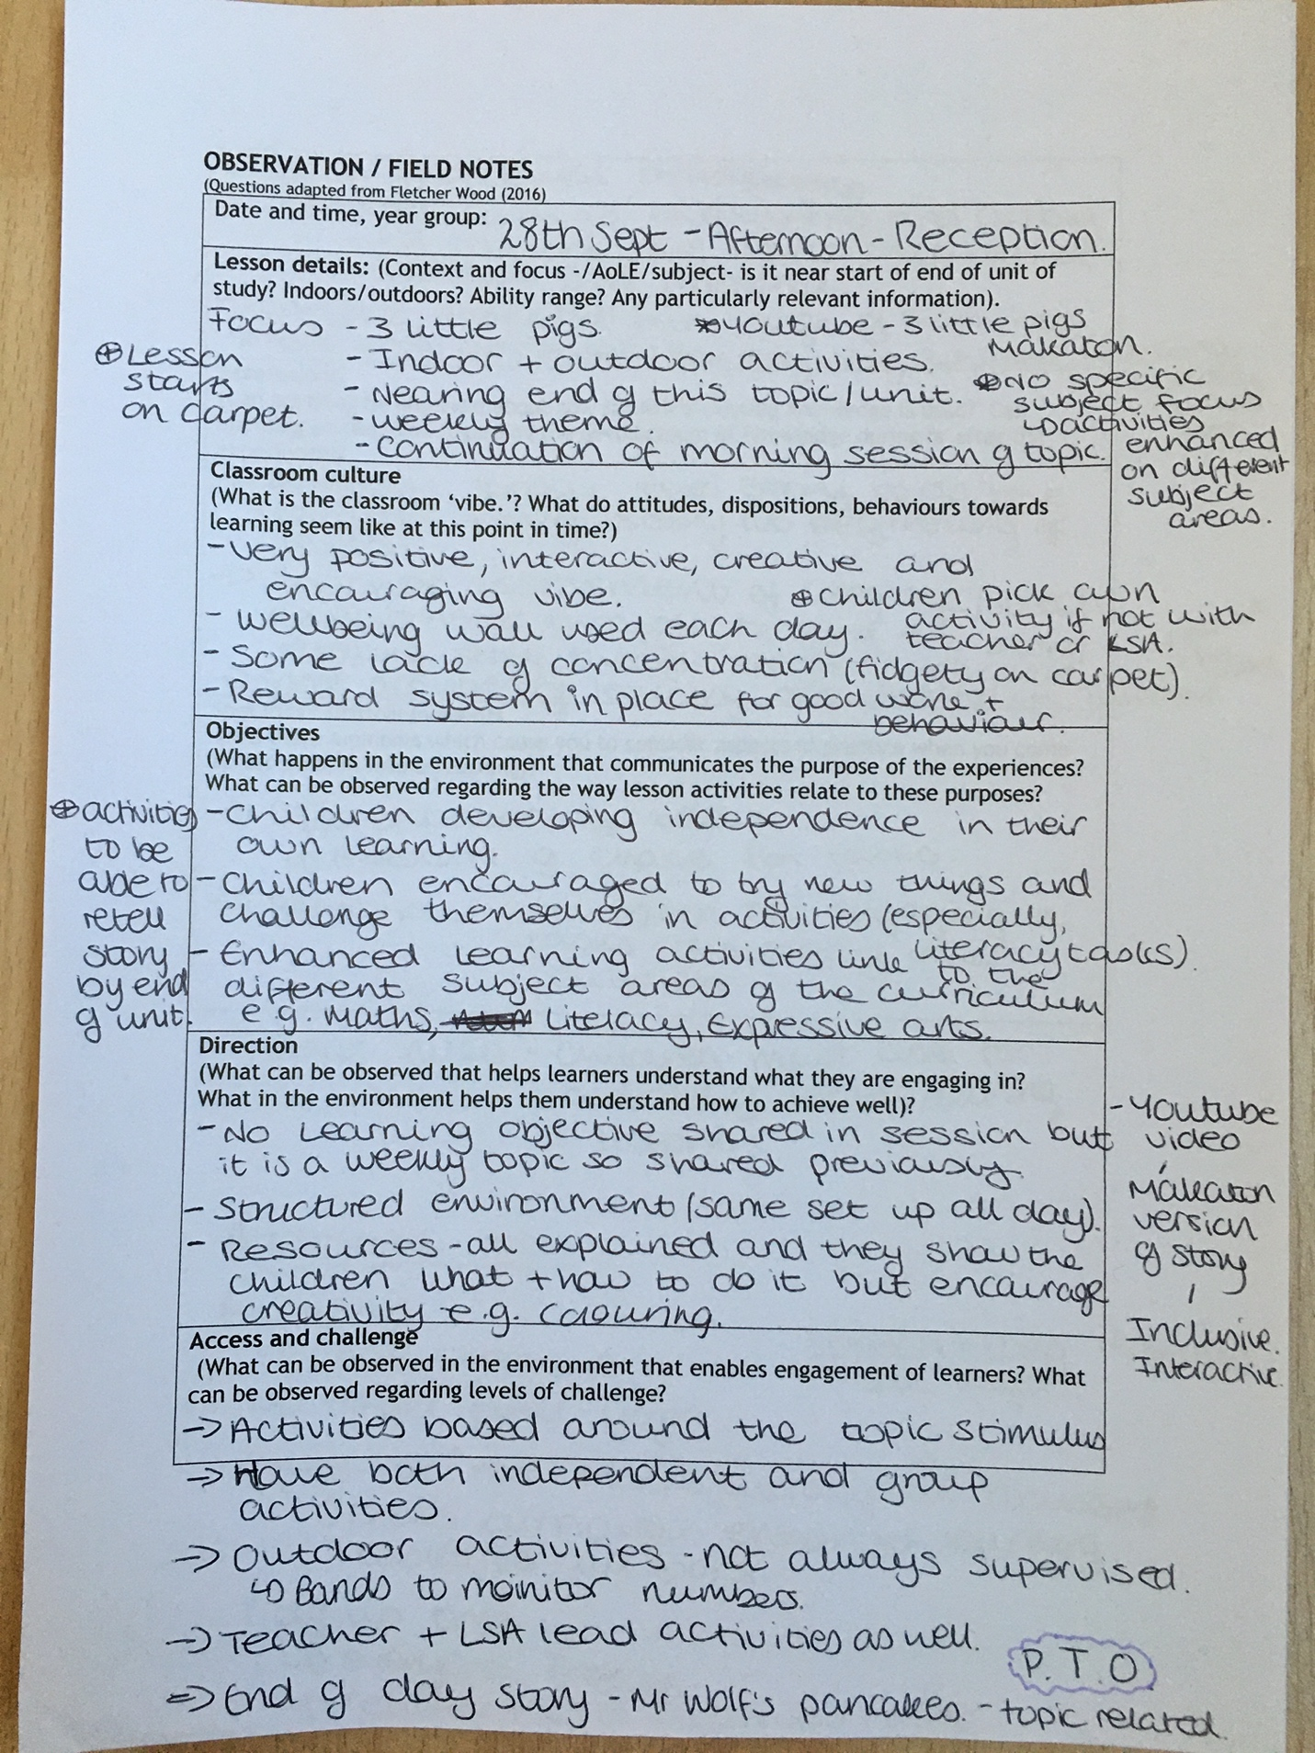
A - 1.1
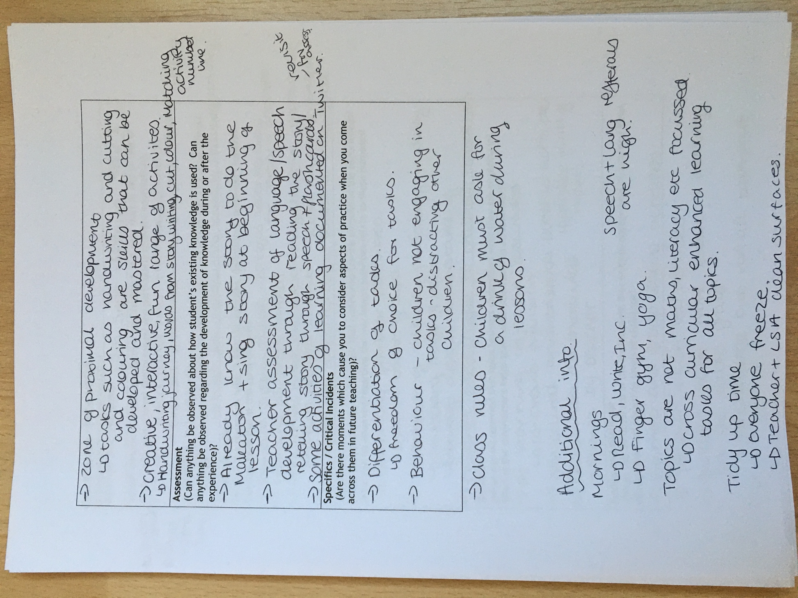

A - 1.2

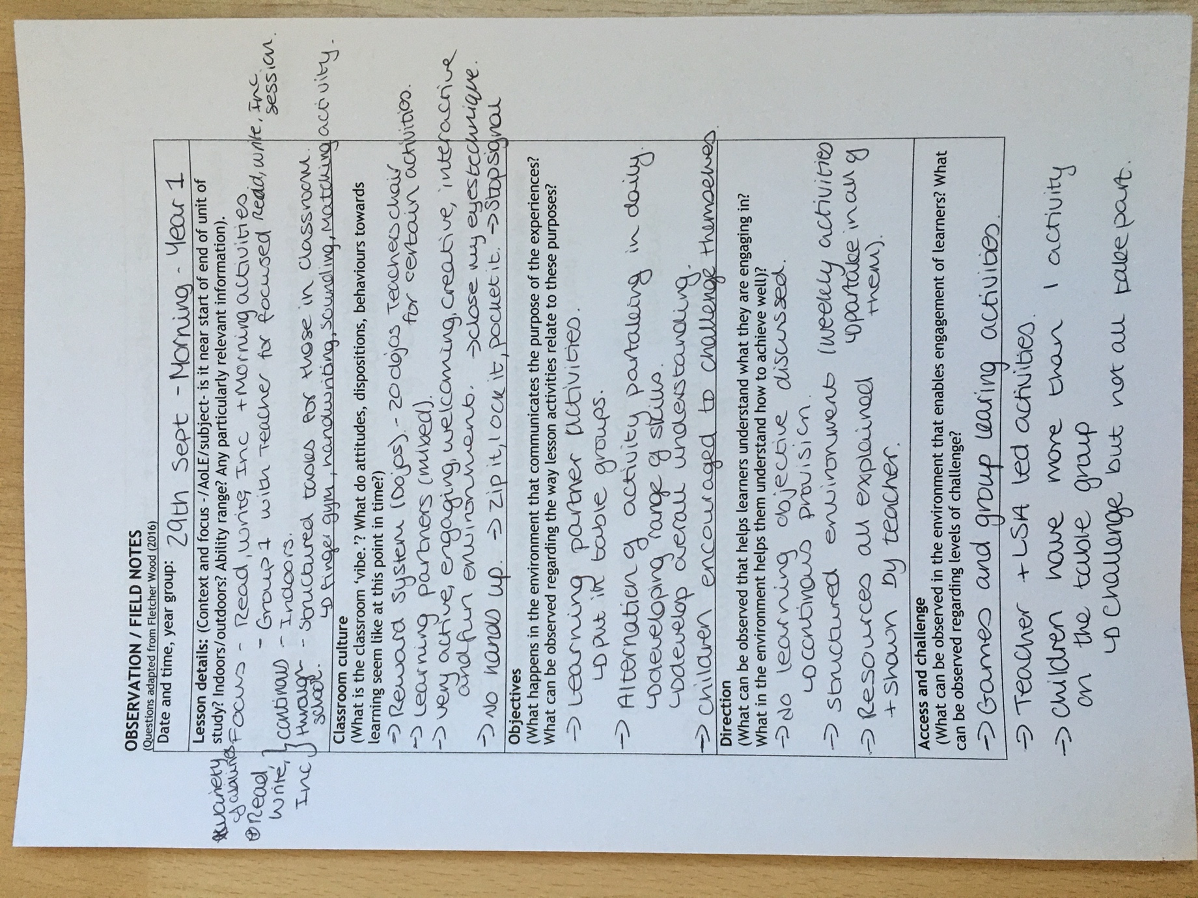

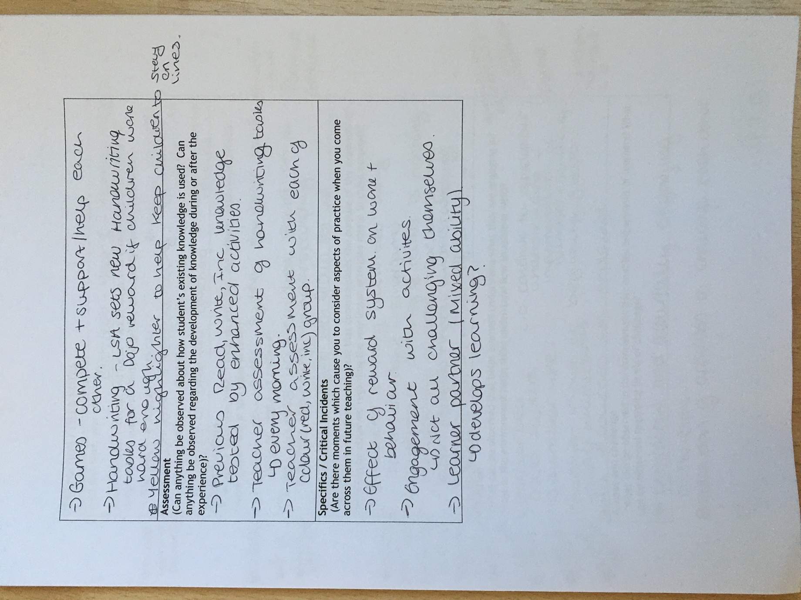

A - 1.3

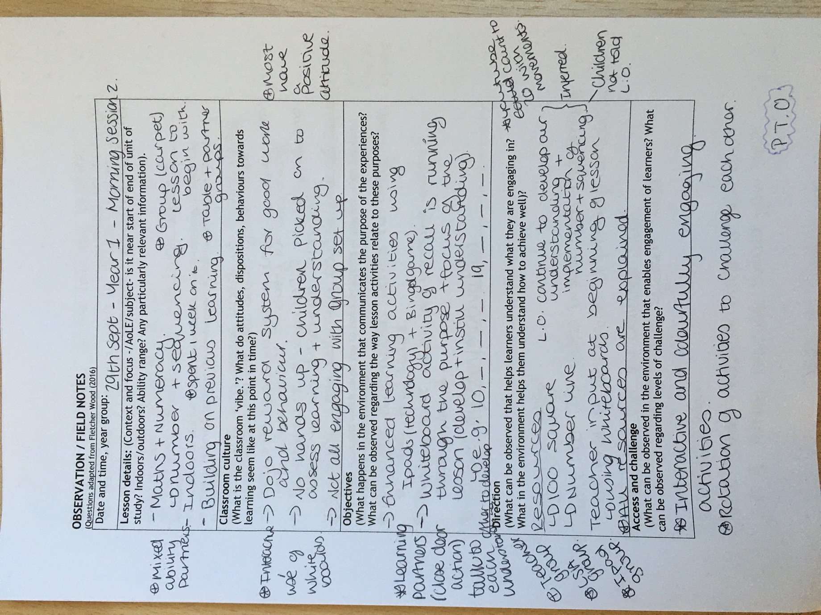

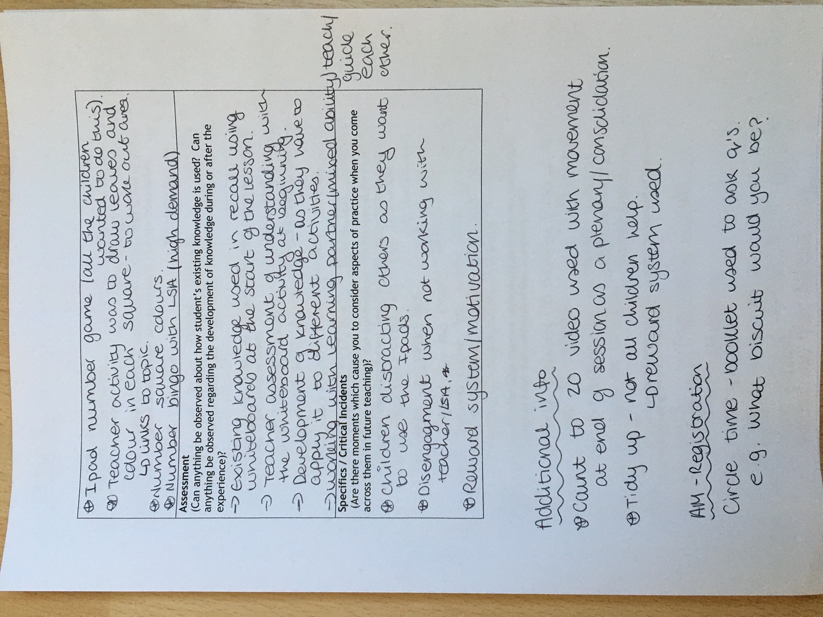

A - 1.4

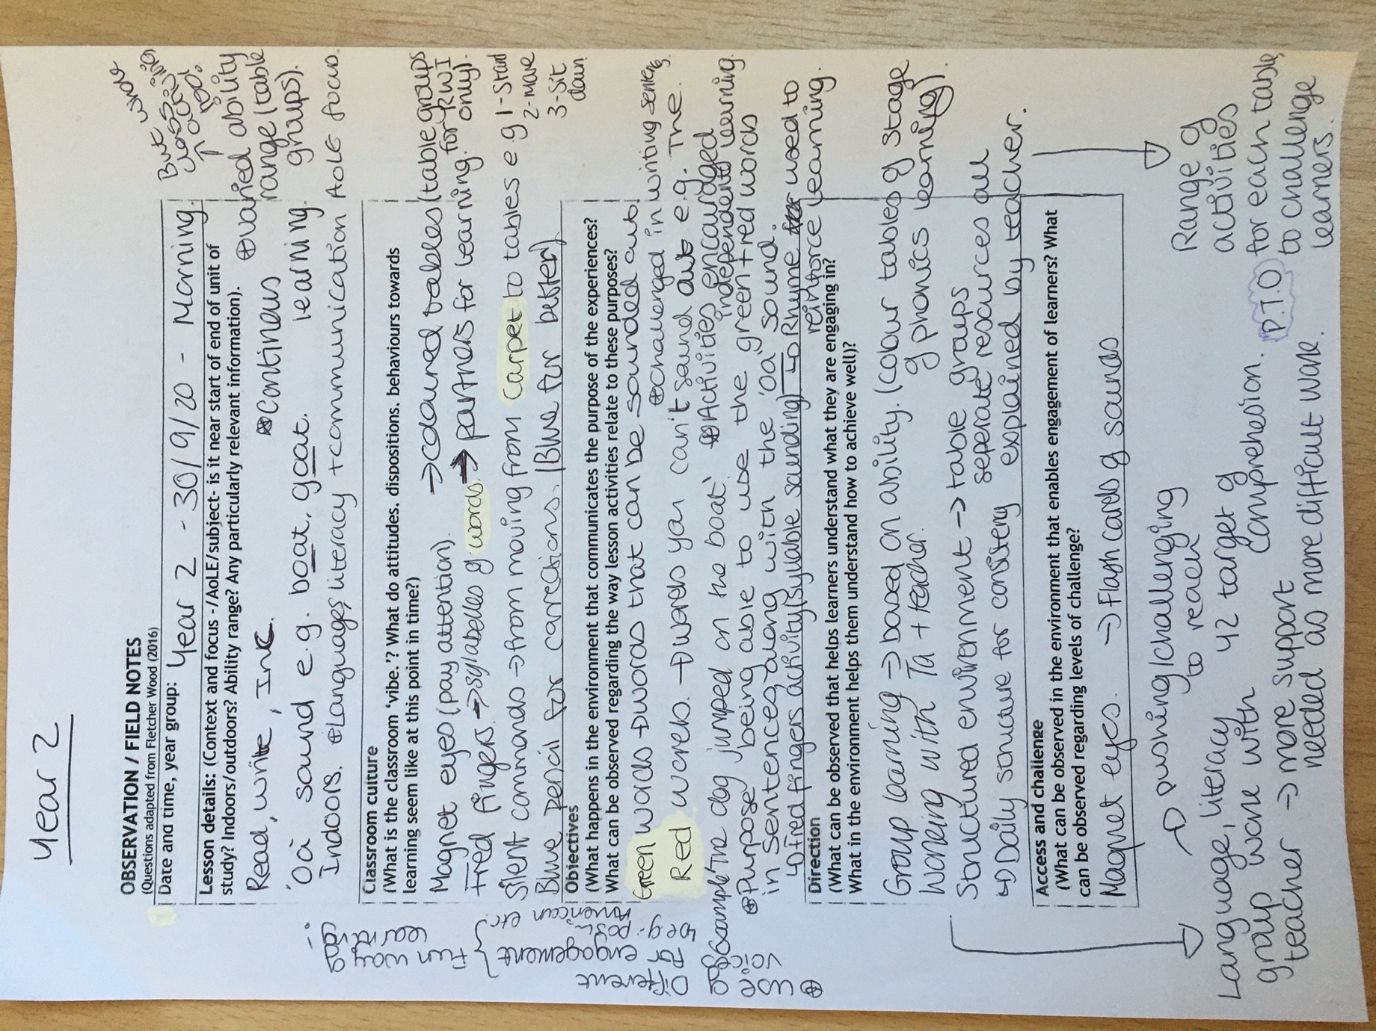

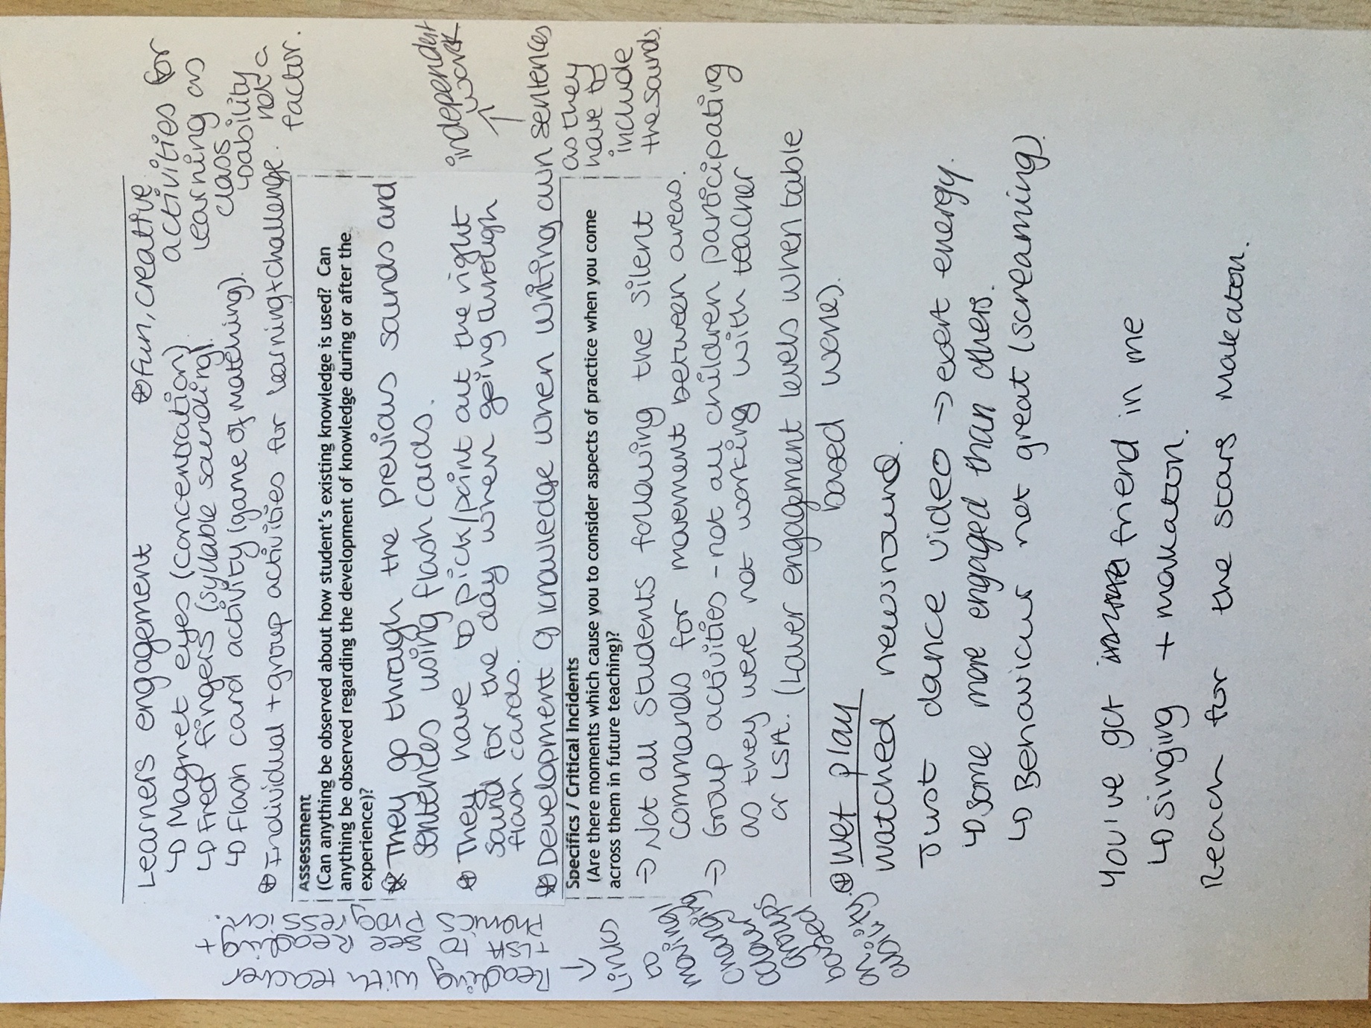

Appendix 2.0 - Critical Incident Sheets

A - 2.1

CRITICAL INCIDENT IDENTIFICATION RECORD

Details relevant to the research context.  Date/time.  Age/Stage of group.  People involved.  Contextual  information from field notes. | Reception - 28th September 2020 - Afternoon Session  Children aged 4-5  People involved - Children in the class, Class Teacher and the Learning Support Assistant for the class.  Focus of the lesson - 3 Little Pigs Story  - Makaton and singing the story following a YouTube video.  - There was a mixture of indoor and outdoor activities for the children to partake in to develop their learning on the topic.  - The topic of the 3 Little Pigs was for the week and it takes place in a cross curricular format with no specific area of learning as the focus each week, they used enhanced activities based on the topic to develop learning across the different areas of learning.  - The learning was a continuation form the morning session, with the some of the same enhanced learning activities for the children to take part in.  - The lesson activities included:  - Role play outside with Learning Support Assistant  - Handwriting journey  - Cutting and Colouring  - Number matching and ordering  - Reading/retelling and Sequencing the story with Teacher  - The children picked their own enhanced activities to take part in after going through the story on the Carpet, expect those who were picked to work with the LSA outside and with the Teacher, but the groups with the adults in the classroom alternated to give everyone a fair opportunity.  - The lesson was very engaging and interactive for children with lots of opportunities for children to challenge themselves.
What happened? A detailed description of what you observed and what thoughts on pedagogy and practice occurred to you as a result, looking towards your research. | There are many different critical incidents I could have picked up on within my time observing in Reception.  But one of the key ones I picked up on was the fact that when children got to pick their own enhanced learning activity, after the input from the class teacher at the beginning of the afternoon, there soon became a high level of disengagement and disruption in the classroom environment. For example, Child A worked well on the first enhanced activity of the handwriting journey they picked but once they had finished that, it appeared as though they thought they had done enough work for the rest of the session, so Child A proceeded to go around the other activity tables in the classroom so that they could talk to and distracting another group of children from the activity they were undertaking. While this was happening the LSA was outside with a group of children undertaking a role play activity on the topic, so she was not seeing what was happening. The teacher was in the classroom, but she was working with a group of children and appeared to be assessing their understanding of the topic, so they were not paying attention to what was going on in the environment all the time.  In the groups that were working with the LSA and the teacher there was not such disengagement or distracting of children, so it raised the question of whether more teacher and LSA input was needed in the environment.  The disengagement and distraction meant that the some of the children then proceeded to get out toys and games from the role play area, which had not been put out for them to use in the lesson, which meant that the classroom environment became chaotic.  The children were told by the teacher to put the games and toys away and encourage the pupils to partake in the enhanced activities put out, so to do this they worked at one of the enhanced activity tables with a group of students on the task and the LSA also came into the class and worked with a group of children on another activity, when this happened more children went to partake in those activities and appreciated the input and engagement with the adults in the classroom.  In terms or pedagogy and research in practise, this raised questions about differentiation tasks, and if they are helpful or not. Additionally, it made me think about the impact of behaviour of pupils on the wider class and the environment. Finally, pupil engagement in different contexts, e.g. working with an adult, inn groups or individually.

A - 2.2

CRITICAL INCIDENT IDENTIFICATION RECORD

Details relevant to the research context.  Date/time.  Age/Stage of group.  People involved.  Contextual  information from field notes. | Year 1 - 29th September 2020 - Morning Session 1  Children aged 5-6  People involved - Children in the class, Class Teacher and Learning Support Assistant associated with the class.  Focus of the lesson - Read, Write, Inc (Literacy) and Morning activities  - Continuous provision throughout the Key Stage.  - 1 group worked with the Teacher outside the classroom (Colour group based on ability - 1 per day)  - All activities were indoors  - Learning partner groups for the activities for the groupings in the classroom  - Structured daily tasks in the classroom include:  - Finger gym  - Balancing chairs game  - Handwriting  - Sounding phonics game  - Matching pairs game  - Alternate activities in the classroom - engages children every morning; getting their minds ready for the day of learning.  - Engaging, creative, fun and interactive environment  - Children encouraged to challenge themselves throughout the read, write, inc and morning activities.  - Reward system (Dojos) in place, children are excited by this!  - No hands up, encouraging all children to try and develop learning
What happened? A detailed description of what you observed and what thoughts on pedagogy and practice occurred to you as a result, looking towards your research. | There are many different critical incidents I could have picked up on within my time observing in Year 1.  The critical incident that I observed was that children placed in learning partners which are mixed ability so the children can develop their learning together. So, they got placed at certain tables to do certain activities to begin the lesson with but the teacher and the LSA also emphasised that the children should challenge themselves and move around the activities on their table or move to another table. There was also and emphasis about certain boys in the class should not just stand and talk and partake in the activities.  However, I noticed that there was no enforcement of moving tables or activities, for example child A stayed at the finger gym section of the table with the group of boys that they were told not to work together all the time, but they all stayed playing with balancing chairs game the whole lesson. That specific group of children therefore didn't engage with their learning partner or in any literacy and phonics focused activities which appeared to be the focus for the session every morning. In the beginning they did work with their learning partner in the finger gym section but the learning partners moved onto to do the sounding phonics game, where you had to roll the dice and match the two sections of the letters together and then sound out the word and write it down - this developed their overall knowledge of the subject.  So, child A, for example, had no literacy focus in the read write ink and morning activity session whereas they should have been doing finger gym and then some form of literacy, so there learning may not be progressing and they are not challenging themselves.  Whereas there were other children in the class we're really working hard on their handwriting and the matching activities which the learning support assistant was overseeing the children knew if they worked really hard, they would probably get a reward of a Dojo when the class teacher came back in.  This raised questions about learning partners and whether they do develop learning from each other, how we can challenge children or encourage them to challenge themselves individually, and whether reward systems work on having an overall positive impact on behaviour and children’s work.

A - 2.3

CRITICAL INCIDENT IDENTIFICATION RECORD

Details relevant to the research context.  Date/time.  Age/Stage of group.  People involved.  Contextual  information from field notes. | Year 1 - 29th September 2020 - Morning Session 2  Children aged 5-6  People involved - Children in the class, Class Teacher and Learning Support Assistant associated with the class.  Focus - Maths and Numeracy  - Number and Sequencing  - Had been working on it for 1 week previously  - Teacher activity linked to topic for the term.  - Indoor activity  - Building on previous learning  - Carpet group learning with teacher, recall and consolidation of number formation and sequencing  - Mixed ability Learning partners, sat together and help each other (Use of close the doors by teacher meaning children turn to talk to their partner before answering the question)  - Different activities on each table (enhanced learning provision)  - Teacher led area - Drawing leaves and colouring in the squares to then count the area of the leaves  - LSA led - bingo game - developing understanding of number formation  - Counting the numbers in the blocks  - iPads used for one group focusing on the drawing and formation of numbers using an app.  - Interactive and creative environment  - YouTube count to 20 video, 100 Square and number line were used as resources to support the children’s learning
What happened? A detailed description of what you observed and what thoughts on pedagogy and practice occurred to you as a result, looking towards your research. | There are many different critical incidents I could have picked up on within my time observing in Year 1.  What I observed was that children were working in their learning partner pairs, and each pair was put on a certain activity table based on what they had already done that week.  I noticed that there was a lot of children either wanted to do the bingo with the LSA or you use the iPads and a lot of children were disappointed if they didn't get to use the iPads. The children who did work on the iPads that lesson worked really well together and were really engaged with the activity of number formation on the app, and they made they were rewarded in the app by collecting stickers for good work, they were very disappointed when they didn’t get to choose a sticker.  I also noticed that those who were not working on the table activity that they wanted to were coming over to the iPad group and trying to watch and then take part in the games, so they were distracting the children already at the activity.  There was less engagement of the children, when not with the teacher or using the iPads as these were the two groups that were getting rewarded for their work more often, so they had a motivation and the work felt less maths based and more interactive and fun for the children.  This observation made me think about how to use technology in the classroom, the positive and negative effects of technology in the classroom and the learning impacts and benefits. It also made me think about differentiation tasks within learning and how we use these effectively to get challenge learners and engage them. In addition, reward systems were something that I took from this observation and how we use it effectively and the impacts it has.

A - 2.4

CRITICAL INCIDENT IDENTIFICATION RECORD

Details relevant to the research context.  Date/time.  Age/Stage of group.  People involved.  Contextual  information from field notes. | Year 2 - 30th September 2020 - Morning Session 1  Children aged 6-7  People involved - Children in the class, Class Teacher and Learning Support Assistant associated with the class.  Focus - Read, Write, Inc  - ‘oa’ sound e.g. goat, boat  - Indoor activities  - Communication methods  - Continuous learning provision  - Coloured table groups for ability in accordance with the Read, Write, Inc guidance and assessment  - Different activities per table group  - Fun and interactive group activities as a whole class that aid overall learning experience  - Structured environment (same daily for consistency)  - Independent Learning is encouraged but also the learning is aided in a way that scaffolds the learning for all children to be able to work independently for at least one aspect of the lesson.  - Non-verbal communication methods  - Magnet eyes  - Silent Commands  - Flash Cards  Interactive and engaging environment
What happened? A detailed description of what you observed and what thoughts on pedagogy and practice occurred to you as a result, looking towards your research. | The critical incident that I focused on was the use of non-verbal communication. I had never seen this used as much as in the time I was in the time I was in Year 2.  One thing that I noticed was something called magnet eyes which both the teacher and the LSA used and it was a way of making sure the children were paying attention, so children would have to have magnet eyes to show their eyes were always focused on either the board or the teacher or LSA and ensures concentration of the children. This technique was one that all the children appeared to understand and engagement with the command was fantastic and all students appeared to conform with the communication method.  The other thing I noticed was the use of silent commands which also linked to the use of the magnet eyes non-verbal communication as the silent command method also increased the need for concentration.  The silent commands were used for when the children were going from sitting on the carpet to sitting at their table groups. When the teacher or LSA raised 1 finger - the children stood up, 2 fingers raised - the children walked to their space at their table and 3 fingers raised - the children sat down in their chair at the table group. I found this really interesting but also a great way of controlling class, without the environment becoming chaotic and overwhelming. All children did respond well to the use of non-verbal communication however I noticed that there were some children even though they were recognising the commands they were not following them as the majority of the class were, they were following the commands but at their own pace.  The whole experience of non-verbal commands made me think about the how I could use them in my own practice, it also made me think about how effective the use of these non-verbal commands is. It also highlighted the importance of effective classroom management and how it can impact learning.

