Name: Maria Alexandra Dumitru
Student number:2224515
Learning in the Digital
Table of Contents
Task 1 – Written summary 2
Task 2 – Mind map 4
Task 3 – Presentation 4
Task 4 – Reflection 8
Reference list 9

Task 1 – Written summary
A person must take a number of crucial steps in order to prepare for higher education so that they are equipped with the skills needed to succeed in their chosen career route. The procedure entails looking into various schools, estimating tuition costs, taking career goals into account, and selecting the best options after doing thorough study.
Researching various institutions and programs is vital before starting your higher education preparation. In his 2013 book "Preparing to Teach in the Lifelong Learning Sector: Level 3 Coursebook," Paul T. Corrigan advised readers to investigate the academic standards, programs provided, campus climate, and extracurricular offerings of different institutions. Individuals can then decide which institutions best suit their requirements and preferences by doing this.
The expense of education is a crucial aspect to take into account when getting ready for higher education. Jennifer Cheeseman Day and Hyon B. Shin (2019), recommended that people learn more about the various types of financial aid they are eligible for, including grants, scholarships, and student loans. Informed decisions about how to pay for education will be made possible by this study, lowering the likelihood of future financial hardship (Vos, 2015).
In terms of getting ready for higher schooling, career aspirations are also very important. People should take into account the job prospects and earning potential of their chosen professional route when choosing an institution and program, according to reliable news article by US News (2021). It is essential to select a program that is in line with the student's career objectives to improve their odds of landing a job after graduation.
In conclusion, getting ready for higher education necessitates cautious planning and judgment calls. To make educated decisions about their prospective educational and professional paths, people must study various institutions, funding possibilities, and career prospects. People can make sure they have the resources and tools they need to succeed in their chosen job paths by doing this.



Task 2 – Mind map
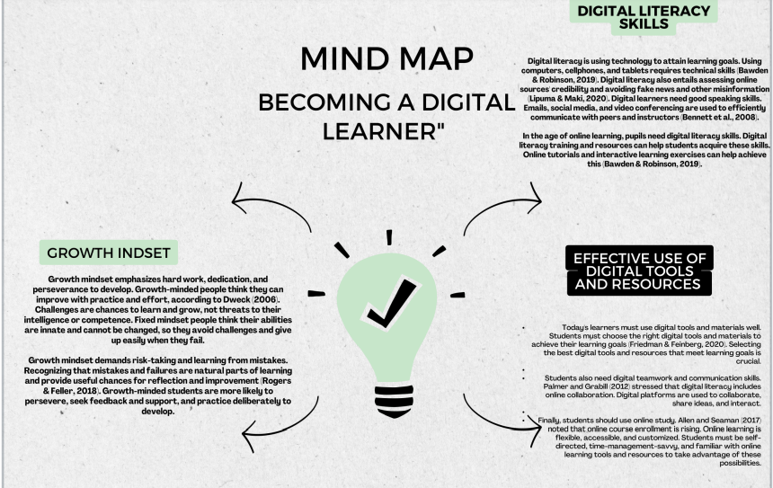

Task 3 – Presentation
Please follow this link to view my presentation:
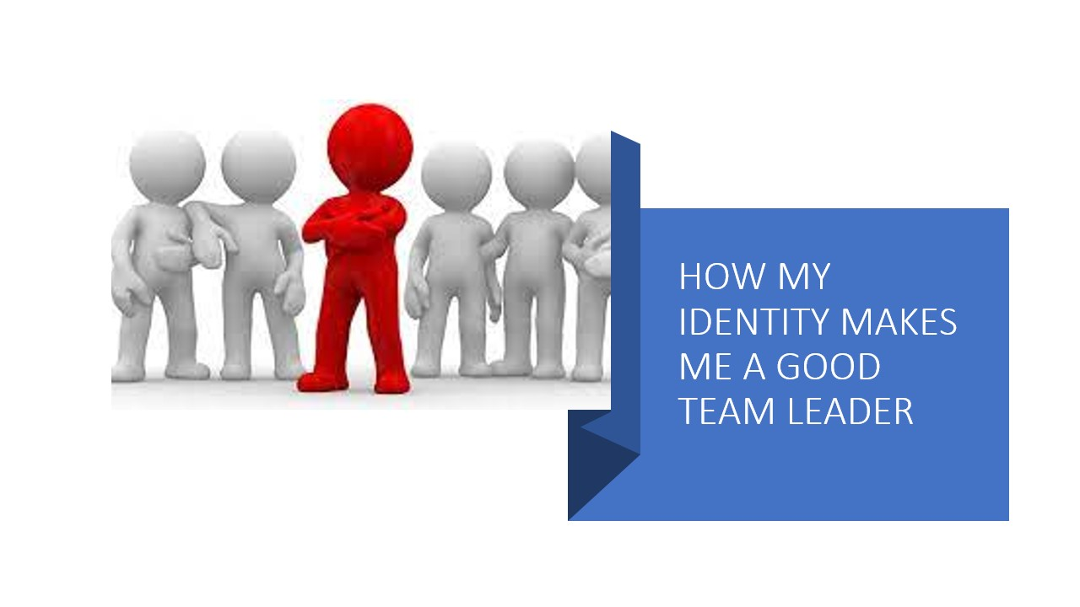

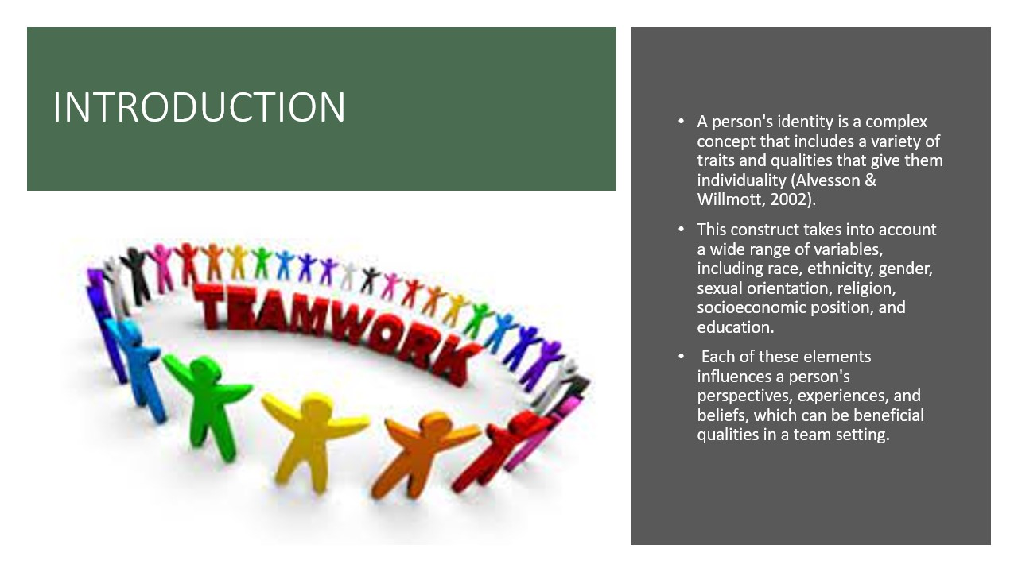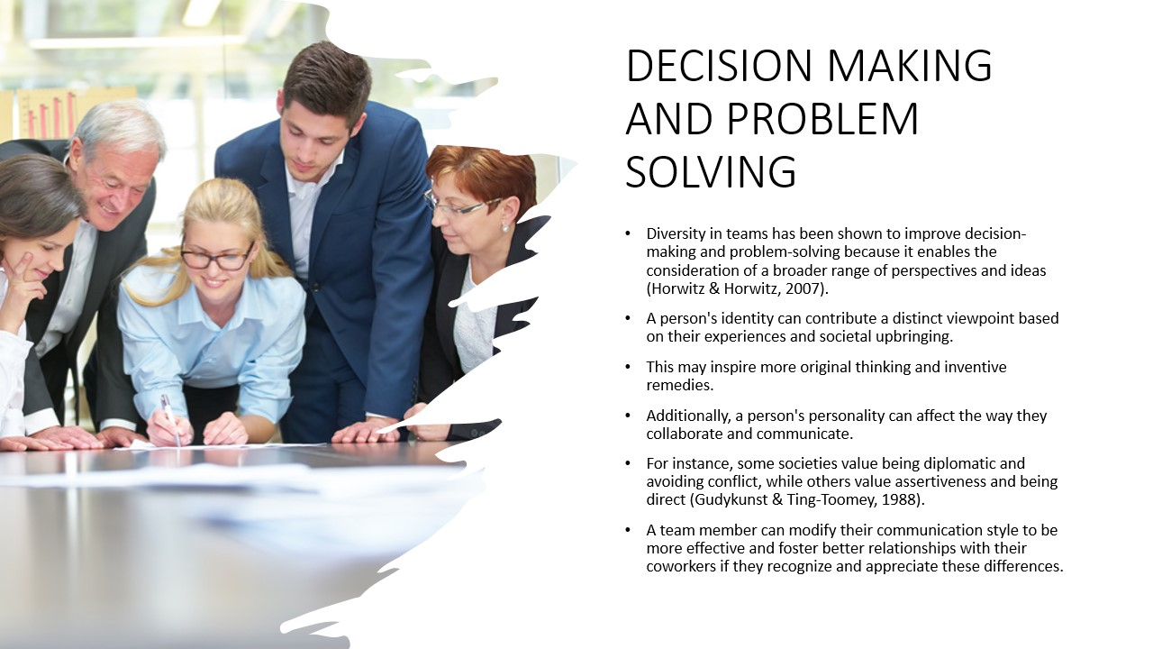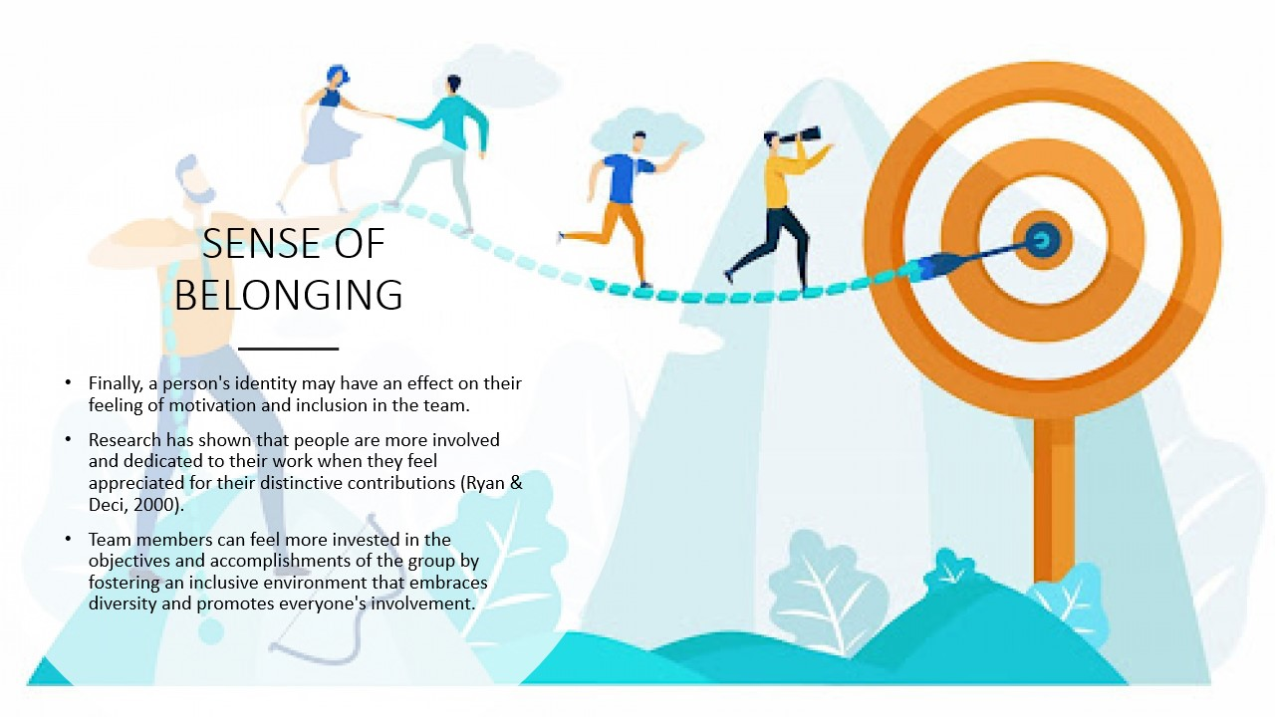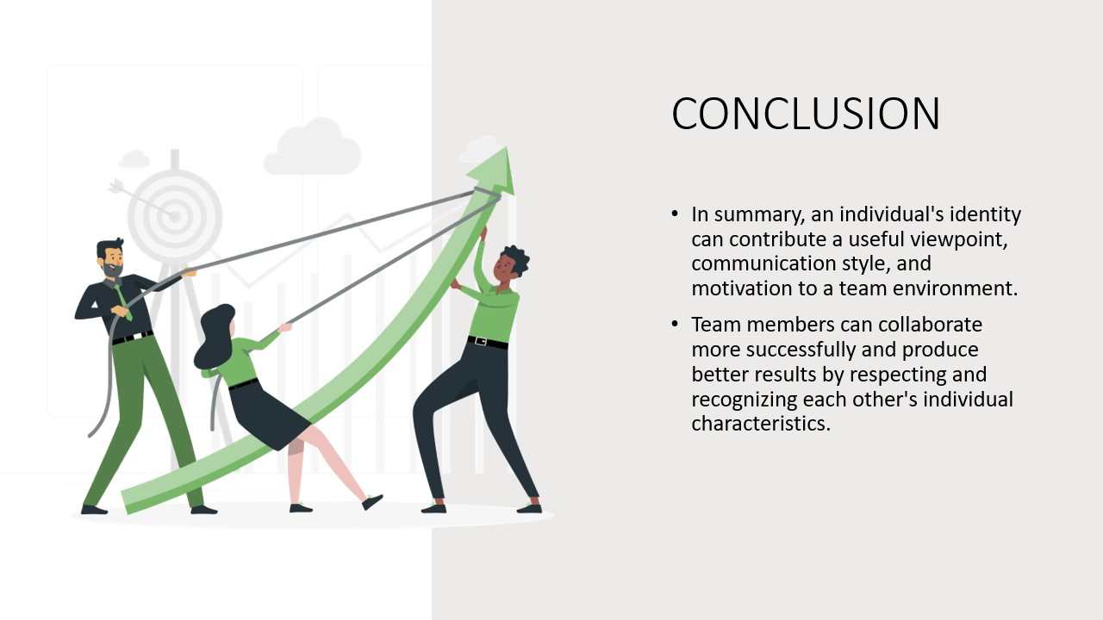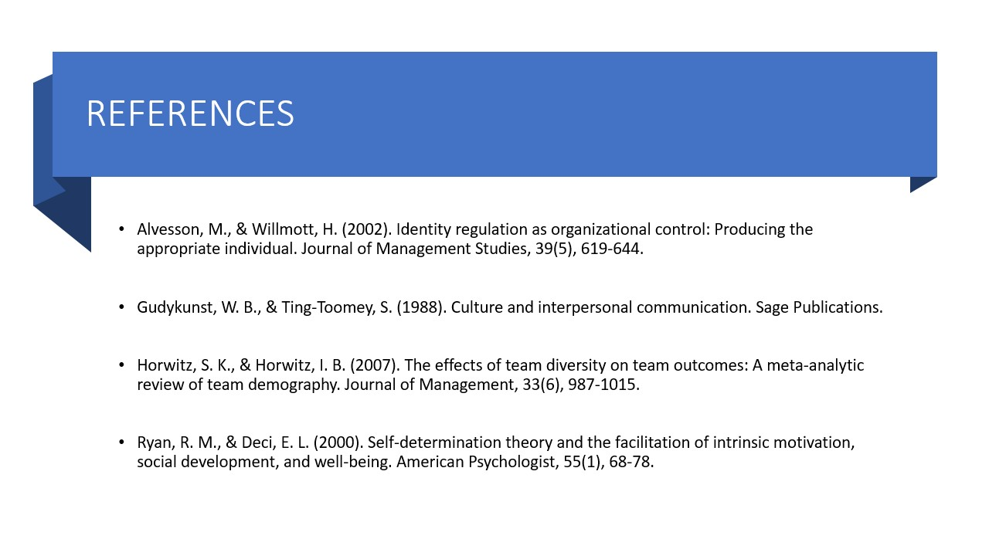

Task 4 – Reflection
The reflective cycle developed by Borton is a useful instrument for exploring and evaluating personal experiences (Kember, 1995). I'll use this model in this reflection to analyze and explain my first-year university experience.
Description: I started my university career with both enthusiasm and trepidation. I felt out of place because of the intimidating nature of the unfamiliar setting, characters, and demands. But as time went on, I began to settle into the new routine and looked forward to the task of learning new things.
Feelings: At first, I was stressed out and overloaded. I was concerned about making new friends, comprehending the course material, and doing well on examinations. But as I started to feel at home, I started to feel more at ease and sure of my skills.
Evaluation: Attending University has been difficult but worthwhile. My horizons have been broadened by the new abilities and information I have acquired (Tinto, 1987). I've occasionally battled with the workload, but I've learned how to effectively manage my time and ask for assistance when I need it.
Analysis: In my life, starting university was a major transition that taught me many important lessons. Being open-minded and accepting of new situations is among the most significant lessons I've learned. I've been exposed to a variety of viewpoints and ideas at university, which has widened my knowledge of the world.
Conclusion: Beginning university has been a rewarding experience that has forced me outside of my comfort zone and assisted in my personal development. Though at times difficult, the work has been worthwhile because of the benefits.

Reference list
Allen, I. E., & Seaman, J. (2017). Digital Learning Compass: Distance Education Enrollment Report 2017. Babson Survey Research Group.
Bawden, D., & Robinson, L. (2019). Information behavior and digital literacy: Interactions and outcomes. Journal of Documentation, 75(3), 566-579.
Bennett, S., Maton, K., & Kervin, L. (2008). The ‘digital natives’ debate: A critical review of the evidence. British Journal of Educational Technology, 39(5), 775-786.
Cheeseman Day, J., & Shin, H. B. (2019). College Financing and Educational Attainment: Evidence from the National Postsecondary Student Aid Study. Journal of Family and Economic Issues, 40(4), 654-666.
Corrigan, P. T. (2013). Preparing to Teach in the Lifelong Learning Sector: Level 3 Coursebook. Learning Matters.
Dweck, C. S. (2006). Mindset: The new psychology of success. Random House Digital, Inc.
Friedman, A., & Feinberg, S. (2020). Leveraging digital learning tools to support student-centered learning. Journal of Educational Technology Systems, 49(1), 77-98.
Kember, D. (1995). Open learning courses for adults: A model of student progress. Englewood Cliffs, NJ: Educational Technology Publications.
Lipuma, J. A., & Maki, W. S. (2020). Assessing digital literacy in higher education: A systematic review of existing frameworks. Journal of Computing in Higher Education, 32(3), 527-556.
Palmer, M., & Grabill, J. T. (2012). Toward a more transformative pedagogy: Engaging digital writing through trailblazing. Computers and Composition, 29(2), 125-140.
Rogers, K., & Feller, R. (2018). Digital Mindsets: A Framework for Institutional Transformation. EDUCAUSE Review, 53(2), 48-61.
Tinto, V. (1987). Leaving college: Rethinking the causes and cures of student attrition. University of Chicago Press.
US News. (2021, January 26). Choosing the Right College Major for Your Career Goals. US News & World Report. https://www.usnews.com/education/best-colleges/articles/2019-01-24/how-to-choose-the-right-college-major-for-your-career-goals
Vos, J., & Buffa, M. (2015). Preparing for College: Nine Elements of Effective Outreach. New Directions for Higher Education, 2015(172), 33-42.

