Leon Mathias
2013015
Computing (Software engineering)
Student University of Wales Trinity St David, Swansea, Wales
L6 - AI and Machine Learning (ACCA6011)
Date of submission: 23/01/2023

Table of Contents
Abstract 3
Introduction 3
Literature Review 3
Methods 4
Results 5
Conclusion 11
References 11

Abstract
In this paper artificial intelligence and machine learning is briefly explained followed by how these can help Teronix in better understanding and using their data. The main benefits of machine learning to Teronix are provided as well as some issues. Different methods of machine learning and how they can be applied to the company are displayed as well as recommendations on how to improve their data set. Results of machine learning applied to the data set are given in order to provide an understanding of how this could be beneficial to Teronix.

Introduction
In order to provide assistance to Teronix based off of the data set given a explanation of how machine learning can benefit the company and how it can be applied to help the company in the future must be undertaken. Because the data set is out of date there will be difficulties producing accurate results. How this can be improved and used by Teronix is explained.

Literature Review
Artificial intelligence (Ai) is a type of computer science that programs machines to think and act like humans. Ai requires large data sets to provide any accurate are useful results. Ai collects data in multiple different ways and then identifies patters in the data [1]. By identifying patterns in data, Ai can then make predictions about the data it has collected. Ai can then recommend actions similar to how humans would based on the data.
Machine learning (ML) is a sub category of Ai this type of Ai learns how to do a given task without being programmed to do so. Similar to how as humans grow up and learn more the more task they can compete and the better they can do those tasks, that is how machine learning works. The computer gains knowledge based on past data or experiences by looking for patterns in the data [2]. The more data the computer receives the more finely tuned and accurately correct the results become [3]. As time goes on more and more data is becoming available from all different kinds of sources.
AI and machine learning can be used in many different ways in order to help with multiple different aspects of online businesses [4]. Because Teronix is a business that allows customers to purchase items online, this allows for the company to collect data about their customers. By collecting data about customers such as their purchase history. This can provide many different types of useful data such as the items they purchased, when they purchase the items, how often they purchase each item, how much of each item they buy as well as how much money they spend each purchase. This data is easy to collect as the business is online. This data can provide personalised product recommendations that can lead to more purchases because the customers are shown the items they like rather than having to go search for them [5]. This can also help provide recommended products to similar customers [6]. This can also be used to create the personalized shopping experience across multiple devices by using a log in for customers.
Automatic pricing optimization can help Teronix by changing the price of products. Based on the amount of sales of each product an AI system can analyse the data and adjust prices accordingly [7]. This can also provide a starting price to new items that Teronix decide to start selling a new product based on the price and how well similar products sell. Discounts can be added to products to attempt to get customers to buy the product passed on the amount of sales the product gets at a time of year [8]. By using machine learning items can be paired together by the amount of times they are purchased together and the types of customers who purchase the product, this could bundle similar products or products frequently bought together and set a price for this bundle of product. Using AI can take the guess work out of deciding items price and can put more accurate and up to date pricing for items. By understanding the location of each customer the prices can be adjusted accordingly to match more closely to the local price.
Another possible future feature that could provide assistance to Teronix would be to have a virtual chat bot that could assist customers by providing support to any issues they would have [9]. This would require Teronix to collect more and different types of data in order for this to provide any assistance.
Machine learning can provide sales and demand forecasting which makes it possible to plan inventory by analysing previous data and predicting the amount of products that will have to be ordered in to keep up with demand. Because machine learning provides up to date data by using real-time updates. This means that in real time machine learning can update forecasts by finding new trends in the data. The accuracy of these forecasts will improve with time the more data that the machine is provided with [10]. Therefore, it is important to provide the machine with up to date data as well as lots of historical data. Although it is possible for machine learning to attempt to make forecasts with incomplete data although the forecast may not be as accurate.
One of the main benefits of machine learning is that it can learn to adapt on its own without any human intervention. Meaning there is no need to keep going back to change the system as it will do this on its own by continuing to make predictions and improving algorithms. Another benefit of machine learning is that the more time and data the system is given the more efficient the machine will become and the more accurate the results will be [11]. By using machine learning larger sets of data can be read much quicker and efficiently than humans would be able to. This also means that it can find patterns in the data and create predictions about the data that would not be easily spotted by humans [12]. As it would be almost impossible to provide each customer with their own personalised recommendations without using machine learning. Meaning that using machine learning can save time as well as money by analysing the data quicker [13]. Using AI also can eliminate any human error because it would be repetitive for a human to analyse a large data set human error could impact the results.
Although there are many benefits to using machine learning as an online business there are also drawbacks. One of the drawbacks is that the predictions and forecasts made by the machine are only as good as the data that it is given [14]. Therefore, if the data is messy or inaccurate the results will not be accurate also in order to predict accurately a lot of data is required [15]. The results can become biased if the data set is not big enough which could cause problems if these predictions are used.

Methods
There are different tools available in order to analyse the data. One analytics platform is Knime [16]which does not require any coding it allows users to drag and drop nodes that can connect to each other to provide results. Orange [17] is another tool that provides the same functionality where users can drag and drop nodes without the use of coding. Orange also allows for interactive data visualisation where the user can select different points in the data and visualise that data in real time.
There are different uses and methods of machine learning that could be useful for the data given by Teronix. One of those methods is classification [18]. This method categorizes the data into two or more categories. This could help Teronix by categorizing the data in order to see what countries order which items or what cost most to ship items to.
Prediction model can be used by Teronix in order to predict if a customer is going to place an order soon. Because prediction model bases its guess off of previous experience and knowledge to create a statement about a future event [19]. Although because the data set is old the likelihood of these predictions still being useful are low.
Forecasting unlike prediction doesn’t ‘guess’ a future statement it can predict how much of one product is going to be sold by analysing the data do observe the recent trends to produce an outcome [20].
Clustering is another machine learning method that could benefit Teronix as this method groups data based on their similarity. This could help Teronix as it could group the products of most sold and price sold for in order to find the similarity between the lowest selling products. By using K-means clustering the data will be separated into a set number of groups [21].
Because the data provided by Teronix is from 2009 – 2011 this data is out of date although it can still be used the results could be out of date and not accurate. Not only could the data inaccurate but it could also cause problems to Teronix if the results from the data is used it could cause a loss of money to the company because an item that was in demand 12 years ago may not be wanted anymore causing the company to order in more of that product, only for it not to sell. A solution for this is to provide newer, more up to date data.
There are also multiple missing values in the data and although it is possible by using machine learning to provide results with missing data it could lead to inaccurate results. Also, the result could be bias depending on the data that is missing. The data that is provided also is not consistent as some products stock code has letters in them while others do not, it is important to keep all the data as consistent as possible to gain relevant results.
In order to get accurate and results that you expect it is important that the data is separated accordingly. For example, all the returns should be in a separate data set because it is easier to join two sets of data rather than try to separate them. Because the price is not in minuses in the data set the returns could be calculated as purchases leading to wrong and misleading results being produced. Also Postage, samples and tests are in the data set which should be placed into their own set to be merged. Test data should be removed as this could also affect the results negatively.

Results
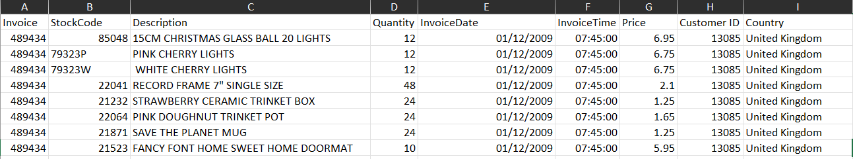
Figure 1: Split date and time
As seen in the image above the invoice date and time into have been split into separate columns in order to gain more accurate results and not to confuse the system.

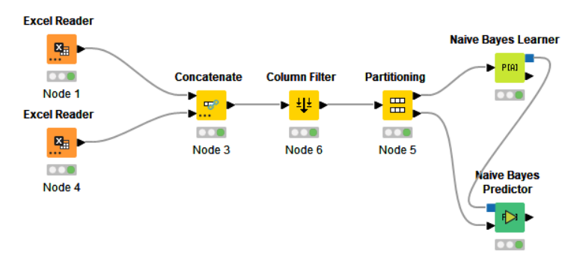
Figure 2: Knime Workflow
The image above is a naïve bayes prediction model using Knime. Both the 2009-2010 and 2010-2011 data sheets are imported and then concatenated in order to merge the both tables of data from the Teronix data set provided. A column filter is used to filter the unwanted or irrelevant columns. Then the data is partitioned into a learner and a predictor.
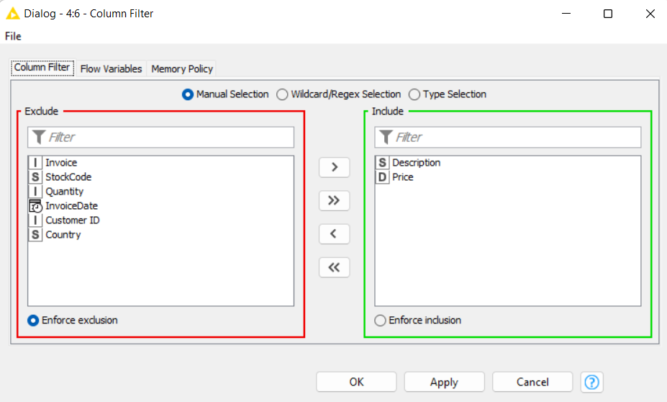
Figure 3: Knime column filter
The column filter for the model above only uses the description of the item as well as the price of that item because no other data is needed to reach the desired result.
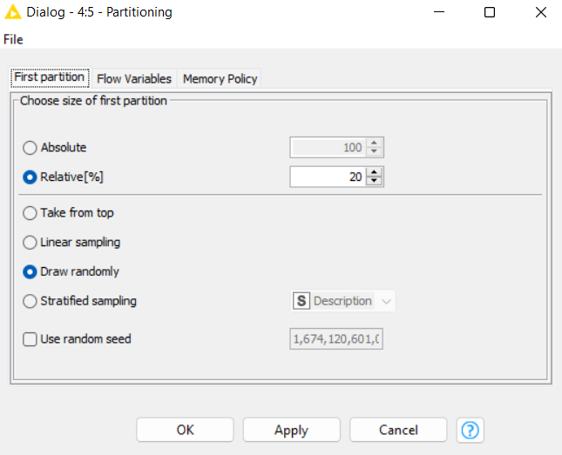
Figure 4: Knime partitioning
As seen in the image above the data set is split 20/80 to train some of the data and test the other.
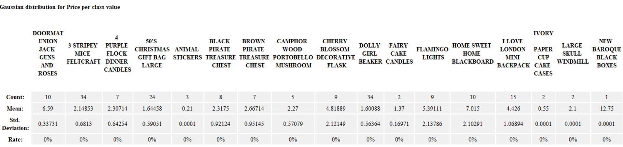

Figure 5: Knime results
The results above show the count of each item as well as the average price the items are sold for to provide useful information on what they should be set at in the future.

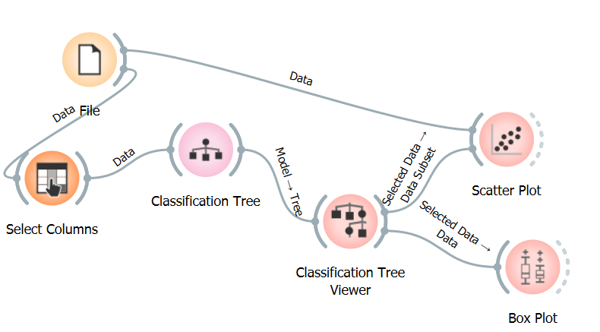
Figure 6: Orange workflow
Orange was used in the image above to produce the results below. This is the model used in order produce a decision tree the File node is where the data is imported into the tool. Then a column is selected to be the target of the decision tree, certain columns are filtered out in this section rather than deleting them in the data set itself. The data is then sorted in the decision tree node and able to view in the decision tree viewer. Orange also allows selected data from the decision tree to be visualised in ways such as scatter plot, box plot and more.
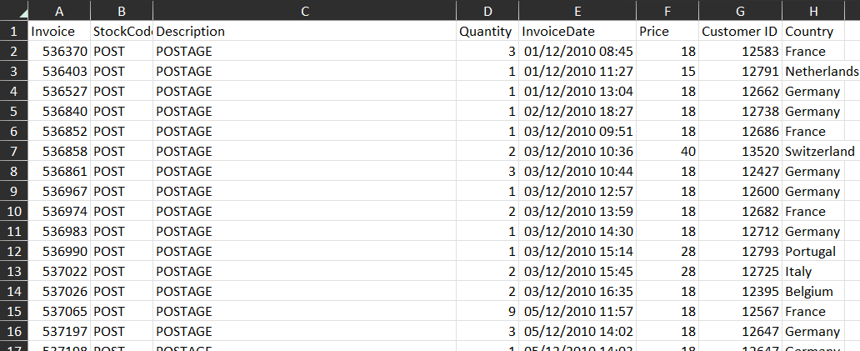
Figure 7: Data set change
The data has been separated as can be seen above as this data set only contains postage data this allows for the program using the data to run quicker rather than having to load in all of the data that is not going to get used. Although it is possible to filter by row to filler only stock codes of POST. It is also possible to concatenate the data to combine multiple data sets to use them together.
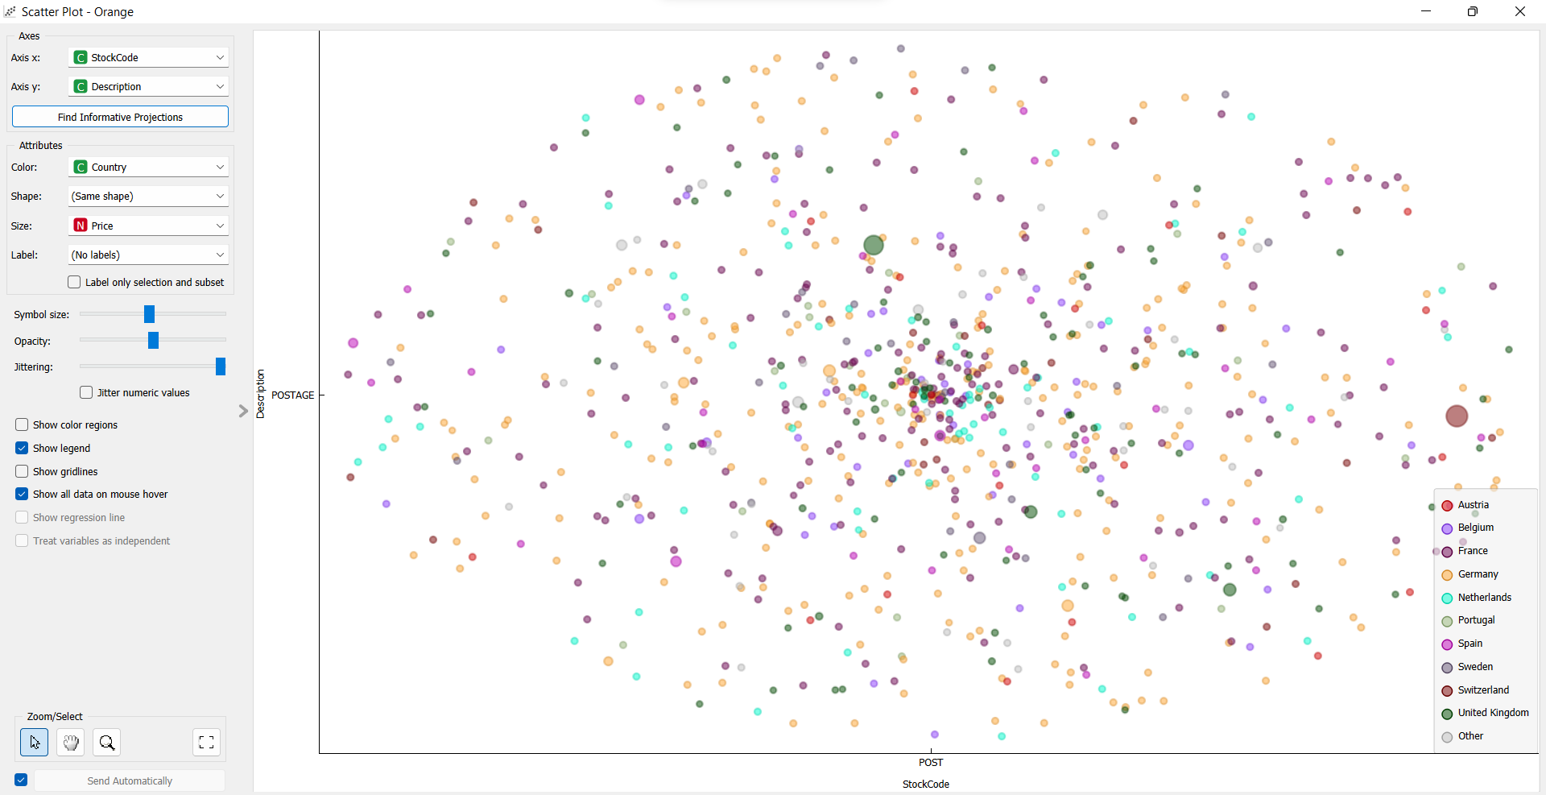
Figure 8: Orange scatter plot
The scatter plot for all of the data can give each row of the data set its own attributes in the image above the different countries are colour coded and placed onto the graph and the larger the circle the higher the price which allows for an easier view of the data.
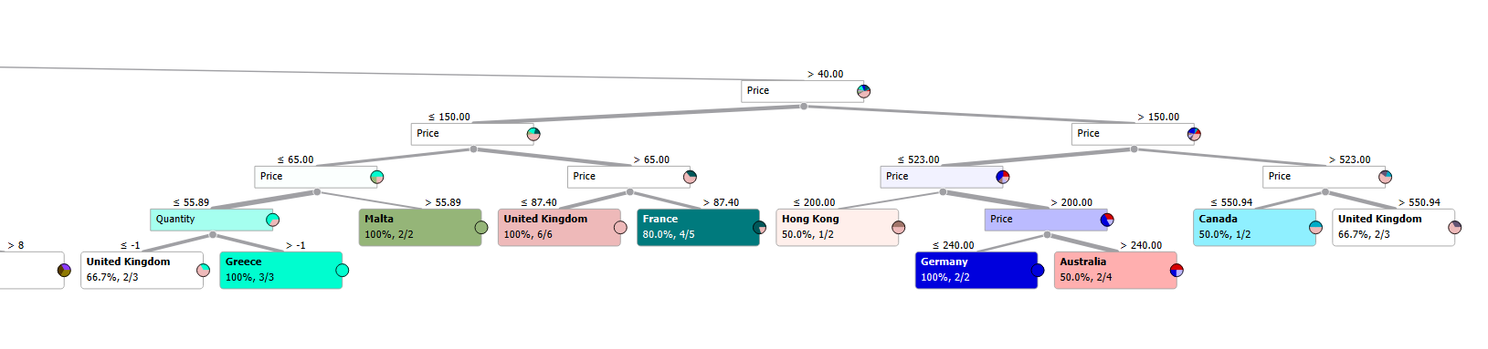
Figure 9: Orange decision tree
As seen in the image above this section of the decision tree is the area where all the POST cost more than 40.00 it then breaks the data down even further into more branches with more decision nodes. If we follow the branch all the way to the right the last decision is whether or not the price is more than 523 if yes the outcome is the United kingdom if no the outcome is Canada. Following the left side of the top node the last decision is not price anymore it is quantity on order to provide different answers.

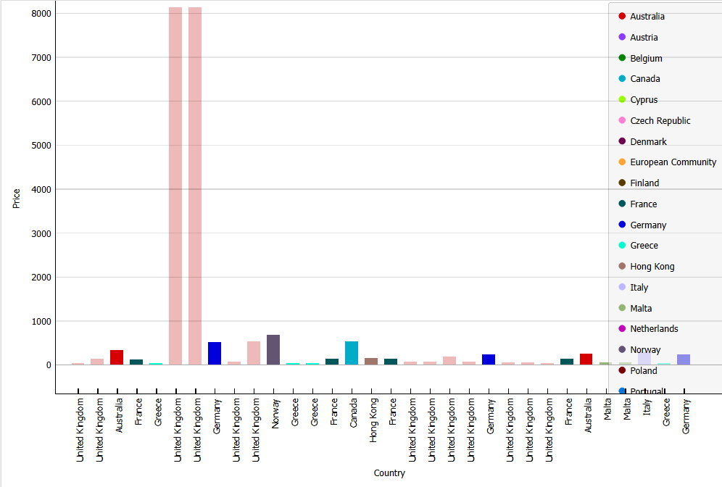
Figure 10: Orange bar graph
The bar graph above is from the selected data in the decision tree therefore it does not represent all the data in the data set only the data that has the price of 40 and above. It can be seen that the too large United Kingdom data is significantly larger than the others therefore it is possible there is a mistake in the data set or these two pieces of data should not be accounted for because there is such a big difference.

Conclusion
To conclude there are many useful ways artificial intelligence and machine learning can be used by Teronix. By using different types of machine learning and different models to provide the results that could be beneficial. Although there are many benefits for Teronix it is important that the business improves their data. The data provided was outdated and messy which effected the possible outcomes and create many difficulties. Therefore, Teronix could benefit from the use of Ai and machine learning as long as their data is updated.

References
[1] M. Ergen, “What is Artificial Intelligence? Technical Considerations and Future Perception.,” Anatolian Journal of Cardiology / Anadolu Kardiyoloji Dergisi, vol. 22, pp. 5–7, Nov. 2019, [Online]. Available: https://ezproxy.uwtsd.ac.uk/login?url=https://search.ebscohost.com/login.aspx?direct=true&db=aph&AN=139775615&site=ehost-live
[2] Zhi-Hua Zhou, “Machine Learning,” Google Books, 2021. https://books.google.co.in/books?hl=en&lr=&id=ctM-EAAAQBAJ&oi=fnd&pg=PR6&dq=machine+learning&ots=oZPlV0Sw1s&sig=xm6SzRrW8GsWiIB6rutbbqBEMPc#v=onepage&q=machine%20learning&f=false (accessed Jan. 20, 2023).
[3] L. Zhou, S. Pan, J. Wang, and A. v Vasilakos, “Machine learning on big data: Opportunities and challenges,” Neurocomputing, vol. 237, pp. 350–361, 2017, doi: https://doi.org/10.1016/j.neucom.2017.01.026.
[4] V. D. Soni, “Emerging Roles of Artificial Intelligence in ecommerce,” Published in International Journal of Trend in Scientific Research and Development (ijtsrd), vol. 4, pp. 223–225, 2020, doi: 10.2139/ssrn.3620017.
[5] L. Liu, “e-Commerce Personalized Recommendation Based on Machine Learning Technology,” Mobile Information Systems, vol. 2022, p. 1761579, 2022, doi: 10.1155/2022/1761579.
[6] M.-C. Enache, “Machine Learning in E-commerce,” 2019, doi: 10.35219/eai1584040920.
[7] K. J. Ferreira, B. H. A. Lee, and D. Simchi-Levi, “Analytics for an Online Retailer: Demand Forecasting and Price Optimization.,” Manufacturing & Service Operations Management, vol. 18, no. 1, pp. 69–88, 2016, [Online]. Available: https://ezproxy.uwtsd.ac.uk/login?url=https://search.ebscohost.com/login.aspx?direct=true&db=bth&AN=114699284&site=ehost-live
[8] Javier Couto, Maia Brenner, Gonzalo Marín, Braulio Ríos, Marcos Toscano, and Martín Fagioli, “How Machine Learning is reshaping Price Optimization | Tryolabs,” Tryo Labs, 2020. https://tryolabs.com/blog/price-optimization-machine-learning (accessed Jan. 20, 2023).
[9] E. Nichifor, A. Trifan, and E. M. Nechifor, “Artificial Intelligence in Electronic Commerce: Basic Chatbots and the Consumer Journey,” Amfiteatru Economic, vol. 23, no. 56, pp. 87–101, 2021, doi: 10.24818/EA/2021/56/87.
[10] T. Kumar and M. Trakru, “THE COLOSSAL IMPACT OF ARTIFICIAL INTELLIGENCE IN E-COMMERCE : STATISTICS AND FACTS,” International Research Journal of Engineering and Technology, vol. 570, 2008, Accessed: Jan. 20, 2023. [Online]. Available: www.irjet.net
[11] T. Wuest, D. Weimer, C. Irgens, and K.-D. Thoben, “Machine learning in manufacturing: advantages, challenges, and applications,” Prod Manuf Res, vol. 4, no. 1, pp. 23–45, Jan. 2016, doi: 10.1080/21693277.2016.1192517.
[12] L. Cheng-Ju, T.-S. Huang, P.-T. Ho, H. Jui-Chan, and H. Ching-Tang, “Machine learning-based e-commerce platform repurchase customer prediction model,” PLoS One, vol. 15, no. 12, Dec. 2020, doi: https://doi.org/10.1371/journal.pone.0243105.
[13] N. Kandekar, “Ecommerce Assisted by Machine Learning,” Int J Res Appl Sci Eng Technol, 2022.
[14] M. Lotfian, J. Ingensand, and M. A. Brovelli, “The Partnership of Citizen Science and Machine Learning: Benefits, Risks, and Future Challenges for Engagement, Data Collection, and Data Quality,” Sustainability, vol. 13, no. 14, p. 8087, 2021, doi: https://doi.org/10.3390/su13148087.
[15] V. Sze, C. Yu-Hsin, J. Emer, A. Suleiman, and Z. Zhang, “Hardware for Machine Learning: Challenges and Opportunities,” arXiv.org. Cornell University Library, arXiv.org, Ithaca, Oct. 17, 2017. doi: https://doi.org/10.1109/CICC.2017.7993626.
[16] “KNIME | Open for Innovation.” https://www.knime.com/ (accessed Jan. 20, 2023).
[17] “Orange Data Mining - Data Mining.” https://orangedatamining.com/ (accessed Jan. 20, 2023).
[18] A.-N. Wong and B. P. Marikannan, “Optimising e-commerce customer satisfaction with machine learning,” J Phys Conf Ser, vol. 1712, no. 1, Dec. 2020, doi: https://doi.org/10.1088/1742-6596/1712/1/012044.
[19] Katrina Wakefield, “Predictive modeling, analytics and machine learning | SAS UK,” SaS. https://www.sas.com/en_gb/insights/articles/analytics/a-guide-to-predictive-analytics-and-machine-learning.html (accessed Jan. 20, 2023).
[20] M. C. Medeiros, G. F. R. Vasconcelos, Á. Veiga, and E. Zilberman, “Forecasting Inflation in a Data-Rich Environment: The Benefits of Machine Learning Methods,” Journal of Business & Economic Statistics, vol. 39, no. 1, pp. 98–119, Jan. 2021, doi: 10.1080/07350015.2019.1637745.
[21] J. Gao, G. Sundström, B. T. Moghadam, N. Zamani, and M. G. Grabherr, “ACES: a machine learning toolbox for clustering analysis and visualization,” BMC Genomics, vol. 19, 2018, doi: https://doi.org/10.1186/s12864-018-5300-y.

