Student ID Number and Name: | 2009654 |  | Svetlana Dimitrova
Programme Title: | BA Business Management
Assignment Title: | Essay
Module Title: | Management economics (LCBB5003)
Module Leader: | Vasilios Tavlaridis
Word Count: | 2265 | Date Submitted: |  | 02.03. 2022

Table of Contents
1. Introduction 2
2. Perfect competition 2
2.1. Example of Perfect Competition 4
3. Monopoly 4
3.1. Examples of Monopoly 5
4. Monopolistic Competition 5
4.1. Examples of Monopolistic competitions 8
5. Duopoly 8
5.1. Examples of Duopoly 9
6. Oligopoly 10
6.1. Examples of Oligopoly 10
7. Market structures and their effect on managerial decisions 10
8. Conclusion 11
9. References 11

Introduction
In this essay it will be looked at the managerial economics, which is the analysis of the main management decisions employing the tools of economics. The concept of the economics applies in supply and demand, price elasticity and cost analysis (Samuelson, Marks and Zagorsky, 2021). In this paper the focus will be on appropriate economic theories. Also, there will be a discussion and evaluation on the possible market structures of Perfect competition, Monopoly, Monopolistic Competition, Duopoly, Oligopoly. And lastly it will explore their effect on managerial decisions by using examples, followed by conclusion.

Perfect competition
In economics theory, Perfect Competition appears when all companies that offer the same products or services. Also, the market share has no influence on the price, companies can enter and leave the market without any barrier restrictions. In addition to that, the buyers have full information about the quality of the products and their price, that’s why the sellers cannot change the prices (Samuelson and Marks, 2010). The below Figure1 illustrates well how the Perfect Competition works.

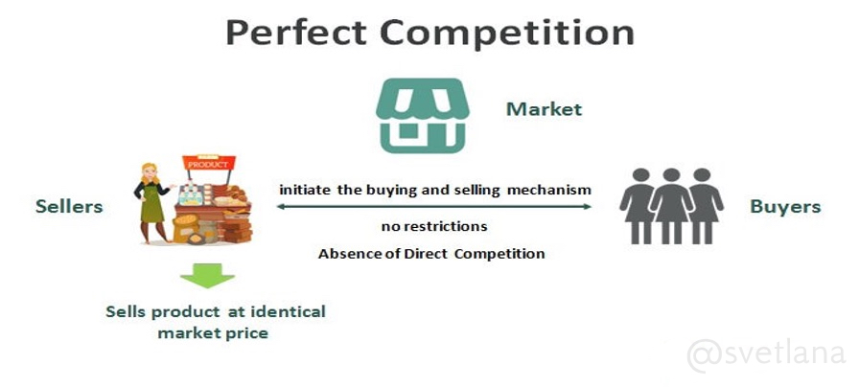
Figure1. Perfect Competition

Can be seen in a figure 1 there is a many buyers and sellers share in the market.
None of which can affect the price. The market itself determines price and output. (supply/demand). Sellers which are on the left-hand side on the picture offer matching products. Products that are considered the same regardless of who makes or sells them. For example: milk, eggs, potatoes. Buyers who are on the right side on the picture are well informed about products and their price. Also, buyers and sellers know enough about the market to find the best deal for them. In a perfect competition the sellers are able freely to enter and exit the market.

Table 1: Perfect Competition Characteristics:
Many sellers: there are enough sellers so the decision of one cannot disturb the market price | Firms are price takers: different companies have to accept the market price and cannot change it
Homogenous or standardized products: all sellers offer unique products | Free entry and exit: there are no significant barriers that could prevent free entry or exit from the market

Source: (Sloman, Hinde and Garrat, 2013; Samuelson and Marks, 2010)

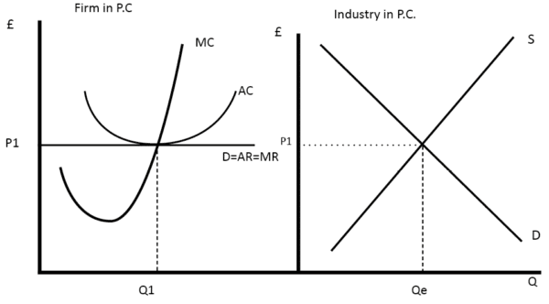
Figure2. Perfect Competition firm vs Industry
The individual company will consider its demand as completely elastic. The perfectly elastic demand curve is a horizontal price line, similar to Figure 2. The demand curve for the industry is not completely elastic, it seems so only for individual companies, as they have to take the market price, no matter how much they produce. Therefore, the firm's demand curve is a horizontal line of the market price.

  - Example of Perfect Competition
The following scenario is an example of Perfect Competition: If one of the many pencil companies decide to increase their product’s price, which is exact same to the other companies, without adding any feature. This company will not have any buyers as the exact same product will be sold on the market at lower price. Hence, increasing the price will be a failure and the company will bankrupt. In summary, the Perfect Competition is a hypothetical market structure, in which there is no competition. In such market aggressiveness lead only to a failure, similarly to the pencil example.

Monopoly
Monopoly is the economic situation where a solitary provider rules the market for a given item. At the end of the day, the customers can purchase a particular product only from one organization. No other organization contends with them there (Marks, 2014). According to Griffiths and Wall (2011), the Monopoly has the opposite context compared to the Perfect Competition. The Monopoly is powerful enough to decide the degree of costs, typically over its peripheral expense. The item has no substitutes, customers are compelled to buy the products from one single market. The imposing business model has two choices: First is deciding the cost of the product, and secondly perceiving how much customers can retain costing this much or determining the amount delivered and seeing at what value it very well may be consumed by purchasers. All things considered, the selling cost should support the most extreme contrast between total expense and comprehensive income. The vital guideline for deciding the selling cost is benefit augmentation. When augmentation is accomplished, the monopoly is in harmony. This implies that it can fulfil shopper needs while augmenting its benefits. Djolov (2014) states that the Monopoly business model suggests restrictive market ownership by providing an item or support for which there is no alternative. In the present circumstance, the provider can choose the cost of the item unafraid of the contest from different sources or through substitute items. Below in Figure3. are given the main characteristics for the Monopoly.

Figure3. Monopoly characteristics

Source: (Griffiths and Wall, 2011; Djolov, 2014)

Below Figure4. Displays the Monopoly Diagram and as it can be seen the Monopoly enhances the profit where the MR is equal to the MC at point M. Hence the Monopoly sets the price of Pm and the Quantity Qm.

Figure4. Monopoly Diagram
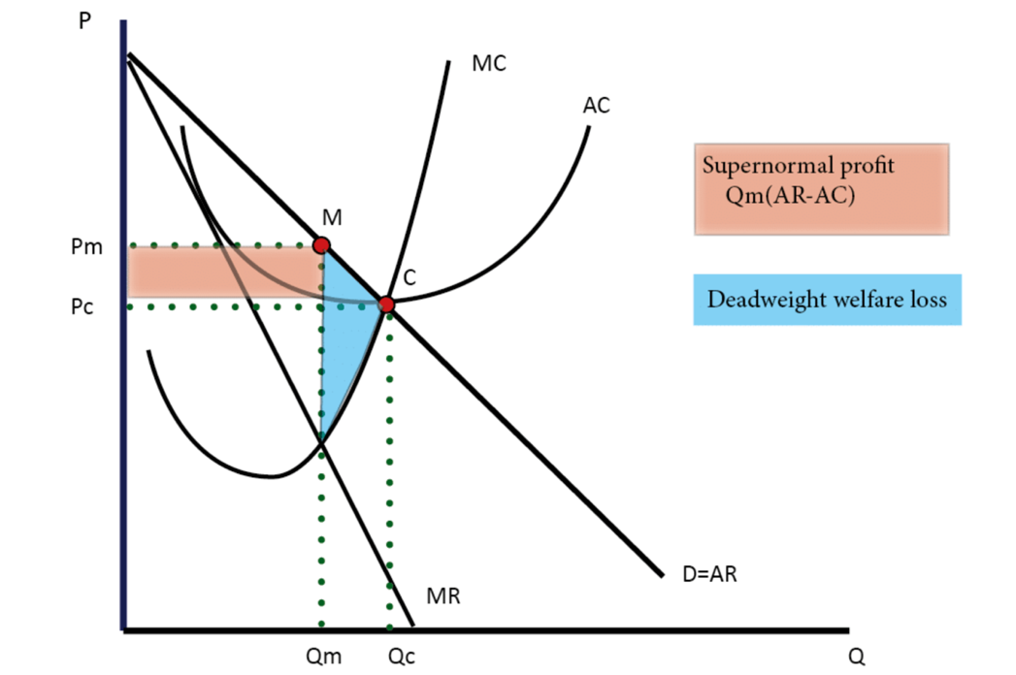
Source: (Griffiths and Wall, 2011)

Examples of Monopoly
The best examples for Monopoly would be considered the following companies: BBC, Microsoft, and Apple. According to Statista (2022) BBC holds 31.8% of the media market in the UK. BBC is an independent corporation from the Government involve and all its activities are overseen from April 2017 regulated by Ofcom and the BBC Board. Another example for Monopoly is Facebook with 37.3% and Apple with 54.45% market shares.

Monopolistic Competition

Nikaido (2015) acknowledges that in monopolistic competition, many companies offer similar products. The companies have the right to enter and exit freely and to differentiate their products, which in turn means that their demand curve is inelastic, and they can set their price as well as make decisions without being influenced by their competitors.

Figure5. Мonopolistic competitive characteristics

Source: (Marks, 2011)

Figure6. Monopolistic competition short run

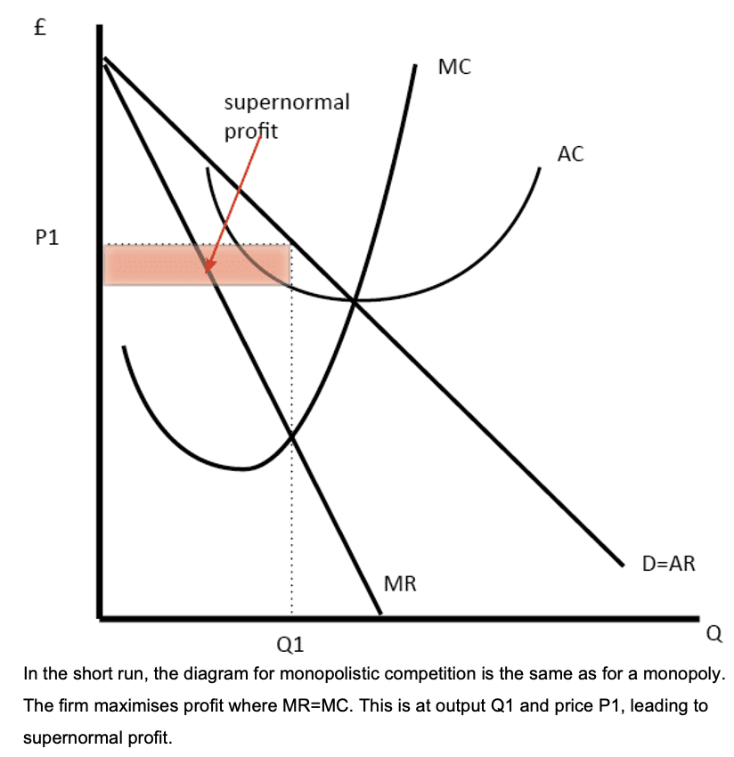

Figure 7. Monopolistic competition long run
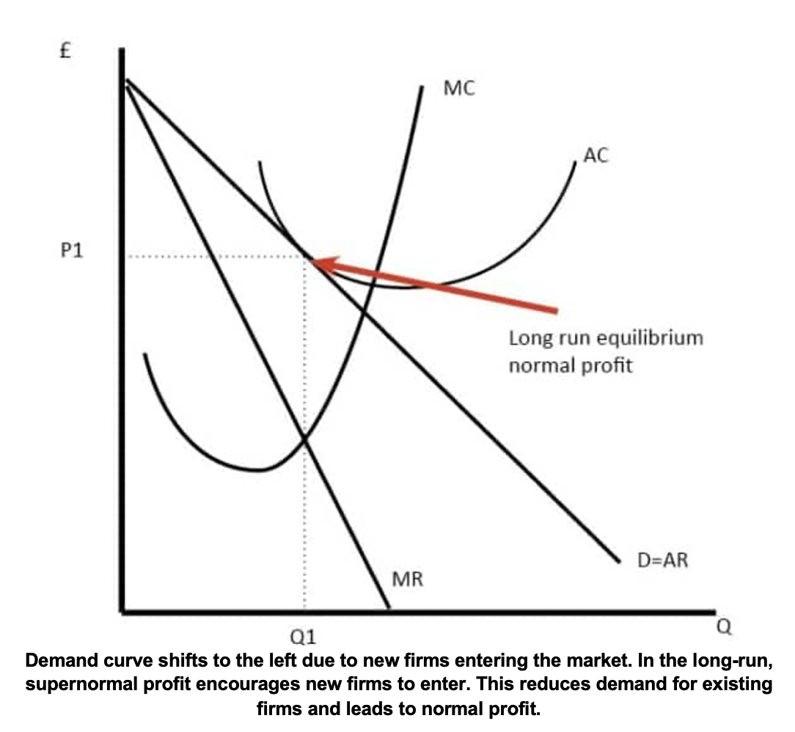

Examples of Monopolistic competitions

Below are the following examples regarding the Monopolistic competition. For instance,
there is a competition between restaurants, both in the quality of food and in the price and service they offer. Barriers to entry and establishment of a restaurant are low. In the clothing sector, designer label clothes are about the brand and product differentiation Hairdressers. In the movie and Television industry, the globalisation has increased the diversity of tv programmes and channels from networks around the world. Consumers can choose between domestic channels but also imports from other countries and new services, for example Netflix.

Duopoly
Keser (2012) states that a Duopoly is a market circumstance that involves two contending organisations that share the market. In this market, two brands can plot to set costs or amounts and get clients pay more cash-flow. In other words, Duopolyy can be observed when two large companies have 70% of the market share. In a duopoly, companies are constantly competing, thus maintaining reasonable prices, which is good for consumers (Fanti, Luciano and Gori, 2012). Below are given the characteristics of the Duopoly.

Figure8. Duopoly characteristics

Source: (Marks, 2014)

Figure9. below illustrates how the Duopoly works. For example, if in the suppose industry the demand is 4K units, the minimum efficient scale will be 2K units. Hence, the most efficient number of two competing companies or Duopoly will be the average number of units, which in this case is 2K units. If there were 4 competing companies, the average unit per company would be 1K units.

Figure9. Duopoly Diagram
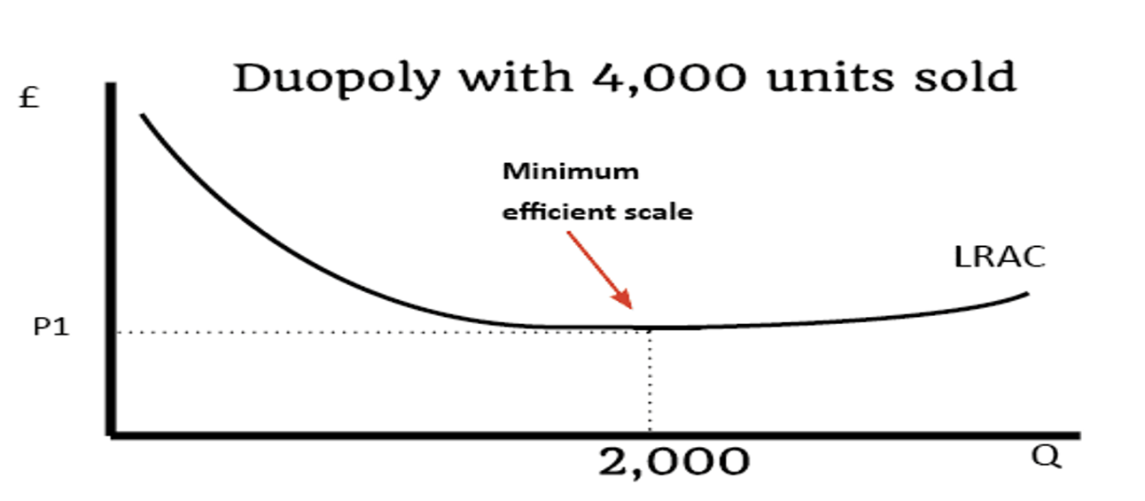
Source: (Produced by the Author)

Examples of Duopoly
A perfect example of the duopoly is two well-known companies for transactions and payments Master Card and Visa. It is a well-known fact that both companies hold about 80% of the card payment market across the European Union. Both corporations have relatively stable financial resources and are tough competition for newcomers to the market. Another example is Pepsi and Coca-Cola. The two world-famous companies known for their fizzy drinks are an excellent example of a duopoly. According to Statista (2022) the two companies together hold 67.8% of the world market, which is evidence of a duopoly.

Oligopoly
Wellmann (2004) acknowledges that an Oligopoly is a market structure with restricted rivalry. A couple of makers control most of the portion of the overall industry and regularly produce comparable or homogenous items. Due to the small number of companies on the market working so to speak without competition, the oligopoly is in a favorable position to build new partnerships and secret agreements between a small number of companies.

Puu, T. (2010) states that Oligopolistic firms are value setters that look for the best organisation to characterise costs higher than their negligible expense, along these lines expanding their benefits. Oligopoly is the after effect of absence of rivalry in the item cost. If a firm brings down the price of an item and accomplishes critical deals development, dominating firms will enter a value battle to match the lower cost; consequently, oligopolistic firms do not bring down their prices, instead increase promoting expenses and exploration to improve their item.

Table 2: Characteristics of Oligopoly
The industry is dominated by small number of large companies | There is a price stability within the market
Big number of companies could make up the industry | Potential for end
High entry barriers | High profits
Products could be highly differentiated | High firms’ independence
Non-price rivalry
Source: (Marks, 2011; Puu, 2010)

Examples of Oligopoly

The best example for Oligopoly in the UK will be formed by the following firms: Barclays, Halifax, HSBC, Lloyds, TSB and Natwest. These companies maintain the UK banking area. In these businesses, a couple of firms control their particular business sectors and give practically unclear labour and products. Along these lines, they can conspire and set their costs. In a genuinely aggressive market, this large number of organisations would not have the option to form their prices; however, they would prefer to be value takers to remain in business. All things being equal, under the oligopoly structure, these organisations are keen on expanding their drawn-out benefits by consuming the market and keeping a strategic advantage. Most nations have regulations set up to forestall value fixing and different acts of conspiracy thus.

Market structures and their effect on managerial decisions

Above in the text, the leading market structures were considered now; we will consider how they work and how they affect managerial decisions. For structures, it is essential to know how high the level of competition is or whether it exists at all. According to this, the management decisions are determined. Figure10 below illustrates the market structure and how the competitors affect the market and, therefore, managers' decisions. The type of market structure is determined by whether or not there is competition in the absence of competition, and we can say that the market is concentrated. As shown in Figure 10, the spectrum covers all structures from perfect competition to monopoly.

Figure10. Market structures
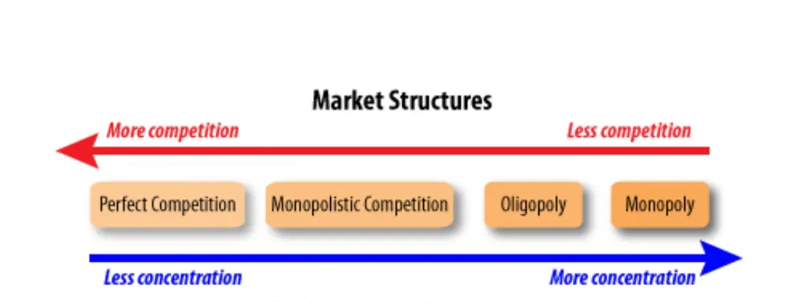
Source: (Produced by the Author)

For example, suppose the market has more competitors. In that case, the managerial decisions will focus on what their competition offers, what prices, and what they would do to attract customers and make a profit without straying from the boundaries of the particular market. Аs we already know in a market with great competition, we have freedom of entry and exit, we have customers who are well acquainted with the product and its price. In this case, we can say that management decision are limited. They cannot change their prices or products because the market is well known to consumers, and they risk losing all their customers.
On the other hand, if the particular market has fewer competitors, it is much more difficult for a company to establish itself. But in this case, the company has more leeway. In this case, for example, if there are companies with similar products on the market, the company can afford to offer its product without profit initially until people get acquainted with the product or use many other marketing strategies to attract more customers.
In this case, management decisions cover a broader range. They need to set the price come up with a good strategy for attracting customers, and they need to be flexible and innovative to keep the customers they have.
From an economic point of view, pricing is the most important aspect. Because in the market, every economic activity is measured by price. For this reason, business managers must make perfect decisions and use all their knowledge and skills, using different strategies, concepts, and theories to create an ideal price.

Conclusion

In conclusion, this paper has looked at different market structure such as Perfect Competition, Monopoly, Monopolistic Competition, Duopoly, Oligopoly, and their effect on managerial decision. Hence, it is important to highlight that the first explored theory Perfect Competition it does not exist as in the reality there is always a revelry. For example, even the Monopolistic market structure it is not always secure as there might be a rising company that could change the market structure into a different one such as Duopoly or Oligopoly. This itself suggest that the managers need to determinate important decision regarding the quality of the products and the most important part of the economic point of view namely the price when its launch and to look at the competition and to be prepared for the future with a contingency plan. In each of the market structures the management decisions are made after a very detailed research of the market.

References

Samuelson, W. F., Marks, S. G.and Zagorsky, J. L. (2021) Managerial Economics. London: Wiley.

Samuelson, W., Marks, S. (2010) Managerial Economics, Study Guide, London: John Wiley & Sons.

Sloman, J., Hinde, K., Garrat (2013) Economics for Business. Harlow: Pearson

Marks, SG 2014, Managerial Economics, Wiley Textbooks. New York.

Sloman, J. and Garratt, D. (2019) Essentials of economics. 8th ed. Harlow: Pearson.

Griffiths, A. and Wall, S. (2011) Economics for business and management. Third edition. Harlow, England: Pearson Education Limited.

Djolov, G. G. (2014). The Economics of Competition: The Race to Monopoly. United Kingdom: Taylor & Francis.

Statista (2022) TV broadcasters market share 2020 Statista. Available at: https://www.statista.com/statistics/269983/leading-tv-broadcasters-in-the-uk-by-audience-share (Accessed: 25/2/2022).

Keser, C. (2012). Experimental Duopoly Markets with Demand Inertia: Game-Playing Experiments and the Strategy Method. Germany: Springer Berlin Heidelberg.

Fanti, Luciano, and Luca Gori. "The dynamics of a differentiated duopoly with quantity competition." Economic Modelling 29.2 (2012): 421-427.

Statista (2022). Soft drink market share in the U.S. 2018 Statista. Available at: https://www.statista.com/statistics/225464/market-share-of-leading-soft-drink-companies-in-the-us-since-2004/ (Accessed: 26/2/2022).

Wellmann, A. (2004). Oligopolies. A Definition of Oligopolistic Markets. Germany: GRIN Verlag.

Puu, T. (2010). Oligopoly: Old Ends - New Means. Germany: Springer Berlin Heidelberg.

Nikaido, H. (2015). Monopolistic Competition and Effective Demand. (PSME-6). United States: Princeton University Press.

