University of Wales Trinity Saint David

Vehicle Dynamics

Steffan Robinson
Vehicle Dynamics
Tim Tudor
16/3/2020

Contents

Introduction………………………………………………………………………………………………3

Experimental Procedure…………………………………………………………………………… 3

Results and Analysis- Aerodynamics.………………………………………………………..4

Results and Analysis- Weight Transfer……………………………………………………10

Math Channel………………………………………………………………………………………..15

Conclusion……………………………………………………………………………………………..16

Evaluation …………………………………………………………………………………………….17

Table of Figures……………………………………………………………………………………18

References……………………………………………………………………………………………19

Introduction

In this coursework we had to use the Base Performance Simulator to obtain values from doing runs of straight line and steady state cornering. In the straight line testing we varied the ride heights and the aerodynamic setup of the Aston Martin to obtain data about straight line, constant velocity and coast down data to evaluate the different effects of the setups and loading of the vehicle. In the steady state cornering, we varied the stiffnesses of the springs and anti-roll bars to see how the roll stiffness distribution effects both load distribution and vehicle balance. We then used Motec and created math channels and setup sheets to match up with our run to obtain values of our predicted and actual values. We wanted to see if there were trends in what we had done. We then put our data in a spreadsheet and created graphs to see the difference in setups and predicted values.

Experimental Procedure

We used the Base Performance simulator to obtain our data, we had one driver and the rest of us collecting and organising data. We began the first session by tuning the aerodynamic setup of the cars wings from minimum to middle to maximum at both the front and rear, we used a combination of all of them to obtain a sufficient amount of data to plot and get a good understanding of what differences are made. We also changed the ride height of the vehicle, we changed them as following, min min, mid mid, max max, min max and max min. We did this to see the impact the ride height had at high velocity. The tests conducted of a straight-line sprint to around 206km/h and a coast down to test the aerodynamic drag of the car.
The second session we were trying to obtain steady state cornering values to see how well the car handled with different anti-roll bar stiffnesses and spring stiffnesses. We did this around a 25m and 75m radius circle. We again did a variety of different setups to get a wide range of data to get a good understanding of how the vehicle balance changes with different stiffnesses of ARB and springs.

Results

Aero Results

Graph 1- Total Aero Load (Aero Setups)

This graph just gives a basic understanding of how the aero load on the car increases as the aerodynamic setup get more aggressive and end on front max rear max. There’s nearly a linear increase in weight transfer except for the first one where we did a repeat of the run because we didn’t do it in both directions to make sure there wasn’t an incline that could’ve affected. The only other time there isn’t a noticeable increase in the aero load is the F2R1 and F1R6 which is very similar because they are both min mid setups at the lower end. Obviously the most aggressive setup is the when both front and rear wings are at their max settings giving more of an aerodynamic effect at higher velocities. Ideally, I would’ve plotted the aero drag on this graph as well for comparison also however we after the third run we cut off the simulator to change the settings and therefore didn’t coast all the way down to 0 this meant that we didn’t have the aero drag values for 7 out of the 10 setups and thought it would’ve been irrelevant to the investigation as it wouldn’t have been accurate data.

Graph 2- Total Aero Load (Ride Height)
This next graph shows the effect of ride height on the aerodynamic load on the car. As you can see the effect on changing the front ride height has minimum effect on the aerodynamic load because the lowest point on the graph has a front ride height of 7cm and at the highest point the front ride height is 7cm. Therefore, we can assume that the rear ride height has much more of an effect on aerodynamic load because the rear of the car squats down with increased downforce creating a venturi, speeding up the air creating negative pressure therefore using ground effect. So therefore, for straight line testing you’d want the least amount of downforce as possible therefore you’d chose the F7R8 setup. However, if you wanted to corner at high speeds, you’d need more aero load and therefore you’d chose the F7R5.6 setup.

Graph 3- Centre of Pressure
This graph shows how the centre of pressure changes with the different aerodynamic setups. As you can see the centre of pressure is very dependent on how the front of the car is setup because it’s the pressure build up at a point in front of the centre of the cars mass. Therefore, when the front has a max setting its going to push the centre of pressure right to the front of the car. However, its not F1R1 that has the lowest centre of pressure it’s the F1R12 setup because the rear of the car has a more aggressive setup it creates more pressure further back therefore pushing the centre of pressure back towards the centre of the car. There needs to be a difference between the front and rear setups otherwise, as you can see, there’s very minimal change because they balance each other out as you can see from the F1R1 (min, min) F2R6 (mid, mid) and F3R12 (max, max) setups.

Graph 4- Aero Drag against Coefficient of lift
Even though most of the data is void, I thought to plot a graph of the effects of the aero drag and coefficient of lift from there minimum setting to their maximum. I did this because I wanted to show the effects of the both with the change in aero setup. As you can tell they’re both proportional to each other as the setups get more aggressive. You would have less aero drag and therefore les coefficient of drag. I would’ve been interested to see how a mixed setup would’ve affected the aero drag however as we didn’t coast down long enough for it to be valid, however if I were to make a guess it would be that the F3R12 would still have the highest amount of drag andF1R1 to have the least amount and the rest would’ve floated in between because there isn’t a more aggressive aero setup than the F3R12.

Graph 5- Coefficient of lift
The coefficient of lift is again slightly proportional to the setup you chose. The setup with the least and most lift is F1R1 and F3R12 respectively. The lift at the front and rear also matches up with the trends you expect to see. As you can see by looking at the Clf and Clr plots they sort of cancel each other out depending on the setup you run, but both gradually increase until the most aggressive setup. This is because at the front for example if you were running F3 you’d expect to see high amount of lift because the pressure below the wing is more than above it which generates lift and when you combine that with an aggressive rear wing such as R12 you generate a lot of total lift which for a vehicle is not a good thing because you want it as planted to the floor as possible.

Graph 6- Centre of pressure and Front Aero Load
Here’s a centre of pressure graph against front aero load graph, there is an obvious correlation between the front load transfer and centre of pressure. The correlation being the setup, the three highest peaks in this graph are when the front wing is at 3 (F3). The biggest impact of the centre of pressure is the offset between the front and rear settings. If you we look at the first three settings, min min, mid mid and max max the centre of pressure varies very little, from 0.335 to 0.353. However, if you have an offset such as the F3R1 setup the centre of pressure has a much larger change in comparison, 0.498. And if we then compare that to the opposite setting F1R12 its centre of pressure is 0.183. Interestingly the front aero load is almost always beneath the centre of pressure apart from three main points F3R12, F2R12 and F3R6 this is because these are balanced and aggressive settings and therefore they will still have a high front aero load but because of the balance will not necessarily have a high centre of pressure.

Weight Transfer Results

Graph 7- Predicted Weight transfer, Weight transfer and Roll Stiffness Distribution at 25m

This is a graph on how the predicted weight transfers and actual weight transfers differed from each other and how the actual weight transfer effected the roll stiffness distribution. As you can see my predicted and actual load transfers at the rear follow a very similar trend and have almost identical values. For the front weight transfer my predicted and actual follow the same trends however the values are slightly off, this could be down to limiting assumptions made by the simulator or errors made in my maths channels that I am unable to find. In terms of trends the roll stiffness distribution follows a similar trend as both predicted and actual load transfer for front and rear, front being proportional and rear being inversely proportional. To get a better understanding of why it varies we need to look at the setup in use. If look at the data, the biggest margin is between FminRmax and FmaxRmin, this is because when we calculated it, we made it front biased therefore when we flip the front and rears setups it going to have the biggest effect. If the front suspension is at a minimum and the rear is at a maximum it, facilities less weight transfer at the front because the rear is stiffer this then applies less load to the contact patch and the result of this is oversteer. And then when the front is a maximum and the rear is on minimum it facilitates more weight transfer at the front because the front is stiffer this then applies more load to the contact patch a result of this is understeer.

Graph 8- Roll angle and weight transfer vs max velocity roll angle and weight transfer at 25m
The purpose of this graph was to see the difference between the max velocity at 25m and the steady state at 25m to see how much of an impact driving at a higher velocity does to the weight transfer and the roll angle. As we can see the difference between them is massive. The difference is weight transfer is huge, from 4576N to 2822N at the minimum minimum setting that’s over x1.5 more weight transfer. However, more interestingly is that the roll angle gradient changes it’s correlation from negative to positive as the setups change. At steady state the roll angle has a negative gradient from min, min to max, max but in the max velocity is has a positive correlation from min, min to max, max. The roll angle correlation change does make a little bit of sense because at the slower velocity we would expect to see less roll angle because of the suspension increasing in stiffness. However, when we pushed the car to its absolute maximum speed where it was just keeping its balance the suspension even though it was getting stiffer was experiencing more roll angle because of the difference in weight transfer from the steady state.

Graph 9- Springs- Setup against Magic Number and Roll Stiffness Distribution
I’m glad to see that this graph follows the same trend as one another because Roll stiffness distribution influences magic number. To see that they go hand in hand is a good thing. As previously mentioned, the most roll stiffness distribution and magic number is at a maximum front and minimum rear. Magic Number is to show whether the car has understeer tendencies or not, so when we run a max min setup the car would show understeer tendencies. The car would see the least understeer tendencies and maybe some oversteer is when the opposite setup is chosen, min max. The third highest peak in this graph is the min min setup, this is because the springs are at their softer setting they allow more weight transfer but because it’s a balanced setup it doesn’t but too much load on one end and to the deform the contact patch causing understeer. That’s why the max min setup given you more understeer tendencies because the offset setup gives more load to the front to cause understeer.

Graph 10- Anti-Roll bars- Setup against Roll Stiffness Distribution and Weight Transfer
This graph shows the impact of the change of anti-roll bar setups against the roll stiffness distribution and weight transfer. It’s clear to see that there is obviously less weight transfer when everything is at its max, stiffest, setting. It’s slightly exaggerated by the scale of the graph; however, it does give a good insight into how the mixed setups effect the roll stiffness distribution. With the introduction of ARB at the same speed and same corner radius the roll stiffness distribution increased by 0.071, from 0.763 to 0.834 for the max min setup. However, it decreased for the min max setup by 0.133, from 0.673 with no ARB to 0.540 with ARB. In the first setup it’s going to tend to give more understeer in that setup with the ARB and less understeer tendencies with the latter setup.

Graph 11- Springs- Max Velocity against Steady State, Roll Stiffness Distribution and Weight Transfer
This graph shows how the roll stiffness distribution and weight transfers vary for different velocities. As you can see the weight transfer is obviously higher at a higher velocity and interestingly the roll stiffness distribution changes its correlation at max velocity compared to steady state. This is what happened to the roll angle as well as we changed to higher velocity. In this case I believe that we might have been going to slowly in the steady state because of the magnitude of the drop for minimum to maximum. However, I think when we pushed the car more it shows that at a higher speed, we can see that the car would tend to understeer more than the steady state with the steady state being slightly balanced.

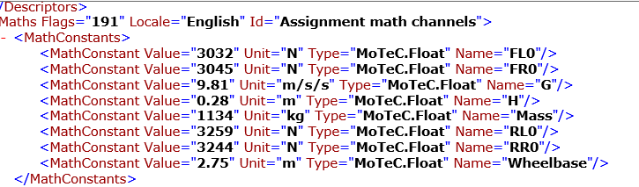
Math Channel

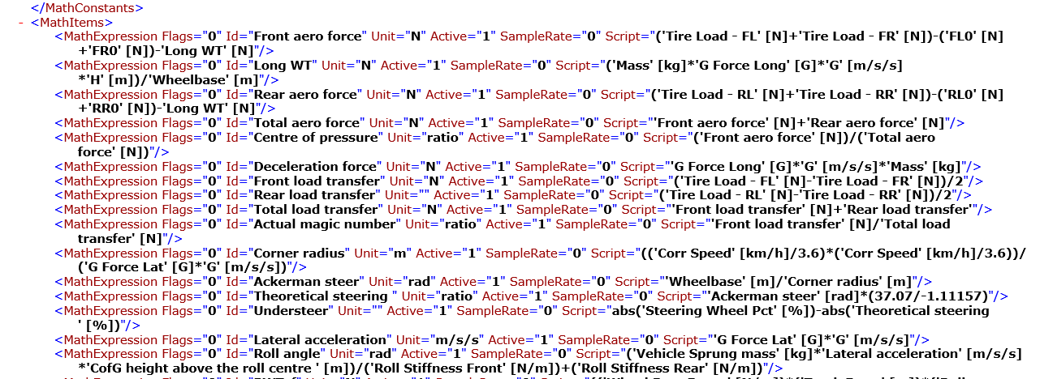

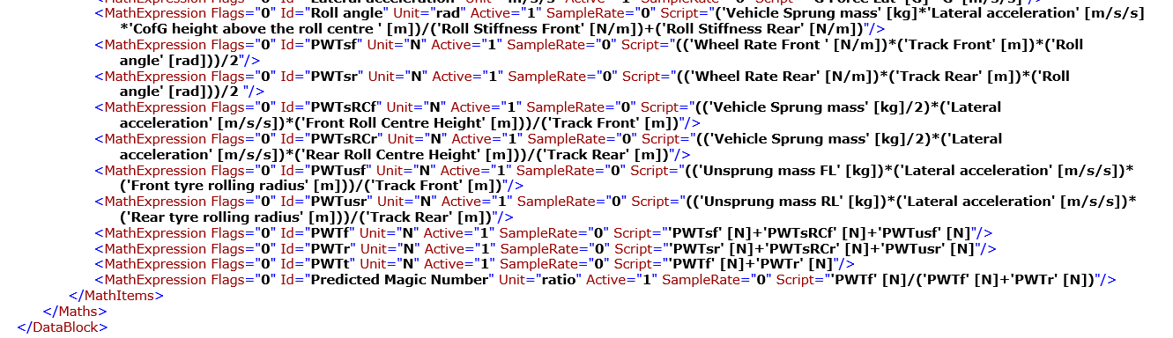

Conclusion
To conclude, it is clear to see that if you vary the settings on a vehicle such as the aerodynamic loadings, springs and anti-roll bars the characteristic and behaviour of the car changes with it. For example, if you change the aerodynamic setup it can affect straight line speed depending on what setup you run. If you change the spring settings for example if you change the front suspension setting to minimum and the rear to maximum it facilities less weight transfer at the front because the rear is stiffer this then applies less load to the contact patch resulting in oversteer, as mentioned above.
Another conclusion made is that the car used in the simulation is setup to understeer because the difference in weight transfer between front and rear is near double at times. And the amount of weight transfer seen in the max velocity test at the front was very high. Therefore, with more front weight transfer there will be tendencies to understeer.

Evaluation
One thing I would change, as already mentioned I would do the steady state cornering at a higher velocity because for roll angle and roll stiffness distribution for steady state compared with the max velocity of the same setups has opposite correlations as seen in graphs 11 and 8. With a higher velocity at the steady state those lines would’ve either have had less of a negative gradient or a slightly positive one. Which would’ve given a more realistic view as in a race car going around a corner at that speed wouldn’t have a large effect in comparison to a higher velocity.
Another part of this assignment I would’ve changed is part of the aerodynamic side. After a few runs on the simulator trying to calculate aero drag we ended the runs short to save time and therefore did not have had the sufficient data.
V1 (km/h) | V2 (km/h) | DfV1 | DfV2 | Aero drag | Cd
185.3 | 8.4 | 1925 | 378 | 1547 | 0.954878
184.8 | 8.4 | 2164 | 382 | 1782 | 1.105891
185.7 | 8.3 | 2454 | 393 | 2061 | 1.266668
185.2 |  | 2222 | 384 | 1838 | 1.135722
185.1 |  | 2135 | 384 | 1751 | 1.083133
185.1 |  | 2049 | 384 | 1665 | 1.029935
185.1 |  | 2031 | 384 | 1647 | 1.018801
185.2 |  | 2338 | 384 | 1954 | 1.2074
185.4 |  | 2274 | 384 | 1890 | 1.165335
185 |  | 1916 | 384 | 1532 | 0.948689

We could not just assume that the data was then accurate, I couldn’t assume them all to be 384N be then we don’t do any justice to the data already collecting because there could be values a fair amount either higher or lower than this.

List of Figures
Graph 1- Total Aero Load (Aero Setups) 4
Graph 2- Total Aero Load (Ride Height) 5
Graph 3- Centre of Pressure 6
Graph 4- Aero Drag against Coefficient of lift 7
Graph 5- Coefficient of lift 8
Graph 6- Centre of pressure and Front Aero Load 9
Graph 7- Predicted Weight transfer, Weight transfer and Roll Stiffness Distribution at 25m 10
Graph 8- Roll angle and weight transfer vs max velocity roll angle and weight transfer at 25m 11
Graph 9- Springs- Setup against Magic Number and Roll Stiffness Distribution 12
Graph 10- Anti-Roll bars- Setup against Roll Stiffness Distribution and Weight Transfer 13
Graph 11- Springs- Max Velocity against Steady State, Roll Stiffness Distribution and Weight Transfer 14

References

https://balancemotorsport.co.uk/Roll-Stiffness-Weight-Transfer
http://racingcardynamics.com/race-car-aerodynamics-air-lap-times/

