Capel and Breckon 2014 p 203
Effective questioning strategies
Blooms taxonomy
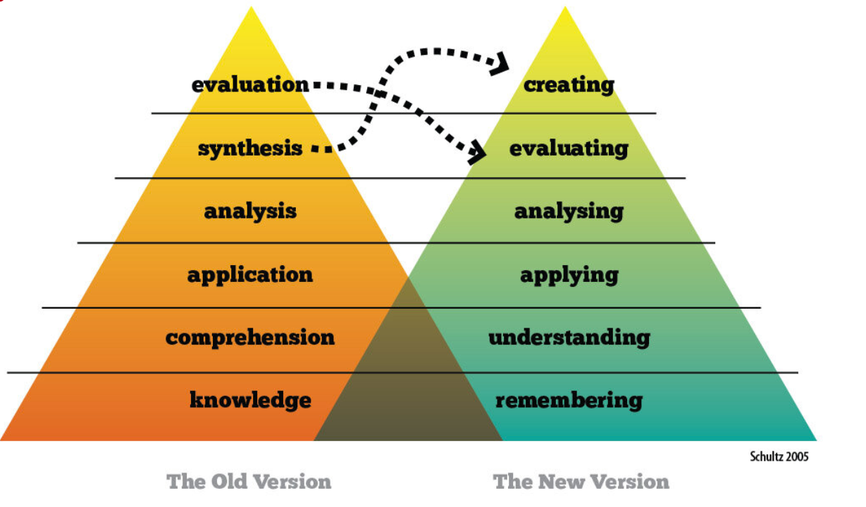
Helps move from simple to complex, concrete to abstract. Remember refers to the lowest level of cognitive rigor
Creating to combine elements of learning to create new or original work
Abstract, assemble, combine, compress, construct, correspond, design, develop, generate, integrate, portray, produce
What would happen if…?  Can you see another solution to…? | Can compose…about…?  How many ways can you…?
PE examples, Can you…
DESIGN a training programme to improve performance?
CREATE a way of building confidence in games?
COMPOSE ways of helping your teammates?
REORGANISE teaching points to help your performance?
COMBINE theory and practical PE?
Evaluating to make and justify a judgement
Appraise, assess, critique, defend, determine. Estimate, explain, grade, justify, rank, rate
What is your position on the text and can you defend it…?  What would you have done…? | Determine the most important points of the text and rank them in order…?  How effective was…?
PE examples, can you:
ASSESS your classmates?
EVALUATE what you achieved?
Appraise or JUDGE your ability?
DEFEND your opinions?
JUSTIFY your grades?
Analysing to make connections; recognise patterns and deeper meanings
Beak down, characterise, classify, contrast, distinguish, explore, identify, investigate, order, prioritise
What is the underlying theme…?  Can you distinguish between…? | Can you identify the main idea/ character/ events…?  What other possible outcomes could work here…?
PE examples, can you:
ANALYSE the difference between your performance and your partners?
RELATE your opinions on how you could improve performance?
BREAK DOWN the components of different skills
EXPLORE how you could become even better at the skills required in this lesson?
Applying to use information, theories, concepts and skills to solve problems
Adapt, assign, calculate, construct, employ, express, illustrate, modify, show, solve, use
Have you experienced anything like this in your own life…?  Could this have happened in…? | What questions would you ask…?  How could you use this…?  What would happen if…?
PE examples, can you:
DEMONSTRATE what we are learning today?
PREDICT what may happen in the game?
SOLVE the problem of poor performance?
USE key words to give feedback?
EMPLOY ways to help your teammates?
Understanding to comprehend information and grasp its meaning
Add, clarify, compare, contrast, explain, give, infer, observe, predict, summarize, translate
Can you write in your own words…?  Can you provide a short outline…?  Who do you think…?  Can you distinguish between…? | What do you think will happen next…?  Who was the main character…?  What was the main idea…?  What were the differences between…?
PE examples, can you:
EXPLAIN how to improve performance?
TRANSLATE the techniques for each skill?
Illustrate why practice can help you in a game?
EXTEND the teaching points given?
Remembering to recall facts and ideas
Cite, define, describe, draw, identify, label, list, match memorize, name, record, repeat, state, write
How many…?  What happened after…?  Who said that…?  What did…?  Which is true and which is false? | Who was it that…?  Can you name the person who…?  What does that mean?  Describe what happened when…?
PE examples, can you:
DEFINE the learning objectives?
RECALL what happened in the lesson?
DESCRIBE what you have learned?
IDENTIFY what makes some people better than others?
MATCH similar techniques in different sports?

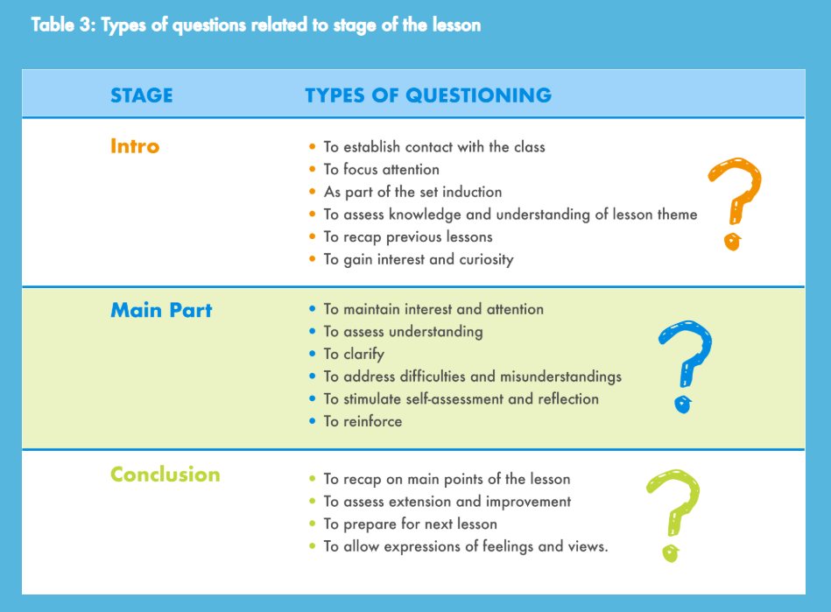
Over two lessons

