Mariana Golemanova - 2030688

Module Code - BMSW4005
Lecturer's Name - SOBAN SADIQ
REPORT CONTAINING PERSONAL REFLECTION ON THE ROLE-PLAY AND MY CAREER DEVELOPMENT PLANNING
Module Title- PROFFECIONAL CAREER DEVELOPMENT

Executive Summary
This written report will try to introduce my knowledge received in this course, according to my personal experience and planning. I will demonstrate my reflection on the role-play as an interviewee for a new professional position and describe my further professional plans.

Table of Contents
Introduction 2
Lifeline 3
Interview reflection 4
Self-evaluation review and self-motivation 6
Learning style 6
Short-term and long-term aims 7
SWOT Analysis 8
Self-reflection Johari window 9
Conclusion 10
References 10
Appendix 1 Application form 11
Appendix 2 Interview questions 15

INTRODUCTION
In this written report, I have reflected upon several learnings during the entire course, such as Gibbs’ Reflective model, approached by Johari window. I will use my personal experience with all my strengths and weaknesses to formulate my future career goals and create an action plan.
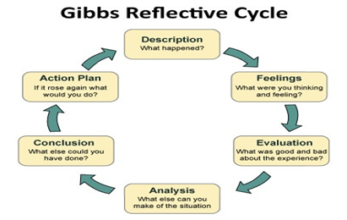

Figure 1 - Gibbs Reflective Cycle Model
Source: (Bintani,2020)

Figure 2 – The Johari window
Source: (Andyekland,2016)

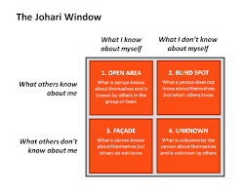

LIFELINE
All these learnings have enhanced my knowledge and competencies, and a complete reflection of these learnings has been provided using the Gibbs Reflective Cycle Model. The various stages of this model have been used to give a detailed analysis of all the education.
My goal is to demonstrate that I possess the qualities and transferable skills necessary for employment requiring some of my responsibilities. My goal is to show that I have the grades and transferable skills needed for a job requiring some of my duties.

Low points
Birth 20 25 30 35 40 50
Start of my career
3 born daughters
Business
Development as a Manager
Divorce
Owner of restaurant
Movement to London
Start of my University education
Dead of my Mom
Source: http://www.open.edu/openlearn/ocw/mod/oucontent/view.php?id=28130&section=2.1

I am Mariana Golemanova, and as can be seen on my lifeline diagram, my personal life was very dynamic and, I could say, a bit busy. Let me start from the beginning!
I am born in a big Bulgarian city, on the river Danube – Ruse. At fifteen, I lost my grannies, carrying after my brother and me. So, I had to move to the capital of my country Sofia with my bigger brother because he was accepted as a student in the most famous University. We were supposed to earn our incomings ourselves, so I started my first job at seventeen. After a short time, I got a more significant position at my workplace, and until I finished High school, I was already Managing a restaurant. After I finished Mathematical high school with intensive study of English, I continued with some additional courses in management, accounting, and public relations. I have been self-learning most of my life because I did not have a chance to finish the University, which I got in due to the birth given to my three daughters.
The growth in my career took all my time, and unfortunately, I got divorced. It was my next challenge to keep carrying on my mother’s duties in accompanying the professional responsibilities of my manager position, so that is my most important goal in my entire life.
After a very long period of a successful career, I met my ex-partner at thirty-eight ages, and we decided to move to London. That was a life-changing step because I had to leave my teenage daughters, my happy life at home, and everything I had already achieved to start from zero. The latest nine years were very hard for me in a new country, creating a new business – a cleaning company (far away from my professional experience), developing and improving services in an area out of my self-comfort.
At the end of the sharp point of visualisation of my life – one year ago, I lost my mom and two days after the funeral, I got success in entering this course and started my University Education. I plan to continue my studies and get a master’s degree in Accounting or Business management. I see myself further as a manager in some big restaurant companies for my professional development or owner of an Accounting Agency.

INTERVIEW REFLECTION
The interview was waiting for so much excitement for a long time as it had to be my first try to present myself in English. Unfortunately, the reality gave me a much more significant challenge with getting sick a few days before the expected date. It was not easy to concentrate, focus, and turn my voice louder than just whisper. Honestly, until the last few hours, before I had to do the play role, I was also without a partner, so I had no chance to practice. During this challenge, my only feeling was, “ I will not give up; I can do it!”.The other point of my reflection was that according to all the stress of my condition, I completely forgot everything, prepared for my presentation and had to do improvisation entirely: and that was not all – I was thinking about how to control my voice to sound clear and loud and in the same time to avoid the horrible cough I had. At the end of the interview, to be honest, I did not remember what I had been talking about and if I had impressed the potential interviewer. I was so blessed to hear those words from my lecturer, “ You did well!” so it was a massive relief that I even had the chance to finish that task. For my peace of mind, knowing that the interview has been recorded, at the first moment I had the condition to do it, I have been watching the video many times to find out how I did my improvisation and what are my negatives from presenting myself under pressure and health issues. The conclusions I made from this experience will create more robust and more self believe me further, and I can say I am thankful to know that I jumped into this gap with the most positive strength – to keep my mind under stress and to balance between unfortunately circumstances and bad self-condition.
I have introduced you to reflective writing techniques that helped me make the most of the reflection process throughout my degree using the DI EP tool:
D describe what happened
I interpret the events
E evaluate the effectiveness
P plan for the future
I have a reflection that allows me to reflect on something, and I think deeply about it. I have developed new insights and perspectives by analysing, questioning, and evaluating the experience. Often, this will, in turn, challenge my beliefs and affect my future actions.

SELF-EVALUATION REVIEW AND SELF MOTIVATION
From my side, my best motivation always has been to be a perfect example for my daughters as a successful careered mom. I have been working all my life under stress, mainly at the workplace and at home, so I have trained myself to keep my mind in good condition in every problematic situation. Doing a lot of duties and tasks stimulates me to focus and give the best of my abilities to achieve the best results in my job. During my thirty-one year’s practice, I have had too many responsibilities in a leadership role, so I have learned how to balance good managing skills with relations and communications at the workplace. According to the self-motivation quiz made in class, I achieved a score of 50 points. This made me believe that I am almost maximum motivated, who never let anything stand in my way, and I get the thing done! I spend a long time setting goals and acting to achieve those objectives. I do my best to attract others with my motivation and enthusiast them to follow me to success.
First, in my opinion, is to draw a line between the different stages in the company to clear the related roles of everyone without losing the employees’ feedback and reasonable tone of the conversation. The second important rule of a good manager is to keep up to date with all happening in his company. To talk with his staff often in meetings, team building, or even in-person to receive information about how they feel, are satisfied with their job, or have any issues. The next step of being a good leader is always to check the progress of the aims and give a bonus to motivate the most participating team members. I feel a bit self-motivated to keep moving forward, and on the “How Self-Motivated Are You?-Taking Charge of Your Goals and Achievements” test in class, I got fifty points, which proved my opinion.

LEARNING STYLE
These and many more tools and technics I have learned and improved all the time using my particular style of learning. Using the in-class exercise Honey and Mumford’s Learning Styles (1986) Questionnaire, I found out what kind I usually practice in my studies. Based on the results of this test, I realised that I am half Reflector and half a Theorist. That means that mostly I combine both styles, including discipline, aiming to fit things into a rational order and at the same time act quickly and confidently on ideas, getting straight to the point. I can think through problems logically and value rationality and objectivity, but I am also keen to put pictures, theories and techniques into practice. Following VAK Learning Styles Self-Assessment Questionnaire, I have an auditory learning style, which covers my real life as I always prefer to see and hear what I have to learn. In my studies, I have remembered easier what has been visualised. I hope to keep evaluating and self-motivating to achieve the best in my professional career.
SHORT-TERM AND LONG-TERM AIMS
PERSONAL DEVELOPMENT PLAN
NAME | MARIANA  GOLEMANOVA | Target Job/career  Example: Teacher, Manager, Business Person | RESTAURANT  MANAGER

PERIOD | From: JULY 2022 | To: DECEMBER 2022

What Skills do I need to achieve my goal?
SKILLS | How Will I get them | What resources or support will I need? | What can prevent me from achieving my goals: (unemployment, illness | How long should it take
Presentation  Communication  Organisation  Interpersonal skills  Conflict resolution  Motivation leader | Online course | Literature | Weakness on time  management | 5-6 months
I have used the personal development plan (PDP) and SMART tasks table (Alan Chapman 2002 Specific - Measurable - Agreed - Realistic - Time-bound) to build my future action plan and hope in the short term to be ready to apply for a Restaurant Manager position in London and later become an owner of a small business in catering or accounting (my other professional area). Here is the place to mention the advantages of the applied position – first of all, I have been doing this job all my life, and I believe my experience will be beneficial to achieving the requested goals; also, I could evaluate my professional perspective with my new qualifications.

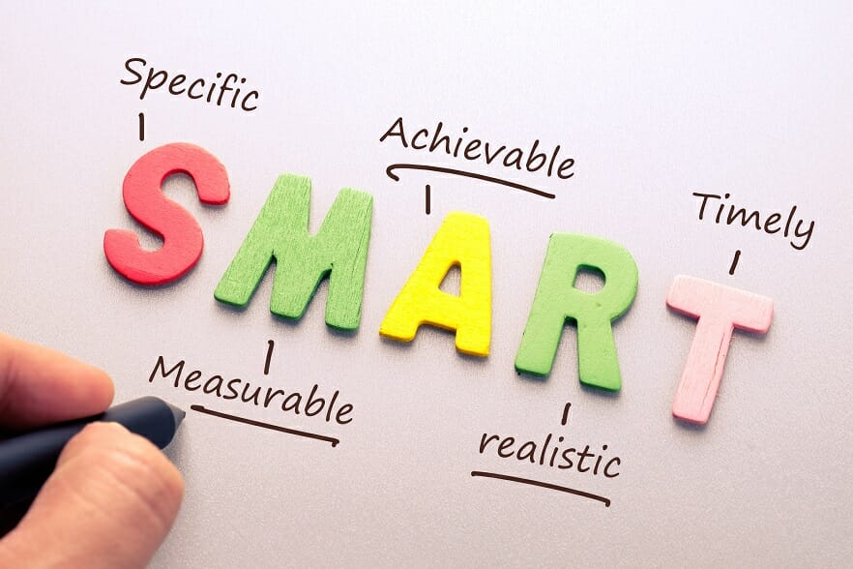
PERSONAL SWOT ANALYSIS
Good organisation skills.  Good communication skills.  Professional experience. | I have to improve my time management.  Too much control.
  Strengths What do you do well? What unique resources can you draw on? What do others see as your strengths
  Weaknesses What could you improve? Where do you have fewer resources than others? What are others likely to see as weaknesses?
Improve my English language.  Motivation skills. | If I do not manage better my time, I should not achieve my goals.  I have to learn to delegate some of my responsibilities to another team member to avoid overwork.
  Opportunities What opportunities are open to you? What trends could you take advantage of? How can you turn your strengths into opportunities?
  Threats What threats could harm you? What is your competition doing? What threats do your weaknesses expose you to?
The tool SWOT analysis helps me allocate my strengths and weaknesses and the opportunities and threats to prepare me to be more confident and competitive in applying for new professional positions. Using this technic, I can correctly push myself to meet the requirements and achieve my goals. When I find these qualities or issues, I can reflect and take action to afford my best behaviour.
SELF-REFLECTION JOHARI WINDOW
When it is about excellent performance, I can use the tool ‘ Johari window’ to improve understanding between the teammates. If we want to work in an ideal environment, the most important is to create an open culture. It is a crucial component of creating an effective and positive atmosphere. The first quadrant in the Johari window is the open area or Arena, and it is about what we know about ourselves. The second part of the tool is the hidden area, where things are unknown to the others (secrets).
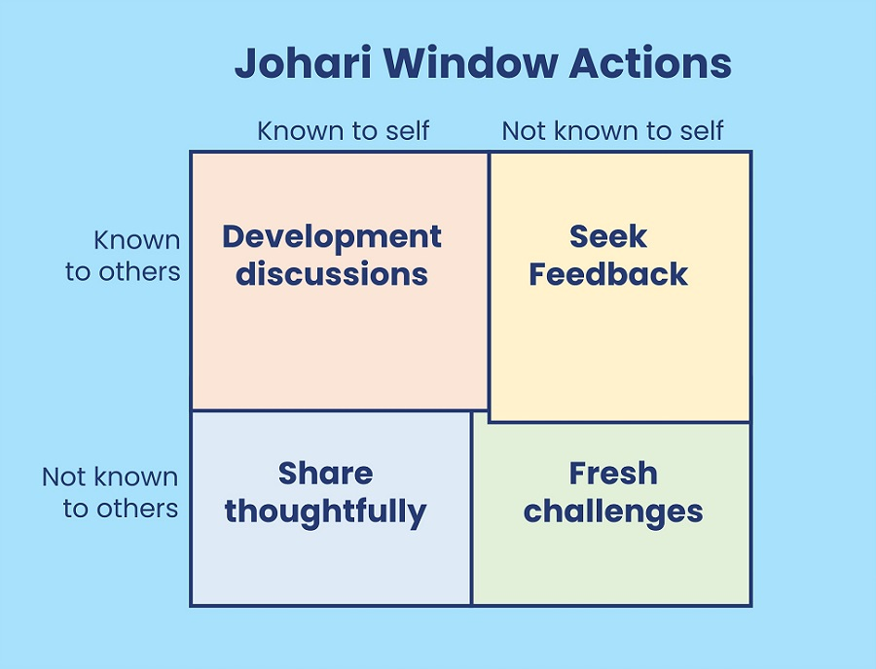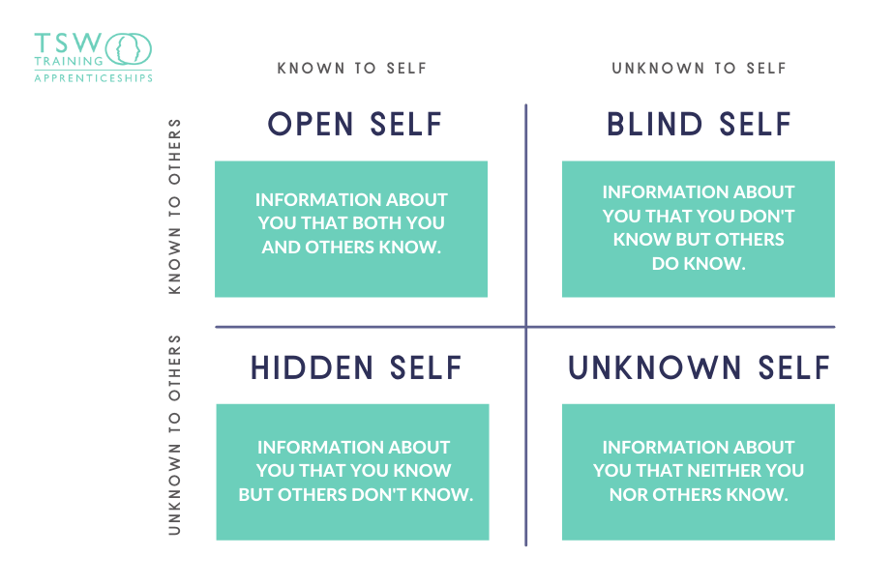
The third part is a blind spot, where we do not know about some of our talents or behaviour visible to the others. The last area is about everything, which eighter we still do not know about ourself, neither the others.
CONCLUSION
In conclusion, I can say that reflecting on the theories I learned and analysing my experience gave me a chance to develop a personal and professional career vision. Using these specific technics helped me describe a picture of my future and take the correct actions more clearly. Professionals need to consider different aspects when aiming to achieve personal or career perspectives, including attainment of knowledge, qualification, and position, so I am pleased to have the chance to enhance my competitiveness and evidence by practising these self-awareness tools.

REFERENCES:
Doyle, A. (2019) Behavioural based job interview questions. Available at: https://www.thebalancecareers.com/behavioral-job-interview-questions-2059620. (Accessed: 23.06.2019).

Indeed.com (2021) ‘14 Common Qualities Employers are Looking For’. https://www.indeed.com/career-advice/finding-a-job/qualities-employers-want (accessed 18 June 2021)

Maund, A. Schriek, M. and Tinkler, P. (2017). Certificate in Higher Education: Skills for the Workplace Student Yearbook. Sage Publications.

Mindtools (n.d.)’ How Self-Motivated Are You? Taking Charge of Your Goals and Achievements’. https://www.mindtools.com/pages/article/newLDR_57.htm (accessed 18 June 2021)

Morgan, P (2017). The Business Student’s Guide to Employability. London: Sage

NIDirect. (n.d.) ‘Written statement of employment particulars.’ https://www.nidirect.gov.uk/articles/written-statement-employment-particulars

Appendix 1 Application form

Job application form

Application for – GENERAL RESTAURANT MANAGER

Name: MARIANA GOLEMANOVA

Education and training:

CERTIFICATE OF HIGH-LEVEL EDUCATION IN THE WORKPLACE-UWTSD 2021-2021

MATHEMATICS HIGH SCHOOL WITH INTENSIFIED STUDY OF THE ENGLISH LANGUAGE

Qualifications:

DIPLOMA IN RESTAURANT MANAGEMENT.
DIPLOMA IN ACCOUNTING.

Employment history

Current or most recent employer:

Name of employer: RESTAURANT AND COCKTAIL BAR KAPRI, Sofia

Job title: GENERAL MANAGER

Length of time with employer: 5 YEARS

Reason for leaving: MOVING TO LONDON

Duties:

GENERAL CREATION OF THE WHOLE IDEA FOR LUXURY RESTAURANTS AND BARS - BRAND STANDARDS, FOOD SAFETY AND STAFF GUIDANCE.

As a General Restaurant Manager, I was in charge of the restaurant's day-to-day operations, including all food service operations, hiring, training, and overseeing employees. Usually, I worked more than 100 hours per week, as I was at the restaurant from opening to closing, usually from 7 a.m. to 12 p.m. (17 hours) seven days a week.
Most restaurant managing partners do not have a bachelor's degree. Still, many of these managers have earned a degree in restaurant and hospitality management, which will provide them with many of the skills they need to run a restaurant successfully. The Foodservice Management Professional designation is also available to those interested in the career. An essential qualification for a restaurant managing partner is experience in the foodservice industry. That is what I have, and I am proud of it.

Previous employers:

MANAGING RESTAURANTS AND CLUBS FOR OVER 25 YEARS AND OWNING SOME OF THEM.

Supporting statement
Please tell us why you applied for this job and why you think you are the best person for the job.

Restaurant managers need exceptional organisational skills to keep track of budgets, schedules, and other critical information. A positive working relationship with subordinates depends on leadership skills to foster a productive work environment. In addition to being detail-oriented, managers must be capable of handling multiple tasks simultaneously.
Job openings for restaurant managing partners are competitive and difficult to obtain, so I am excited about the challenge, and I will be pleased to be selected.
I believe my knowledge, experience, and professional credentials will help your company reach its goals and increase its potential.
My skills will also enhance teamwork and customer service. My previous employers have provided examples of my positives and personal activities, but I prefer to demonstrate them all in person at work.
To conclude my short presentation, I would like to assure you that my key characteristic is being a well-practised leader working under pressure. I believe that I can continue to improve my problem-solving skills in your company.

Right to work in the UK
Do you need a work permit to work in the UK? Yes

References
Please give the names and contact details of 2 people we can ask to provide you with a reference. We may ask them before an employment offer is made. We will not ask your current employer until we get your permission. Yes

Declaration
I confirm that the information I have provided on this form is correct to the best of my knowledge, and I accept that providing deliberately false information could result in my dismissal.

Name: MARIANA GOLEMANOVA
Signature:
Date: 17.04.2022

Appendix 2 Interview questions
1. Tell me about yourself
2. What are your strengths, and what are your weaknesses?
3. Why should we hire you, and what can you do for us those other candidates cannot?
4. What are your goals, and where do you see yourself in five years?
5. What are three positive things your last boss would say about you?

