University of Wales
Trinity Saint David



Assignment Topic: ESP32-Based Gas, Air Quality and Fire Detection System
Module: Independent Project
Module Code: ACCA6020
Student: Gabriel Munteanu
Student Id: 2318069
Lecturer`s Name: Renuga Jayakumar

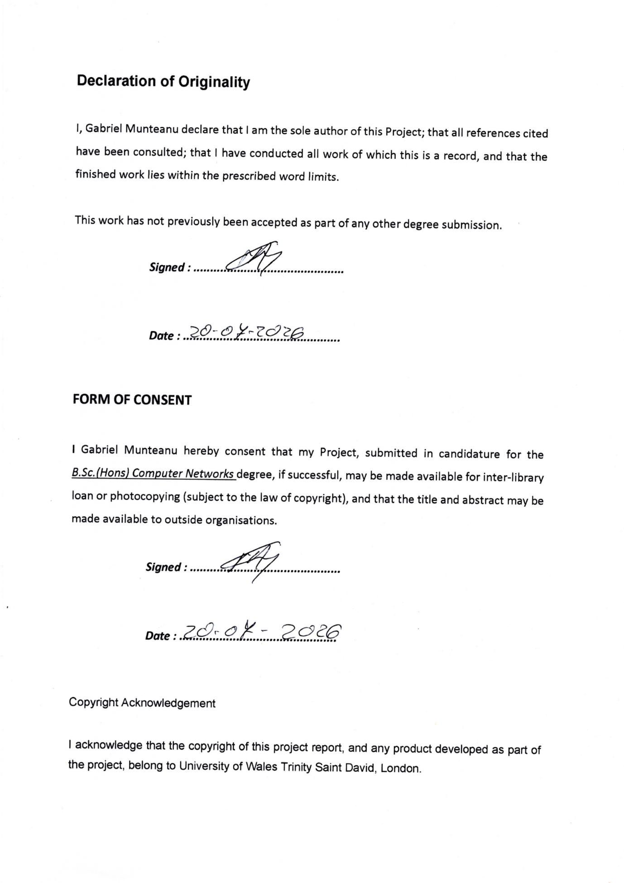

Contents
Abstract 6
S1 – Introduction 7
1.1 Background 7
Figure 1 8
1.2 Project Problem 8
1.3 Project Aim 9
1.4 Project Objectives 9
1.5 Project Scope 9
1.6 Structure of the Report 10
S2 – Research and Literature Review 10
2.1 Indoor Air Quality and Environmental Hazards 10
2.2 Semiconductor MQ Gas Sensors 10
2.3 MQ-2 Sensor 11
2.4 MQ-135 Air-Quality Sensor 11
2.5 MQ-4 Methane / Natural Gas Sensor 12
2.6 MQ-7 and Carbon Monoxide Response 12
2.7 ADS1115 Analogue-to-Digital Converter 12
2.8 Environmental Monitoring Using AHT20 and BMP280 13
2.9 Sensor Response, Recovery and False Warnings 13
2.10 Multi-Sensor Correlation 13
2.11 IoT and Remote Monitoring 14
2.12 Related Systems and Research Gap 14
S3 – Research and Development Methodology 15
3.1 Development Approach 15
3.2 Initial Requirements and Planning 16
3.3 Hardware Development and Changes 17
3.4 Software Development 17
3.5 Development of the Warning Logic 18
3.6 Multi-Sensor Correlation and Operating Modes 20
3.7 Testing and Data Collection 21
3.8 Safety, Ethics and Limitations 22
S4 – Design, Implementation and Testing 24
4.1 Final System Design 24
4.2 Hardware Implementation 25
4.3 Sensor Reading and Response Processing 26
4.4 Web Dashboard 27
4.5 Settings and Operating Modes 28
4.6 Warning and Danger Engine 30
4.7 Multi-Sensor Correlation 31
4.8 Alerts, Email and Logging 32
4.9 Testing the Final System 33
4.10 Post-Exposure Recovery 36
S5 – Evaluation 38
5.1 Evaluation Against the Project Aim 38
5.2 Evaluation Against the Project Objectives 38
5.3 Hardware Evaluation 39
5.4 Dashboard and Usability Evaluation 39
5.5 Warning Logic and False-Alert Reduction 40
5.6 Multi-Sensor Correlation Evaluation 41
5.7 Alerts and Logging Evaluation 41
5.8 Sensor Recovery Evaluation 42
5.9 Overall Evaluation 43
S6 – Conclusions and Recommendations 43
6.1 Conclusion 43
6.2 Main Recommendations 44
6.3 Future Development 45
S7 – Reflection 46
7.1 Reflection on the Development Process 46
7.2 What I Learned from the Sensors 46
7.3 Software Development Reflection 46
7.4 Project Planning and Changes 47
7.5 What I Would Improve 48
References: 50

Abstract
This project presents the design, development and evaluation of ESP32 AirMonitor Pro, a low-cost environmental monitoring and hazard-warning prototype intended for indoor commercial environments. The project was originally proposed as an ESP32-S3 touchscreen system using a smaller number of sensors and simple threshold-based warning logic. During development, practical hardware and sensor behaviour led to several changes in the design.
The final prototype uses an ESP32 Dev Module together with MQ-2, MQ-135, MQ-4 and MQ-7 sensors, an ADS1115 analogue-to-digital converter and an AHT20 with BMP280 environmental module. The system monitors LPG and smoke response, air-quality and VOC response, methane and natural-gas response, possible CO and combustion-risk response, temperature, humidity and atmospheric pressure.
A browser-based dashboard was developed to replace the originally planned touchscreen interface. The dashboard provides live readings, sensitivity controls, operating modes, warning states, system information and access to settings. Local warnings are provided through a buzzer and red alarm LED, while remote notification is provided through email. Event logging and CSV download are also included.
Testing showed that the MQ sensors do not behave like simple instant detectors. Sensor values can rise quickly during exposure but may recover slowly afterwards. This influenced the development of verification delays, hysteresis, persistence, rate-of-rise analysis and multi-sensor correlation. The final system uses several states from NORMAL through to CRITICAL and RECOVERING instead of relying only on a single threshold.
The project achieved the main objective of developing a working multi-sensor ESP32 monitoring prototype. However, the system is not intended to replace certified commercial safety equipment and the MQ readings are treated as relative responses rather than certified gas concentrations. The main area identified for future development is improved post-exposure recovery handling, together with longer-term testing and improved calibration.

S1 – Introduction

Background
Whenever we have gas and electricity within a business there are hazards as well such as gas leaks, poor air quality, smoke, carbon monoxide and fire-related conditions that can create serious risks . If these conditions are not identified early, they can lead to health problems, property damage, financial losses and disruption to normal activities.In the original project proposal I have identified this area as suitable for an Independent Project because it combines embedded sensing, local processing, networking and digital communication within one practical system.
These types of connected environmental monitoring have become quite common. One example is Google nest protect that demonstrates the use of connected smoke and carbon-monoxide monitoring together with local and remote warnings [1]. Another one is Airthings View Plus that provides continuous indoor environmental monitoring using several sensors, including measurements associated with indoor air quality and environmental conditions [2]. Kidde and X-Sense also provide connected safety products that support mobile notifications for smoke, carbon monoxide and other household hazards [3], [4].
Looking at all these commercial products, we can see that connected environmental monitoring and remote notifications are established approaches. What bothers me is that all of them are closed commercial systems and provide limited opportunity for hardware modification or experimental development. In this project we are investigating if a lower-cost and more flexible prototype could be developed using an ESP32 platform.
In the original project I was proposing an ESP32-Based Gas, Air Quality and Fire Detection System. In that design I was using an ESP32-S3 touchscreen controller together with an MQ-2 sensor, a BME680 environmental sensor and a flame or temperature sensor. The proposed prototype would read environmental conditions, compare them against predefined thresholds and provide visual, audible and email warnings when a hazardous condition was detected.
During the development, the design changed considerably. The final system, named ESP32 AirMonitor Pro is using an ESP32 Dev Module rather than the originally proposed touchscreen controller. I have chosen the ESP32 family because it provides integrated Wi-Fi together with interfaces suitable for embedded sensor applications [5]. The firmware for the board was developed in C/C++ and loaded onto the ESP32 board using Arduino IDE [6], continuing the development approach identified in the original proposal [20].
We have expanded the sensor array to include MQ-2, MQ-135, MQ-4 and MQ-7 sensors together with an AHT20 and BMP280 environmental module. An ADS1115 analogue-to-digital converter was also added to provide four separate analogue channels for the MQ sensors.
In the original project we were expecting that the system will operate mainly through predefined thresholds [20]. During development we have seen that practical sensor behaviour needed a more advanced approach. The final AirMonitor Pro system therefore developed above simple threshold comparison by introducing persistence, rate-of-rise analysis, hysteresis, verification timing, multi-sensor correlation and a combined danger score.
Figure 1 presents the initial system architecture proposed at the beginning of the project, while Figure 5 presents the final AirMonitor Pro architecture.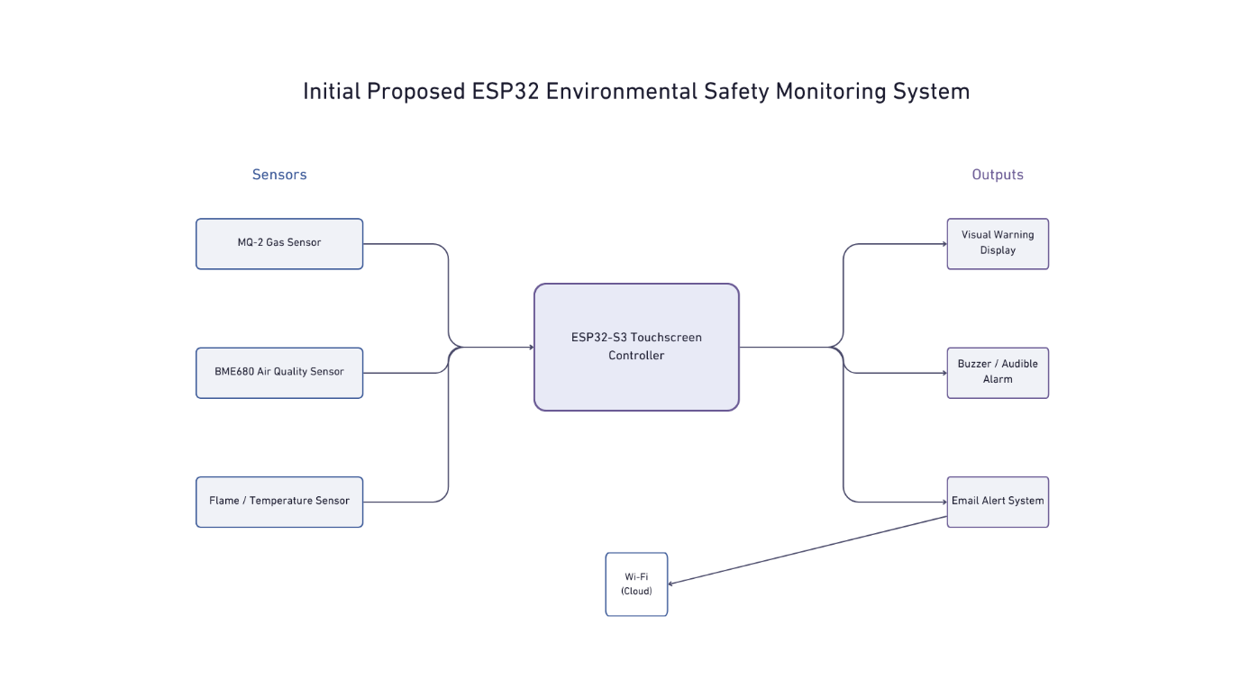

1.2 Project Problem
The main problem addressed by this project is the development of a low-cost environmental monitoring system that can provide useful warnings without assuming that every change in an individual sensor is an immediate emergency.
The initial proposal concentrated on threshold-based detection [20]. As development went forward, the system became more focused on interpreting combinations of sensor responses and changes over time. This was very important for the intended indoor commercial environment, where normal activities such as cooking, cleaning and ventilation changes may influence environmental sensor behaviour.
The final prototype is monitoring different sensors instead of depending on the readings of one sensor alone. The firmware reads sensor response the changes that take place, persistence and whether other sensors are responding at the same time.
The system remains an academic prototype and is not intended to replace an approved commercial safety product. This limitation was already identified in the original proposal [20].

1.3 Project Aim
The final project aim is:
To design, develop and evaluate a low-cost ESP32-based environmental monitoring and hazard-warning prototype for indoor commercial environments, capable of monitoring gas, air-quality and environmental conditions, applying verified multi-sensor warning logic, and providing local and remote alerts through a web-based interface.
This aim develops the original proposal, which focused on designing and evaluating a flexible ESP32-based environmental safety system with local and remote warning functions [20].

1.4 Project Objectives
The objectives are:
- To design and build a multi-sensor ESP32 monitoring system using MQ-2, MQ-135, MQ-4, MQ-7, AHT20 and BMP280 sensors together with an ADS1115 analogue-to-digital converter.
- To develop a web-based monitoring interface capable of presenting live gas-response and environmental information.
- To implement configurable sensitivity settings and OPEN, CLOSED, CLEANING and AUTO operating modes.
- To develop a verified hazard-detection process using thresholds, persistence, rate of rise, hysteresis and verification delays.
- To implement multi-sensor correlation and a combined danger score.
- To provide local and remote warnings through a buzzer, alarm LED, event logging and email notifications.
- To test and evaluate the prototype in terms of functionality, responsiveness, reliability, recovery behaviour and limitations.
The final objective continues the evaluation approach established in the original proposal, which identified functionality, responsiveness, reliability and limitations as key areas of assessment [20].

1.5 Project Scope
The project is limited to the design and evaluation of an academic prototype. It demonstrates how low-cost sensing, ESP32 processing and network communication can be combined in one monitoring platform.
The final prototype includes sensor monitoring, configurable settings, local warnings, Wi-Fi communication, email notifications, event logging and a browser-based dashboard. ESP32 Wi-Fi capability provides the networking foundation required for these functions [5].
The system does not claim to provide certified gas concentration measurements or formal life-safety certification. This follows the limitation established in the original proposal that the prototype should be evaluated as an academic system rather than as a replacement for certified commercial alarms [20].

1.6 Structure of the Report
Section 2 presents the research and literature review. Section 3 describes the research and development methodology and explains how the project changed from the original plan. Section 4 presents the design, implementation and testing of the final AirMonitor Pro prototype. Section 5 evaluates the final system against the project objectives. Section 6 provides the conclusions and recommendations, while Section 7 reflects on the development process and the skills and knowledge gained.

S2 – Research and Literature Review

2.1 Indoor Air Quality and Environmental Hazards
Indoor air quality is the most important part of environmental safety because people can be exposed to different hazards for long periods while inside buildings focused on their tasks without realising. The World Health Organization identifies carbon monoxide as an important indoor pollutant associated with serious health risks [7].
Within any business small or big dealing with commercial kitchens air quality can change because of cooking, heating equipment, cleaning products and ventilation.
Combustion can convert gasses like Natural or LPG and can introduce other hazards in to the air. Cleaning products can make a difference as well by increasing the VOC levels. This means that if we monitor only one environmental condition the system may not provide enough information to understand what is happening.
In section 1 we have discussed some commercial alternatives , these show that environmental monitoring can combine several measurements within one connected device [1]–[4]. AirMonitor Pro has a different approach it is a modifiable prototype where sensors, processing behaviour and warning rules can be adjusted during development. The purpose of this project is not only to detect that a value has changed, but also to consider whether the behaviour is more likely to represent normal activity or a potentially hazardous condition.

2.2 Semiconductor MQ Gas Sensors
The main gas sensors used in this project belong to the MQ family of semiconductor gas sensors. These sensors commonly use tin dioxide, SnO₂, as the gas-sensitive material. When certain gases are present, the conductivity of the sensing material changes and this can be converted into an electrical output [8].
The reason for choosing MQ sensors is because they are inexpensive, widely available and can respond to several gases. While we talk about what`s good let`s see also what`s bad , an important limitation is that they are not normally selective to one gas only. Different gases may influence the same sensor and environmental conditions can also affect its behaviour. Research into metal-oxide gas sensors identifies selectivity, reproducibility, humidity effects and ageing as important limitations [9].
All these factors have influenced the final AirMonitor Pro design. Instead of treating MQ outputs as certified gas concentrations, the system uses them mainly as relative responses and also considers changes over time and responses from other sensors.

2.3 MQ-2 Sensor
The MQ-2 is listed as being used mainly for LPG and smoke-related response. Manufacturer information describes it as sensitive to propane and smoke and also responsive to other flammable gases [8].
The MQ-2 was included in the original proposal and remained part of the final system. Its role became more clearly defined during development. The dashboard displays the MQ-2 separately as an LPG/smoke response rather than treating it as proof that one specific gas is present.
A high MQ-2 output on its own does not identify the exact gas that caused the response. It is therefore considered together with other sensor channels and the operating conditions of the system.

2.4 MQ-135 Air-Quality Sensor
The MQ-135 was added during development to provide a broader air-quality and VOC-related response. The manufacturer identifies the sensor as responsive to several gases and vapours associated with air quality, including ammonia, sulfides and benzene-series vapours [10].
This broad response makes the MQ-135 useful in an environment where cooking fumes and cleaning products can affect air quality. At the same time, it means that its output cannot be interpreted as one specific pollutant without suitable calibration and controlled testing.
The manufacturer documentation also shows that temperature and humidity influence sensor characteristics and that the sensor has a measurable response and recovery behaviour [10]. This relates directly to observations made during development, where the sensor could remain elevated after strong cooking fumes or VOC exposure.
For this reason, AirMonitor Pro does not force the displayed response quickly back to zero. Different response profiles are used to make the dashboard more realistic while allowing the safety logic to react more quickly when required.

2.5 MQ-4 Methane / Natural Gas Sensor
The MQ-4 is used as the dedicated methane and natural-gas response channel. Manufacturer documentation describes it as having high sensitivity to methane and shows that its conductivity changes as target gas concentration increases [11].
The MQ-4 also requires a substantial initial preheating period under standard testing conditions [11]. This shows that MQ sensors need time to reach stable operating conditions and should not be treated as simple instant switches.
Adding the MQ-4 was an improvement over the original proposal. In the final system, LPG/smoke response from the MQ-2 and methane/natural-gas response from the MQ-4 are kept separate. The system does not calculate a natural-gas value from the MQ-2 reading. This allows both combustible-gas channels to contribute independently to the multi-sensor correlation process.

2.6 MQ-7 and Carbon Monoxide Response
The MQ-7 is used to provide an indication of possible carbon monoxide or combustion-related risk. Carbon monoxide is colourless and odourless and is associated with incomplete combustion, making it an important indoor safety concern [7].
An important limitation was identified when researching the MQ-7 operating method. Manufacturer documentation specifies a heater cycle that alternates between high and low temperatures. The lower-temperature phase is used for CO detection while the higher-temperature phase assists in sensor cleaning [12].
The current AirMonitor Pro prototype does not operate a formally calibrated alternating heater cycle. For this reason, it does not present the MQ-7 result as a certified ppm carbon-monoxide measurement. The reading is instead described as a CO / combustion-risk response.

2.7 ADS1115 Analogue-to-Digital Converter
In the final hardware we are using an ADS1115 to receive the analogue outputs from the four MQ sensors. Texas Instruments describes the ADS1115 as a 16-bit I²C-compatible analogue-to-digital converter supporting four single-ended analogue inputs [13].
The four channels are used as follows:
- A0 – MQ-2
- A1 – MQ-135
- A2 – MQ-4
- A3 – MQ-7
The ADS1115 communicates with the ESP32 through I²C and provides a clean way of keeping the four gas-sensor channels separate. This became useful as the project expanded beyond the simpler sensing arrangement proposed at the beginning.

2.8 Environmental Monitoring Using AHT20 and BMP280
AirMonitor Pro also records temperature, humidity and pressure. The AHT20 supplies temperature and humidity, while the BMP280 provides atmospheric pressure and a secondary temperature reading. The BMP280 is a digital pressure sensor designed to provide pressure and temperature information [14].
Pressure is not treated as direct evidence of a fire. It can change because of weather, doors, ventilation or extraction. In this project it is therefore used only as supporting information, for example when considering whether ventilation or extraction conditions may have changed.
Temperature and humidity are also relevant because environmental conditions can influence metal-oxide sensor behaviour. Research has shown that humidity can affect the response of this type of gas sensor [9]. Monitoring climate information alongside the MQ sensors therefore provides useful supporting context.

2.9 Sensor Response, Recovery and False Warnings
One of the most important practical findings was that gas-sensor behaviour does not match a simple on/off model. A sensor may rise quickly during exposure but recover more slowly after the source is removed. Manufacturer information for the MQ-135 includes response and recovery characteristics that support this behaviour [10].
This creates a problem for warning systems based only on fixed thresholds. If a warning starts at one value and clears immediately when the reading drops slightly below it, small fluctuations can cause repeated transitions between warning and normal states.
AirMonitor Pro uses hysteresis to reduce this problem. A warning can begin at one level but requires a lower clear level before the condition is removed. This prevents small movements around a threshold from causing repeated state changes.
The final design also uses verification periods. A warning condition must remain present for a set period before escalation, while more severe conditions can escalate faster. This is useful in a kitchen environment where a short cooking-fume spike should not necessarily behave in the same way as a sustained or rapidly increasing hazard.
The slow recovery observed after prolonged exposure also led to the proposed post-exposure recovery logic shown in Figure 12. The planned approach distinguishes between elevated and rising, elevated and flat, and elevated and falling sensor behaviour. The purpose is to recognise genuine recovery without hiding the real sensor readings.

2.10 Multi-Sensor Correlation
Using several sensors allows the system to compare patterns rather than relying on one signal alone. Research into multi-sensor fire and hazard detection has shown that combining information from different sensors can improve early-warning decisions and help separate hazards from unwanted alarms [15], [16].
This principle influenced the AirMonitor Pro danger engine. For example, a rapid increase from the MQ-135 while MQ-2, MQ-4 and MQ-7 remain relatively stable may be more consistent with cooking fumes or VOC exposure. In comparison, several gas sensors rising rapidly at the same time should be treated with greater concern.
Figure 10 illustrates the difference between an isolated sensor event and a correlated event.
The final danger assessment considers four main factors:
- current sensor response;
- rate of rise;
- persistence;
- multi-sensor correlation.
These factors contribute to the overall danger score rather than relying on one fixed threshold for the whole environment.

2.11 IoT and Remote Monitoring
The ESP32 provides the main processing and communication platform. Its integrated Wi-Fi capability allows local sensor processing to be combined with browser-based monitoring and network communication [5].
In AirMonitor Pro, the ESP32 hosts the web dashboard and also uses Wi-Fi for time synchronisation and email notifications. The software was developed using Arduino IDE [6], which supported the required sensor, networking, storage and email libraries.
The browser-based dashboard became an important change from the original proposal. The first design planned to use a touchscreen as the main interface. During development, the web interface became more practical because it could display more information, offer detailed settings and allow access from another device on the same network.

2.12 Related Systems and Research Gap
The commercial systems discussed earlier show that connected environmental and safety monitoring is already established [1]–[4]. However, these systems are closed products with fixed hardware and limited opportunity for experimental modification.
The purpose of AirMonitor Pro is not to replace or directly compete with certified commercial alarms. The project instead investigates how a low-cost, modifiable ESP32 platform can combine several semiconductor gas sensors, environmental measurements, an external ADC, Wi-Fi communication and custom warning logic.
The literature shows that individual metal-oxide sensors have limitations such as cross-sensitivity, environmental influence and imperfect selectivity [9]. Multi-sensor approaches provide one way of improving interpretation by considering patterns across several signals [15], [16].
The research gap addressed by AirMonitor Pro is therefore the use of several low-cost sensor responses together with persistence, rate of change, hysteresis, verification and operating context to produce more meaningful warnings. This research directly influenced the move from the simple threshold-based design in the original proposal to the final multi-sensor warning system.

S3 – Research and Development Methodology

3.1 Development Approach
For this project I have used an iterative development methodology because the system included different areas such as hardware selection, sensor integration, software development, Wi-Fi communication, warning logic and testing. It would have been difficult to complete all these parts in one stage, so the project was developed gradually.
The iterative approach was also included in the original proposal. This method allows a system to be developed through repeated stages of building, testing, identifying problems and improving the design [17].
The general development cycle used during the project was:
Plan → Build → Test → Identify Problems → Modify → Test Again
This process was repeated during both hardware and software development. Some parts worked as expected, while others needed to be changed after practical testing.
The original development stages are shown in Figure 3.
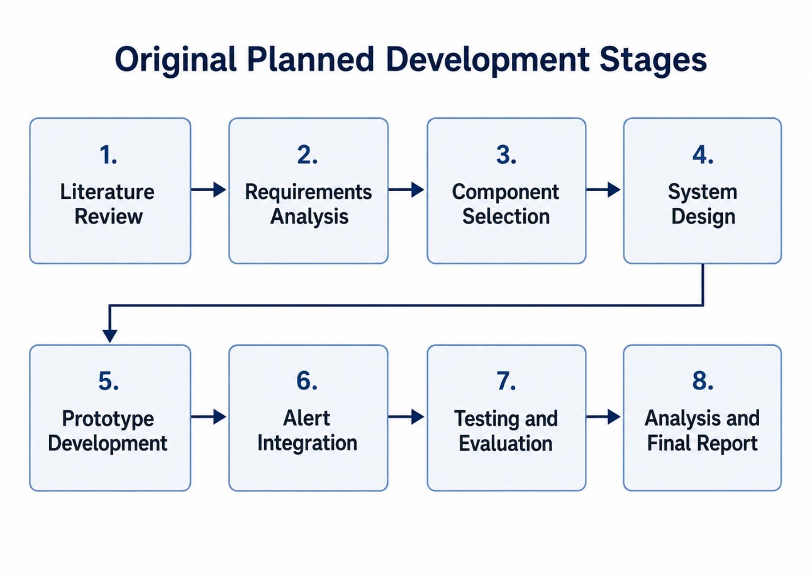
The original Gantt chart is shown in Figure 4. It provided the initial project schedule, although some development tasks changed as the project became more complex.
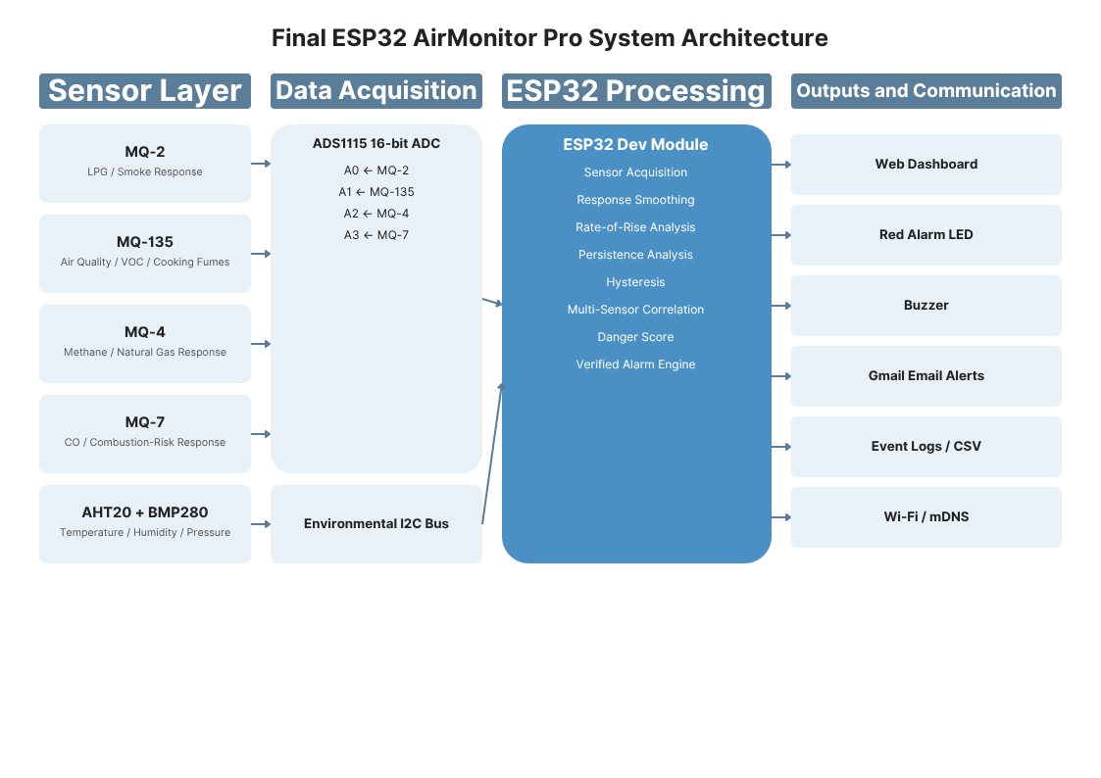

3.2 Initial Requirements and Planning
The original project requirements were based around developing a low-cost system capable of monitoring gas, air quality and possible fire-related conditions.
The first design included an ESP32-S3 touchscreen controller, MQ-2 sensor, BME680 environmental sensor and either a flame or temperature sensor. The prototype was planned to provide visual warnings, an audible warning through a buzzer and remote email alerts through Wi-Fi.
The original system was expected to operate mainly using predefined thresholds. Sensor readings would be compared against these thresholds and a warning would be activated if the set level was reached.
This provided a simple starting point, but during development it became clear that the real sensor behaviour required a more flexible approach. Some sensors could respond to more than one environmental condition and could also take time to return to normal after exposure.
For this reason, the project moved away from relying only on one sensor value and one fixed threshold.

3.3 Hardware Development and Changes
The hardware was developed in stages so that individual components could be tested before everything was connected together.
One of the biggest changes was moving away from the original ESP32-S3 touchscreen design. During development the touchscreen introduced additional problems with display libraries, memory use and compatibility. The display was taking a large amount of development time while the main purpose of the project was environmental monitoring and hazard warning.
The final design therefore uses an ESP32 Dev Module with the main interface provided through a browser-based dashboard. The ESP32 still provides the Wi-Fi communication and processing required by the project [5].
The sensor configuration was also expanded. Instead of the original MQ-2, BME680 and flame-sensor arrangement, the final system uses MQ-2, MQ-135, MQ-4 and MQ-7 sensors together with an AHT20 and BMP280 environmental module.
As four MQ sensors were now being used, an ADS1115 analogue-to-digital converter was added. The ADS1115 provides four analogue input channels through I²C [13], allowing each MQ sensor to remain separate.
Figure 6 shows the final hardware configuration.
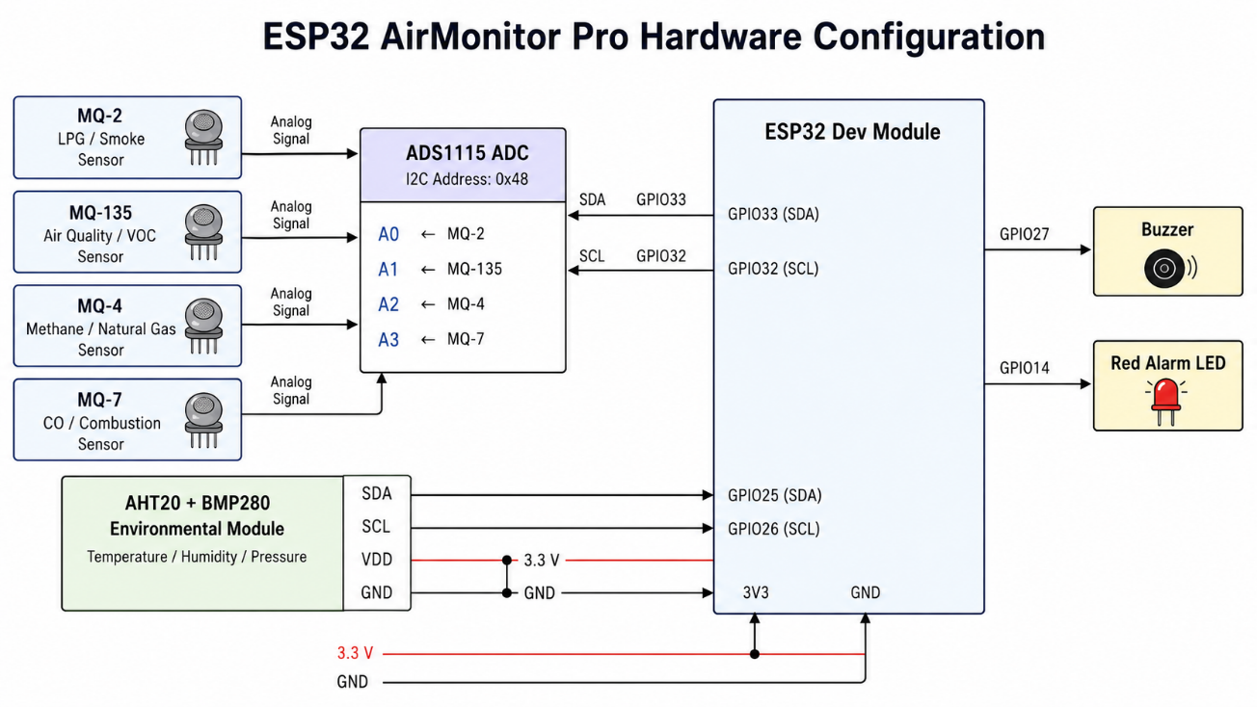

3.4 Software Development
The firmware for the ESP32 had been written in C/C++ using Arduino IDE [6]. At the beginning the code was quite simple and mainly focused on reading the sensors and displaying their values. As more features were added, the program became harder to manage, so I separated the main functions into different modules.
The final AirMonitor Pro software includes the main program, a sensor module, an alarm module, a web interface and a help module, as shown in Figure 7.
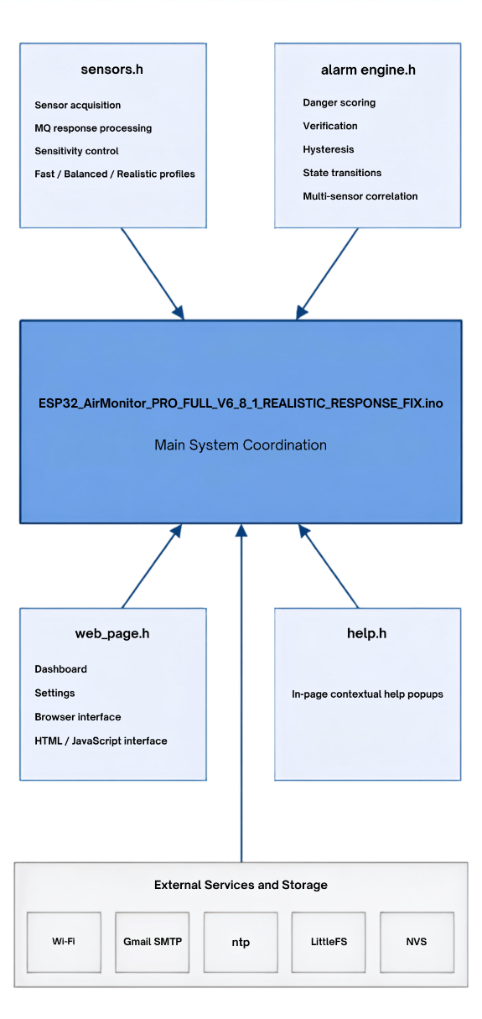
This structure was introduced gradually during development.one of the reasons was that the dashboard uses HTML, CSS and JavaScript, while the ESP32 firmware uses C/C++. If I was keeping all of this together would have made the project harder to manage. Separating the web interface and warning logic made it easier to test and modify individual parts without affecting the complete system without scrolling thru 5000 lines of code.

3.5 Development of the Warning Logic
The original design was based mainly on simple threshold comparison. During practical testing this approach showed limitations because the MQ sensors did not always behave like instant on/off detectors.
A short increase from one sensor did not always mean that a dangerous condition was present. For example, the MQ-135 could react to cooking fumes or cleaning products. The sensors could also remain elevated for some time after exposure had stopped.
For this reason, the warning logic was developed to consider more than the current sensor value. The final system considers:
- current sensor response;
- rate of rise;
- persistence;
- hysteresis;
- verification time;
- multi-sensor correlation.
The warning system also developed from a simple normal/alarm condition into several different states:
NORMAL, ELEVATED, VERIFYING, WARNING, HIGH RISK, CRITICAL and RECOVERING.
Figure 8 shows the final alarm structure.

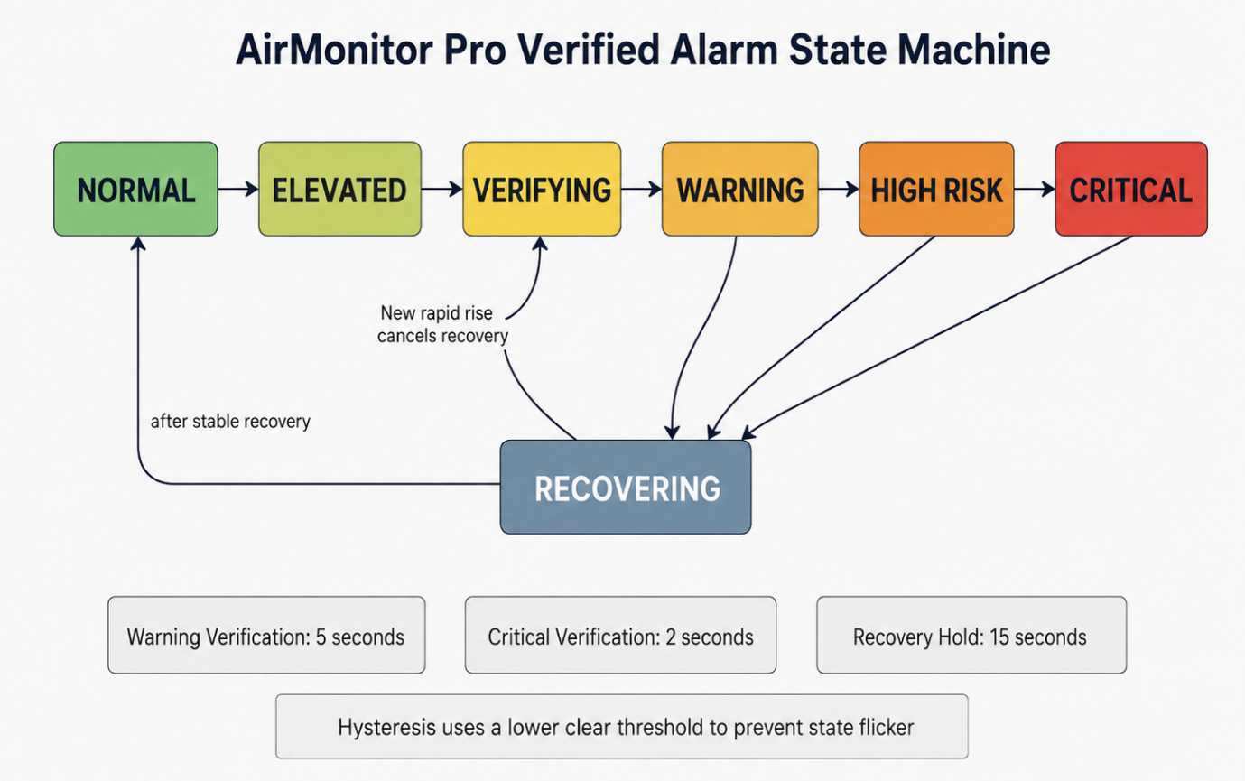The system is also using a danger score from 0 to 100. This provides a combined indication of the current condition instead of displaying only one sensor threshold.

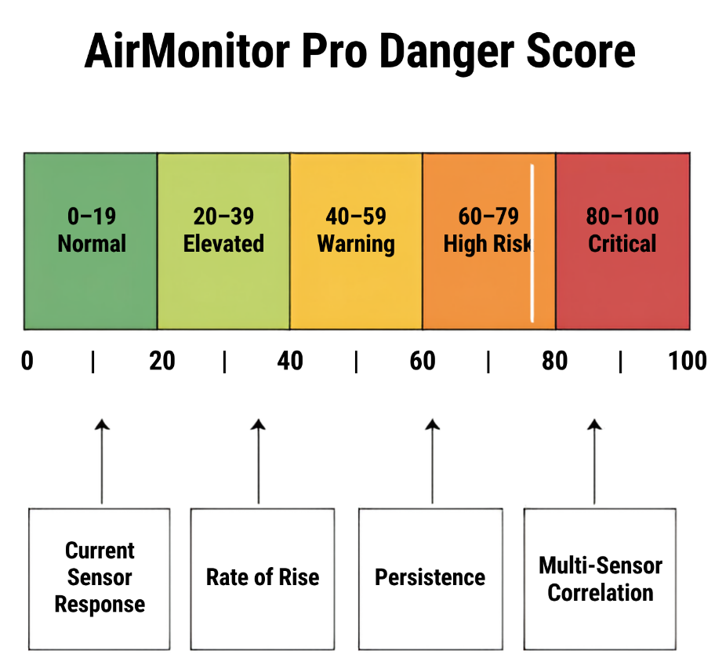

3.6 Multi-Sensor Correlation and Operating Modes
Another change during development was the introduction of multi-sensor correlation. Research shows that information from several sensors can help improve hazard interpretation compared with relying on only one source [15], [16].
For example, if only the MQ-135 increases while the other sensors remain stable, this may be related to cooking fumes or VOCs. If MQ-2, MQ-4, MQ-7 and MQ-135 start rising together, the situation may require more attention.
Figure 10 shows the difference between an isolated sensor event and a correlated event.
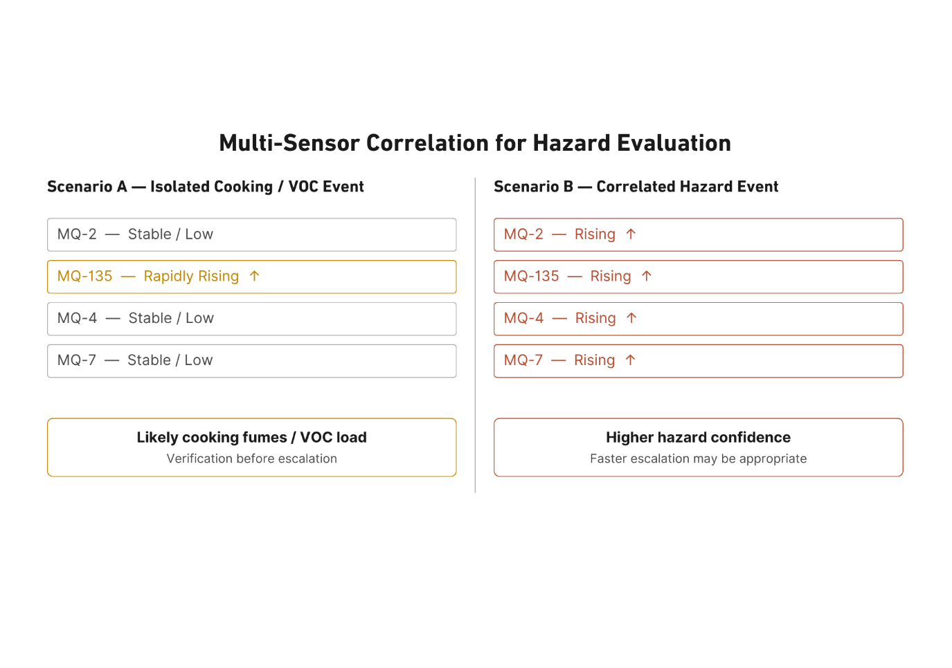
The final system also includes four operating modes:
- OPEN;
- CLOSED;
- CLEANING;
- AUTO.
These modes were introduced because the expected environmental conditions are different depending on whether the business is open, closed or being cleaned. Cooking fumes are more likely during OPEN mode, while unexpected gas activity during CLOSED mode may be more suspicious.
The operating modes are shown in Figure 11.
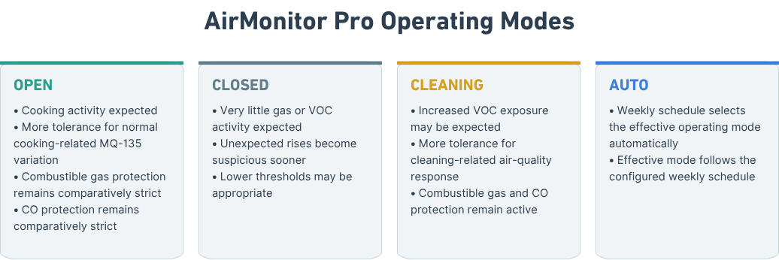
3.7 Testing and Data Collection
Practical testing is the main method used to evaluate the prototype. The project does not involve surveys or human participants. The main data comes from observing the system behaviour during controlled tests.
The testing process includes checking:
- whether all sensors are read correctly;
- whether the dashboard updates correctly;
- whether warning states change as expected;
- whether the buzzer and LED operate;
- whether Wi-Fi communication works;
- whether email alerts are sent;
- whether events are recorded in the logs;
- how sensors respond during exposure;
- how long sensors take to recover;
- whether short spikes are rejected;
- whether sustained conditions create warnings;
- whether several sensors rising together affect the danger state.
The results are mainly evaluated by comparing the expected system behaviour against what actually happened during testing. This follows the approach already identified in the original proposal where functionality, responsiveness, reliability and limitations were the main areas to be evaluated.
Research methods guidance from the module was also used when planning the testing and evaluation process [18].

3.8 Safety, Ethics and Limitations
The project does not involve human participants, so the ethical risk is relatively low. However, testing gas sensors still requires safe and controlled conditions.
The prototype is not used as the only safety device in a real hazardous environment. Testing is carried out only to observe sensor response and software behaviour, not to create dangerous gas concentrations.
UWTSD ethical guidance requires projects to consider safe working, responsible data handling and possible risk to the researcher [19].
Another limitation is that the MQ sensor readings are treated as relative responses rather than certified gas concentrations. This is particularly important for the MQ-7 because the current prototype does not use a formally controlled alternating heater cycle for calibrated CO measurement [12].
A further issue found during development was the slow recovery of the MQ sensors after longer exposure. Because of this, a post-exposure recovery system has been planned as a future improvement.
Figure 12 shows this proposed recovery logic.
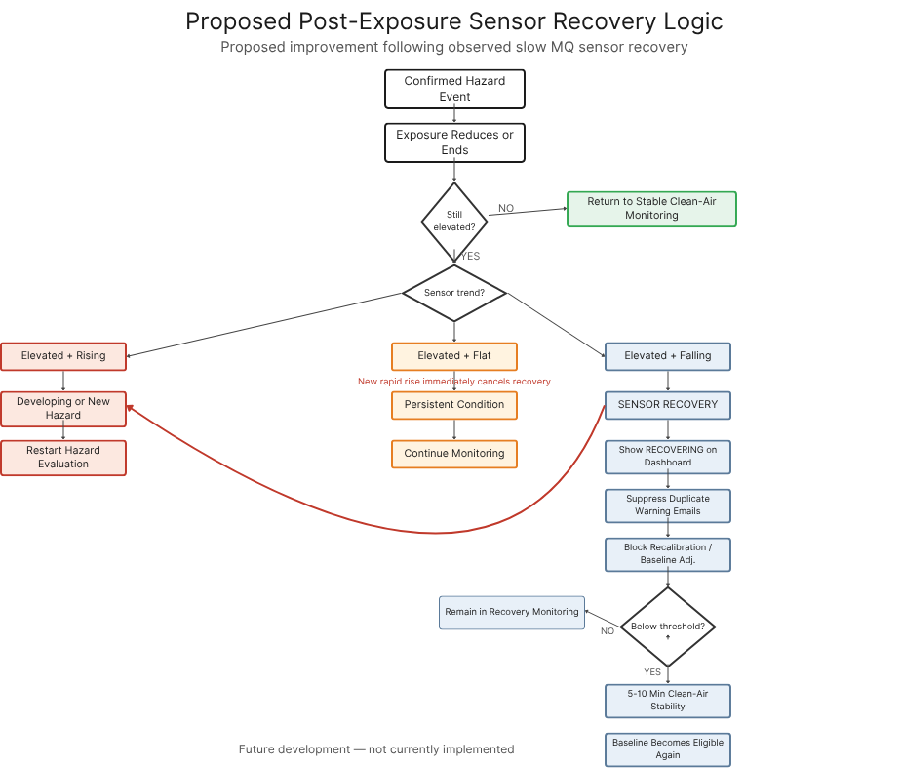
The planned recovery logic will distinguish between:
- elevated and rising readings;
- elevated and stable readings;
- elevated and falling readings.
This should allow the system to recognise when a sensor is recovering rather than treating every elevated reading as a completely new event.
Finally, Figure 13 summarises how the project changed from the original proposal to the final AirMonitor Pro design.
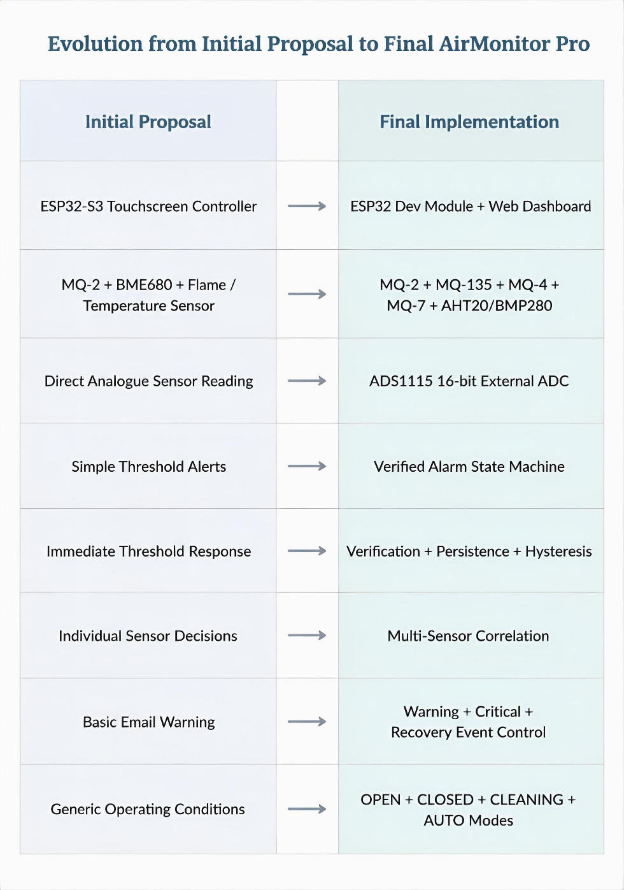
These changes were mainly caused by practical testing, hardware limitations and the behaviour of the sensors. The iterative methodology allowed the project to be modified rather than forcing the final system to follow the original design when a better solution became available.

S4 – Design, Implementation and Testing

4.1 Final System Design
After the changes made during development, the final AirMonitor Pro system was designed around an ESP32 Dev Module connected to several gas and environmental sensors. The main purpose of the final design is to collect different sensor responses, process them locally and provide the user with a clear indication of the current environmental condition.
The system is divided into four main parts:
- sensing;
- data acquisition;
- processing;
- outputs and communication.
The MQ sensors provide the gas and air-quality responses, while the AHT20 and BMP280 provide temperature, humidity and pressure information. The ADS1115 collects the four analogue MQ sensor outputs and sends the readings to the ESP32 through I²C [13].
The ESP32 then processes the values, applies the warning logic and provides the results to the web dashboard, buzzer, alarm LED, email system and logs.
Figure 5 shows the final overall architecture.
This design is more complex than the first architecture proposed at the beginning of the project, but it also gives each sensor a clearer role and allows the warning system to use several pieces of information at the same time.

4.2 Hardware Implementation
The final hardware uses four MQ sensors connected to the ADS1115:
- MQ-2 → A0;
- MQ-135 → A1;
- MQ-4 → A2;
- MQ-7 → A3.
The ADS1115 is using I²C address 0x48 and is connected to the ESP32 via GPIO33 for SDA and GPIO32 for SCL. The ADS1115 was useful because it provides four separate analogue channels while communicating with the ESP32 using only the two I²C connections [13].
The AHT20 and BMP280 environmental board is connected using a separate I²C bus. SDA goes to GPIO25 and SCL to GPIO26. The board is powered from 3.3 V rail on the ESP32.
The buzzer is connected to GPIO27 and the red warning LED to GPIO14.
Figure 6 shows a crude hardware configuration.

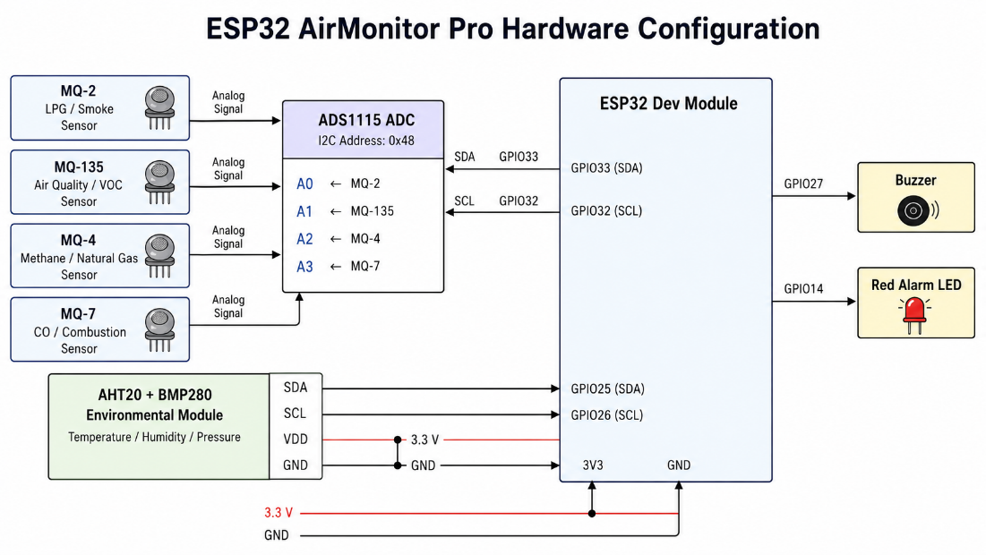
The use of two separate I²C arrangements also made the hardware easier to organise. The ADS1115 handles the analogue gas sensors while the environmental board provides digital temperature, humidity and pressure information.
The final sensor roles are shown in Figure 14.
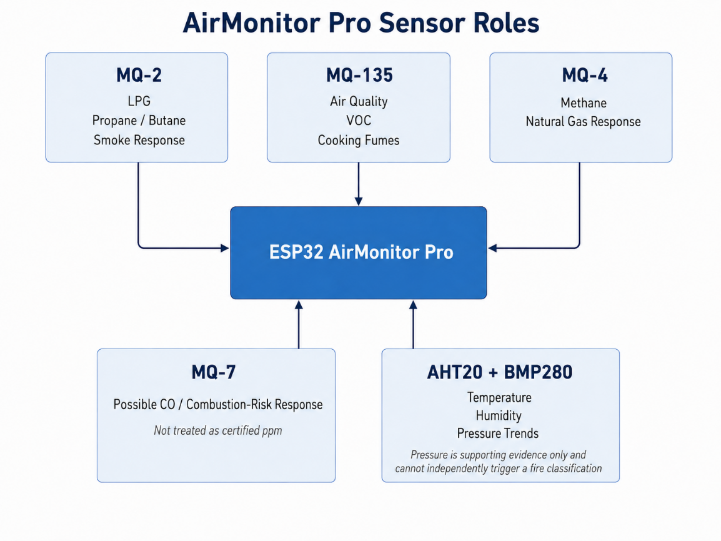
The MQ-2 is mainly used for LPG and smoke response [8]. The MQ-135 provides the wider air-quality and VOC response [10]. The MQ-4 provides a separate methane and natural-gas response [11], while the MQ-7 is used as a possible CO and combustion-risk indicator [12].
The AHT20 provides the main temperature and humidity measurements, while the BMP280 provides pressure and a secondary temperature reading [14].

4.3 Sensor Reading and Response Processing
One of the main parts of the implementation was deciding how the raw sensor readings should be presented and used.
The early versions were closer to displaying a direct sensor response and then comparing it against a fixed threshold. During testing I found that this did not give a realistic representation of how the MQ sensors behaved. Some sensors could rise quickly when exposed but would fall much more slowly afterwards.
Because of this, the final software uses different behaviour when a reading is rising and when it is falling. This is known in the project as asymmetric response smoothing.
Three response profiles were created:
- Fast;
- Balanced;
- Realistic.
The Balanced profile is used as the normal setting.
The purpose of these profiles is mainly to control how the dashboard responds visually. The safety path is kept faster so that smoothing the display does not create an unnecessary delay in detecting a serious rise.
Sensitivity can also be adjusted between 0.01x and 5.00x for Climate, Air Quality, Combustibles and Carbon Monoxide.
This gave me a way to adjust how strongly a response is represented without changing the physical sensor or creating artificial values.

4.4 Web Dashboard
The final system uses a browser-based dashboard as its main interface.
The dashboard contains four main cards:
- Climate Metrics;
- Air Quality;
- Combustibles;
- Carbon Monoxide.
The Climate Metrics card displays temperature, humidity, their current condition and the climate sensitivity setting.
The Air Quality card displays the MQ-135 response and current state.
The Combustibles card keeps the MQ-2 LPG response and the MQ-4 natural-gas response separate. This is important because the natural-gas reading is not calculated from the LPG reading.
The Carbon Monoxide card displays the MQ-7 response separately and does not describe it as a certified ppm value.
The page header also displays the current IP address, shop information and access to the settings.
A system danger bar is shown across the dashboard using a gradual green, yellow, orange and red scale. The bar provides the current state, trend, duration, danger score and operating mode.

The danger-score concept is shown in Figure 9.
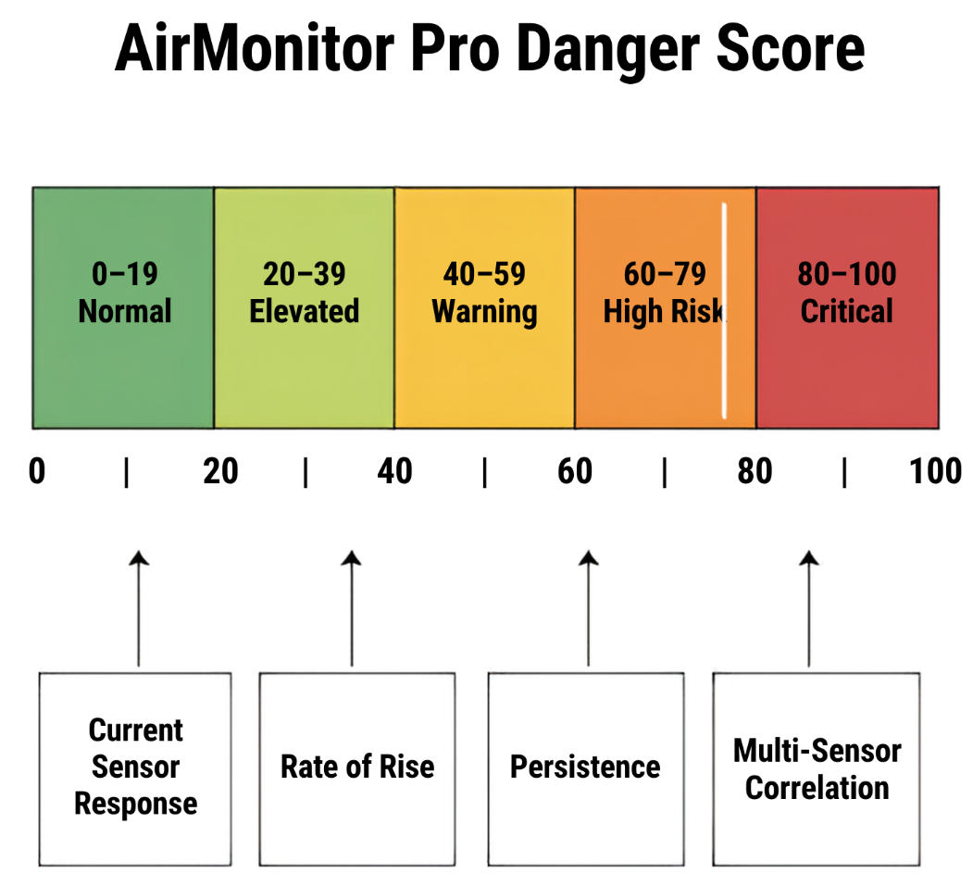
The use of a web interface also made it possible to include more settings than would have been practical on the original small touchscreen.

4.5 Settings and Operating Modes
The settings area was developed so that the prototype could be adjusted without changing and uploading the firmware every time.
The main settings sections are:
- Network;
- Operations;
- Climate;
- Response;
- Alerts;
- Email;
- Logs;
- System.
The Network settings allow Wi-Fi scanning, connection, reconnection and forgetting the current network.
Operations contains the weekly schedule and the four operating modes:
- OPEN;
- CLOSED;
- CLEANING;
- AUTO.
Figure 11 shows the purpose of these operating modes.
OPEN mode allows more tolerance for normal cooking-related air-quality variation. CLOSED mode expects less gas or VOC activity, so unexpected changes can be treated with more suspicion. CLEANING mode allows more VOC activity while keeping combustible gas and CO protection active. AUTO uses the weekly schedule to choose the operating mode.
The Climate section allows the temperature and humidity boundaries to be adjusted.
For temperature, the visual range remains from -10°C to 100°C. The default temperature bands are:
- Very Low: 0°C or below;
- Low: 0–5°C;
- Normal: 5–35°C;
- High: 35–50°C;
- Very High: above 50°C.
Humidity uses:
- Low: below 30%;
- Normal: 30–60%;
- High: 60–80%;
- Very High: above 80%.
The colours are blended rather than changing suddenly at each boundary. This was done so that normal values do not appear visually dangerous simply because they are close to the next band.

4.6 Warning and Danger Engine
The warning engine became one of the most developed parts of the project.
Instead of using only NORMAL and ALARM, the final system uses:
- NORMAL;
- ELEVATED;
- VERIFYING;
- WARNING;
- HIGH RISK;
- CRITICAL;
- RECOVERING.
Figure 8 shows the state process.
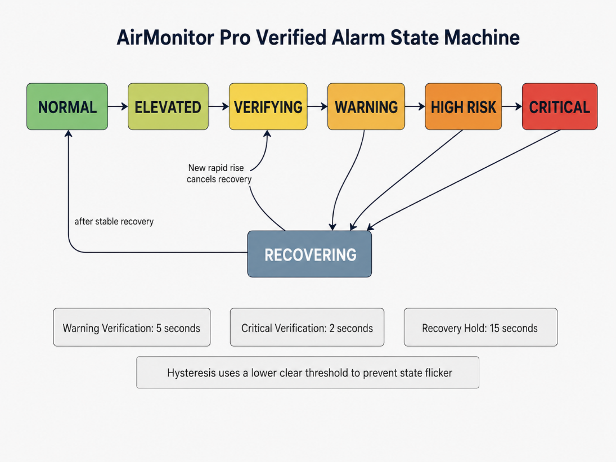

The normal warning verification time is 5 seconds. Critical verification is shorter at 2 seconds because a severe condition should not wait as long before escalation. A recovery hold of 15 seconds is used before the system returns fully to normal.
The warning engine also uses hysteresis. This means that the value required to clear a warning is lower than the value that caused the warning in the first place.
For example, if a warning started around a response of 40%, it should not disappear immediately if the sensor drops to 39.9%. Without hysteresis, small changes could repeatedly move the system between WARNING and NORMAL.
The danger score ranges from 0 to 100:
- 0–19: Normal;
- 20–39: Elevated;
- 40–59: Warning;
- 60–79: High Risk;
- 80–100: Critical.
The score considers the current response, rate of rise, persistence and multi-sensor correlation.

4.7 Multi-Sensor Correlation
Multi-sensor correlation was introduced because one sensor response on its own may not provide enough information to understand what is happening.
For example, the MQ-135 can respond strongly to cooking fumes and cleaning-related VOCs [10]. If the MQ-135 rises while the combustible and CO-related channels remain stable, the system can treat the event differently from one where several sensors are increasing together.
Figure 10 shows these two situations.
A correlated increase across MQ-2, MQ-4, MQ-7 and MQ-135 provides more evidence that the environmental condition is changing significantly.
This does not mean that the system can identify the exact cause of every event. The purpose is to improve the warning decision by using more than one signal.
The danger engine can also use different descriptions depending on the pattern, including conditions such as:
- normal cooking variation;
- cooking fumes / extraction load;
- possible LPG / combustible gas;
- possible natural-gas leak;
- possible combustion / CO risk;
- cleaning chemical / VOC load;
- high kitchen air risk;
- critical kitchen atmosphere.
These descriptions are intended to give the user more useful information than a general ALARM message.

4.8 Alerts, Email and Logging
The final system provides local and remote warning methods.
Local warnings are provided through the web dashboard, buzzer and red LED. Remote notification is provided through email.
The email system uses Gmail SMTP. The stored App Password is not sent back to the browser when settings are viewed. The dashboard only indicates whether a password has already been saved.
One problem considered during development was repeated email warnings from the same physical event. If every sensor sent its own warning message, one incident could create several emails within a short period.
The final approach therefore treats the warning as a system event rather than four completely separate sensor alarms.
A normal event can generate:
- one Warning email;
- one Critical email if the condition becomes more severe;
- one Recovery email when the condition has cleared.
A Critical escalation is still allowed even if a Warning email has already been sent.
The system also records recent events using local storage. Event information can be viewed through the dashboard and downloaded as CSV data. NTP is used to provide timestamps when network time is available.
These logs are important for testing because they provide evidence of when state changes occurred rather than relying only on what was observed on screen.

4.9 Testing the Final System
The final prototype was tested by checking each main function separately before observing how the complete system behaved. The functional testing included sensor operation, dashboard updates, warning-state transitions, local alarms, Wi-Fi communication, email notifications, event logging and sensor recovery.
Sensor behaviour was also observed during exposure and recovery. The testing showed that the MQ sensors could increase quickly when exposed but could take considerably longer to return towards the original level. This was especially noticeable after stronger or longer exposure. Testing also showed that a brief increase from one sensor did not always need to become a full warning, particularly when the increase appeared mainly on the MQ-135 channel.
The results of the main functional tests are summarised below.
Test | Expected Behaviour | Actual Behaviour | Result
Sensor startup | All connected sensors should initialise and provide readings to the ESP32. | The MQ-2, MQ-135, MQ-4 and MQ-7 channels were detected through the ADS1115. Temperature, humidity and pressure readings were also received from the AHT20/BMP280 environmental module. Sensor information became available to the firmware after startup. | Pass
Dashboard update | Current sensor and environmental information should be displayed through the browser interface. | The dashboard loaded successfully through the ESP32 network connection and displayed the four main monitoring areas: Climate Metrics, Air Quality, Combustibles and Carbon Monoxide. Changes in sensor response were reflected on the dashboard during testing. | Pass
Brief MQ-135 increase | A short isolated increase should enter verification but should not immediately produce a full system alarm. | During short air-quality disturbances, the MQ-135 response increased while the other gas channels remained comparatively stable. The verification stage prevented the short isolated response from immediately being treated as a confirmed high-risk event. | Pass
Sustained warning condition | A condition that remains above the warning criteria should progress through verification and reach a warning state. | When an elevated sensor response remained present rather than immediately falling, the system progressed through the verification process and entered the appropriate warning state. The dashboard state and danger indication changed accordingly. | Pass
Critical escalation | A severe condition should progress through the shorter critical verification path. | During functional testing of the warning engine, conditions meeting the Critical criteria used the 2-second critical verification period rather than the normal 5-second warning verification period. This test verified the system logic without deliberately creating hazardous gas concentrations. | Pass
Multi-sensor response | Several sensors increasing together should produce a stronger system response than one isolated sensor change. | When several gas-response channels changed together, the danger engine treated the condition as more significant than an isolated MQ-135 response. Multi-sensor correlation therefore increased the overall danger assessment. | Pass
Buzzer and alarm LED | The local warning outputs should activate when the system reaches the configured warning condition. | The buzzer on GPIO27 and the red warning LED on GPIO14 activated when the warning logic reached the configured alarm condition and returned to their normal condition after the warning cleared. | Pass
Operating modes | OPEN, CLOSED, CLEANING and AUTO modes should be selectable and should affect the operating context of the warning system. | The operating modes could be changed through the settings interface. The selected mode was displayed by the system and used as part of the warning context. AUTO mode used the configured operating schedule. | Pass
Wi-Fi connection | The ESP32 should connect to the configured Wi-Fi network and make the dashboard available to another device. | The ESP32 connected successfully to Wi-Fi and the web dashboard could be accessed from another device on the same network using the ESP32 IP address. | Pass
Email warning | A confirmed warning event should generate an email notification when email settings and network access are available. | Email notification was successfully generated during warning testing. The system treated the condition as one overall event rather than sending separate warning emails from each individual sensor. | Pass
Event logging | Warning and state-change events should be stored with timestamp information. | System events were recorded in local storage and could be viewed through the dashboard. Logged information could also be downloaded as CSV data. | Pass
Sensor recovery | Sensor values should decrease after the exposure source is removed. | After stronger exposure, the MQ sensor responses decreased more slowly than they had increased. Some readings remained elevated for a noticeable period after the source was removed. This confirmed that post-exposure recovery requires additional handling and supported the use of the RECOVERING state. | Partially achieved
Extended recovery re-trigger | A new rapid increase during recovery should cancel recovery and return the system to hazard evaluation. | This behaviour forms part of the proposed extended recovery logic and was not fully validated during final prototype testing. Further implementation and long-duration testing are required. | Future development
The functional tests confirmed that the main hardware and software components operated as intended. Sensor information was available to the ESP32, the browser dashboard updated correctly, warning states were generated, local alarm outputs operated, Wi-Fi communication was available, email notifications could be generated and events were recorded.
The most significant behaviour observed during testing was the difference between sensor response and recovery. The MQ sensors could react relatively quickly during exposure but could remain elevated for a longer period after the source had been removed. This behaviour supported the use of verification, hysteresis and the RECOVERING state and identified post-exposure recovery as the main area requiring further development.
The results also supported the use of multi-sensor correlation. An isolated air-quality response, particularly from the MQ-135, did not necessarily indicate the same level of risk as several gas-response channels changing at the same time. The final warning engine therefore considers sensor response, rate of rise, persistence and multi-sensor correlation rather than relying only on a single fixed threshold.

4.10 Post-Exposure Recovery
The main behaviour still identified for further improvement is the period after a sensor has been strongly exposed.
The current system already includes a RECOVERING state and recovery hold, but longer real sensor recovery showed that a more detailed process would be useful.
The proposed improvement would separate three situations:
- elevated and rising;
- elevated and stable;
- elevated and falling.
An elevated but consistently falling reading is different from a new developing hazard. In this case the dashboard could show SENSOR RECOVERY while continuing to display the real sensor value.
During this period the system should also prevent automatic baseline adjustment and avoid sending duplicate warning emails.
A new rapid rise during recovery would immediately cancel the recovery condition and return the event to hazard evaluation.
Figure 12 shows the proposed extended recovery process.
This figure represents planned development rather than a feature being presented as fully completed.
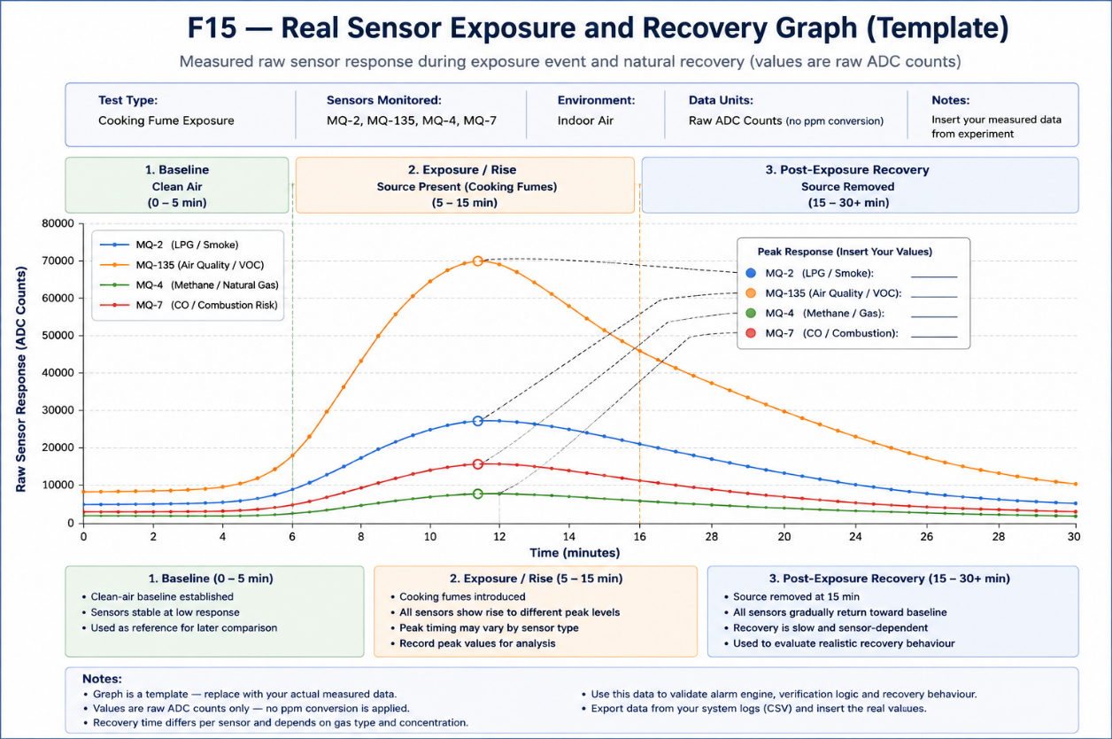
The final implementation therefore meets the main purpose of monitoring and warning, while the recovery behaviour remains an area where the system can be improved further.

S5 – Evaluation

5.1 Evaluation Against the Project Aim
The main aim of this project was to design, develop and evaluate a low-cost ESP32-based environmental monitoring and hazard-warning prototype for indoor commercial environments. Looking at the final AirMonitor Pro system, I consider that the main aim has been achieved, although there are still limitations that need to be considered.
The system is able to read several gas and environmental sensors, process the information locally and display the results through a web dashboard. It also provides local warnings through the buzzer and red LED, and remote warnings through email.
Compared with the original proposal, the final system is more advanced because it does not rely only on simple threshold detection. The final version also considers persistence, rate of rise, hysteresis, verification time and multi-sensor correlation.
At the same time, the system remains an academic prototype. The MQ sensors are low-cost semiconductor sensors and are not being used as certified gas analysers. This means that the success of the project should be judged by whether the prototype can detect and respond to changes consistently rather than whether it can provide laboratory-quality gas concentration measurements [8]–[12].

5.2 Evaluation Against the Project Objectives
The seven objectives defined in Section 1 can now be compared with the final system.
Objective | Evaluation | Status
Build a multi-sensor ESP32 monitoring system | MQ-2, MQ-135, MQ-4, MQ-7, AHT20 and BMP280 are integrated with the ESP32 and ADS1115 | Achieved
Develop a web-based monitoring interface | Live sensor information, states, sensitivity and system information are available through the dashboard | Achieved
Add configurable sensitivity and operating modes | Sensitivity controls and OPEN, CLOSED, CLEANING and AUTO modes are implemented | Achieved
Develop verified hazard detection | Verification, persistence, hysteresis, rate of rise and multiple warning states are included | Achieved
Implement multi-sensor correlation and danger score | Several sensor responses can contribute to the overall danger state | Achieved
Provide local and remote warnings | Buzzer, LED, email alerts and event logging are included | Achieved
Test functionality, responsiveness, reliability and recovery | Functional and practical testing has been carried out, with further recovery testing still useful | Partially / Ongoing
The final objective remains partly ongoing because sensor recovery is an area where additional longer-term testing would improve the evaluation. The system already includes a RECOVERING state, but practical observations showed that some MQ sensors may remain elevated for several minutes after stronger exposure.

5.3 Hardware Evaluation
One positive part of the final hardware design is that each MQ sensor has its own analogue channel. The ADS1115 supports four single-ended channels [13], which allowed the four MQ sensors to remain independent.
This is better than trying to create one gas reading from another sensor. For example, the natural-gas response is taken directly from the MQ-4 rather than being calculated from the MQ-2.
The separate AHT20 and BMP280 environmental module also provides additional information without using the same analogue channels as the MQ sensors.
Another advantage is that the hardware is based on relatively inexpensive and easy to replace components. If one MQ sensor fails, it can be replaced without redesigning the complete project.
The main hardware limitation is the MQ sensor technology itself. These sensors can respond to several gases and can also be influenced by environmental conditions [9]. They also require warm-up and can have slow recovery behaviour [10], [11].
Because of this, the hardware is suitable for an experimental prototype but should not be described as equivalent to a certified commercial detection system.

5.4 Dashboard and Usability Evaluation
Moving from the original touchscreen design to a browser-based interface was one of the larger project changes.
In the final system this became an advantage because the dashboard can show more information than would comfortably fit on the small touchscreen. Settings can also be changed from a phone, tablet or computer connected to the network.
The four-card layout separates the information into Climate Metrics, Air Quality, Combustibles and Carbon Monoxide. Keeping the sensors grouped by their purpose makes the dashboard easier to understand.
Another useful design choice is keeping LPG and natural gas separate. This avoids suggesting that they are the same measurement.
The use of blended colours on the climate and danger displays also improves the interface. A normal temperature or humidity value should not suddenly turn bright red because it is close to a boundary. Gradual colour changes provide a clearer indication of whether conditions are moving towards a warning range.
A limitation of the web-based approach is that the main dashboard depends on another device such as a phone or computer if the user wants to see detailed information. The buzzer and LED still provide local warning output, but the original touchscreen would have provided more local information directly on the unit.

5.5 Warning Logic and False-Alert Reduction
The warning logic is one of the strongest improvements compared with the original proposal.
A basic threshold system would be easier to program, but it could react unnecessarily to short sensor spikes. In the intended kitchen environment this could be a problem because cooking fumes or cleaning products can influence sensors such as the MQ-135 [10].
The verification stage provides a delay before a normal warning is confirmed. The 5-second warning verification gives the system time to check whether the condition continues, while a more severe condition can use the shorter 2-second critical verification.
Hysteresis also improves stability because the system does not immediately clear a warning as soon as the value drops slightly below the starting threshold.
The use of several system states is more useful than a basic NORMAL/ALARM approach because it gives the user an indication of how the condition is developing.
The state-machine design is shown in Figure 8.
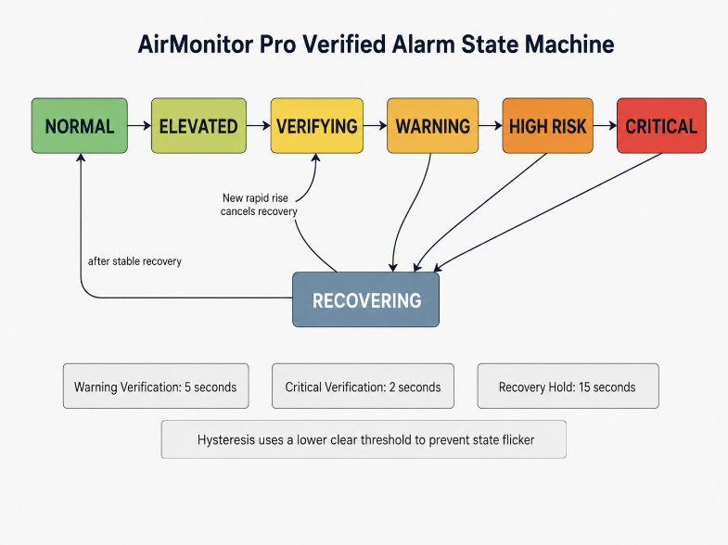
One limitation is that the warning logic still depends on settings that have been selected for this prototype. Longer-term testing would be required before deciding whether the same values are suitable for every indoor environment.

5.6 Multi-Sensor Correlation Evaluation
Multi-sensor correlation was introduced because an isolated response does not always provide enough information.
This approach is supported by research showing that information from several sensors can improve hazard interpretation [15], [16].
In AirMonitor Pro, an isolated MQ-135 increase can be treated differently from several sensor channels rising together.
Figure 10 shows the intended difference.
This does not make the prototype able to identify the exact gas involved. Instead, it improves the amount of information available to the warning engine.
The main strength is therefore not exact gas identification but the ability to recognise whether an event appears isolated or is affecting several sensor channels at the same time.

5.7 Alerts and Logging Evaluation
The combination of local and remote alerts meets an important part of the original proposal.
The buzzer and red LED provide immediate local warning, while email provides remote notification. The event log also allows previous conditions to be reviewed.
Another improvement was controlling repeated email messages. Instead of every sensor generating its own separate warning for the same event, the system treats the situation as one overall physical event.
This reduces the chance of receiving several warning emails for the same condition.
The system can still send a Critical message if an existing Warning becomes more serious, which means that reducing repeated messages does not prevent important escalation information.
A limitation is that email depends on network availability. If Wi-Fi or the external email service is unavailable, the local warning functions remain available but the remote notification may fail.

5.8 Sensor Recovery Evaluation
The most important limitation identified during practical development is post-exposure sensor recovery.
The MQ sensors can rise relatively quickly but may take much longer to return towards their previous clean-air level. This behaviour is particularly noticeable after stronger or longer exposure.
The current system already includes a RECOVERING condition, but the observations suggest that this part can be improved further.
The proposed next version would distinguish:
- elevated and rising;
- elevated and stable;
- elevated and falling.
This would make it easier to recognise whether an elevated reading represents a developing condition or a sensor that is gradually returning towards normal.
Figure 12 shows the planned extension.
The planned logic would also stop automatic recalibration during recovery and require a stable clean-air period before a new baseline becomes eligible.
This is not presented as a completed feature. It is one of the main recommendations resulting directly from the evaluation.

5.9 Overall Evaluation
Overall, AirMonitor Pro meets most of the objectives established for the project.
The strongest parts of the final system are the multi-sensor hardware design, web dashboard, modular software, verified warning states, operating modes, multi-sensor correlation and combined local and remote alerts.
The main limitations come from the low-cost sensor technology and from the amount of long-term calibration and testing that can be completed within the project period.
For this reason, the prototype should be considered successful as a development and research project rather than as a finished commercial safety product.
The project also demonstrated that the original simple threshold-based design was not sufficient for the sensor behaviour observed during development. The final system became more complex, but the additional processing provides a more realistic way of dealing with temporary events, changing conditions and slow sensor recovery.

S6 – Conclusions and Recommendations

6.1 Conclusion
The purpose of this project was to design, develop and evaluate a low-cost ESP32-based environmental monitoring and hazard-warning prototype for an indoor commercial environment. Looking at the final AirMonitor Pro system, I consider that the main aim of the project has been achieved.
The final prototype is able to monitor several environmental conditions at the same time using MQ-2, MQ-135, MQ-4 and MQ-7 sensors together with an AHT20 and BMP280 module. The MQ sensors are connected through the ADS1115, which keeps the analogue channels separate and allows the ESP32 to process each response individually [13].
The project changed considerably from the original proposal. The first idea was based around an ESP32-S3 touchscreen, a smaller number of sensors and a simple threshold-based warning system. During development it became clear that this approach was too limited for the behaviour of the sensors and the amount of information that needed to be displayed.
The final version therefore moved to a browser-based dashboard and a more developed warning system. Instead of reacting only to one threshold, AirMonitor Pro also considers persistence, rate of rise, hysteresis, verification time and multi-sensor correlation.
One of the most important findings from the project was that low-cost MQ sensors do not behave like simple digital detectors. Their outputs can rise quickly during exposure but can also remain elevated for some time after the source has been removed. Their responses can also be affected by more than one gas and by environmental conditions [9]–[12].
Because of this, the project does not treat the MQ readings as certified gas concentrations. The readings are used as relative responses and are interpreted together with other sensor information.
The warning engine was developed to reflect this behaviour. The system now uses several states including NORMAL, ELEVATED, VERIFYING, WARNING, HIGH RISK, CRITICAL and RECOVERING. This provides more information than a basic normal/alarm system and also helps reduce unnecessary warnings caused by short spikes.
The project also achieved the original requirement of providing both local and remote warnings. Local warnings are available through the web dashboard, buzzer and red LED, while email notifications and event logs provide additional remote and historical information.
Overall, AirMonitor Pro should be considered a successful academic prototype. It demonstrates that a low-cost ESP32 platform can be used to combine several sensors, network communication and custom warning logic within one monitoring system. At the same time, it is not intended to replace certified commercial safety equipment.

6.2 Main Recommendations
The first recommendation is to continue developing the post-exposure recovery system. Practical testing showed that this is one of the main areas where the current warning process can be improved.
The next version should distinguish between:
- elevated and rising readings;
- elevated and stable readings;
- elevated and falling readings.
A reading that remains elevated but is consistently falling should be treated as sensor recovery rather than automatically as a new hazard. During this period the system should continue displaying the real reading but avoid repeated warnings from the same event.
The planned recovery logic should also prevent automatic baseline adjustment while a sensor is still recovering. A new clean-air baseline should only become available after the sensors have returned below the recovery limits and remained stable for a suitable period.
A second recommendation is to carry out longer-term testing. The current project demonstrates the operation of the system, but testing over several weeks or months would provide more information about sensor drift, environmental influence and differences between repeated exposure events.
A third recommendation is to improve calibration. The MQ sensors are useful for detecting relative changes, but their limitations mean that they should not currently be treated as accurate concentration instruments [8]–[12]. Future testing could compare the prototype against calibrated reference equipment.
The MQ-7 is a particular area for improvement. The current prototype uses it as a possible CO / combustion-risk response. A future version could investigate a properly controlled heater cycle and suitable calibration procedure before attempting to display carbon-monoxide values as ppm [12].
Another recommendation is to investigate environmental compensation. Since temperature and humidity can influence metal-oxide gas sensors [9], future software could use the AHT20 measurements to help compensate for these effects.

6.3 Future Development
There are several ways the project could be expanded beyond the current prototype.
One possible development is cloud-based storage. The current system keeps logs locally, but sending selected data to a cloud service would allow long-term trends to be reviewed remotely.
Another improvement would be support for several AirMonitor Pro units in different areas of the same building. Each unit could report its own readings while a central dashboard provides an overview of the complete site.
Mobile notifications could also be considered in addition to email. This could provide faster notification while still keeping email for reports and recorded events.
The physical hardware could also be developed further. The current prototype is suitable for development and testing, but a future version could use a purpose-designed PCB and enclosure. This would reduce loose wiring and make the system more suitable for permanent installation.
Power backup is another possible improvement. A small UPS or battery-backed supply could allow the monitoring system to continue operating during short power interruptions.
Finally, if enough real labelled sensor data was collected over a long period, a future version could investigate more advanced classification methods. This would only be useful after reliable test data had been gathered, because any more complex decision method would still depend on the quality of the sensor information.
The main recommendation is therefore to continue improving the project through real testing rather than adding unnecessary complexity. The most useful next step is to improve recovery handling, collect more long-term data and compare the system against known reference measurements before making any stronger claims about accuracy.

S7 – Reflection

7.1 Reflection on the Development Process
Looking back at the project, the biggest change was how different the final AirMonitor Pro system became compared with the original proposal. At the beginning I expected to build the project around an ESP32-S3 touchscreen, a smaller number of sensors and a simple threshold-based warning system. During practical development it became clear that this approach was too limited and would not give enough flexibility for the type of monitoring I wanted.
One of the first problems was the touchscreen. It introduced extra issues with libraries, memory and compatibility. A lot of time was spent trying to make the display work reliably. Eventually I decided that continuing with it was taking too much attention away from the main purpose of the project.
Moving to an ESP32 Dev Module with a browser-based dashboard became a better solution. It allowed more information to be displayed, more settings to be added and the system could be accessed from another device on the same network.
The iterative development method was useful because it allowed these changes to be made without treating the original proposal as something that could not be changed.

7.2 What I Learned from the Sensors
The sensor behaviour was one of the most important parts of the project.
Before testing, I expected the MQ sensors to react more like simple detectors where a reading rises during exposure and then returns fairly quickly to its normal value. In practice this did not always happen. Some sensors increased quickly but recovered much more slowly, especially after a stronger or longer exposure.
The MQ-135 was particularly useful in showing this behaviour because it could react strongly to cooking fumes and VOCs. This showed me that using only one fixed threshold could create unnecessary warnings.
Because of this, the system developed from simple threshold detection to using verification time, hysteresis, persistence, rate of rise and multi-sensor correlation.
I also learned that it is important not to claim more accuracy than the sensor can provide. For example, the MQ-7 is used as a possible CO and combustion-risk response, but the prototype does not use the full controlled heater cycle needed for a calibrated CO measurement [12]. For this reason I did not present the result as certified ppm.

7.3 Software Development Reflection
The software also became more complex than I originally expected.
At the beginning the program was mainly reading sensors and showing values. As the dashboard, settings, email alerts, logging and warning logic were added, the code became much more difficult to manage.
Separating the project into a main program, sensor module, alarm module, web interface and help module made it easier to work with. This also made debugging easier because a problem could be traced to one part of the system instead of searching through a very large single program.
Another useful lesson was separating the browser interface from the main C++ firmware. The dashboard uses HTML, CSS and JavaScript, while the ESP32 program uses C/C++. Keeping these parts separate made the project easier to understand and modify.

7.4 Project Planning and Changes
The original development plan and Gantt chart provided a useful starting point, but the actual project did not follow them exactly.
Some tasks took longer than expected, especially display development, hardware compatibility and sensor testing. Other parts, such as the web dashboard and multi-sensor warning logic, became more important than they were in the original proposal.
Figure 13 shows the main differences between the original proposal and the final AirMonitor Pro design.
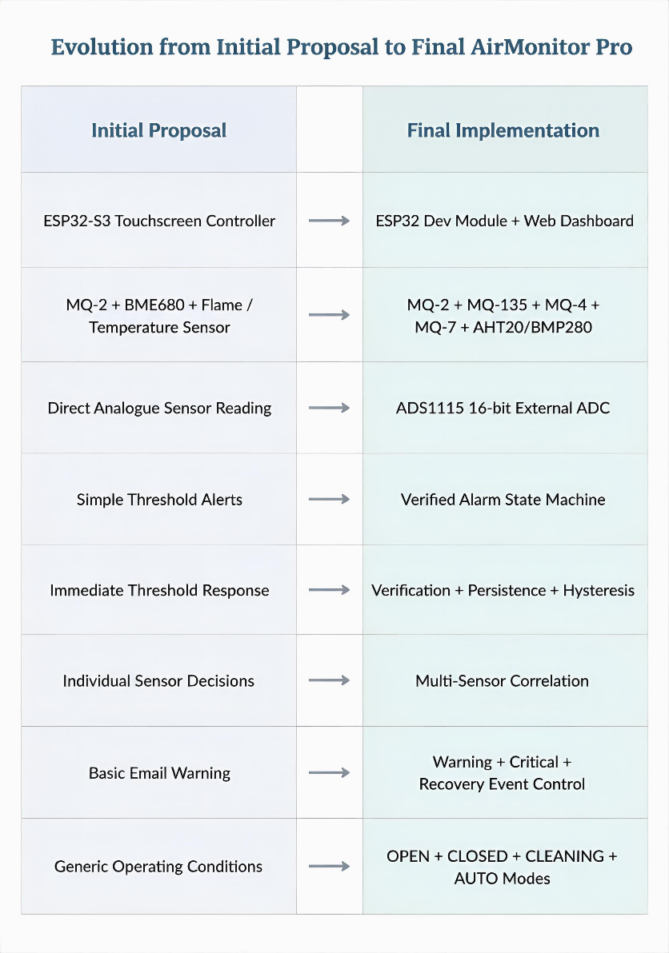
The main lesson from this was that a development plan needs to be flexible. The final system improved because changes were made when practical testing showed that the original approach was no longer the best solution.

7.5 What I Would Improve
If I started the project again, I would test the individual MQ sensors for a longer period before developing the full interface. This would have helped me understand their response and recovery behaviour earlier.
I would also separate the software into modules from the beginning instead of waiting until the program became difficult to manage.
Another improvement would be collecting structured test data earlier in the project. More organised logs from each stage would make it easier to compare versions of the software and to produce stronger graphs for the final evaluation.
The main technical area I would continue improving is post-exposure recovery. The current system already has a RECOVERING state, but the next version should distinguish more clearly between an elevated reading that is rising, one that is stable and one that is falling.
Overall, the project improved my practical understanding of ESP32 programming, I²C communication, analogue sensor reading, web interfaces, Wi-Fi communication, warning logic, testing and debugging. The main lesson I take from the project is that the final design should be based on what the hardware actually does during testing rather than only on what was expected at the proposal stage.

References:
[1] Google, “Nest Protect 2nd generation technical specifications,” Google Home and Nest Help. [Online]. Available: https://support.google.com/googlehome/answer/9229922. [Accessed: Jul. 2026].
[2] Airthings, “Airthings View Plus – Smart radon and air quality monitor,” Airthings. [Online]. Available: https://www.airthings.com/view-plus. [Accessed: Jul. 2026].
[3] Kidde, “Smart Combo Smoke + CO Alarm, Hardwired with AA Backup Battery,” Kidde. [Online]. Available: https://www.kidde.com/products/smart/smart-combo-smoke-co-alarm-hardwired-aa-backup-battery. [Accessed: Jul. 2026].
[4] X-Sense, “Smart Smoke and Carbon Monoxide Alarms,” X-Sense. [Online]. Available: https://www.x-sense.com/collections/smart-smoke-and-co-alarm. [Accessed: Jul. 2026].
[5] Espressif Systems, “ESP-IDF Programming Guide – ESP32,” Espressif Systems Documentation. [Online]. Available: https://docs.espressif.com/projects/esp-idf/en/latest/esp32/. [Accessed: Jul. 2026].
[6] Arduino, “Arduino IDE 2 Documentation,” Arduino Documentation. [Online]. Available: https://docs.arduino.cc/software/ide/. [Accessed: Jul. 2026].
[7] World Health Organization, WHO Guidelines for Indoor Air Quality: Selected Pollutants. Copenhagen, Denmark: WHO Regional Office for Europe, 2010. [Online]. Available: https://iris.who.int/handle/10665/260127. [Accessed: Jul. 2026].
[8] Zhengzhou Winsen Electronics Technology Co., Ltd., MQ-2 Semiconductor Sensor for Smoke & Flammable Gas, Ver. 1.4, technical manual. [Online]. Available: https://www.winsen-sensor.com/d/files/PDF/Semiconductor%20Gas%20Sensor/MQ-2%20%28Ver1.4%29%20-%20Manual.pdf. [Accessed: Jul. 2026].
[9] H. Mahdavi, S. Rahbarpour, S. M. Hosseini-Golgoo, and H. Jamaati, “Reducing the destructive effect of ambient humidity variations on gas detection capability of a temperature modulated gas sensor by calcium chloride,” Sensors and Actuators B: Chemical, vol. 331, Art. no. 129091, Mar. 2021, doi: 10.1016/j.snb.2020.129091. [Online]. Available: https://doi.org/10.1016/j.snb.2020.129091.
[10] Zhengzhou Winsen Electronics Technology Co., Ltd., MQ135 Semiconductor Sensor for Air Quality, Ver. 1.4, technical manual. [Online]. Available: https://www.winsen-sensor.com/d/files/PDF/Semiconductor%20Gas%20Sensor/MQ135%20%28Ver1.4%29%20-%20Manual.pdf. [Accessed: Jul. 2026].
[11] Zhengzhou Winsen Electronics Technology Co., Ltd., MQ-4 Semiconductor Sensor for Flammable Gas, Ver. 1.6, Jul. 2021. [Online]. Available: https://www.winsen-sensor.com/d/files/mq-4-%28ver1_6%29---manual.pdf. [Accessed: Jul. 2026].
[12] Zhengzhou Winsen Electronics Technology Co., Ltd., “MQ-7B Semiconductor Sensor for Carbon Monoxide,” product documentation. [Online]. Available: https://www.winsen-sensor.com/product/mq-7b.html. [Accessed: Jul. 2026].
[13] Texas Instruments, ADS111x Ultra-Small, Low-Power, I²C-Compatible, 860-SPS, 16-Bit ADCs with Internal Reference, Oscillator, and Programmable Comparator, Datasheet SBAS444E, rev. E, Dec. 2024. [Online]. Available: https://www.ti.com/lit/ds/symlink/ads1115.pdf. [Accessed: Jul. 2026].
[14] Bosch Sensortec GmbH, BMP280 Digital Pressure Sensor Data Sheet, document BST-BMP280-DS001. [Online]. Available: https://www.bosch-sensortec.com/media/boschsensortec/downloads/datasheets/bst-bmp280-ds001.pdf. [Accessed: Jul. 2026].
[15] L. Wu, L. Chen, and X. Hao, “Multi-Sensor Data Fusion Algorithm for Indoor Fire Early Warning Based on BP Neural Network,” Information, vol. 12, no. 2, Art. no. 59, Jan. 2021, doi: 10.3390/info12020059. [Online]. Available: https://doi.org/10.3390/info12020059.
[16] J. Fonollosa, A. Solórzano, and S. Marco, “Chemical Sensor Systems and Associated Algorithms for Fire Detection: A Review,” Sensors, vol. 18, no. 2, Art. no. 553, Feb. 2018, doi: 10.3390/s18020553. [Online]. Available: https://doi.org/10.3390/s18020553
[17] University of Wales Trinity Saint David, Development Methodology, ACCA6020 Independent Project course materials, 2026.
[18] University of Wales Trinity Saint David, Research Methods, ACCA6020 Independent Project course materials, 2026.
[19] University of Wales Trinity Saint David, Ethical Process and UWTSD Code of Practice, ACCA6020 Independent Project course materials, 2026.
[20] G. Munteanu, “ESP32-Based Gas, Air Quality and Fire Detection System,” ACCA6020 Independent Project proposal, University of Wales Trinity Saint David, 2026.

