How to acknowledge your use of AI
I confirm that I have not used any AI tools in the research and creation of this assignment. I confirm that I have not presented any AI generated materials as my own work. I confirm I have copies of my drafts, notes, and other resources I used, which I may be asked to provide in evidence.

How does music make you feel?
When people listen to music, do they feel happiness, sadness, or another emotion? If so, why do they feel that way?
Why does music change their mood? There may be many reasons, but here I will outline two major ones. The first is that the brain produces neurochemicals when music is heard. For example, when people listen to calming music at the same time as practicing meditation, they can feel relaxed and calm because the feel-good hormone serotonin is released. When serotonin is at “normal” levels, people feel happier and calmer. When people want to be motivated to exercise, they listen to energetic music because the happy hormone dopamine is produced. They may also get through a long car journey with a similar technique. It gives people pleasure and the motivation to do something. Fast food restaurants play upbeat and energetic music to encourage customers to eat faster and staff members working there to provide quick service because the brain produces more dopamine when listening to upbeat music, this helps make people energetic too. When people break up from their partner, sad music helps them to bring tears to their eyes and let the relationship go because the brain produces stress-releasing hormones endorphins.
The second reason is that music reminds people’s memories. When people listen to music from childhood, it will help them recall childhood memories. Releasing stress hormone endorphins may decrease anxiety and depression.
When people who are suffering from Alzheimer’s and have difficulty speaking, listen to music from childhood, they are sometimes able to sing. They sometimes remember the lyrics and the tune. Music therapy is increasingly popular as this seemingly mysterious ability for music to unlock previously unconnected parts of the brain becomes more understood. People who have memory loss or have Alzheimer’s, use music to create joy for themselves and retrain memory. They also use music as a tool to reconnect with their family and their friends.
Music makes people have different feelings such as happiness, relaxation and sadness because their brain produces different types of hormones like serotonin, dopamine and endorphin. Music also improves the quality of people’s life who suffer from memory loss and Alzheimer’s,

References of “How does music make you feel ?”
CLRN team. (2025,7,2) What does sad music do to your brain? CLRN California learning resource network. https://www.clrn.org/what-does-sad-music-do-to-your-brain/#google_vignette
Dopamine. (2022,3,23). Cleveland clinic. https://my.clevelandclinic.org/health/articles/22581-dopamine
Music and music therapy for people living with dementia. (2025,7)
Dementia UK.https://www.dementiauk.org/information-and-support/living-with-dementia/music-and-dementia/
Serotonin. (2022,3,18). Cleveland clinic. https://my.clevelandclinic.org/health/articles/22572-serotonin

Reference of “Discuss how our understanding of melancholia and approaches to treatment have changed over time.”
Scull. A. (2022). Desperate Remedies: Psychiatry and the Mysteries of Mental Illness. Penguin Random House UK
Scull, A. (2020) Madness in Civilization: A cultural history of insanity from the Bible to Freud, from the madhouse to modern medicine. Thames and Hudson.

Discuss how our understanding of melancholia and approaches to treatment have changed over time.
Introduction
Nowadays we have therapy and medication for mental illness, however how could it be treated mentally ill people?
Main body
- Ancient Greece and Rome: Sickness was sent by God. Black pile was believed to cause depression, often treated as bloodletting and whipping. Talking therapy is not a new idea and is in the evidence within the ancient Greek text.
- Medieval (5th-late 15th centuries): Insanity was treated by restoring balance. Galen's four humour. Medieval hospitals Almshouses was created by bishop of Worcester. The first hospital was developed by the Byzantine empire around the 8th century. England’s first hospital for the mental ill.
- Renaissance (14th-15th centuries):
- Enlightenment (17th-18th centuries):
- 18th and 19th centuries: Asylums were established.
- The early 20th century: more human treatments, such as therapy by Freud.
- 1950s: Mental health hospital, and psychiatric medications.
- Modern: Therapy, metal health hospital, community care, clinic and medication. Isolation like a past finished.
- Earlier times: Belief that madness was caused by possession of evil spirits and demons. Insane people were isolated from society. Whipped, beaten, starved and treated like an animal.
- In 400BC: Hippocrates sought to prove that madness and other illness were caused by illness within the body, rather than the ill favour of the gods. He influences on the development of medicine even into the 19th century.
- Dancing Plague of 1518: Around 400 people danced for days without rest, over the period of one month some died of a heart attack, exhaustion and stroke.
- Islamic (250BC-1500AD): Galen. Supplied with food twice a day, musicians to cure the insane person, beating, bath, massage, bloodletting and cupping.
Conclusion
Our understanding of melancholia and approaches to treatment have changed a lot over time. We need compassion and effective treatment for mental health challenge.

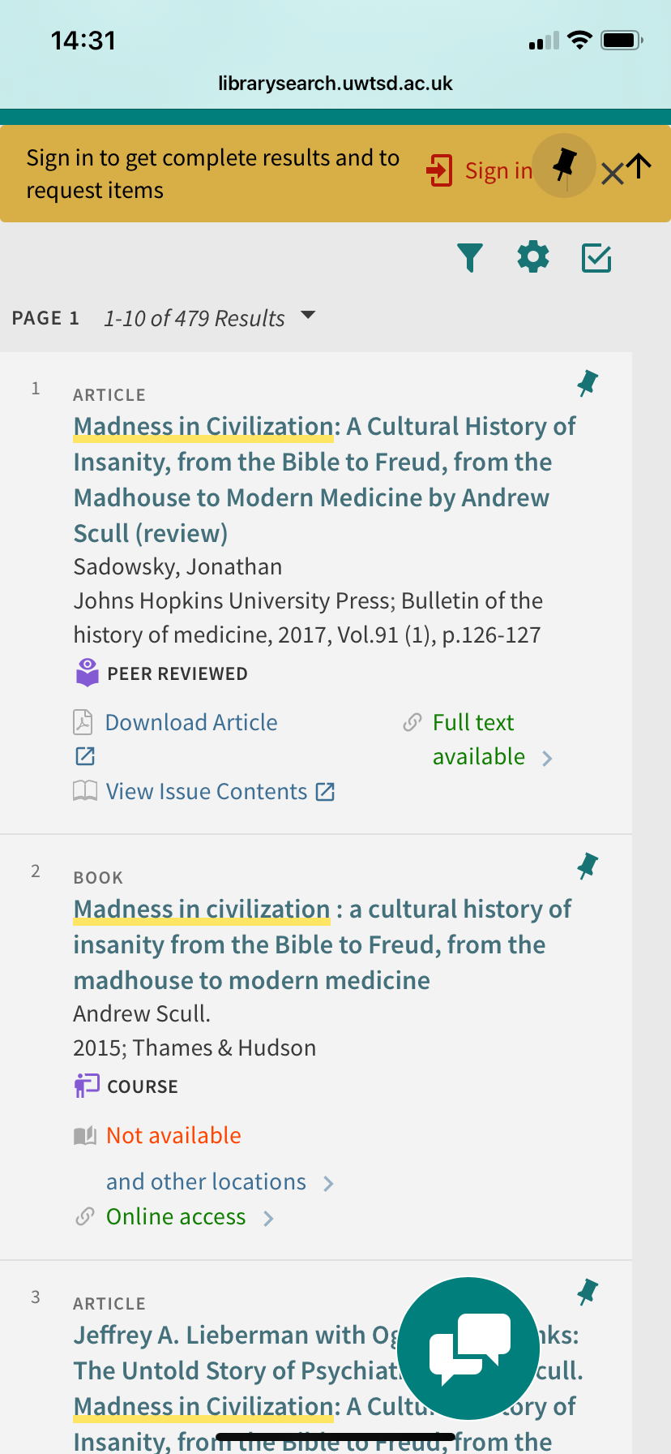

The CRAAP method is used to evaluate. It stands for Currency, Relevance, Authority, Accuracy, and Purpose.

