How Ceramic Clay Public Art Installations Evoke Sympathy

Zheng Zeng,University of Wales Trinity Saint David

Introduction

As the relationship between public art and materials in contemporary art garners increasing attention, clay, an ancient and symbolically significant material, plays an indispensable role in contemporary artistic creation. This article first clarifies the content and definition of public art, and discusses the cultural significance and spiritual value of clay within the unique context of China. Through practical attempts, I have sought to integrate ceramic creations bearing Chinese cultural symbols into the Western art discourse. Additionally, the article delves into the impact of cultural differences between East and West on artistic creation, as well as the interactions between art, the environment, and the community.

Keywords: Anthropology, Autoethnography, Public Art, Ceramics, Clay

The Concept and Definition of Public Art

From its literal meaning, public art refers to art in public spaces or public domains. The interdisciplinary nature of public art determines the complexity of its concept. The concept of public art has mainly gone through three development stages（Knight, C.K., 2011）:

- The Mexican mural movement of the 1920s-1930s and the Roosevelt New Deal, which have become signposts for public art;

- The "Arts in Public Places Program" by the National Endowment for the Arts (NEA) in 1965, which provided significant development opportunities for public art. However, the concept of public art was still in a vague stage;

- The removal of Serra's "Tilted Arc" in 1989 sparked a discussion on the "publicness" of public art, leading to a greater focus on the relationship between art, the public, and the environment rather than merely the expression of the artist's individuality.

In "The Practice of Public Art," Cameron Cartiere and Shelly Willis highlight the dilemmas faced by public art（2008）. As a concept within the fine arts discipline, public art has failed to achieve a consensus in professional circles, becoming a symbol of compromise, dilution, and dependence. Although public art boasts exceptional expansiveness, enabling it to integrate various media and disciplines, it remains marginalized in academic circles due to the lack of public art criticism, education, evaluation, and a clear definition.

Cameron Cartiere's article "Coming in from the Cold: A Public Art History" introduces Rosalind Krauss's 1979 concept of "the expanded field mode." Moreover, Cameron Cartiere and Shelly Willis together summarized a definition of public art（Cameron Cartiere，2008）:

Public art is art outside of museums and galleries and must fi t within at least one of the following categories:
- in a place accessible or visible to the public: in public
- concerned with or affecting the community or individuals: public interest
- maintained for or used by the community or individuals: public place
- paid for by the public: publicly funded

Chang (2008) also believes that contemporary public art should contribute to local development and invigorate communities. However, he raises concerns about the constraints placed on artists when implementing public art commissions, particularly regarding the issues of "publicness" and "autonomy" in public art. Chang argues that scholars, artists, social activists, and policymakers often do not discuss the same topics (Chang, 2008, p. 1925).

Autonomy and Publicness in Public Art

In the discussion of public art, we have already touched upon two key core aspects: "publicness" and "autonomy." According to Hulatt, Owen (2013), autonomy is a concept borrowed from political and moral philosophy and has corresponding applications in the field of art. In art, autonomy can be understood from two perspectives:

Aesthetic Autonomy: This refers to the inherent value of an artwork, independent of its external social functions. Artists can achieve aesthetic autonomy by uniquely handling forms to explore the universality and timelessness of human experiences. Aesthetic autonomy emphasizes the artwork as an independent aesthetic object, possessing the autonomy to be appreciated for its formal beauty, emotional expression, and intellectual content without external interference. In the creative process, artists are free to explore various artistic expressions without societal or political pressures.

Social Autonomy: This denotes the art field as a relatively independent value domain, not directly influenced by other domains such as cognition, morality, society, or politics. However, this does not imply that the value of art is entirely independent of these external factors. Social autonomy highlights that art, while independent, interacts with and is connected to the social environment, cultural background, and political-economic conditions. Art reflects and responds to social realities to some extent but maintains independence in value judgments and modes of expression.

These two forms of autonomy are distinct concepts. Recognizing the social autonomy of art does not equate to accepting the concept of aesthetic autonomy. Therefore, defining and interpreting the autonomy of art requires distinguishing between these two levels and acknowledging the potential value conflicts between them.

Publicness and the public sphere have the following characteristics: Firstly, they are products of civil society. In feudal and autocratic systems, publicness and the public sphere are almost non-existent because these systems often suppress spaces for public discussion and social participation. Secondly, they are democratic and open; the public sphere stands in opposition to privacy and exclusivity. In a healthy public sphere, all members of society have the opportunity to participate, express themselves, and interact, forming an open and inclusive space. Lastly, it is driven by public opinion and participation, allowing for free exchange and mutual discussion (Massey and Rose, 2003 ). The public sphere provides a platform for the public to share views and discuss public affairs, thereby promoting social progress and democratic development. The publicness of art refers to the relationship between the artist and the site/community.

Therefore, the publicness of public art and the "autonomy" of art are essentially contradictory. Autonomy demands that art be "independent" from other human activities, maintaining its purity and creativity without interference from external political, economic, or social factors. In contrast, the "publicness" of public art requires that art engage with social life, serve society, and promote democratic politics.

Definition and Development of Ceramic Materials

Clay has been discovered and utilized by humans since prehistoric times, boasting a long historical heritage. Not only did humans craft clay into everyday functional objects, but they also developed ritual ceramics with religious significance. According to the research framework of Chinese ceramic history, "Chinese ceramic culture" can be summarized into three levels:

First, it focuses on ceramic craftsmanship techniques, exploring the evolution and development of ceramic production processes.

Second, it takes the ceramic objects themselves as research subjects, including aesthetic studies related to glaze color, shape, and other features, evaluating their artistic value and aesthetic characteristics.

Finally, it examines the social organization and market relationships that emerged based on ceramic objects, from industry beliefs and craftsman lineages to market transactions, revealing the impact of the ceramic industry on social structure and economic development.

These research frameworks are invariably built upon the basic material of clay. Clay is not only the raw material for ceramic production but also a fundamental microcosm and metaphor for Chinese history and social culture. In Chinese culture, clay holds significance beyond the material level, bearing rich cultural connotations. It stands as a testament to the ingenuity and creativity of ancient Chinese craftsmen and serves as a medium for social, economic, and cultural exchanges. Through the study of clay and ceramics, we can gain insights into the complex aspects of Chinese social organization, market relationships, and cultural beliefs. Therefore, clay plays an indispensable role in Chinese ceramic culture and is crucial to understanding Chinese history and culture.

Clay's Sacred Attributes

Clay has long been endowed with sacred attributes across various cultures, symbolizing creation, life, and transformation. In many ancient civilizations, clay was revered as a divine substance due to its ability to be molded into various forms and then solidified through fire, representing both the earth and transformative processes.

As the raw material for sacrificial ceramics, clay naturally embodies the cultural connotations of these ceremonial artifacts. By examining the sacred attributes of sacrificial ceramics, we can explore their cultural and humanistic values and trace the original meanings of clay within the Chinese context.

Sacrificial ceramics refer to the porcelain used in ancient Chinese royal religious activities and rituals, such as offerings to heaven and earth. These include vessels like dou, gui, incense burners, and vases. As tools used in ceremonial settings, sacrificial ceramics possess religious attributes and functions as ritual utensils. Their use and production were influenced by the distinctions in social identity within ancient Chinese society, and they can be categorized into three main types: official Confucian rites, ancestral worship in clan temples, and religious offerings. During the Ming and Qing dynasties, different social strata had their own spiritual needs and aesthetic awareness, reflected in the functions and cultural significance of sacrificial ceramics (Rong Hu, 2022).

In summary, sacrificial ceramics were special porcelain used in both royal and folk religious ceremonies in ancient China. Their cultural attributes and artistic value are manifested in their forms, functions, and symbolic meanings.

The sacred attributes of sacrificial ceramics are not only reflected in their material and artistic value but also in their profound cultural and religious significance. Through multi-layered and multi-perspective research, we can comprehensively understand the cultural genesis of sacrificial ceramics and their importance in ancient society. Such research not only enhances our understanding of ancient Chinese ritual culture and religious life but also provides valuable references for contemporary cultural heritage preservation and research.

Yanik Potvin (2024) posits that despite the vastly different times and spaces in which clay has appeared in human societies, the fact remains that it is the material and spiritual relationship of the human body, along with the representation of the body through the material, that allows us to propose its epistemological uses. These relationships appear in ancient times, in the history of urbanization around the world, and in contemporary cognitive archaeology research. The unity between humans and the biosphere can be glimpsed in the bodily images of Upper Paleolithic clay figurines or in the biological metaphors used by certain human cultures on pottery or combustion structures. ("Creative Anthropology" as a Cognitive Unit: Clay as an Epistemic Object and Experimental System in Research-Creation, 2024,p. 115)

By examining the sacred attributes of sacrificial ceramics, we can conclude that, as these ceramics are made from clay, their religious and cultural attributes have influenced the clay itself through centuries of cultural evolution in China. The distinctive characteristics of sacrificial ceramics have also been imparted to the clay. This impartation can be examined from two perspectives:

Firstly, the physical characteristics of an object are among the most critical factors in visual arts. When people perceive an object, they often focus on its physical attributes. This observation process is also the most accessible channel and method for viewers to resonate emotionally and feel the spiritual power of the work. The primary physical characteristics include size, color, and texture, which are crucial factors in eliciting viewer resonance.

When clay is used as the primary raw material for making sacrificial ceramics, the characteristics it exhibits after firing are linked to the sacred attributes of the sacrificial ceramics. The changes clay undergoes during the firing process endow sacrificial ceramics with unique size, color, and texture. These features not only visually attract viewers but also psychologically evoke feelings of awe and reverence. This connection imbues sacrificial ceramics with special symbolic significance in religious and ceremonial activities.

Color, the fired clay can exhibit a rich variety of hues, each with specific symbolic meanings in ancient China. For example, the green of celadon symbolizes nobility and purity, while the red of redware represents auspiciousness and celebration. These colors not only beautify the objects but also enhance their symbolic significance, giving them deeper cultural meaning in sacrificial rituals.

Texture, the surface quality of sacrificial ceramics directly affects the perceptual experience. A smooth surface provides visual and tactile pleasure, while a slightly rough texture can convey a sense of simplicity and solemnity. Through touch, viewers can more intuitively appreciate the craftsmanship and cultural heritage of the objects, further deepening their understanding of the sacred attributes.

Secondly, sacrificial ceramics imbue clay with spiritual and cultural values, which can be understood from the production process. In primitive times, human ancestors already attempted to use clay to make various utensils, including daily items as well as tools for rituals and divination. Even today, many parts of the world still preserve quite primitive pottery-making techniques. This gives clay a deep cultural and spiritual significance beyond just being a material for crafting.

The choice of clay as a material metaphorizes the process of human labor. It is seen as a conduit connecting humans to the earth, where through labor, people establish a close relationship with the land and nature. Clay's ability to retain the marks of its shaping and firing process makes it more likely to be viewed as the embodiment of labor. The making of each sacrificial ceramic piece represents the wisdom and hard work of the craftsmen, and it is also the result of human interaction with nature.

Antony Gormley's art project "Clay and the Collective Body" (2009) vividly illustrates the profound relationship between clay, humanity, and the earth. In this project, Gormley placed a hundred tons of giant cubic soft clay in an inflatable dome in the center of Helsinki and invited hundreds of city residents to process and transform it over ten days. To ensure the best experience, Gormley created a controlled environment where humidity and temperature were maintained at optimal levels. This setting allowed participants to engage with the material in the most primal and direct way, experiencing the texture and smell of the clay.

When asked about the artistic nature of this project, Gormley ( Antony Gormley interviewed by Alan Macfarlane, April 29, 2009) responded that the simple act of shaping clay, the smell of the clay, and the sense of the space constitute the essence of its artistic value. Gormley's "Clay and the Collective Body" project not only showcased the unique allure of clay as an artistic material but also profoundly addressed the relationship between clay and artistic creation. In this project, clay was no longer merely a crafting material but became a medium for human interaction with nature, reflecting humanity's dependence on and reverence for the natural world.

This art project demonstrated the infinite possibilities of clay as a medium through public participation. Every participant, through their contact and interaction with the clay, engaged in a primal and pure creative activity. This creation was not just about altering the form of the clay but also about expressing the relationship between humans and materials, and between humans and nature. The malleability of the clay, combined with the creativity of the participants, infused each piece with personal emotions and collective memories.

Through the "Clay and the Collective Body" project, Gormley explored the multiple meanings of clay in artistic creation. Firstly, clay, as a natural material, carries the history of human labor and creativity. In this project, clay was given new life, becoming a vessel for people's emotions and memories. Secondly, the plasticity of clay makes it an ideal material for creation, capable of recording the marks of each participant's work, reflecting their inner world and artistic expression.

Moreover, this project revealed the collective and interactive nature of artistic creation. Through the shared process of creation, participants not only established a connection with the clay but also formed emotional bonds with each other. This experience of collective creation transformed clay from a tool of individual expression into a medium for collective memory and cultural sharing.

Gormley's "Clay and the Collective Body" project fully demonstrated the unique charm and profound significance of clay as an artistic material. By shaping and interacting with clay, participants not only experienced the joy of creation but also felt a deep connection between humans and nature. This project not only addressed the relationship between clay and artistic creation but also uncovered the rich cultural and spiritual connotations of clay.

The Integration of Ceramic Materials into Public Art

Based on our examination of public art and clay, we can summarize the following points. Public art must possess the independent thought of the artist and be a tangible reality with a specific form. Additionally, it needs to establish a relationship with the community. This relationship can be a direct interaction with the audience or community members on a practical level, or a cultural connection. In this process, public art is not merely an expression of the artist's individual vision but a product of interaction with society, culture, and the public.

In the creative process, artists need to start from their own perspective, clarify their cultural position, and deeply explore the Chinese cultural connotations related to themselves. This involves not only understanding the material properties of clay but also recognizing its cultural and historical significance. By doing so, artists can integrate personal experiences, cultural backgrounds, and the attributes of public art into their works, creating art pieces with profound cultural heritage and social significance.

Additionally, it is crucial to consider how to uncover connections between Chinese culture and local culture in the creative process. Through this cross-cultural perspective, artworks can convey the artist's personal expression while resonating within a broader cultural context, promoting understanding and exchange between different cultures. In this process, artists are both inheritors and innovators of culture, capable of combining personal cultural exploration with public needs through the form of public art, thereby creating artworks with unique value.

During this time, I have expressed my feelings and emotional experiences in Swansea through ceramic creations, as well as through AI-based projects. These works are mainly inspired by my impressions of Swansea's gardens. Additionally, I visited numerous art galleries and museums, which have given me much inspiration and ideas. However, what I find most intriguing is the phenomenon of the integration of natural and cultural landscapes in the UK.

In natural settings, we are not merely physical beings; our perceptions, emotions, and thoughts become active through interaction with our surroundings. As experienced in Clyne Gardens, different weather conditions and environmental factors affect our moods and feelings, fundamentally exploring our relationship with the world. Within Heidegger's framework, this experience highlights the core characteristic of "Dasein"—our existence is not static or isolated but dynamic and continuously intertwined with the world.

Clyne Gardens offers a unique environment to deeply feel this dynamic existence. Various natural elements, such as trees, lawns, and pathways, imbue the space with different symbolic meanings and emotional atmospheres. Trees symbolize towers, offering an upward perspective; lawns are considered living rooms, representing openness and comfort; pathways symbolize cellars, suggesting secrecy and exploration.

In artistic creation, particularly in public art and ceramic work, this experience and reflection on existence are equally important. Clay, as an ancient and symbolically rich material, serves not only as a medium for creation but also as a bridge for expressing the relationship with nature and the world. In my creative process, I strive to capture and express this complex relationship through the shape, color, and texture of clay. Each piece is not merely an isolated artwork but a dynamic presence interacting with its environment and audience.

This respect for the natural landscape and the restrained use of artificial elements has inspired my thoughts on ceramic and public art creation. I hope to incorporate this philosophy into my work, using ceramics, a material with deep historical and cultural roots, to create public art that embodies the richness of traditional Chinese culture while harmonizing with the natural environment of Swansea.

My year in Swansea has deepened my understanding of cultural differences and the importance of cross-cultural exchange. By integrating elements of both Eastern and Western cultures, I aim to create a new form of artistic expression that allows more people to appreciate the beauty and harmony of these two cultures. This process involves not only exploring materials and techniques but also delving into and understanding my cultural identity.

I draw inspiration from Clyne Gardens and plan to apply it to future creations. Utilizing Gaston Bachelard’s (2014) analytical approach to "house" in "The Poetics of Space," I reinterpret my memories of Clyne Gardens as a space filled with rich intentionality. Just as parts of a house (like cellars, attics, and drawers) can evoke specific emotions and memories, the natural landscapes and elements of Clyne Gardens (such as trees, lawns, and paths) can also evoke profound emotional responses and reflections.

Analyzing space in this manner reveals the structure of Clyne Gardens in relation to human spatial memory. This connection inevitably evokes emotional resonance, leading us into a deeper exploration of the topic. Combining this with our earlier discussion on materiality, we see that clay in human society holds significant labor and earth symbolism. Re-emphasizing clay's role as a symbol of connection to the earth can further strengthen the bond between humans and nature. In other words, nature here can be viewed as a community of nature, with Clyne Gardens as an exemplar. This approach is equally applicable to spatial analyses in other locales.

creative practice

This approach, combined with Bachelard’s (2014) method of spatial analysis, not only enriches my creative thinking but also allows me to more profoundly understand and express the complex relationship between space, memory, and emotion. In my specific creations, I merge clay with spatial imagery to evoke the audience’s resonance with spatial memories and emotions. For instance, the tower symbolized by trees can be represented in ceramic works as towering structures, while the living room symbolized by grasslands can be depicted through open and flat forms.

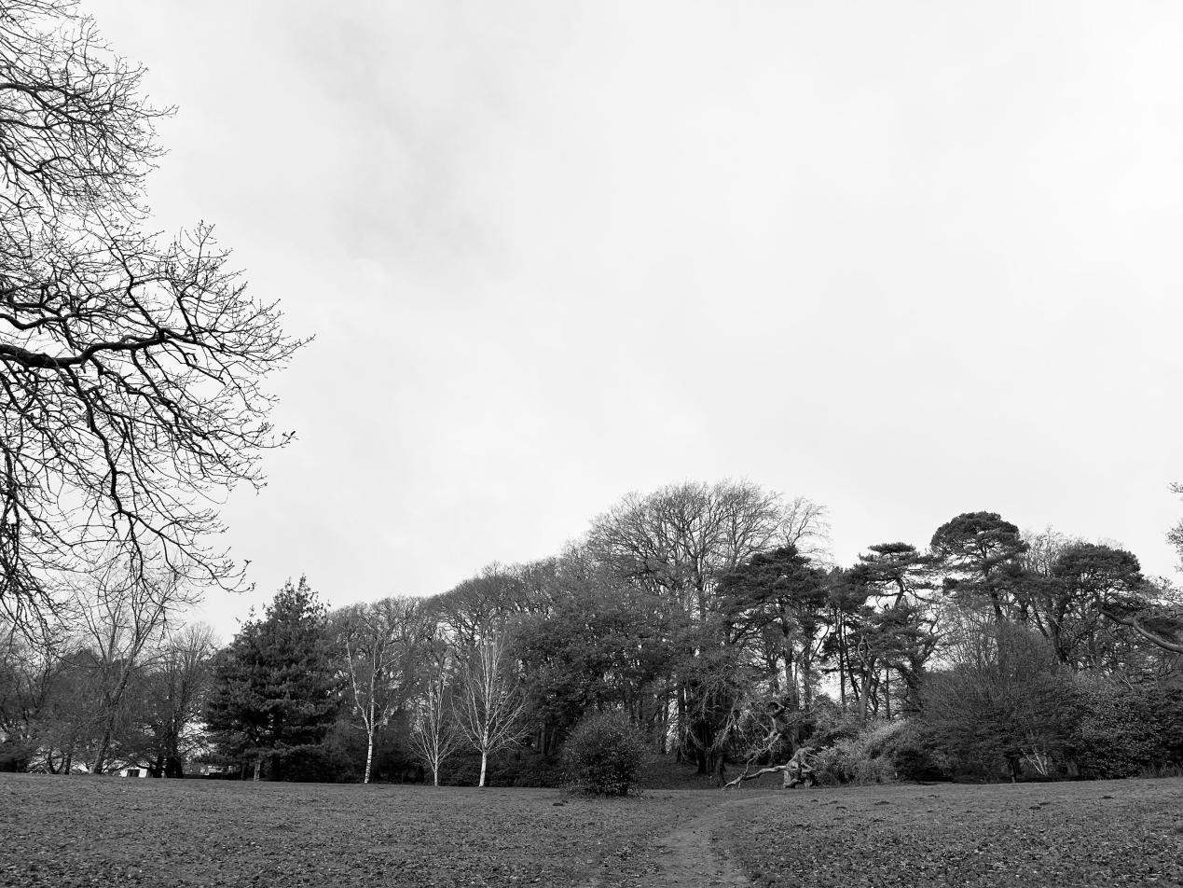

This method of creation is not only applicable to Clyne Gardens but can also be extended to the spatial analysis and artistic creation of other places. By understanding and utilizing these spatial images and emotional connections, I hope to create more public artworks with profound cultural connotations and emotional resonance. Ultimately, this method will help me explore and realize the creative possibilities of ceramics and public art in different cultural contexts, further promoting cultural exchange and understanding.

According to Tim Ingold’s anthropological perspective, he offers a new way to consider the relationship between humans and their environment, especially in terms of materials and the making process. Ingold (2013) argues that making is not just a form of creation but an interactive process between humans and the world. This viewpoint also prompts us to rethink the relationship between art and the surrounding environment.

By integrating Ingold’s perspective, I aim to emphasize that the act of creating with clay is a dialogue with nature, where the material itself becomes a co-creator in the artistic process. This interaction mirrors the natural integration seen in Clyne Gardens, where human-made elements harmonize with natural surroundings. In this light, my ceramic pieces and public art projects aspire to reflect not only personal artistic expression but also a deeper connection and response to the environment.

For instance, in crafting ceramic artworks inspired by the natural elements of Clyne Gardens, I will consider how each piece can resonate with its surroundings and evoke a sense of place and memory. Tall, slender forms can symbolize the towering trees, while expansive, open shapes can represent the welcoming grasslands. These artistic choices aim to evoke a sense of familiarity and emotional engagement in viewers, bridging the gap between personal experience and collective memory.

At the beginning of my creative process, I made three small clay maquettes. Their small size allowed me to quickly grasp my creative inspiration and ideas. These three pieces have entirely different creative styles and represent three distinct feelings I experienced here. The first maquette leans towards structural composition, exploring the geometric relationships of shapes and lines. The second focuses on the human body, emphasizing the dynamics and details of human form. The third piece combines both structural and human elements, attempting to find a balance between form and content by integrating composition and human figures. These works explore the issue of creative form from different perspectives.

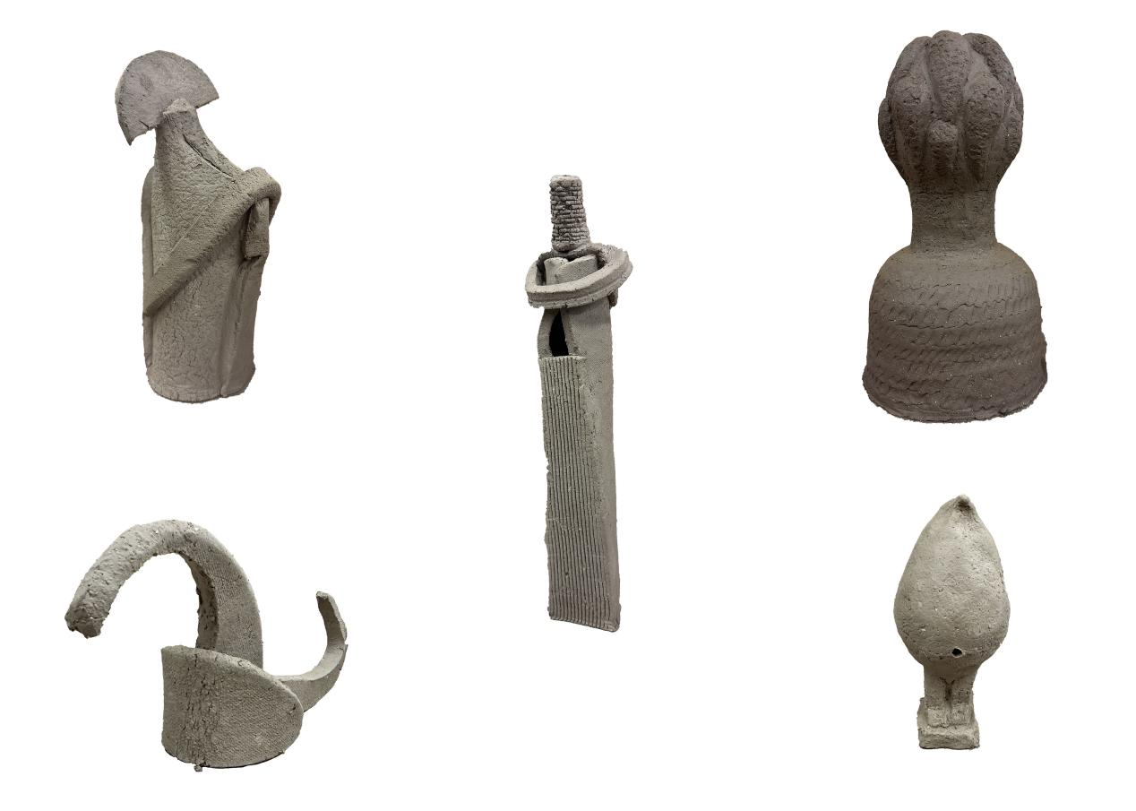

Subsequently, I explored the possibility of combining AI with sculpture and created AI-generated renderings. These renderings provided new creative ideas and laid the foundation for my 3D sculpture creations. I then proceeded to create and render 3D sculptures, expanding the boundaries of traditional clay creation and introducing new technological methods to achieve new heights in both visual and conceptual terms.

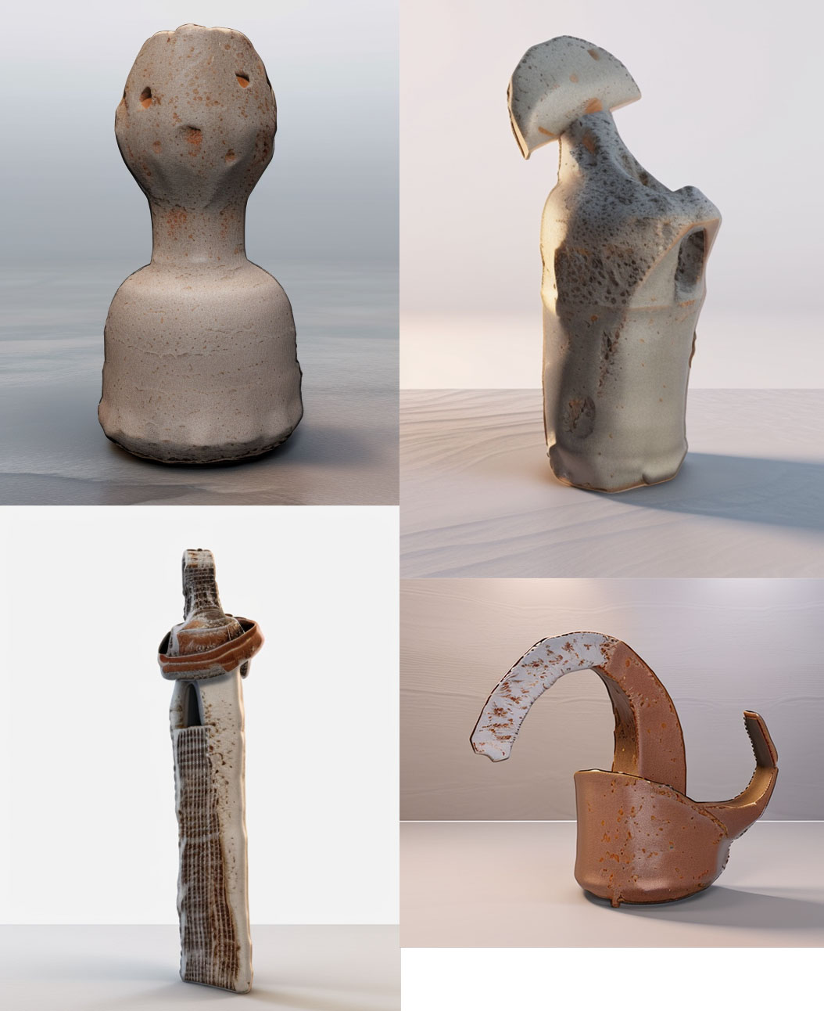

Tim Ingold's viewpoints helped me to understand the significance of making as an interaction between humans and the world more deeply. In my creations, materials are not just mediums of expression but bridges for interacting with the environment and the audience. By combining clay, AI, and 3D technology, I attempt to find a new balance and form of expression between tradition and modernity, nature and technology.

After this, I re-examined my relationship with space and the community and realized that the aforementioned methods required creating larger works to express my ideas fully and test the feasibility of this approach.

Ultimately, I completed these four pieces. They reflect the results of the above experiments. In terms of color, I chose black and white as the basic tones, hoping to highlight the distinction between individual forms and nature through a monochromatic palette. Clearly, very few things in nature have this black-and-white mottled texture. However, in terms of shape, I leaned towards natural forms. These shapes were inspired by the oddly shaped trees I saw in Clyne Gardens and were artistically processed. They resemble natural forms and appear to be dancing or embracing figures or even some kind of organic entities. This design aims to imbue the works with more vitality in their appearance.

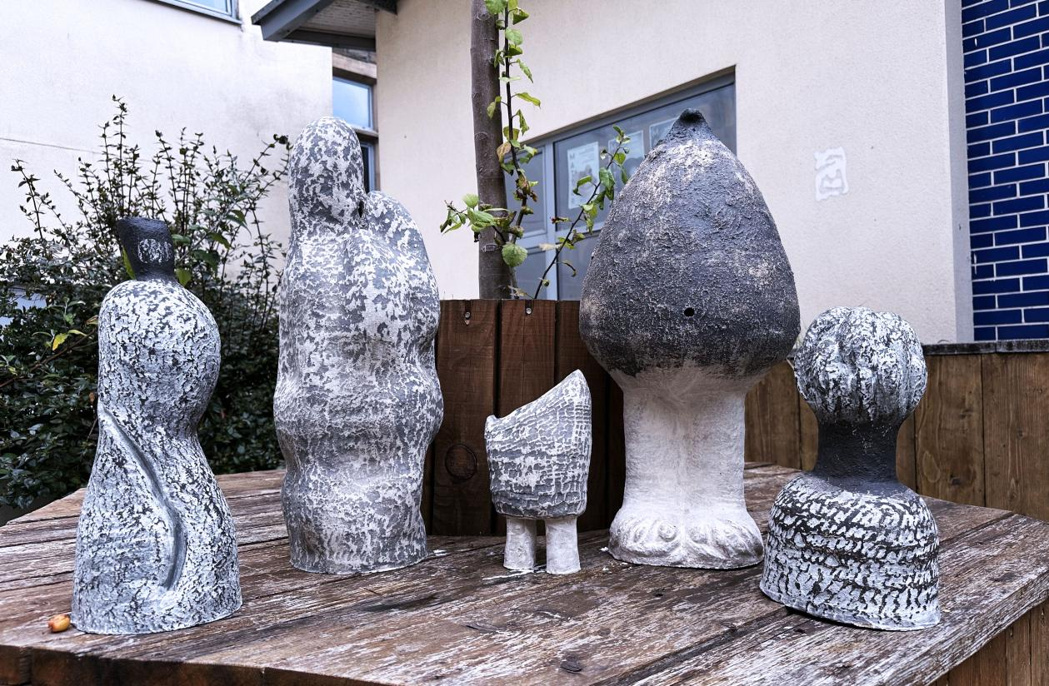

Conveyance of emotions

The black and white colors hint at their nature as man-made artifacts. This conflict between artificiality and nature simultaneously evokes a contradictory human emotion, making the works appear somewhat disharmonious. This disharmony resonates within the viewer's mind. In this way, I hope to convey the complex and profound relationship between nature and artificial objects.

These works are not merely the results of personal creation but also reflections on the relationship between humans and nature, and humans and technology. Through the choice of form, color, and materials, they convey a complex emotional experience and philosophical contemplation. I hope that viewers, when appreciating these works, can feel the vitality and inner tension within them and perceive the deep connection between humans and nature, and humans and their environment.

Of course, I also considered the expression of monumentality in the forms. As mentioned earlier, clay possesses unique psychological effects and colors, qualities that can instinctively evoke a sense of reverence. However, how to integrate the essential attributes of sacrificial ceramics into modern ceramic art creation is a question that requires deeper exploration. Currently, my creations are relatively small in size and have yet to fully explore the emotional reactions elicited by the works in specific environments. This is an important consideration, as the placement environment significantly impacts the emotional resonance with the audience.

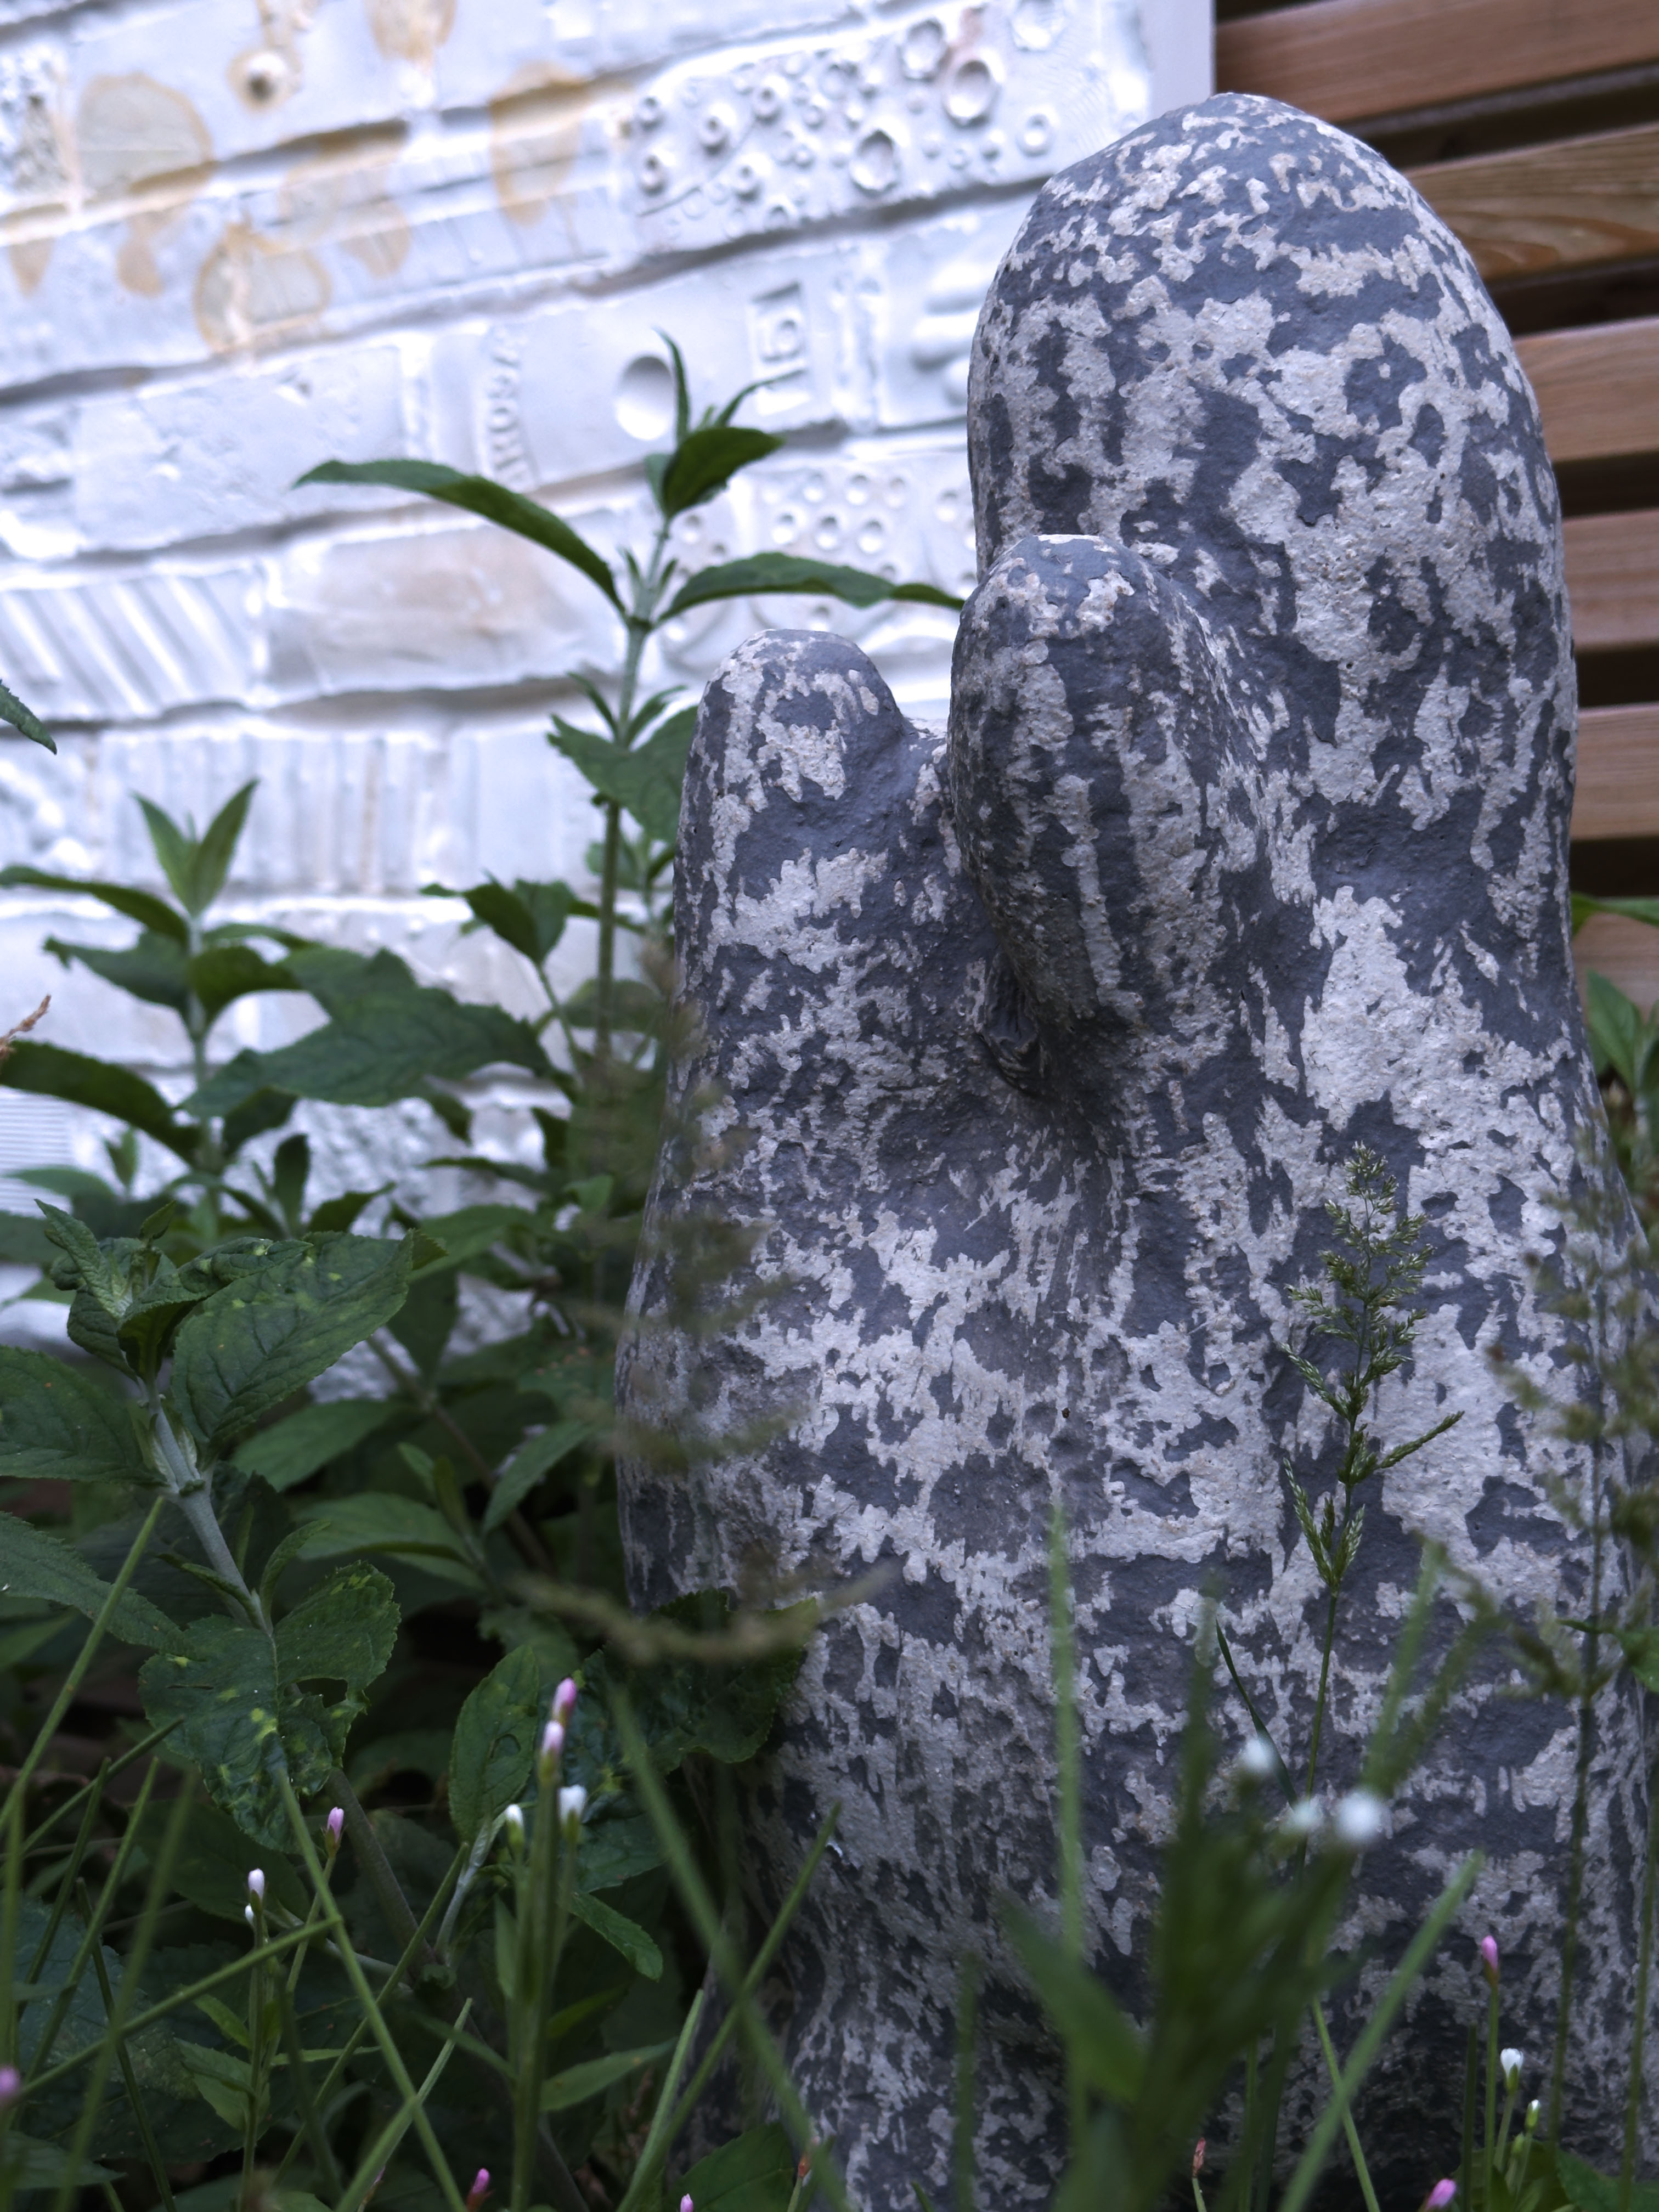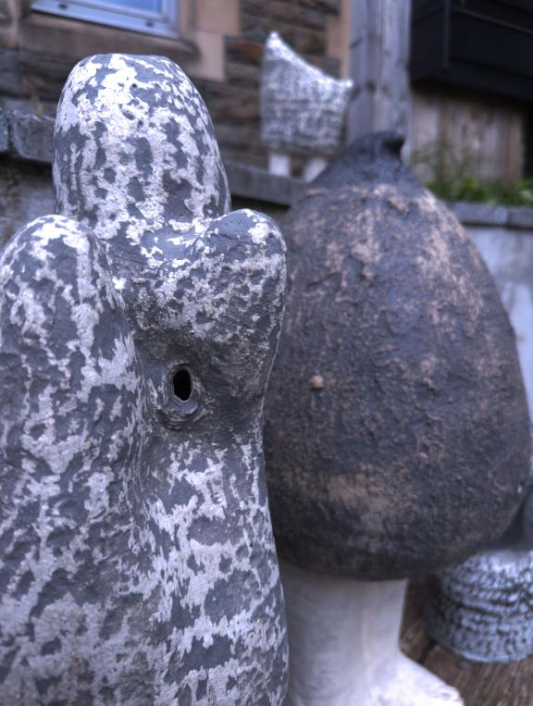

The thesis does not discuss in detail the relationship between sacrificial ceramics and the environment, which is a regrettable omission. However, it can be imagined that the placement of sacrificial ceramics in specific environments would have a significant impact on emotional resonance. Therefore, the display space of the works needs special consideration to maximize the emotional and resonant impact on the audience.

In my next creation, I will focus on this aspect. The creative practice can be divided into two parts: first, experimenting with form, color, and size based on surface characteristics; second, exploring community connections. Currently, the experiment still lacks community engagement, meaning it lacks audience feedback. This absence makes it challenging to analyze the works thoroughly. In the next stage, I plan to create with community interaction and design public art projects.

By integrating community feedback and interaction, the artworks will not only serve as expressions of individual creativity but also as collaborative projects that reflect the collective experience and resonance of the community. This approach aims to create more meaningful and impactful public art that bridges the gap between personal expression and communal experience.

This approach will not merely focus on the exploration of materials and forms but will emphasize community interaction. Through this method, I hope to better understand audience feedback and incorporate it into the creative process. Specifically, I plan to hold community workshops, inviting local residents to participate in the creation process. Their involvement and feedback will help make the works more attuned to the public's emotions and needs.

Furthermore, I plan to exhibit the works in various public spaces, observing and recording audience reactions. This will not only provide more sample data but also offer better insights into the performance and impact of the works in different environments. This process will provide valuable experience and insights for my creations, helping me better balance artistic expression and public interaction in future works.

In summary, by combining monumentality, community interaction, and environmental considerations, I hope to achieve new breakthroughs in modern ceramic art creation, producing works with deeper cultural significance and emotional resonance. This approach will enrich my creative practice and contribute to the development and innovation of public art.

By integrating community feedback and interaction, the artworks will not only serve as expressions of individual creativity but also as collaborative projects that reflect the collective experience and resonance of the community. This approach aims to create more meaningful and impactful public art that bridges the gap between personal expression and communal experience.

References

Aesthetic and Artistic Autonomy / Hulatt, Owen - London : Bloomsbury Publishing, 2013 - 256 p. - Bloomsbury Studies in Philosophy - ISBN: 9781441126078 - Permalink: http://digital.casalini.it/9781441126078 - Casalini id: 5201261

Bachelard, G. (2014). The Poetics of Space. [online] Google Books. Penguin. Available at: https://www.google.co.uk/books/edition/The_Poetics_of_Space/tN3bAwAAQBAJ?hl=en&gbpv=1&dq=The+poetics+of+space&printsec=frontcover [Accessed 10 May 2024].

Butz, D. and Besio, K. (2009). Autoethnography. Geography Compass, 3(5), pp.1660–1674. doi:https://doi.org/10.1111/j.1749-8198.2009.00279.x.

Clements, P., 2008. Public art: radical, functional or democratic methodologies?. Journal of Visual Art Practice, 7(1), pp.19-35.

Denzin, N.K. (1989). Interpretive Biography. Newbury Park.

Ernst Fischer, Berger, J. and Bostock, A. (2010). The necessity of art. London ; New York: Verso.
Heidegger, M., Schmidt, D.J. and Stambaugh, J. (2010). Being and time. Albany: State University Of New York Press.

Gormley, A. (2009). Interview of Antony Gormley. [Video]. Apollo - University of Cambridge Repository. http://www.dspace.cam.ac.uk/handle/1810/221898

Hu Rong. Creation and Utensils:Research on the Reconstruction of the Sacred Properties of Sacrificial Porcelain,2022.DOI:10.27661/d.cnki.gzhnu.2022.000683.

Ingold, T. (2013). Making: Anthropology, Archaeology, Art and Architecture. [online] Google Books.Routledge.Availableat:https://www.google.co.uk/books/edition/Making/wwzUj2o42fUC?hl=en&gbpv=1&dq=Making+Ingold&printsec=frontcover [Accessed 10 May 2024].

Knight, C.K., 2011. Public art: Theory, practice and populism. John Wiley & Sons.

Knight, C.K. and Senie, H.F., 2016. A companion to public art: Introduction. A Companion to Public Art, pp.1-12.

Mcewan, I. (2006). Ian McEwan & Antony Gormley: A Conversation about Art and Nature. Source: The Kenyon Review, 29(1).

Massey, D. and Rose, G., 2003. Personal views: Public art research project. Milton Keynes: The Open University

Mccarthy, J. (2006) ‘Regeneration of Cultural Quarters: Public Art for Place Image or Place Identity?’, Journal of Urban Design, 11(2), pp. 243–262. doi: 10.1080/13574800600644118.

Nietzsche, F. (2019). The Will to Power. [online] Google Books. Courier Dover Publications. Available at:https://www.google.co.uk/books/edition/The_Will_to_Power/_ZeWDwAAQBAJ?hl=en&gbpv=0 [Accessed 10 May 2024].

Phillips, P. C. (1989) ‘Temporality and Public Art’, Art Journal, 48(4), pp. 331–335. doi: 10.1080/00043249.1989.10792651.

ZEBRACKI M, VAN DER VAART R, VAN AALST I, 2010. Deconstructing public artopia: Situating public-art claims within practice[J/OL]. Geoforum, 41(5): 786-795[2019-10-09]. DOI:https://doi.org/10.1016/j.geoforum.2010.04.011.

