Name: Latheisha Brewster
Title: Assessment 1 Report
Course: BMSP7003D: Embedding Sustainability within organisations.

Nature Care SVG
SUSTAINABILITY REPORT 202
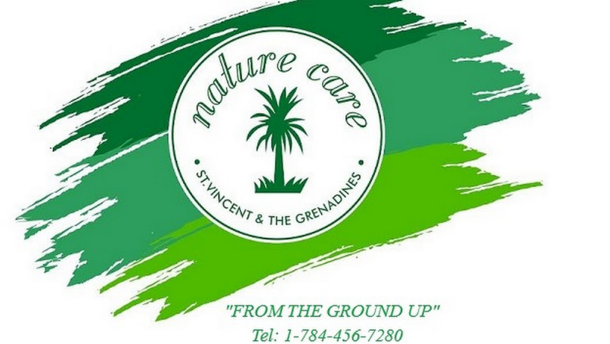

Executive Summary
Planet Earth is our home and as businesses we have an essential role to play in protecting and preserving the earth. Draper (2015) suggested that there needs to be a shift through system innovations in businesses to a more sustainable path. Sahin and Cankaya (2020) pointed out that when businesses do sustainability reporting it benefits the company so that it can evaluate its strengths and weaknesses consequently making important decisions. This is a sustainability report for Nature Care SVG. It will critically and innovatively analyse the business as it relates to sustainability. The current sustainability initiatives, practices and processes from various functions will be identified. Throughout, there will be highlights of issues between stakeholders and a comparative understanding of the current sustainability level of this plant nursery business will be provided.

Our Mission
Nature Care SVG is on a mission to make this world a better place by helping people to become caretakers of plants. We aim to make our beautiful country greener by providing a wide variety of quality plants for businesses and homes. We are also known to make available the most affordable consultations and environmentally friendly pesticides and fertilisers so that plants can bloom from the ground up.

About Nature Care SVG
Nature Care SVG is a company that is involved in the cultivation and sale of plants, landscaping, garden maintenance, plant and household pest control and consultancy. We offer the best and most environmentally friendly products to facilitate the growth and maintenance of plant life of all different kinds and species.
Message from CEO Mr. Gideon Nash
The world we are living in today has transformed before our very eyes. With a rise in industrialization we are now in a concrete jungle battered with the challenge of climate change. This has put lots of pressure on production and the natural resources available to us. Thomas and Anderson (2011) brilliantly and reflectively stipulated through poetry that we must live our today thinking about Tomorrow’s Child. As a father and a grand dad I believe that I have an obligation to advocate for sustainable living. As a businessman, I believe too that I have a responsibility to the earth and must do whatever I can to ensure that my descendants are able to have resources and livelihood years after I would have transitioned to another life. My company specializes in plant growth and care and I believe that we can help the planet one plant at a time. Anderson, Meenken, Peterson and Beare (2018) show us that plants can be beneficial to humans and the environment. My company is therefore committed to making sure that true sustainability remains the helm of our organisation. We can help to save the earth, from the ground up.


Gideon Nash


Picture of our main office

Nature Care’s commitment to the SDG’s
Freeman (2013) suggested that the narrative of businesses must change whereby businesses should not just aim for the maximisation of profits. Furthermore as Young and Dhanda (2012) highlighted, businesses can focus on making maximum profits and can still make sustainability their mission. As a matter of fact, they argue that businesses who concentrate on sustainability are more innovative and reap success because sustainability ushers in the birth of new products and services. Nature Care realises the importance of this as a result we have chosen to focus on five of the seventeen Sustainable Development Goals to which are directly related to our business’ mission.
Goal 8
Nature Care prides itself on creating job opportunities for young members of the society in which it operates it. Geza, Ngidi, Slotow and Mabhaudhi (2002) posited that with a young staff in agricultural businesses the prospects of sustainability are limitless since youth are not only strong but can be innovative and creative in their thinking to transform the agricultural sector. Hence, just about 78% of our employees are youth and have worked audaciously to aid Nature Care fulfill their mission.

Goal 12
The nature of our businesses means that we use a lot of water in an effort to realise production. However we are very careful in the way things are done as we believe in responsible consumption and production. The idea of Circular Economy guides our activities and helps us very much in our management of waste and energy.

Goal 15
The nature of Nature Care is about protecting and improving life on earth. Hence, through the planting of plants, soil care and landscaping we are able to help in the realisation of Agenda 2030 by promoting, protecting and restoring our terrestrial Ecosystem. We are also able to stop and reverse land debasement and cripple biodiversity failure.
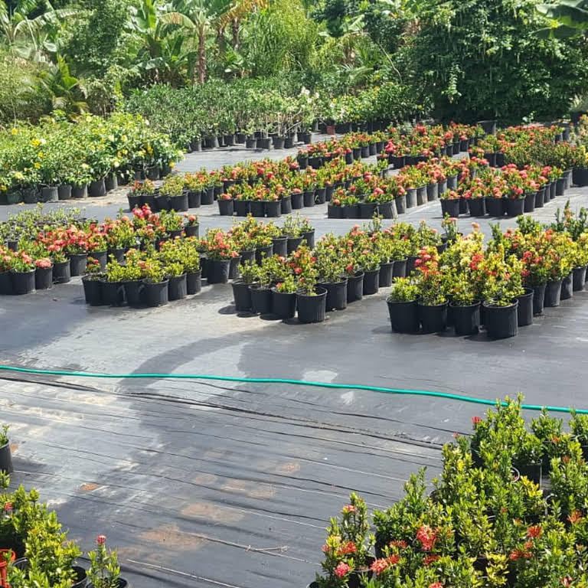
Picture of a section of our plant nursery

Goal 13
Evich (2019) displayed how dangerous climate change can be to the environment. Operating in a Caribbean country prone to yearly hurricanes and uncertain weather conditions is one of the challenges our business faces. Nonetheless, we are stern advocates of com-batting climate change and so we make it a mandate to do all we can to fight this issue.
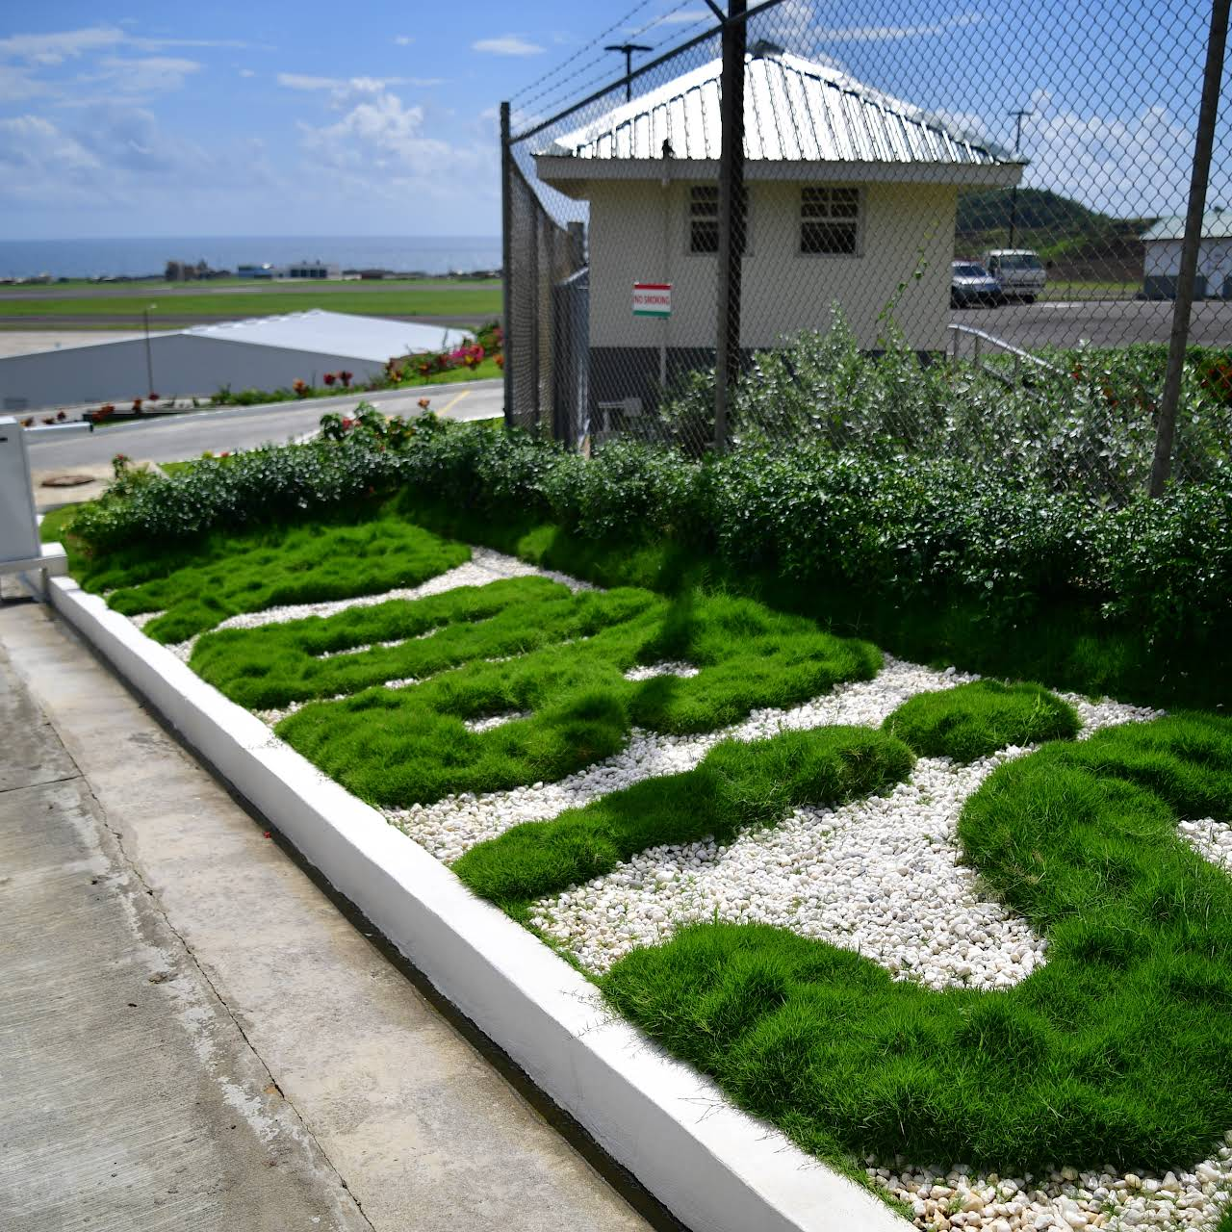
Goal 5
We operate in a very small community in a small island developing state. Therefore, we know what it means when members of our community are educated and so we strive to help in this area by sponsoring yearly scholarships for two secondary school students and three A Level students. To date, we have given over one thousand scholarships to students within the community we operate.

Nature Care’s Value Chain

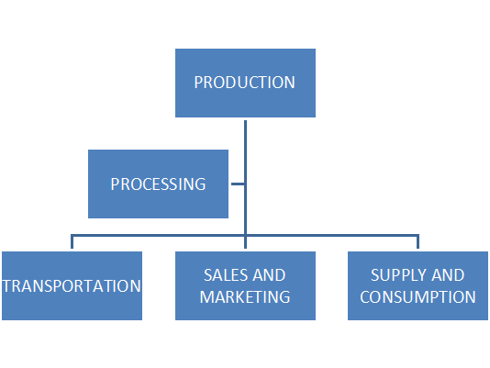
Our Value Chain framework
PRODUCTION
Our business is operating in an uncertain and competitive market place as it faces challenges of globalisation, scarcity of resources, rise in the cost of materials for production and many more. Nonetheless, the value chain of Nature Care is built with the philosophy of creating shared values by our insistence on responsible and sustainable management, consumption and production.

Production
Activities: Plants, fertilisers and pesticides
We ensure that we provide customers with products that are environmentally friendly and effective in achieving growth and care. Furthermore, Ceschin and Gaziulusoy (2016) posited that when businesses design products they should always consider the effects that that product can have on the environment. Therefore, Nature Care is always mindful of how the products they offer can affect society.

Processing
Activities: planting of a variety of plants, making fertilisers and pesticides.
There is a tremendous amount of work that goes into the achieving of products. From the soil used for the plants to the products used in creating our fertilisers and pesticides are all environmentally friendly and monitored so that the company’s carbon footprint is sustainably accepted.
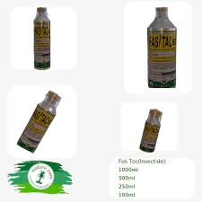
Image of our pesticides
Transportation
Activities: Walk and delivery, drive to deliver
Consumers can get our products at our nursery's location. We also deliver by the use of a company’s vehicle. Deliveries are dependent on the amount of products bought in a particular area. It is always communicated to customers that when they come to the store they can walk with the product at the same time or if not they will have to wait on delivery when there are at least five customers in that area. This is done so that we control emissions and save energy.

Marketing and Sales
Activities: Direct sales, customer relationship
Customers are always consulted when there is a new product. They are always part of product testing and their suggestions are always welcomed. Furthermore, we try our best to ensure that our business is sustainable as it relates to sales.

Supply and Consumption
Activities: wholesale
The people who supply us with ingredients for our pesticide and fertilisers production must be partners with us in sustainability. Willard Supply Store is one of our main suppliers and they are known advocates of championing sustainability in our country.

Providing Value to our stakeholders
Our sustainability Value Framework adopted by Hart and Milstein (2003)
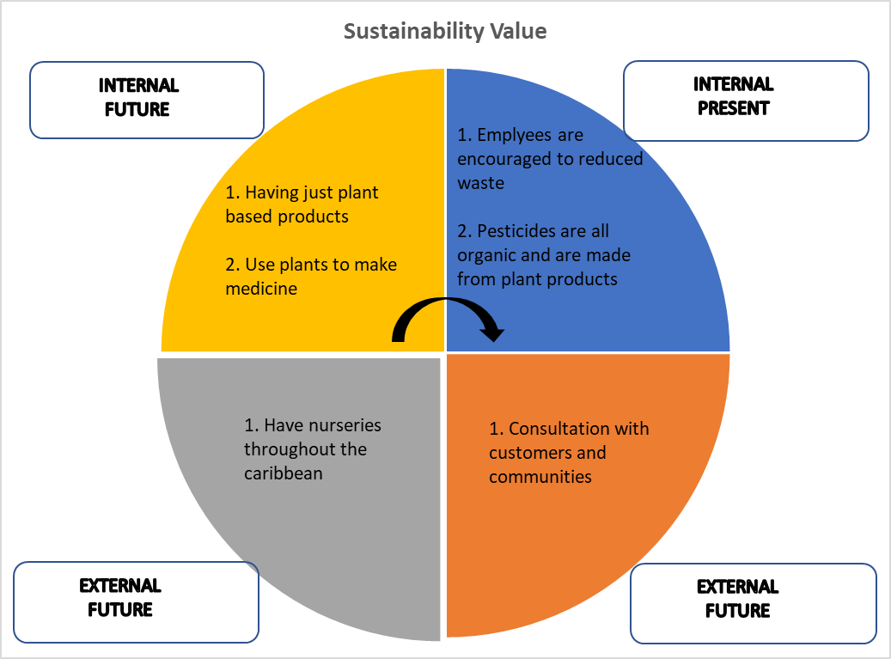

Our Sustainability Policy.
Our sustainability policy is guided by the four principles to win sustainability. We therefore work to make sure that the visions, initiatives, practices and processes undertaken by our organisation adhere to these principles. In essence we are guided by the philosophy of Karl-HenrikRobert to make sure that nature is not subjected to:
1. Systematically increasing concentrations of substances the organisation produces.
2. Systematically increasing concentrations of substances extracted from the earth’s crust.
3. Systematically degradation by physical means.
We also make sure that people are not:
4. Subjected to conditions systematically undermine their capacity to meet their needs.

Our policy summarised
Environment | Social | Governance
1. We endlessly undertake actions that will allow us to minimise our impact on the surroundings.  2. We monitor our resource consumption and emissions to the surroundings. | 1. Making sure that all of our employees are well taken care of and are respected.  2. Contributing to the community in which we are operating and ensuring its wellbeing and development. | 1. Making sure that there is the maintenance of good working relationships with stakeholders and that they are complying with our business’ sustainability policy.  2. Making sure that our business operates within the confines of the laws that govern business.

Our Performance on :
1. Waste Management
Our company believes in the concept of the circular economy since when this is employed it lessens exploitation of the resources that the earth needs to replenish (Lauten Weiss and Romesohl). We have been preventing and reducing waste production at our business. Recycling of rainwater, the use of animal waste as fertilisers and strategic transporting have helped us in this regard.
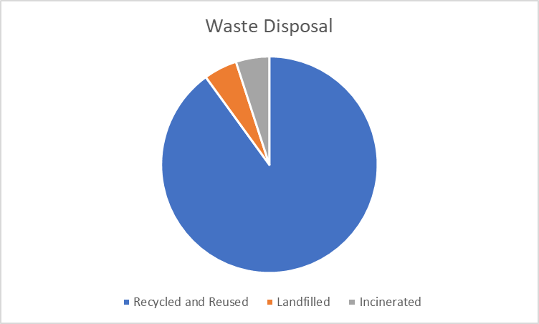
Pie Chart showing waste disposal at Nature Care.

2. Water Conservation
We understand the importance of taking care of our natural capital and so we endeavour to preserve and protect our resources. Therefore the water used in our business is solely from rain water. Our piping system allows water to be filtered so that the plants can be watered. This water is also used to flush the toilets and do basic clean up around the business. The water consumption in our business is high compared to other businesses but because of the nature of our business using water to water plants is inevitable so the system of recycling rain water has helped tremendously.
3. Energy Efficiency and Emission
At the startup of the business over twenty years ago, the company struggled to control its energy emission. However for the past fifteen years, the company has been using renewable energy through solar electricity. We are powered by solar and this has benefited the business as we do not have to pay any third party an electricity bill at the end of the month.
Challenges to sustainability at Nature Care
Like many businesses operating in a small island developing state like St. Vincent, there are lots of challenges to sustainability. Being a business that focuses on planting, Nature Care faces the challenge of climate change through hurricanes and uncertain weather patterns. While we are happy for the rains as it helps in our water conservation system, it can pose a threat because heavy rains can cause flooding and landslides and directly damage the plants in our nursery. Furthermore, even though we have a competitive advantage as we are the only plant nursery on the Leeward side of the island, many people opt to do their own plant nursery at home and so this means that we have to do lots of marketing to get people to buy our produce.
Nature care is nonetheless aware of these challenges but is confident that the opportunities for sustainability are overwhelming and will continue to be advocates of sustainability.
Recommendations
The following are recommendations in light of the challenges faced in sustainability.

- 1. Nature Care must be commended for its efforts to promote sustainability. Since there is a challenge as it relates to climate change it is recommended that Nature Care do more to educate the community and the country on the importance of sustainable living. At the consultations and workshops they have with their customers they can use this opportunity to make people aware of the impact of climate change on resources and what they can do as citizens to help in this fight.
- 2. It is also recommended that Nature Care SVG work as quickly as possible to ensure the realisation of its internal goal of using plants to make medicine. This is indeed a lucrative market and can help in the reduction of processed medicines.

Conclusion
Nature care SVG is indeed on the right path to sustainability through its initiatives, policies and processes. It has done well in fulfilling its responsibility to the environment and the society. Given that it operates in a world where resources are scarce and there are many uncertainties it has done well to overcome these challenges and have taken most of the opportunities they have to promote sustainability. Their concise yet deep policies to ensure that Agenda 2030 becomes a reality are noteworthy and if the recommendations given are followed Nature Care SVG will become an international name in why businesses can still maximise profits while adapting to sustainability.

References

Carr, J.A., Petrokofsky, G., Spracklen, D.V., Lewis, S.L., Roe, D., Trull, N., Vidal, A., Wicander, S., Worthington-Hill, J. and Sallu, S.M., 2021. Anticipated impacts of achieving SDG targets on forests-a review. Forest Policy and Economics, 126, p.102423.

Ceschin, F. and Gaziulusoy, I., 2016. Evolution of design for sustainability: From product design to design for system innovations and transitions. Design studies, 47, pp.118-163.

Dalampira, E.S. and Nastis, S.A., 2020. Mapping sustainable development goals: A network analysis framework. Sustainable Development, 28(1), pp.46-55.

Draper, S. (2015). Creating the Big Shift.

Evich, B., 2019. Agriculture Department buries studies showing dangers of climate change. POLITICO, June, 23.

Geza, W., Ngidi, M.S.C., Slotow, R. and Mabhaudhi, T., 2022. The dynamics of youth employment and empowerment in agriculture and rural development in South Africa: A scoping review. Sustainability, 14(9), p.5041.
Hart, S.L. and Milstein, M.B., 2003. Creating sustainable value. Academy of Management Perspectives, 17(2), pp.56-67.
Lauten-Weiss, J. and Ramesohl, S., 2021. The circular business framework for building, developing and steering businesses in the circular economy. Sustainability, 13(2), p.963.

Leal Filho, W., Raath, S., Lazzarini, B., Vargas, V.R., de Souza, L., Anholon, R., Quelhas, O.L.G., Haddad, R., Klavins, M. and Orlovic, V.L., 2018. The role of transformation in learning and education for sustainability. Journal of cleaner production, 199, pp.286-295.
Lewandowski, M., 2016. Designing the business models for circular economy—Towards the conceptual framework. Sustainability, 8(1), p.43.
Şahin, Z. and Çankaya, F., 2020. The importance of sustainability and sustainability reporting. In New Approaches to CSR, Sustainability and Accountability, Volume I (pp. 45-59). Springer, Singapore.
Sustainability Explained (2013), 4 Root causes of sustainability ,https://www.youtube.com/watch?v=2Gng0tfOuNM available from November 13th 2013, accessed on 4th October 2023.
TedExTalks. (2013) Business is about purpose: R. Edawrd Freeman at TEDx Charslottesville. January . Available at: https://www.youtube.com/watch?v=7dugfwJthBY (Accessed October 2021)

Thomas, G. and Anderson, R., 2011. Tomorrow’s Child
Vezzani, F.M., Anderson, C., Meenken, E., Gillespie, R., Peterson, M. and Beare, M.H., 2018. The importance of plants to development and maintenance of soil structure, microbial communities and ecosystem functions. Soil and Tillage Research, 175, pp.139-149.

Young, S.T. and Dhanda, K.K., 2012. Sustainability: Essentials for business. Sage Publications.

