Energy Efficiency In Buildings

Analysis of the building envelope at UWTSD Business Campus for U-Values

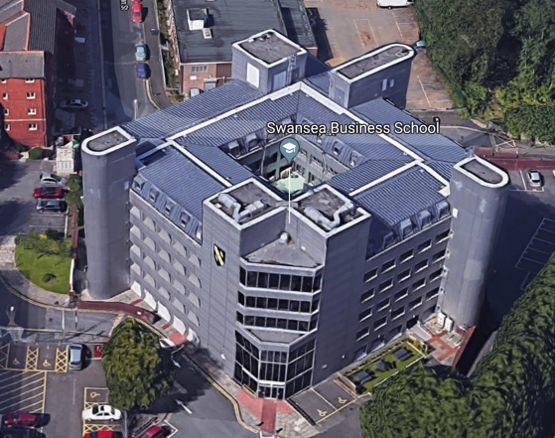

TAble of Contents
1.0 - Introduction
1.1 - Aims + objectives
1.2 - Rationale
2.0 - Methodology
2.1 - Case study
2.2 - Characteristics of the building
2.3 - Identification of current situation and construction method
2.4 - Calculations being used to calculate U-values
2.5 - Standardised values of LAMBDA table
2.6 - Building regulations for U-values
3.0 - Results + discussion
3.1 - Problems + limitations
4.0 - Conclusions
5.0 - References
6.0 - Appendix

1.0 – Introduction

1.1 – Aims + objectives

The aim of this report is to find out the thermal transmittance value of a building envelope over a number of different cross sections in order to evaluate if the thermal resistance and transmittance are to a high enough standard once compared with the building regulations.

1.2 – Rationale

This is important for a few reasons. One being an economic stand point of knowing how much energy is wasted through poor thermal transmittance and solving that to save energy therefore money. Another reason being due to global warming becoming a more major issue of the 21st century and this being one way we can access buildings into how they manage or use their energy by comparing it to the British standards recommended values.

2.0 – Methodology

2.1 – Case study

The building being assessed for this study will be the UWTSD Swansea Business School which is on the High Street of Swansea, SA1 1NE. This building was owned and used by the land registry office before they sold it and recladded the building in 2009 which is the year before the building regulations was updated in 2010. This will be interesting to note for the results as its possible the thermal transmittance could be of an acceptable level of the envelope once it was refurbished in 2009 but now it may be below standards due to the updated regulations. (Cenwyn Jones, Interview, Appendix A)

2.2 – Characteristics of the building

This building is used by the university for an education campus to teach students whom enrol themselves onto the business school’s courses. Due to it being a university campus we can expect this building to be a very actively used building with a heavy traffic of people coming in and out of the premises. This will mainly be by students, teaching staff and general UWTSD staff such as ground keepers. We can safely expect the rooms to be laid out to suit the narrative of teaching with computer rooms or normal teaching rooms with desks and chairs facing white boards.

A building providing a service like this will be open throughout the working week of Monday to Friday but possible also open on weekend for certain purposes. This is an important reason for why there are regulations on the construction industry to construct builds with in certain standards. As this building will be frequently used throughout the days of the week with such a vast number of occupants the energy consumption will also be high. Which is why these energy efficiency tests and standards like U-Values all play a role in maintain the efficiency of a buildings energy consumption saving money and helping the planet building by building.

2.3 – Identification of current situation and construction method

Different methods have been used in order to identify the current situation and construction methods. A visual inspection was carried out with a group of assessors on the 30th October 2018. This was to visually see and to calculate the amount of energy was being used in various rooms of the building as an estimate to get an understanding on the scale of how much energy could be used in the campus and how this could affect the university’s costs.

Another method was while carrying out the energy efficiency survey further information was gathered using thermal imaging by taking live photos of external walls, windows and various other elements of the building using a thermal camera. This was to show various information such as possible thermal bridges in exterior walls for example, heat loss through the roof or windows and it can be used for much more applications. The main purpose of it was to discover any heat loss or faulty cabling and thermal bridges which could be increasing the energy consumption of the building to more than it needed to be creating a poor efficiency in how the energy was being used.

The final method to be carried out was primary interviews which were conducted with the head of maintenance, Cenwyn Jones at the business campus. He couldn’t answer all of the questions for definite on what the buildings external walls were made from and the correct layering of materials. He did provide the information on the building being re-cladded in 2009 and the building was empty for about 4 years prior to the UWTSD moving in there. (Cenwyn Jones, Interview, Appendix A)

2.4 – Calculations being used to calculate U-values

In order to work out the thermal transmittance (U-value), the thermal resistance (R-value) must be worked out first. The thermal resistance is calculated by the thickness measurement of one material in meters divided by the materials LAMBDA value provided by the supplier which “is a measure of the thermal conductivity of a material, that is how easily heat passes across it.”(Designingbuildings.co.uk, 2019) Then repeating that for each layer of material from inside the building cross section outwards.

Once that is calculated all that needs to be done to calculate the U-value of the cross section which has been selected is to work out the value of “1 / (the sum of the R-values of the layers of the element + the resistance of the internal and external surfaces of the element)” (Designingbuildings.co.uk, 2019). This provides the result of that particular cross sections U-value which can be compared to the building regulations to see if the building is preforming at the recommended standard, better than that or even in some cases under standard.

2.5 – Standardised values of LAMBDA table

Appendix 4 shows a table of common building materials value of thermal conductivity also known as LAMBDA. This is needed for the calculation for the R-value helping get the result for the U-value. These values should always be found on the materials suppliers technical information data sheets.

2.6 – Building regulations for U-values

Building regulations regarding U-values are completely dependant on what country you are in as the UK has different standards for all countries within. Scotland has the strictest U-values most likely due to the weather normally being cold compared to England and Wales. Wales has the next best with England after that. These U-values are shown in Part L of the building regulations which can be found on the government’s website for building regulations.

There are four sub parts to this document one for new dwellings, another for existing dwellings, one for new buildings not used for dwellings and another one for existing buildings not used for dwellings. The Swansea Business Campus is an existing building which isn’t used for the purposes of a dwelling which falls under Part L2B.

Table 1 (Appendix 2) - (Gweddill.gov.wales, 2019)

Table 2 (Appendix 3 )- (Gweddill.gov.wales, 2019)

These tables show the welsh building standards for U-values for the type of building the university is. This is what the results gathered will be compared against to see if they are better and fine or worse and need some form of improvements to better the rating.

3.0 – Results + discussion

UWTSD Swansea Business Campus – Main Glass Curtain Entrance (South Facing)
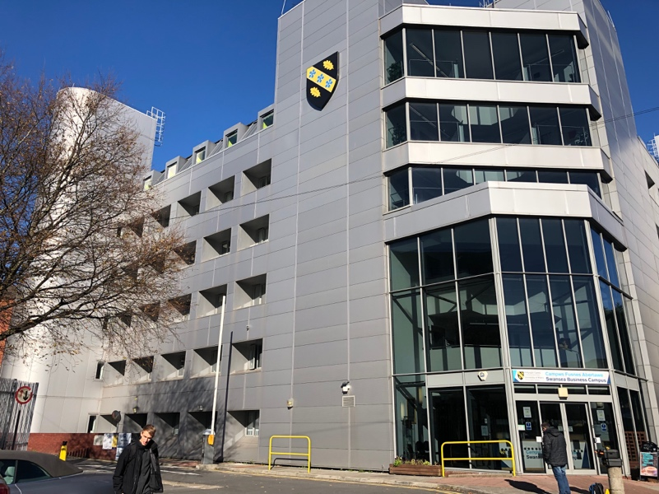
Main Glass Curtain Entrance
Cross Section  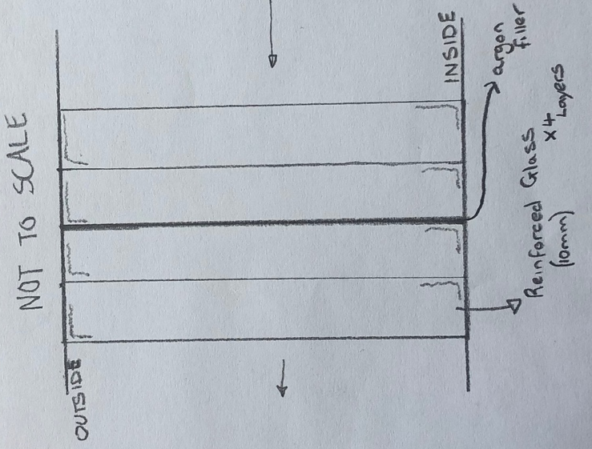 | Results and notes  After some research I’m led to believe the curtain wall of glass at the entrance is a thick impact resistant layer of smaller layers of glass and possibly plastic films to prevent glass going everywhere once broken.  R-value = (Glass) + (Glass) + (Argon Gas) + (Glass) + (Glass) = M2K/W  R-value = (0.010/1.05) + (0.010/1.05) + (0.020/0.016) + (0.010/1.05) + (0.010/1.05) = 1.289M2K/W  U-value = 1/1.289 = 0.78W/m2K  This reinforced glass curtain wall meets the correct criteria for U-values rating and as its impact resistant I’d not recommend changing anything as the glass is already of a good quality and value.

UWTSD Swansea Business Campus – Main Building Envelope (South-West Facing)
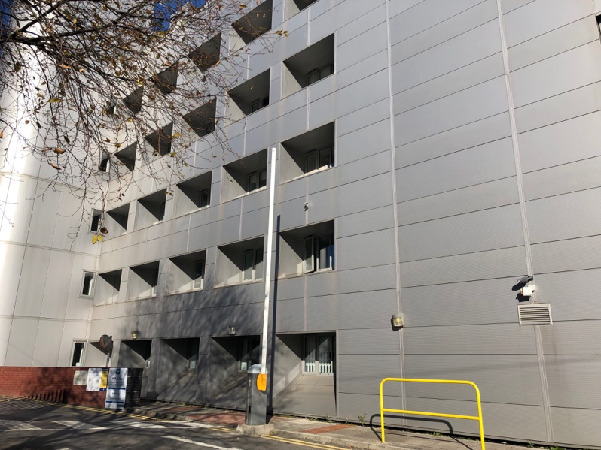
Main Buildings Envelope
Cross Section  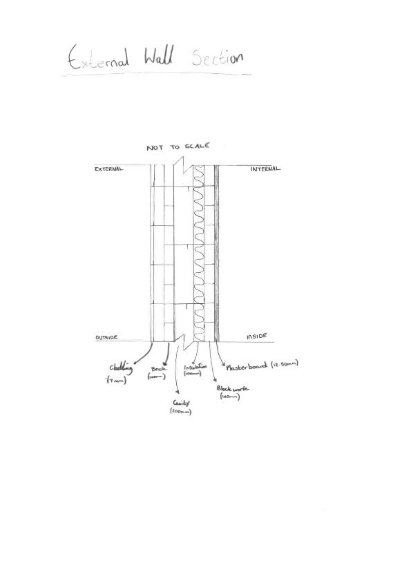 | Results and notes  R-value = (Platerboard) + (Brick) + (Insulation) + (cavity) + (Brick) = M2K/W  R-value = (0.0125/0.16) + (0.10/0.62) + (0.10/0.033) + (0.20) + (0.10/1.63) = 3.53M2K/W  U-value = 1/3.53 = 0.28W/m2K  Based on these results the external wall has a better U-value rating than the recommended value by the welsh building standards. This is a good result and is to be expected as the envelopes external walls at the university are thick suggesting U-values would be of a good level.  I wouldn’t recommend any improvements as the work required to improve the value would be to great considering it has already got a better standard, however if a better standard is needed id recommended increasing the thickness of insulation.

UWTSD Swansea Business Campus – External Window (South-West Facing)
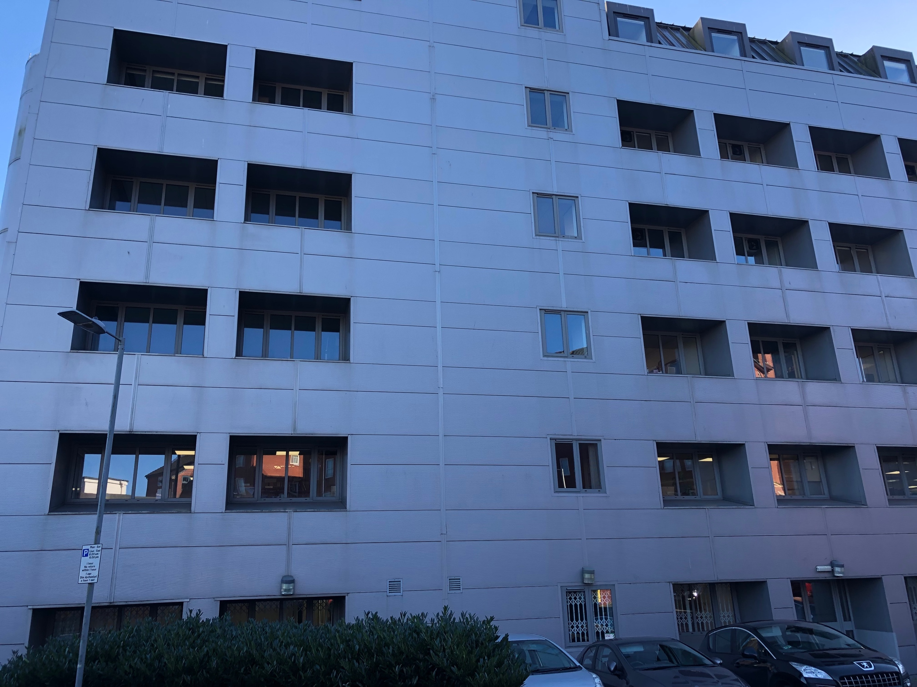
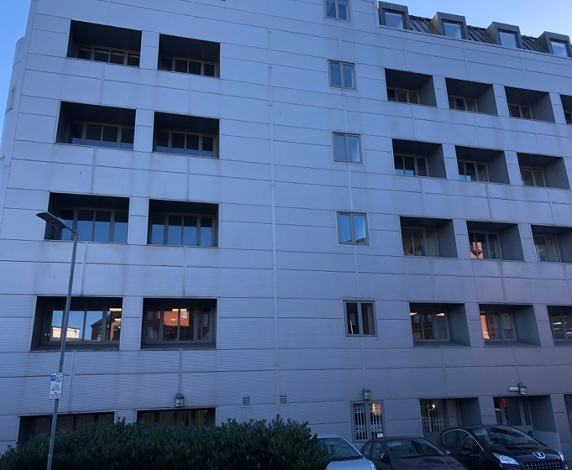
External Window
Windows Location
Cross Section  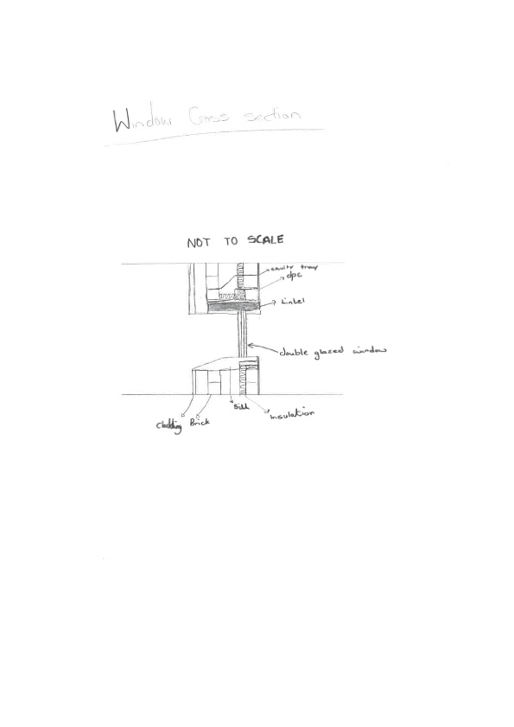 | Results and notes  R-value = (Window Glass 5mm) + (Vacuum) + (Window Glass) = M2K/W  R-value = (0.005/0.78) + (0.020) + (0.005/0.78) = 0.033M2K/W  U-value = 1/0.033 = 30.30W/M2K  Under the assumption the double-glazed window has a vacuum fill then the U-value rating isn’t up to par with current standards. I’d suggest changing the vacuum to be filled with argon gas allowing the U-value to improve as shown below.  Improved U-value:  R-value = (0.005/0.78) + (0.020/0.016) + (0.005/0.78) = 1.26M2K/W  U-value = 1/1.26 = 0.79W/M2K

UWTSD Swansea Business Campus – Main Flat Roof
Main Flat Roof of Building
(No image was able to be taken or provided due to access restrictions)
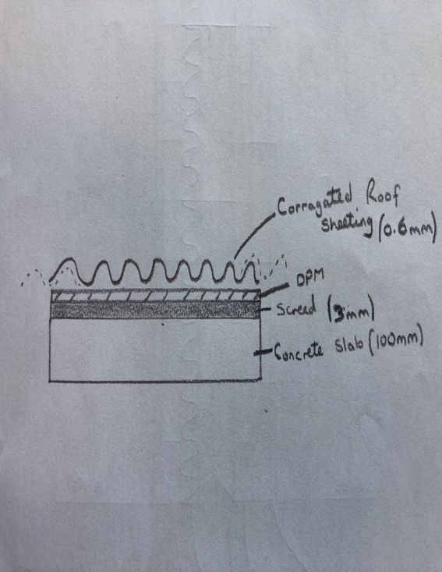  Cross Section | Results and notes  R-value = (Concrete Slab) + (Screed) + (DPM) + (Corrugated Steel Sheeting) = M2K/W  R-value = (0.10/0.16) + (0.003/0.41) + (0.0003/0.039) + (0.0006/50) = 0.64M2K/W  U-value = 1/0.64 = 1.56W/M2K  Based on my assumptions of the makeup of the roof materials while taking into account the age of the building. I believe these results reflect the value and show that it doesn’t conform to the standards set.  To Improve this a I’d recommended a 155mm layer of insulation in order for the U-value to hit the maximum standard.  Improved U-value:  R-value = (0.10/0.16) + (0.155/0.033) + (0.003/0.41) + (0.0003/0.039) + (0.0006/50) = 5.34M2K/W  U-value = 1/5.34 = 0.187W/M2K
Recommended Improved Cross Section
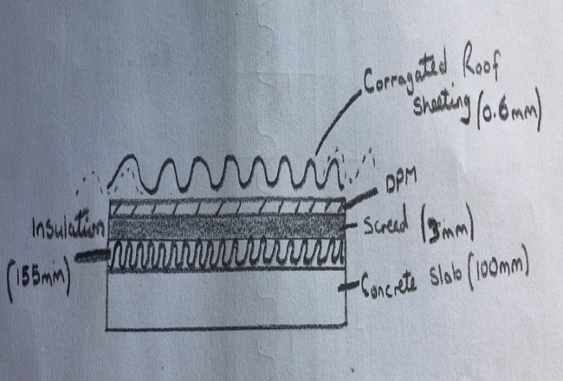

UWTSD Swansea Business Campus – Ground Floor Foundation
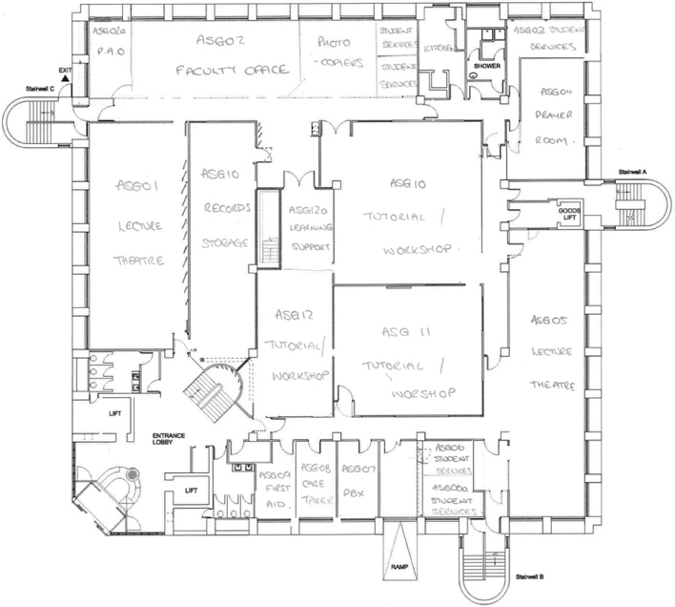
Ground Floor Plan (Provided by UWTSD)
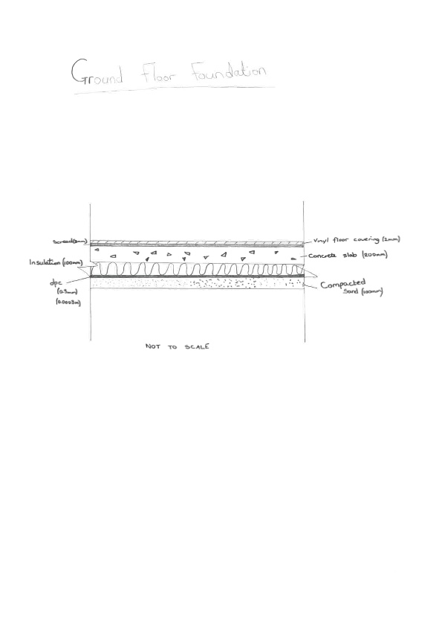  Cross Section | Results and notes  R-Value = (screed) + (Concrete) + (Insulation) + (DPC) + (Compacted Sand)  R-value = (0.003/0.41) + (0.20/0.16) + (0.10/0.033) + (0.0003/0.039) + (0.10/0.50) = 4.5M2K/W  U-value = 1/4.5 = 0.20W/m2K  Based on these results the ground floor foundation has a slightly better U-value rating than the recommended value by the welsh building standards.  I would recommend any improvements as the floor already has a better standard however, in the future if the value becomes worse due to the British standard improving then an easy solution is to apply either a thicker screed with possible a DPM and a thin layer of insulation under the DPM.

UWTSD Swansea Business Campus – External Stairwell Wall
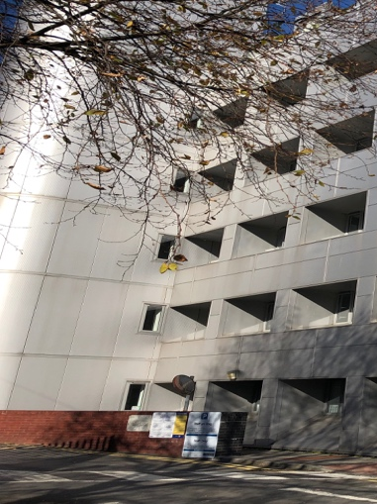
Figure 7 – External Stairwell Wall
Cross Section  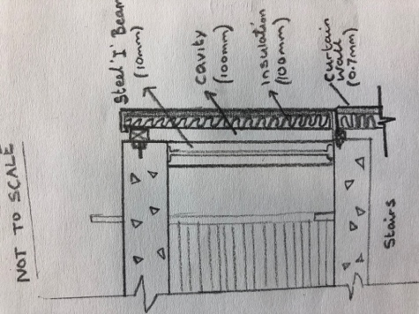 | Results and notes  R-value = (Plasterboard) + (Steel I Beam) + (Cavity + (Insulation) + (Cladding) = M2K/W  R-value = (0.0125/0.16) + (0.010/0.50) + (0.10) + (0.10/0.033) = 3.23M2K/W  U-value = 1/3.23 = 0.31W/M2K  The external partition type wall for the external stairwell conforms with in the welsh standards of U-values based on the assumption of the materials making up the cross section.  There isn’t any need to make changes to this external wall however, if any changes were to be carried out I would apply an additional layer of insulation into the cavity filling it up helping to provide heat loss.

UWTSD Swansea Business Campus – External Stairwell Roof
External Stairwell Roof
(No image was able to be taken or provided due to access restrictions)

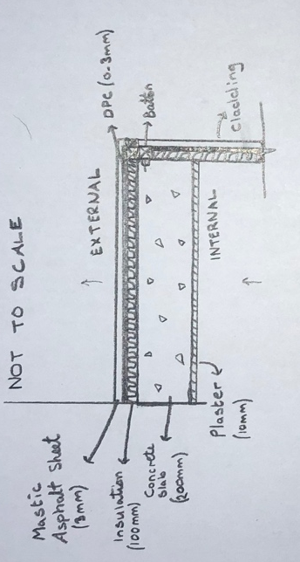  Cross Section | Results and notes  R-value = (Plaster) + (Concrete Slab) + (Insulation) + (DPC) + (Mastic Asphalt) = M2K/W  R-value = (0.010/0.46) + (0.20/0.16) + (0.10/0.033) + (0.0003/0.039) + (0.003/0.50) = 4.316M2K/W  U-value = 1/4.316 = 0.232W/M2K  The U-value for this cross section is more than the maximum level of thermal transmittance. The value doesn’t need to be reduced by much so for an easy solution is for a layer of insulation in between the ceilings plaster and roofs main concrete slab, bring the value to where it needs to be helping retain heat with in this part of the building.  Improved U-value:  R-value = (0.010/0.46) + (0.10/0.033) + (0.20/0.16) + (0.10/0.033) + (0.0003/0.039) + (0.003/0.50) = 7.346M2K/W  U-value = 1/7.346 = 01362W/M2K
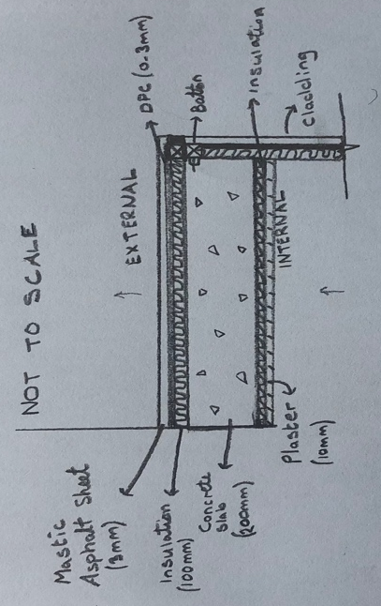
Recommended Improved Cross Section

3.1 – Problems + Limitations

The main problem with in the assessment was the fact that a lack of information of the buildings exact materials used for the envelope was accessible. This has limited the report as assumptions have had to be made for what the cross sections of the envelope is constructed from and what thicknesses. This does mean the results found aren’t accurate and realistically need to be done again with more information on this matter. Both university campuses, Business and architecture campuses did not have any drawings of these which were needed, grounds keepers as mentioned in the interview conducted didn’t have a complete understanding either, therefore as much as possible was done to uncover this information which is why the assumptions were made.

For further reports of analysing building envelopes for U-values, the process would be made smoother if there were accurate drawings representing the cross sections needed made by the contractor whom carried out the works of construction accessible to the surveyor.

4.0 – Conclusions

My conclusion based on the UWTSD Business campus’s envelope that the majority of the building completely conforms to the Welsh governments U-value standards which was to be expected due to the building having a refurbishment back in 2009.

There were two elements that didn’t meet the standard, however, were not far out making the changes needed in order to make them follow suit relatively easy as not much work would need to be done. This was to be expected also as the British standards updated the year after refurbishment meaning any values changed slightly could have impacted the building.

On the whole the campus is running at a good thermal transmittance level meaning they are able to use their energy more efficiently there keeping costs down and have heating last longer. This does also help in the summer as any heat entering in from the sun’s rays would last longer and take a longer duration of time to transmit out of the building.

These are the standards and practices that should be implemented and improved over the years as it would bring a more eco-friendly future and industry which is what is wanted in this modern time with global warming occurring.

5.0 – References

Designingbuildings.co.uk. (2019). K-value - Designing Buildings Wiki. [online] Available
at: https://www.designingbuildings.co.uk/wiki/K-value [Accessed 26 Mar. 2019].

Designingbuildings.co.uk. (2019). R-value - Designing Buildings Wiki. [online] Available at: https://www.designingbuildings.co.uk/wiki/R-value [Accessed 26 Mar. 2019].

Designingbuildings.co.uk. (2019). Thermal conductivity - Designing Buildings Wiki. [online] Available at: https://www.designingbuildings.co.uk/wiki/Thermal_conductivity [Accessed 1 Apr. 2019].

Gweddill.gov.wales. (2019). [online] Available at: https://gweddill.gov.wales/docs/desh/publications/171108building-regs-approved-document-l2b-existing-buildings-other-than-dwellings-en.pdf [Accessed 29 Mar. 2019].

6.0 – Appendix

Appendix 1 – Cenwyn Jones Interview

Interviewer(s): Lewis Williams + Adam Meyrick
Interviewee: Cenwyn Jones (Head of Estates at UWTSD Business Campus)

Question 1: When was the structures current cladding implemented?
Answer: The building has had it’s cladding changed more than once in it’s
lifecycle however, the current installation was installed about 10 years ago in 2008/2009.

Question 2: What are the buildings current and previous usages?
Answer: The current structure serves as a place of education for the UWTSD students,
but previously was the land registry office, it was then left disused for 4 years before
being bought by the UWTSD.

Question 3: Are there any construction details for the cladding available?
Answer: There are details relating specifically to the buildings cladding but are difficult
to obtain. A cladding report was ordered after the Grenfell disaster completed last
year (2018) by a relevant Health & Safety Officer.

Appendix 2 – U-value Table (Gweddill.gov.wales, 2019)
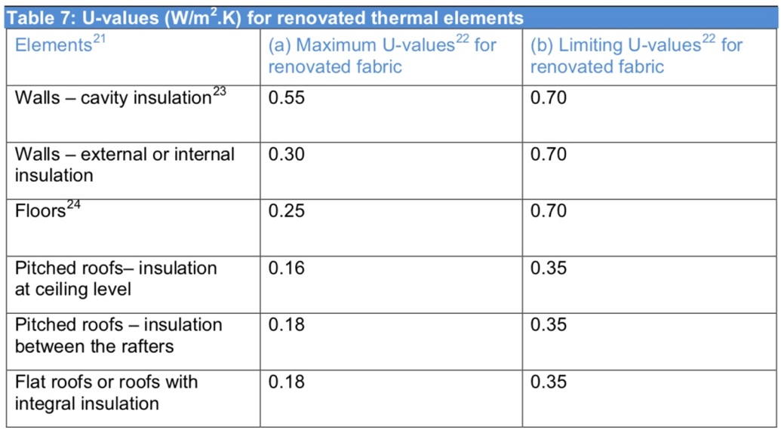

Appendix 3 – U-value Table (Gweddill.gov.wales, 2019)
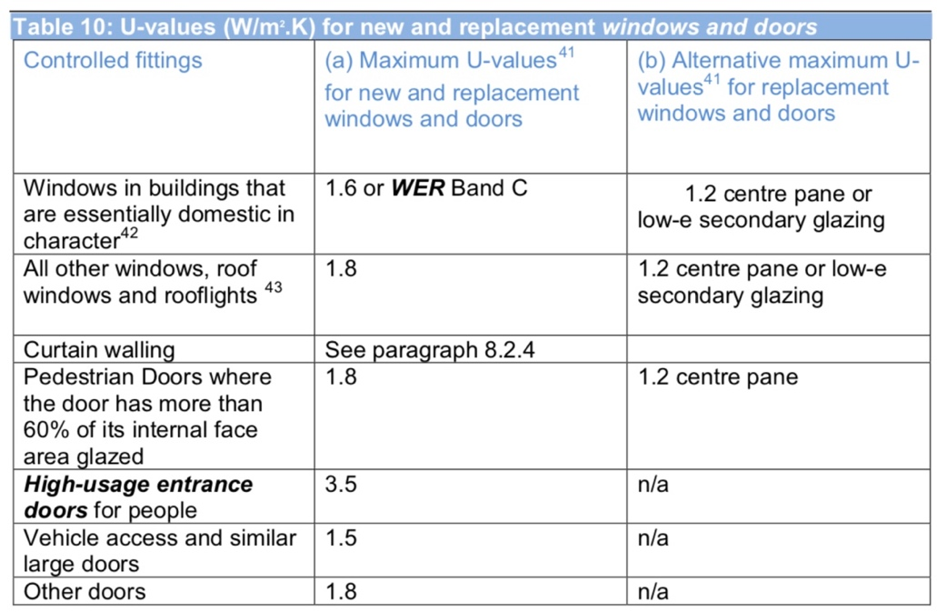

Appendix 4 – Thermal Conductivity Table

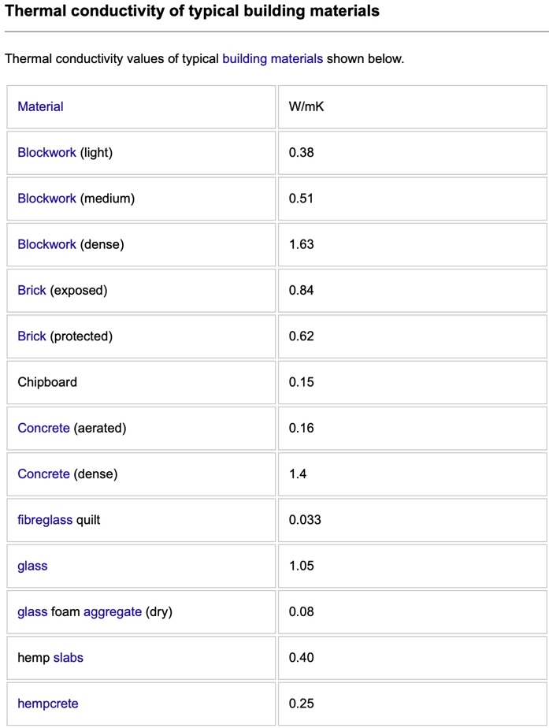
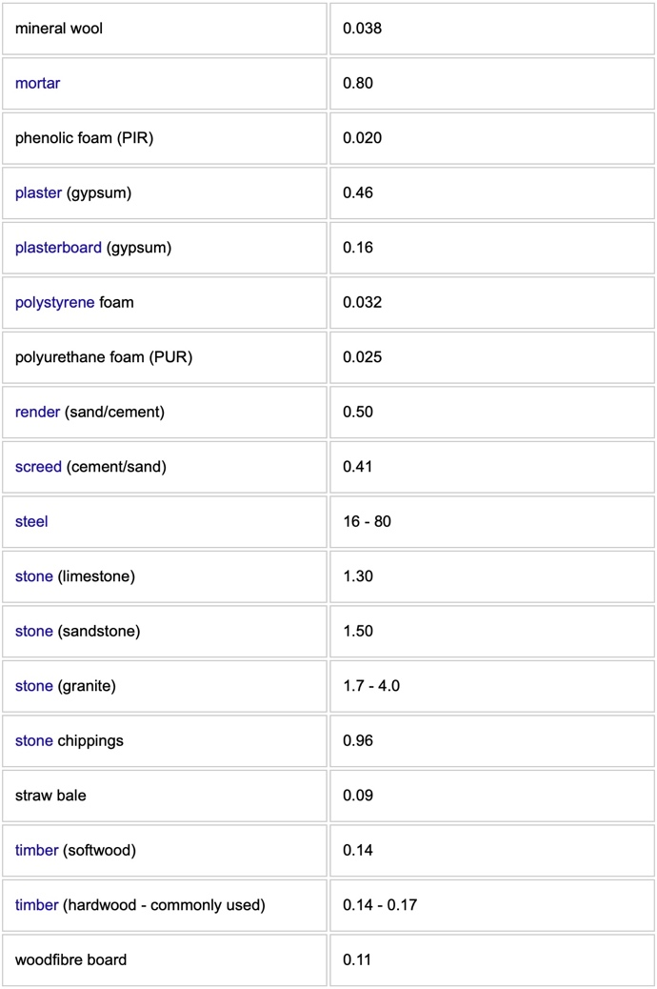

(Designingbuildings.co.uk, 2019)

