

Applied Leadership and Management in the Workplace
Module Assignment
Student Name: | Carla O’Keefe
Student Number: | 2433175
Module No: | BMSK4013
Module Title: | BMSK4013 – Management Communication
Statement of Confirmation of Authenticity
By the act of making this submission, the student declares that this is the work of the student named above. The work has not, in whole or in part, been knowingly presented elsewhere for assessment, or where assessment has been built on a previous assessment, this has been identified. Where materials have been used from other sources it has been properly acknowledged. If this statement is untrue, the student acknowledges that an assessment offence has been committed.
Attention is drawn to the plagiarism and unfair practice policies of both the University and of ILM

Table of Contents
- Introduction – p.3
1.1 Purpose of the Report
1.2 The Communication Cycle: Definition and Stages
• Idea/Aim
• Encoding
• Transmission/Channel
• Reception
• Decoding
• Understanding
• Feedback
- The Relevance of the Communication Cycle in Management – p.4
2.1 Ensures Clarity and Purpose
2.2 Facilitates Appropriate Channel Selection
2.3 Promotes Active Listening and Understanding
2.4 Enables Feedback and Continuous Improvement
2.5 Supports Motivation and Engagement
2.6 Identifies and Addresses Communication Barriers
2.7 Reflection
- Types of Communication Models – p.5
3.1 Definitions and Applications
- Tone, Language, and Formality in Recruitment Communication – p.6
4.1 Importance of Tone
• Positive and Professional Tone
4.2 Use of Appropriate Language
• Jargon vs. Clarity
4.3 Matching the Level of Formality to Context
- Types of Communication in Recruitment – p.9
5.1 Verbal Communication – p.9
• Face-to-Face Meetings/Interviews
• Phone Calls
• Video Calls
5.2 Written Communication – p.10
• Emails
• Job Descriptions and Adverts
• Text Messaging and Chat Platforms
• Reports and Internal Notes
- My Recommendations for Effective Communication – p.11
6.1 When to Use Verbal vs. Written Communication
6.2 Best Practices for Combining Communication Modes
- Motivation in the Workplace – p.11
7.1 Definition and Importance
7.2 Theories of Motivation
• Maslow’s Hierarchy of Needs
• Herzberg’s Two-Factor Theory
• McClelland’s Theory of Needs
• McGregor’s Theory X and Theory Y
- Intrinsic vs. Extrinsic Motivation – p.13
8.1 My Primary Motivator: Maslow’s Hierarchy
8.2 Assertive Communicator Profile
• Questionnaire Methodology
• Results and Interpretation
8.3 Assertive Communicator
- Self-Evaluation as a Manager – p.15
- Reflection – p.16
- Personal Development Plan – p.16
- Reflection – p.17
- Conclusion – p.18
- References – p.18

Management Report on Communication and Motivation in the Recruitment workplace.

1. Introduction
In recruitment, communication is at the heart of every process—from sourcing candidates to negotiating offers and onboarding new hires. Recruitment consultants, hiring managers, and HR professionals must communicate effectively with diverse stakeholders including job applicants, employers, internal teams, and external vendors. Communication that is clear, audience-appropriate, and motivating can improve candidate experience, client satisfaction, and team performance. (Guffey & Loewy, 2021; Robbins & Judge, 2019). This report evaluates key communication elements—tone, language, formality, structure, and delivery mode—in recruitment environments and discusses their effect on stakeholder motivation and outcomes.
1.1 Purpose
Effective communication is fundamental to successful management. It underpins organisational performance, enhances motivation, and fosters strong working relationships. The communication cycle provides a structured framework for understanding and improving communication processes within management contexts
1.2 The Communication Cycle: Definition and Stages
The communication cycle is a process that describes how information is transmitted from sender to receiver, ensuring the intended message is delivered, understood, and acted upon. Most models identify six or seven key stages:
- Idea/Aim: The sender formulates the intention or purpose behind the communication.
- Encoding: The sender translates the idea into a message, choosing appropriate language, tone, and medium.
- Transmission/Channel: The message is sent through a selected channel (e.g., email, meeting, report).
- Reception: The receiver receives the message.
- Decoding: The receiver interprets and processes the message.
- Understanding: The receiver comprehends the message as intended.
- Feedback: The receiver responds, providing feedback that completes the cycle and informs the sender of the message’s effectiveness

2. The relevance of the Communication Cycle in Management
2.1 Ensures Clarity and Purpose
The communication cycle emphasises the need for a clear aim and careful encoding of messages. Managers must tailor their communication to the audience and context, ensuring that the message is relevant and easily understood. This reduces ambiguity and minimizes misinterpretation, which is critical for effective decision-making and direction.
2.2 Facilitates Appropriate Channel Selection
Selecting the right communication channel is essential. The cycle prompts managers to consider whether information is best conveyed through written, verbal, or nonverbal means, and to match the channel to the sensitivity and complexity of the message.
2.3. Promotes Active Listening and Understanding
By highlighting decoding and understanding as distinct stages, the communication cycle encourages managers to be attentive to how their messages are received. This includes being aware of potential barriers such as language differences, cultural factors, or emotional states that may hinder understanding.
2.4 Enables Feedback and Continuous Improvement
Feedback is a crucial element of the communication cycle. It allows managers to assess whether their message was understood as intended and to make necessary adjustments. This iterative process helps refine communication skills and fosters a culture of openness and mutual respect.
2.5 Supports Motivation and Engagement
Effective communication, as structured by the communication cycle, is linked to higher employee motivation and engagement. When employees feel that communication is two-way and their feedback is valued, they are more likely to be committed and perform well.
2.6 Identifies and Addresses Communication Barriers
The communication cycle provides a mechanism for managers to identify where breakdowns occur—often during encoding, decoding, or feedback stages—and to implement strategies to overcome these barriers, such as clarifying messages, encouraging questions, or adapting communication styles.
2.7 Reflection:
By applying the principles of the communication cycle, managers can enhance organisational performance, motivation, and workplace relationships.
3. Types of communication models:
Below are the different types of Models that can managers and organisations improve clarity, reduce misunderstandings, and foster effective interactions. I have also highlighted what the meaning is of each individual model and the relevant elements they refer to and included credible sources to reference my findings.
3.1 Definitions & Applications
Model | Description | Elements
Shannon-Weaver | Communicates as a linear, one-way process from sender to receiver. Developed in 1949, the Shannon-Weaver model concepts communication as a one-way, linear process involving a sender, encoder, channel, decoder, and receiver, with "noise" potentially distorting the message (Shannon & Weaver, 1949). While foundational, it lacks attention to feedback and context, making it suitable for mass communication but limited for interactive dialogue (Foulger, 2004). | Sender, Encoder, Channel, Decoder, Receiver, Noise
Berlo’s SMCR | Expands on Shannon-Weaver, emphasising the influence of source, message, channel, and receiver. Berlo’s (1960) SMCR model builds on Shannon and Weaver’s framework by emphasising the roles of source, message, channel, and receiver, along with encoding and decoding. It draws attention to the influence of communication skills, attitudes, and social systems but still treats communication as primarily linear and unidirectional (McQuail & Windahl, 2015). | Source, Message, Channel, Receiver; includes encoding/decoding
Lasswell | Focuses on "Who says what in which channel to whom with what effect?" Lasswell’s (1948) model is structured around the question: "Who says what in which channel to whom with what effect?" It is particularly relevant to media and political communication, although it neglects feedback and contextual variables (Briggs & Burke, 2009). | Sender, Message, Channel, Receiver, Effect; linear, lacks feedback/noise
Osgood-Schramm | Introduces feedback, making communication cyclical and reciprocal. The Osgood-Schramm model introduced a cyclical perspective, suggesting that communication is a two-way process with both parties acting as encoder and decoder in turn. Feedback and mutual understanding are central components, making it suitable for interpersonal and managerial communication (Osgood & Schramm, 1954). | Encoder/Decoder (roles switch), Message, Feedback, Noise
Westley & Maclean | Highlights feedback and the influence of context and environment. This model extends the cyclical concept by incorporating environmental factors and multiple sources of information. It reflects the complexity of modern communication in organisations, accounting for both feedback and the dynamic influence of context (Westley & Maclean, 1957). | Source, Encoder, Message, Decoder, Receiver, Feedback, Context
Transactional | Views communication as simultaneous, with all parties as communicators, not just senders/receivers. The transactional model views communication as simultaneous and ongoing, with participants continuously encoding, decoding, and interpreting messages. It includes noise, feedback, and shared context, representing the most realistic depiction of communication in management and teamwork (Barnlund, 2008). | Communicators, Encoding, Decoding, Message, Channel, Feedback, Noise, Conte

4. Appropriate Tone, Language, and Level of Formality in the Recruitment workplace and examples:
4.1 Importance of Tone
Tone influences how messages are perceived and affects relationships with candidates and clients. In recruitment, an encouraging and professional tone is essential when delivering interview feedback or job offers.
Example:
- When providing constructive feedback to a candidate who was not selected, a recruitment consultant should adopt a supportive and respectful tone, emphasising development opportunities to maintain goodwill and protect the agency’s reputation.
- Conversely, a decisive and confident tone is required when advising a client on a shortlisted candidate to reflect authority and expertise.
4.2 Use of Appropriate Language
Language in recruitment must balance professionalism with accessibility. Overly complex HR jargon can confuse candidates, while casual language may appear unprofessional to clients.
Example:
- For candidates, recruitment professionals should use clear, jargon-free language when describing job roles or explaining interview processes.
- With HR professionals or hiring managers, the use of industry-specific terminology such as “time-to-hire” or “candidate pipeline” is appropriate and efficient (Daft & Marcic, 2020).
4.3 Formality
The recruitment process involves communication across varying levels of formality. Formality must match the situation to ensure credibility and rapport.
Example:
- A formal email is appropriate when sending a client, a CV shortlist or contract details.
- An informal Slack message or internal chat may be used between recruitment consultants to discuss candidate availability or interview scheduling.
5. Modes of Communication in Recruitment
Recruitment requires a variety of communication channels:
- Video or face-to-face: For interviews, onboarding, or resolving disputes.
- Phone calls: For discussing offers or urgent client updates.
- Video calls: Teams/ Zoom
- Instant messaging apps (e.g., Teams, WhatsApp): For scheduling or casual check-ins.
- Recruitment CRMs and applicant tracking systems (ATS): For documenting communication history.
Example:
- A recruiter may email a contract to a successful candidate, follow up with a congratulatory phone call, and later send onboarding details via the company’s ATS.
Using the appropriate channel enhances efficiency and professionalism while supporting motivation and engagement (Daft & Marcic, 2020).
5.1 Types of verbal communication in my recruitment workplace:
Face-to-Face Meetings / Interviews
Assessment: Evaluate tone, clarity, confidence, and active listening.
Advantages: Builds trust and rapport. Immediate feedback.
Disadvantages: Time-consuming. May be intimidating for some candidates.
Appropriate? Yes, especially for final stage interviews
What Works? Eye contact, clear questions l-stage interviews., active listening.
What Doesn’t? Interrupting, unclear or biased language.
Phone Calls
Assessment: Listen for tone, pace, and understanding. Advantages: Quick, accessible. Suitable for initial screening.
Disadvantages:
Lacks visual cues. Prone to distractions.
Appropriate? Yes, for quick follow-ups or screenings.
What Works? Structured scripts, warm tone.
What Doesn’t? Monotone delivery, unclear purpose.
Video Calls (Zoom/Teams)
Assessment: Watch for non-verbal cues and tech comfort.
Advantages: Combines visual and verbal cues. Cost-effective for remote hiring.
Disadvantages:
Tech issues. Harder to build rapport than in-person.
Appropriate? Yes, for remote interviews or collaboration.
What Works? Good lighting, stable connection, eye contact.
What Doesn’t? Poor audio, unpreparedness.
5.2 Types of written communication in my recruitment workplace:
Emails
Assessment: Review tone, grammar, and structure.
Advantages: Documented trail. Easy to share and forward.
Disadvantages:
Misinterpretation of tone. Delayed responses.
Appropriate? Yes, for confirmations, offers, updates.
What Works? Clear subject lines, concise body, professional tone.
What Doesn’t? Overuse of jargon, vague messages.
Job Descriptions and Adverts
Assessment: Analyse clarity, inclusivity, and accuracy.
Advantages: Sets expectations. Attracts the right candidates.
Disadvantages:
Poorly written ads deter talent.
Appropriate? Yes, as a first touchpoint.
What Works? Clear requirements, inclusive language.
What Doesn’t? Bias, outdated language, too generic.
Text Messaging / Chat Platforms (Slack, WhatsApp)
Assessment: Check for clarity, brevity, appropriateness.
Advantages: Fast, informal. Good for quick updates.
Disadvantages:
Not suitable for complex or sensitive topics.
Can blur professional boundaries.
Appropriate? Sometimes, for quick check-ins or availability updates.
What Works? Short, polite, time-appropriate messages.
What Doesn’t? Emojis/slang in formal communication, ambiguity.
Reports and Internal Notes (e.g., candidate assessments)
Assessment: Look for objectivity, structure, and completeness.
Advantages: Supports decision-making. Useful for audits or reviews.
Disadvantages:
Can be time intensive. Risk of bias if poorly written.
Appropriate? Yes, for structured candidate evaluation.
What Works? Standardised formats, clear scoring.
What Doesn’t? Vague comments, subjective language.
6. My recommendations
6.1 Use verbal communication for nuanced discussions, especially where empathy and trust are crucial.
Use written communication where clarity, record-keeping, or wide distribution are priorities.
6.2 Combine both for a balanced process: e.g., call to follow up an email, or summarise a call in writing.
7. Motivations in the workplace
7.1 Motivation is the the internal or external drive that initiates, directs and sustains goal-directed behaviours. In the workplace, motivation influences how hard a person works, how persistent they are, and how committed they remain to their job or goals.
Robbins & Judge (2019) define motivation as "the processes that account for an individual’s intensity, direction, and persistence of effort toward attaining a goal.
7.2 Theories of Motivation:
Maslow’s Hierarchy of Needs (1943)
Theory: Human needs are arranged in a hierarchy from basic to complex:
- Physiological (food, salary)
- Safety (job security)
- Love/Belonging (team cohesion)
- Esteem (recognition)
- Self-Actualisation (personal growth). Maslow, A.H. (1943).
Strengths:
- Highlights that basic needs must be met first.
- Useful for designing progressive workplace rewards.
Conflict:
- Not always linear – needs may overlap.
- May not apply cross-culturally.
- Self-actualisation is vague and difficult to measure.
Herzberg’s Two-Factor Theory (1959)
Theory: Motivation is influenced by two factors:
- Hygiene Factors (e.g. salary, company policies) → prevent dissatisfaction.
- Motivators (e.g. recognition, achievement) → increase satisfaction. Herzberg, F., Mausner, B., & Snyderman, B.B. (1959).
Strengths:
- Separates what causes dissatisfaction from what creates motivation.
- Useful for improving job design.
Conflict:
- Overlooks individual differences.
- Based heavily on self-reports, which may be biased.
McClelland’s Theory of Needs (1961)
Theory: Motivation is based on three dominant needs:
- Need for Achievement (nAch): desire to excel.
- Need for Power (nPow): desire to influence others.
- Need for Affiliation (nAff): desire for friendly relationships. McClelland, D.C. (1961). "The Achieving Society."
Strengths:
- Explains personalized motivation strategies.
- Effective in leadership development.
Conflict:
- Difficult to measure dominant needs reliably.
- May not capture all motivational drivers.
McGregor’s Theory X and Theory Y (1960)
Theory:
- Theory X: People are lazy, dislike work, and need control.
- Theory Y: People are self-motivated and seek responsibility. McGregor, D. (1960).
Strengths:
- Encouraged participative management styles (Theory Y).
- Challenged old, rigid assumptions about workers.
Conflict:
- Too simplistic – not all employees fit neatly into one category.
- Doesn’t explain how to change from X to Y behaviour.
8. Intrinsic vs. Extrinsic Motivation

Intrinsic Motivation
- Driven by internal rewards—personally satisfied, interest, or passion.

Extrinsic Motivation
Driven by external rewards—money, praise, promotions, or avoiding negative consequences.

8.1. My Primary Motivator - What motives me as a recruiter.

Type | Description | Personal Examples | Colleagues Examples
Intrinsic | Comes from within the individual. Driven by personal satisfaction. | I enjoy solving hiring challenges because it’s intellectually rewarding. | Karens motivation is self driven and often leads to long term satisfaction
Extrinsic | Comes from external rewards or pressures. | I would work harder to hit targets for a bonus or promotion. | Karen is motivated by money and is reward driven

8.2. My personal motivator: Maslow’s Hierarchy
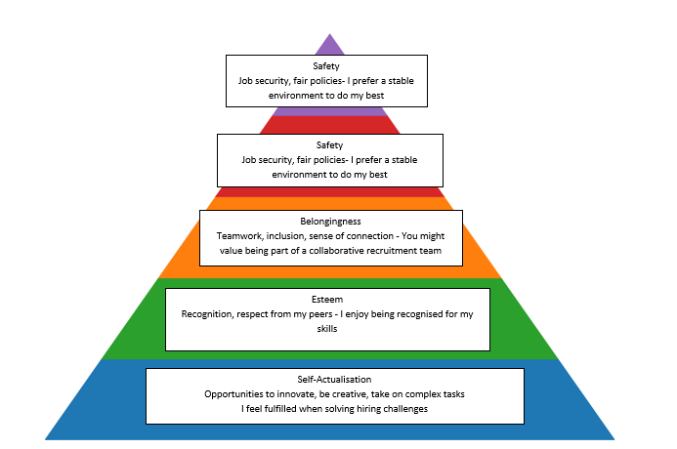
(The desire for personal growth, creativity, and problem-solving.)
Physiological Needs Basic salary, working conditions These need to be met, but they’re not my main driver

8.3 Assertive Communicator:
From creating a questionnaire with several colleagues in my workplace I was seen to be an Assertive Communicator.
Methodology
A 10-item communication style questionnaire was administered, each question offering four multiple-choice options corresponding to the four main styles. With an example of some questions highlighted below:
  - How do you express disagreement in a conversation?
  - 2How do you ask for help?
  - When your angry what do you do?
  - In group discussions how do you participate?
Each answer was mapped as follows:

A = Passive
B = Aggressive
C = Passive-Aggressive
D = Assertive
Results
Out of the 10 questions answered, the response distribution was as follows:
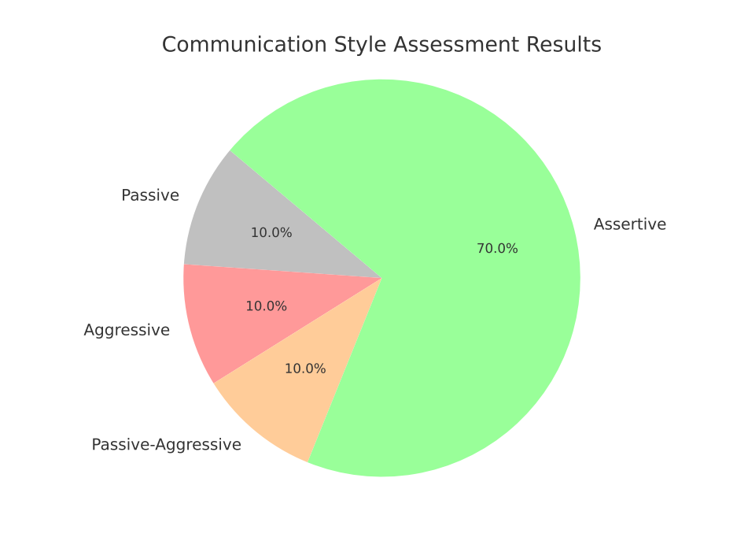
9. Self-Evaluation of communication skills as a manager:
I believe I am a confident and assertive communicator who values clarity, respect, and active listening. I create a psychologically safe environment where team members are encouraged to speak up. However, as a growing leader, I recognise the need for continuous improvement in written tone, emotional intelligence, and maximising inclusivity in communication—particularly in hybrid or digital spaces.

10. Reflection
Through evaluating my verbal and written communication skills, I have been able to identify key areas for development. This has enabled me to create a focused Personal Development Plan to strengthen my capabilities as a manager and elevate my communication skills to a more advanced and impactful level.
11. Personal Development Plan
PDP | Strength | Area for Improvement | Goal Example
Physiological | *Communicating physical needs clearly  *Advocating for regular breaks | Maintain healthy routines with boundaries.  Balancing screen time and rest | Say "no" when tired  Schedule daily digital detox time
Safety | *Boundary setting  *Awareness of personal limits | Conflict resolution, financial talk  Risk assessment and proactive planning | Attend workshops  Use a planner to foresee stress triggers
Love & Belonging | *Honest, respectful communication  *Building trust with others | Active listening,  Develop emotional intelligence, ensure to be empathetic | Practice empathy  Practice patients, take a short EI course or read relevant books
Esteem | *Confidence and assertiveness  *Setting personal standards | Seeking feedback, affirmations.  Avoid comparison | Be consistent with writing weekly journals.  Track progress only against personal goals
Self-Actualisation | *Clear purpose and independence  *Create value for others | Leadership, purpose-driven speaking  Mentor or coach others | Lead a workshop  Volunteer with leadership and team bonding workshops

12. Reflection
Through my exploration of communication within the recruitment environment, I’ve come to realise that effective communication isn’t just a soft skill—it’s a strategic tool that directly shapes outcomes for candidates, clients, and internal teams. Applying the communication cycle in real scenarios—from encoding messages to gathering feedback—has deepened my understanding of how crucial it is to tailor language, tone, and delivery methods to suit each unique context.
In my own practice, I’ve witnessed how unclear or poorly timed communication can demotivate candidates or cause unnecessary friction with clients. On the other hand, clear, empathetic messaging builds trust and improves engagement—particularly when discussing feedback or managing expectations.
Exploring different communication models, such as Shannon-Weaver, Berlo, Osgood-Schramm, and the Transactional model, has helped me appreciate how communication theory has evolved. I personally relate most to the Transactional model because it mirrors the fast-paced, two-way interactions I regularly experience in recruitment—where feedback, tone, and interpretation shift constantly across email, calls, and messaging platforms.
Reflecting on tone, formality, and language choices, I now better understand the importance of striking the right balance between professionalism and accessibility. For example, overly formal communication with candidates can come across as distant, whereas being too informal with clients might unintentionally reduce my credibility. I’ve found that adapting my style to the specific audience and situation makes my communication clearer and more motivational.
In the workplace, motivation theories—especially Maslow’s Hierarchy and Herzberg’s Two-Factor Theory—resonated with my own professional journey. I am strongly motivated by personal development, problem-solving, and the satisfaction of helping others succeed. However, I also recognise the role that external factors like recognition, career progression, and team feedback play in driving my engagement and performance. Understanding that different team members are motivated by different things has also shaped how I communicate with colleagues—whether through praise, providing autonomy, or offering clarity on expectations.
Lastly, completing the communication style questionnaire confirmed that I lean towards an assertive communication style, which aligns well with my aspirations to grow into a stronger managerial role. It reaffirmed my strengths in being clear, fair, and confident in how I communicate. At the same time, it also highlighted areas where I can improve—particularly in refining my emotional intelligence and ensuring that my communication remains inclusive, especially in hybrid or digital workspaces.

Conclusion
In conclusion, communication in recruitment is multi-faceted and pivotal to achieving successful outcomes across all stages of the hiring process. Mastery of communication elements—tone, structure, channel, and audience awareness—greatly enhances stakeholder satisfaction and organisational performance. By integrating communication theories, especially the communication cycle and transactional model, recruiters and managers can foster clearer understanding, reduce misunderstandings, and build stronger relationships.
Going forward, my aim as a recruitment professional and manager is to continuously refine my communication skills—particularly in written tone and inclusive language—and to lead by example in fostering a culture where open, adaptive, and motivational communication is the norm. This reflection has reinforced that great communication is not just about speaking—it’s about connecting with intention and impact.

References
Barnlund, D. C. (2008). A transactional model of communication. In C. D. Mortensen (Ed.), Communication theory (2nd ed., pp. 47–57). Transaction Publishers. [Accessed 12th may]
Berlo, D. K. (1960). The process of communication: An introduction to theory and practice. Holt, Rinehart, and Winston.
Briggs, A., & Burke, P. (2009). A social history of the media: From Gutenberg to the Internet (3rd ed.). Polity Press. [Accessed 17th May]
Daft, R. L., & Marcic, D. (2020). Understanding management (11th ed.). Cengage Learning. [Accessed 9th May}
Department for Digital, Culture, Media and Sport. (2020). UK Government communication plan. https://www.gov.uk [Accessed 10th May 2025]
Foulger, D. (2004). Models of the communication process. https://davis.foulger.info/research/unifiedModelOfCommunication.htm [Accessed 14th May 2025]
Guffey, M. E., & Loewy, D. (2021). Essentials of business communication (12th ed.). Cengage Learning. [Accessed 14th May]
Herzberg, F., Mausner, B., & Snyderman, B. B. (1959). The motivation to work. Wiley.
Lasswell, H. D. (1948). The structure and function of communication in society. In L. Bryson (Ed.), The communication of ideas (pp. 37–51). Harper & Row. [Accessed 17th Myay]
Maslow, A. H. (1943). A theory of human motivation. Psychological Review, 50(4), 370–396. https://doi.org/10.1037/h0054346 [Accessed 10th May 2025]
McClelland, D. C. (1961). The achieving society. Van Nostrand.
McGregor, D. (1960). The human side of enterprise. McGraw-Hill.
McQuail, D., & Windahl, S. (2015). Communication models for the study of mass communications (2nd ed.). Routledge. [Accessed 20th May]
Mullins, L., & Christy, G. (2016). Management and organisational behaviour (11th ed.). Pearson Education. [Accessed 18th May]
Osgood, C. E., & Schramm, W. (1954). The nature of communication: A transactional view. Psychological Bulletin, 61(1), 3–26. https://doi.org/10.1037/h0063090 [Accessed 25 May 2025]
Robbins, S. P., & Judge, T. A. (2019). Organizational behaviour (18th ed.). Pearson Education.
Robbins, S. P., & Judge, T. A. (2022). Organisational behaviour (18th ed.). Pearson Education.
Shannon, C. E., & Weaver, W. (1949). The mathematical theory of communication. University of Illinois Press. [Accessed 20th May]
Westley, B. H., & MacLean, M. S. (1957). A conceptual model for communications research. Journalism Quarterly, 34(1), 31–38. https://doi.org/10.1177/107769905703400103 [Accessed 14th May 2025]

