Module Code and Title:
BMSW4009 Effective Team-working and Communication
Task 2:
Presentation Title:
Understanding Effective Teamwork in the Modern UK Workplace
RUMI BEGUM(2216573)
Lecturer:Muhammed Cassamo

Table of Contents
Introduction 3
Understanding the Difference Between Groups and Teams 4
Team Role Composition and Dynamics 5
Stages of Team Development 6
Building Effective Relationships and Communication 7
Conflict Management and Resolution Strategies 8
Reward, Recognition and Delegation 9
Conclusion 10
References 12

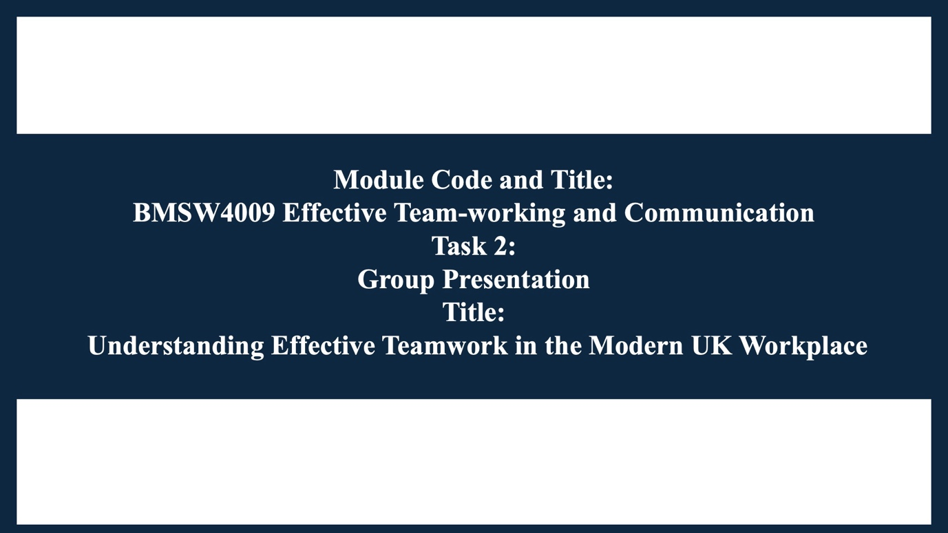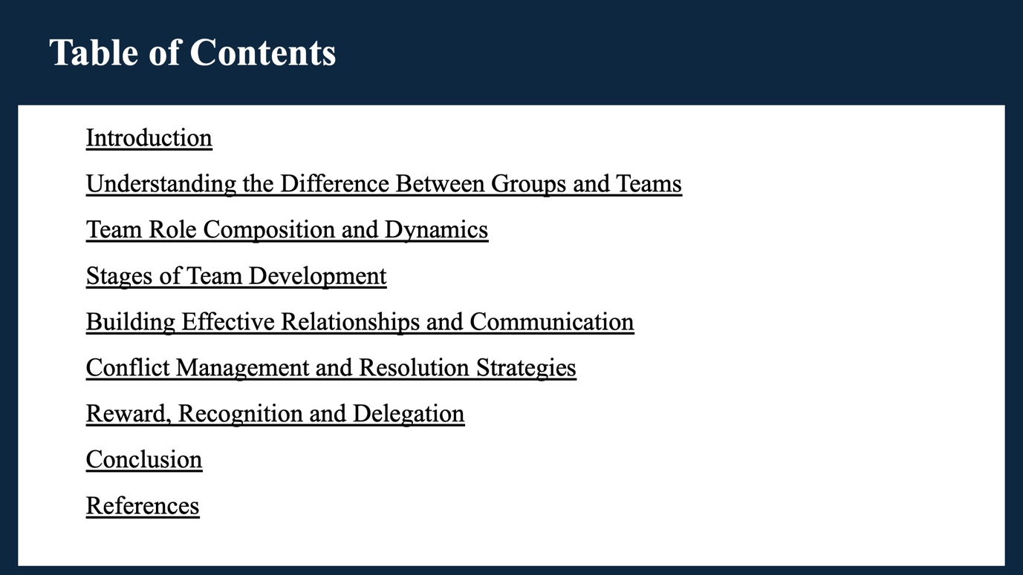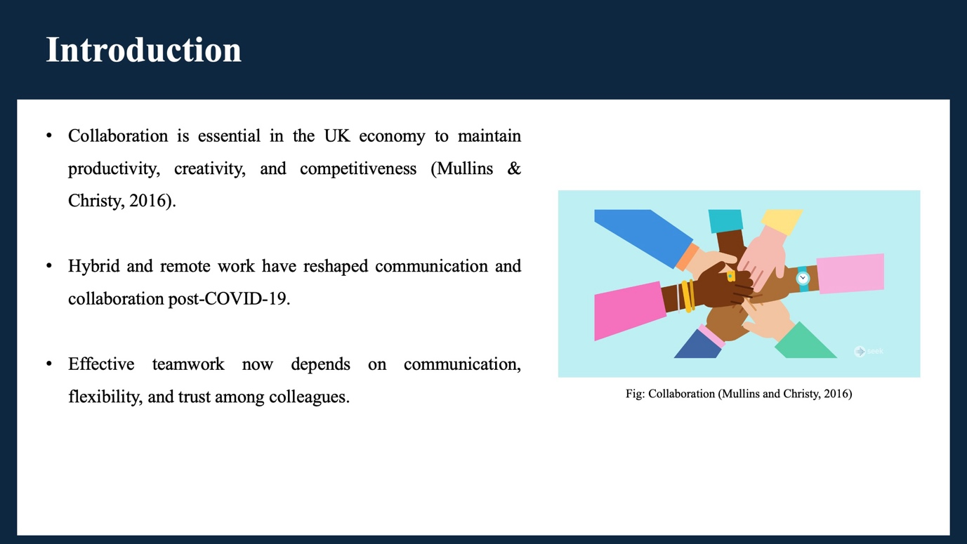

Introduction
Teamwork is essential in the current UK economy where organisations have to rely on collaboration to remain productive, creative and competitive. Hybrid and remote working has transformed the ways of communication and exchange of ideas since the COVID-19 pandemic. Effective collaboration has now to be marked by effective communication, flexibility, and trust among co-workers.

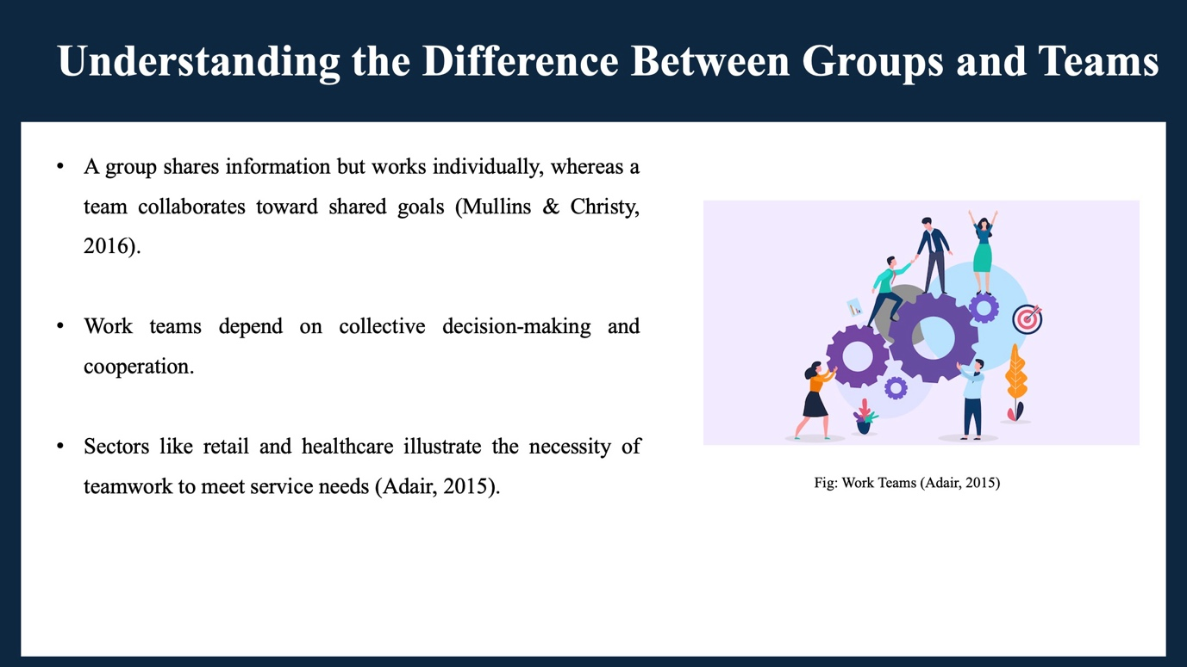

Understanding the Difference Between Groups and Teams
A group consists of people who share information but operate mainly separately whereas team consists of people operating towards a common goal and sharing in the results (Mullins and Christy, 2016). Work groups are more dependent on group decision making and collaboration. As an illustration, retail or healthcare team heavily depend on teamwork to be effective in meeting customer and patients needs (Adair, 2015).
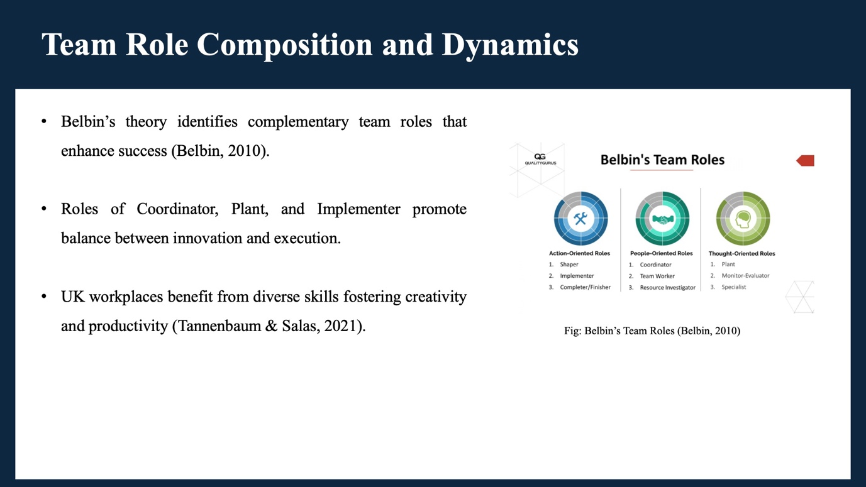

Team Role Composition and Dynamics
The Team Role theory by Belbin (2010) demonstrates that successful teams are a blend of roles and strengths. During our group we identified the roles of Coordinator, Plant and Implementer. The Coordinator assisted in facilitating discussions, the Plant provided innovative ideas and the Implementer made plans to be realistic. This is true of most UK workplaces, where diversity in skill set leads to innovation and productivity (Tannenbaum and Salas, 2021).
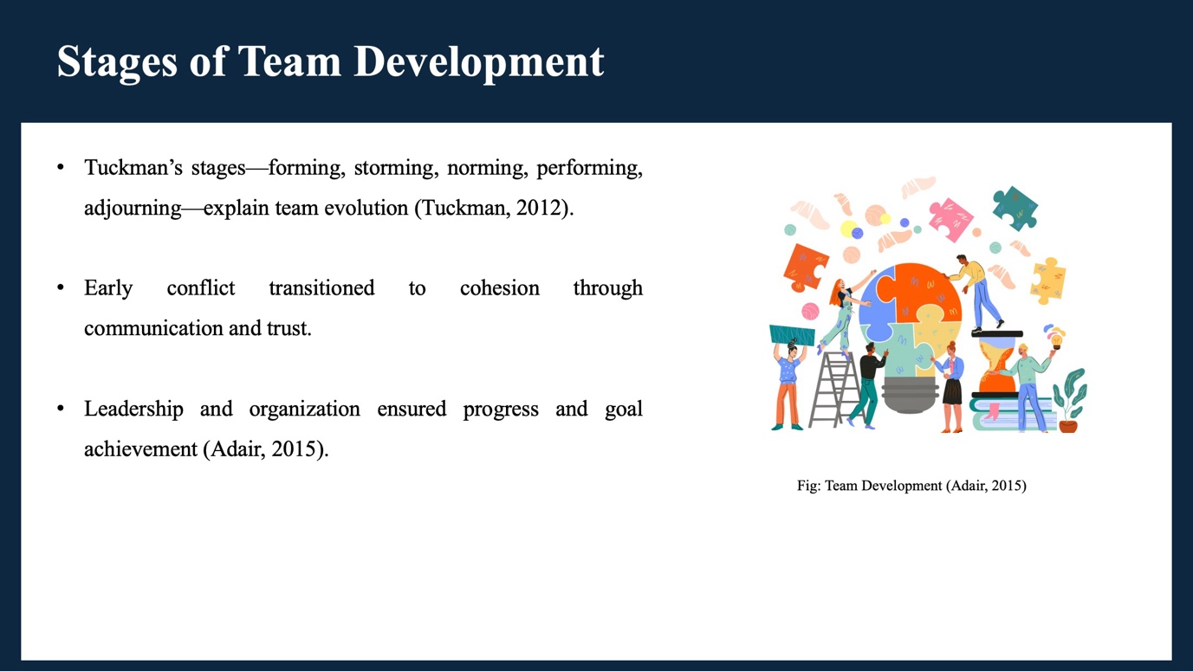

Stages of Team Development
In our case, the stages of forming, storming, norming, performing, and adjourning by Tuckman (2012) were evident. Initially we were sociable and at cross purposes. During the storming phase, we experienced minor disputes, and as time elapsed, we came to an understanding through communication. Our team work increased and we were in the performing stage as we got to trust each other. The adjourning stage involved reflection of our progress as the project was ending. Organisation and leadership were important in ensuring that the team was on track (Adair, 2015).
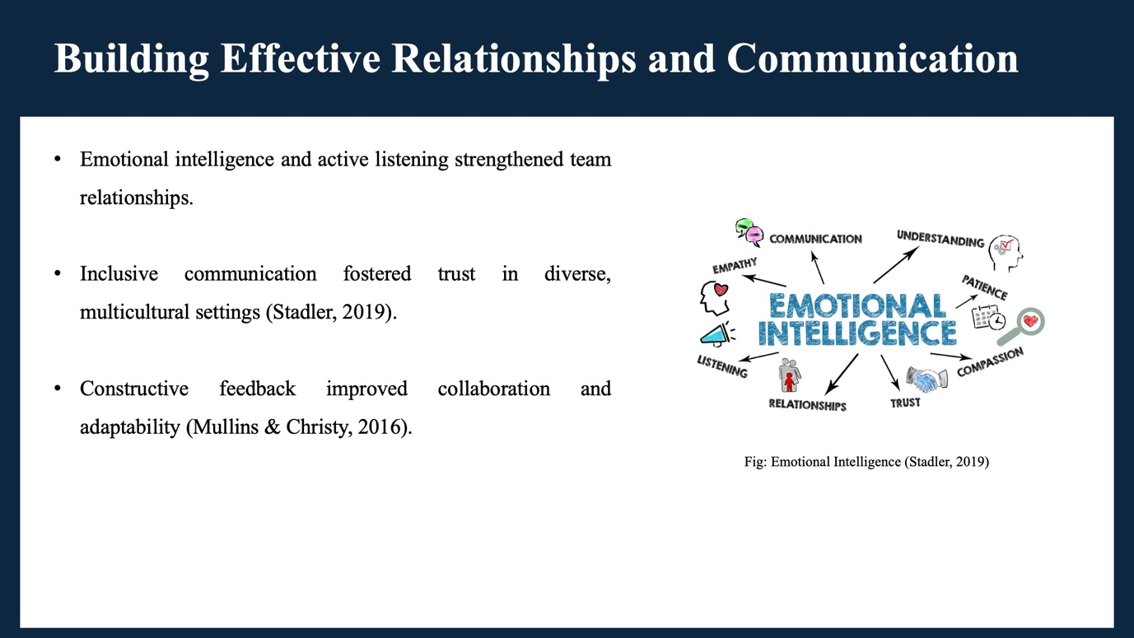

Building Effective Relationships and Communication
We were able to establish good relationships with each other due to effective communication and emotional sensitivity. Active listening was practised and everyone was encouraged to give ideas which generated trust and inclusion. This would be significant at the multicultural workplace of the UK where the styles of communication vary (Stadler, 2019). Positive feedback also enhanced our collaboration and made us adjust to the needs of each other (Mullins and Christy, 2016).
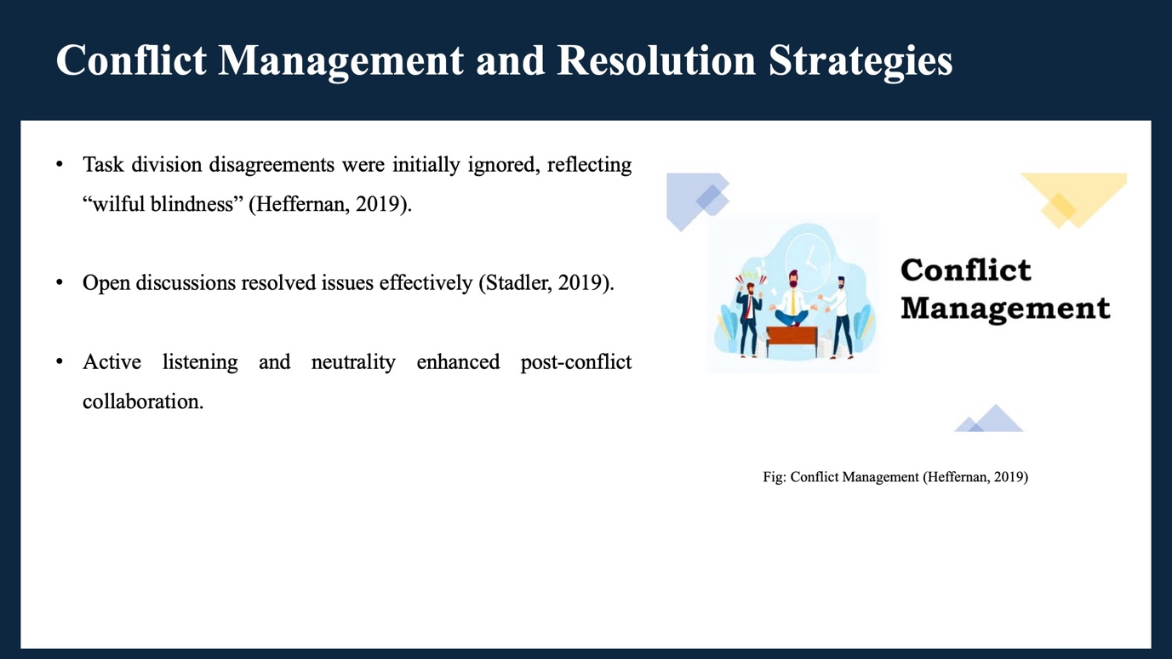

Conflict Management and Resolution Strategies
There was an argument between us regarding the division of presentation tasks. Initially it had been overlooked, but this did not help at all. According to Heffernan (2019), it is wilful blindness. We later on pursued the recommendations of Stadler (2019) on resolving conflict via an open conversation. Listening to everyone, we managed to find a neutral decision and enhance our collaboration.
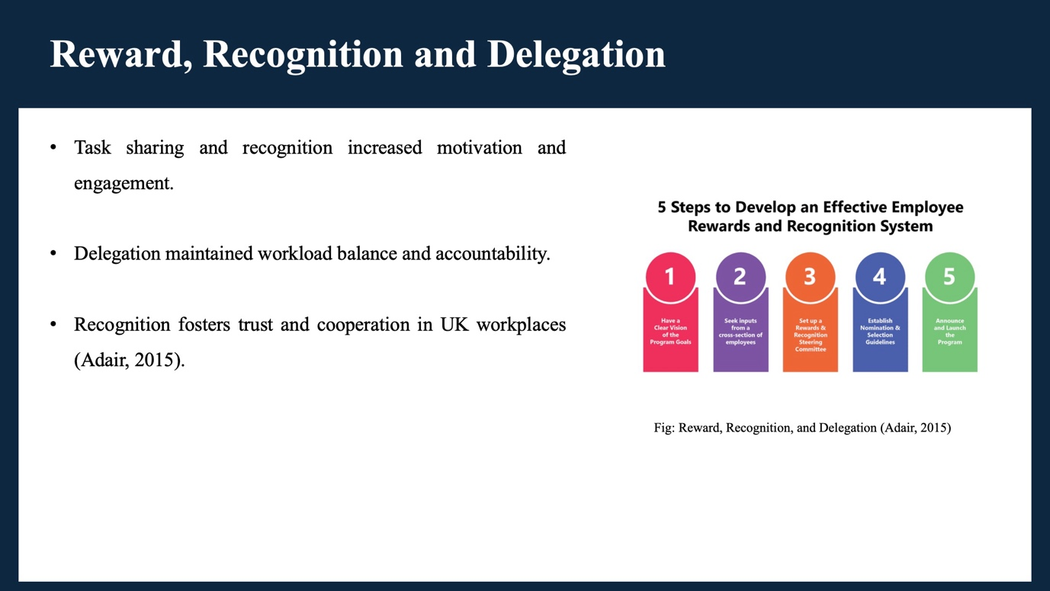

Reward, Recognition and Delegation
We had to share tasks and reward each individual effort so that we were motivated. Delegation so made created balance, and appreciation fostered participation. Recognition and equitable delegation in the UK work environment is known to create accountability and trust among the colleagues (Adair, 2015).

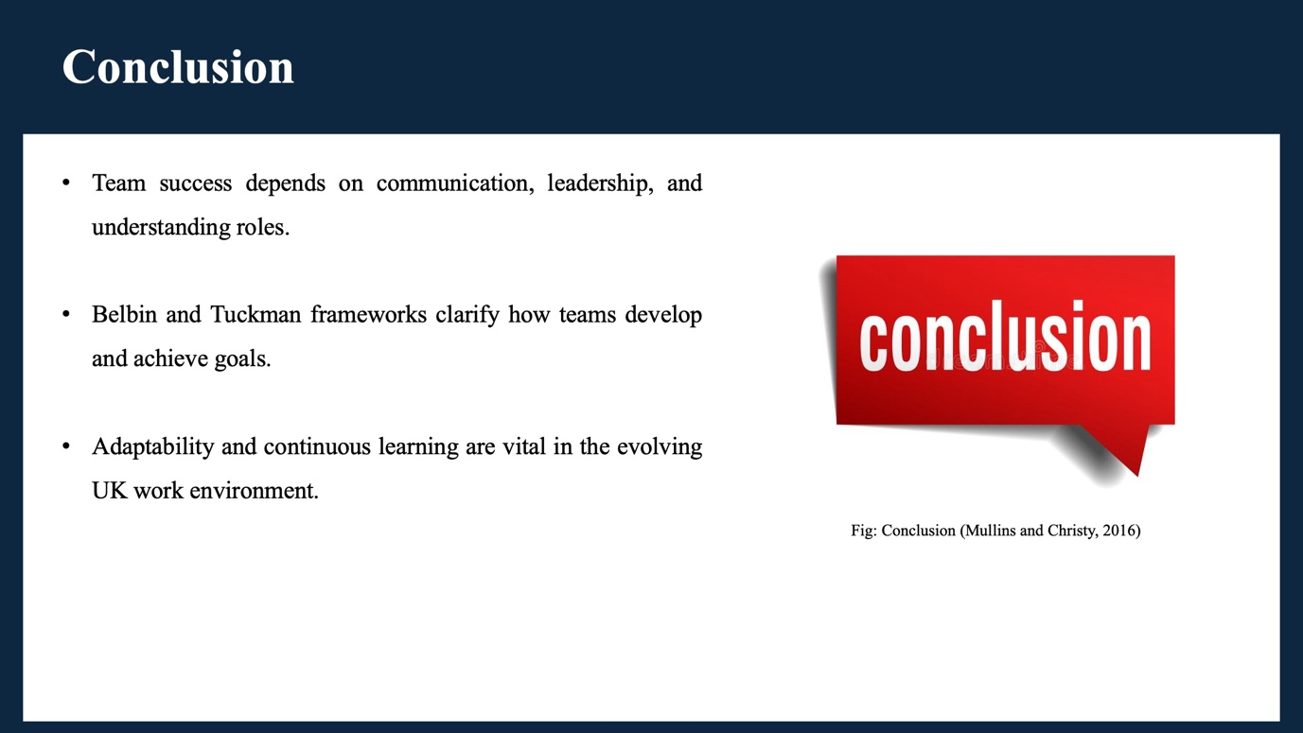

Conclusion
Finally, this teamwork experience made us learn the importance of communication, leadership and role comprehension to achieve success. Belbin (2010) and Tuckman theories assisted us in determining the way teams develop and accomplish objectives. The ability to change and learn continuously is the key to success in the dynamic work culture of the United Kingdom.
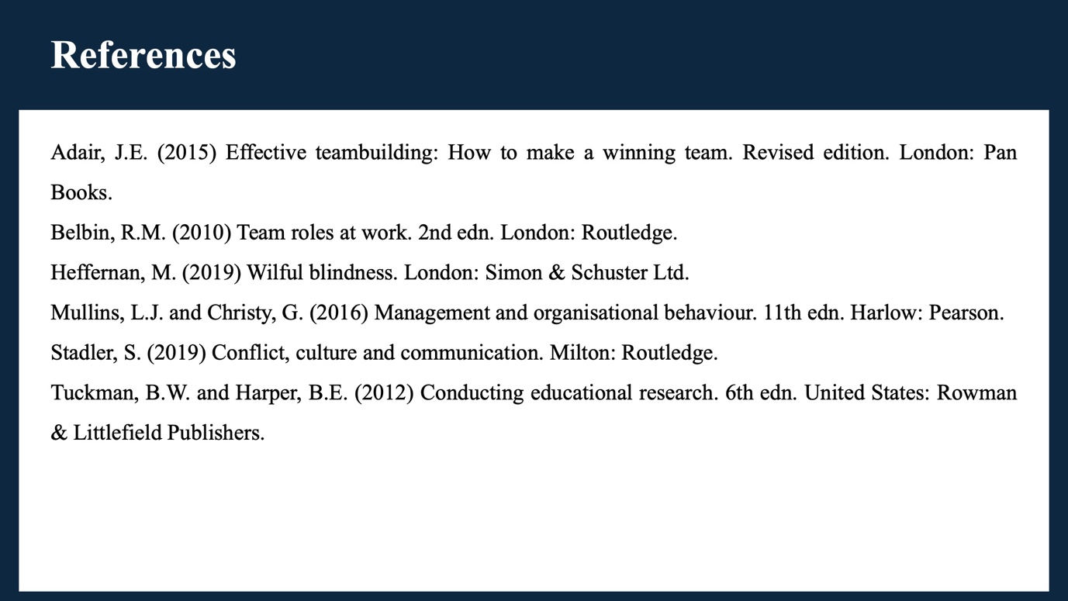

References
Adair, J.E. (2015) Effective teambuilding: How to make a winning team. Revised edition. London: Pan Books.
Belbin, R.M. (2010) Team roles at work. 2nd edn. London: Routledge.
Heffernan, M. (2019) Wilful blindness. London: Simon & Schuster Ltd.
Mullins, L.J. and Christy, G. (2016) Management and organisational behaviour. 11th edn. Harlow: Pearson.
Stadler, S. (2019) Conflict, culture and communication. Milton: Routledge.
Tuckman, B.W. and Harper, B.E. (2012) Conducting educational research. 6th edn. United States: Rowman & Littlefield Publishers.

