KDU DS1 ASSESSMENT .

kdu
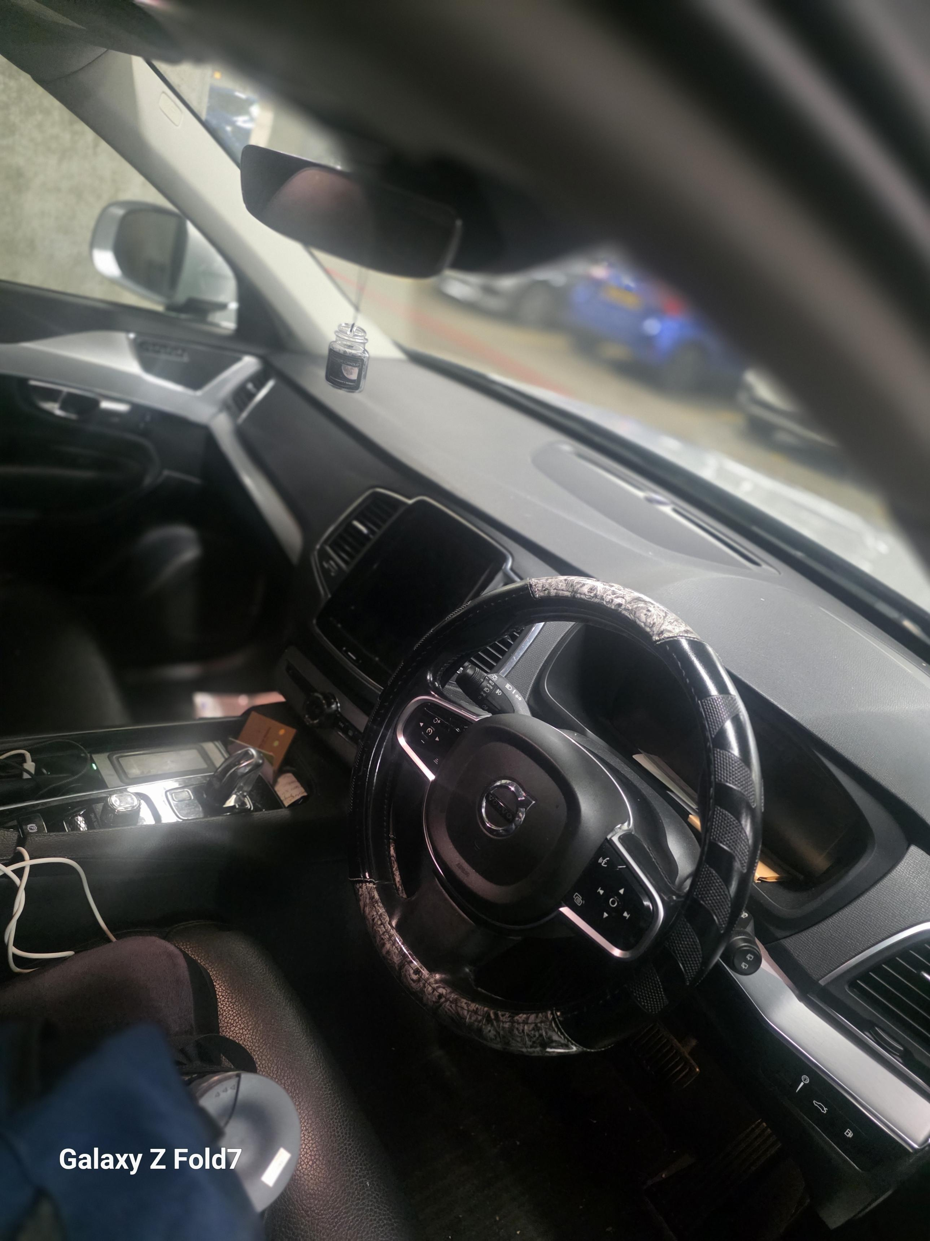
The is my personal car with day-to-day digital use made by google and supported with Volvo car app, which enable you to control the car, anywhere in the world.
I love the digital function, because you can open the car and lock remotely, you can also start the car and turn on the climate function remotely, this car is loaded with latest.

Screenshot/Photo 2
I CALL THIS CAR {MY MICROSOFT MECHINE}, THIS CAR DOES EVERYTHING, REPLY EMAILS, CALLED, OR TEXT ON MY BEHALF IF PROGRAMMED, WHICH MY AUTHORIZATION.
I LOVE MY VOLVO XC90 T8 PLUGIN HYBRID, BECAUSE IT IS VERY RELIABLE AND ECONOMIC PETROL HYBRID CAR.

Screenshot/Photo 3
THIS CAR START AND DRIVE ITSELF, THERE ARE SO MANY TECHNOLOGIES ON THIS CAR, THAT I STILL NEED TO LEARN, BUT AT THE MOMENT I MAKE USE OF THE EASY ONCES FOR MY DAY -TO-DAY ROUTINE.

Screenshot/Photo 4
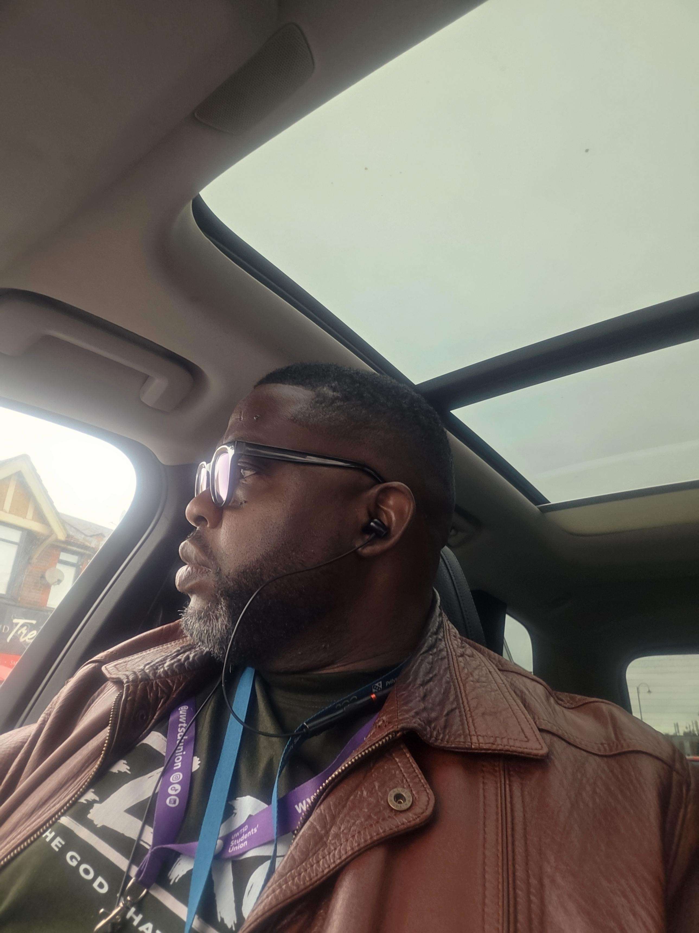
I TOOK THE PICTURE WITH MY SAMSUNG GALAXY FOLD 7, WHILE I WAS WAITING FOR THE SOFTWARE ON THE CAR TO DOWNLOAD.
MANY PEOPLE PREFER APPLE OPERATING SYSTEM, BUT I LOVE MY ANDRIOD OPERATING SYSTEM.

Screenshot/Photo 5
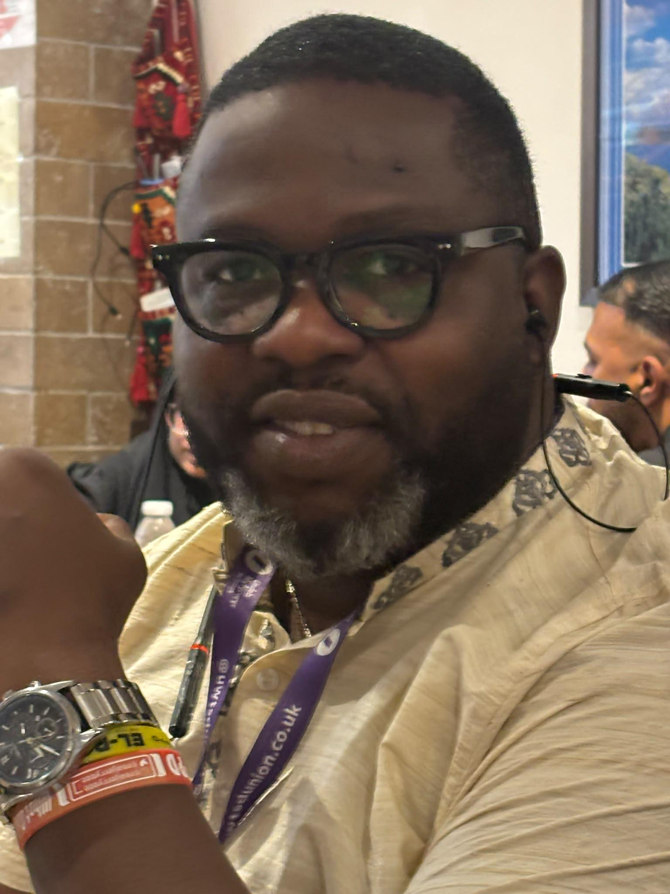 I TOOK THE PIC WITH MY PHONE, NOT USED TO TAKING SELFIES BUT DUE TO THE ASSESSMENT, I HAVE TO MAKE SURE I LEARN HOW TO DO IT, AND I, M SATISFY WITH IT.

Screenshot/Photo 6
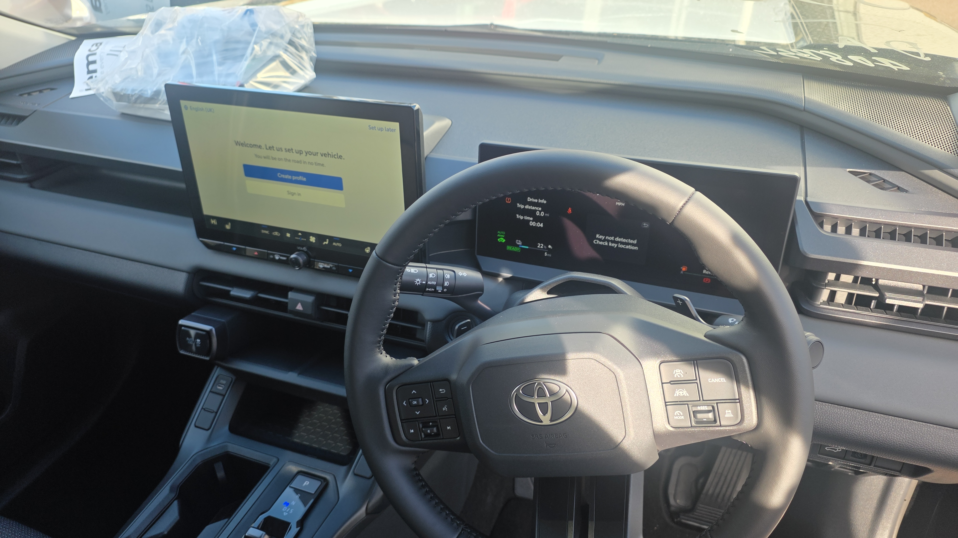
THIS IS MY NEW RAV4,2027 PLUGIN HYBRID.
DUE TO MY EXPERENCE WITH HYBRID CARS, I HAVE DECIDED NOT TO BUY ANY CARS WITHOUT LASTEST TECHNOLOGIES

My Short Reflection
- I use digital tools to help me with my daily life now, because it makes things easier, e.g. if I have to go somewhere, usually because I know the place, I never plan the distances to check if they is road closure or traffic, but because of the digitals I rely on, everything I do when connecting my digital technology appears to work well and stress free.

- I feel confident when, I know that my device is working well, especially my Volvo app to check my status remotely, if it is properly locked.

- I want to continually improve my I.T skills, to make sure, I properly check the problem first, before coming up with a solution.

- I often use these tools every day and without it my day is not complete.

- I sometimes feel nervous about the navigation system, the satnav could be offline, and cause a bit of distress, so I end up using my phone with android auto connectivity.
- I can tell that the modules will help me 100%, because I notices that my brain is trying to learn fast.

- Digital skills are important for me because …for you to able to do anything now, you need to know base I.T, and you need to embrace and accept new technology and A.I.
- THIS HAS HELP OR IT IS HELPING ME NOW WITH MY LOGISTIC BUSINESS CHAIN.

Signed by me KDU-2609885.

Submission Checklist
Before you submit, please check:
​​​ ☒ I added 4–6 screenshots
☒ I wrote short sentences for each screenshot
☒ I wrote my short reflection
☒ My work is my own
☒ My file opens correctly
​​☒ My file opens correctly

