Business Model of Cottage Stay Hotel

Student Name: Vasile – Florin Apostol
Student ID number: 2131343
The module title: Entrepreneurship BMIH5001
Lecturer’s name: Chris Wilkin

Entrepreneurship occurs when an individual or a small group of peers decides to venture out and establish a company (Williams, 2021). Individuals who aspire to become entrepreneurs proactively pursue a particular industry sector. Entrepreneurial risk is primarily associated with the undertaking. Therefore, this individual will gain the most if the strategy is successful. Being inventive is frequently required of entrepreneurs. Large corporation employees should strive to emulate this quality by promoting intrapreneurship (Barringer and Ireland, 2018). Organisations desire employees who approach challenges with an entrepreneurial mindset, contributing novel ideas that benefit the company. This essay aims to make a business plan for Cottage Stay Hotel by using a business model canvas.

The Business Model Canvas (BMC) is a strategic management tool that helps users design, build, and assess business models. There are nine fundamental parts to the framework that deal with business-related subjects (Dr. Jack McGourty, 2023). Each component is essential to the overall strategy and operations of the organisation. In 2022, the UK hotel industry was valued at around 16.42 billion British pounds, up from 11.28 billion British pounds the previous year. According to estimates, the market for this business will be worth 19.76 billion British pounds by 2023 (Statista, 2022). The hospitality industry will change with the opening of the Cottage Stay Hotel in London. This idea came about due to a thorough examination of industrial processes. Using specific examples and references to back up its assertions, this business plan presents the essential components of the Cottage Stay Hotel in line with the Business Model Canvas (BMC).
Customer segmentation is the group of people that a company want to approach for their specific products. The aim of a business is to cater for a particular clientele. This section outlines and clarifies the needs and aspirations of various communities (Indeed.com, 2022). A company may increase its marketability and competitiveness by tailoring its goods and services to meet the particular needs of each area. Accurate classification is essential for focused marketing and happy customers. Premier Inn is a hotel chain in the United Kingdom that attracts International tourists toward its business in order to improve its operations (Bigdifferencemarketing.com, 2024). The Cottage Stay Hotel caters to wealthy tourists who want more from their trip than just a place to stay. This group includes visitors who are interested in local culture, business travellers looking for a unique but affordable place to stay, and guests of boutique hotels. According to Aksu et al. (2022), interactive travel will become increasingly popular in 2023 because customers prioritise unique experiences above traditional comforts. As a consequence, the Cottage Stay Hotel is able to offer customers unique hotel experiences.
A company's Value Proposition outlines its particular advantages or values to target market groups. A great value offer must include knowing what customers want and making sure the company's products work together. In addition to making money, it keeps clients loyal (Saradh Kumar, 2018). The Cottage Stay Hotel offers a superb blend of contemporary amenities and a classic rural British ambience. The appeal is in providing visitors with a comfortable and contemporary place to stay. Travelodge is also a hotel chain in the United Kingdom that does not compromise on the quality of services and provides its best to make strong bonds with guests (TRAVELODGE STATEMENT TO WATCHDOG, 2011). According to Leroi-Werelds et al. (2021), wellness and cultural education centres will be more prevalent. The Cottage Stay Hotel successfully meets this requirement by combining classic and modern ideas.
Through channels, a corporation may tell customers about its value offer. Using targeted marketing and outreach tactics is the planned strategy for connecting with and interacting with the target market. Channels include things like partnerships, internet, direct sales, and storefronts. Channel management increases customer happiness and optimises the flow of products and services (Andrew Constable MBA, 2022). The Cottage Stay Hotel accepts internet bookings and advertising. An organisation may broaden its appeal to various tourists by forging strategic alliances with local firms, travel agencies, and event management. Present patterns suggest that more and more individuals are planning their travels online (Sun et al., 2022). By emphasising online channels, Cottage Stay Hotel considers its patrons' tastes and makes itself more accessible to a wider range of people.
Interactions between a business and its customers are known as Customer Relationships. This section discusses customer acquisition, retention, and growth methods. Loyal and satisfied customers want positive interactions with businesses, whether it be in the form of personalised support, self-service support, or participation in community events (Saradh Kumar, 2018). Marriot is a global hotel chain that offers high-quality accommodation and uses friendly behaviour with employees that directly impacts their relationships (csr-marriott, 2023). A steward's help helps the Cottage Stay Hotel build stronger bonds with its visitors. Gourmet dinners and guided tours throughout the area provide wonderful opportunities to make enduring memories and build relationships with other hotel guests. Sofi et al. (2020) stated that hotels need tailored services. Cottage Stay Hotel keeps its visitors longer by offering individualised experiences that meet their requirements, elicit good feedback, and raise the possibility of their return.
An organisation's revenue streams are its sources of income. The value-based setup for the pricing and revenue systems is defined in this section. Revenue generating involves the use of contracts, licencing, advertisements, and product sales (Indeed.com, 2022). Diverse revenue streams lessen reliance while boosting financial security. It is possible to make money by booking rooms at the Cottage Stay Hotel, buying experience packages, and attending events showcasing regional chefs, artists, and business owners. Organisations may generate a variety of income sources via diversification. As per Zaki (2022), companies that have successfully created new income streams to reduce risk and adjust to market changes have done so. The adaptive business strategy of the Cottage Stay Hotel enables it to capitalise on opportunities and navigate unpredictable circumstances.
Key Resources are equipment, knowledge, and skills needed to manage a company, interact with clients, and provide value. In this block, individuals have to find and use resources efficiently. Valuable assets include real land, trained labour, intellectual property, and technology (Saradh Kumar, 2018). Maintaining value and a competitive advantage requires effective resource management. Heaven Inn is a well-reputed hotel chain that hires only skilled employees in the workplace which helps to enhance the efficiency of business organisations. By using old buildings, the Cottage Stay Hotel manages to retain its charm. It makes visitors' experience easier by providing them with a solid technology base and well-trained personnel. Duric and Potočnik Topler found in 2021 that combining various forms of technology improves process performance and simplifies customer operations. The Cottage Stay Hotel harmonises parts of the past and current by keeping many of its original features.
Company Key Activities are the most crucial actions the organisation must take to carry out its business plan. Identify workable projects that provide benefits and value for other company aspects in this field (Saradh Kumar, 2018). Product development, marketing campaigns, and supply chain management must align with the organisation's objectives for operations to run smoothly. Maintaining the uniqueness of historic hotels requires ongoing maintenance. Including the neighbourhood and promoting cooperation is a great idea. When it comes to innovative offerings, the Cottage Stay Hotel is leading the way. According to Choi and Choi (2021), innovation is essential to the hospitality sector. The efforts made by the Cottage Stay Hotel to maintain, engage, and produce new ideas are indicative of the organisation's development.
Key Partnerships increase competencies, reduce risks, or get resources from other sources. This section looks at the important connections that make the company plan work. Strong connections provide business access to fresh people, markets, and technology, which could lead to creative ideas and business growth prospects (Indeed.com, 2022). The Cottage Stay Hotel collaborates with local designers to improve the rooms' visual appeal, chefs to ensure delicious food, and event planners to provide unique experiences. When local businesses collaborate, tourism benefits local businesses. According to Espino-Rodríguez and Ramírez-Fierro (2018), working with locals makes guests happier and fosters community wealth. The Cottage Stay Hotel distinguishes the neighbourhood and benefits everyone via its beneficial ties with other companies.
The Cost Structure illustrates the monetary outlay necessary to guarantee the ongoing functioning of vital devices, procedures, and linkages. This division includes the expenses related to maintaining the business model and providing the value offer. A key component of preserving security and profitability is effective cost control (Andrew Constable MBA, 2022). The Cottage Stay Hotel makes significant expenditures in staff training, history preservation, and brand awareness to provide exceptional service. Mashayekhi and Ara, in 2017 that a hotel company's growth necessitates financial expenditures in areas including employee training, upkeep of the facility, and promotion. Long-term investments are part of the Cottage Stay Hotel's cost structure.

In conclusion, the Cottage Stay Hotel makes a bold debut in the competitive hotel industry by fusing traditional and contemporary design features. The Business Model Canvas provides a comprehensive framework that makes understanding and validating this idea easier. The Cottage Stay Hotel offers more than just a place to stay. Because of well-informed judgements based on historical precedent and current trends, they will enjoy an unmatched and authentic experience.

In order to acquire a more profound comprehension of my own entrepreneurship, I used leadership evaluations and assessments of business traits and team activities. Apart from using scholarly models and frameworks, I also used the Gibbs Reflective Cycle to evaluate my goals and characteristics me.

Description: The quizzes on leadership and business characteristics revealed who I am as a potential entrepreneur. The findings highlighted my strengths and places for development in a few key areas of my personality. My study suggests that people are open to business uncertainty because they are prepared to try new things and take chances. Furthermore, a creative mindset indicates the possibility of leadership and teamwork.
Feelings: As soon as I realised how competent I was, I felt confident and satisfied. I knew exactly where I was going since I had skills that help firms succeed. Because of the constantly changing nature of the business world, entrepreneurship requires a dynamic skill set and continuous personal growth (Rae, 2008).
Evaluation: To get an understanding of the reasoning behind my business choices, I used academic frameworks and ideas. Self-Determination Theory (SDT) helped me understand why I wanted to start a company. According to this viewpoint, people are motivated by relatedness, competence, and freedom (Positivepsychology.com, 2022). That is my route to becoming independent and flexible in my career. We conducted a more comprehensive analysis using the Entrepreneurial Orientation (EO) model, which considers traits including a tendency to take risks, aggressiveness, and inventiveness. Inventiveness met my urge to research new ideas and cope with pain. A solid business viewpoint requires the guts and desire to take measured risks Mariotti and Glackin, 2012.
Analysis: The more I learned, the more I could see how my objectives and business sense aligned. The assessments made me aware of my independence and impulsivity. There is a relationship between my personality and my propensity for entrepreneurship. A deeper look at the issue revealed several directions for development (Action, 2014). Despite my adventurous nature and creative tendencies, I recognised I needed to work on my leadership skills. The polls emphasised the need for sustaining team-oriented management and communication, focusing on the collaborative aspect of entrepreneurship.
Conclusion: My natural goal is to find out via finishing the analysis of company traits and reasons. A dynamic combination of creative ideas, a risk-taking attitude, and flexibility led to my company's expansion. Besides teaching me the importance of personal growth, the mindful method helped me become a better team leader.
Action Plan: Now that I have a better grasp of my own driving forces and what makes my company unique, I am ready to make the required adjustments. I must register in classes that promote teamwork, force people to take on leadership roles and encourage the development of original ideas. to maximise one's potential and develop the areas that enhance one's overall business judgement.

In conclusion, as an entrepreneur, the Gibbs Reflective Cycle helped me learn more about myself. Integrating survey answers into academic frameworks gave me a more profound comprehension of my motivations and goals for being an entrepreneur. This allowed me to take a purposeful and well-informed approach to pursuing entrepreneurship.

References
‌Action, in (2014). Cultures of Thinking in Action. [online] Cultures of Thinking in Action. Available at: https://www.cultures-of-thinking.org/7-point-of-challenge.
Aksu, A., Albayrak, T. and Caber, M., 2022. Hotel customer segmentation according to eco-service quality perception: the case of Russian tourists. Journal of Hospitality and Tourism Insights, 5(3), pp.501-514.
Andrew Constable MBA (2022). The Components of a Business Model Canvas. [online] Visualise Consulting. Available at: https://visualisesolutions.co.uk/the-components-of-a-business-model-canvas/.
Adeani, I.S., Febriani, R.B. and Syafryadin, S., 2020. Using GIBBS’reflective cycle in making reflections of literary analysis. Indonesian EFL Journal, 6(2), pp.139-148.
Barringer, B. R. & Ireland, R.D. (2018) Entrepreneurship: Successfully Launching New Ventures, 4th Ed., Prentice Hall: New Jersey
Bigdifferencemarketing.com. (2024). Customer segmentation Whitbread Premier Inn case study | Big Difference Marketing leadership-speaking-training-consulting. [online] Available at: http://www.bigdifferencemarketing.com/home/marketing-case-studies/hotel-market-customer-segmentation/.
Choi, M. and Choi, Y., 2021. Employee perceptions of hotel CSR activities during the COVID-19 pandemic. International Journal of Contemporary Hospitality Management, 33(10), pp.3355-3378.
csr-marriott. (2023). Sustainable Goals | Marriott International Serve360 - csr-marriott. [online] Available at: https://serve360.marriott.com/sustainable-goals/.
Dr. Jack McGourty (2023). Key Components of the Business Model Canvas: Exploring the Building Blocks. [online] Substack.com. Available at: https://innovatethrive.substack.com/p/key-components-of-the-business-model.
Duric, Z. and Potočnik Topler, J., 2021. The role of performance and environmental sustainability indicators in hotel competitiveness. Sustainability, 13(12), p.6574.
Espino-Rodríguez, T.F. and Ramírez-Fierro, J.C., 2018. Outsourcing performance in hotels: Evaluating partnership quality. Sustainability, 10(8), p.2766.
Indeed.com. (2022). What Is a Business Model Canvas? (With Sections and Example) | Indeed.com. [online] Available at: https://www.indeed.com/career-advice/career-development/example-business-model-canvas.
Leroi-Werelds, S., Verleye, K., Line, N. and Bove, L., 2021. Value proposition dynamics in response to external event triggers. Journal of Business Research, 136, pp.274-283.
Mariotti, S. and Glackin, C. (2012) Entrepreneurship: Starting and Operating a Small Business (3rd Ed), London: Prentice-Hall.
Mashayekhi, B. and Ara, M., 2017. Activity-based costing in the hospitality industry: a case study in a hotel. International Journal of Social and Business Sciences, 11(9), pp.2254-2258.
Positivepsychology.com. (2022). Available at: https://positivepsychology.com/self-determination-theory/.
Rae, D. (2008) Entrepreneurship: from opportunity to action, 2nd Ed., Basingstoke: Palgrave Macmillan
SaradhKumar (2018). Nine Components Of Business Model Canvas - Saradh Kumar - Medium. [online] Medium. Available at: https://medium.com/@sarathkumar_66483/nine-components-of-business-model-canvas-cc67607ccb53.
Sofi, M.R., Bashir, I., Parry, M.A. and Dar, A., 2020. The effect of customer relationship management (CRM) dimensions on hotel customer satisfaction in Kashmir. International Journal of Tourism Cities, 6(3), pp.601-620.
Statista. (2022). Hotel industry market size UK 2022 | Statista. [online] Available at: https://www.statista.com/statistics/1364712/hotel-industry-market-size-uk/#:~:text=In%202022%2C%20the%20market%20size,reach%2019.76%20billion%20British%20pounds.
Sun, S., Law, R. and Luk, C., 2022. Tourists’ travel-related information search channels. International Journal of Hospitality & Tourism Administration, 23(2), pp.149-164.
TRAVELODGE STATEMENT TO WATCHDOG. (2011). Available at: https://www.travelodge.co.uk/watchdog/Watchdog_Statement.pdf.
Williams, S. (2021) FT Guide to Business Start Up: The most comprehensive guide for entrepreneurs, 32nd Ed., Financial Times Press: Harlow.
Zaki, K., 2022. Implementing dynamic revenue management in hotels during Covid-19: value stream and wavelet coherence perspectives. International Journal of Contemporary Hospitality Management, 34(5), pp.1768-1795.

Appendices

Appendix 1
Key partnership  - Supplier of packaging materials.  - Meat supplier  - Distributor of cooking equipment. | Key activities  - Cleanliness and safety in a sitting environment.  - Effective customer service. | Value Proposition  - Variety of Chinese dishes.  - The attractive atmosphere of the restaurant. | Customer relationship  - Online ordering platform.  - Customer support services.  - Digital platform to get feedback. | Customer segment  - People in business and employees.  - Families.  - Tourist
 | Key Resources  - Dining environment.  - Kitchen to cook food.  - Employees working in the environment. |  | Channels  - Digital marketing channels.  - Acquiring check-out orders.
Cost Structure  - Equipment cost  - Marketing cost.  - Labour cost.  - Food cost. |  | Revenue stream  - Dining service.  - Take away service.  - Delivery service.

Appendix 2
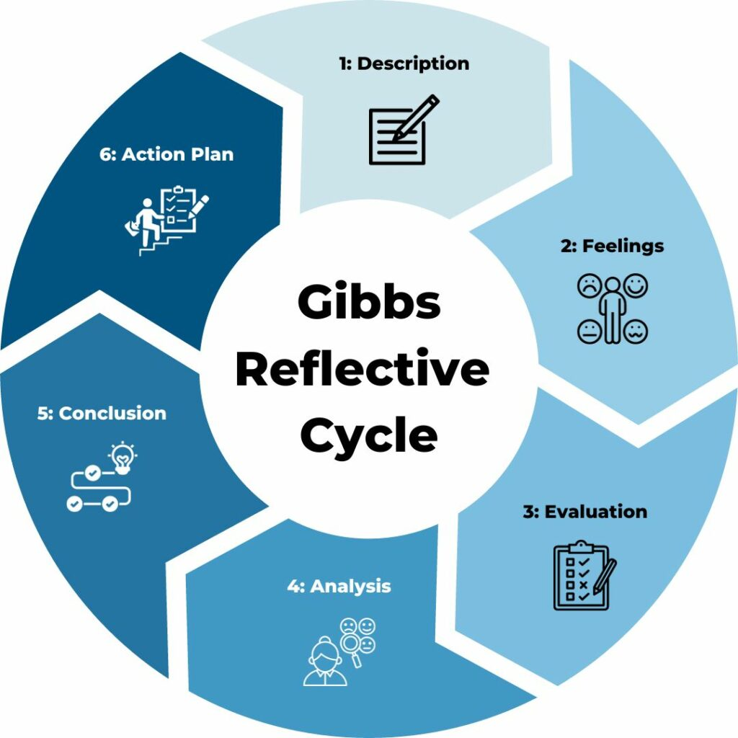
Figure 1:Gibb's Reflective Cycle
Source: (Adeani et al., 2020)

