Max Cobb

GROUND INVESTIGATION

Table of Contents
1 Introduction 4
1.1 4
2 History 5
2.1 Site location 5
2.2 Previous use 5
3 site specific risk assessment 6
3.1 Risks 6
3.2 potential left over services 6
3.3 flood risk 6
3.4 Environmental Contamination 6
3.5 mining 6
3.6 UXO 6
3.7 Ground conditions 6
4 Investigation 7
4.1 Background 7
5 Recommended site investigations 8
5.1 Tests and surveys 8
5.2 Justifications 8
5.2.1 Borehole drilling 8
5.2.2 SPT 9
5.2.3 CPT 9
5.2.4 Soil gas monitoring 9
5.2.5 Groundwater monitoring 9
6 Conclusion 10
7 Recommendation 11
8 Bibliography 12

Table of Figures
Figure 1; Old map of proposed Tesco site (Old maps online, 2025) 7

Introduction
The purpose of this study is to demonstrate the authors ability to perform and construct a new five storey hotel, restaurant and bar and conference area on a building footprint where there was previously a Tesco as well as a car park located in Swansea. This project is to help with the growing demand for housing and rising population of the area especially near the LC2 entertainment building, this project will cover multiple different things such as ground investigation, the appropriate foundations to use and what the area was previously used as and what was built there.
The aim of this report is to investigate the possibility of developing a 400 room hotel on the site which will be vacant after the current Tesco has been decommissioned and demolished. This will be achieved through the creation of a preliminary study which will serve as a starting point for the feasibility stage of the project.
Much research will be required for this project. The ground has previously been built on therefore making it a brownfield site. Being a brownfield site means additional research is required to test potential issues like loose soil; for example, after the demolition of Tesco which could have caused the soil to become more loose after the demolishment of the previous building. Another issue could potentially be ground contamination so this will be tested for as well to ensure the ground we will be building on is fit for purpose. Being a brownfield site can mean that the ground is compacted due to the weight of the previous structure and an increased chance of contamination to the soil.

The objective of this report is to carry out a prelim site investigation to assess whether the proposed site is suitable for the construction of a five storey hotel, restaurant, bar and conference facility built in Swansea. This involves evaluating the ground conditions and identifying the geotechnical conditions and ground conditions. The goal of this report is to gather enough information to support safe and effective design of foundations, contamination risks due to previous industrial use and to ensure the ground is fit for future development

History

Site location
The site is located in the central Swansea area in the SA1 postcode. The site is directly across from the LC2 leisure centre and is near to the Quadrant Shopping Centre and city centre making it a desirable and convenient location. It is currently a Tesco supermarket and has parking located on the same premises.

Previous use
The author states the site used to be a gas works prior to the construction of the Tesco. This could potentially suggest that there are underground storage tanks as well as coal and tar. Due to the previous construction on this site this means it’s a brownfield site which indicated previous development. The site being a brownfield site could potentially mean contaminated land, buried demolition material and other risks (bench mark data base, n.d.).

site specific risk assessment

Risks
Although after the gas works the site is urban and has been redeveloped remains of the gas works could have still potentially left remains below ground.

potential left over services
Given the sites previous use existing underground service could be left over such as:
- Electrical supplies
- Foul drainage system or surface drainage
- Water supply
- Gas line
These must be tested for, found out and mapped to prevent accidents or incidence involving these potential issues or drilling into them (improving performance reducing risk, 2022).

flood risk
A flood risk map shows that the postcode SA1 3RA shows low to medium risk of floods in the area with low risk of surface water flooding. Site drainage should be explored.

Environmental Contamination
Due to the previous structure being a gas works this introduces high chance of asbestos as well as heavy metals and tar and solvents. Contamination must be tested for before the commencement of the build.

mining
The coal authority map does not indicate that mining activity happened within the site boundary but to confirm a mining risk assessment is recommended.

UXO
Swansea was heavily bombed during WW2 so checking Swansea bombing records are recommended before commencing with the construction

Ground conditions
In section 7.2 of the borehole analysis:
- 0.1m = made ground
- 1 to 3m = gravelly land
- 3m = weathered sandstone/ mudstone
Groundwater was encountered within depth range of the borehole log.

Investigation
The author would look at maps of previous structures in the area as well as ensure ground testing is completed to check the quality of the soil and make sure it is safe to commence with the construction of the project.

Background
As the author mentioned in the site specific risk assessment The project was previously a Tesco and has been built of before and prior to that was a gas works. A soil test will need to be done as well as checking the maps over history to confirm that their was a gas works structure there prior to Tesco.
Appropriate reports will be researched and the appropriate tests will be conducted to check for any problems that could potentially cause problems delays or a stop to the construction of the hotel, such as:
- Loose soil
- Contaminated soil
- Remaining building materials
- Environmental site assessment
- Chemical testing
- Geotechnical testing
The area was previously a Tesco with a carpark and prior to that a gas works (gov.scot, 2020).
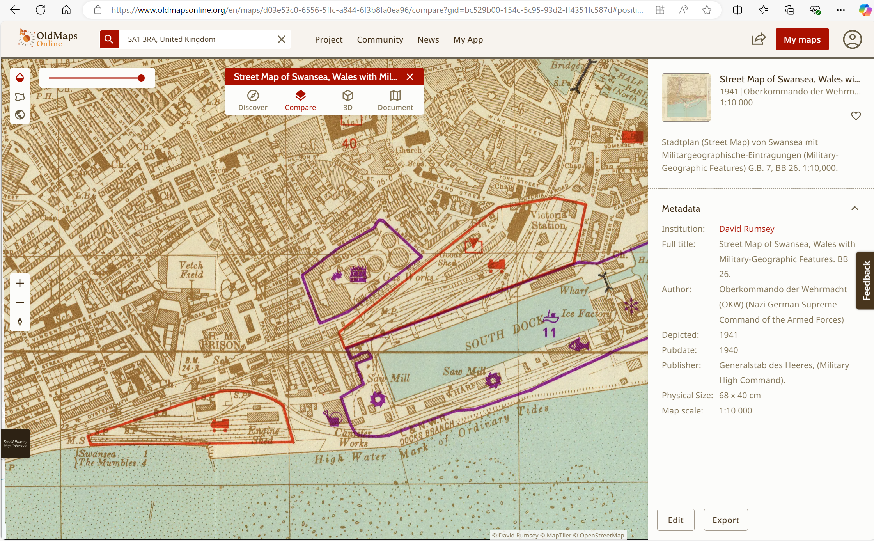
Figure 1; Old map of proposed Tesco site (Old maps online, 2025)

Recommended site investigations

Tests and surveys
The proposed tests that the author believes to be the most appropriate as well as suitable and effective are as follows:
- Borehole drilling and logging
- Standard penetration testing
- Cone penetration testing
- Soil gas monitoring
- Groundwater monitoring and sampling (achademic library , 2014)

Justifications
These ground investigation techniques are justified due to the ground being used previously as industrial use this being gas works in this specific scenario which increases contamination likelihood. Variable made ground may be looser or poorly compacted leading to problems in the future for the structure such as making it unstable therefor crucial to conduct ground investigation to ensure the ground is suitable to build on. Groundwater depth will affect foundation designs and can affect the stability of the structure if the wrong foundation is used. It is important to confirm the soil bearing capacity and load distribution for deeper foundations.

Borehole drilling
This test involves drilling into the ground to analyse the different layers of soil and rock there are. Il helps to find out how deep any of the old ground is and where strong natural ground starts. By recording what is found in these boreholes engineers can then learn how much weight the ground can hold and how wet the soil is and whether there are any other problems such as left over rubble from the gas works previously in the site boundary (achademic library , 2014).

SPT
This test checks how hard the ground is. A metal tube is hammered into the soil and the number of hits the soil takes is then recorded. The results of this test show how firm and dense the soil is. This test is especially important for sandy layers. It helps with foundation design by showing how much the ground might settle by under the buildings weight.

CPT
This test pushes a cone shaped tool into the ground and measures how much resistance the soil gives. It gives a detailed reading of the soils strength and changes in different ground types and ground conditions. This method is especially useful for spotting weak areas I the ground and checking if the soil is consistently the same throughout. It can also help estimate how the soil behaves without needing to take lots of samples of it (achademic library , 2014).

Soil gas monitoring
Because this site used to be a gas works there may still be harmful gasses present in the ground such as methane or chemicals that can effect air quality. This test checks if gases are still present in the ground and how dangerous they might be. It helps decide whether special protection measures are needed to keep the building safe (achademic library , 2014).

Groundwater monitoring
This checks how high the groundwater is and what’s in it. Its important to see if the ground is stable for building on, know if the water needs to be pumped out during construction and find out if pollution has spread underground. Water samples can be tested for thing like metals or chemicals that have leaked into the ground from the industrial use (achademic library , 2014).

Conclusion

The proposed development site in Swansea presents both the opportunity and challenges due to its location and historical use. The site formerly occupied by Tesco supermarket and originally a gas works is classified aa a brownfield site due to it having been built on before. The site being a brownfield one increases the likelihood of contamination, buried services and variable ground conditions. Although through the recommended investigations these being : borehole drilling, SPT, CPT, soil gas monitoring, and groundwater sampling important information will be gathered about the strength, composition and the safety on the ground.
These investigations are essential to confirm the site is suitable for development and suitable for foundation designs as well as to decide on the most appropriate foundation design and to ensure that any environmental risks are properly addressed and dealt with. These findings will help support the construction of the 400 room hotel helping to meet with local development whilst protecting the environment and ensuring the structure remains safe and stable.

Recommendation
Based on the findings of this preliminary assessment the following recommendations should be followed before construction begins:
Firstly carry out all the proposed ground investigation techniques to assess the strength of the soil,. any contamination in the ground and the groundwater conditions.
Conduct laboratory testing on the soil and groundwater samples that were collected to check for pollutant such as heavy metals, VOCs and hydrocarbons.
Review historic records and maps to confirm the exact location and the layout of the gas works that was formerly stood in the site boundary.
Investigate the Prescence of any underground services or storage tanks and create a site service map.
Complete a UXO risk assessment using Swansea bombing records during WW2.
Use all investigation data to inform a suitable and safe foundation design and consider mitigation measures such as gas protection systems if contamination is found in the soil after the tests have been completed.
Consult with environmental specialists if contamination levels are high to determine if remediation is needed.

Bibliography
achademic library , 2014. GROUND INVESTIGATION. [Online]
Available at: https://ebrary.net/199702/engineering/ground_investigation#:~:text=Ground%20investigation%20usually%20involves%20the%20use%20of%20some,pitting%3B%20in%20situ%20testing%3B%20geophysics%3B%20and%20laboratory%20testing.
[Accessed Friday Juky 2025].
bench mark data base, n.d. Cut Mark: Swansea, Oystermouth Road, Gas Works. [Online]
Available at: https://www.bench-marks.org.uk/bm51960
[Accessed Friday July 2025].
Google, 2022. How to search. [Online]
Available at: www.google.com
[Accessed 05 12 2022].
gov.scot, 2020. Building standards technical handbook 2020: non-domestic. [Online]
Available at: https://www.gov.scot/publications/building-standards-technical-handbook-2020-non-domestic/3-environment/3-1-site-preparation-harmful-dangerous-substances/
[Accessed friday July 2025].
improving performance reducing risk, 2022. Existing services on construction sites – the Dos!. [Online]
Available at: https://www.dcpsafetyandtraining.co.uk/existing-services-on-construction-sites-the-dos/
[Accessed friday july july].
Old maps online, 2025. SA1 3RA. [Online]
Available at: https://www.oldmapsonline.org/
[Accessed wednesday October 2024].
Stephens, R., 2022. Emojis make you cry. Journal of nonsence, 1(1), pp. 111-222.
Williams, D., 2022. study skills. 1 ed. Swansea: UWTSD.

