Programme: | Public Service Portfolio
Module: | Learning in the Digital Era
Module code: | BMPS4009 & BMPL4007
Learning in Digital Era
Contents
Introduction 3
Summary of preparation for higher education 4
Mind map on becoming a digital learner 6
Video presentation 8
Reflection 9
Personal Development Plan 12
Conclusion 15
References 16

Introduction
Learning has become more digital than ever due to the recent advancements in technology. Even higher education is also now provided using both digital and traditional learning methods. This report is prepared keeping the focus on learning in digital era. The first section is a summary of the preparation needed to be done before starting to intake higher education. The second section analyses the mind map for becoming a digital learner. The third one is about being a team player. A brief discussion on the ways to become a team player have been mentioned in this section. Then a reflection of starting of university, getting used to with digital learning and resources, and preparing first assignment report has been prepared. Then a personal development plan has been provided at the final section of this report.

Summary of preparation for higher education
Higher education offers more sophisticated learning than high school learning, which requires more planning to be done before starting to take higher education (Mayer, 2016). Before starting, a student must analyse his choice or preference about his learnings. It can ease the selection of the field of higher education. Also, a student must need to analyse the performances of the colleges and universities, where he wants to get admitted. It will help the student to get an overview of the performance of the faculties in that university or college. Every college and university have their own requirements for joining them, and so, the students must know the requirements of the colleges, which will make the preparation for higher education easier. Students need recommendation for joining a college or university, and for this purpose, they must make a strong relation with their high school teachers for getting recommendations from them (Riemer, 2007).
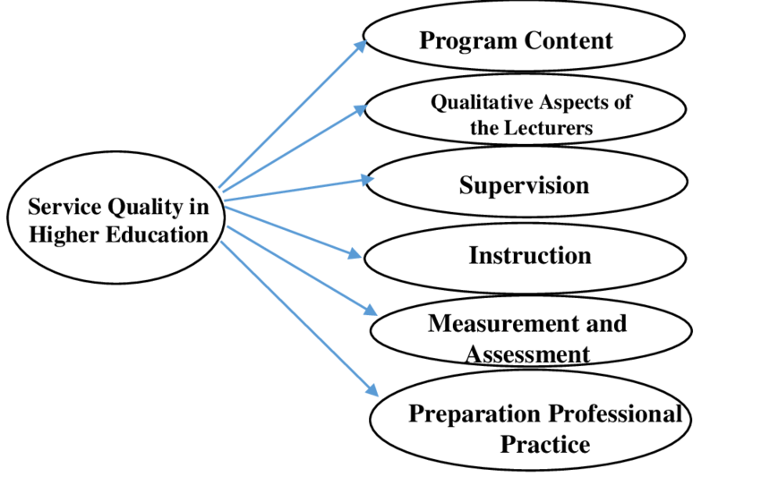
Figure-1: Preparing for higher education (Rivers, 2020)
Besides, the students also have to research for financial aid from different sources as taking higher education in UK is a costly process. Thus, a source of financial aid can help students to make their higher education even better. It will enable the students to save their money in primary stage to start their higher education, which they can use later for other purposes. Also, students must analyse their career preference and then choose what to study in higher level. It will increase the employability of students in higher education. Thus, these are some preparations students need to take before starting their higher education in college or universities. If a student fails to make proper preparation before entering into higher study, it can be a messy situation for the student as this decision is related to many things, most importantly it’s directly related to career development and financial decisions (Rivers, 2020).

Mind map on becoming a digital learner
For being a digital learner, a student must improve his motivation for learning topics from digital sources, since learning from digital sources isn’t like learning from physical sources. For learning from online sources, students must improve their patience to look at the screen for a longer time. Besides, for learning from digital sources, there are a number of sources where same contents are available. Students have to figure out their preferences of learning and then select the sources they will use for learning the topics (Ott, 2015). For this purpose, they have to make research on their sources, that will make their source selection better. When source selection is properly done, students have to ensure that they are collecting the proper information they need to make their learning fruitful. For this reason, students have to make some study before enrolling into any digital learning process, otherwise, it can be a failed attempt to learn from digital sources, wasting valuable time of the student.
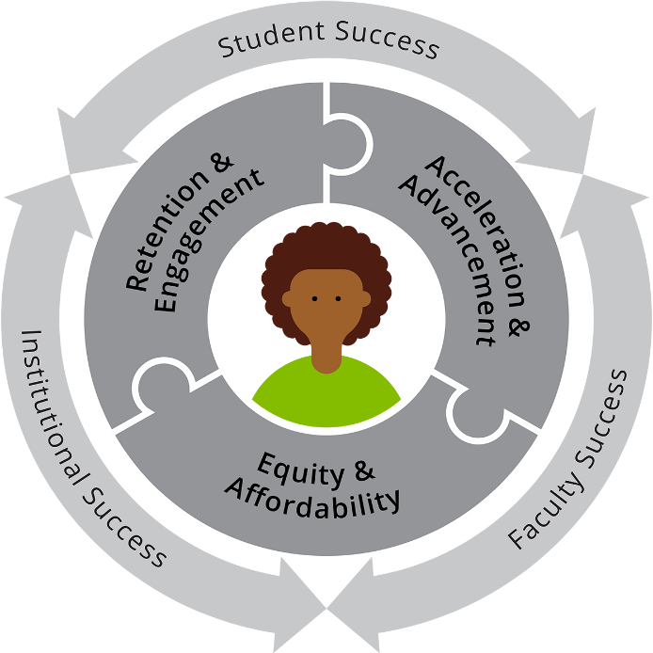
Figure-2: Digital learner (Riemer, 2007)
Though digital leaning can help the students a lot for improving their education, only digital learning can be monotonous, since this learning process doesn’t offer any proper environment to make the learning interesting. Thus, the students must make a synchronization between their traditional learning on classes and digital learning topics. It will allow them to understand the lessons of the class in detail if the teacher misses any point of the topic, or if the student gets it difficult to understand the topic. Thus, for making digital learning fruitful, preparing a mind map can help the students to get a proper idea about the whole process and the outcomes of the learning they will intake from different digital sources. (Serrat, 2017).

Video presentation.
https://youtu.be/bHYktzqreWA - click on link for video.

Reflection
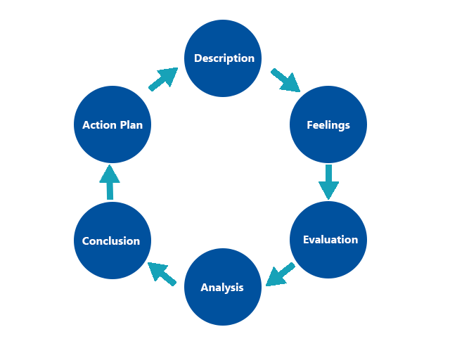
Figure-3: Gibb’s reflective cycle (Lencioni, 2016)
Description: While starting university I lacked a number of information about higher education, which made me the starting of my university a bit difficult. However, the lessons I got from online sources helped me a lot to overcome the difficulties of the topics that were taught in the classroom in traditional ways. As a result of this, I came to understand the topics taught in the classroom easily. Before this, I had very few ideas about the effectiveness of digital learning and digital resources. Also, the first writing of assignment enabled me to perform a number of skills at a time since I had to research for making my assignment better. Besides, my writing skill was also applied for making the assignment look like a formal one. As a result, completion of the assignment helped me to improve a few of interpersonal skills that are necessary for a student for starting a better career in future (Lowe, 2003).
Feelings: Before enrolling into the course, I had very few ideas about higher education, and the level of difficulties in this level of study. I used to think only the traditional classroom lessons will be enough for me to understand the topics that will be taught throughout my university life. But as time passed on, I came to realise the importance of using digital learning method and digital resources to make the traditional learning more effective and more fruitful (Kanesan, 2019). Also, I used to think assignment writing needs a very few amounts of effort, but as soon as I was assigned with my first task, I came to know about the research needed to be done for an effective assignment report. I also came to know about the importance of writing and analysing skills for making the content of my report better. Now I know the importance of conducting research before putting a conclusion to any discussion.
Evaluation: While I prepared the assignment, I experienced the importance of being able to analyse the information collected. If I were unable to select the necessary information, my assignment report would be full of unnecessary contents. Thus, this assignment helped me to experience the importance of analytical ability of a student. At the same time, I also experienced the effectiveness of digital learning, as it helped me to understand the topics that teacher taught in the classroom lectures (Gurung, 2014). However, I also experienced some bad situations regarding digital learning. For example, being a sinus patient, looking at a screen for a longer time sometimes increased my headache, which diverted my mind while reading the digital resources that the teacher provided us. Besides, while using a digital device for studying the materials, I was able to use social media websites, which also diverted my mind from study.
Analysis: The whole process of learning something in digital platforms or using digital resources can be a great medium of learning if something can be controlled by the learner. From my own experience, when I lacked motivation to learn the topic that the teacher provided digital resources of, I could barely hold my attention to the learning process, or the reading of the materials the teacher provided. On the other hand, another important fact that needs to be considered for the betterment of digital learning is the environment of the learner (Grissom, 2015). I tried to join digital learning from parks and restaurants, which was a bad idea as my attention was being diverted very frequently. Besides, a person should also know about the initial tasks and activities that will be done in university, which can reduce the level of stress in fist few months as a fresher in university. The same goes for selecting university to undertake higher education. Choosing the university must be considered as the most crucial stage while preparing for higher education.
Conclusion: To conclude, digital learning can be more interested than traditional learning, if the learner can increase his motivation for using digital media for learning a certain topic. Also, some attractive graphics or audios can increase the acceptability of the materials provided in digital learning. In this way, the effectiveness of digital learning can be ensured in this era. For preparing a formal assignment report, the writer of the report must analyse different perspectives of the given topic for the assignment (Bullen, 2011). The selection of information is mostly crucial for preparing an effective report. As a result, choosing the information from different online sources must be analysed with extra care, as selecting unnecessary information can make the report unworthy to read it fully. Analytical skill has to be developed in order to make the assignment or report writing more effective and fruitful. As a result, higher education can be made an enjoyable process for a learner like me.
Action plan: Because I am a first-time writer of an assignment and made a number of blunders while preparing the project, I need to modify the method in which I think about things. It has the potential to significantly alter the standard of the information contained in my report. If the material that was chosen is useful, it will be easier for me to create a report that is worth taking a look at (Awang, 2015). However, in the future I will approach digital learning with greater caution because parts of my education that I obtained through the use of digital resources turned out to be more difficult than they should have been because I was uninformed of the strategies that are necessary for successful digital learning. I'm going to work on boosting people's motivations to use online resources to further their education.

Personal Development Plan
Specific | Measurable | Achievable | Relatable | Timebound
Time management | For managing time effectively, I will have to ensure preparing a proper routine of the tasks I need to do in time with a priority list. | - Reminder of tasks  - Prioritising tasks chronologically  - Time limit for every task  - To-do list at every night | When the achievable stage is done, I will imply this skill for managing my university activities, which will be remarked by my teachers. | 8 months
Communication | To enhance communication, a number of online platforms is available, where tips and tricks on performing better communication are available. | - Communication master class  - Careful word selection  - Thinking before speaking, even in friendly gossips  - Less slangs  - Listening before speaking | The application of the skills will enable me to achieve both my personal and academic goals. | 4 months
Presentation | This skill is important for presenting my ideas to others. Improving this skill can enable me to make my presentations more attractive and fruitful. | - Online course  - Nurturing body language  - Strengthening nerve  - Gesture and facial expression  - Practice | This skill will be needed for academic presentations, and the feedback from the teacher will work as my feedback for learning this skill. | 4 months
Creativity | Increasing creativity is needed in this era. This will enable me to think a problem from different point of views, which will allow me think of a number of ideas that can be used to solve any problem. | - Open mindedness  - Respecting reasons and evidence  - Think about different perspectives and point of views  - Less anchoring bias  - Clarity of thoughts and goals | While preparing my academic reports and presentation, my creative ideas will be represented. The remarks of the teacher will be my feedback here. | 8 months
Emotional intelligence | Managing emotion is one of the biggest challenges to perform better in a business organisation. It eases the completion of tasks if any emotional situation that can hamper the performance occurs. | - Understanding own feelings- what & why  - Managing the negative emotions  - Motivation for managing emotions  - Empathy- put yourself at others shoes | While I will perform in a team, I will be able to use this skill more appropriately. The comments of other team members regarding this will help me to improve emotional intelligence skill | 10 months

My time management will improve if I write out all of the things I need to get done, along with a brief explanation of how important each one is. After I've done everything that's in my control, I'm going to use this information to plan out my college schedule, and I have no doubt that my professors will take note of it. Many websites provide advice on how to improve one's communication skills, and one such website is this one. It is only through putting my abilities to use that I will be able to advance in both my academic and professional careers. This ability is essential for effectively conveying my thoughts to other people. If I am able to perfect this ability, then everyone who participates in my presentations will find them to be more engaging and fruitful as a result. The academic world has a high need for someone with this expertise, and the instructor's feedback will be extremely helpful to me as I work to improve it. Never before has there been such a pressing need for inventive approaches to issue solutions (Alvarez Sainz, 2019). As a result, I will be in a better position to evaluate a problem from a variety of angles and generate a number of potential solutions to the problem that I have identified. In the upcoming reports and presentations that I give, I intend to include some of my very own distinctive ideas and points of view. In this particular circumstance, I shall react with the feedback provided by the instructor. One of the most difficult problems that one could encounter in business is learning how to keep one's feelings under check. This will make it easier for you to get the work done in the event that an emotionally challenging situation arises. My ability to employ this skill to its full potential will be made possible by the presence of others working together. If any of my teammates have any opinions on this topic, I would greatly appreciate it if they could share them with me so that I can increase my emotional quotient (Ackley, 2016).

Conclusion
Higher education is different from every perspective compared to study in high school level. Topics taught in higher education are more difficult and hectic, and so, the use of digital learning and digital resources are important. Besides, digital learner gets a number of benefits over a traditional learner. It will also help to be a team player for managing the team effectively. A Personal Development Plan can enhance the motivation of people for making a better career selection. It also helps to detect the strengths and weaknesses of a student.

References
Ackley, D., 2016. Emotional intelligence: A practical review of models, measures, and applications. Consulting Psychology Journal: Practice and Research, 68(4), p.269.
Alvarez Sainz, M., Ferrero, A.M. and Ugidos, A., 2019. Time management: skills to learn and put into practice. Education+ Training, 61(5), pp.635-648.
Awang, H. and Daud, Z., 2015. Improving a communication skill through the learning approach towards the environment of engineering classroom. Procedia-social and behavioral sciences, 195, pp.480-486.
Bullen, M., Morgan, T. and Qayyum, A., 2011. Digital learners in higher education: Generation is not the issue. Canadian Journal of Learning and Technology/La revue canadienne de l’apprentissage et de la technologie, 37(1).
Grissom, J.A., Loeb, S. and Mitani, H., 2015. Principal time management skills: Explaining patterns in principals’ time use, job stress, and perceived effectiveness. Journal of Educational Administration.
Gurung, B. and Rutledge, D., 2014. Digital learners and the overlapping of their personal and educational digital engagement. Computers & Education, 77, pp.91-100.
Kanesan, P. and Fauzan, N., 2019. Models of emotional intelligence: A review. e-Bangi, 16, pp.1-9.
Lencioni, P.M., 2016. The ideal team player: How to recognize and cultivate the three essential virtues. John Wiley & Sons.
Lowe, H. and Cook, A., 2003. Mind the gap: are students prepared for higher education?. Journal of further and higher education, 27(1), pp.53-76.
Maxwell, J.C., 2006. The 17 essential qualities of a team player: Becoming the kind of person every team wants. HarperCollins Leadership.
Mayer, J.D., Caruso, D.R. and Salovey, P., 2016. The ability model of emotional intelligence: Principles and updates. Emotion review, 8(4), pp.290-300.
Ott, M., Baca, E., Cisneros, J. and Bates, E., 2015. A Competency-Based Approach to the Master's Degree Preparation of Higher Education Professionals. Journal of Case Studies in Accreditation and Assessment, 4.
Riemer, M.J., 2007. Communication skills for the 21st century engineer. Global J. of Engng. Educ, 11(1), pp.89-100.
Rivers, S.E., Handley-Miner, I.J., Mayer, J.D. and Caruso, D.R., 2020. Emotional Intelligence.
Serrat, O. and Serrat, O., 2017. Understanding and developing emotional intelligence. Knowledge solutions: Tools, methods, and approaches to drive organizational performance, pp.329-339.

