
Design & Analysis of Extended Surfaces

April 1, 2026
University of Wales Trinity Saint David

Advanced Thermofluid Mechanics
ACMA6011
2117931
Ashley James
AI Acknowledgement

I confirm that I have not used any AI tools in the research and creation of this assignment. I confirm that I have not presented any AI generated materials as my own work.

Table of Contents
Table Of Figures 4
1 Introduction 5
2 Task A 5
3 Task B 8
4 Task C 11
4.1 Determine the temperature at the free end of the handle if it was manufactured from each of the four materials given below. Would it be safe to pick up the saucepan of boiling water for each, or any, of the handles? 11
4.2 Determine the temperature distribution along the handles by computing and plotting on a temperature scale from 20 °C to 100 °C. It is suggested that you analyse the handles in increments of 10 mm. Plot all four temperature distributions on the same axes for a direct comparison. 13
4.3 Determine the corresponding values of heat loss for the four handles analysed above. 14
4.4 Determine the length of each of the four handles based on the assumption of an optimum length fin to provide an estimate of the heat loss. How do these values of heat loss compare with those from part 3) above? 14
4.5 Determine the temperature distribution for the four handles for their corresponding optimum lengths and plot these values as per part 2) above. Discuss the difference in these values compared to those determined in part 2). Suggest a suitable optimised length of the saucepan handle for each of the four materials, justifying your answers. 15
References 17

Table Of Figures

Figure 1 History of car radiator design and numerical data (The History and Evolution of Car Radiator Design, 2024) 6
Figure 2 Table to show heat transfer vs fin length parameters 9
Figure 3 A graph to show heat transfer vs optimum fin length parameters 10
Figure 4 Table to show figures of Question 1 12
Figure 5 Calculations of m for different materials 12
Figure 6 Temperature of handle of different materials 12
Figure 7 Table to show distribution of heat along saucepan handle for different materials 13
Figure 8 A graph to show temperature distribution along suacepan handles for different materials 13
Figure 9 table to show heat loss for the four handles at intervals 14
Figure 10 table to show optimum fin length vs heat loss using optimum length 14
Figure 11 Temperature Distribution Along Saucepan Handles For Different Materials 15

Introduction

This report is broken into three sections task A will investigate the application of fins utilised to improve heat transfer in automotive design as well as how extended surfaces have been incorporated into the design of micro-processors. Task B comprises of a table and graph related to fin length and heat transfer and task C is comprised of 5 questions related to heat transfer of different materials and saucepan handles.

Task A

Fins are extended surfaces that improve the rate of heat transfer by increasing the surface area of the component. Without fins the natural or forced convection over the given surface is not enough, so fins are added to increase surface area and improve the overall thermal efficiency. The fins allow for an improved heat exchange between the component and its surrounding whether it be air or liquid (Use, 2025). By increasing the surface area the fins allow for a more efficient heat dissipation, making them important in various applications (Lee, 2025). A crossflow heat exchanger is widely used in a car as a radiator, heat transfer occurs from hot water present in the radiator and the flow of air circulating in an orthogonal direction to each other, meaning hot and cold flow cross each other. (Shah and Gaurvadkar, 2023). According to (Vishal V. Kulkarni, Abhijeet S. Dhakane, and Savitribai Phule Pune University, 2016) the fin designs, material, tube core, and coolant flow arrangement may improve the heat transfer and thermal conductivity also the sizing is an important factor for the cooling system, depending on heat load and space availability.
There are two basic types of radiators tubular and cellular type, tubular type water passes through a series of tubes which link the upper and lower tanks. Fin are placed around these tubes for better heat transfer.air moves around the tubes and fins and absorb the heat from the water. The cellular type also know as a honey comb radiator has many different air cells that are surrounded by water. (‘Know more about Car Radiators - Motrparts’., 2020)
The use of fins in automotive design have been used for many years and with technology advances fins have improved, with the use of improved manufacturing techniques and materials, modern fins are designed to be lightweight, efficient, and come in different shapes and materials depending on the application they are being used for (Lee, 2025). Car radiators were initially made from cooper and brass due to the materials impressive heat conductivity (Radiating History: A Look at Vintage Car Radiators and Their Evolution, [no date]) and according to (Automotive - Radiator History, [no date]) with the materials many advantages there was no reason to use other materials. However in the 1970’s the radiators started to change and aluminium was introduced. With aluminium being less dense than copper and brass and can handle heat well (Automotive - Radiator History, [no date]). However aluminium was prone to leaking and corrosion, so hybrids of copper, brass and aluminium were used (Ackodrive, 2024). Currently alloy radiators are used with copper and brass alloys or composites, will continue leading radiators into the future. (Ackodrive, 2024). (Advancements and Innovations in Cooling Technology, 2023) also suggests that engineers are now exploring lightweight alloys and composites due to their improved heat transfer properties, increased durability and corrosion resistance.

Some of the common radiator fin designs can consist of the follow (Comparing Fin Designs in Heavy-Duty Radiators, 2024).
Plain fins – provide large straight channels for the air to flow through, straight corners and side walls, low pressure drop and increased mass airflow, good for dirty environments where contaminants could clog lower clearance fin designs. The higher velocity airflow design serves in part as a self cleaning feature.
Offset fins – similar to plain fin channels however the rows are slightly unaligned and offset. The offset channels increase turbulent flow and an increased surface area that together improve heat transfer capacity, because of smaller spaces they are more prone to clogging and so are better in cleaner environments. With the offset fins increase in cooling potential in a small area they are suitable for high performance situations.
Wavy fins – wavy fins are a mid point between plain and offset profiles. The wavy fin has less restrictive airflow then offset fins but still increases surface area and adds turbulence airflow over plain fin designs. ‍

Era | Material | Cooling Type | Efficiency | Weight (kg) | Cost ($)
1920s | Copper | Air | 50% | 15 | 100
1950s | Brass | Water | 70% | 10 | 80
1980s | Aluminum | Water | 85% | 7 | 60
2000s | Aluminum | Hybrid | 90% | 5 | 50
2010s | Composite | Hybrid | 95% | 4 | 40
2020s | Carbon Fiber | Advanced | 98% | 3 | 70

Figure 1 History of car radiator design and numerical data (The History and Evolution of Car Radiator Design, 2024)

Figure 1 shows the timescale and numical data of car radiators, a brief analisies of this table can be that in the early years of the 1920’s copper was used as material for car radiators with a 50% efficiency, weight of 15kg and cost of $100 compare that to carbon fibre radiators of 2020’s they car radiators in the 2020’s are more efficient, weigh less and are slightly cheaper than the original copper. Microprocessors generate significant heat due to electrical resistance during their operation. This heat has the potential to cause damage to the microprocessor. To maintain performance and longevity of these parts, there are several methods that can be used to keep them cool. One of the most common is the use of heat sinks, this method, increases the surface area of the microprocessor to allow cooling (Shroff, Barnwal and Sharma, 2024). A study carried out on fin designs came to the conclusion that the fin design with thinner cylinders exhibited the best cooling compared to 4 other designs. Thin cylinders have the highest transfer coefficients because theirs larger surface area improves heat dissipation. Their shape also helps efficient airflow, compared to thicker more complex shapes. So fin size and shape is an important factor to consider when considering cooling (Shroff, Barnwal and Sharma, 2024). With recent advances in AI technology, the chips that run these data centres generate much more heat than previous generations of silicon. However new cooling systems that remove heat up the three times better than cold plates are being tested. This new cooling system uses microfluids, which brings liquid coolant directly inside the silicon. Channels are etched into the silicon chip, which allow cooling liquid to flow directly onto the chip removing heat more efficiently (Catherine Bolgar, [no date]).

Task B
When designing a fin of finite length (i.e. one that exhibits an adiabatic tip boundary condition), it is typically considered that the fin parameter mL should not be any greater than approximately 2.65. It is possible to plot the ratio of heat transfer for a fin with an adiabatic tip ${\dot{Q}}_{finite}$ with the heat transfer rate for an infinitely long fin ${\dot{Q}}_{∞}$ against a function of mL.
Using either MS Excel or MatLab, produce the plot described above to confirm that optimum fin length is generally considered as $mL ≈2.65$ for a finite length fin. Plot the mL parameter as the x-axis and in increments of 0.1 from 0 to 4.

Task B

ML | Ratio Of Heat Transfer
0 | 0
0.1 | 0.099667995
0.2 | 0.19737532
0.3 | 0.291312612
0.4 | 0.379948962
0.5 | 0.462117157
0.6 | 0.537049567
0.7 | 0.604367777
0.8 | 0.66403677
0.9 | 0.71629787
1 | 0.761594156
1.1 | 0.800499022
1.2 | 0.833654607
1.3 | 0.861723159
1.4 | 0.885351648
1.5 | 0.905148254
1.6 | 0.921668554
1.7 | 0.935409071
1.8 | 0.946806013
1.9 | 0.956237458
2 | 0.96402758
2.1 | 0.970451937
2.2 | 0.97574313
2.3 | 0.980096396
2.4 | 0.983674858
2.5 | 0.986614298
2.6 | 0.989027402
2.65 | 0.990066397
2.7 | 0.991007454
2.8 | 0.99263152
2.9 | 0.993963167
3 | 0.995054754
3.1 | 0.995949359
3.2 | 0.996682398
3.3 | 0.99728296
3.4 | 0.997774928
3.5 | 0.998177898
3.6 | 0.998507942
3.7 | 0.998778241
3.8 | 0.998999598
3.9 | 0.999180866
4 | 0.9993293

Figure 2 Table to show heat transfer vs fin length parameters

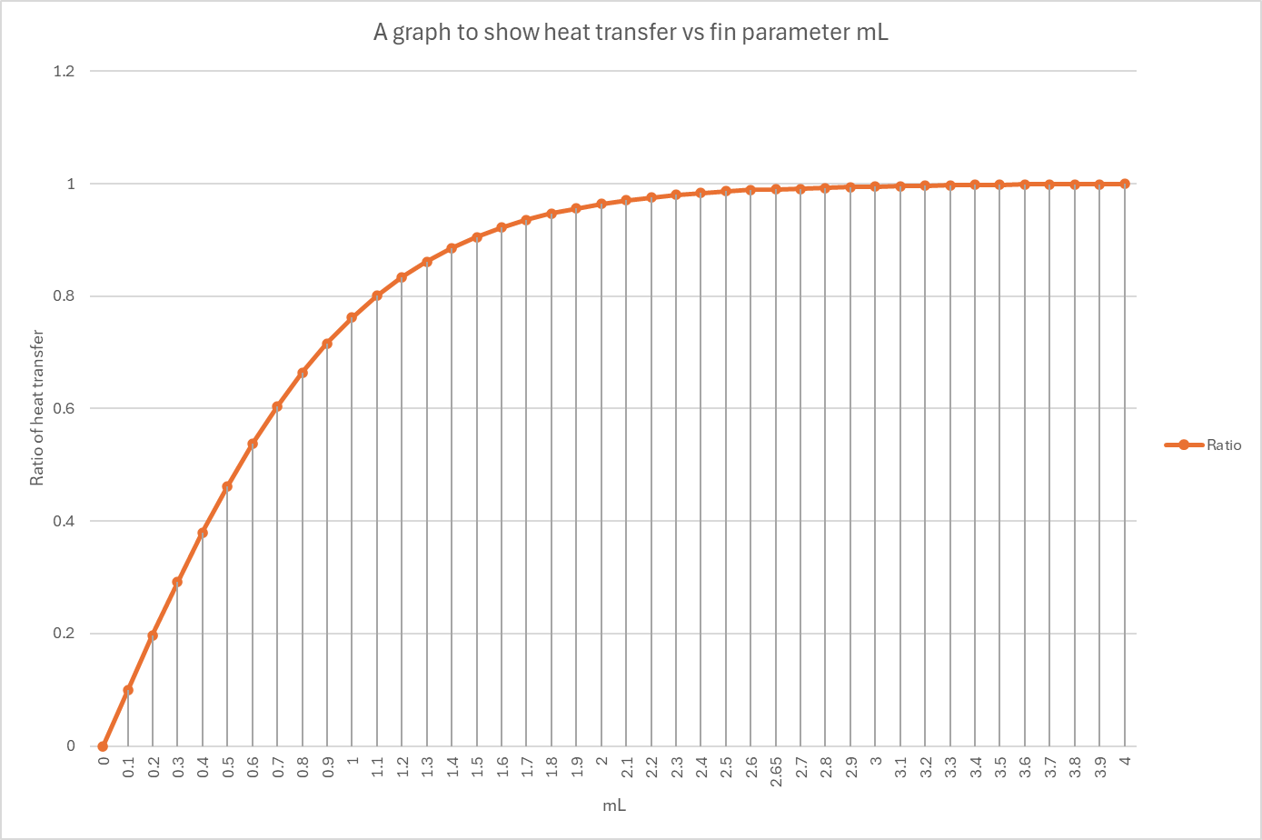

Figure 3 A graph to show heat transfer vs optimum fin length parameters

Figure 1 shows a table of heat transfer vs fin length parameter, from analysing the table in figure 1 a graph was produced to create figure 2, from analysing both the table and graph an observation can be made that as mL increases the rate of heat transfer also increases. Heat transfer has a steep and steady increase rate up to the point of 2.65mL where after this point the increase rate is so minimal that the increase rate starts to plateau off. The ratio of heat transfer was calculated by TANH x (mL).

Task C

Determine the temperature at the free end of the handle if it was manufactured from each of the four materials given below. Would it be safe to pick up the saucepan of boiling water for each, or any, of the handles?

Saucepan handle 200mm x 30mm x 5mm
Surface heat transfer coefficient from the handle is 7.5 W/m² K
Room temperature of 22 °C
Material properties:
Copper: k = 385 W/m K
2024 Aluminium alloy: k = 205 W/m K
Brass (70 Cu/30 Zn): k = 99 W/m K
304 Stainless Steel: k = 15 W/m K

Assumption- As there is a length given it is Adiabatic

$T\left(x\right)= T_{∞}+ (T_{b}- T_{∞})\frac{cosh⁡[m\left(L-x\right)]}{cosh⁡(mL)}$
where, $m^{2}= \frac{hP}{kA_{c}}$
$m=√ \frac{hP}{kA_{c}}$ = $√\frac{7.5 x 2 x (0.03+ 0.005) }{385 x (0.03 x 0.005) }$

H = 7.5 W/m² K
Tb = 100°C
$T_{∞}$ = 22°C
L = 0.2m
P = 2 x (0.03 + 0.005)
Ac = 0.03 x 0.005

h | Tb | T∞ | L | P | Ac | Tb-T∞
7.5 | 100 | 22 | 0.2 | 0.07 | 0.00015 | 78
Figure 4 Table to show figures of Question 1
copper m | 3.015113446
aluminium alloy m | 4.131969353
brass m | 5.9458839
s/s m | 15.27525232
Figure 5 Calculations of m for different materials
copper handle | 87.69001655
aluminum handle | 79.29631463
brass handle | 65.46798583
s/s handle | 29.33448853
Figure 6 Temperature of handle of different materials

Figure 4 is the table of figures referencing question 1 which have been used in the calculation process.
Figure 5 are the calculations of m for the different materials
Figure 6 is the temperature of each material of the handles at the end. Based on (What Temperature Is Too Hot to Touch?, 2026) Injury to the skin tissue begins at 44 °C though this requires a prolonged exposure time, which if picking up a sauce pan one could argue that is prolonged exposure, so based on that the only saucepan handle which would be safe to touch would be the stainless steel handle. The others would be too hot and cause injury.

Determine the temperature distribution along the handles by computing and plotting on a temperature scale from 20 °C to 100 °C. It is suggested that you analyse the handles in increments of 10 mm. Plot all four temperature distributions on the same axes for a direct comparison.

Length | Copper | Aluminium | Brass | Stainless steel
0.01 | 99.96456 | 99.93346 | 99.86232 | 99.09876406
0.02 | 99.8584 | 99.73441 | 99.45172 | 96.49637864
0.03 | 99.68199 | 99.40454 | 98.77533 | 92.47022726
0.04 | 99.43615 | 98.94663 | 97.84476 | 87.40623662
0.05 | 99.12195 | 98.36447 | 96.67557 | 81.71870259
0.06 | 98.74081 | 97.66282 | 95.28663 | 75.78436204
0.07 | 98.2944 | 96.8473 | 93.69949 | 69.90411738
0.08 | 97.78465 | 95.9243 | 91.93756 | 64.29164608
0.09 | 97.21373 | 94.90081 | 90.02535 | 59.08039486
0.1 | 96.58405 | 93.78438 | 87.98777 | 54.33941968
0.11 | 95.8982 | 92.58292 | 85.84948 | 50.09105757
0.12 | 95.15895 | 91.30462 | 83.63429 | 46.32659796
0.13 | 94.36919 | 89.95782 | 81.36476 | 43.01853453
0.14 | 93.53196 | 88.5509 | 79.06181 | 40.12936322
0.15 | 92.65039 | 87.09215 | 76.74449 | 37.6174925
0.16 | 91.72765 | 85.58973 | 74.42987 | 35.44097689
0.17 | 90.767 | 84.05153 | 72.13294 | 33.55971729
0.18 | 89.77168 | 82.48515 | 69.86664 | 31.93663513
0.19 | 88.74494 | 80.89781 | 67.64196 | 30.53818902
0.2 | 87.69002 | 79.29631 | 65.46799 | 29.33448853
Figure 7 Table to show distribution of heat along saucepan handle for different materials

Figure 8 A graph to show temperature distribution along suacepan handles for different materials

Determine the corresponding values of heat loss for the four handles analysed above.

Figure 9 table to show heat loss for the four handles at intervals

Determine the length of each of the four handles based on the assumption of an optimum length fin to provide an estimate of the heat loss. How do these values of heat loss compare with those from part 3) above?

Figure 10 table to show optimum fin length vs heat loss using optimum length
Comparing these figures to the above, the optimum fin lengths are longer apart from stainless steel which is within range of what is in figure 9. When observing the heat loss, for stainless steel there is a slight difference by 0.5 the other materials the figures will potentially be quite different as for brass at 0.2 the heat loss is 1.40 whilst for the optimum length is almost double at 0.44 with a heat loss of 1.43 so only 0.03 of a difference on heat loss but almost double the length.

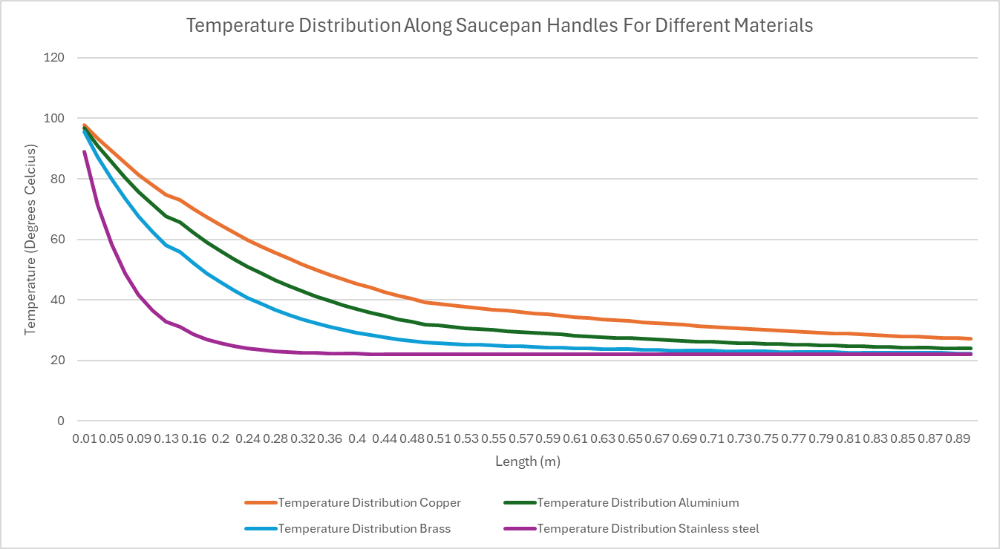
Determine the temperature distribution for the four handles for their corresponding optimum lengths and plot these values as per part 2) above. Discuss the difference in these values compared to those determined in part 2). Suggest a suitable optimised length of the saucepan handle for each of the four materials, justifying your answers.

Figure 11 Temperature Distribution Along Saucepan Handles For Different Materials
Comparing the results from figure 11 to those in figure 8. Figure 11 shows a exponential decay curve. An observation can be made that as the length of the handle increase the temperature decreases.
Suitable optimum lengths for each material could be as follows

Copper – length around 0.86 after this the decrease in heat is very small and starts to plateau
Aluminium – length 0.66 after this the increments of decrease rate increases as it starts to fall slowly.
Brass – length 0.49 again after this the change is numbers is very slight.
Stainless steel – 0.17 falls sharply to begin with and after this the numbers decrease slowly and starts to plateau.

References

Ackodrive, T. (2024) What is a Radiator and How Does it Work? Available at: https://ackodrive.com/car-guide/what-is-a-car-radiator-and-how-does-it-work/ (Accessed: 26 April 2026).
Advancements and Innovations in Cooling Technology (2023) ‘Future of Car Radiators: Advancements and Innovations’. 7 June. Available at: https://www.nargroup.com/the-future-of-car-radiators-advancements-and-innovations-in-cooling-technology/ (Accessed: 26 April 2026).
Automotive - Radiator History ([no date]). Available at: https://www.copper.org/applications/automotive/radiators/no_flux_history.html (Accessed: 26 April 2026).
Catherine Bolgar ([no date]) ‘AI chips are getting hotter. A microfluidics breakthrough goes straight to the silicon to cool up to three times better.’ Source . Available at: https://news.microsoft.com/source/features/innovation/microfluidics-liquid-cooling-ai-chips/ (Accessed: 27 April 2026).
Comparing Fin Designs in Heavy-Duty Radiators (2024). Available at: https://www.cincyradiator.com/blog/comparing-fin-designs-in-heavy-duty-radiators (Accessed: 26 April 2026).
‘Know more about Car Radiators - Motrparts’. (2020) 29 June. Available at: https://www.motrparts.com/know-more-about-car-radiators/ (Accessed: 26 April 2026).
Lee, S. (2025) Fins in Thermal Engineering. Available at: https://www.numberanalytics.com/blog/ultimate-guide-to-fins-in-thermal-engineering (Accessed: 26 April 2026).
Radiating History: A Look at Vintage Car Radiators and Their Evolution ([no date]). Available at: https://www.autoradiators.com (Accessed: 26 April 2026).
Shah, A.P. and Gaurvadkar, A. (2023) ‘Design and development of automotive radiator for better cooling efficiency’. Materials Today: Proceedings 72, pp. 1028–1034. Available at: doi:10.1016/j.matpr.2022.09.153.
Shroff, K., Barnwal, S.K. and Sharma, A. (2024) ‘Effect of Fin Geometry and the Convection Conditions on the Cooling of Electronic Microprocessors’. 11(10)
The History and Evolution of Car Radiator Design (2024). Available at: https://www.carworship.com/car-radiators/history-evolution-car-radiator-design/ (Accessed: 26 April 2026).
Use, O. (2025) ‘What are applications of fins?’. 14 November. Available at: https://www.howengineeringworks.com/questions/what-are-applications-of-fins/ (Accessed: 26 April 2026).
What Temperature Is Too Hot to Touch? (2026). Available at: https://biologyinsights.com/what-temperature-is-too-hot-to-touch/ (Accessed: 26 April 2026).

