INTRODUCTION

Global marketing is basically the beginning, middle and end of how a company organizes, creates, places, and promotes its products and services on a global scale. Giant corporations have always been involved in global marketing by setting up branches, agents, and employees in other countries.

Each of the Companies tend to adapt unique Marketing strategies to expand their business on a global scale, this includes Market entering method, pricing and product strategies, companies tend to choose the international target market based on various market studies and research. In the past decade we have witnessed a huge expansion in the global market and fashion industry is one of the major sector that benefited. Increasing awareness of western fashion through the popularity of internet helped the European and American fashion labels to expand the business to Asian markets.
British Retailor Marks and Spencer is one of the prestigious brand that founded more than hundred years ago and operates in various international markets. In this assignment I am comparing M&S’s Clothing business UK operations vs India ( one of the largest international business market for the company)

COMPANY BACKGROUND
Marks and Spencer, one of the iconic British retail brand founded in 1884 in Leeds, operate more than 1000 stores across UK & Ireland. M&S international business serves customers across 100 markets globally through strong local partners and online channels. have more than 405 stores and over 100 websites.
A cautious international expansion began with the introduction of Asian food in 1974. M&S opened stores in continental Europe in 1975 and in Ireland four years later. Marks and Spencer expanded their Asian operation through opening the first store in Chennai, India on 2008.
Macro-Environmental Analysis of M&S in UK and INDIA
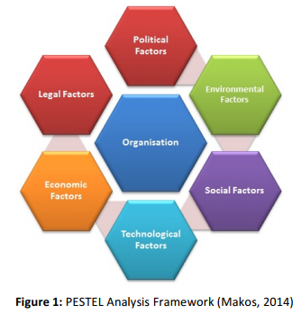
Source:https://www.ivoryresearch.com/samples/strategic-analysis-marks-spencer-plc/

PESTEL ANALYSIS M&S UK & INDIA

Political Factors

- According to Experts, M&S has been favourably suffering from the UK Commission`s loose alternate agreements that have made product imports lots easier (EC, 2013) and feature caused a lower in sourcing costs. However, the run-as much as and results of the British EU referendum on 23 June 2016 ended in a dip withinside the corporation`s income in its ultimate quarter (Davey, 2016). Due to a relatively better price structure, the corporation has additionally suffered marketplace percentage losses while coming into new markets (Marks & Spencer, 2015).

- In Indian Market M&S always face the challenges to introduce the food business due to the political factors present in th country. FDI (foreign direct investment) rules are still not favoring the brand to launch their core business category to their largest international market outside UK. In UK 60% of brands business contribution is coming from M&S FOOD.

The political Factors in both UK and INDIAN market is not favourable for the Company due to the Un-crinites in UK and least global friendly political decisions in INDIA.

Economic Factors

- M&S accentuate higher quality products and better consumer satisfaction (The Marketing Society, 2010). While this strategy resulted in decreased sales in the short term, it resulted in elevated consumer confidence in the long term due to the choice and desires of UK consumers for both value and quality. But post Brexit and Covid 19 the British economy is in a declining trend and the inflation is at 10% for 2022, both factors bothering the brands growth and expansion plans in the market.

- Despite the covid 19 and its economic turbulences, the INDIAN retail market is expected to reach $ 2 trillion by end of 2034. Increasing percentage of middle-class population and more emerging cities in the country will play a key role in its economic growth for the coming decade.

M&S already operate 1000+ stores in UK market and its economy is in a declining stage so the scope of expansion in the market will remain a challenge for the company. In INDIAN market the brand only operates 95 stores and the country’s economy is expected to grow in coming years hence the brand got huge potential to capitalize this opportunity.

Socio-Cultural Factors

Two external factors that affecting the retailers are changing values in the population and a generational shift as the baby boomer generation shifts with the Baby Boomer generation retiring .The company needed to turn its attention to Generation Gen X and the Millennials. Different generations bring perceptible tangible shifts in consumer behaviour , from the way how customers do their shopping to the channels and technologies they use, how products are perceived. Two trends the retailer should take into consideration are the different generations' shopper preferences for fashionable fashion items and/or the growing perception that British produce products are no longer considered to be of seen as high quality (Experian, 2015).Green consumerism 2015). Eco-conscious consumption and customers' ethical concerns about the socio-environmental society -Environmental costs of the brands they use is are one of the factors contributing to the development of companies corporate sustainability reporting and related activities. In the case of M&S, the company has placed considerable great emphasis on its social agenda.
For analysing the Cultural dimensions of two market Hofstede’s Cultural Dimensions Theory is the best tool to consider.

HOFSTEDE MODULE OF CULTURAL DIMENSIONS OF UK and INDIA

- Hofstede's Cultural Dimensions Theory, developed by Geert Hofstede, is a framework used to understand the differences in culture across countries.
- Hofstede’s initial six key dimensions include power distance, uncertainty avoidance, individualism-collectivism, masculinity-femininity, and short vs. long-term orientation. Later researchers added restraint vs. indulgence to this list.
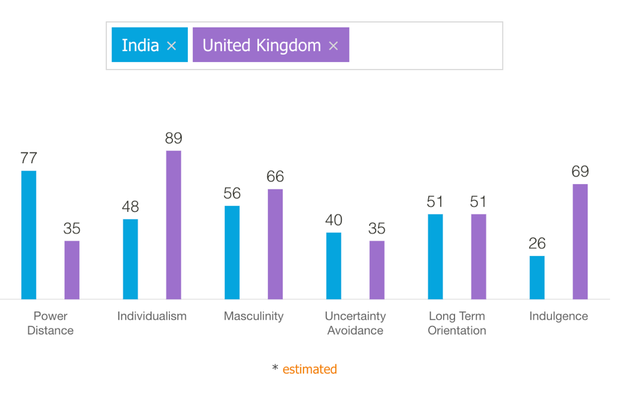

ADVANTAGES AND DISADVANTAGES OF HOFSTEDE MODULE

Some advantages include Hofstede's description of culture and his explanation of how culture may be measured. His study demonstrated the significance of cultural distinctions. Additionally, Hofstede's model gives cross-cultural relationship managers a tool to better comprehend variations in value systems and behaviours. The Hofstede model aided individuals in daily life by educating them about various cultures. The Hofstede model's confirmation that there are various organisational and institutional structures disproves the idea that one set of rules applies to all situations.
Some drawbacks include the fact that many academics at the time questioned Hofstede's initial findings. Additionally, culture is simply too intricate and multifaceted to be used as a simple organisational change management strategy. Some says it’s an outdated study and only included samples from one organisation.

Technological Factors

Technology plays an integral role in modern day retail, M&S took this step from 2007, by revamping its website and digitalising it’s retail stores from 2014.

Self-checkout
Self-checkout is one of the major innovations in today's retail, particularly in stores. This widespread trend is intended to save businesses money that would otherwise be spent on cashiers while also giving customers a quicker checkout experience. Marks and Spencer has already installed a number of self-service checkout systems throughout its stores, similar to the most of other major retailers in the UK.

Online shopping
Online purchasing is another significant trend in the retail industry. As would be expected, Marks and Spencer already has a significant online presence, offering practically all of their products online, including apparel and home goods. M&S delivers products directly to customers when selling apparel online, following the conventional model.
Technological factors in both UK and INDIA is favourable to the brand since the company is talking aggressive measures to keep up with the digital transitions in both the market.

Legal Factors

Legislation in every country in subject to be changed time to time, and Marks and spencer always give predominant focus on ensuring the legal compliances are followed in the home market and international markets.
Currently, legal factors are favouring the business of M&S in the UK, since 80% of its apparel imports are from India, and a new agreement for reducing the import duty has been signed by both countries, which will benefit M&S. But in the Indian market, a brand is facing issues with its FDI rules on food imports from international brands. This is preventing M&S from launching the food stores in Indian market.

Environmental Factors

The following are the environmental factors that have an impact on Marks & Spencer's business:
The problems associated with the current environment are frequently discussed on television, in periodicals, and in newspapers. The green policy that Marks & Spencer has devised is now known as "Plan A." The company has taken this initiative in an effort to improve people's lives, communities, and the environment. They collaborate closely with the Better Cotton Initiative (BCI) and have done so in order to create procedures that would encourage sustainable methods of cotton processing and procurement. They have consistently served as catalysts for bringing about a significant transformation that includes around 75000 employees.

The PESTLE analysis of Marks & Spencer above reveals the numerous factors that have an impact on the company's financial success. This knowledge aids in determining how important external business aspects are to any brand. In Both the markets Environmental factors are favourable for the brand.

Porter five forces of Model of Marks and Spencer for INDIA and UK

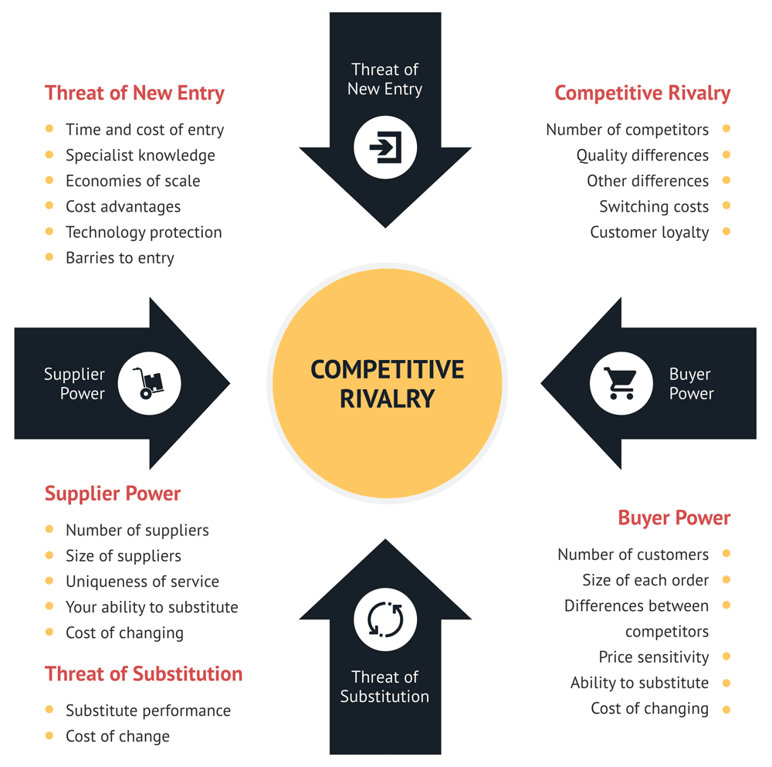

Figure 2: Porters Five Forces Analysis
(Source: https://consulterce.com/)

Industry Competition
UK
The retail industry faces intense competition from other brands. Users that choose click and collect to have a pseudo in-store buying experience at lower prices than in-store shopping are increasing the level of competition in the online market. M&S has been able to increase its online sales, with the proportion of online sales in total retail sales consistently increasing year over year. Loyalty membership cards can help stop this tendency, but other supermarket chains can use the same tactic. According to Euromonitor, the highly tailored Sparks reward programme is now helping M&S. The emphasis has switched away from discounts and toward older female customers and consistently low prices. The low-cost strategy has caused the garment industry's sales to fall. Rival Brands such as H&M,ZARA and Uniqlo are hitting M&S’s Market share in recent years.
INDIA
M&S started its operations in India in 2008, which is well before its competitor brands launched their operations in the market. This aided the brand in establishing itself in the market and establishing a sourcing centre for the country; additionally, the brand opened 100+ stores in less than ten years, whereas competitors that launched after 2015 are struggling to establish brick and mortar businesses in major cities. This enabled the company to expand its footprint to more than 25 Indian cities. All of this reduces the threat of industry-wide competition for brands in the market.

Bargaining Power of Buyers

UK
The buying power of the consumer matters a lot. The retailer may be forced to act because of the customer's price sensitivity. The cost of switching for the customer is quite minimal, and there are numerous options. M&S needs to increase consumer loyalty by providing them with unbeatable conveniences and prices. M&S is susceptible to changes in the UK market's unfavourable impression of its products. Any effort to distance oneself from British goods is going to have a big impact on the outlook for the entire business. Competitors of M&S are also emphasising client relationships; therefore, M&S needs to be watchful and defend its territory. M&S had a 40% value share in department stores, per Euromonitor. M&S is vulnerable in this market because of its high market share, and in 2016, a stock surplus in clothes and footwear due to unseasonably warm weather contributed to a value loss.
There for Bargaining power of buyers in the UK market is High for M&S.

INDIA
The absence of an international competitive brands on the market benefits the company because consumers have fewer options to choose from. Despite the lack of international competition, consumers can always choose similar products at a lower price from local players, who fall into the unorganised category. And this segment is considered to be popular in the market. This makes consumers' bargaining power in the market high.

Threat of New Entrants

UK
Continuous innovation is necessary for M&S to maintain a strong brand position and to be unique in order to satisfy the needs of its clientele. The garment industry is plagued by knockoffs since it is so simple to replicate designs and find similar designs elsewhere for a far lower price. The M&S private label product line continues to be unique. Going forward, M&S's emphasis on its food line is anticipated to give it a distinct advantage over its rivals (ivory research, 2016). This makes threat of New Entrants High in the Market.

INDIA
The fashion industry seems difficult to successfully dive into, and bleak for companies already within this space. Setting up stores in Indian cities continues to be a problem due to the shopping mall culture in the country; the majority of the malls have successfully leased their spaces to retailers, and establishing a new store can be a challenge. Furthermore, rising rental rates and market infrastructure investment make the threat of new entrants medium.

Bargaining Power of Suppliers

UK
The majority of M&S's suppliers were British in the late 20th century, but due to competitive pressure, M&S was obliged to outsource and cut costs, which diminished the influence of its suppliers. M&S's emphasis on private label also offers it influence over outside suppliers. Given that M&S relies on external suppliers, switching costs for suppliers are also relatively low.

INDIA
Since the brand follow a global sourcing strategy through their sourcing offices in India, Sri Lanka and Bangladesh the bargaining power of suppliers remain Low in both the markets.

Threat of Buyers Opting for Substitute Products

Fortunately for those in the fashion retail industry, there is little to substitute clothes with. This force is almost negligible — all ‘substitution’ in the fashion industry is really just competition.
To sum up, the fashion industry seems difficult to successfully dive into, and bleak for companies already within this space.

Considering Porter's Five Forces for M&S in both the UK and Indian markets, there are a lot of similarities and differences in the environment. UK can be considered a very mature market for fashion brands, and on the other hand, the Indian market is still in a growing stage as far as the industry is concerned. The presence of competition is one of the major examples of how both markets behave differently; in the UK, competition is high, whereas in the Indian market, international competition is low.

SWOT Analysis of Marks And Spencer for INDIA and UK
UK
Strengths | Weakness | Opportunities | Threats
Market experience: More than 130 years of Heritage  Brand recognition: M&S got a great reputation in the market for its quality of products and services.  Focus on  sustainability:  Marks and Spencer has a strong emphasis on sustainability and social responsibility.  Strong Private Label: M&S Fashion sales are coming from its own private label brands, which have unique themes and brand propositions. Autograph and Jager are two of the most well-known. | Sales drop:  Sales declines have been observed by M&S over the past few years. experienced a £201.2 million yearly loss (Chapman, 2021). The company was greatly impacted by this. Over the following ten years, it intends to close another thirty stores.  Public perception:  There is a common misconception that Marks and Spencer does not do anything to cater to teenagers and young people. The business caters to older customers and is not very edgy. Marks and Spencer has experienced a number of issues as a result of this reputation. | Online opportunities:  The online presence of Marks & Spencer is strong. It is, however, lagging behind other significant UK shops. It should take advantage of some attractive internet growth chances. In fact, it just disclosed its aim to shift a sizable chunk of home and clothing sales online in preparation for a future dominated by digital commerce. | Competition:  H&M, Next, Gap, Sports Direct, Debenhams, John Lewis, and Amazon are just a few of the major rivals that Marks and Spencer has to contend with in the UK. The level of competition is so high that Marks & Spencer is really in danger of losing its market share.

Strengths | Weakness | Opportunities | Threats

Marketing mix for UK and INDIA

Product
In its marketing mix, Marks & Spencer offers a wide range of products that cater to customers of all ages, including both adults and children. Clothing like Blazers, Cardigans, Cashmere, Jeans, Linen, shirts, skirts, and many more are available for women at Marks & Spencer. Women's footwear options include boots, sandals, loafers, pumps, heels, and more. Women's bags and accessories include handbags, beach bags, jewellery, sunglasses, and other items. Women's well-known brands include Foot Glove, Autograph, Classic, Indigo, Per Una, Twiggy, and Twiggy. Women's clothes from Marks & Spencer includes blazers, jackets, shirts, jumpers, suits, and many other items.
In the Indian market, brands use the same product strategy as range branding, except for the changes that are made according to the tropical seasons in the country. The brand doesn’t really focus on the winter wear collection in the Indian market and instead focuses on more summer-range products..

Price
For clothes for men, women, and children, Marks & Spencer offers its own house brands. Due to their superior quality, these in-house brands typically have prices in the medium range. However, M&S continues to use a competitive pricing strategy because there are more options available to customers due to the increased competition. Online merchants and other significant retail companies are also a threat to Marks & Spencer. The company also has a "dynamic pricing" strategy, whereby, in order to attract more customers, it offers greater discounts on products during certain seasons and typically lists older stock at a lower price than just-arrived material.
In the Indian market, the company follows a competitive pricing strategy and also has an entry-level pricing range to attract new consumers. Since the majority of its apparel is sourced from the Indian subcontinent, it can implement this strategy without hampering its bottom line.
Place

M&S has over 1,000 stores in the UK, with 50% of them selling clothing. The primary locations where M&S clothing can be found are on all the major high streets across the UK, and the average store size is 25000 sq ft. The brand's global flagship is located in Marble Arch, London, on Oxford Street, which spreads across 175,000 sq ft.
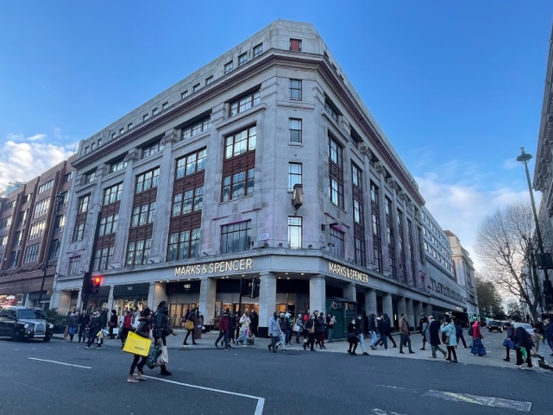
Figure 3: M&S Marble arch UK
(Source: M&S.com)
M&S has 100 stores in India, including its new concept Lingerie & Beauty stores. Unlike its home market, the company chose to focus more on premium shopping malls and less on high-street locations. The company's flagship store is in Ambiance Mall Delhi, and the average store size in the country is 10000 sq ft.
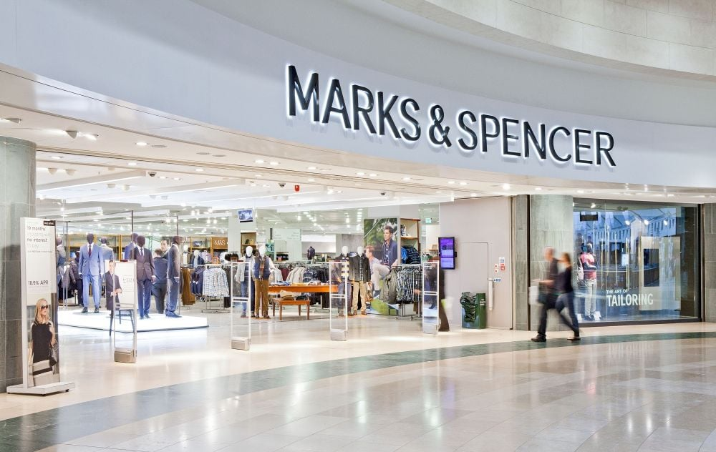

Figure 3: M&S Delhi store, India
(Source: M&S.com)
Market entry Method

M&S operates The whole company operates stores across the UK and doesn’t do any licencing or franchise models in the country. Being a UK-based retailer with more than 100 years of operating expertise, the company didn’t have to choose any other methods to enter the market since, UK was its origin of business and they had organic growth in the country over the course of years.
M&S opened its first store in India back in 2008, and they entered the market through a joint venture deal with the multi-million dollar Indian conglomerate Reliance. This JV was strategically formed back in 2008 due to the FDI rules in India, which restricted any international brands from operating in the market through a wholly owned format. But this strategic JV helped the company establish the business in the market well ahead of the competitor. (ZRA and H&M only started operating in the Indian market in 2014).

There ae advantage s and disadvantages of market entering methods.
- The following benefits of joint ventures:
The capacity to combine local expertise with that of a foreign partner who has technical or process know-how.
The ability to share risk.
May be only means of entry
- Additionally, they have drawbacks.
Partners may disagree on the third party markets to service, partners may have differing views on expected advantages, and partners may not have complete control over management.
Many issues can be resolved if the partners properly lay out in advance what they hope to accomplish and how.

Promotion
Marks & Spencer chooses its marketing approach extremely carefully in order to coordinate its advertising campaign with its in-store and internet marketing strategies. M&S highlights the need for a consistent message across all communication channels. Print media, TV advertisements, mobile ads, and other social media campaigns are all used by Marks & Spencer. The business promotes its brand, as well as items for men, women, and children, on its own website. On its website, customers can access blogs and fashion advice. By offering them exclusive discounts, Marks & Spencer encourages its regular consumers to shop during the seasonal sale.

Figure 4: M&S Spark card
(Source: M&S.com)

Additionally, M&S has a unique loyalty programme called "Sparks" that credits customers' accounts with points based on how much they spend on purchases( UK locality programs). Then, these reward points can be applied to further purchases at Marks & Spencer stores. As part of its promotion and marketing plan, the business has used digital marketing, social media promotions, and online advertisements.

People
More than 1,000 Marks & Spencer locations can be found in more than 50 nations. In total, Marks & Spencer employs about 70,000 people. The company gives its workers special consideration. To retain its personnel, the organisation has a competitive compensation policy. In addition to base pay, the company provides performance-based bonuses to its employees in order to improve individual performance. Additionally, employees receive a special discount on M&S products, whether they are ordered online or in-store. Additionally, the corporation offers its employees share purchases, health insurance plans, pension benefits, and life insurance plans. Additionally, Marks & Spencer offers specialised programmes for higher roles as well as a learning and development programme for its new trainees. In order to accommodate working parents or employees who want to pursue other career opportunities, the organisation also offers the option of flexible working hours. M&S also places a strong emphasis on diversity in each location to encourage the hiring of women by implementing more female-friendly rules. For the first time ever, the corporation experienced losses and layoffs as a result of the epidemic.

Process
Malls and suburban regions are where you can find Marks & Spencer stores. Compared to other stores like Pantaloons, Wills Lifestyle, etc., these stores are gorgeous and well-organized. The floors of the Marks & Spencer stores are separated into sections for clothing, gifts and flowers, furniture, and other home furnishings. There are separate subsections for men, women, and children inside each part. The ground floor is typically reserved for furniture and personal items. Kids', men's, and women's apparel can be found on the first floor. Furniture and other gift shops are on the second floor. Customers can choose what they want, and each business has a check-out counter where they can pay their expenses. Like other e-commerce websites, clients can also make purchases online by entering the M&S website. If the consumer has a Marks & Spencer Sparks card as part of their loyalty programme, they can additionally claim reward pints.

Physical evidence
M&S connects with customers through its retail stores and online website in both markets. All the M&S stores are designed with modern themes and concepts. Windows and mannequins are frequently changed across all stores with the assistance of the visual merchandising team to refresh the shopping experience.

Between the UK and Indian markets, M&S plans to roll out different strategies for each marketing element, considering various influencing factors of the market. On the people, process, and physical evidence aspects of the business, the brand executes a common strategy between two countries. But when it comes to product and place, the brand has different strategies for each market based on its positioning.

Ansoff Metrix analysis of M&S for UK and INDIA
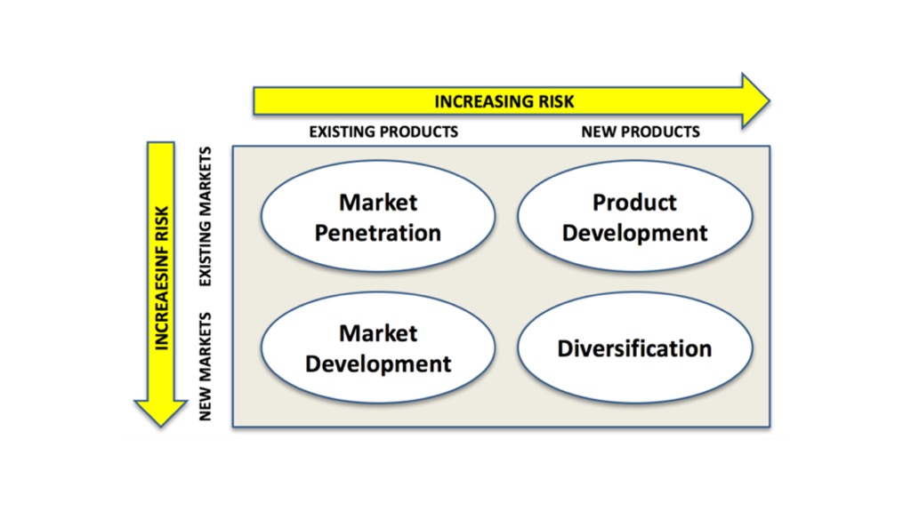
Figure 5: Ansoff Metrix
(Source: Ansoff grid)

Market penetration
Businesses that want to expand their offerings in markets where their brands are already well-established and in use employ the market penetration strategy.
- Increase production capacity
Marks & Spencer will be able to serve more clients in the same market thanks to increased production capacity.
The consumers in the same market would be attracted by competitive pricing as a result of controlled overhead expenditures.
Increased sales and consumption will result in more attractiveness and competitive pricing within the same market, which will boost market penetration.

- Competitive pricing
To make its items more appealing, Marks & Spencer Group may implement competitive pricing and price reductions.
Competitive pricing will give the business a competitive advantage and increase consumer interest in the product.
Additionally, competitive pricing will boost Marks & Spencer Group sales and result in greater penetration.

Product development
Product development refers to the process by which a business strives to increase its growth in current markets through new goods. Different strategies are used by The Marks And Spencer Group to drive product development.
- Modifications to current products
The Marks And Spencer Group Plc can make changes and upgrades to current products to provide customers with fresh and improved options.
This will result in greater product sales and consumption.
- Strategic partnerships
Before beginning full-scale manufacture of its own products, Marks & Spencer Group Plc must be able to comprehend the new product's creation process as well as the market's response and acceptability of the same.

Market Development
Through the introduction of current products in new markets, Marks & Spencer Group can accelerate the growth of its business. With various tactics, the Marks And Spencer Group Plc will be able to achieve this.

In the UK market, exploring new markets remains a concern since its strong regional presence covers all major cities and counties in the country. However, with only 100 operational stores in the Indian market, the company's brand has a huge potential for business development through the opening of new stores.
- New customer segments
In the same market for its goods, Marks & Spencer Group might potentially investigate new consumer segments.
The business can determine new product features and uses as well as new consumer segments to target with its current items.
In order to grow and expand, the business will be able to take advantage of new markets and market trends in the same industry.

Diversification
When a business creates new products for new markets, it is said to be "diversified." This relates to the expansion and development of the business. Businesses like the Marks & Spencer Group can remain competent, innovative, and competitive through diversification, which helps them stay relevant to consumer markets.

- Vertical diversification
For Marks & Spencer Group, vertical diversification implies offering new items under existing product lines to grow the company.
This implies that the Marks & Spencer Group's new product developments and launches will be comparable to and classified under already-existing product groups and categories.

.

