Rhea Pittaway (P149829)

The powerful tools of excel and weka
Data analysis of Dragon Office Supplies

Abstract

This report evaluates the importance of implementing data mining processes into businesses, such as WEKA and Excel. Data analysis helps businesses with gaining insight into predicting customer trends and behaviours, analysing, interpreting and delivering data in simple forms. This results in more informed decision making and better overall performance.

Table of Contents
Abstract 1
Table of contents 1
Introduction 1
Main body 1
The importance of Excel 1
The importance of WEKA 4
Conclusion 7
Reference List 7
Bibliography 8
Appendix 8

Introduction

Businesses have become fast-paced and driven by technology, as a result there has been more demand for data analysis. According to Getsmarter (2018), “data analysis is an internal organisational function performed by data analysts” Data analysis involves delivering numbers and figures to management, analysing and dismembering data and then presenting the findings in the easiest format. Data analysis can provide businesses with insight into predicting customer trends and behaviours, analysing, interpreting and delivering data in simple forms. Other key areas involve increasing the productivity of the business and helping businesses to make effective decision-making. Through the use of data analysis software such as Microsoft Excel™ (Excel) and WEKA, it is possible to summarise data in flexible ways, being able to quickly explore data and produce valuable observation from any accumulated data provided. This report evaluates Dragon Office Supplies data through using data mining software such as Excel and WEKA and evaluates benefits of adopting these approaches.

Main body

The importance of Excel

EDX (2018), claims that it is a “powerful skill” having the ability to analyse data. Furthermore, it can aid in making better decisions. Excel has been rated one of the top tools for data analysis and its pivot table feature is one of the most popular analytics tools. He also suggests that several businesses use pivot tables to be able to understand the business’s performance. Additionally, Excel formulas can help with aggregating data to create useful reports. Moreover, pivot charts and slicers can be combined to visualise data.

Excel can be used for the purpose of pre-processing data. According to Techopedia (2018), pre-processing data is a data mining technique which involves transforming raw data into a clear format. Raw data can often be incomplete, inconsistent, or lacking in trends, and is likely to contain many errors. Therefore, pre-processing raw data can resolve such issues. Finally, data pre-processing prepares raw data for further processing on data mining software such as WEKA. The pre-processing data technique involves a number of stages, for further information see Appendix A.

Kirk (2016), defines visualising data as “a profile of the options for interactively configuring the presentation of data” This suggests that visualisation involves presenting data findings in a graphical or pictorial format. This enables businesses to see analytics in a simpler form, so they can understand complex concepts and can identify patterns easier. According to Microsoft (2018), Excel has a wide range of analytical and visualisation functionalities which makes it ideal for pre-processing data and for visualising data. The functionalities include colour-coded data values, timelines, indicators and charts.

Figure 1 – Bar chart demonstrating Sales vs Region

This figure displays the benefits of visualisation through bar chart. This figure also identifies that Dragon Office Supplies highest portion of sales are located in the Mid Glamorgan area, with its least sales based in South Glamorgan. The small amount of sales in the South Glamorgan area indicates that there may be an issue with awareness of the business in that area. Therefore, Dragon Office Supplies should focus on advertising more in that area. The implementation of visualisation through charts and graphs is simple due to the general data already being present through Excel.

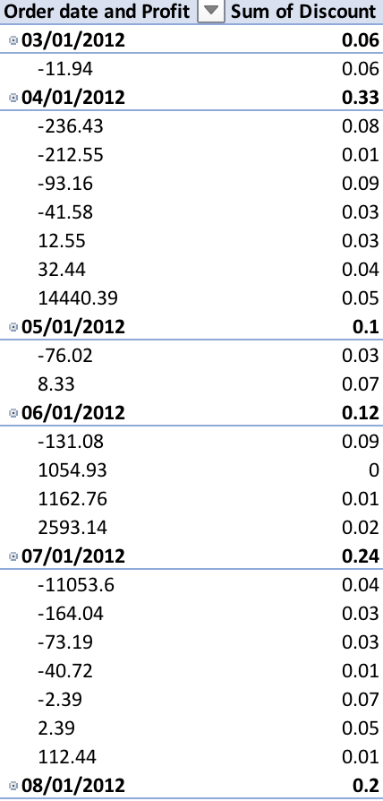
Figure 2- Pivot Table demonstrating the correlation between Order date, Profit and Discount

Pivot tables are essential in data analysis as they can quickly demonstrate the relationship between multiple variables, in this case the figure above shows relationship between profit and discount throughout 2012. The figure indicates that the greater the discount applied the less profit Dragon Office Supplies achieved. Pivot tables can also provide detailed analysis between specific time periods, for example, figure from 2012 can be cross-examined with figures from 2015 to pinpoint whether profit has deteriorated. Despite profit fluctuations, by 2015 the business ended up with a profit of 177.55 pounds.

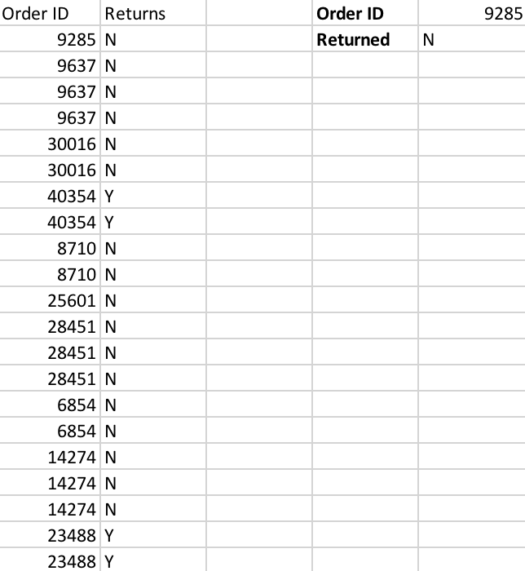
Figure 3- Lookup function illustrating Dragon Office Supplies returns
Figure 3 presents that through using the lookup function on Excel, by simply inputting a value, in the case the order ID number, the function searches the database automatically and presents a specific outcome, in this figure it shows whether that specific order was returned, or not. This function can help Dragon Office Supplies with time-management as it reduces the time it can take looking through data manually, as a result employee productivity can increase. Moreover, the business will become more effective.

Figure 4- Nested IF function illustrating the profit or loss of the business in relation to its unit price

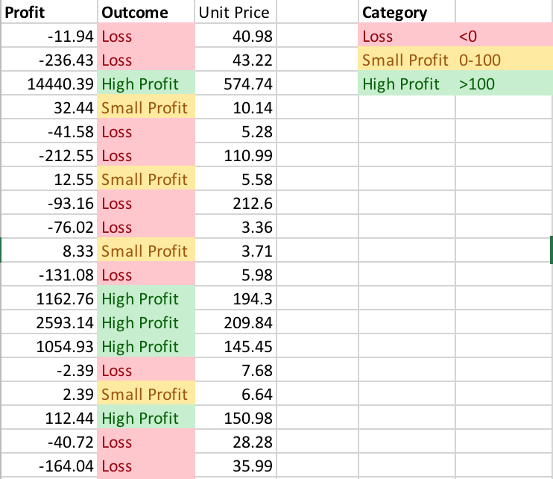

The nested IF function as opposed to a standard IF function allows for more than one outcome. In this figure it demonstrates the greater the unit price for the customer, the more profit the business makes. The nested IF function provides more of an in depths analysis because it can accumulate more than one result. Dragon Office Supplies should use this function to identify which products are making them the most profit and they should focus more on that product and determine whether to abolish the product that is making the most loss.

The importance of WEKA

WEKA is an accumulation of machine learning algorithms for data mining tasks. According to WEKA The University of Waikato (2018), “Weka contains tools for data pre-processing, classification, regression, clustering, association rules, and visualization” The ability to use this function and create visual results ensures organisational development as well as the ability to predict consumer trends.

The limitations of WEKA include it lacking in proper documentation, system updates are constant, and it isn’t very compatible with Excel spreadsheets and non-Java based software. On the other hand, the benefits of Weka are vital to most trading businesses. Weka can help identify key problem areas, drive targeted marketing campaigns as well as gaining a better understanding of the internal and external environments.

WEKA deploys a multitude of data mining algorithms that can be tailored to any organisational objective. Using WEKA is knowing how to upload the data and then manipulate that data to get results and then you can analyse your findings.
Numeric data can only be used through linear progression, nominal can be displayed through category data such as decision tree.

Figure 1- Classification

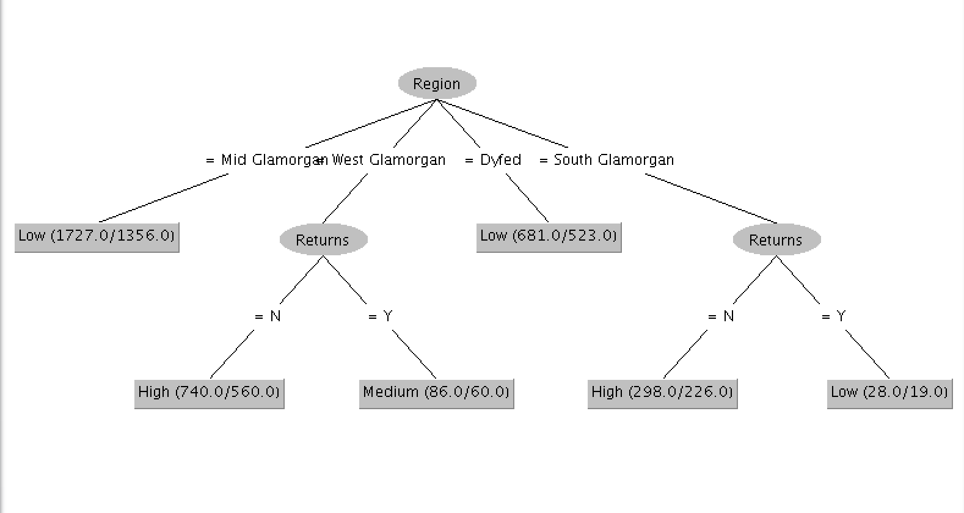

The figure above shows the classification of serval sub categories that make up the prediction of the priority of customer orders. It is critical that Dragon Office Supplies adopts classifications as further prediction to their consumer behaviour is valuable, this can help to predict further trends and gain customer loyalty.

Figure 2- Linear Regression Model
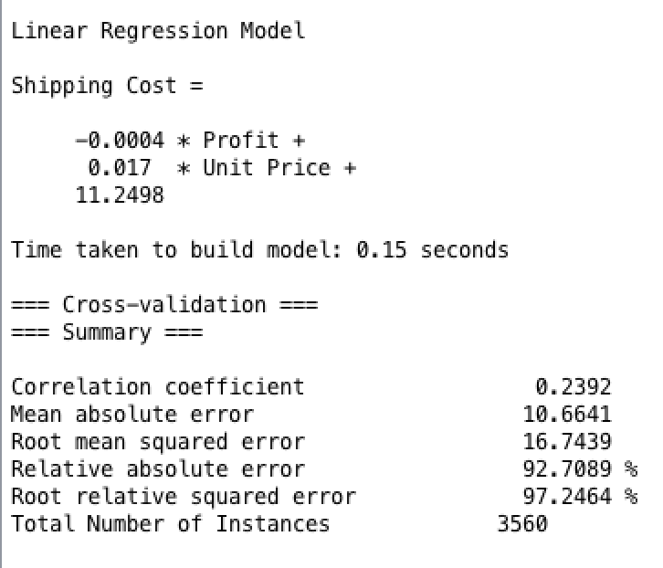

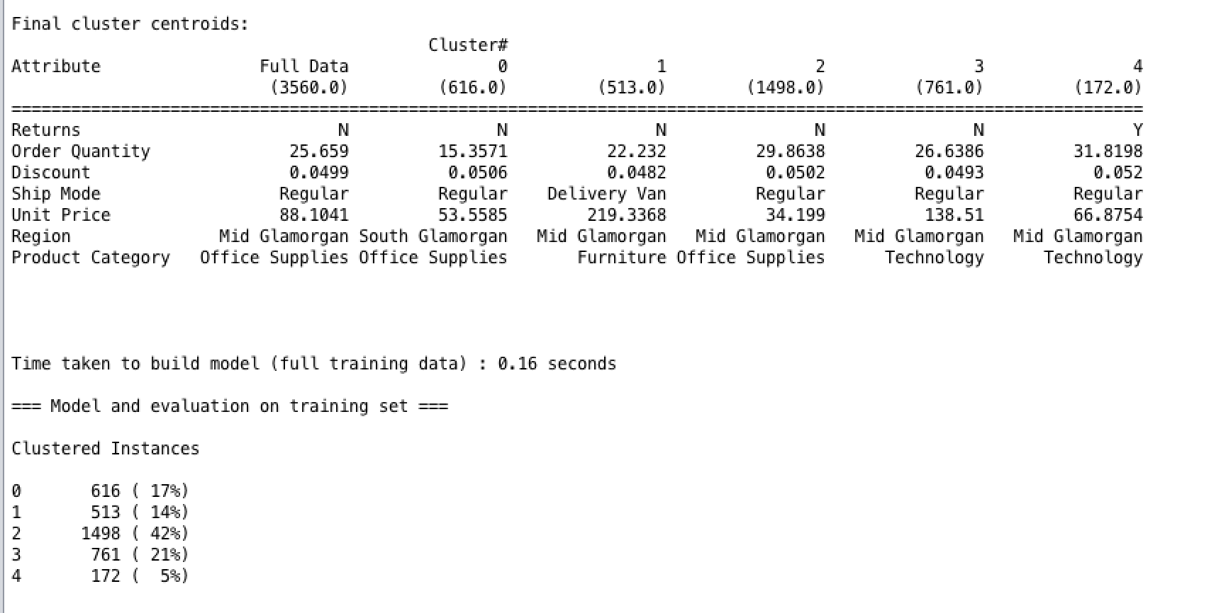
This figure above shows the linear regression model for the predict of shipping costs. It is calculated by the profit plus the unit price, whilst this is a very productive approach it can also have varying degrees of inaccuracy. This model’s predictive accuracy is 92% for the given data set therefore the reliability of this model is excellent. Dragon Office Supplies should implement more regressive models for other areas of the business in order to help evaluate the cost of something before trying it out. For example, the price of a new product can be evaluated before it was released use this model.

Figure 3 – Clustering Model

Clustering is also a very important data mining tool adopted by Weka as it indicates customer segments and can also increase a company’s prospective on that group. The figure above shows four types of consumers for Dragon Office Supplies, the second group being the largest at 42% shows customers who prefer office supplies and live in mid Glamorgan. This can translate well to the total amount of sales for that region, clustering can help identify Dragon Office Supplies most popular region and its preferences therefore, Dragon Office Supply should adopt this approach in order to successfully target the right consumer segments.

Association is the final data mining tool that can be adopted by Dragon Office Sales to tackle their issues of profit loss. Association is based on ‘basket marketing’, this form of analysis identifies the likely hood of a consumer buying a product based on previous products they have interest in. For example, a customer may purchase paper then the association may suggest that the likely-hood of the customer buying related products such as pens is likely. Finally, Dragon Office Supplies should adopt this approach due to its inherent ability of prediction of consumer behaviour.

Conclusion

In conclusion, it is clear from the findings that Dragon Office Supplies should adopt data mining processes through Excel and WEKA. The benefits of implementing data mining processes is crucial to the development of Dragon Office Supplies. Furthermore, the ability to predict consumer trends and gain their loyalty, it also offers the ability to sustain competitive advantage. The use of Excel is more simplistic than WEKA, therefore the implementation of Excel is a lot easier. However, WEKA’s more complex approach to data allows for more in depth analysis.

Reference List
EDX, 2018. Introduction to Data Analysis using Excel. [Online]
Available at: https://www.edx.org/course/introduction-data-analysis-using-excel-microsoft-dat205x-2
[Accessed 21 April 2018].
Getsmarter, 2018. WHY IS DATA ANALYSIS IMPORTANT IN BUSINESS?. [Online]
Available at: https://www.getsmarter.com/career-advice/industry-advice/data-analysis-important-business
[Accessed 21 April 2018].
Kirk, A., 2016. Data Visualisation: A Handbook for Data Driven Design. London: SAGE.
Microsoft, 2018. Visualizing data in Excel. [Online]
Available at: https://msdn.microsoft.com/en-us/library/dn749860.aspx
[Accessed 21 April 2018].
Techopedia, 2018. Data Preprocessing. [Online]
Available at: https://www.techopedia.com/definition/14650/data-preprocessing
[Accessed 21 April 2018].
WEKA The University of Waikato, 2018. Software. [Online]
Available at: https://www.cs.waikato.ac.nz/ml/weka/
[Accessed 26 April 2018].

Bibliography

Han, J., Kamber, M. & Pei, J., 2011. Data Mining: Concepts and Techniques. 3rd ed. London: Morgan Kaufmann.
Kotsiantis, S., Kanellopoulos, D. & Pintelas, P., 2006. Data preprocessing for supervised leaning. International Journal of Computer Science, 1(1), pp. 111-117.
Ritholtz, B., 2016. Beware of Data Mining. [Online]
Available at: https://www.bloomberg.com/view/articles/2016-11-23/beware-of-data-mining
[Accessed 22 April 2018].

Appendix

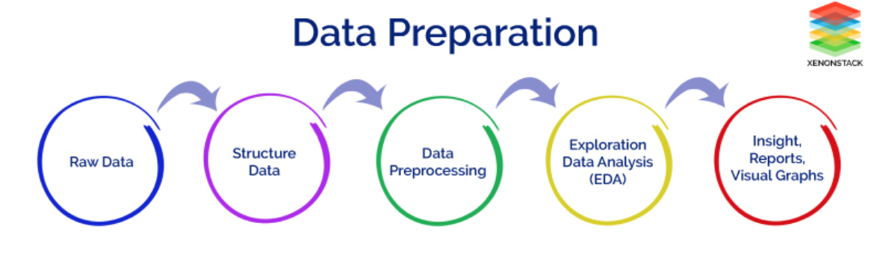
Appendix A: Pre-processing data tasks
Source: Xenonstack (2017)

