Game Design & Asset Creation 2 Written Evaluation Report
By Muhammad Rizwan Miah: Student Number 2106089
Introduction
In this assignment, I worked in a group of 4 to create a short demo of a game in the FPS genre. Over the course of the project, I worked with the team to create the game concepts, researched specific imagery to use as reference for my work, created 3D models in Maya modelling software, attempted to UV unwrap my models and texture them to finally be placed in the Unreal game engine to be used in the demo. In the following report, I will elaborate on each part of the design process I had an effect on and reflect on the project as a whole to learn lessons to take into the next piece of work.
Overview of the general game idea
In this game, the player is an ancient skeleton litch that lives alone in the dark corners of an underground dungeon. In the cave lies extremely valuable treasures that local adventurers want to collect to become rich and wealthy. The player must therefore defend himself and the treasures from the enemy adventurers. There are a variation of different enemies such as the basic adventurers, berserkers, and rogues. The player will have many spells and abilities at their disposal to defend from each wave and successfully defend the area. The player can use the environment around them to weave and dodge the overwhelming enemy groups and then attack when an opportunity presents itself, making sure to take advantage of it.
Target Audience
The target audience for this game ranges from teenagers to young adults in their 20s. We are looking for a crossover between FPS players and fantasy genre fans. The main target audience point is the theme and aesthetic design choice being set in an olden time with knights and mages. The main source of inspiration for the games is from Dungeons & Dragons [38]. The games theme is a classic dark fantasy aesthetics with a humour, parody like tone. This will be portrayed to the player by having classic fantasy characters and dungeon setting, over the top, violent death animations and absurdist scenarios such as an excessive number of adventures breaching the dungeon and raiding the treasures while attacking the player. Regal choir music, dark moody lighting, and grey stone walls with dusty old hanging ornaments to invoke the full experience of the game. The PEGI rating will be 12 and Teen for the ESRB Rating. The art style is intended to have an unrealistic cartoonish aesthetic but still have blood effects to portray the themes and give off the feeling we want to player to experience
My Experience in this project
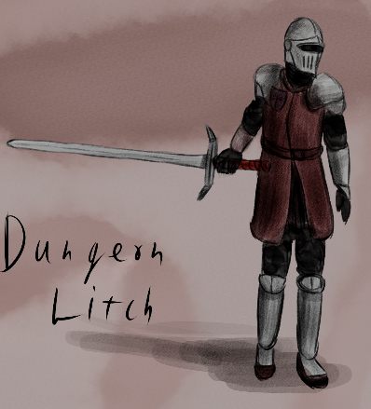
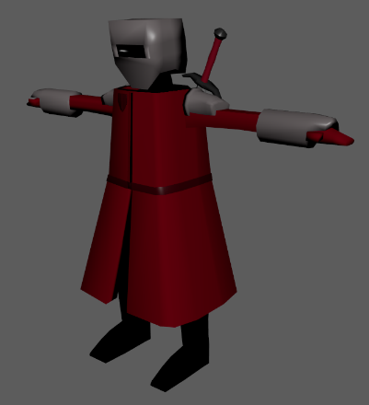
For this project, I was the character and environmental modeller. I created the main enemy model with a few variations and some environmental props such as a torch, treasure chest, sword, shield, and barrel. I used a plethora of different references images [13] to create the enemy adventurer model. I completed my referencing and inspiration research at the very beginning of the project in the first week alongside completing the game design document with the team members. During this time, the team were creating original concept art for our game and also finding references for their work. I also used some of my teams concept artwork as a heavy reference for my model. During the 2nd week of the project, I had to undergo emergency foot surgery since I got an infection. This had everlasting effects on my ability work going forward with this project. I was forced to take a few weeks off to recovery from the initial surgery, but the full recovery would take 10-12 weeks since my overall body and immune system are weak compared to the average human. Knowing this, I planned to start working again as soon as I could since I couldn’t waste any more time. I worked closely with Brecon as he created the main reference for the enemy adventurer model. He helped me with some modelling tips, and we discussed the overall project in unreal too. I created the required asset list early on and throughout the project, Brecon would ask for additional assets to be created and I would fulfil the requests. This provides me with a great sense of teamwork, good communication and accomplishment especially when the assets are then imported into the final game. I communicated with the other members of the team too, Ryan and Lewis, about the asset list, ideas, general conversation and in meetings. As a team, we planned regular meetings to update each other but sometimes we all couldn’t attend since one of the members was ill with covid and my pain from the surgery sometimes forced me to change the meeting time. It was a great experience being able to practice my modelling skills and learn new techniques throughout this project. For example, with the treasure chest, I used the lattice tool under the deform tab to create this cartoonish effect on the chest enlarging the top half while keeping the integrity of the model. Ever since I learnt about this tool, I have been using it on other models to get the look I want. Overall, I’m very happy with treasure chest and the details I was able to place on it to put across the time era of the game and theme. I attempted to learn to UV wrap my models during this project and I successfully unwrapped a simple barrel prop that I created for the game. I attempted to UV unwrap my other models but because of time restraints and the loss of time from the surgery, I had to focus on the most important elements of the game first. To combat this in the future, better resource management here would help me. I could gather together tutorials, videos, and explainers so I have a bank of resources to learn from instead of attempting to learn in a short span of time with no direction. This would save precious time completing the processes together so I can focus on gathering then learning and implementing. With the adventurer enemy model, I looked at many different sources of inspiration to visualize and articulate the model before starting. In the end, the main sources were Dark Souls knights [13], Minecraft art style [13] and Brecons concept drawing. I started working on a detailed version of the adventurer since I’ve never created a character model before. This goal was way too ambition for my skill level I found out fast. I created the headpiece well but ultimately knew that the whole model would take way too much time and we didn’t have that available. To combat this setback, I decided to pivot into an inspired Minecraft simple art style look that would still work for our game. It took me many hours to create the adventurer model dedicating several evenings taking a trial and error approach to it and then finalising the creation and I’m very proud with how it turned out for this project. I started with the inside body and legs. I extruded out geometry to create the cloak looking effect and gave it a gap near the knees with a belt across the torso. I then created the low poly arms and headpiece and finally created armour pieces. I chose to not overwhelm the model with armour pieces since the simple look worked for the default enemy and I knew I would create a boss type variation. The berserker model has increased armour size pieces and additional pieces on the legs and feet. This is to signify to the player that he has increased health and the player should respect him when he enters since he can end the game quickly. He can be distinguished from the default enemies from his intimidating head mask. The inspiration for this variation came from a couple sources. The iconic Friday the 13th character, Jason [13] and the berserker urukai from The Lord Of The Rings [35]. Even in gameplay too the inspiration live, the berserker is relentless as Jason and fast and resilient as the film berserker. I created a few other variations such as a hooded, headless, and armed sword version. The headless would be used to populate the game environment as corpses to signify, game story wise, other adventurers have tried to steal the treasures but failed miserably. I used the chamfer technique on the vertices to create the effect the head was torn off. I modelled a sword and shield as props and to be used on the enemy models. The simplistic nature of these models was exactly what I intended to go with the character models. I used the lattice tool on the shield here to create a curved effect. Lastly, I created a torch model requested by Brecon to be used as a lighting source. I’m very happy with this model. It successfully fits in with the time era the game takes place in. I realised making this model, free handily, that my modelling skills have improved drastically, and I feel much more confident now compared to at the beginning of the project. I’d say the model successfully fulfils its purpose here but if we were to continue the game, I would create a similar but lower poly looking model to fit into this game world since the characters and environmental props look like that.
Brecons Concept Artwork
I used as a reference
Adventurer Sword Variant
Reflection
At the beginning, We could have defined team roles better since there was some overlap in roles, especially modelling, where 3 out the 4 of us were modelling throughout the project. This led to some of our models not being textured properly for the demo. To combat this, in the first meeting, we find out each other’s greatest strengths and any areas where a member of the team wants to learn and focus on then we allocate that role, this will help define the roles much more. The teams communication throughout the project was very good. We established a core idea at the beginning using the game design document and decided what needed to be done. We regularly text in Discord and had meetings. We had a dedicated channel for files and gave feedback to each other about our work. I used the Gantt chart at the beginning of the assignment to structure my time and tasks accordingly. Unfortunately, the unexpected surgery caused my whole plan to go into a state of flux where I now had to plan again to accommodate for my recovery while also completing my required workload. I was looking forward to implementing my own textures and rigging my models for this project but ultimately, I had to prioritize what was most important and didn’t have the required time to fulfil these desires. I still learnt a great deal about them during this time, but the implementation of these learnings wasn’t able to happen this time. Brecon and I communicated via email to send over the unreal engine file so I could do some game testing and I found a few issues with the demo. Going forward into future project, I wish to be more hands on with the engine work since I enjoy it, have some prior experience, and want to continue learning as much as I can to provide value to the team in this department too. From time being taken away from illness, we didn’t have much time to change the game after taking feedback from game testing, we established the issues but didn’t have time to fix them properly despite making some attempt to. To combat this, we could have put a soft deadline on us to have the demo ready a few days before the main deadline to be ready to test and altered. The workload was evenly spread out between the weeks we worked on the project. I feel we could have developed the game design document more to really flesh out the game idea back to front and this would have presented us with more tasks at the very beginning to spread over all the team members. Despite only filling in the basics, since our communication was strong, we all remained on the same page throughout the project but going forward, it would be wise to make it a habit to fill out the game design document in detail, so all members of the team are guaranteed on the same page. Our group was small here, so we managed to get counteract it for this project but a large scale project of 10-50 people, a GDD is vital. Utilising the Gantt chart more would have helped us see into the future and plan more effectively in terms of soft deadlines with the design process tasks. With more time I would have definitely created more enemy variants and different style of enemies. I heavily enjoyed the design process of the adventurer models.
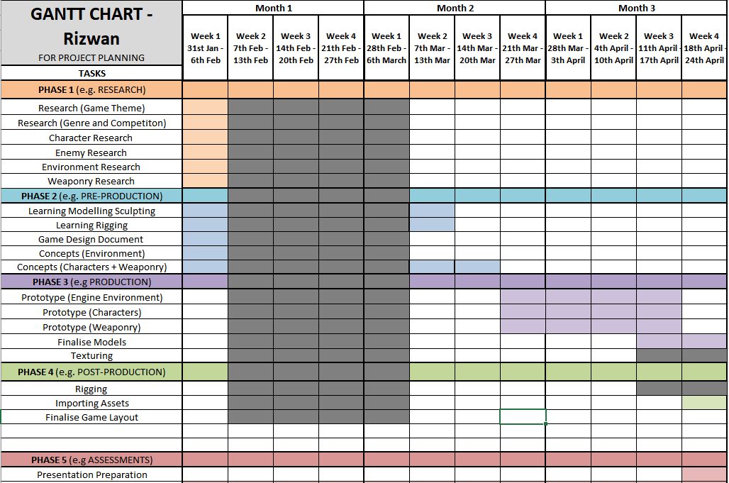
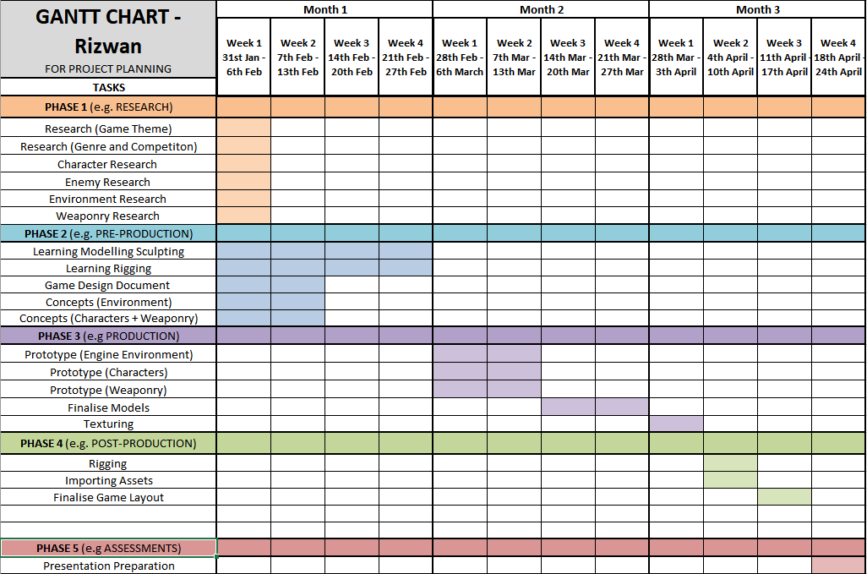
Proposed Gantt Chart
Reality

Conclusion

To conclude, I believe I did a good job in creating the required models for the project. The mesh topology is at a good standard, and I made sure there wasn’t any glaring ngons or other issues. From this experience, I learnt a new process and tools that I will be using going forward such as the lattice tool. The researching element went very well, and I bonded fast with my team. The pre-production was harmed greatly from the expected surgery, but I manged to complete the requirements in order to go into the next phase. The production of the models were to a very good standard. I believe they portrayed the themes well and fulfilled the requirements and more. I do hope to be a bigger part of the engine work going forward into the next project. The demo we presented is at a good standard considering we are all remote learning, but it could have had a little more time to cook to be great. Our time was taken away from illness and without these setbacks, I believe we would have made all the necessary changes and upgrades. From this assignment, I have become more confident in my modelling skills and can now conceptualize and visualise in my mind a plan of the model before I start. Working with the team, I improved my communication and planning skills. Going forward, I need to apply my knowledge in the other areas of the design pipeline such as texturing, and I want to enhance my engine knowledge.

References
[38] Dungeons & Dragons. [Software], Wizards of the Coast, 1997. Available at: https://dnd.wizards.com/

[13] LiewJJ, “Dark Souls 3 – Red Knight,” Deviant Art, Dec 29, 2015. [Online]. Available at: Dark Souls 3 - Red Knight by LiewJJ on DeviantArt
[13] Parker Brown, “Visored Barbute with visor closed,” crafthaus, Oct 17, 2013. [Online]. Available at: http://crafthaus.ning.com/photo/visored-barbute-with-visor-closed?context=user
[13] Jacob Dressler, “’Friday The 13th’ Movie Rights Lawsuit Decided – And Jason Voorhees’ Future Is Confusing.” Screengeek, Oct 1, 2018. Available at: 'Friday The 13th' Movie Rights Lawsuit Decided - And Jason Voorhees’ Future Is Confusing (screengeek.net)

[35] Peter Jackson, Director, The Lord of the Rings, [DVD]. New Line Cinema, 2002. Referenced Image Available at: Berserkers | The One Wiki to Rule Them All | Fandom

Bibliography

[13] JS_Morgan, “Unit 5 Dungeon VR”, Polycount, Dec 2015, [DVD]. Available at: https://polycount.com/discussion/162094/unity-5-dungeon-vr
[13] BITGEM, “Low Poly Treasure Chest - Medium”, 3docean, 3 June 2012. Available at: https://3docean.net/item/low-poly-treasure-chest-medium/2446795?WT.ac=portfolio_item&WT.seg_1=portfolio_item&WT.z_author=BITGEM
[13] Treasure Chest. Available at: https://www.turbosquid.com/3d-models/3d-model-medieval-treasure-chest/1098680
[14] Berserker. Available at: Costume Medieval Berserker Riveted Viking Helmet & Face Guard Pleather Armor (swordsaxe.com)
[13] Adventurer Character Model. Available at: Elden Ring Final Boss Leaked : Eldenring (reddit.com) & https://minecraftfanon.fandom.com/wiki/Demised_Knight

