

Evaluate and model vulnerabilities discovered during an assessment of IT systems at Carmarthenshire County Council

By
John M Williams (student 1202877)

Supervisor: Munyaradzi Nicholas Murira
Second Marker: Nitheesh Kaliyamurthy

Project submitted as part of the requirements for the award of BSc (Hons) Computing (Computer Networks and Cybersecurity)

July 2023

Abstract

This study explores the field of vulnerability assessment, focusing on its methodologies, considerations, and best practices. Vulnerability assessment is a critical component of proactive risk management, enabling organizations to identify and address weaknesses in their systems and environments. The study delves into the nature of vulnerability assessment, selecting three vulnerabilities to study in detail, researching their mechanism of action, testing in a virtual lab environment, exploring threat modelling, and providing an outcome.
The study will select a critical, high, and medium risk vulnerability from an assessment undertaken by Carmarthenshire County Council, researching the background of vulnerability assessments and its link to penetration testing, analyse in detail the selected vulnerabilities, explore threat models available to determine a risk rating, prepare a lab environment to undertake the analysis and conclude with recommendations based on the selected threat modelling and results.
A virtual lab environment is used to see if the results from the assessment provided can be replicated, and if any identified vulnerabilities can be exploited by a penetration testing. This will be based on what has been learned during the literature received for this study. The results are recorded in tables and displayed graphically.
The conclusion finds similarities and differences between the initial assessment results and the finding from the laboratory testing and the DREAD threat modelling selected. Overall, it is determined that the vulnerabilities with the highest rating from the provided report may not pose the greatest risk, and based on the testing, research and methodology adopted, the Council may wish to reassess the way they address vulnerabilities in the future.

TABLE OF CONTENT

CHAPTER 1 - INTRODUCTION 1
AIMS AND OBJECTIVES 3
BRIEF OVERVIEW OF THE STUDY 5
CHAPTER 2 - RESEARCH & REVIEW OF LITERATURE 7
INTRODUCTION TO THE LITERATURE REVIEW 7
VULNERABILITY ASSESSMENTS. 8
PENETRATION TESTING 10
SELECTED VULNERABILITIES FROM THE ASSESSMENT 11
MICROSOFT PROTECTED EXTENSIBLE AUTHENTICATION PROTOCOL (PEAP) REMOTE CODE EXECUTION VULNERABILITY - CRITICAL RISK VULNERABILITY. 11
MICROSOFT WINDOWS UNQUOTED SERVICE PATH ENUMERATION - HIGH RISK VULNERABILITY. 13
WINDOWS SPECULATIVE EXECUTION CONFIGURATION CHECK - MEDIUM RISK VULNERABILITY. 16
LAB TESTING VULNERABILITIES 18
TEST LAB REQUIREMENT 21
SYSTEM REQUIREMENTS 22
CASE STUDIES 23
A CASE STUDY BY SANS 23
NHS WANNACRY 24
RISK MODELLING METHODOLOGIES 25
CVSS 25
THE OWASP APPROACH 26
STRIDE 26
DREAD 27
CHAPTER 3 - RESEARCH METHODOLOGY 30
INTRODUCTION TO RESEARCH 30
RESEARCH PHILOSOPHY 32
RESEARCH APPROACH 32
RESEARCH STRATEGY 34
CHAPTER 4 – DESIGN 35
INTRODUCTION 35
HIGH LEVEL DESIGN OF LAB 36
LAB SYSTEM REQUIREMENTS 37
VULNERABILITY TESTING SCHEDULE 39
DETAILED SYSTEM REQUIREMENTS 40
SYSTEM SETUP FOR THE HOST LAB PC 40
SYSTEM REQUIREMENTS FOR VIRTUAL MACHINES IN VIRTUAL BOX 41
WINDOWS SERVERS 2019 CONFIGURATION 42
KALI LINUX CONFIGURATION 44
ASSESSMENT & PENETRATION TESTING METHOD 45
DESIGN OF DREAD MODEL CALCULATION TABLE 47
CHAPTER 5 – IMPLEMENTATION 48
INTRODUCTION 48
VULNERABILITY ASSESSMENT 49
VULNERABILITY ASSESSMENT RESULTS 50
IMPLEMENTATION OF THE PENETRATION TEST 52
PENETRATION TEST RESULTS 54
DREAD THREAT MODELLING 56
DAMAGE 57
REPRODUCIBILITY 57
EXPLOITABILITY 57
AFFECTED USERS 57
DISCOVERABILITY 58
CHAPTER 6 – EVALUATION 61
EVALUATING THE OBJECTIVES. 62
LABORATORY TESTING 63
THE RESULTS 64
AIMS OF THE STUDY 65
CHAPTER 7 - CONCLUSIONS 66
INTRODUCTION 66
CONCLUSION AND RECOMMENDATIONS 66
CHAPTER 8 – REFLECTION 68
CHAPTER 9 – REFERENCES 69
CHAPTER 10 – BIBLIOGRAPHY 76
APPENDICES 81
Appendix A – see spreadsheet Nessus Feb 23 2023 report.xlxs 81
Appendix B - ping success during implementation 82
Appendix C – see spreadsheet Kali Linux Lab Nessus Scan 14th June.xlxs 83
Appendix D – see supporting text document Metasploit unquoted path success.txt 84
Appendix E – see spreadsheet dread scoring spreadsheet.xlxs 85
Appendix F - Gantt Project Plan.pdf 86
Appendix G – declaration and consent form 87

TABLE OF FIGURES

Figure 1 - Black, Grey, and White box testing . 8
Figure 2 - Critical Risk Vulnerability 11
Figure 3- High Risk vulnerability 13
Figure 4 - Example of unquoted service path 14
Figure 5 - Example of unquoted service path exploit 15
Figure 6 - Medium Risk Vulnerability 16
Figure 7 - Type 1 Hypervisor . 18
Figure 8 - VMware workstation 17 player price 20
Figure 9 - Diagram of type 1 'hosted' virtual environment 21
Figure 10 - DREAD model 27
Figure 11 - DREAD threat levels 28
Figure 12 - research onion by Saunders 30
Figure 13 - Quantitative vs Qualitative 32
Figure 14 - Design of lab setup in VirtualBox. 45
Figure 15 - Dread model table 46
Figure 16 - Virtual hosts running in Virtual Box. 48
Figure 17 - table of results for vulnerability assessment 49
Figure 18 - Graphical representation of vulnerability assessment results 49
Figure 19 - creating test service. 51
Figure 20 - test executable. 51
Figure 21 - running port scan on Metasploit. 52
Figure 22 - Success with Metasploit 52
Figure 23 - Penetration test results. 53
Figure 24 - Threat rating of vulnerabilities. 55
Figure 25 - Chart of dread threat modelling results 57
Figure 26 – Dread Threat rating 58
Figure 27 - Nessus vs dread results. 63
Figure 28 - Final ranking & rating of vulnerabilities. 66

CHAPTER 1 - INTRODUCTION

In a world that is driven by information, where every individual, business and organisation rely on technology in some form or another, testing for vulnerabilities has become part of the routine maintenance needed by system developers and the Information Technology departments supporting operations [1]. The need to know and secure against current and future threats is core to organisations that rely on information systems [2]. In today’s age, internet applications from simple email communication to web-based system hold personal and sensitive information. They are susceptible to cyber-attacks due to vulnerabilities within the systems, and the threats could come from lone hackers to state funded groups, terrorists, spies, and large criminal organisations [3].
IT Security sits within the remint of Information Security and is seen as the protection of electronic data. The sub-set of electronic data inevitably includes information systems, storage systems and media, the infrastructure that transports the data, and the people that have access to the systems [4]. One approach to information security assessment is based on the extensive searching for vulnerabilities, using all relevant experience, knowledge, insight, and creativity available [5]. Other approach-based ways of characterising security assessments are intrusive or non-intrusive.

Carmarthenshire County Council is the local authority in place for the county of Carmarthenshire, in South Wales in the United Kingdom. It came into existence on the 1st of April in the year of 1996 under the Local Government (Wales) Act of 1994 [6]. The Council has a population of approximately 185,000 spamming across an area of 2395km2. It is one of the largest employers in the area employing over 9000 people, who provide services across the county [7]. The Council is connected to the Public Services Network (PSN), which is a government connected Wide Area Network (WAN) setup to allow public sector organisations to work together and share resources. A requirement of the Code of Connection to the network is that each host organisation must undertake annual vulnerability assessments and penetration testing [8], [9].

The Council has two data centres running approximately 250 virtualised Windows servers and a handful of standalone UNIX systems. A vulnerability assessment was run on the server estate at the Council on the 23rd of February 2023 and the results have been provided for the purpose of this study (See appendix A - Nessus Feb 23 2023 report).

AIMS AND OBJECTIVES

The three vulnerabilities selected from the report provided are:
- Microsoft Protected Extensible Authentication Protocol (PEAP) Remote Code Execution Vulnerability.
- Microsoft Windows Unquoted Service Path Enumeration.
- Windows Speculative Execution Configuration Check.

The stated aim of the project is:
The aim of this study is to analyse and understand the vulnerabilities, model the threat, and provide a conclusion and recommendations based on the modelling and testing that has been undertaken, to assist with improving the security posture of the IT systems under assessment.

The objectives of the project are:
Study a critical, high, and medium risk vulnerability from an assessment undertaken by Carmarthenshire County Council on the 23rd of February 2023 and to:

- Research - the study will aim to research the background into vulnerability assessments and look at case studies where vulnerabilities have been exploited and the impact on the host organisations.

- Analysis - the three vulnerabilities that have been selected for this study will be analysed, to understand how they work and potential of exploitation of each.

- Model - the study will select a threat modelling methodology to use and provide a threat rating for each of the vulnerability.

- Prepare a lab environment based on the analysis of the three vulnerabilities. Run a vulnerability assessment to see if they can be discovered. Run a penetration test against any found vulnerabilities to see if they can exploit.

- Evaluate the results from the laboratory testing, establish the threat level using the chosen model, and analyse and compare the risk levels of the selected vulnerabilities.

- Provide a conclusion and recommendation as to the level of threat from each vulnerability in relation to the original assessment and the results from this study.

BRIEF OVERVIEW OF THE STUDY

To begin, chapter 2 will research the literature available in the selected area of study. It will investigate the background on vulnerability assessments and why they are done, delving into the different types of information security assessments available and the pros and cons of each. It will analyse in depth the three vulnerabilities that have been selected, looking at the technical components of each and how they could potentially be exploited. Testing methods along with modelling methodologies will be researched, which will form part of the design, implementation, and evaluation.
The third chapter will discuss the research philosophy, approaches, and methodology selected and the detail of rationale for each. A positivist approach to the philosophy will be adopted, with objective analysis of the data. The approach will be deductive, observing results from the test undertaking in the virtual lab environment. The strategy will be to focus on three vulnerabilities from the assessment provided, and these will be categorised to a critical, high, and medium risk rating from provided assessment. The DREAD risk model will be used to provide a subjective analysis of the vulnerabilities being tested.
The design of the virtual laboratory will be discussed in detail in the fourth chapter, taking into consideration the hardware and software requirements discovered during the literature review. A high-level design of the lab will be provide visual interpretation of the virtual testing environment. There will be three servers, each being configured to mirror the system and the technical details in the assessment report. A calculation table will be designed based on the DREAD model, which will be used later to determine a subjective threat level for each vulnerability.
Implementing the test will be documented in the fifth chapter, using the virtual lab to run a vulnerability assessment following by a penetration test. The results will be recorded in a spreadsheet and used in the threat modelling calculation. Graphical and tabled results will be shown.
The evaluation will investigate what conclusions can be made following the lab test results and what has been learned during the literature view. The aims and objectives of the project will be analysed and discussed to see if they have been met. Suggested outcomes will be provided, and recommendations from insight gained for any future studies into this area.
The conclusion will draw together all the findings and results, providing a rating for each of the three vulnerabilities that have been studied. The results will be discussed and compared with the initial assessment, to look for any similarities or differences.
Finally, a chance to reflect on the study and what has been learnt whilst it has been done, what has gone well and what hasn’t gone to plan. What was learnt from doing this project and how has it broadened my understanding in the subject area.

CHAPTER 2 - RESEARCH & REVIEW OF LITERATURE

INTRODUCTION TO THE LITERATURE REVIEW

The review will begin with a discovery into the background of vulnerability assessments and why they are done, the types of information security assessments, with examples of where vulnerabilities have been exploited and the impact this has had on organisation.
It will delve into a detailed investigation into the specific vulnerabilities selected for this topic of study, looking at their mechanics of action and possible ways they could be exploited.
So why is there a need to do vulnerability testing? Applications and systems contain faults in the code that can be exploited by hackers to gain unauthorised access. Software and applications and inherently flawed, because they are written and tested by humans and there is only a finite amount of time and fault checking that can be done to detected before being made available to the public [10].
The literature review will research threat modelling to help select an appropriate method to use to analyse the vulnerabilities identified for this study and provide a solid conclusion.

VULNERABILITY ASSESSMENTS.

Assessments can be done in an intrusive or non-intrusive manner. An intrusive test actively tries to run or execute the vulnerability, which can cause systems to malfunction or alter the target [1]. A non-intrusive test would have no effect on the target and usually tests for remote service versions and looks for flags or signs that a vulnerability may exist. The non-intrusive test is considered less effective at determining if a vulnerability exists, whereas an intrusive test provides more accurate results [11]. An analogy of intrusive and non-intrusive vulnerability assessments is that the former is active whereas the latter is passive [5].

Information security assessments can be divided into 3 varieties namely – Black box, grey box, and white box [5].
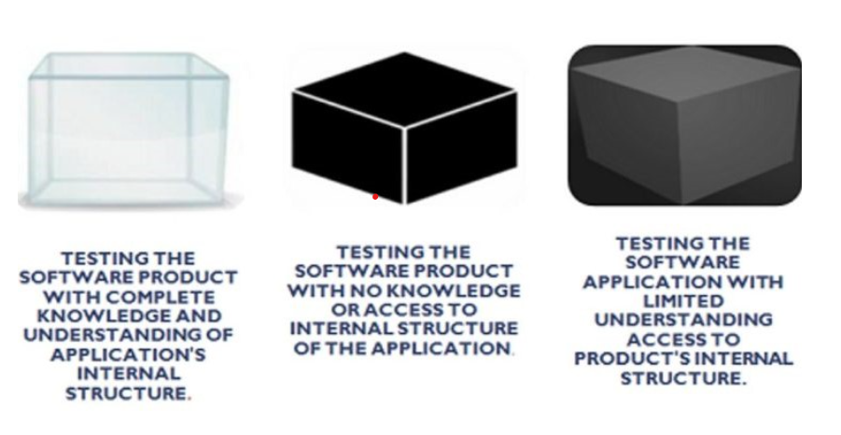
Figure 1 - Black, Grey, and White box testing [12].

Black box assessment is a term used for testing a system or software without any prior details in advanced; the auditor has no access rights or credentials for the system being checked. The tester enters the box ‘blindfolded’ and the outputted results mimic someone who could be potentially targeting the system without any prior knowledge or access [5], [13].
White box tests are where the assessor has full access to the system and possibly the underlying code[13]. This test aims to achieve the highest efficiency in finding any security flaws within a system. In vulnerability assessments, a white box test searches for system vulnerabilities with full access and credentials to all components being checks on the target network. These are usually undertaken by known IT security professionals within the organisation[5].
Gray box tests are somewhere in between both black and white box testing. Grey box tests usually have some level of access to the system or network but not full access. Grey vulnerability assessments could mimic employees or customers with access to the host network or an external contractor working for the organisation[5], [13]. A grey box test is a useful vulnerability assessment to undertaken when considering the ‘insider threat’[5].
Vulnerability assessments differ from scanning for vulnerabilities, as the assessment can form part of the overall security strategy to remediate against risks. The assessment provides details on the impact and severity of the vulnerabilities identified, and how they could potentially put the organisation at risk. Identified issues are prioritised, usually as high, medium, or low, ranking how much of a risk they pose [14].

A vulnerability can simply be an error in the coding that wasn’t detected during the development phase, or a bug or flaw in the code that has been discovered post release and has subsequently been exploited[15].

PENETRATION TESTING

System and network administrators as well as an employed penetration tester would undertake a careful and diligent review of the target IT system. This would include checking it from every possible attack vector, for example, looking at the system from the internal network as well as the internet facing network. An assessment is made and possible ways the system or application can be exploited are identified and documented within a report [16]. This report will provide valuable information and identify possibly unknown holes in the security of the system that can then be addressed and fixed.
Kevin M. Henry gives a good analogy of a penetration tester in his example, where he compares the tester to an army general planning to attack a medieval walled city.

‘The General must consider all possible attack angles in estimating the strength of the defences, determining the best way to attack, and deciding which resources are required to launch the attack. The General must walk around the city looking for weak points, examining defensive strategies and considering the best way to proceed. Without proper reconnaissance, the General may attack a point on the city that is well defended and miss the opportunity to attack via a port or gateway that is relatively undefended [17] .’

Penetration testers or Ethical Hackers? The names are interchangeable, and they both basically do the same function. They use the skills and knowledge they have obtained for good (not evil which would be a hacker). A penetration tester would mimic what a hacker would be doing to try and gain access, the difference being the penetration tester would be employed by the organisation being targeted and the results would be shared with them. The report would include details of the vulnerabilities or ‘holes’ found in the IT infrastructure and systems, and details on possibly ways these could be fixed or as the term used in the IT industry is ‘patching the vulnerability’ [18].

SELECTED VULNERABILITIES FROM THE ASSESSMENT

MICROSOFT PROTECTED EXTENSIBLE AUTHENTICATION PROTOCOL (PEAP) REMOTE CODE EXECUTION VULNERABILITY - CRITICAL RISK VULNERABILITY.

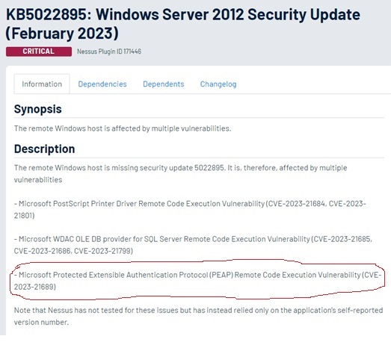
Figure 2 - Critical Risk Vulnerability

This vulnerability has been identified within Microsoft’s PEAP protocol.
Microsoft’s extensible authentication protocol, known as EAP, provides a framework for authentication methods that are used for network technologies and access. An example of this would be the Point-to-point connection protocols used for virtual provide networking (VPN’s) [19]. PEAP (Protected Extensible Authentication Protocol) is an updated version of EAP which provides enhanced secure authentication using certificate-based authentication and Transport Layer Security (TLS). This protocol was jointly created by partners within the industry, Microsoft, RSA Security and Cisco Systems[20], [21].

This vulnerability in the PEAP protocol that could allow the execution of remote code has been given an CVS scoring of 9.8 and is considered a high-risk vulnerability.
- It is remotely exploitable and can be exploited over the network.
- Specialised Access conditions are not required to exploit this vulnerability.
- No privileges are required to the target systems and the attacker is unauthorised and does not require elevated access to execute the exploit.
- The system can be exploited within interaction from an end user.
- There is the potential for total loss of confidentiality, integrity, and availability of the target system if the vulnerability is exploited [22].

There is no literature found on how this vulnerability can be exploited, however it does share similarities with CVE-2022-26923 Active Directory Certificate Services (ADCS) privilege escalation [23]. This vulnerability can be exploited by impersonating a genuine certificate on a domain controller, using it to authenticate. There are several other methods available to exploit this vulnerability, one is using the Metasploit tool [24].

MICROSOFT WINDOWS UNQUOTED SERVICE PATH ENUMERATION - HIGH RISK VULNERABILITY.

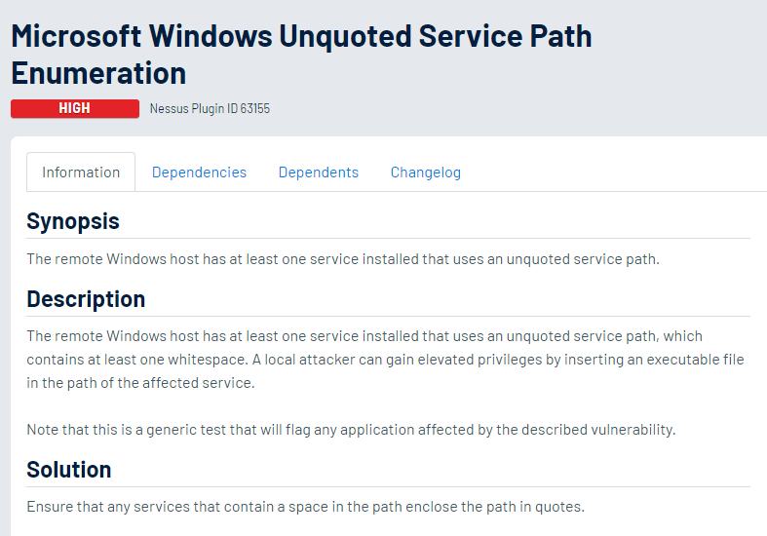
Figure 3- High Risk vulnerability

This vulnerability is an unquoted space being left in path to a service installed on a Windows system. This can potentially allow an attacker to gain elevated permissions by inserting an executable file in the path and then running the service [25], [26].
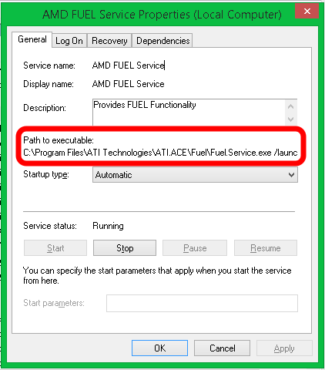
Figure 4 - Example of unquoted service path [27].
A path containing spaces should be defined using quotation marks so that the operating system is able to identify the executable to run. For example:

“C:\Program Files (x86)\ExpressVPN\nssm.exe”

In the example in figure 4, quotation marks have not been used and a space has been left between ATI technologies, and it could be possible for an attacker to exploit this and insert a malicious executable file within the space and run the service [27].
User defined services can be created in Windows at the command line level. This will create a windows service to run an executable [28].
The format of the command to be run is:
path \INSTSRV.EXE My Service path \SRVANY.EXE

Metasploit contains modules that can be used to exploit the unquoted path vulnerability and provide elevated privileges to the target if successful [29], [30].
Run msfconsole to launch the Metasploit framework. Then, use the search command to find modules related to unquoted service path vulnerabilities. For example, you can try searching for "unquoted" or "service_path" to find relevant modules[29].
exploit/windows/local/unquoted_service_path is an advertised module to specifically target the Windows Unquoted Service Path Privilege Escalation vulnerability [31].

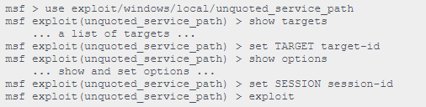
Figure 5 - Example of unquoted service path exploit [31].

WINDOWS SPECULATIVE EXECUTION CONFIGURATION CHECK - MEDIUM RISK VULNERABILITY.

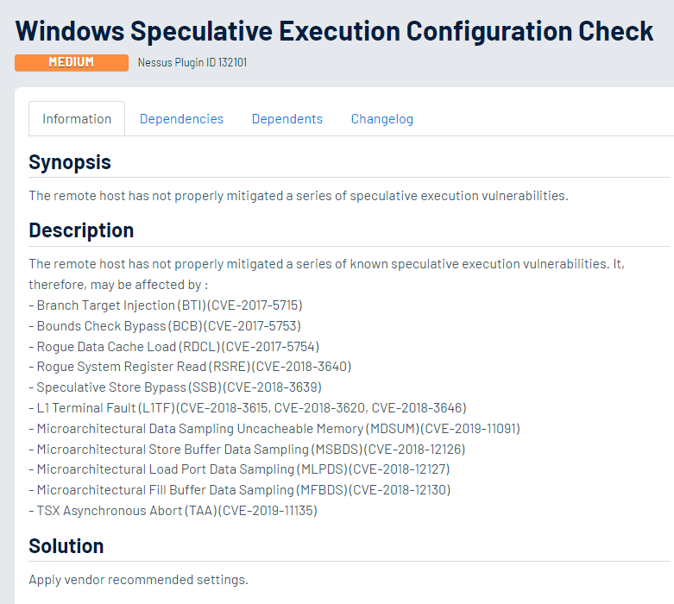
Figure 6 - Medium Risk Vulnerability

The Windows Speculative Execution Configuration Check, also known as Speculation Control, is a feature introduced by Microsoft to mitigate potential security vulnerabilities related to speculative execution in modern processors. Speculative execution is a performance optimization technique used by CPUs to predict and execute instructions ahead of time, improving overall processing speed [32].

However, certain vulnerabilities, such as Spectre and Meltdown, were discovered in early 2018 that could exploit speculative execution to access sensitive information. To address these vulnerabilities, Microsoft released software patches and updates to mitigate the risks associated with speculative execution[33], [34].

The Speculation Control feature helps users determine if their Windows operating system is protected against these vulnerabilities. It checks for the presence and status of mitigations against Spectre and Meltdown vulnerabilities on the system. These mitigations typically involve a combination of software patches, firmware updates, and microcode updates provided by CPU manufacturers [32], [35].

To perform a Speculative Execution Configuration Check on Windows, you can use the PowerShell script called "SpeculationControl.psd1." This script examines the system and provides information about the protections in place against speculative execution vulnerabilities[32].

LAB TESTING VULNERABILITIES

A testing lab can be setup in a virtual environment to allow testing of vulnerable systems and to use security tools to run penetration tests and exploits. A virtual lab can provide a safe environment for this. It is isolated from the ‘outside world’ allowing you to safely perform tests on the systems [36]. To setup a virtual environment, a hypervisor is required to run the host devices needed in the lab.

A hypervisor is an application that allows virtual machines (VMs) to be installed and run on a host computer or server, by sharing the host machines resources such as the CPU, memory and storage. There are two types of hypervisors known as ‘Type 1’ or bare-metal and ‘Type 2’ or hosted. The most used is type 1 which is installed on large host servers and used in data centres by companies and organisations to run their server estates [37], [38].

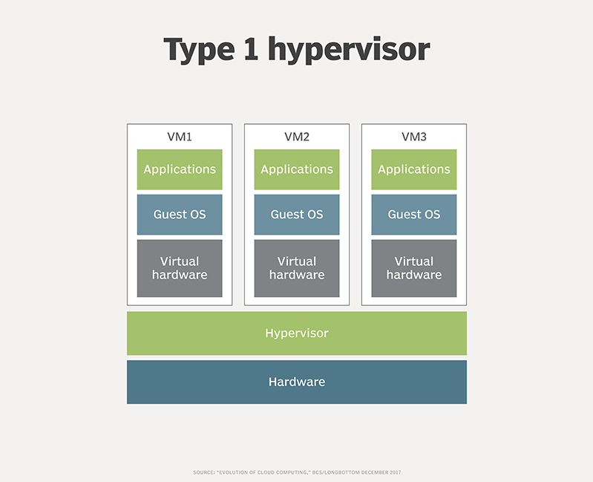
Figure 7 - Type 1 Hypervisor [38].

There are free to use and commercial hypervisor software available, with two of the most common being VMWare and VirtualBox [36].

VirtualBox developed by Oracle is a powerful type 2 ‘hosted’ hypervisor, which requires an existing operating system to be installed. It supports many 64-bit systems such as Windows 7, 8, 10 and Windows server 2012, 2016, 2019 and 2022. It can host MacOS systems as well as Linux hosts such as Ubuntu, Debian, Fedora, and Oracle Solaris 11.4 systems. It is freely available, licenced as open-source software under the GNU General Public License version 3 [39].

VMware Inc. is a commercial company offering virtualisation technology applications and multi-cloud ready services [40]. They were one of the first companies to provide hypervisor technology, releasing VMware Workstation 1.0 in 1999 [41]. They provide both type 1 and type 2 hypervisor technologies, with hype 1 ‘hosted’ products named VMware Workstation and Fusion. VMware workstation is still considered the company’s flagship product and is sold on a license basis [42].

VMware Workstation 17 Player, which is their entry level host virtualisation product supporting secure, local virtualisation, is currently priced at £127.49 [43].


Figure 8 - VMware workstation 17 player price [43].

TEST LAB REQUIREMENTS

Once a hypervisor has been selected, there are a few other requirements that need to be considered. The host computer or server will need hardware to support the running of the virtual machines in the lab, and the three main components to consider here are the Central Processing Unit (CPU), Memory (RAM) and Disk Storage[44].

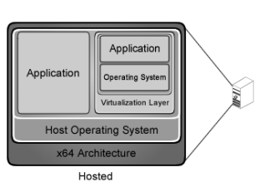

Figure 9 - Diagram of type 1 'hosted' virtual environment [45].

CPU’s – not all CPU’s support hypervisor virtualisation which is a requirement to run a virtual server. Both Intel and AMD chipsets can support virtualisation and they have tools that are available to check host system [46].

RAM – the memory on the host system will be shared across the virtual machines. The recommended system requirements of the virtual machines should be checked prior to install to ensure the host has enough RAM available to allocate. Some memory will have to be retained for running the host operating system [44].

Disk Storage – The host will need enough storage to install the virtual machines. Checking the recommended storage requirements of the host system is suggested prior to installation [44].

SYSTEM REQUIREMENTS

Windows Server 2019 has the ‘minimum’ requirements to run as:

- CPU – 1.4 GHz 64-bit processor
- RAM – 512 MB
- Disk Space – 32GB

These are the absolute minimum requirements for the operating system to install and run and requirements may change depending on the server’s role [47].
Kali Linux systems requirements are:
- CPU – A single core 32 or 64bit CPU running 2GHz or higher.
- RAM - At least 2GB of memory
- Disk Space – 20GB of disk space available

When using resource intensive applications, there may be a need to increase the memory to 8gb [48], [49].
Kali Linux is a Debian-based Linux operating system with a focus on use by ethical hackers and penetration testing. It includes a wide range of tools as standard, which can be used for computer forensics, reverse engineering, security assessment and penetration testing [50], [51].
Nessus essentials is an vulnerability scanner than can be used for free and installed on Kali Linux. It provides an array of services which include vulnerability assessments, website scanning, internal server scans and more. It is used by cybersecurity experts to proactively find issues on a network so that they can be mitigated[52].

CASE STUDIES

A CASE STUDY BY SANS
We look at the white paper ‘Full Lifecycle Security Assessment – A Case Study’ by SANS institute, who are a co-operative for the information security professionals[53].
They had the opportunity to run a security assessment for a charity, who remains anonymous in the report. They completed the project following lifecycle model:
- Assess (prepare before assessing)
- Design (During the assessment stage)
- Deploy (During the assessment stage)
- Optimize (After the assessment stage)

The summary of the report states that security assessments are the first steps to creating awareness of potential security flaws within an organising [53].

NHS WANNACRY
We look at the WannaCry cyber-attack that effected the NHS on the 12th of May 2017 as an example of a vulnerability being exploited. This was a ransomware virus that targeted a known vulnerability in the Microsoft Windows XP operating system [54]. The vulnerability was in the Server Message Block protocol (SMB) which is used by Windows devices to communicate across the network. Ironically, the vulnerability had already been identified by Microsoft and a patch was released and available for download in Microsoft’s Security Bulletin MS17-010 [55].
In 2016, the NHS were reported as having hundreds of thousands of PC’s still running Microsoft’s Windows XP operating system, a version no longer supported. In 2017, approximately 60 NHS trusts and 595 general practices within the UK were affected by the WannaCry virus [54], [55]. The attack didn’t just effect computers, it bought down blood storage refrigeration units, vital operating room equipment and even MRI scanners [54].
Once a computer has been infected by the virus, files on the hard drive are encrypted making them impossible for the end user to access. A ransom is demanded in bitcoin which the users must pay to have the files decrypted [55].
This attack had a catastrophic effect on the services being provided, with 7000 outpatient appointments having to be postponed, operations cancelled at the last minute, and patients in need of urgent care in the cases of emergencies diverted to alternative facilities [56]. The National Audit Office reported that no NHS trusts reported actual harm to patients from the attack, although it did say that evidence was very limited from this [56].

The way the WannaCry incident effected the NHS had a direct impact on the public and highlights that fact vulnerabilities and penetration testing is a vital part of any IT operation. Without it, there is the real potential for severe harm to be done which can have a direct impact on the human population [56].

Following the WannaCry outbreak, funding of £21 million and an additional £25 million was urgency reprioritised by the NHS to address any vulnerable systems across the organisation [57]. This would allow them to move away from the unsupported Windows XP operating system to an updated version supported by Microsoft.

RISK MODELLING METHODOLOGIES

CVSS
CVSS stands for Common Vulnerability Scoring System. It is a framework used to assess the severity of software vulnerabilities based on various factors. The CVSS score is a numerical representation of the vulnerability's severity, ranging from 0.0 to 10.0, with higher scores indicating more severe vulnerabilities[58], [59].

The CVSS score considers several metrics to evaluate the impact and exploitability of a vulnerability[60], which include:

- Base Score: This metric represents the intrinsic qualities of a vulnerability, such as its impact on confidentiality, integrity, and availability. The base score is calculated based on factors like the attack vector, attack complexity, authentication requirements, and impact on the system.

- Temporal Score: This metric reflects the vulnerability's severity at a specific point in time. It considers factors like the availability of exploit code, known instances of the vulnerability being exploited, and the likelihood of a successful exploit.

- Environmental Score: This metric allows organizations to customize the CVSS score based on their specific environment. Factors considered include the vulnerability's impact on the affected system and the level of security measures in place [60].

CVSS scores can be used to prioritize vulnerability management efforts. By considering the score, organizations can assess the potential risk associated with a vulnerability and allocate appropriate resources for mitigation [60].

It's important to note that while the CVSS score provides a standardized measure of vulnerability severity, it should not be the sole factor considered when assessing the impact of a vulnerability. Additional factors, such as the value of the affected assets and the potential for business impact, should also be considered [58]–[61].

THE OWASP APPROACH

A generic qualitative model to consider risk calculation is [62]:

- RISK = (Probability that threat occurs) x (Cost to organisation)

The likelihood can be calculated depending on the type of threat and considering the countermeasures in place. The cost to the organisation is the impact it may have if the threat was exploited, considering if it would disable a single system or the entire network[62].

STRIDE
The STRIDE threat categorisation model is used to identify threats by classifying attacks goals into the following categories:
- Spoofing
- Tampering
- Repudiation
- Information Disclosure
- Denial of Service
- Elevation of Privilege

This method is useful to identify threats from the perspective of the attacker and looking into their goals [63].

DREAD
The DREAD subjective model [64] is a quantitative approach to modelling threat using 5 categories each with a score from 0 to 10:

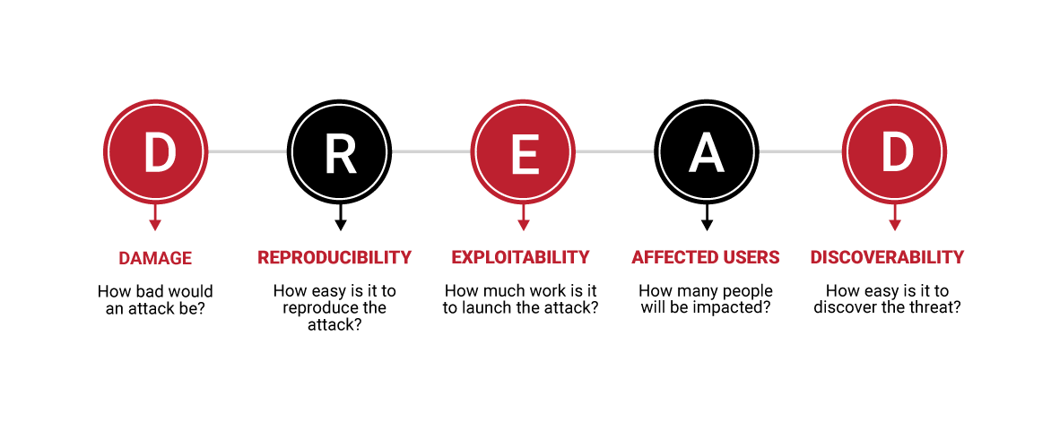
Figure 10 - DREAD model[64] .

- Damage potential (out of 10)
- Reproducibility (out of 10)
- Exploitability (out of 10)
- Affected users (out of 10)
- Discoverability (out of 10)

Critical (40–50) | Critical vulnerability mut be address immediately.
High (25–39) | Severe vulnerability should be considered for review and resolution soon
Medium (11–24) | Moderate risk needs to review after addressing above.
Low (1–10) | Low risk poses the lowest risk to the infrastructure and data.
Figure 11 - DREAD threat levels [65].

Exploitability evaluates the level of difficulty for an attacker to exploit a vulnerability. It considers factors like the attacker's skill level, available tools, and the resources needed to exploit the vulnerability [65].
The overall DREAD score calculation is:

(a+b+c+d+e) / 5 = result

The higher the number, the higher the risk [62], [66]. It does not have a widespread use across the industry; however, it can be useful for organisations to use when looking to categorise risks.

In conclusion, vulnerability assessments and penetration testing are important parts of cyber resilience to protect from weakness in system, and to prevent them from being exploited.
The three selected vulnerabilities from the assessment report on Carmarthenshire Council systems have information available around the potential impact they could have and what should be done to mitigate, however there is limited details on how some can be exploited.
Virtual labs are used for both penetration testing and vulnerability assessments and are considered a safe and cost-effective way to run a test environment [67]. Types 1 hypervisors that were researched for this study could be used to run the lab. Options available are VMWare and Virtual Box.
There were a few modelling methodologies discovered for threat analysis. Some of these are quantitative, whereas others are subjective. The DREAD model could be useful for organisations to use when looking to categorise risks.

CHAPTER 3 - RESEARCH METHODOLOGY

INTRODUCTION TO RESEARCH

There are various philosophical paradigms to guide researchers in their pursuit of knowledge and understanding. One such paradigm is positivism, a research philosophy that emphasises empirical observation, objectivity, and the scientific method. Positivism seeks to uncover universal laws and patterns that govern human behaviour and social phenomena, ultimately aiming to produce reliable and valid knowledge [68].

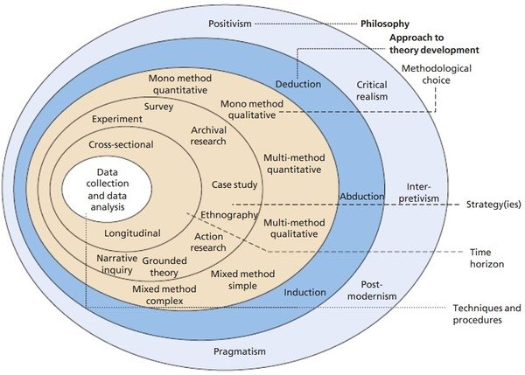
Figure 12 - research onion by Saunders [69].

There are several approaches that guide the design, implementation, and analysis of research studies. These approaches provide frameworks for conducting research and vary in their emphasis on data collection methods, theoretical perspectives, and the overall goals [70].
The research strategy refers to the overall approach adopted by researchers to conduct studies. It outlines the steps and methods that will be used to gather data, analyse information, and address the research objectives. A research strategy provides a framework to the whole process when it comes to research, providing a guide in making decisions on how to collect data, sampling, how to analyse and interpretation it [71].

RESEARCH PHILOSOPHY

A positivist research philosophy approach will be used for research, as sample data will be collected in the form of the vulnerability assessment already provided by Carmarthenshire Council, and the resulting data from the lab tests. This will be interpreted to come up with a result. It is an objective analysis of the data sets and there will be no preconceived opinions made.

RESEARCH APPROACH

The research approach will be deductive as generalised data has been provided for each vulnerability being assessed, and the data will be tested, and results formulated through observation from the lab results along with the vulnerability assessment results provided.
The data already provided for the purpose of the testing is quantitative; these are the results from the Nessus scan where the data have been given a rating using the CVSS scoring system. The DREAD risk modelling methodology will be used to produce a comparative threat rating using the lab testing results. As this modelling technique is subjective, the results provided will be qualitative.
The lab will be used to observe the studies into the vulnerabilities through the form of a penetration test following a specific testing method to try and exploit each identified vulnerability, with the results analysed. The DREAD threat model will be used to determine a threat level. This will be repeated for each vulnerability identified for the study. Therefore, a mix method approach will be adopted.

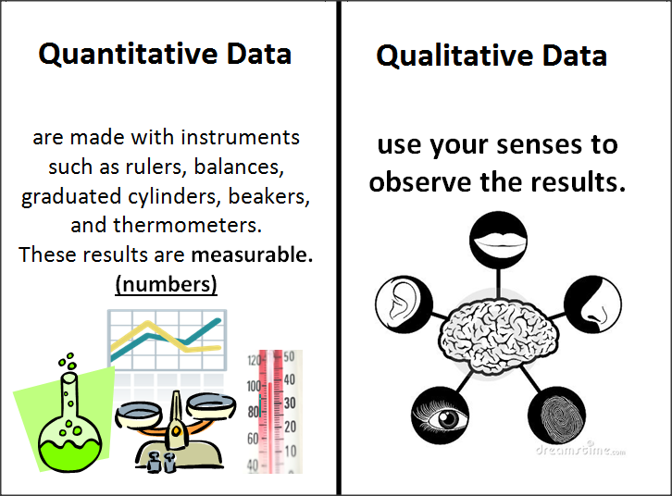
Figure 13 - Quantitative vs Qualitative [72].

RESEARCH STRATEGY

It was recognised that there were many vulnerabilities identified on the Nessus scan report provided (See appendix A). For this study, a critical, high, and medium risk will be selected, a total of 3.
A mix methodology, mainly aligned to experimental based research strategy will be adopted. The data has been provided in the form of a vulnerability assessment, which will be used to select the 3 vulnerabilities. A lab environment mirroring the setup on the vulnerability assessment will be created.
An assessment and penetration test will be run in the lab to find out if the results concur with the report. The lab results will be used to calculate a threat level for each vulnerability based on the DREAD threat methodology. A Conclusion and recommendations on the fundings will be provided.
Penetration testing is considered an experimental-based methodology as it is an approach used to assess the security of computer systems, networks, or applications. It involves actively attempting to exploit vulnerabilities and weaknesses in the target system to identify potential risks, and then recommends appropriate security measures. The outcome is not known until the experiment has been concluded.
To conclude, a mix method approach to the research strategy will be developed and used for the purpose of this study.

CHAPTER 4 – DESIGN

INTRODUCTION

The design will initially detail the system requirements needed for the setup of the virtual laboratory. This will take into consideration the hardware and software resources, based on research done in this area.
A high-level visual diagram of the lab will display the interdependencies between each component. This will include the virtual network range to be used and the IP addresses assigned to each host.
Each virtual server will be assigned one of the three vulnerabilities, and an assessment and penetration test will be run targeting each of them.
Detailed requirements for each host will be provided, with tables used to show the resources and setup required.
Finally, the DREAD modelling calculation to be used will be formulated, to assess each vulnerability, which will provide a threat level. This will be forming part of the conclusion chapter of this study.

HIGH LEVEL DESIGN OF LAB

HOST PC
Microsoft Windows 10, 2GHz 64bit single core – 16GB RAM – 1TB Storage
Running Oracle VM Virtual Box

8
Virtual Network 192.168.1.0 / 255.255.255.0
Server 1 – CRITICAL
192.168.1.2

Server 2 - HIGH
192.168.1.3

Server 2 - MEDIUM
192.168.1.4

PEN TEST CLIENT
Kali Linux
192.168.1.1

LAB SYSTEM REQUIREMENTS

The lab virtual servers will be setup and installed to run Microsoft Windows Server 2019. This is the operating system listed in the report provided by Carmarthenshire County Council on the scan done on February 2023 (see Appendix A). A white box approach to the assessment will be used, and accounts will administrative access to the systems will be created.

LAB REQUIREMENTS
3 x Windows Server 2019 | Windows PEAP enable
1 x Kali Linux | Windows Remote Services Enable
Type 2 hypervisor | Speculative Execution Configuration Check
Virtual Networking | Static IP addresses
2GHz CPU x 4 | Connectivity testing
2GB RAM x 4 | Metasploit installed on Kali
120GB Disk Space | Nessus Essentials installed on Kali
Internet connectivity | NAT enabled

Based on the research conducted, the chosen setup will use Oracle’s Virtual Box as the virtualisation emulator. The latest version of 7.0.8 being selected.

Considerations in this decision are:
- Both virtual box and VMWare are type 2 hypervisors.
- The cost comparison between virtual box and VMWare workstation. Virtual Box is open-sourced software and there is no cost to use. VMWare is commercial and would cost £127.49.
- The lab requirements are small, with a single host server and 4 virtual machines (3 virtual servers and a host running Kali Linux). Both products are listed with the ability to run several operating system simultaneously.
- Both products support Windows and Linux based operating systems.
- The overarching decision for this is down to cost. Both products seem to be similar when comparing functionality.

VULNERABILITY TESTING SCHEDULE

Server1
To assess the critical risk vulnerability Microsoft Protected Extensible Authentication Protocol (PEAP) Remote Code Execution Vulnerability (CVE-2023-21689)

Server2
To assess the high-risk vulnerability Windows Unquoted Service Path Enumeration

Server3
To assess the medium risk vulnerability Windows Speculative Execution Configuration Check

DETAILED SYSTEM REQUIREMENTS

SYSTEM SETUP FOR THE HOST LAB PC

A physical lab PC running a 64-bit version of Microsoft Windows 10 operating system. Windows 10 is listed as a supported operating system for virtual box [73].
Intel Core i5 supporting SSE2.
16GB of RAM
1TB of SSD storage

Considerations in this decision are:
- This is based on the requirements of virtual box as researched during the literature review.
- The specifications are adequate to support the number of virtual machines that the host will be running.

SYSTEM REQUIREMENTS FOR VIRTUAL MACHINES IN VIRTUAL BOX

3 x virtual machine running 64-bit version of Microsoft Windows Server 2019.
1 x virtual machine running Kali Linux
2GHz CPU per VM
2GB RAM per VM
120GB Disk Space per VM
Enable NAT for networking
Network Settings:
VM1 192.168.1.2 / 24
VM2 192.168.1.3 / 24
VM3 192.168.1.4 / 24
VM4 192.168.1.5 / 24

Considerations in this decision are:
- These are based on research into the recommended specification for the virtual machines.
- Microsoft Windows 2019 is the system running on the servers at Carmarthenshire County Council and this will be providing a consistent test environment.
- Kali Linux will be the testing host client based on research.
- NAT to be enabled in virtual box to allow each client to connect to one another. IP address within the same network range to be allocated to allow communication.

WINDOWS SERVERS 2019 CONFIGURATION

Change computer name to: server1, server2 and server3
Create user: testuser (Control Panel -> User Accounts -> Create Local Accounts).
Testuser account to be added to the local administrator group.
Server1 – Enable PEAP service.
Server 2 – standard install
Server3 – standard install
Server 1 – additional configuration for PEAP
Configuring the Wired Network (IEEE 802.3) Policies and Wireless Network (IEEE 802.11) Policies extensions in Group Policy.
Computer Configuration > Policies > Windows Settings > Security Settings
Server 2 – additional configuration a test service.
Create folder and file c:\testservice\testservice.exe
Run the following command to create the test service (include the space).
sc.exe create testservice binPath= c:\testservice\ testservice.exe
Static IP Address settings
VM1 192.168.1.2 subnet 255.255.255.0 gateway 192.168.1.1
VM2 192.168.1.3 subnet 255.255.255.0 gateway 192.168.1.1
VM3 192.168.1.4 subnet 255.255.255.0 gateway 192.168.1.1

Considerations in this decision are:
- Each server to be assigned a name for easy identification.
- Testing user account to be created for logging into each server before undertaking the test. Provide local admin access to the test user to run an intrusive assessment.
- PEAP service to be installed and enabled on server1 as this was running on one of the servers listed in the scan results provided by Carmarthenshire.
- Configure static IP addresses and subnets on each server. This will allow communication between the servers.

KALI LINUX CONFIGURATION
Change hostname to: Kali
Run OS updates
Update Metasploit to latest version
Configure static IP address under /etc/network/interfaces
Kali 192.168.1.5 subnet 255.255.255.0 gateway 192.168.1.1
Install Nessus Essentials

Considerations in this decision are:
- Host name changed to Kali for identification purposes.
- Update Kali to the latest version as per recommendations on the official Kali Linux website [74].
- Install and update Metasploit so it has access to the latest information.
- Configure static IP and subnet within the same range as the test servers. This is to allow communication and the scanning to take place.
- Install Nessus and test.

ASSESSMENT & PENETRATION TESTING METHOD

Nessus will be installed and run on the Kali Linux client device and a vulnerability assessment run for all 3 servers.
A penetration test using Metasploit will be run against any identified vulnerabilities.
Available exploits will be used to target known vulnerabilities.
The methodology is outline in the following table:
- Planning and Preparation:
Define the scope – scan servers 192.168.1.2 / 3 / 4
Gather information about the target environment and assets.
- Reconnaissance:
Perform active reconnaissance to scan the target network and identify potential entry points, open ports, and services.
- Vulnerability Assessment:
Conduct a systematic scan of the target environment using automated tool.
Look for vulnerabilities and misconfigurations in the target systems, applications and networks.
Prioritize the vulnerabilities based on their severity and potential impact.
- Exploitation:
Attempt to exploit the identified vulnerabilities using Metasploit.
Use various penetration testing tools, techniques, and scripts to exploit the vulnerabilities and gain control over the target systems.
Document the successful exploits and any associated risks.
- Analysis and Reporting:
Analyse the findings and data collected during the penetration test.
Evaluate the impact and potential risks associated with the identified vulnerabilities and successful exploits. This will be used in the threat modelling.
Use the findings from the analysis to form part of the recommendations for this report.
- Remediation and Follow-up:
Provide a threat model for each vulnerability in this study recommendations to remediate the identified vulnerabilities and weaknesses.

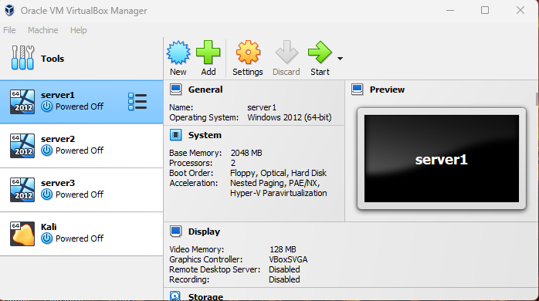
Figure 14 - Design of lab setup in VirtualBox.

DESIGN OF DREAD MODEL CALCULATION TABLE

THREAT  ID | D | R | E | A | D | TOTAL | RATING
T1
T2
T3
Figure 15 - Dread model table
- Damage – how bad would an attack be?
- Reproducibility – how easy is it to reproduce the attack?
- Exploitability – how much work is it to launch the attack?
- Affected users – how many people will be impacted?
- Discoverability – how easy is it to discover the threat [65]?

To conclude, the design will provide the system requirements for the virtual lab that will be used for testing, providing details on the requirements for each host and server. A high-level diagram will display the interdependencies between the components. The assessment and penetration method adopted is highlighted, explaining the mechanism of action, and how the results will be analysed and reported. Finally, the design of the DREAD threat model is shown in figure15, which will be populated following testing.

CHAPTER 5 – IMPLEMENTATION

INTRODUCTION

The implementation phase will begin by loading the virtual lab and running a Nessus scan from the Kali Linux. The results will export to an excel file and saved (see Appendix C).
Based on the outcome, a penetration test will be run using Metasploit and any associated modules against identified vulnerabilities. The results of the test will be recorded.
Each vulnerability selected for this study will be modelled, based on the results from the lab test and evidenced gathered during the literature review. The threat model scores will be recorded (see Appendix D).
Results will be displayed in table and graphical form.

VULNERABILITY ASSESSMENT

- Each virtual machine was powered on in Virtual Box
- Diagnostic PING tests were run from each host to check for connectivity (see Appendix B).
- Server1, server2 and server3 were configured as per the requirements.
- Nessus Essential was started on the Kali test host.
- The address IP for server1, server2 and server3 were entered into the target for the Nessus scans.
- The Nessus scan was completed (see Appendix C - Kali Linux Lab Nessus Scan 14th June).

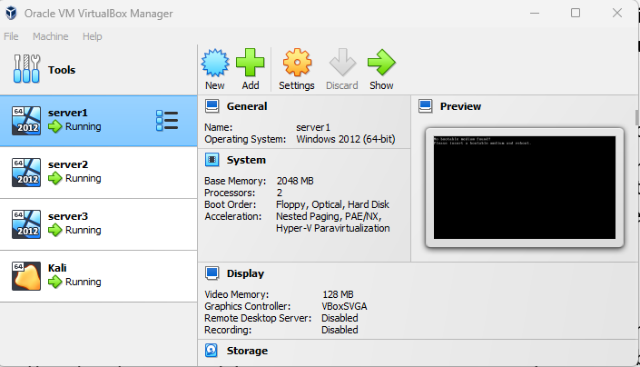
Figure 16 - Virtual hosts running in Virtual Box.

VULNERABILITY ASSESSMENT RESULTS

SERVER | VULNERABILITY | RESULT
Server1 (critical) | Microsoft Protected Extensible Authentication Protocol (PEAP) Remote Code Execution Vulnerability | NOT DETECTED
Server2 (high) | Microsoft Windows Unquoted Service Path Enumeration | DETECTED
Server3 (medium) | Windows Speculative Execution Configuration Check | DETECTED

Figure 17 - table of results for vulnerability assessment

Figure 18 - Graphical representation of vulnerability assessment results

The vulnerability assessment was run from the Kali Linux host using Nessus.
The summary of results is shown in the figure 17. The full results can be seen in appendix c.
Two out of the three vulnerabilities were identified during the test. This was a partial outcome of what was expected. The two vulnerabilities found did correlate to the research done in the literature review based on the assessment done at Carmarthenshire Council.
The critical vulnerability which was not detected during the assessment did not correlate with what was expected.
It is not known exactly why the critical vulnerability ‘Microsoft Protected Extensible Authentication Protocol (PEAP) Remote Code Execution Vulnerability’ was not found. It may be down to the fact that there was additional configuration required on the server to enable the PEAP service. This was done following the information found during the literature review, however there may have been some additional configuration requirements which was unknown.
Overall, the results from the vulnerability assessment were somewhat disappointing as only 2 of the 3 vulnerabilities were identified. The unidentified vulnerability was the highest rated one on the CVSS scoring.

IMPLEMENTATION OF THE PENETRATION TEST

A service was created on server2 for the purpose of this test.

Figure 19 - creating test service.

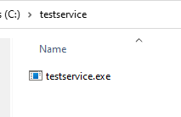
Figure 20 - test executable.

Metasploit was loaded on the Kali Linux virtual machine. A port scan was run targeting server2 & server3.
*As no vulnerability had been detected on server1, this was out of scope.

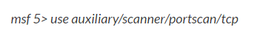
Figure 21 - running port scan on Metasploit.

The Metasploit Trusted Service Path exploit was used on server2.

The exploit was run successfully targeting server2 (See Appendix D - Metasploit unquoted path success).
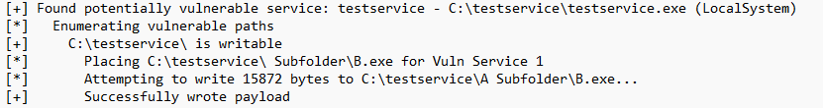
Figure 22 - Success with Metasploit

No exploits were detected on server3.

PENETRATION TEST RESULTS

SERVER | VULNERABILITY | RESULT
Server1 (Critical) | Microsoft Protected Extensible Authentication Protocol (PEAP) Remote Code Execution Vulnerability | N/A
Server2 (high) | Microsoft Windows Unquoted Service Path Enumeration | EXPOLITED
Server3 (Medium) | Windows Speculative Execution Configuration Check | FAILED
Figure 23 - Penetration test results.

A vulnerability was detected on server2 and was identified during the penetration test as exploitable. The Trusted Service Path module was loaded in Metasploit, and it was successful in targeting server2 with the payload being bring deployed to the target server.
This did concur with the research done into the ‘Microsoft Windows Unquoted Service Path Enumeration’ vulnerability which had been categorised as high. There was notable research as to where this had been exploited successfully on several occasions and it did pose a risk if left exposed.
The results for server3 displayed that the penetration test was unable to find an exploit for the medium risk vulnerability ‘Windows Speculative Execution Configuration Check’. This was an expected outcome, as the literature review identified some information in regards to the vulnerability and how it related to the CPU, however no documented literature was found as to how to exploit it.
There was no vulnerability detected on server1 therefore this was out of scope for the penetration test.
Overall, the results from the penetration test were pleasing. One of the identified vulnerabilities was able to be fully exploited with the Trusted Service Path payload being deployed to server2 via Metasploit.

DREAD THREAT MODELLING

Using the table in figure 10, we can model the threat of each vulnerability based on the results of the test (see Appendix E - dread scoring spreadsheet).

THREAT  ID | D | R | E | A | D | TOTAL | RATING
T1 | 10 | 1 | 1 | 10 | 0 | 22 | Medium
T2 | 8 | 10 | 7 | 10 | 10 | 45 | Critical
T3 | 5 | 2 | 1 | 10 | 5 | 23 | Medium
Figure 24 - Threat rating of vulnerabilities.

T1 = critical vulnerability
T2 – high vulnerability
T3 – medium vulnerability
All scored were out of 10 (range 1 to 10).

DAMAGE
The damage scoring was determined based on the severity of the vulnerability as categorised by CVSS score.
T1 was given a score of 10 T2 a score of 8 and T3 a score of 6.

REPRODUCIBILITY
This score was determined based on the lab test results.
T2 was the only vulnerability that was exploited during the lab test. It was straightforward to launch the attack using Metasploit. It was given a score of 10.
T3 was discovered during the assessment but no exploits found. It was given a score of 2.
T1 was not discovered nor exploited and was given a score of 1.

EXPLOITABILITY
This score was determined based on the lab test results.
T2 required moderately technical skills to exploit. The Trusted Service Path module had to be loaded within Metasploit and configured to target the vulnerable server. The payload was then deployed.
It was given a score of 7.
T1 and T3 were unable to be exploited and were given scores of 1.

AFFECTED USERS
This score was determined from the literature reviewed and the CVSS score.
All were given a score of 10 as they had the potential to affect many users

DISCOVERABILITY
This score was determined based on the lab test results and literature reviewed.
T2 was given a score of 10 as it was discovered during the vulnerability assessment and there was plentiful literature available about how to exploit.
T3 was given a score of 5 as it was discovered during the assessment however there was little literature about the vulnerability.
T1 was given a score of 0 as it was not discovered during the assessment.

Critical (40–50) Critical vulnerability; address immediately.
High (25–39) Severe vulnerability; consider for review and resolution soon.
Medium (11–24) Moderate risk; review after addressing severe and critical risks.
Low (1–10) Low risk to infrastructure and data.

Figure 25 - Chart of dread threat modelling results

VULNERABILITY | RATING
Microsoft Protected Extensible Authentication Protocol (PEAP) Remote Code Execution Vulnerability | Medium
Microsoft Windows Unquoted Service Path Enumeration | Critical
Windows Speculative Execution Configuration Check | Medium
Figure 26 – Dread Threat rating

In conclusion, the results for the vulnerability assessment scan done using Nessus were that two out of the three were detected. The same tool was used as was done by the provided assessment, so it is not fully known why critical risked vulnerability relating to the Microsoft Protected Extensible Authentication Protocol was not discovered in the lab test. We can theorise that it may be the case that the PEAP protocol was not configured in the same manner in the virtual environment as it was done on the Council’s environment. Another rationale could be that a security update was installed on server1 in the lab environment, which fixed the known vulnerability.
There was some success when implementing the penetration test, with the ability to exploit the vulnerability identified on server2 relating to the Unquoted Service Path. A test service was created on the server as per the design plan and this vulnerability was detected during the assessment stage. Metasploit was used to launch an attack, which was a success. This would have enabled the attacker to gain network access with administrative privileges to the server.
No exploit was found to use to target the Windows Speculative Execution Configuration Check vulnerability that was identified.
The DREAD threat modelling worked. By using the results from the lab testing, along with the literature researched, each vulnerabilities was scored under the 5 categories and the total score were used to determine a threat rating. This will be used in formalising the conclusion and recommendations to this study.

CHAPTER 6 – EVALUATION

The evaluation will look at that specific conclusion can be drawn from the data provided from the lab testing, along with the researched literature, to analyse any relationships between both. Correlation between the CVSS and DREAD threat rating will be investigated.
The aims and objectives will be analysed, and a conclusion drawn to see if they were met during this study.
A summary of the expected outcomes will be provided, and a suggestion for changes that could be made if the study was repeated in the future.

EVALUATING THE OBJECTIVES.

There was plentiful research into the background of vulnerability assessments and how they are used to assess IT security standards of organisations, to detected and fix, to protect susceptible systems from cyber-attacks. Assessments can be broken down into black, grey, and white with advantages and disadvantages to all three approaches. The relationship between vulnerability assessments and penetration testing was understood, with a thoughtful example given by Kevin M. Henry, who compared them to a general who was assessing his target and attack vectors before war.
The first case study looked at how security assessments are considered the first step in identifying potential security flaws, with the second case study looking at the catastrophic effects exploiting a vulnerability can have on an organisation, the NHS is this example.

There was literature available on all three vulnerabilities selected, which was used as pat of the analysis. This included details about how each vulnerability works and within which part of the system they existed, any associated services or hardware that are vulnerable. The research found much literature on penetrating testing and exploiting the high-risk issue relating to the unquoted path, and how tools such as Metasploit can be used, and examples were provided on how to do this.
There was however little information on how the PEAP vulnerability can be exploited, although it did share similarities with another authentication exploit which had been documented.
There was no information to be found on how to exploit the medium risk vulnerability relating to the Windows Speculative Execution Configuration Check.
There was sufficient literature available to compare the threat models that were available to rate each vulnerability. The DREAD model was selected for this for it subjective approach and ease of understanding.
The virtual lab was straightforward to configure and setup, making use of open-source virtualisation software. Configuration of the virtual servers and network, Kali Linux testing system, Nessus vulnerability scanner and Metasploit was straightforward. As only three vulnerabilities were selected for the study, is as simple to record the results data directly into tables within this report.

LABORATORY TESTING

The lab results for the vulnerability assessment in figure 16, found that the high and medium risk vulnerability were detected during the Nessus scan and the critical risk was not. This was not the expected outcome, as it was thought that all three would be detected during the assessment.
If this test was to be repeated, then access to the server running the PEAP service would be useful, to gather further information to enable to tester to check configuration settings on the server, ensuring they a mirrored in the virtual lab environment.
Other vulnerability assessments tools could also be used to cross reference the results. This was not possible in this study due to time constraints.
The successful penetration test targeting the unquoted service path vulnerability was an expected outcome, as there was much literature available as to how the exploit can be deployed on an identified system. The unquoted_service_path module available in the Metaspoilt framework was simple and straightforward to use.
There was no definitive literature available as to how the critical and medium risk vulnerabilities could be exploited, therefore the results that they were unsuccessful were expected. Further research could have been conducted into these vulnerabilities, which may have exposed potential ways to exploit or provided further understanding of how the system could have been setup in a better way.

Overall, the testing undertaken did concur with the literature that was reviewed relating the vulnerabilities in question.

THE RESULTS

The DREAD model selected was easy to understand and the table created (see figure 15) was used to evaluate each vulnerability. The modelling technique to determine the scores being subjective was helpful, which were done for each category within the model based on the research, CVSS score and the results from the lab testing. The DREAD modelling evaluated the vulnerabilities with the threat rating shown in figure 23.
Figure 27 compares the CVSS and DREAM ratings, displaying there are similarities and differences in the categorisation of each one.

VULNERABILITY | CVSS (Nessus) | DREAD
Microsoft Protected Extensible Authentication Protocol (PEAP) Remote Code Execution Vulnerability | CRITICAL | MEDIUM
Microsoft Windows Unquoted Service Path Enumeration | HIGH | CRITICAL
Windows Speculative Execution Configuration | MEDIUM | MEDIUM
Figure 27 - Nessus vs dread results.

The threat level results for each vulnerability are a factor for determining the outcome of this study, where a conclusion and recommendation will provide an opinion as to if the severity rating provided by the vulnerability assessment results from Carmarthenshire Council is warranted in relation to the findings of this study.

AIMS OF THE STUDY

The results are subjective and further research into the subject matter and testing could been done to provide more data to assist in the aims. The study into vulnerabilities is a large, highly complex area with multiple issues being identified daily. The Windows Speculative Execution Configuration Check was an example of the complexity when determining what a vulnerability related to and how it could potentially be exploited. This was only slightly understood. A threat model was selected and used to successfully model threat for each, and along with the research and testing results, a conclusion can be reached.

To conclude this section, the aim of this study was to analyse and understand the vulnerabilities, model the threat, and provide a conclusion and recommendations based on the modelling and testing that has been undertaken, to assist with improving the security posture of the IT systems under assessment, and it is determined that this aim has been met.

CHAPTER 7 - CONCLUSIONS

INTRODUCTION

This section will look at the rating of each vulnerability from the initial assessment provided by Carmarthenshire Council, the research conducted, the results from the virtual lab testing and the threat level modelling results, to draw a conclusion on the potential threat of each vulnerability.

CONCLUSION AND RECOMMENDATION

It is known from the research that CVSS scoring is quantitative based on the exploitability, scope, and impact. It provides a numeric rating within a scale of between 0.0 and 10.0 and from this a risk determined.
The DREAD results have been determined by modelling each vulnerability after completing the assessment and penetration test in the lab.

There is an identical rating of MEDIUM for the Windows Speculative Execution Configuration vulnerability.
There is a difference between the rating of the Microsoft Protected Extensible Authentication Protocol (PEAP) Remote Code Execution Vulnerability, which as a ranking of CRITICAL under the CVSS system and MEDIUM under DREAD.
The Microsoft Windows Unquoted Service Path Enumeration vulnerability has a rating of HIGH under the CVSS scoring and CRITICAL following the DREAD modelling.

There are some disparities in the rating of the vulnerabilities which will need to be considered when looking to address in the future. For the purpose of this study, as the DREAD rating has considered the background research as well as the results from the testing, this classification will be taken as the most accurate for the rating of the selected vulnerabilities.
As two of the vulnerabilities were rated as medium, the PEAP vulnerability will be given a higher ranking of priority as it had the highest CVSS score.

RANKING | VULNERABILITY | RATING
1 | Microsoft Windows Unquoted Service Path Enumeration | CRITICAL
2 | Microsoft Protected Extensible Authentication Protocol (PEAP) Remote Code Execution | MEDIUM
3 | Windows Speculative Execution Configuration | MEDIUM
Figure 28 - Final ranking & rating of vulnerabilities.

To conclude, the recommendation is that the Microsoft Windows Unquoted Service Path Enumeration vulnerability would be of the greatest concern, and should be addressed primarily before undertaking remedial work on the remaining two. It was easy to identify and exploit and would provide an attacker with elevated privileged access to a susceptible target system, which could potentially have catastrophic consequences on the hosting organisation.

CHAPTER 8 – REFLECTION

During this study, I gained valuable insights into the importance of identifying and addressing vulnerabilities in various systems and environments. Vulnerability assessment is a proactive approach that enables organisations to understand their weaknesses and potential risks, allowing them to implement appropriate measures for mitigation and improvement.
One of the key aspects I researched was the significance of vulnerability assessments and how any identified could potentially be exploited. This involves a thorough examination of all potential vulnerabilities. It requires assessing various factors such as software vulnerabilities, network weaknesses, physical security, human factors, and organizational vulnerabilities. By considering this broad range of factors, organizations can gain a holistic understanding of their vulnerabilities.
I also delved into the different methodologies and tools employed in vulnerability assessment, and what software options could be used to create a virtual lab environment for testing. I learned that there is paid for and free tools available to undertake assessments and run tests in a protective virtual environment using hypervisor technology. Case studies were examined and technical aspects for the testing considered.

Another vital aspect of vulnerability assessment that I examined was the integration of findings into a risk management framework. Identifying vulnerabilities is just the first step; organisations must then prioritise and remediate these vulnerabilities based on their potential impact and likelihood of exploitation. By integrating vulnerability assessment findings with the DREAD risk model, I was able to provide insight, and determine a conclusion.
I learnt that with more time, further research could be conducted into the vulnerabilities to try and determine factors about how they could be exploited. Had I to do this study again, I would allocate more time to this and look to setup further lab tests and use other tools to do penetration tests to look for possible exploits.
Overall, my study into vulnerability assessment has provided me with a deeper understanding of the processes, methodologies, and considerations involved. These should definitely be considered by organisations when looking to address any identified vulnerabilities, making risk-based decisions and best use of the resources available to them.

CHAPTER 9 – REFERENCES

[1] K. M. Henry, ‘Penetration testing : protecting networks and systems’, 2012.
[2] P. S. Antón, R. H. Anderson, R. Mesic, and M. Scheiern, ‘INTRODUCTION’, in Finding and Fixing Vulnerabilities in Information Systems, 1st ed.in The Vulnerability Assessment and Mitigation Methodology. RAND Corporation, 2003, pp. 1–4. [Online]. Available: http://www.jstor.org/stable/10.7249/mr1601darpa.9
[3] S. V. Dhavale, ‘Constructing an Ethical Hacking Knowledge Base for Threat Awareness and Prevention’, Constructing an Ethical Hacking Knowledge Base for Threat Awareness and Prevention, Apr. 2019, doi: 10.4018/978-1-5225-7628-0.
[4] A. VLADIMIROV, K. GAVRILENKO, and A. MICHAJLOWSKI, ‘INTRODUCTION’, in Assessing Information Security, in Strategies, Tactics, Logic and Framework. IT Governance Publishing, 2010, pp. 13–26. [Online]. Available: http://www.jstor.org.ezproxy.uwtsd.ac.uk/stable/j.ctt5hh6v9.5
[5] A. VLADIMIROV, K. GAVRILENKO, and A. MICHAJLOWSKI, ‘SECURITY ASSESSMENTS CLASSIFICATION’, in Assessing Information Security, in Strategies, Tactics, Logic and Framework. IT Governance Publishing, 2010, pp. 113–160. [Online]. Available: http://www.jstor.org.ezproxy.uwtsd.ac.uk/stable/j.ctt5hh6v9.8
[6] ‘CIVIC HERALDRY OF ENGLAND AND WALES-WALES CURRENT’. http://civicheraldry.co.uk/wales_current.html (accessed Mar. 09, 2023).
[7] ‘The Council’. https://www.carmarthenshire.gov.wales/home/council-democracy/the-council/ (accessed Mar. 09, 2023).
[8] ‘The Public Services Network (PSN) Is Your Business Ready? Why a Public Services Network (PSN)?’.
[9] ‘Public Services Network (PSN) - GOV.UK’. https://www.gov.uk/government/groups/public-services-network (accessed Jun. 08, 2023).
[10] ‘What Are Software Vulnerabilities, and Why Are There So Many of Them? - Scientific American’. https://www.scientificamerican.com/article/what-are-software-vulnerabilities-and-why-are-there-so-many-of-them/# (accessed Mar. 09, 2023).
[11] ‘3. Vulnerability Scanning - Security Power Tools [Book]’. https://www.oreilly.com/library/view/security-power-tools/9780596009632/ch03.html (accessed Apr. 27, 2023).
[12] ‘Gray Box Testing – The New Normal? - TestProject’. https://blog.testproject.io/2021/10/12/gray-box-testing-the-new-normal/ (accessed Apr. 27, 2023).
[13] ‘What is Black vs Gray vs White Box Testing? | CBT Nuggets’. https://www.cbtnuggets.com/blog/technology/networking/what-is-black-vs-gray-vs-white-box-testing (accessed Apr. 27, 2023).
[14] ‘💬1 - A Complete Guide on Vulnerability Assessment Methodology’. https://www.getastra.com/blog/security-audit/vulnerability-assessment-methodology/ (accessed May 15, 2023).
[15] T. Ishio, R. G. Kula, T. Kanda, D. M. German, and K. Inoue, ‘Software ingredients: Detection of third-party component reuse in Java software release’, Proceedings - 13th Working Conference on Mining Software Repositories, MSR 2016, pp. 339–350, May 2016, doi: 10.1145/2901739.2901773.
[16] ‘VULNERABILITY ASSESSMENTS from Penetration Testing: Protecting Networks and Systems on JSTOR’. https://www-jstor-org.ezproxy.uwtsd.ac.uk/stable/j.ctt5hh74m.11?searchText=&searchUri=&ab_segments=&searchKey=&refreqid=fastly-default%3Afca2ecfeaed0d448889b48ef43042cb0 (accessed Mar. 09, 2023).
[17] K. M. HENRY, ‘VULNERABILITY ASSESSMENTS’, in Penetration Testing, in Protecting Networks and Systems. IT Governance Publishing, 2012, pp. 77–93. [Online]. Available: http://www.jstor.org.ezproxy.uwtsd.ac.uk/stable/j.ctt5hh74m.11
[18] ‘Hacking, But Make It Ethical: How “The Good Guys” Are Boosting Cybersecurity - ProQuest’. https://www.proquest.com/docview/2562245508?accountid=130472&parentSessionId=LjKh%2BA5DCVnf9MpD7vZ3VBbllKPNI7qEXl9CLOcc0ZI%3D&pq-origsite=primo (accessed Mar. 09, 2023).
[19] ‘Extensible Authentication Protocol (EAP) for network access | Microsoft Learn’. https://learn.microsoft.com/en-us/windows-server/networking/technologies/extensible-authentication-protocol/network-access (accessed May 12, 2023).
[20] ‘Protected Extensible Authentication Protocol (PEAP) | UB CSE IT Service Catalog’. https://wiki.cse.buffalo.edu/services/content/protected-extensible-authentication-protocol-peap (accessed May 12, 2023).
[21] ‘What is PEAP (Protected Extensible Authentication Protocol)? | Definition from TechTarget’. https://www.techtarget.com/searchsecurity/definition/PEAP-Protected-Extensible-Authentication-Protocol (accessed May 12, 2023).
[22] ‘CVE-2023-21689 - Security Update Guide - Microsoft - Microsoft Protected Extensible Authentication Protocol (PEAP) Remote Code Execution Vulnerability’. https://msrc.microsoft.com/update-guide/vulnerability/CVE-2023-21689 (accessed May 12, 2023).
[23] ‘CVE-2022-26923 - Security Update Guide - Microsoft - Active Directory Domain Services Elevation of Privilege Vulnerability’. https://msrc.microsoft.com/update-guide/vulnerability/CVE-2022-26923 (accessed Jun. 14, 2023).
[24] ‘Attacking AD CS ESC Vulnerabilities Using Metasploit | Metasploit Documentation Penetration Testing Software, Pen Testing Security’. https://docs.metasploit.com/docs/pentesting/active-directory/ad-certificates/attacking-ad-cs-esc-vulnerabilities.html (accessed Jun. 14, 2023).
[25] ‘Windows Unquoted Service Path Enumeration - Is this still a case in modern Windows (10, 11) ? - Microsoft Community Hub’. https://techcommunity.microsoft.com/t5/windows-security/windows-unquoted-service-path-enumeration-is-this-still-a-case/m-p/3298358 (accessed Jun. 08, 2023).
[26] ‘Microsoft Windows Unquoted Service Path Enumeration | Tenable®’. https://www.tenable.com/plugins/nessus/63155 (accessed Jun. 08, 2023).
[27] ‘Practical Guide to exploiting the unquoted service path vulnerability in Windows - TrustFoundry’. https://trustfoundry.net/2015/09/10/practical-guide-to-exploiting-the-unquoted-service-path-vulnerability-in-windows/ (accessed Jun. 08, 2023).
[28] ‘Create a user-defined service - Windows Client | Microsoft Learn’. https://learn.microsoft.com/en-us/troubleshoot/windows-client/deployment/create-user-defined-service (accessed Jul. 06, 2023).
[29] ‘metasploit-framework | Kali Linux Tools’. https://www.kali.org/tools/metasploit-framework/ (accessed Mar. 20, 2023).
[30] ‘What is Metasploit? The Beginner’s Guide’. https://www.varonis.com/blog/what-is-metasploit (accessed Mar. 20, 2023).
[31] ‘Windows Unquoted Service Path Privilege Escalation - Metasploit - InfosecMatter’. https://www.infosecmatter.com/metasploit-module-library/?mm=exploit/windows/local/unquoted_service_path (accessed Jul. 17, 2023).
[32] ‘Windows guidance to protect against speculative execution side-channel vulnerabilities - Microsoft Support’. https://support.microsoft.com/en-us/topic/windows-guidance-to-protect-against-speculative-execution-side-channel-vulnerabilities-ae9b7bcd-e8e9-7304-2c40-f047a0ab3385 (accessed Jun. 08, 2023).
[33] ‘KB4073119: Windows client guidance for IT Pros to protect against silicon-based microarchitectural and speculative execution side-channel vulnerabilities - Microsoft Support’. https://support.microsoft.com/en-gb/topic/kb4073119-windows-client-guidance-for-it-pros-to-protect-against-silicon-based-microarchitectural-and-speculative-execution-side-channel-vulnerabilities-35820a8a-ae13-1299-88cc-357f104f5b11 (accessed Jun. 08, 2023).
[34] ‘Windows Speculative Execution Configuration Check | Tenable®’. https://www.tenable.com/plugins/nessus/132101 (accessed Jun. 08, 2023).
[35] ‘Enabling Hypervisor-Specific Mitigations for Machine Check Error on Page Size Change (MCEPSC) Speculative-Execution vulnerability (CVE-2018-12207) (59139)’. https://kb.vmware.com/s/article/59139 (accessed Jun. 08, 2023).
[36] ‘How To Setup A Virtual Penetration Testing Lab - NoobLinux’. https://nooblinux.com/how-to-setup-a-virtual-penetration-testing-lab/ (accessed Apr. 20, 2023).
[37] ‘What is a Hypervisor? | VMware Glossary’. https://www.vmware.com/topics/glossary/content/hypervisor.html (accessed Apr. 20, 2023).
[38] ‘A beginner’s guide to hosted and bare-metal virtualization | TechTarget’. https://www.techtarget.com/searchitoperations/tip/A-beginners-guide-to-hosted-and-bare-metal-virtualization (accessed Apr. 20, 2023).
[39] ‘VirtualBox – Oracle VM VirtualBox’. https://www.virtualbox.org/wiki/VirtualBox (accessed Apr. 20, 2023).
[40] ‘VMware Inc Company Profile - Overview - GlobalData’. https://www.globaldata.com/company-profile/vmware-inc/ (accessed Apr. 20, 2023).
[41] E. Bugnion, J. Nieh, and D. Tsafrir, ‘Hardware and software support for virtualization’, Synthesis Lectures on Computer Architecture, vol. 12, no. 1, pp. 1–206, 2017, doi: 10.2200/S00754ED1V01Y201701CAC038.
[42] ‘VMware: An IPO Companion Guide.: EBSCOhost’. https://web-s-ebscohost-com.ezproxy.uwtsd.ac.uk/ehost/pdfviewer/pdfviewer?vid=5&sid=90751a7f-6386-4870-98ce-8b6b65154dfd%40redis (accessed Apr. 20, 2023).
[43] ‘Workstation_Buy_Dual’. https://store-uk.vmware.com/workstation_buy_dual?country_code=GB#GS (accessed Apr. 20, 2023).
[44] ‘Building A Test Lab For Pentesting Guide | White Oak Security’. https://www.whiteoaksecurity.com/blog/building-a-test-lab-for-pentesting/ (accessed Apr. 20, 2023).
[45] B. Marshall, G. College, B. M. Edu, and P. Cardon, ‘USING VMWARE VCENTER TO TEACH SYSTEM ADMINISTRATION IN A LAB’, Issues in Information Systems, vol. XII, no. 2, pp. 153–161, 2011, doi: 10.48009/2_iis_2011_153-161.
[46] ‘Check if your Intel or AMD processor supports Hyper-V using these tools’. https://www.thewindowsclub.com/check-intel-amd-processor-supports-hyper-v (accessed Apr. 20, 2023).
[47] ‘System Requirements and Installation Information for Windows Server 2012 R2 | Microsoft Learn’. https://learn.microsoft.com/en-us/previous-versions/windows/it-pro/windows-server-2012-r2-and-2012/dn303418(v=ws.11) (accessed Apr. 20, 2023).
[48] ‘Installing Kali Linux | Kali Linux Documentation’. https://www.kali.org/docs/installation/hard-disk-install/ (accessed Apr. 20, 2023).
[49] ‘Kali Linux System Requirements | Hardware Selection and Security’. https://www.educba.com/kali-linux-system-requirements/ (accessed Apr. 20, 2023).
[50] ‘What is Kali Linux? | Kali Linux Documentation’. https://www.kali.org/docs/introduction/what-is-kali-linux/ (accessed Mar. 20, 2023).
[51] P. Cisara and R. Pinterb, ‘Some ethical hacking possibilities in Kali Linux environment’, Journal of Applied Technical and Educational Sciences, no. 4, pp. 129–149, Jan. 2019.
[52] ‘Nessus Essentials’. https://community.tenable.com/s/article/Nessus-Essentials (accessed Jul. 06, 2023).
[53] G. Golightly, ‘Full Lifecycle Security Assessment - A Case Study | SANS Institute’, Aug. 2002. https://www.sans.org/white-papers/714/ (accessed May 15, 2023).
[54] G. Martin, S. Ghafur, J. Kinross, C. Hankin, and A. Darzi, ‘WannaCry - A year on’, BMJ (Online), vol. 361, 2018, doi: 10.1136/bmj.k2381.
[55] ‘WannaCry explained: A perfect ransomware storm | CSO Online’. https://www.csoonline.com/article/3227906/wannacry-explained-a-perfect-ransomware-storm.html (accessed Mar. 09, 2023).
[56] S. Mayor, ‘Sixty seconds on . . . the WannaCry cyberattack’, BMJ, vol. 361, p. k1750, Apr. 2018, doi: 10.1136/bmj.k1750.
[57] William Smart - Chief Information Officer for Health and Social Care, ‘Lessons learned review of the WannaCry Ransomware Cyber Attack’, Feb. 2018, Accessed: Mar. 09, 2023. [Online]. Available: www.nationalarchives.gov.uk/doc/open-government-licence/
[58] ‘Common Vulnerability Scoring System SIG’. https://www.first.org/cvss/ (accessed Jul. 17, 2023).
[59] ‘CVSS vs. VPR (Tenable Security Center 6.1.x)’. https://docs.tenable.com/security-center/Content/RiskMetrics.htm#CVSS (accessed Jul. 17, 2023).
[60] ‘NVD - Vulnerability Metrics’. https://nvd.nist.gov/vuln-metrics/cvss (accessed Jul. 17, 2023).
[61] ‘Number Of Security Vulnerabilities By CVSS Scores’. https://www.cvedetails.com/cvss-score-distribution.php (accessed Jul. 17, 2023).
[62] ‘Threat Modeling Process | OWASP Foundation’. https://owasp.org/www-community/Threat_Modeling_Process#determine-and-rank-threats (accessed Jun. 08, 2023).
[63] ‘Threat Modeling Process | OWASP Foundation’. https://owasp.org/www-community/Threat_Modeling_Process#stride (accessed Jul. 18, 2023).
[64] ‘Threat Modeling — wildcardcorp.com’. https://wildcardcorp.com/security/threat-modeling (accessed Jun. 14, 2023).
[65] ‘DREAD Threat Modeling: An Introduction to Qualitative Risk Analysis | EC-Council’. https://www.eccouncil.org/cybersecurity-exchange/threat-intelligence/dread-threat-modeling-intro/ (accessed Jul. 13, 2023).
[66] ‘Your InfoSec S.W.A.T Team’. https://cyberarch.eu/our-blog/application-threat-modeling-using-dread-and-stride/ (accessed Jun. 08, 2023).
[67] ‘9 Ways Virtual Lab Cloud is Driving Innovation in Education’. https://www.readytech.com/virtual-lab-cloud/ (accessed Jul. 06, 2023).
[68] F. Kaboub, ‘Positivist paradigm’, Encyclopaedia of counselling, vol. 2, no. 2, p. 343, 2008.
[69] Saunders Mark, Lewis Philip, and Adrian Thornhill, ‘Research Methods for Business Students’, Research Methods for Business Students, pp. 125–171, 2019.
[70] ‘Research Approach - Research-Methodology’. https://research-methodology.net/research-methodology/research-approach/ (accessed Jul. 06, 2023).
[71] ‘How to formulate a research strategy?’ https://www.projectguru.in/how-to-formulate-a-research-strategy/ (accessed Jul. 06, 2023).
[72] ‘Quantitative vs. Qualitative Data | Following Data’. https://kenandeen.wordpress.com/2015/01/18/quantitative-vs-qualitative-data/ (accessed Jul. 06, 2023).
[73] ‘1.4. Supported Host Operating Systems’. https://docs.oracle.com/en/virtualization/virtualbox/6.0/user/hostossupport.html (accessed Jun. 14, 2023).
[74] ‘Updating Kali | Kali Linux Documentation’. https://www.kali.org/docs/general-use/updating-kali/ (accessed Jul. 06, 2023).

CHAPTER 10 – BIBLIOGRAPHY

Larry B Christensen 1941- (ed.) (2001) Experimental methodology. 8th ed. Boston, Allyn and Bacon.
Philip S Antón & United States. Defense Advanced Research Projects Agency. (eds.) (2003a) Finding and fixing vulnerabilities in information systems the vulnerability assessment & mitigation methodology. Santa Monica, CA, Rand.
Ranjit Kumar author (ed.) (2019a) Research methodology : a step-by-step guide for beginners. Fifth edition. London ;, SAGE.
Vladimirov, A., Gavrilenko, K. & Michajlowski, A. (2010) Assessing Information Security: Strategies, Tactics, Logic and Framework. Cambs, IT Governance Publishing.
Anton, P.S., Anderson, R.H. & Mesic, R. (2004) Finding and Fixing Vulnerabilities in Information Systems: The Vulnerability Assessment and Mitigation Methodology. 1st edition. Santa Monica, RAND Corporation. doi:10.7249/mr1601darpa.
Lawrence J Fennelly 1940- compiler & Lawrence J Fennelly author (eds.) (2017c) Effective physical security. Fifth edition. Amsterdam, [Netherlands, Butterworth-Heinemann.
Lawrence J Fennelly 1940- compiler & Lawrence J Fennelly author (eds.) (2017d) Effective physical security. Fifth edition. Amsterdam, [Netherlands, Butterworth-Heinemann.
Michael, K. (2012) The Basics of Information Security: Understanding the Fundamentals of InfoSec in Theory and Practice. Computers & Security.31 (4) pp.634–635. doi:10.1016/j.cose.2012.03.005.
Sommestad, T. (2012) A framework and theory for cyber security assessments.
Philip S Antón & United States. Defense Advanced Research Projects Agency. (eds.) (2003b) Finding and fixing vulnerabilities in information systems the vulnerability assessment & mitigation methodology. Santa Monica, CA, Rand.
Bryan Marshall, Peter Cardon, Craig Callender, Philip Robertson & Nipul Patel (2011) USING VMWARE VCENTER TO TEACH SYSTEM ADMINISTRATION IN A LAB. Issues in information systems. 12 (2), 153–161. doi:10.48009/2_iis_2011_153-161.
Peppers, J. (2018) Creating a Malware Analysis Lab and Basic Malware Analysis. 2018.
Daniel Lustig author & Abhishek Bhattacharjee author (eds.) (2018b) Architectural and operating system support for virtual memory. San Rafael, California, Morgan & Claypool Publishers. doi:10.2200/S00795ED1V01Y201708CAC042.
Dan Tsafrir author, Jason Nieh author, & Edouard Bugnion author (eds.) (2017a) Hardware and software support for virtualization. San Rafael, California, Morgan & Claypool Publishers. doi:10.2200/S00754ED1V01Y201701CAC038.
Anon (n.d.) Black Book - VMware: An IPO Companion Guide. Bernstein Global Wealth Management.
Dan Tsafrir author, Jason Nieh author, & Edouard Bugnion author (eds.) (2017b) Hardware and software support for virtualization. San Rafael, California, Morgan & Claypool Publishers. doi:10.2200/S00754ED1V01Y201701CAC038.
Zhdanov, N.S. & Materukhin, A.V. (2020) Using a virtual laboratory environment for penetration-testing skills training. Bezopasnostʹ informat͡s︡ionnykh tekhnologiĭ. 27 (4), 95–107. doi:10.26583/bit.2020.4.08.
Kumar, H., Kumar, S., Joseph, R., Kumar, D., Shrinarayan Singh, S.K., Kumar, A. & Kumar, P. (2013) Rainbow table to crack password using MD5 hashing algorithm. IEEE. doi:10.1109/CICT.2013.6558135.
Umesh Hodeghatta Rao author & Umesha Nayak author (eds.) (2014) The InfoSec Handbook An Introduction to Information Security. 1st ed. 2014. Berkeley, CA, Apress. doi:10.1007/978-1-4302-6383-8.
Ruby B Lee author (ed.) (2013) Security basics for computer architects. San Rafael, California (1537 Fourth Street, San Rafael, CA 94901 USA), Morgan & Claypool. doi:10.2200/S00512ED1V01Y201305CAC025.
Martin Paul Eve 1986- author (ed.) (2020) Password. London, England, Bloomsbury Academic. doi:10.5040/9781501314902.
Nikita S. Zhdanov & Andrey V. Materukhin (2020a) Using a virtual laboratory environment for penetration-testing skills training. Bezopasnostʹ informat͡s︡ionnykh tekhnologiĭ. 27 (4), 95–107. doi:10.26583/bit.2020.4.08.
Bartolomie, J. (2013) Book Review: Professional Penetration Testing: Creating and Learning in a Hacking Lab 2e. Journal of Digital Forensics, Security and Law.8 (3) pp.87–90. doi:10.15394/jdfsl.2013.1152.
Nikita S. Zhdanov & Andrey V. Materukhin (2020b) Using a virtual laboratory environment for penetration-testing skills training. Bezopasnostʹ informat͡s︡ionnykh tekhnologiĭ. 27 (4), 95–107. doi:10.26583/bit.2020.4.08.
Smith, M. (2017) EternalRocks network worm uses 7 NSA hacking tools. Network World (Online).
Liu, Z. (2021) Working mechanism of Eternalblue and its application in ransomworm. doi:10.48550/arxiv.2112.14773.
Mehrotra, N. (2021) Kali Linux: Use this Popular Linux Distribution for Penetration Testing. Open Source for You.
Sharma, M. (2016) Kali Linux: Security testing. Linux Format. (207), 70–70.
Cisara, P. & Pinterb, R. (2019) Some ethical hacking possibilities in Kali Linux environment. Journal of Applied Technical and Educational Sciences. 9 (4), 129–149.
Ivan M. Babincev & Dejan V. Vuletić (2016) Web application security analysis using the Kali Linux operating system / Анализ безопасности веб-приложений оперционной системой Kali Linux / Analiza bezbednosti web aplikacija operativnim sistemom Kali Linux. Vojnotehnički glasnik. 64 (2), 513–531. doi:10.5937/vojtehg64-9231.
Anon (2018a) EternalBlue Exploit more Popular today than during WannaCry Outbreak.
Cooney, M. (2019) Cisco warns WLAN controller, 9000 series router and IOS/XE users to patch urgent security holes: Cisco says unpatched vulnerabilities could lead to DoS attacks, arbitrary code execution, take-over of devices. Network World (Online).
Mayor, S. (2018) Sixty seconds on . . . the WannaCry cyberattack. BMJ (Online). 361, k1750–k1750. doi:10.1136/bmj.k1750.
Martin, G., Ghafur, S., Kinross, J., Hankin, C. & Darzi, A. (2018) WannaCry—a year on. BMJ (Online). 361, k2381–k2381. doi:10.1136/bmj.k2381.
Blosfield, E. (2021) Hacking, But Make It Ethical: How “The Good Guys” Are Boosting Cybersecurity. Insurance Journal.
Dracker, R. (2020) How I Would Hack You: Confessions of an Ethical Hacker. The Business Journal - Central New York. 34 (27), 2B–7B.
Bishop, M. (2002) Trends in academic research: vulnerabilities analysis and intrusion detection. Computers & security. 21 (7), 609–612. doi:10.1016/S0167-4048(02)01106-9.
Sunita Vikrant Dhavale author (ed.) (2019b) Constructing an ethical hacking knowledge base for threat awareness and prevention. Hershey, PA, IGI Global.
Sunita Vikrant Dhavale author (ed.) (2019c) Constructing an ethical hacking knowledge base for threat awareness and prevention. Hershey, PA, IGI Global.
Isaac Sharpe (ed.) (2015) Hacking : basic security, penetration testing and how to hack. North Charleston, South Carolina, [CreateSpace].
Ian Lewis (2015) Council quizzed over lights cash: “Pounds 4.5k given to Llanelli - but nothing for Carmarthen” [Edition 3]. Carmarthen journal.
Richotte, J.E. & Al-Howaishy, D.K. (2018) FOIA Wars: The Government Strikes Back. Communications Lawyer : Publication of the Forum Committee on Communications Law, American Bar Association. 34 (1), 17–21.
Kingston, S., Elliott, A. & Thomas, T. (2019) “Cost” calculations as a barrier to gaining information under the Freedom of Information Act 2000 from the police in England and Wales. Policing & society. 29 (7), 834–847. doi:10.1080/10439463.2018.1424156.
Barnes, T. (2005) New development: local authority publication schemes under the freedom of information act 2000. Public money & management. 25 (5), 315–318.

APPENDICES

Appendix A – see spreadsheet Nessus Feb 23 2023 report

Appendix B - ping success during implementation

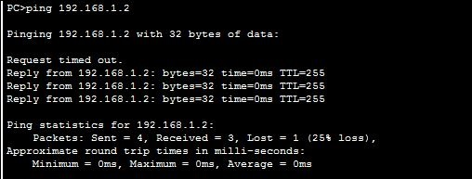

Appendix C – see spreadsheet Kali Linux Lab Nessus Scan 14th June

Appendix D – see supporting text document Metasploit unquoted path success.

Appendix E – see spreadsheet dread scoring spreadsheet.

Appendix F - Gantt Project Plan

Appendix G – declaration and consent form

DECLARATION

I, JOHN MEREDITH WILLIAMS declare that I am the sole author of this Project; that all references cited have been consulted; that I have conducted all work of which this is a record, and that the finished work lies within the prescribed word limits.

This work has not previously been accepted as part of any other degree submission.

Date : 14th of July 2023

FORM OF CONSENT

I JOHN MEREDITH WILLIAMS hereby consent that my Project, submitted in candidature for the B.Sc.(Hons) Computing (stream) degree, if successful, may be made available for inter-library loan or photocopying (subject to the law of copyright), and that the title and abstract may be made available to outside organisations.

Date : 14th of July 2023

