

Guide to Enfranchisement for Leasehold Apartments (GELA)
Research Proposal
Theresa Darzins
James Wiliams

Contents
1. 0 Introduction 1
1.1 Proposal Structure 1
1.2 Website - Guide to Enfranchisement for Apartment Leaseholders 1
1.2.1 The Scale of Leasehold 3
1.2.2 Links to other Useful Websites/Databases 4
1.3 Investigation of Future Development of Website into an App 6
2. 0 Background to the Proposed Research 7
2.1 The History of Leasehold 7
2.1.1 Timeline Graphic 8
2.2 The Principle of Leasehold 10
2.3 Recent Legislation (Housing Minister) 11
2.4 Conditions to Enfranchise Apartments 11
3. 0 Aims & Objectives 13
3.1 Aim 13
3.2 Objectives 13
4. 0 Project Design 14
4.1 Outline of Project Process 15
4.2 Data Collection 17
4.3 Data Evaluation 17
4.4 Risks & Limitations 17
4.5 Ethical Issues 17
5.0 Resources & Planning 19
5.1 Resources Required 19
5.1.1 Hardware Resources 19
5.1.2 Software Resources 19
5.1.3 Other Resources 19
5.2 Planning Chart 20
6.0 Reference List 21
7.0 Bibliography 23

Table 1 MOSCOW Requirements for Website 15
Table 2 MOSCOW Requirements Additional for Future App Development 16
Table 3 Planning Chart 20

Figure 1 Storyboard for Website Use 2
Figure 2 The Scale of Leasehold 3
Figure 3 Leasehold Valuation Tribunals 4
Figure 4 NLC - National Leasehold Campaign 5
Figure 5 App for Enfranchisement Guide 6
Figure 6 Password Reset Task Flow Example 6
Figure 7 History - Timeline of Leasehold Laws 8
Figure 8 Flow Chart for Collective Enfranchisement 14

1. 0 Introduction

Proposal Structure

    - Introduction
    - Background to Proposed Research
    - Aims and Objectives
    - Project Design
    - Resources and Planning
    - References
    - Bibliography

Website - Guide to Enfranchisement for Apartment Leaseholders

Although gaining the freehold is straightforward for houses, there is a lack of clarity for apartment leaseholders on:

- The pre-requisites for leaseholders to purchase the freehold (enfranchise).
- If eligible, how to go about it.

Figure 1 Storyboard for Website Use
^{[1]}
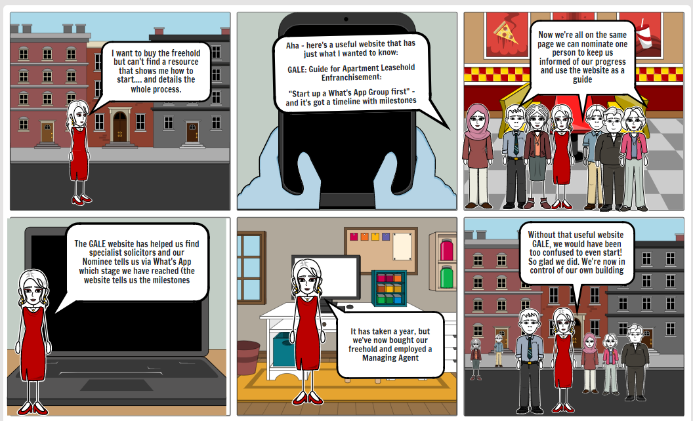

It is proposed to:

- Design and build a website that clarifies eligibility, and helps kickstart the process, to follow up with Solicitors and show timeline with milestones in order.
- Other websites will be linked to provide details (see 1.2.2).
- Proposed website will be aimed at leaseholders to show them practically how to set about organising themselves to successfully enfranchise.
- Once website complete, future development investigations will be carried out to survey users’ needs, to distil the website into an App (see 1.3).

1.2.1 The Scale of Leasehold

^{[2]} In England, approximately 80% of private apartments are leasehold (8.2% houses); over 4 million properties, with 94% in the private sector. Annually approximately a quarter of all residential transactions are leasehold. 42% of all new builds are leasehold.
Figure 2 The Scale of Leasehold
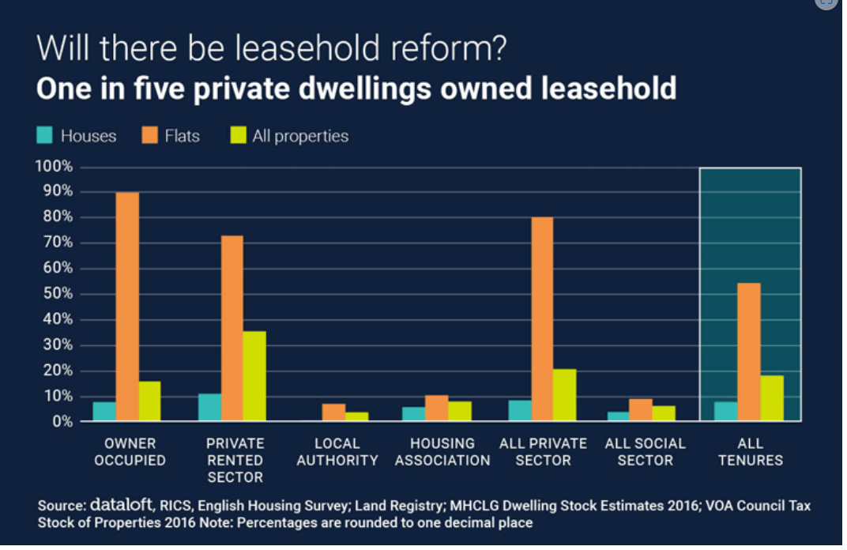

1.2.2 Links to other Useful Websites/Databases
- ^{[3]} Leasehold Valuation Tribunals will provide an estimate of how much freeholder should charge for enfranchising each apartment.
Figure 3 Leasehold Valuation Tribunals
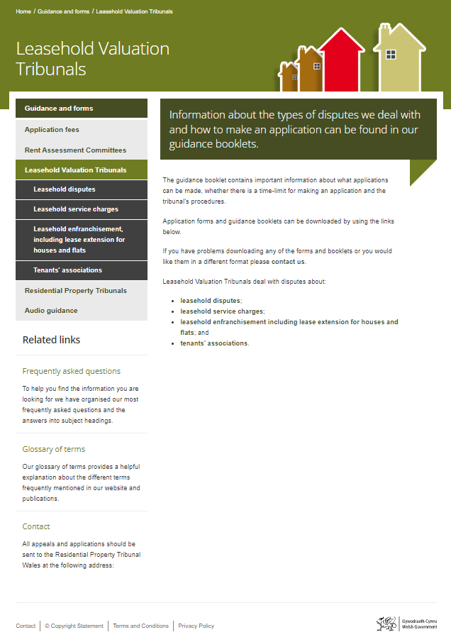

- ^{[4]} Katie Kendrick’s National Leasehold Campaign, for the abolition of leaseholds, provides useful information on the fight against unfair leasehold terms.
Figure 4 NLC - National Leasehold Campaign

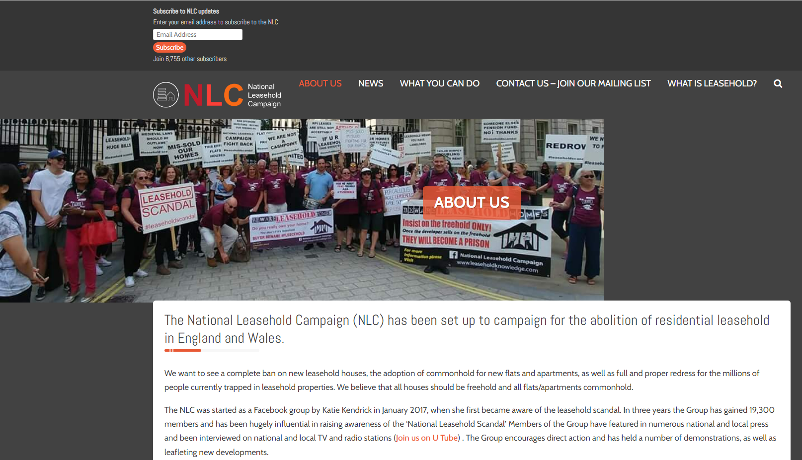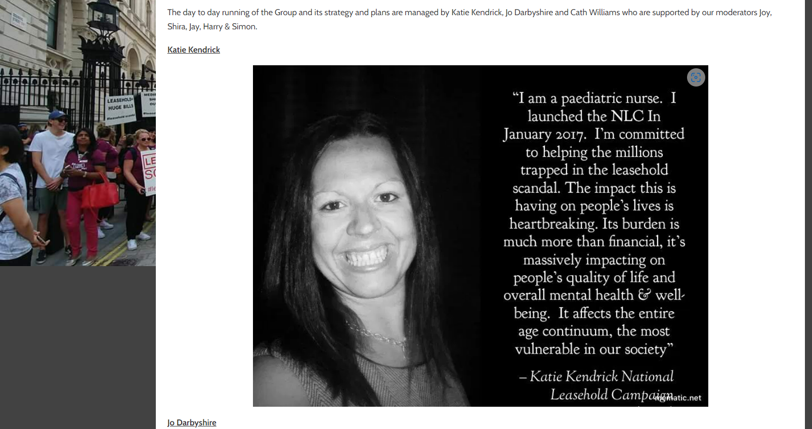

1.3 Investigation of Future Development of Website into an App

One lead nominee from each building/estate would have read/write ability; others concerned would only have ‘read/contact the nominee’ ability.

Figure 5 App for Enfranchisement Guide
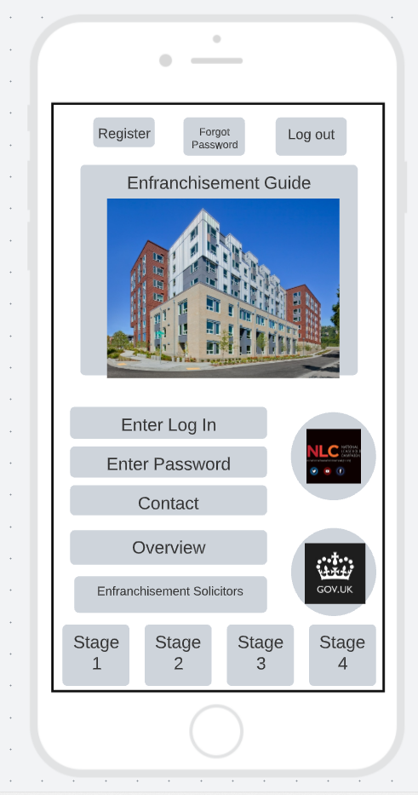
Figure 6 Password Reset Task Flow Example
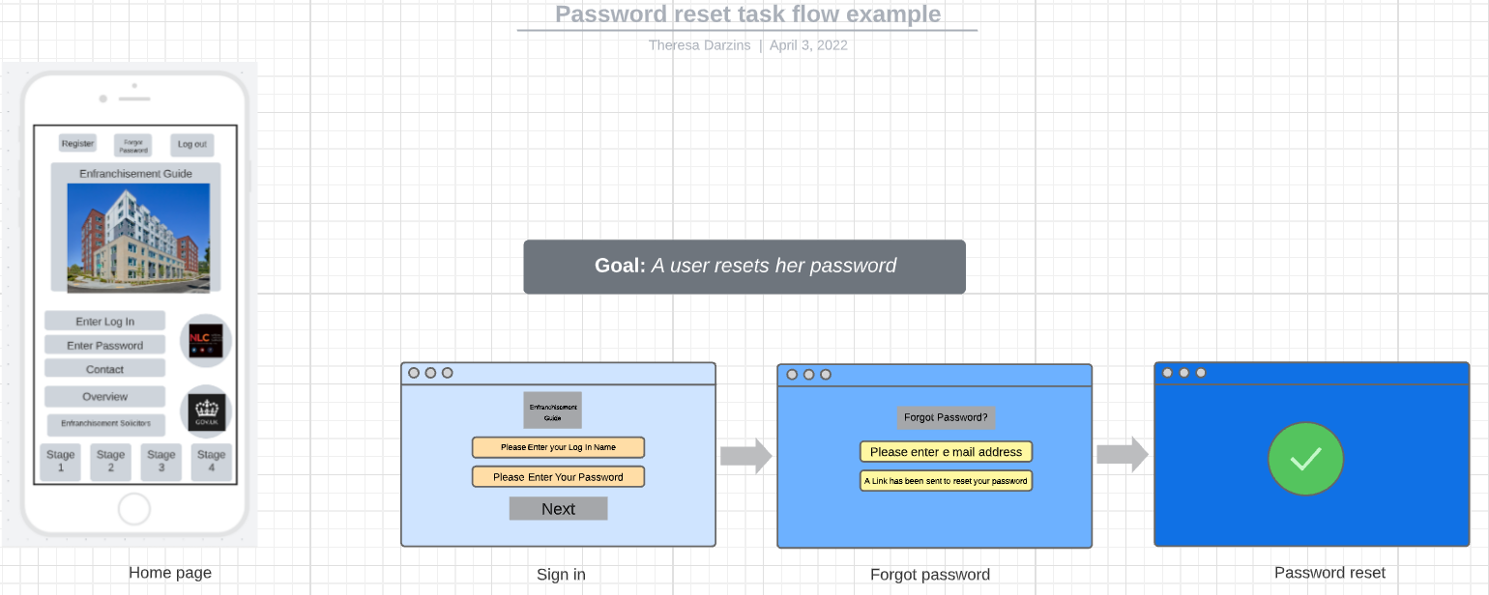

2. 0 Background to the Proposed Research

Whilst there is a surfeit of enfranchisement information online, having a website aimed only at apartment enfranchisement procedures, linked to other useful resources, would be an improvement upon these.
The information already provided is valuable, but because it is scattered, it is problematic for leaseholders to see the entire enfranchisement process. It is hoped that by constructing this website, that an overview will encourage them to rally support and use it as a guide.

2.1 The History of Leasehold
Leasehold is a remnant from feudal times, in the ^{[5]} 11th Century, when the land was owned by nobility and/or rich landlords.
- Only England and Wales use the ‘leasehold’ system; elsewhere, apartment owners are entrusted with management of their buildings.
- Scotland and Northern Ireland successfully rid themselves of leasehold and gained ‘commonhold’. This means that they do not have a freeholder charging them Ground Rent for nothing, other than being the owner of the land, or unnecessarily inflating service charges and insurance costs, whilst pocketing sizable commissions.

2.1.1 Timeline Graphic
^{[6]}
Figure 7 History - Timeline of Leasehold Laws
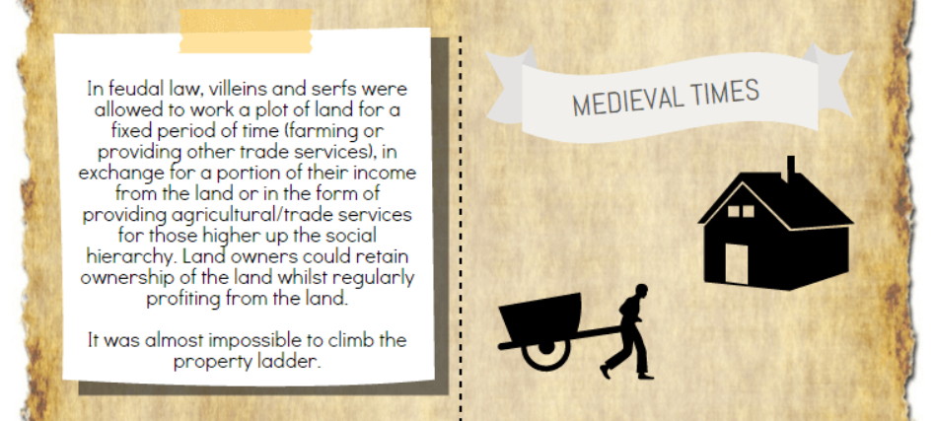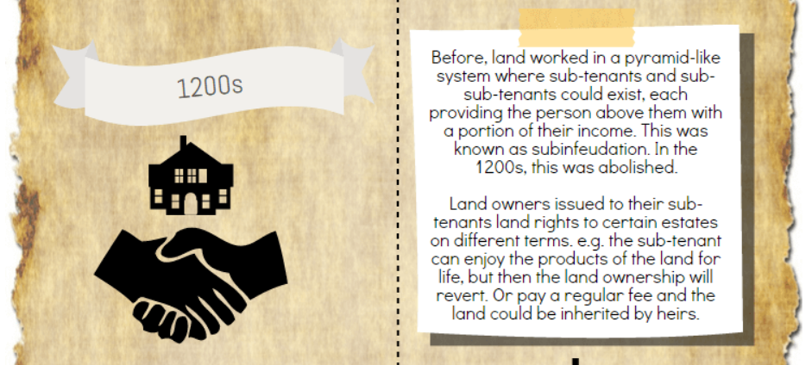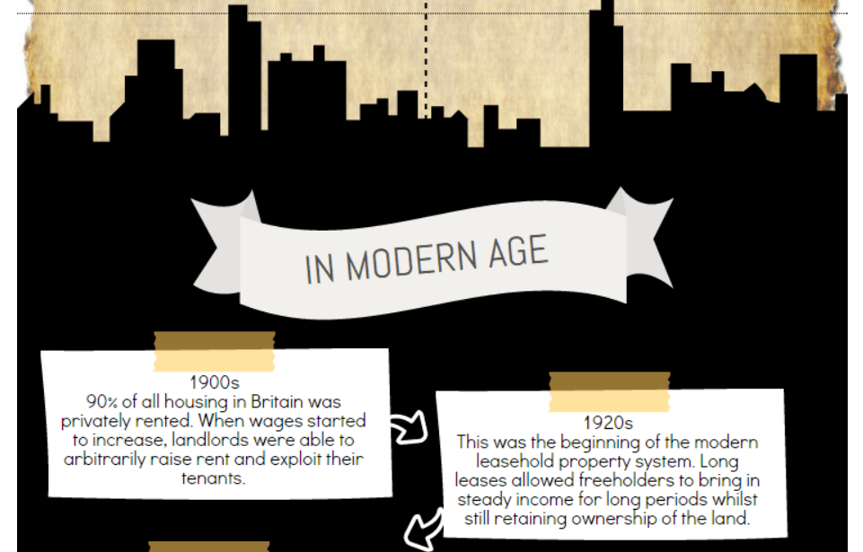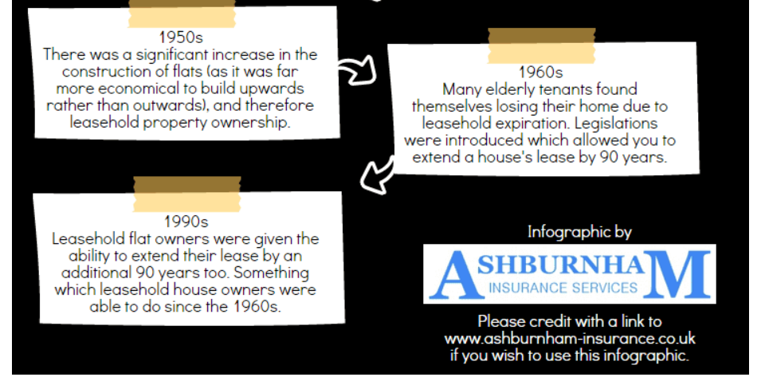

2.2 The Principle of Leasehold
^{[7]}
- When one purchases an apartment, they do not own it, but rather have the right to occupy it for a time specified, after which the apartment reverts to the freeholder, who owns the land it occupies.
- Subject to conditions (see 2.4) for a fee, and specific term, which the freeholder decides, extension of the lease is possible.
- Should a leaseholder default on Ground Rent or Service Charges, the freeholder can, in theory, confiscate the apartment (although this is rare).

2.3 Recent Legislation (Housing Minister)
^{[8]}
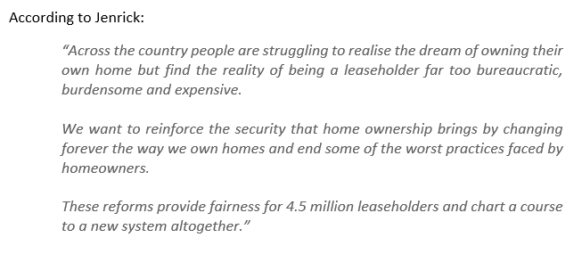

2.4 Conditions to Enfranchise Apartments
^{[9]} The Building must:-
- Contain no less than two apartments.
- At least two-thirds of apartments must be owned by qualifying tenants (a leaseholder with a lease that was 21+ years when initially granted).
- Other leases within the definition of a qualifying tenant as follows :-
  - shorter lease containing clause providing perpetual renewal.
  - terminable on death/marriage/date yet unknown
  - continuation of a long lease following the expiry of the original term.
  - shared ownership where tenant’s share is 100%.
  - ‘right to buy’ or ‘right to acquire on rent to mortgage terms.
Even if above applicable, they will be ineligible if any of the following apply:
- the landlord a charitable housing trust and provided as part of the charity’s functions.
- the tenant owns more than two flats in the building. This is either jointly with others or solely in their own name. Where this applies these flats will be discounted from the two-thirds.
- the tenant has a business or commercial lease.
The 25% non-residential rule: If over 25% of the internal area, excluding common parts, is neither used nor intended to be used for residential purposes, then the building is disqualified (shops/offices). Garages and parking spaces used by flats in the building are classified ‘residential’.
Resident landlord exemption:- No right of collective enfranchisement exists where:-
- building is a conversion into four or fewer flats and
- not purpose-built; and
- same person has owned the freehold since before the conversion of the building into flats; and
- he or an adult member of his family has lived there for the past 12 months.
Properties excluded from the rights of lease extension and collective enfranchisement:
- buildings within a cathedral precinct.
- National Trust properties.
- Freehold includes track of an operational railway, including bridge/tunnel/ retaining wall to railway track.
- Crown properties*.* Although the Crown is not bound by the legislation, the Minister has made a statement to the House of Commons that the Crown will be prepared to comply with the principles of it.
If building qualifies, to proceed, it is necessary to establish there are sufficient qualifying tenants.
Minimum number of participating tenants must equal half the total number of flats in the building:
- e.g., if there are 10 flats, at least five of qualifying tenants must participate.
Where there are only two flats in the building, both flats of qualifying tenants must participate.

3. 0 Aims & Objectives

3.1 Aim
To provide a guide on a website for leaseholders to gain enfranchisement.

3.2 Objectives
- To design and build a useful website to show path to enfranchisement and make it as user-friendly as possible.
- To test said website fulfils requirements.
- To conduct user survey to narrow down essential information for future conversion of website into an App, tailored to specific users to log on to track own estate/building enfranchisement progress.

Deliverables:
- A data set of documents used to build the website, pertinent to leasehold enfranchisement.
- A website to guide users to enable them to see timeline of overall picture when contemplating/attempting buying their freehold.
- A report detailing how this was done by deadline of 26/04/23.

4. 0 Project Design
^{[10]} Show the overall requirements to enfranchise apartments:
Figure 8 Flow Chart for Collective Enfranchisement
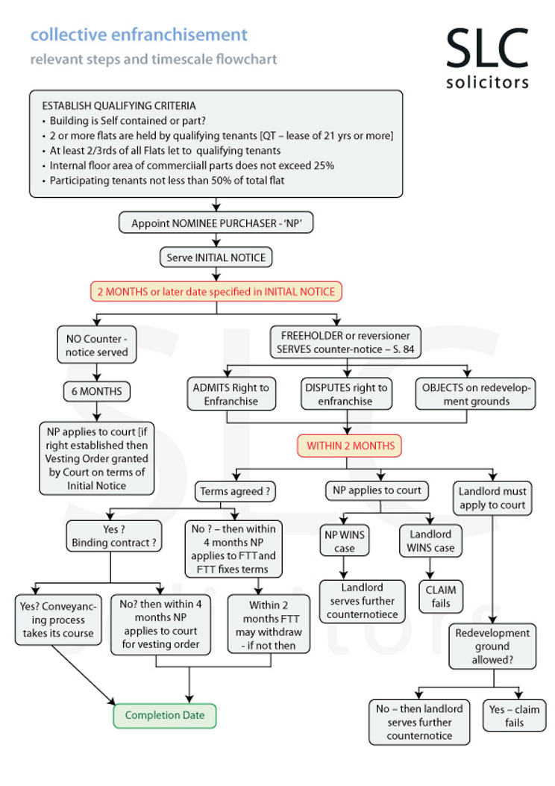

4.1 Outline of Project Process

- Literature Review: Research current legislation/journal articles to conduct a literature review.
- Design a Website using a ‘Requirements Analysis’ (preliminary requirements listed below in Table 1).
- Build and Test Website according to the revised MOSCOW requirements.
- Evaluate:
  - Conduct Primary Research: Survey users’ preferences for requirements for the future development of an App. This could enable personalised logins, tailored to apartment block/estate conditions.
  - Conclusion/Recommendation: Is an App possible? or is a Website only resource possible due to convoluted nature of the problem.
- Document throughout to assemble into a report to be submitted by 26/04/23

Table 1 MOSCOW Requirements for Website
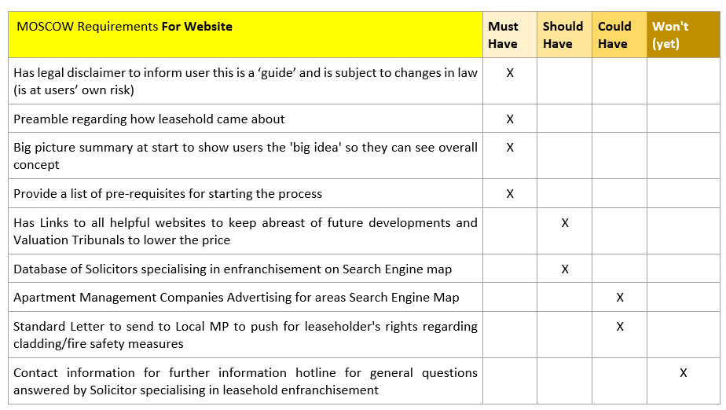

Table 2 MOSCOW Requirements Additional for Future App Development

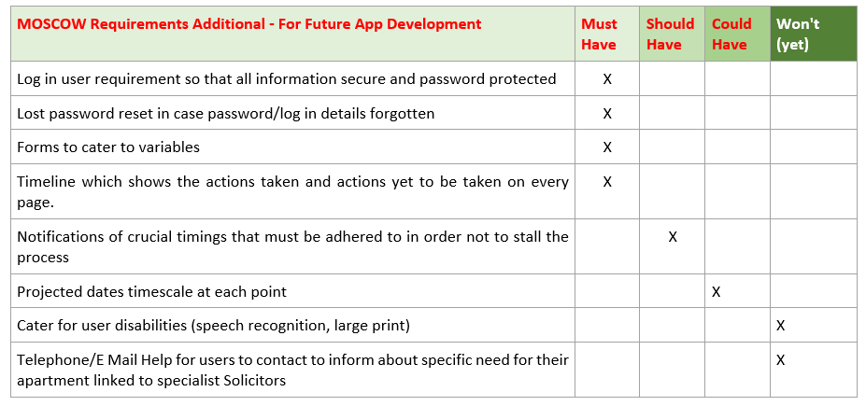

4.2 Data Collection
- Collect relevant data and categorise.
- Preparation – organise to insert in pertinent place and order.
- Review - check for any patterns to identify a theme and categorise.

4.3 Data Evaluation
- Interpretation - Analyse to reveal meaningful discoveries.
- Documentation - to conclude findings.

4.4 Risks & Limitations
- Legislation changes, making website/application obsolete.
- Running out of time/schedule slippage due to unrealistic deadlines.
- Website too general due to lack of knowledge regarding specific leases, as difficult to cater to tens of thousands of exceptions on individual leases.
- Gaining enough users willing to spend time testing.
- Development of future Application not viable due to too many variables owing to widespread lease conditions.

4.5 Ethical Issues
- Legislation: changes, so it is essential the website be up to date.

- User testing: dealing with people and their confidential information which needs to be safeguarded and backed up.

- Data Protection: all data collected must be:

  - Stored in safe secure location
  - Be identifiable, retrievable and accessible by the researcher
  - Accurate/reliable
  - Available to participants
  - Retained in a manner which is legal-compliant.
  - Deleted once used

- Reliability: must be a reliable source of information.

- Generalisability: must be generalisable for wide appeal.

- Validity: must be valid to be useful.

5.0 Resources & Planning

5.1 Resources Required

5.1.1 Hardware Resources
- Laptop - Victus intel core i7
- Brick - My Passport Memory 1TB
- Printer (HP)

5.1.2 Software Resources
^{[11]} Free Website Builders

5.1.3 Other Resources
- ^{[12]} Legal and Government Information regarding leasehold legislation
- ^{[13]} UWTSD Lecturers for technical advice in creating website
- Users to test

5.2 Planning Chart
Tasks envisaged as follows:-
- Literature Review – 1 month (October)
- Design – 1 month (November)
- Build and Test - 2 months (December and January)
- Evaluate – 2 months (February and March)
Table 3 Planning Chart
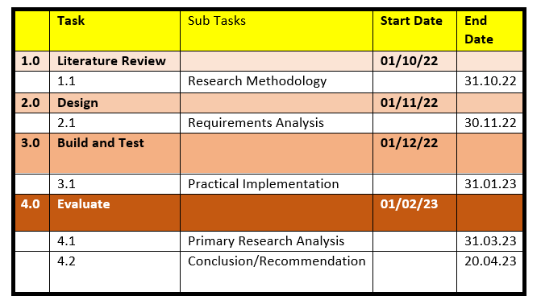
1,535 Words

6.0 Reference List

[1[ | “Storyboard Creator, Comic Strip Maker, Storyboard Maker (Storyboardthat.com”. Accessed: Oct 10, 2022. [Online]. Available: https:// Storyboard Creator | Comic Strip Maker | Storyboard Maker (storyboardthat.com)
[2] | Waterfords, “Will there be leasehold reform? Expert estate agents in property sales and lettings in Camberley, Chobham, Farnham, Fleet and Yateley (waterfords.co.uk)”. Accessed: Oct 10, 2022. [Online]. Available: https://Will there be leasehold reform? | Expert estate agents in property sales and lettings in Camberley, Chobham, Farnham, Fleet and Yatele (waterfords.co.uk)
[3] | “Welcome to the Residential Property Tribunal (gov.wales)”. (2022 March 2). Accessed Oct 10, 2022 [Online]. Available: https://Welcome to the | Residential Property Tribunal (gov.wales)
[4] | K. Kendrick “Who are the national leasehold campaign, National Leasehold Campaign (NLC)”. Accessed Oct 10, 2022. [Online]. Available: https://WHO ARE THE NATIONAL LEASEHOLD CAMPAIGN | NATIONAL LEASEHOLD CAMPAIGN (NLC)
[5] | “How we got here – the history of Leasehold Property Ownership (lease extension uk info)”. Accessed: Oct 10, 2022. [Online] Available: https://How we got here – The History of Leasehold Property Ownership (leaseextension-uk.info)
[6] | S. Smith, (June 1, 2015), “The History of Leasehold Property[INFOGRAPHIC] Ashburnham Insurance (ashburnham-insurance.co.uk. Accessed Oct 10, 2022 [Online]. Available: https://The History of Leasehold Property [INFOGRAPHIC] | Ashburnham Insurance (ashburnham-insurance.co.uk)
[7] | “Living in Leasehold Flats – A guide to how it works – The Leasehold Advisory Service (lease-advice.org)”. Accessed Oct 10, 2022. [Online]. Available: https//Living in Leasehold Flats - A guide to how it works - The Leasehold Advisory Service (lease-advice.org)
[8] | B. Johnson, “A summary of proposed leasehold reform in 2021 – Yopa Homeowners Hub”. Accessed Oct 10, 2022. [Online]. Available: https//A summary of proposed leasehold reform in 2021 - Yopa Homeowners Hub
[9] | The Leasehold Advice Centre “Collective Enfranchisement – Getting Started – The Leasehold Advisory Service”. Accessed Oct 10, 2022. [Online] Available: https://Collective Enfranchisement - Getting Started - The Leasehold Advisory Service (lease-advice.org)
[10] | SLC Solicitors “Leasehold enfranchisement flowchart main jpg (595x 842) (SLC Solicitors)”. Accessed Oct 10, 2022. [Online]. Available: https://leasehold-enfranchisement-flowchart-main.jpg (595×842) (slcsolicitors.com)
[11] | “Comparing the Best UK Website Builders – Build Your Website Today! (top 10.com)”. Accessed Oct 16, 2022. [Online] . Available: https://Comparing the Best UK Website Builders - Build Your Website Today! (top10.com)
[12] | “Residential leasehold and commonhold Law Commission”. Accessed Oct 16, 2022. [Online]. Available: https://Residential leasehold and commonhold | Law Commission
[13] | “Applied Computing (BSc, HND, HNC, Foundation Entry UWTSD”. Accessed Oct 16, 2022. [Online]. Available: https://Applied Computing (BSc, HND, HNC, Foundation Entry) | UWTSD

7.0 Bibliography

“UK Government plans to reform leasehold and commonhold systems inside conveyancing.co.uk”. Accessed Oct 6, 2022. [Online]. Available: https//UK Government plans to reform leasehold and commonhold systems insideconveyancing.co.uk)
“Buying or owning a leasehold home – GOV.UK (www.gov.uk)”. Accessed Oct 6, 2022. [Online]. Available: //Buying or owning a leasehold home - GOV.UK (www.gov.uk)
D. Latuhamina "Learn New Skills With Project-Based Learning - Life Optimizer". Accessed Oct 6, 2022. [Online]. Available: https//Learn New Skills With Project-Based Learning – Life Optimizer
A. Aston "Key Skills for your Project Management Resume in 2022 (the digital project manager.com)". Accessed Oct 6, 2022. [Online]. Available: https//21 Key Skills For Your Project Management Resume In 2022 (thedigitalprojectmanager.com)
J. Kylliäinen "The Importance of Innovation - What Does it Mean for Businesses and our Society?(viima.com)". Accessed Oct 6, 2022. [Online]. Available:https://The Importance of Innovation – What Does it Mean for Businesses and our Society? (viima.com)
Price Waterhouse Coopers Global "The World in 2050: PwC". Accessed Oct 6, 2022 [Online] . Available: https://The World in 2050: PwC
"9 Project Management Challenges and How to Overcome Them (kissflow.com)". Accessed Oct 6, 2022 [Online]. Available: https://9 Project Management Challenges and How to Overcome Them (kissflow.com)

