
My Mind Map
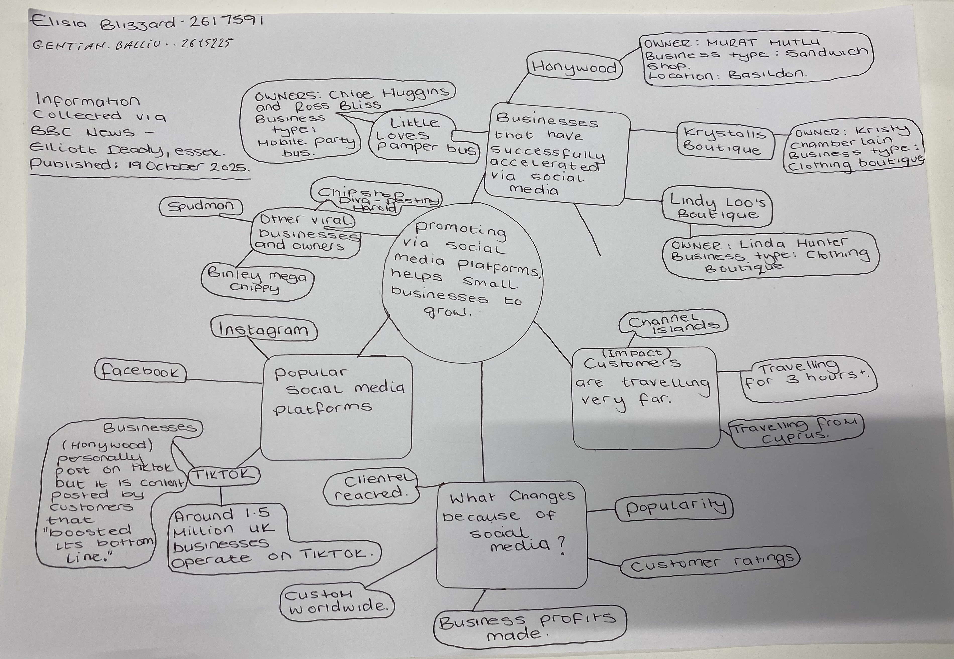

What is the main idea of the whole text?
The main idea of the text is that promoting via social media, helps small businesses to grow. The text specifically mentions platforms; TikTok and Instagram and explain that not only does social media assist in business growth but also, if your videos become viral, it can significantly accelerate business progression and popularity.

- What is one key point that supports the main idea, and which specific example from the text shows this?
One key point from the text which supports the main idea (promoting via social media helps small businesses to grow) is a statement from business owner (Murat Mutlu) stating that customers had travelled for 3 hours to buy a chicken burger from his shop.
Murat also explains that this increase in popularity and sales is mainly due to his customer’s content relating to the business, rather than just his own.

- What is a different key point that supports the main idea, and which specific example from the text shows this?
Another key point is a statement from Linda Hunter who promotes her boutique clothing business via Instagram. Linda explained that after 46 years of selling her merchandise on market stalls in Essex, Kent and London, she was finally able to move her business online due to the popularity growth via Instagram and now ships across the UK and even to Australia.
According to the Government’s Business Academy, Instagram have more than 200 million business owners worldwide, using the platform to promote.
- Which part of the text do you think is most important, and why?
I think that the most important part of the text is the conclusion ‘people buy from people’ where a marketing expert (Faye Martin) states that “social media has made it easier than ever for traders to reach new customers.”
I believe that this along with the statistics mentioned, are most important because it shows certainty from reliable sources.
Reflection:
- What did you find difficult in this task (including in-class components), and why was it difficult?
I would have liked more time to gather information from the text, and have it structured before drawing my mind map. It is also not as neat as I would have liked.
Though I didn’t find it difficult.
I did however find it difficult to choose the most important part of the text as I believe that there are various important parts, and I did not know if a specific quote was needed or whether I could generalise the most important part.

- What helped you with this difficulty, and how did it help you?
Reassurance of my work and encouragement from my lecturer.

