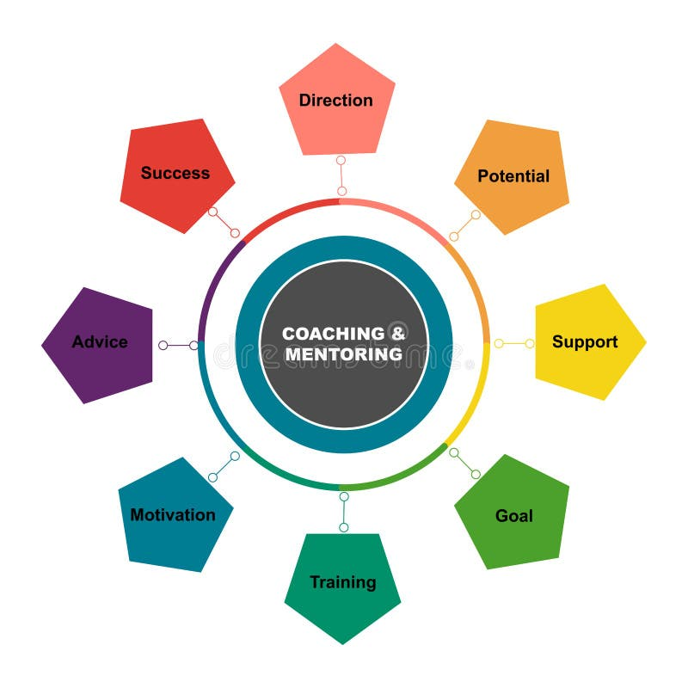

Enhancing Professional Development Through Coaching& Mentoring:

A Reflective Analysis within the NHS

Student : Md. Abdul Q Chowdhury
ID: 21199999
Lecturer : Miss Nishi Ramsurrun
Module Code : BMSW6105

Table of Contents
1. Introduction 3
2. Advantages of Coaching & Mentoring 3
3. Ten Coaching Skills and Their Importance 4
4. GROW Model 6
5. Reflection Using Gibbs Reflective Cycle 6
6. Honey and Mumford Questionnaire 11
7. Feedback 12
8. Conclusion 13
References 14

1. Introduction
In the NHS (National Health Service), coaching and mentoring are essential tools for continuous professional development and improved patient outcomes. Coaching focuses on unlocking potential and enhancing specific skills, while mentoring provides long-term career guidance (Hawkins and Smith, 2013). These practices align with NHS goals of fostering leadership, reducing staff turnover, and enhancing clinical performance (Smith, Fletcher and Hughes, 2017). Effective coaching and mentoring not only benefit healthcare professionals by improving competencies but also ensure patients receive high-quality care. This report explores their advantages, essential coaching skills, the GROW model, and reflections on a recent coaching session.

2. Advantages of Coaching & Mentoring
In the NHS, coaching and mentoring offer critical advantages for developing healthcare professionals and enhancing patient care quality. Coaching helps employees develop specific skills and improve performance. For example, a nurse struggling with time management can benefit from a coaching session where goals are set using the SMART framework (Whitmore, 2017). By improving this skill, the nurse can better prioritize patient needs, reducing delays and improving care efficiency.
Mentoring, on the other hand, offers long-term professional development. Senior doctors mentoring junior colleagues facilitate knowledge transfer, helping them navigate complex medical procedures and institutional protocols (Garvey, Stokes and Megginson, 2014). This not only increases confidence but also reduces the likelihood of errors, contributing to better patient outcomes (Smith, Fletcher and Hughes, 2017).
Coaching and mentoring also address workplace challenges such as stress and burnout. For instance, coaching sessions focused on stress management help staff cope with high-pressure environments, a frequent issue in NHS emergency departments (Jones, Woods and Guillaume, 2016). Additionally, mentoring programs promote career progression and employee retention. A junior nurse who feels supported through mentorship is less likely to leave the organization, reducing turnover rates and associated recruitment costs (Parsloe and Leedham, 2016).

3. Ten Coaching Skills and Their Importance
Active Listening: Active listening is foundational for effective coaching in the NHS. It ensures that the coachee feels heard and understood, fostering trust. For example, during a session with a nurse dealing with patient workload issues, active listening enables the coach to capture subtle cues about underlying stress (Garvey, Stokes and Megginson, 2014). Failure to actively listen may lead to superficial solutions that do not address core challenges (Smith, Fletcher and Hughes, 2017).
Open-Ended Questioning: Asking open-ended questions encourages deeper reflection and problem-solving. In a coaching session aimed at improving a doctor's leadership skills, questions such as "What challenges do you face in leading your team?" promote exploration and insight (Whitmore, 2017). However, over-reliance on open-ended questions can sometimes derail sessions if the coachee lacks clarity on their issues (Passmore, 2016).
Empathy: Empathy helps coaches connect with coachees on an emotional level, essential in high-stress NHS environments. For instance, empathizing with a junior doctor struggling with burnout can help uncover solutions tailored to their emotional state (Jones, Woods and Guillaume, 2016). Without empathy, coaching sessions may feel transactional, reducing their impact (Hawkins and Smith, 2013).
Patience: Patience is crucial when coachees need time to process information. In NHS settings, where staff often face high workloads, giving them time to reflect during sessions allows for meaningful outcomes (Clutterbuck, 2014). However, excessive patience can hinder progress if sessions become unstructured (Wilson, 2014).
Goal Setting: Effective goal setting using the SMART framework (Specific, Measurable, Achievable, Relevant, Time-bound) ensures actionable outcomes. For example, setting a goal to “reduce patient check-in times by 20% within two months” provides clear direction (Whitmore, 2017). Poorly defined goals can lead to frustration and lack of progress (Downey, 2014).
Constructive Feedback: Providing constructive feedback helps coachees identify areas for improvement while maintaining motivation. In the NHS, feedback such as “You managed your time well, but consider delegating minor tasks to optimize efficiency” balances praise and improvement (Garvey, Stokes and Megginson, 2014). Harsh or vague feedback, however, can damage confidence (Rogers, 2016).
Non-Judgmental Attitude: Maintaining a non-judgmental attitude creates a safe space for honest dialogue. For example, a coach working with a midwife addressing clinical errors must avoid judgment to foster open communication (Hawkins and Smith, 2013). Judgmental attitudes can lead to defensiveness and hinder growth (Passmore, 2016).
Building Rapport: Building rapport quickly helps establish trust and cooperation. In NHS coaching, where time is limited, establishing rapport by showing genuine interest in the coachee’s challenges improves engagement (Parsloe and Leedham, 2016). Without rapport, sessions may feel forced and unproductive (Cox, Bachkirova and Clutterbuck, 2018).
Observation Skills: Observing non-verbal cues such as body language or tone helps identify underlying issues. For example, a nurse expressing time management concerns while showing signs of anxiety may need stress management support (Jones, Woods and Guillaume, 2016). Missing these cues can lead to incomplete solutions (Whitmore, 2017).
Communication Skills: Clear and concise communication is vital for delivering insights and instructions effectively. In the NHS, a coach guiding a team leader on delegation must communicate expectations clearly (Downey, 2014). Ambiguity can lead to misunderstandings and ineffective coaching outcomes (Rogers, 2016).
In conclusion, while these skills significantly enhance coaching effectiveness, they require continuous refinement. Coaches in the NHS must balance these skills carefully to address the unique challenges faced by healthcare professionals (Hawkins and Smith, 2013; Wilson, 2014).

4. GROW Model
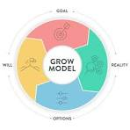
The GROW model (Goal, Reality, Options, Will) is an effective framework for coaching sessions within the NHS, offering a structured approach to problem-solving and development (Whitmore, 2017). It ensures the coachee moves from identifying goals to actionable steps, enhancing performance and skill development.
Goal: In a coaching session with a nurse aiming to improve time management, the goal might be: "Reduce patient check-in times by 15% within two months." Clear goals provide direction and motivation (Passmore, 2016).
Reality: This step involves assessing the current situation. For example, identifying that the nurse is frequently interrupted by administrative tasks provides context for why time management is challenging (Garvey, Stokes and Megginson, 2014).
Options: Exploring different strategies helps generate potential solutions. In this case, options might include delegating paperwork to administrative staff or using digital tools for scheduling (Wilson, 2014). The coach should use open-ended questions to encourage creative thinking.
Will:: This step solidifies the action plan. The nurse may decide to implement a digital scheduling tool and delegate minor tasks to support staff. Setting a follow-up session ensures accountability and progress tracking (Hawkins and Smith, 2013).

5. Reflection Using Gibbs Reflective Cycle
The Gibbs Reflective Cycle (2013) is a structured model for reflection that encourages critical analysis of experiences to improve future practice. It consists of six stages: Description, Feelings, Evaluation, Analysis, Conclusion, and Action Plan. This reflection focuses on a coaching session I conducted with Olufemi in the context of the NHS, where the goal was to improve time management skills.
1. Description
In the coaching session, I (Abdul) used the SMART framework to help Olufemi develop better time management strategies. The session began with an explanation of the session's purpose. I asked structured, open-ended questions and actively listened to Olufemi’s challenges. The session lasted 15 minutes and concluded with a summary and action plan. I maintained a professional demeanor and focused on Olufemi’s agenda. Feedback highlighted my strengths in active listening, patience, and professionalism, but suggested improving questioning techniques and adopting a more approachable demeanor (e.g., smiling).
2. Feelings
Initially, I felt confident and prepared. I believed the SMART model would provide a clear structure, and I was determined to remain patient and non-judgmental. During the session, I felt engaged, particularly when Olufemi identified practical solutions. However, I noticed moments where my questions did not prompt deeper exploration. After receiving feedback, I felt slightly disappointed about the suggestion to improve my questioning and demeanor. However, I recognized the value of this feedback in enhancing my coaching effectiveness.
3. Evaluation
Several aspects of the session were successful. My active listening skills ensured that Olufemi felt heard, which is crucial in NHS coaching contexts where staff often deal with high-stress situations (Garvey, Stokes and Megginson, 2014). My focus on Olufemi’s agenda, specifically his time management challenges, made the session relevant and productive (Smith, Fletcher and Hughes, 2017). Additionally, my patience allowed Olufemi to process information and arrive at solutions in his own way (Downey, 2014).
However, the session also had weaknesses. My questioning techniques were limited to structured, open-ended questions. I missed opportunities to use probing or Socratic questions to explore Olufemi’s challenges more deeply (Whitmore, 2017). For instance, instead of asking, “What do you think is causing these time management issues?” I could have followed up with, “Can you give an example of a situation where time management was particularly challenging?” This approach could have uncovered more detailed insights. Additionally, the feedback suggested that a more approachable demeanor, such as smiling, could improve rapport and make the coachee feel more at ease (Passmore, 2016).
4. Analysis
The strengths in my active listening and patience align with best practices in NHS coaching, where trust and understanding are essential (Cox, Bachkirova and Clutterbuck, 2018). However, the limited variety in my questioning techniques restricted the session’s depth. Effective questioning is critical for uncovering root causes of challenges and stimulating reflective thinking (Wilson, 2014). In NHS settings, where professionals often face complex issues, deeper questioning can lead to more sustainable solutions.
The lack of a warm, approachable demeanor may have unintentionally created a formal atmosphere, hindering full engagement (Hawkins and Smith, 2013). In high-stress environments like the NHS, where staff may feel overwhelmed, a friendly and supportive demeanor can help alleviate anxiety and foster openness (Jones, Woods and Guillaume, 2016).

Personal SWOT Analysis
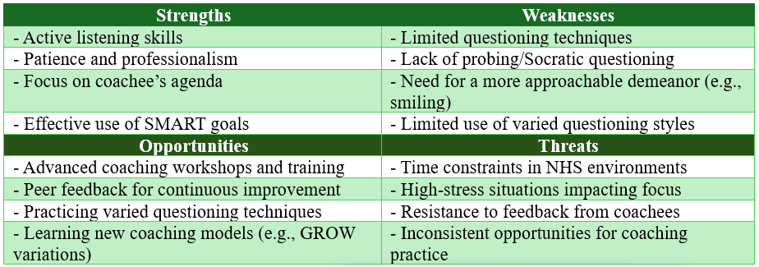
5. Conclusion
In summary, the session effectively set goals and maintained a professional, patient approach. However, improving my questioning techniques and adopting a friendlier demeanor could enhance the depth and comfort of future coaching sessions. These changes would lead to more insightful discussions and stronger coachee engagement.
6. Action Plan
To enhance the effectiveness of future coaching sessions within the NHS, I will implement the following detailed actions:
Objective | Specific | Measurable | Achievable | Relevant | Time-Bound
Improve questioning techniques | Practice probing and Socratic questioning during coaching sessions. | Incorporate at least 3 probing questions per session. | Allocate 1 hour weekly for practice. | Enhances depth and effectiveness of coaching. | 3 months
Adopt a more approachable demeanor | Smile and use open body language to build rapport. | Receive positive feedback on demeanor from at least 80% of coachees. | Implement in each session. | Builds trust and openness with coachees. | 2 months
Seek regular feedback | Use feedback forms after each coaching session. | Collect feedback from 100% of coachees. | Create a short, standard feedback form. | Ensures continuous improvement and adaptation. | 1 month
Attend advanced coaching training | Enroll in a coaching workshop focusing on advanced techniques. | Complete at least 1 certified workshop. | Identify and register for an online course. | Expands skills in questioning and rapport-building. | 6 months
Develop reflective practice | Reflect on each session using the Gibbs Reflective Cycle. | Complete a reflection within 24 hours post-session. | Schedule 30 minutes for each reflection. | Improves self-awareness and coaching effectiveness. | 4 weeks
- Practice Probing and Socratic Questioning Techniques: To deepen exploration during coaching sessions, I will actively incorporate probing and Socratic questions. For example, after an initial response from the coachee, I will ask follow-up questions like, “What led you to that conclusion?” or “Can you provide a specific example of when this issue occurred?”
- Adopt a More Approachable Demeanor: Building rapport and creating a comfortable environment are essential for effective coaching. I will consciously work on adopting a warmer and more approachable demeanor by smiling, maintaining open body language, and using a supportive tone. For example, I will begin each session with a friendly greeting and casual conversation to put the coachee at ease (Passmore, 2016). Practicing in front of a mirror or recording short role-play sessions will help me observe and refine my non-verbal cues. Feedback from peers on my demeanor will further assist in this improvement.
- Seek Regular Feedback from Coachees: Continuous improvement relies on understanding how my coaching is perceived. After each session, I will provide a brief feedback form with specific questions such as, “Did the session meet your expectations?” and “What could I do differently to support your goals better?” (Cox, Bachkirova and Clutterbuck, 2018).
- Attend training sessions on advanced coaching techniques (Cox, Bachkirova and Clutterbuck, 2018).

6. Honey and Mumford questionnaire
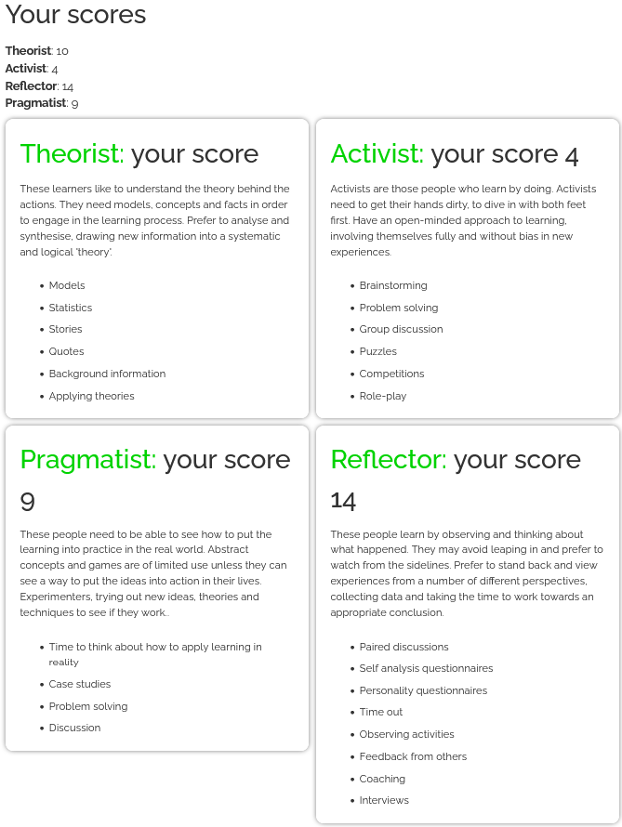

7. Feedback
BMSW 6005 |  | FEEDBACK |  |  | Date of Interview: |  | 02.11.2024
Coach |  | Abdul |  |  | Coachee |  | Olufemi
Coaching Model: |  | SMART /GROW/MMM/RAW |  |  |  |  | SMART
The numerical rating system is based on the scale below.
Scale: | 5 – Yes |  | 4 – Most of the time | 3 – Some of the time |  | 2 – Almost never |  |  |  | 1 – No
Explained the purpose of the session first. |  |  |  |  |  |  |  | Rating
 |  |  |  |  |  |  |  | 5 | 4 |  | 3 | 2 | 1
Is the coach asking open ended questions or closed questions  The questions used were structured allowing the coachee to respond accordingly , however you may also want to review different questions technique such as probing and socratic |  |  |  |  |  |  |  | ☐ | ☒ |  | ☐ | ☐ | ☐
Is the coach patient? Is He/She giving the coachee time to think through issues and arrive at a conclusion in the way THEY process information?Active listening and full attention to details practiced , the coach was relatively calm and approachable |  |  |  |  |  |  |  | ☒ | ☐ |  | ☐ | ☐ | ☐
Is the coach focused on the coachee’s agenda?  The Coach focus on the coachee’s agenda - Time Management skills – 15 minutes were fully utilised with a summary of the conversation provided |  |  |  |  |  |  |  | ☒ | ☐ |  | ☐ | ☐ | ☐
The coach was professional and at any time acted as judgmental |  |  |  |  |  |  |  | ☒ | ☐ |  | ☐ | ☐ | ☐
Is the coach acting as a problem solver, providing the solutions for the coachee?  The coach did not provide solutions but instead planned for a mentoring session without solving problems |  |  |  |  |  |  |  | ☒ | ☐ |  | ☐ | ☐ | ☐
Has the SOLER technique been applied  Applied |  |  |  |  |  |  |  | ☒ | ☐ |  | ☐ | ☐ | ☐
Additional Comments
Coaching skills were satisfactory but a smile goes a long way

8. Conclusion
In conclusion, coaching and mentoring within the NHS play a pivotal role in enhancing professional development, improving staff performance, and ensuring high-quality patient care. The GROW model and essential coaching skills, such as active listening, effective questioning, and empathy, provide a structured and impactful approach to these sessions. Reflecting using Gibbs' model highlighted strengths and areas for improvement, such as refining questioning techniques and adopting a warmer demeanor. By addressing these aspects, coaching sessions can become more effective, fostering a supportive environment that benefits both NHS staff and the patients they serve (Garvey, Stokes and Megginson, 2014; Whitmore, 2017).

References
Clutterbuck, D. (2014) Everyone Needs a Mentor: Fostering Talent in Your Organisation. 5th edn. London: Chartered Institute of Personnel and Development (CIPD).
Cox, E., Bachkirova, T. and Clutterbuck, D. (2018) The Complete Handbook of Coaching. 3rd edn. London: SAGE Publications.
Downey, M. (2014) Effective Coaching: Lessons from the Coach's Coach. 4th edn. London: Thomson Learning.
Garvey, B., Stokes, P. and Megginson, D. (2014) Coaching and Mentoring: Theory and Practice. 2nd edn. London: SAGE Publications.
Gibbs, G. (2013) Learning by Doing: A Guide to Teaching and Learning Methods. Oxford: Oxford Brookes University.
Hawkins, P. and Smith, N. (2013) Coaching, Mentoring and Organizational Consultancy: Supervision and Development. 2nd edn. Maidenhead: Open University Press.
Jones, R. J., Woods, S. A. and Guillaume, Y. R. F. (2016) ‘The effectiveness of workplace coaching: A meta-analysis of learning and performance outcomes from coaching’, Journal of Occupational and Organizational Psychology, 89(2), pp. 249-277.
Parsloe, E. and Leedham, M. (2016) Coaching and Mentoring: Practical Techniques for Developing Learning and Performance. 3rd edn. London: Kogan Page.
Passmore, J. (2016) Excellence in Coaching: The Industry Guide. 3rd edn. London: Kogan Page.
Rogers, J. (2016) Coaching Skills: The Definitive Guide to Being a Coach. 4th edn. Maidenhead: Open University Press.
Smith, J., Fletcher, C. and Hughes, M. (2017) ‘The role of coaching in the NHS: Improving healthcare outcomes’, British Journal of Healthcare Management, 23(6), pp. 262-269.
Whitmore, J. (2017) Coaching for Performance: The Principles and Practice of Coaching and Leadership. 5th edn. London: Nicholas Brealey Publishing.
Wilson, C. (2014) Best Practice in Performance Coaching: A Handbook for Leaders, Coaches, HR Professionals and Organizations. London: Kogan Page.

____________________________________^^^_______________________________________

