REFLECTIVE PORTFOLIO

Module: Professional Career Development
Module Code: BMSW4005
Lecturer Name: Masud Ibrahim
Student name and number:
Paul Enache: 2129433

Table of content

Overview……………………………………………………………………………………………….3
Skills and knowledge required for the Lorry Driver job……………………………...……………3
SWOT Analysis……………………………………………………………………………………….4
Personal Development Plan…………………………………………………………………………5
Learning styles……………………………………………………………………………………….6
Impact of learning styles in my career………………………………………………….………….7
What I have learned this module……………………………………………………………………8
Assessment of the concepts learned from this module…………………………………………..9
Conclusion…………………………………………………………………………………………...10
References…………………………………………………………………………………….…….11

Overview
My name is Paul Enache, and I am student at UWTSD, course Skills for the Workplace, Level 4.
I work like a Lorry driver for a company in Tamworth and I want to apply for the same job, but to another company.
With ten years of lorry driving experience, I am confident in my ability to contribute to the efficient and safe transportation of goods and supplies.
As a Class 1 Lorry Driver, I am knowledgeable about loading and unloading goods and materials, as well as digital tachographs and other technology required to assure compliance with driving requirements. I can also properly manage my time and prioritise projects to achieve tight deadlines and timelines.
My strong work ethic, attention to detail, and commitment to customer service make me a great fit for this position.

Skills and knowledge required for the Lorry Driver job.
Valid Class 1 driver's license
CPC and Digital Tachograph Card
Minimum of 2 years' experience as a Class 1 Lorry Driver
Good knowledge of road safety regulations and best practices
Excellent communication and interpersonal skills.
Ability to work independently and as part of a team.
Good time management and organizational skills

SWOT Analysis
SWOT analysis is a strategic planning tool that stands for Strengths, Weaknesses, Opportunities, and Threats. It is a process of assessing the internal and external factors that can affect a business or an individual in achieving their goals or objectives. In a SWOT analysis, strengths and weaknesses are internal factors that are within the control of the business or individual, while opportunities and threats are external factors that are outside of their control. The purpose of a SWOT analysis is to identify key areas of focus and develop strategies to improve or take advantage of the identified factors.
My SWOT Analysis:
Strengths | Weaknesses
Excellent driving skills and spotless driving record  Strong dedication to road safety  Exceptional communication and interpersonal abilities  Knowledgeable about loading and unloading goods and materials, as well as digital tachographs and other technology required for compliance.  Ability to manage time and prioritise projects to achieve tight deadlines and timelines.  Strong work ethic and attention to detail  Commitment to customer service | Limited experience in certain types of cargo and routes  Possible limitations on work schedule due to legal restrictions on driving hours  May need additional training to use new or unfamiliar technology.
Opportunities | Threats
Opportunities to learn and gain experience in new types of cargo and routes.  Possibility for advancement to higher positions within the company  Possibility for further training and professional development opportunities  Possibility for increased earning potential through bonuses and incentives | Competition from other experienced and qualified lorry drivers applying for the same position.  Possible economic downturns affecting the demand for lorry drivers and the transportation industry.  Possible changes in regulations and requirements for lorry drivers, potentially affecting employment opportunities and working conditions.

Personal Development Plan

For a Lorry Driver job this is my Personal Development Plan:
Strengthen driving skills: | Take additional training courses or seek out opportunities to improve driving skills, such as specialized cargo transport or defensive driving courses.
Learn new technologies: | Keep up to date with new digital tachographs and other technology required for compliance with driving requirements.
Expand knowledge and experience: | Seek out opportunities to gain experience with different types of cargo and routes and learn new safety protocols and procedures.
Develop time management skills: | Work on managing time more efficiently to meet tight deadlines and achieve timelines.
Improve communication skills: | Enhance communication skills to build better relationships with co-workers, clients, and suppliers.
Build relationships: | Attend industry events and network with other lorry drivers to learn about new opportunities and industry trends.
Prioritize safety: | Continuously prioritize road safety, follow all driving regulations and procedures, and work to maintain a spotless driving record.
Set achievable goals: | Develop a plan to achieve career goals, such as earning additional certifications or advancing to higher positions within the company.
Maintain a positive attitude: | Maintain a positive attitude and a strong work ethic, even in challenging situations.

Learning styles
Learning styles are a common notion in psychology and education that aim to determine how people learn best.

In this module I studied about the two learning models:

VARK learning styles.

According to VARK learning styles, there are four types of learners: visual, auditory, reading/writing, and kinesthetic:
Visual learning (pictures, movies, diagrams)
Auditory learning (music, discussion, lectures)
Reading and writing (making lists, reading textbooks, taking notes)
Kinesthetic learning (movement, experiments, hands-on activities)
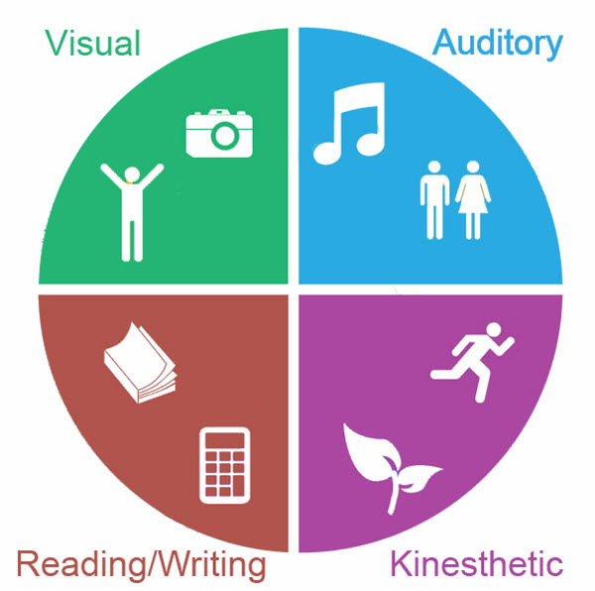

VARK Learning model.

Honey and Mumford’s Learning Styles
Honey and Mumford defined four distinct learning styles: "activist," "theorist," "reflector," and "pragmatist." Some people, according to the hypothesis, naturally gravitate towards a particular learning style. As a result, Honey and Mumford suggest that to attain optimum learning, one needs recognise his natural learning style, understand it, and develop ways to study that match the type.

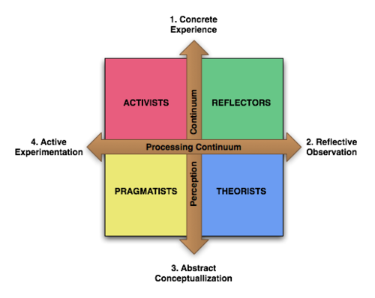
Honey and Mumford’s Learning Styles

After I did the tests for these two different learning styles, I found out that I am an Auditory learner and a Pragmatist.

Impact of learning styles in my career
I process material best as an Auditory learner through sound and spoken explanations. This implies I can benefit from verbal instructions, dialogues, and information recordings. As a lorry driver, I can use this learning method by paying close attention to instructions from dispatchers, co-workers, and managers. I can also benefit from clarifying information with questions and recording it to listen to later.
As a pragmatist, I learn best by putting theories and concepts into practise. Hands-on experiences, simulations, and problem-solving activities are how I prefer to learn. As a lorry driver, I can use this learning method at work by actively participating in tasks and looking for opportunities to apply what I've learned. I can profit from trial-and-error learning by experimenting with different ways and modifying my methods based on the results.
Understanding my learning styles preferences allows me to alter my learning tactics and apply them in my job as a lorry driver. This can result in a more effective and efficient learning experience, helping me to learn and improve in my professional driving career.

What I have learned this module.

Throughout the PCD module, I have learned about various concepts and topics related to self-awareness tools, open-book assessment, career development, employment legislation, and mock interview experience. Below I wrote some reflections on each:

Self-awareness tools
The PCD module has taught me the importance of self-awareness in personal and professional development. Self-awareness tools, such as personality tests and SWOT analysis, can help me better understand my strengths, weaknesses, opportunities, and threats. These tools can also help me identify areas for improvement and create a plan to achieve my goals.
Open-book assessment
This module has introduced me to the concept of open-book assessment, which is an approach to testing that allows me to refer to my course materials and notes during an exam. Open-book assessments can be useful in measuring my abilities to apply knowledge and solve problems, rather than just memorizing information. It also promotes a deeper understanding of the subject matter.
Career development
The module has stressed the significance of career development, which includes setting objectives, pursuing chances to learn and improve, and establishing a professional network. The PCD has taught me the value of ongoing learning and professional development to remain competitive in the job market and achieve my career objectives.
Employment legislation
The PCD module has given me a basic awareness of employment legislation, such as anti-discrimination laws, minimum wage rules, and health and safety regulations. This knowledge is vital for everyone looking for work and can help safeguard employees from unfair treatment and harmful working conditions.
Mock interview experience
On this module I had the opportunity to practice my interviewing skills through a mock interview experience. This experience helped me understand the importance of preparation, effective communication, and professional demeanor in a job interview. It also allowed me to receive constructive feedback on my performance and identify areas for improvement.
I learned a lot about personal and professional development from the PCD module. I hope to attain my job goals and continue to grow and learn by utilising these concepts and techniques in my life.

Assessment of the concepts learned from this module.

Gibbs reflective cycle is a popular model for reflection and analysis and can be used to explore experiences and learning in a structured way.
Below is my assessment of the concepts I have learned this module:
Description:
I have completed the PCD module, which covered various topics such as self-awareness tools, open-book assessment, career development, employment legislation, and mock interview experience. Throughout the module, I engaged in a range of activities, including self-assessment tests and mock interview.
Feelings:
I felt engaged and interested in the module. I found the content to be relevant and practical, and I have appreciated the opportunity to apply the concepts and tools in my life. At times, I also felt a bit overwhelmed by the amount of new information and the pace of the course.
Evaluation:
In terms of learning outcomes, I feel that I have gained a better understanding of my own strengths and weaknesses, as well as practical tools for personal and professional development. I also feel more confident in my ability to navigate the job market and understand employment legislation.
Analysis:
Reflecting on my experiences in the module, I realize that self-awareness is an important aspect of personal and professional development. By taking the time to understand my own strengths, weaknesses, and goals, I can make more informed decisions and take proactive steps to achieve my objectives. Additionally, the mock interview experience was particularly valuable, as it allowed me to practice my communication skills and receive constructive feedback from my lecturer.
Conclusion:
Overall, I feel that the PCD module was a positive learning experience. I gained practical skills and knowledge that will help me in my personal and professional life, and I also gained a better understanding of myself as a learner and as a professional. Moving forward, I plan to continue to apply the concepts and tools from the course to my own development and growth.
Action plan:
To continue my learning and development, I plan to review the self-awareness tools and career development resources from the course and create a plan to achieve my personal and professional goals. In addition, I intend to look for more possibilities for feedback and skill development, such as networking events and mentorship programmes.

Conclusion

For me the PCD module is a positive and valuable learning experience.
This module provided me useful tools and resources for personal and professional development, which can be applied in the workplace to enhance performance and achieve career goals.
The module emphasized the importance of self-awareness and reflection, which can help me better understand my own strengths and weaknesses and make more informed decisions about my career path.
The mock interview experience was a valuable opportunity to practice communication skills and receive feedback, which can be applied in my future job interviews and interactions with colleagues and clients.
The module also covered important topics related to employment legislation and career development, which can help me to navigate the job market and advance in my careers.
Overall, the PCD module provided me a well-rounded and practical approach to personal and professional development, which can be beneficial for me in a wide range of industries and job roles.

References

Cashdan, A., Lee, V.J. and Lee, V.J. (Victor J. (1971) Learning styles. Bletchley: Open University Press.

Heerkens, G. (2006) The business-savvy project manager: indispensable knowledge and skills for success. Place of publication not identified: McGraw-Hill.

Honey, P. and Mumford, A. (1995) Using your learning styles. 3rd ed. Maidenhead: Honey.

Megginson, D. and Whitaker, V. (2007) Continuing professional development. 2nd ed. London: Chartered Institute of Personnel and Development.

Paterson, C. and Chapman, J. (2013) ‘Enhancing skills of critical reflection to evidence learning in professional practice’, Physical therapy in sport, 14(3), pp. 133–138. Available at: https://doi.org/10.1016/j.ptsp.2013.03.004.

Paul, D., Cadle, J. and Thomas, P. (2012) The human touch: personal skills for professional success. London: British Computer Society.

Peruniak, G.S. (Geoffrey S. (2010) A quality of life approach to career development. Toronto, [Ontario]; University of Toronto Press. Available at: https://doi.org/10.3138/9781442686885.

Pritchard, A. (Alan M. (2008) Studying and learning at university: vital skills for success in your degree. Los Angeles, CA; SAGE.

Sarsby, A. (2016) Swot analysis: a guide to SWOT for students of business studies. England: Leadership Library, an imprint of Spectaris Limited.

Tarrant, P. (2017) Reflective practice and professional development. First edition. Thousand Oaks, CA: SAGE Publications.

